**DESIGN OF DDS WITH OPTIMIZATION TECHNIQUES AND IMPLEMENTATION IN FPGA**

Sreeshma Sasidharan

*Department of Electronics and Communication Govt. Engineering College, Thrissur Kerala, India sreeshmasasidharansree@gmail.com*

**Abstract:**—This paper presents an analysis of a Direct Digital Synthesizer (DDS) using various optimization techniques to achieve high-frequency waveform generation. Enhanced waveforms with multiple parameters are simulated in MATLAB SIMULINK and implemented on an FPGA board. The principles of DDS, along with its structural schematic model, are outlined. This approach enables the synthesis of signals with precise frequency generation and phase modulation across a frequency range of up to 200 MHz, making it suitable for diverse applications. Additionally, a PN sequence method is introduced to improve model accuracy by adjusting phase values. The DDS system, incorporating various optimization techniques, undergoes parameter analysis to ensure accurate signal generation. Fast Fourier Transform (FFT) analysis of the signals reveals low total harmonic distortion, achieved through these optimization methods. This work highlights the significance of advancements in DDS technology in enhancing signal processing efficiency across multiple fields.

**Keywords:** Direct Digital Synthesizer (DDS), Digital to Analog Communication (DAC), Total Harmonic Distortion (THD).

---------------------------------------------------------------------------------------------------------------------------------------

Date of Submission: 23-11-2024 Date of acceptance: XX-XX-2018

---------------------------------------------------------------------------------------------------------------------------------------

1. **INTRODUCTION**

Direct Digital Frequency Synthesizers (DDFS) have been used in digital communication systems to create wave signals. DDS have several characteristics that make them preferable over analog Phase-Locked Loops (PLLs), including fast continuous switching, fine frequency resolution, the ability to operate over a large frequency range, and high spectral purity [1]. Most Direct Digital Synthesizers are based on a structure first proposed by Tierney, Rader, and Gold in 1971. The structure of a DDS consists of two primary components: a phase accumulator and a sine or cosine mapping function (SCMF). The phase accumulator consists of an N-bit adder and a register. The frequency tuning word, M, controls the sampling of data at a given constant value, which determines the output frequency. The N-bit output of the phase accumulator is truncated to generate data, which serves as input to the SCMF. The size of the lookup table grows exponentially with the number of bits N. The number of data points in the lookup table is (2 power 18) +1. The internal prioritization of the lookup table relies primarily on precision. Consequently, significant research has been conducted over the last 40 years to reduce the size of lookup tables. FPGAs are increasingly popular for implementing digital circuits, despite the significant clock speed reduction and power overhead compared to ASIC designs in the same process. FPGA-based DDS technology is used to generate wave signals with specified frequency and phase. The feasibility and simulation results of the designed signal generator were produced using VIVADO simulation software. Signal generators have evolved significantly with the rapid advancement of modern technology in electronics, from simple signals to high-speed arbitrary signals. With the adoption of digital technology in instruments and communication systems, direct digital frequency synthesizers were developed [2] [3]. Direct digital frequency synthesis is a type of frequency synthesis in which the target waveform is synthesized directly from the phase angle. To improve spur reduction and reduce memory usage, dithering techniques are applied, implemented in MATLAB SIMULINK using a PN Sequence Generator. In telecommunications, aerospace, instrumentation, and other fields, frequency synthesis technology is widely used. Today, direct, phase-locked, and direct digital methods are primarily used to synthesize frequency [4]. Direct digital frequency synthesis is a modern frequency synthesis technique that allows for waveforms to be synthesized directly from the phase of signals using fast frequency tuning [5] [6].

1. **METHODOLOGY**

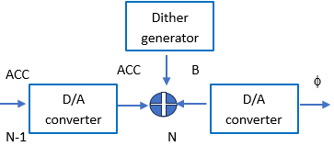

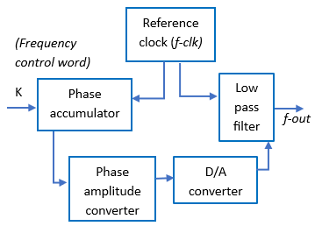

(a) (b)

**Figure 1:** *Block* diagram showing (a) *Structure of direct digital synthesizer, (b) Structure of direct digital synthesizer with dither generator.*

The various units involved are as follows:

1. Phase accumulator
2. Low pass filter
3. Phase amplitude converter
4. Digital to analog converter
5. Reference clock

The Structure of DDS Signal Generator includes a phase accumulator with a phase amplitude converter and a Digital or analog converter including a low-pass filter as illustrated in [Fig.1]. The phase accumulator is consisting of an adder and a register. The main function is to complete phase accumulation and waveform data output. The phase or amplitude converter is mainly to convert the output signal on the basis of the needed output form. The function of the Digital or Analog converter is mainly to convert the digital phase amplitude into analog quantity. The low pass filter that filters the signal to the needed form. It reduces the unwanted signal that obtained through the quantization. The signal is smoothened by the low pass filter by the filtering. The components of a Direct Digital Synthesizer (DDS) involve a phase generator also known as accumulator, phase to waveform convertor, low pass filter. To generate precise and adjust able output frequencies digital signal processing and analog components can be included. The circuit sequence is such that at turn on, it initialises the LCD.

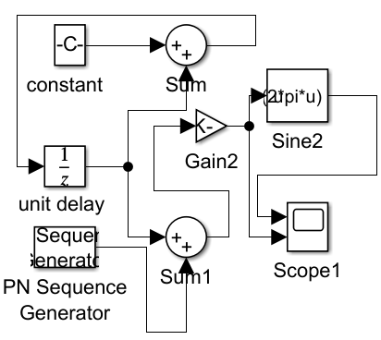

Figure 2: DDS with dither generator in MATLAB

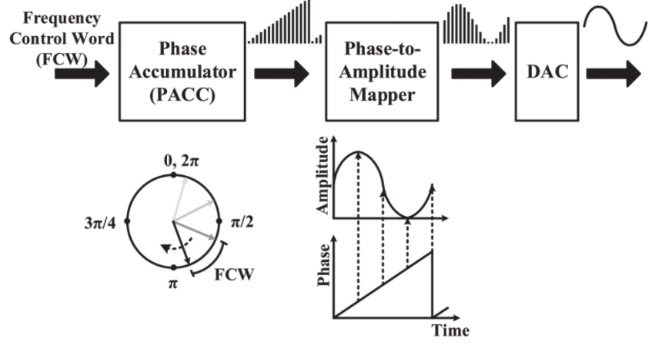

**Figure 3:** working of DDS

DDS WITH OPTIMIZATION TECHNIQUES

1. Dither Generator: The Dither Generator Approach In another method to spread the spurs throughout the available bandwidth. The dither signal from the Dither Generator can add a dither signal to the Accumulator phase value The model of DDS with Dither generated as illustrated in [Fig.2] The dither generator is mainly a pseudo-random noise sequence (generated, for example, with binary shift registers and exclusive-or gates, and having a repetition period much greater than the output signal period) whose word width is B bits providing noise values in the range of 0 and 2B. it is mainly a sprinkles of noise particles or sequence which added to the signal to increase the accuracy with less spur. The Total Harmonic Distortion can be also reduced through it. The DDS with dither generator is modified using PN sequence.
2. Odd Number Approach: The Odd Number Approach enhance the performance of DDS system and reduce the unwanted spur in the signal frequencies in the output waveform. In Direct Digital Synthesizer, a phase accumulator is typically used to produce the phase in formation of the output waveform. This phase information can be changed on the basis of the optimization technique. The information of the phase is then used to address a lookup table. The look up table contains the digital samples of the waveform. The output frequency of the DDS is identified by the value at which the phase accumulator is increased. Parameters such as the clock frequency and the number of bits in the phase accumulator. In that method the spurious frequencies produced by the DDS are odd multiples of the output frequency. It helps to reduce the spectral components in the output waveform. That are typically easier to filter the unwanted signal.

1. Noise Shaping Approach: Noise shaping is also most significant technique used in direct digital synthesizer to enhance the signal-to-noise ratio (SNR) of a system. The effect of noise which can degrade the quality of the synthesized waveform. Quantization noise occurs mainly by the effect of limited precision of the digital samples. The digital samples are stored in the waveform lookup table and the finite resolution of the phase accumulator. That noise content leading to distortion and reduced signal stability. Noise shaping contains the use of digital filters to shape the spectral distribution of the quantization noise. It is pushed to frequencies where it is less perceptible or easier to filter out. This is typically made by adding feedback of the quantization error into the DDS system, effectively shaping the noise spectrum. The DDS system generates a digital representation of the desired waveform by quantizing the output of the waveform lookup table. The quantized output is compared to the desired output, resulting in an error. The quantization error is processed by a digital filter, it is often a high-order filter. The filtered quantization error is fed back into the DDS system. By shaping the quantization noise spectrum to concentrate energy at higher frequencies or frequencies where it is less perceptible, noise shaping allows for a more efficient use of the available quantization levels, effectively increasing the SNR of the DDS system and improving the quality of the synthesized waveform.
2. **PERFORMANCE EVALUATION**

Direct digital frequency synthesis technology which can convert a continuous digital signal into analog signals through a digital or analog converter. The reference clock signal frequency is f-clk, the number of bits of the phase accumulator is N. The frequency control word also known as frequency tunning word. By changing the size of the frequency control word k, the output frequency can be changed. Total Harmonic Distortion (THD): 0.00048383. The DDS with Dither generated also known as PN Sequence output sine wave form of 1000 frequency are generated as shown in [Fig.5].

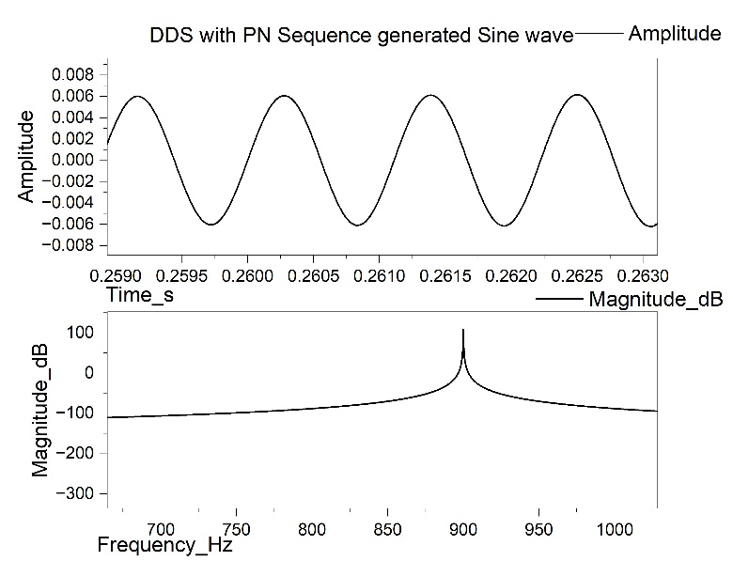

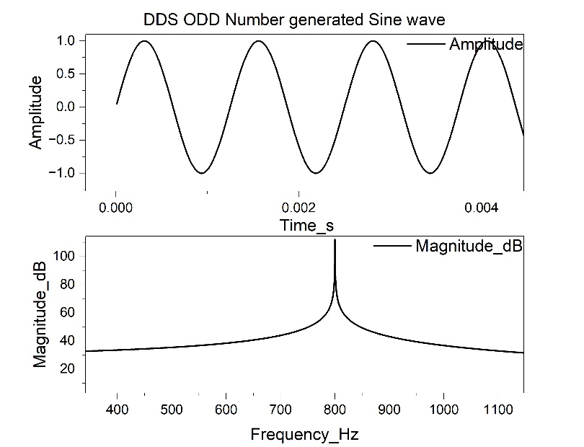

1. (b)

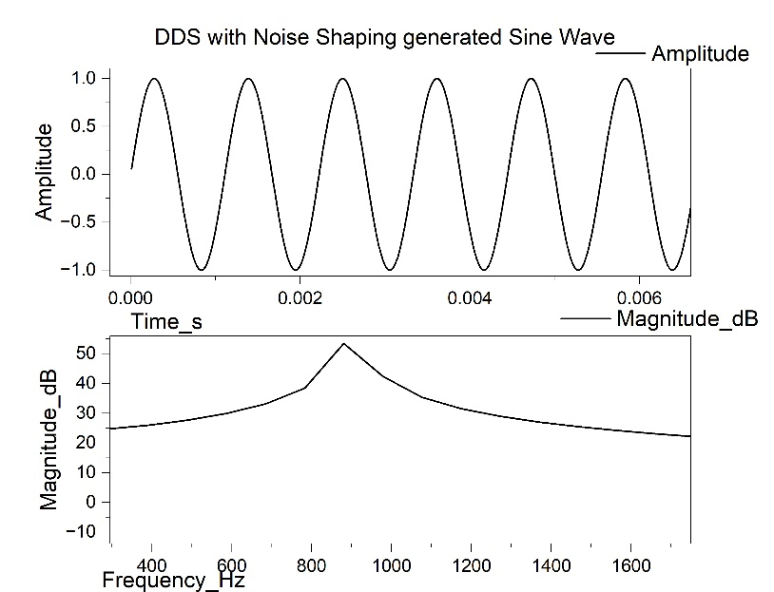

(C)

Figure 4: Output wave of DDS with different optimization techniques (a) PN sequence, (b) Odd number approach, (c) Noise shaping approach

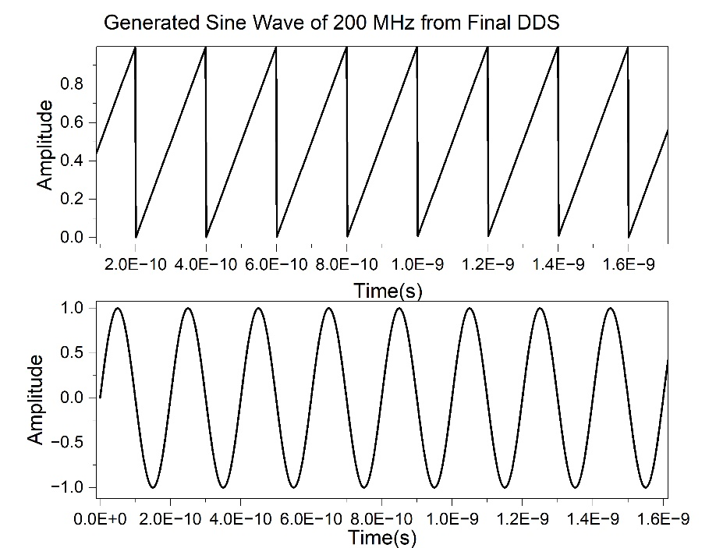

**Figure 5:** 7. Wave form of DDS with Dither generator (200 Mhz)

**Table 1:** Summary of performance evaluation Table Size (10)

|  |  |  |
| --- | --- | --- |
| Optimization techniques | Parameter | s |
| *Target Frequency (Hz)* | *THD* |
| PN Sequence Approach  No of bits: - 1024  Sample Frequency=100000 Hz | 1000 | 0.001972 |
| 900 | 0.0010726 |
| 800 | 0.0004838 |
| 700 | 0.00040897 |
| 600 | 0.0001283 |
| Odd Number Approach  Sample Frequency=100000 Hz | 1000 | 0.0026202 |
| 900 | 0.0022824 |
| 800 | 0.0029022 |
| 700 | 0.0005292 |
| 600 | 0.0002924 |
| Noise shaping approach copy  No of bits: - 1024  Sample Frequency=100000 Hz | 1000 | 0.080333 |
| 900 | 0.080795 |
| 800 | 0.080133 |
| 700 | 0.078261 |
| 600 | 0.080333 |

**IV. CONCLUSION**

This paper presents a Direct Digital Synthesizer (DDS) incorporating various optimization techniques. Different parameters are analyzed to enhance signal accuracy and performance. The DDS model, designed with a PN sequence approach, achieves more accurate and precise signal generation. By adjusting the input parameters on the board, waveforms at different frequencies can be manually generated. This work addresses the limitations of DDS at frequencies around the 200 MHz range, implementing improvements that enhance signal quality and stability.

**REFERENCES**

1. I. V. Strelnikov, I. V. Ryabov and E. S. Klyuzhev, ”Direct Digital Synthesizer of Phase-Manipulated Signals, Based on the Direct Digital Synthesis Method,” 2020 Systems of Signal Synchronization, Generating and Processing in Telecommunications (SYNCHROINFO), Svetlogorsk, Russia, 2020, pp. 1-3, doi: 10.1109/SYNCHROINFO49631.2020.9166040.
2. I. V. Ryabov, I. V. Strelnikov, S. V. Tolmachev and E. S. Kljuzhev, ”Direct Digital Synthesizers of Complex Broadband Signals,” 2019 Systems of Signals Generating and Processing in the Field of on Board Communications, Moscow, Russia, 2019, pp. 1-4, doi: 10.1109/SOSG.2019.8706776.
3. D. N. Bochkarev, I. V. Ryabov, I. V. Strelnikov and N. V. Degtyarev, ”Direct Digital Synthesizers of Frequency and Phase-Modulated Signals,” 2019 Systems of Signal Synchronization, Generating and Processing in Telecommunications (SYNCHROINFO), Russia, 2019, pp. 1-4, doi: 10.1109/SYNCHROINFO.2019.8814244.
4. I. V. Ryabov, S. V. Tolmachev and P. M. Yuriev, ”DIRECT DIGITAL SYNTHESIZER WITH FAST FREQUENCY TUNING,” 2018Systems of Signal Synchronization, Generating and Processing in Telecommunications (SYNCHROINFO), Minsk, Belarus, 2018, pp. 1-3, doi: 10.1109/SYNCHROINFO.2018.8456988.
5. S. Saad, M. Mhiri, A. B. Hammadi and K. Besbes, ”An Enhanced Variable Phase Accumulator with Minimal Hardware Complexity Dedicated to ADPLL Applications,” 2018 15th International Multi-Conference on Systems, Signals and Devices (SSD), Yasmine Hammamet, Tunisia, 2018, pp. 1447-1452, doi: 10.1109/SSD.2018.8570405.
6. S. Narayan Sinha, S. Chatterjee and R. K. Palani, ”A 2-GHz Two-Tone Direct Digital Frequency Synthesizer,” in IEEE Transactions on Circuits and Systems II: Express Briefs, vol. 69, no. 12, pp. 5109-5113, Dec. 2022, doi: 10.1109/TCSII.2022.3202903.
7. Bochcarev, ”Formation of Frequency-Modulated Signals Using the Direct Digital Synthesis Method,” 2021 Wave Electronics and its Application in Information and Telecommunication Systems (WE\CONF), St. Petersburg, Russia, 2021, pp. 1-4, doi: 10.1109/WECONF51603.2021.9470536.
8. Yan, J. Sun and W. Liu, ”An Efficient High SFDR PDDS Using HighPass-Shaped Phase Dithering,” in IEEE Transactions on Very Large Scale Integration (VLSI) Systems, vol. 29, no. 11, pp. 2003-2007, Nov. 2021, doi: 10.1109/TVLSI.2021.3114680.
9. V. Strelnikov, I. V. Ryabov and E. S. Klyuzhev, ”Direct Digital Synthesizer of Phase-Manipulated Signals, Based on the Direct Digital Synthesis Method,” 2020 Systems of Signal Synchronization, Generating and Processing in Telecommunications (SYNCHROINFO), Svetlogorsk, Russia, 2020, pp. 1-3, doi: 10.1109/SYNCHROINFO49631.2020.9166040
10. I. V. Ryabov, N. V. Degtyarev and D. N. Bochcarev, ”Formation of Frequency-Modulated Signals Using the Direct Digital Synthesis Method,” 2021 Wave Electronics and its Application in Information and Telecommunication Systems (WECONF), St. Petersburg, Russia, 2021, pp. 1-4, doi: 10.1109/WECONF51603.2021.9470536.