BUILDING A MATHEMATICAL MODEL FOR DETERMINATION OF THE MISS DISTANCE OF ARTILLERY SHELLS USING PROXIMITY FUZES WITHOUT TARGET ANGULAR POSITION INFORMATION
Ph.D Pham Xuan Quyen1
1 Le Quy Don Technical University

Abstract: Artillery shells equipped with proximity fuzes neutralize targets using fragments generated upon detonation. The survivability of a target significantly depends on the distance between it and the explosion center. The closer the target is to the explosion center, the higher the probability of destruction, as it is located in a high-fragment-density zone and subjected to intense shock waves. Conversely, the farther the target is from the explosion center, the lower the fragment density and the weaker the shock wave intensity, reducing the likelihood of target destruction. Thus, the distance between the explosion center and the target is a crucial parameter in the design and manufacturing of artillery shells, directly affecting their lethality. Moreover, calculating this parameter serves as an essential foundation for determining other technical specifications within proximity fuzes. This paper presents the theoretical basis for developing a mathematical model that determines the miss distance of artillery shells using proximity fuzes without knowledge of the target's angular position, employing an analytical approach. The study's results indicate that the miss distance depends on the artillery shell's detonation angle, phase, and the distance between the antenna location and the detonation point.
Keywords: Proximity fuse; radio fuse; fuse utilizing the Doppler effect; warhead.
1. Problem statement
Many studies have been conducted on the optimal coordination between the fragmentation flow and the antenna wavefront of proximity fuzes [1-7]. The simulation study of fuzes for low-altitude surface-to-air missiles [2] discusses the anti-jamming capability and guidance of the proximity radar system. The Doppler effect has been utilized in proximity fuzes by S. Veksin [3]. In Vietnam, the concept of target miss distance has been briefly mentioned but lacks specific evaluations [8].
Fragmentation-based munitions neutralize or damage targets through the dispersion of high-velocity fragments at a certain distance. This distance is referred to as the target miss distance of the ammunition. When this value ranges from a few meters to several tens of meters, an external observation post that determines the positions of both the ammunition and the target assumes that these two positions coincide. This assumption presents challenges in accurately determining the ammunition's target miss distance. Analytical methods and Matlab software are employed to establish relationships between the target miss distance, detonation angle, phase of deviation, and the spatial separation between the antenna position and the detonation point. These calculations provide munition fuze designers with objective and relatively clear assessments when selecting structural parameters.
I. Problems Statement
Numerous researches have been conducted on the optimal coordination between fragment dispersion and the antenna wavefront of proximity fuzes [1-7]. The research on the simulation of proximity fuzes for short-range air defense missiles [2] discusses the system’s jamming resistance and the guidance capabilities of proximity radar. The Doppler effect has been utilized by S. Veksin in terminal proximity fuzes [3]. In Vietnam, the concept of target miss distance has been briefly mentioned but has not been thoroughly evaluated [8].
Lethal fragmentation munitions neutralize or damage targets using ammunition fragments at a certain distance. This distance is referred to as the target miss distance of the ammunition. When this value ranges from a few meters to several dozen meters, external observation systems that determine the positions of the ammunition and target often assume that these two positions coincide. This assumption poses challenges in accurately determining the ammunition’s target miss distance. Analytical methods and Matlab software are employed to establish relationships between the target miss distance, detonation angle, phase shift, and the distance between the antenna and warhead detonation point. These calculations provide designers with an objective and relatively clear basis for selecting structural parameters when designing fuzes.
II. Methods
1. Coordinate system
To determine the Doppler frequency, a conical coordinate system is used in conjunction with a linear velocity coordinate system, with its origin located at the transmitting antenna of the radar system (Figure 1). Axisis parallel to the relative velocity vector between the ammunition and the target, Coordinate plane coincides with the velocity triangle plane, which is formed by the velocity vectors . Here, correspond to the ammunition velocity and target velocity, respectively. The target’s position at pointis determined by the quantities , where represents Cartesian coordinates; is the distance from the origin O to the projection of point on plane , characterizing guidance accuracy and referred to as the miss distance, is the polar angle, representing the phase of the miss distance. are the polar coordinates of point .
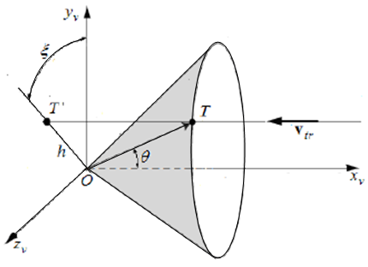
Figure 1: Relative position of the ammunition and target in space
In Figure 1, the relative position of the ammunition and the target in space is illustrated, with the ammunition located at O and the target positioned at T.
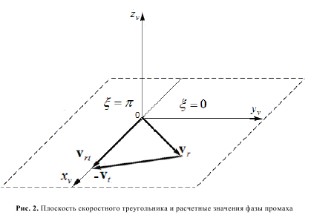
Figure 2: The relationship between relative velocity
and the phase value of the miss distance
From the coordinate system used to determine the detonation region (Figures 1 and 2), two observations can be made:
- If the miss distance (Figure 1), the coordinate surface takes the form of a cylindrical shape symmetric around the axis, representing the Doppler-undefined region.
- The half-plane, which contains the positive semi-axis and the velocity triangle (Figure 2), corresponds to a miss distance phase value of , meanwhile, the half-plane, which contains the negative Oy semi-axis (Figure 2), corresponds to a miss distance phase value of .

2. Determination of the Target Miss Distance of the Ammunition
To describe the operation of the warhead, a coordinate systemis typically employed, with its origin positioned at the detonation point of the warhead. The axis aligns with the longitudinal axis of the ammunition, oriented from the center of mass toward the ammunition's nose.
When coordinating the operation of the antenna and the fragment stream, the phase of the miss distance assumes a value of . In practice, for a warhead that is symmetric along the ammunition’s longitudinal axis and employs a Doppler fuse, it is possible to constrain the phase value of the miss distance and . These two cases are illustrated in Figures 3 and 4.
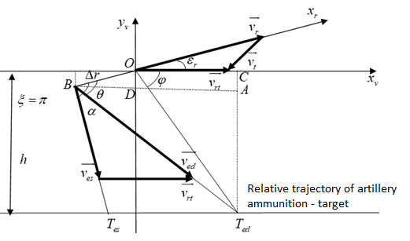
Figure 3: Relative motion of the ammunition and target
when the phase of the miss distance is
In figure 3,is the directional angle formed by the ammunition velocity vector and the relative velocity vector between the ammunition and the target; Point B represents the detonation location of the warhead and is positioned from the antenna at a distance ;represents the average dispersion angle of the static fragments; is the average dispersion angle of the dynamic fragments; denotes the velocity vector of the static fragments; denotes the velocity vector of the dynamic fragments; is the intersection between the trajectory of the static fragment and a straight line containing the target, which is parallel to the Ox axis; is the intersection between the straight line containing the target (parallel to the Ox axis) and the direction of motion of the dynamic fragment; is the angle formed by the Ox axis and the line . This is the angle at which the proximity radar system decides to detonate the ammunition, commonly referred to as the detonation angle.
For each miss distance (Figure 3), there corresponds a range of detonation angles in the velocity coordinate system, with the coordinate origin at O and the detonation command is executed when the fragment and the target meet at point.
Formula for Calculating the Velocity of Dynamic Fragments:
(1)
Considering vector , the time required for the static fragment to travel the distance with velocity is:
(2)
Meanwhile: . The target will be damaged if the dynamic fragment and the target meet at position. At that moment, the distance is determined by the following formula:
(3)
Meanwhile: . Thus, the velocity vector of the dynamic fragment () is directed toward point The time required for the dynamic fragment to travel the distance is determined by the following formula:
(4)
Meanwhile: .
- Considering case (Figure 3)
In the right triangle , where A is the right angle, we have: , thus
, khi (5)
In the right triangle, where D is the right angle, we have:
, khi (6)
Substituting equation (6) into equation (5), we obtain:
, khi (7)
- Considering case (Figure 4)
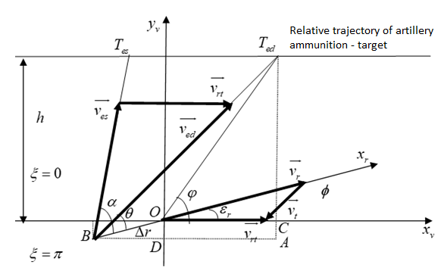
Figure 3: Relative motion of the ammunition and target
when the phase of the miss distance is
In the right triangle , where A is the right angle, we have: , thus .
, khi (8)
In the right triangle, where D is the right angle, we have:
, khi (9)
Substituting equation (9) into equation (8), we obtain:
, khi (10)
According to Figures 3 and 4, the target miss distance is determined by the following formula:
, khi (11)
(12)
Substituting equation (7) into equation (12), we obtain:
, khi (13)
Substituting equation (13) into equation (11), we obtain:
, khi
Thus,
,while (14)
Substituting equation (10) into equation (12), we obtain:
, khi (15)
Substituting equation (15) into equation (11), we obtain:
,while (16)
Thus, formulas (14) and (16) determinecorresponding to the phase shift and .
III. Results and Discussion
The assessment of the target miss distance of the ammunition depends on several parameters, such as the detonation angle and the phase of the miss distance. This can be analyzed through the following examples:
Example 1: ; ; và . Applying formulas (14) and (16) to determine the target miss distance of the ammunition. The values are calculated using Matlab software (Figure 5).
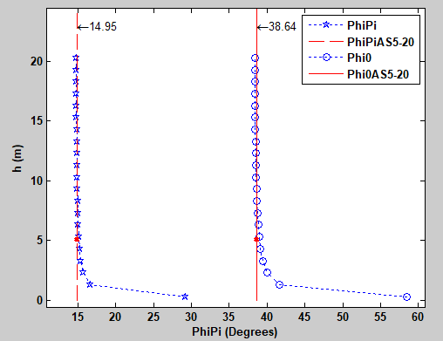
Figure 5: The target miss distance of the ammunition depending on the detonation angle for the phase of the miss distance and .
From Figures 3, 4, and 5, as well as formulas (14) and (16), it can be observed that at position B (Figures 3 and 4), the detonation angle reaches its maximum value. When gradually increases from, the value of gradually decreases and fluctuates slightly around the asymptotic value corresponding to the miss distance, ranging from 5m to 20m. According to the computational analysis shown in Figure 5, when using the PhiPAS5-20 approximation method, the system determines that the warhead detonation angle remains constant at for a miss distance between 5m and 20m, with a phase value of. For the Phi0AS5-20 approximation method, the system determines that the detonation angle remains constant at for the same range of miss distances with a phase value of. The detonation angle φ\varphiφ is allowed to fluctuate within the ranges forand for , when the miss distance is less than 5m.
Example 2: ; ; and . The computational result for using formulas (14) and (16) in Matlab is illustrated in Figure 6. Unlike in Example 1, here , meaning the antenna position coincides with the warhead detonation point.
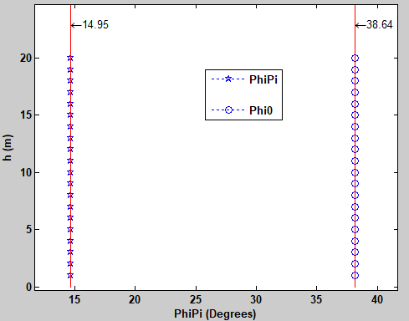
Figure 6: The target miss distance of the ammunition
when the detonation angle is at its minimum value

According to the results obtained in Figure 6, when, for all miss distance values, there is always a unique detonation angle of corresponding to the miss distance phase value, and a detonation angle of corresponding to the miss distance phase value . In practical scenarios, a condition whereis very unlikely to occur. This is because both the antenna and the signal processing system are complex structures with significant dimensions. Therefore, thevaries depending on the specific type of ammunition.
Example 3: ; ; . Calculation of using Formulas (14) and (16) in Matlab (Figure 7). Here, the relationship between the miss distance and the detonation angle is evaluated by varying. This aims to determine the corresponding miss distance for each detonation angle value and the relative distance between the antenna position and the detonation point.
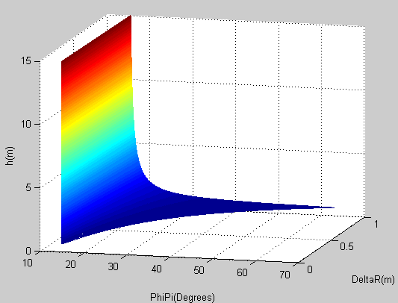
Figure 7: The dependence of the miss distance h onand
According to the results shown in Figure 7, the value ofis proportional to the range width of the detonation angle when the miss distance is less than 5m. Specifically, in the case where the miss distance phase iswhen the detonation angle is for all miss distance values and when the detonation angle falls within the range for a miss distance in the range . When the miss distance exceeds 5m, the detonation angle tends to stabilize at for all values of . In this case, to control the miss distance , the detonation angle must be within the rangeand .
Example 4: ; và ; ; . Calculation of using Formulas (14) and (16) in Matlab (Figure 8). In this case, the study examines the variation of for two different heading angle values, and to determine the corresponding ​ value.
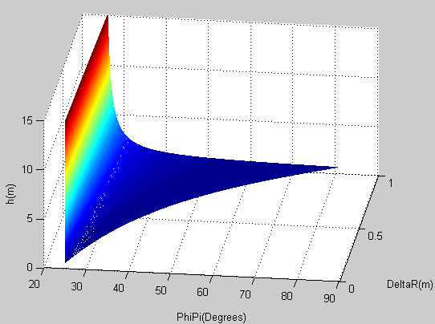  ; | 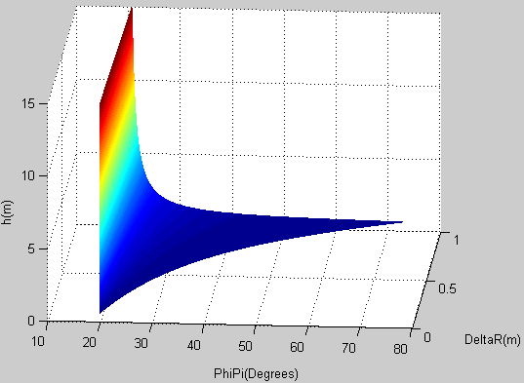  ;
Figure 8: The miss distance of the ammunition as a function of ,and
The results indicate that the miss distancereaches its maximum value when is at its smallest, and conversely, as increases, decreases. When the angle formed by the ammunition velocity vector and the relaive velocity of the ammunition-target system (​) increases, the detonation angle () decreases.
Example 5: ; ;;; . The miss distance is computed using equations (14) and (16) in Matlab (Figure 9). This example investigates the variation in the miss distance for two cases of dynamic fragment dispersion angles, and aiming to determine how influences the miss distance .
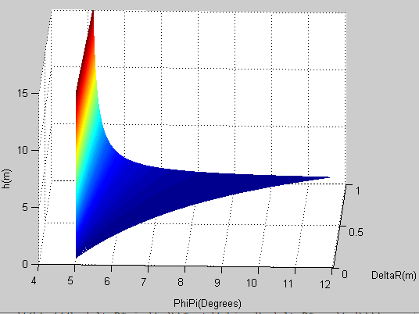  ; | 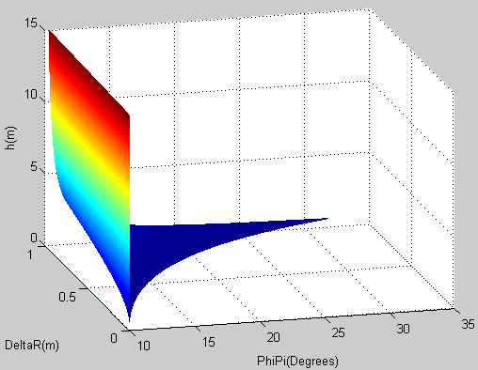  ;
Figure 9: The miss distance of the ammunition as a function of , and .
When the dispersion angle of dynamic fragments ( ) increases, the detonation angle () also increases. This means that the ammunition detonation angle depends on its velocity. However, the impact of on the miss distance is insignificant.
IV. Conclusion
Solving equations (14) and (16) enables the determination of the ammunition's miss distance for specific structural parameters. The interpretations and analyses above provide a foundation for identifying additional parameters of the proximity fuze, such as ammunition-target contact angle , miss phase , distance between the antenna and detonation point, average fragment dispersion angle, this is crucial for proximity fuze design. The development of parameters and solution methods will be presented by the author on another occasion. The obtained results open up several potential directions, such as multi-point detonation, compact antenna design to ensure compatibility with various ammunition types, assessing target survivability after fragmentation impact, etc.

References
- Z.H.Huang, Q.J.Feng, Research on optimum fuze-warhead coordination based on antenna beamforming of fuze. The 2007 international autumn seminar on propellants, explosives and pyrotechnics; oct 23-26 Xi'an, China (2007), pp. 861 - 864,2007.
- Q.Zhao, G.Y.Du, B.Zhang, et al, Simulation design of fuze warhead system of air defense missile at very low altitude. J Syst Eng Electron, 28 (3), pp. 572-584, 2017.
- S.Veksin, Processing of radar signals in Doppler homing heads, Moscow: MAI, p. 304, 2005.
- M.A.Kolodny, Radar proximity fuzing and the Cold War paradigm, in Microwave Symposium Digest (MTT), 2011 IEEE MTT-S International, 2011.
- Z.-B,Li, Implementation and development of compact UWB proximity
fuze sensor system in Computational Problem-Solving (ICCP), 2011
International Conference,2011.
- Yu.M.Astapov, V.I.Kozlov, N.S.Soboleva, V.K.Khokhlov; A.B.Borzov, E. D. Avtonomnye, Autonomous information and control systems". In 4 vols. Vol. 1: Proc. of department Autonomous information and control systems of Bauman MSTU, Autonomous information and control systems, vol. 1, pp. 409-464, 2011.
- Klement C., Comanescu I.S., Clinciu M., The mathematical model of the simulation of the Doppler effect, ICMS 2019 & COMEC 2019, Brasov, ROMANIA, vol. 5, №1, p.105,2019.
- Pham Xuan Quyen, Determining the dependence of doppler frequency on the slip between the artillery shell and the target when using a Doppler non-contact fuse. Journal of natural science-engineering-technology, Thai Nguyen University, vol. 228 . №02, 2023.

