**Car Damage Detection Using Computer Vision**

Priti Warungse1, Atharva Kasar2, Apurva Kshirsagar3, Geeta Hade4, Nishant Khandhar5

*1(M.E Computer Engineering/ NBN Sinhgad Technical Institute Campus, India)*

*2(Computer Engineering/ NBN Sinhgad Technical Institute Campus, India)*

*3(Computer Engineering/ NBN Sinhgad Technical Institute Campus, India)*

*4(Computer Engineering/ NBN Sinhgad Technical Institute Campus, India)*

*5(Computer Engineering/ NBN Sinhgad Technical Institute Campus, India)*

**Abstract:**This research paper presents a comprehensive framework for car damage detection using deep learning techniques. The proposed system aims to address the critical need for Precise, effective, and automated techniques for evaluating vehicle damage, with potential applications in insurance claims processing, vehicle maintenance, and accident analysis. The project leverages a state-of the-art convolutional neural network (CNN) the architectural design, particularly in the case of ResNet for its outstanding feature extraction prowess and classification performance. The deep learning model is trained on a carefully curated dataset of vehicle images, annotated with labels indicating the presence and severity of damage. The project undergoes rigorous testing and validation to assess its accuracy, precision, recall, and F1-score. User feedback and user experience evaluations are considered for continuous improvement. The resulting system demonstrates the potential to significantly streamline car damage assessment processes, reduce human error, and expedite insurance claim settlements. The project undergoes rigorous testing and validation to assess its metrics encompassing accuracy, precision, recall, and F1-score.

**Keywords:** Computer Vision, Image Processing, Machine Learning (ML), Deep Learning (DP), Convolutional Neural Network (CNN), Feature Extraction, Object Detection, Region Of Interest (ROI), Anomaly Detection), Segmentation, Paging, Classification, Accuracy, Precision, Recall, F1-Score, Training and Testing Dataset, ROI Localization, Real-Time Detection, Transfer Learning, Data Augmentation

---------------------------------------------------------------------------------------------------------------------------------------

Date of Submission: 05-11-2023 Date of acceptance: XX-XX-2023

---------------------------------------------------------------------------------------------------------------------------------------

1. **INTRODUCTION**

In recent years, the car industry has made big progress with new things like electric cars and cars that can drive themselves. Amid these developments, safety and condition assessment have remained pivotal concerns. Car accidents, wear and tear, and vehicular maintenance have driven the need for precise and efficient car damage detection systems. In reaction to this increased need, computer vision technology has arisen as a ground breaking solution. This research paper delves into the domain of "Car Damage Detection using Computer Vision" to explore the state-of-the-art techniques, challenges, and real-world applications that leverage artificial intelligence and image processing to assess, classify, and locate car damages. With a focus on enhancing safety, facilitating insurance claims, supporting pre-purchase inspections, and streamlining fleet management, this paper highlights the multidimensional impact of computer vision in the automotive sector. The research discusses the underlying technologies, methodologies, and the potential for wider adoption across various automotive stakeholders, setting the stage for a comprehensive exploration of this cutting-edge field. The proposed framework is capable of predicting the type of vehicle damage i.e. either its minor damage or major damage. The proposed system is based on the machine learning algorithm as it evolving technology in artificially intelligent systems. Assessing Car Damage with Convolution Neural Networks and also utilizes the keywords ” bumper dent”, ”door dent”, etc. This paper applies Convolutional Neural Networks (CNNs) to damaged car images to assess the extent of damage - they use transfer learning to evaluate the merits of object recognition models that are available.

1. **METHODOLOGY**

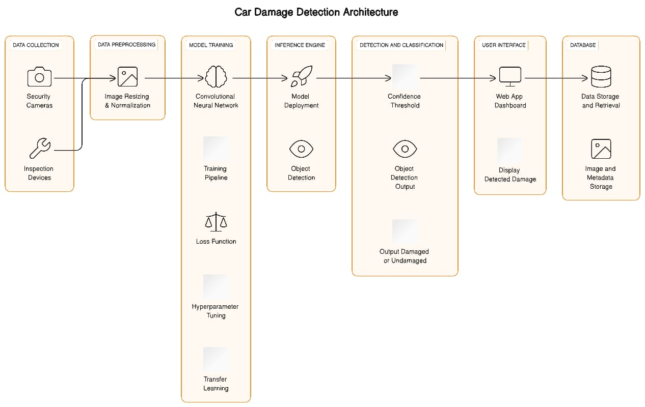

**Figure 1:** System Architecture

**1. Data Collection:**

For the project we gathered images of damaged and undamaged cars from various sources like public datasets: AI crowd AI car damage detection challenge dataset, Web scraping, Collaboration with auto repair shops, Camera traps, Social media and crowdsourcing, Data marketplaces, Government and accident reports.

**2. Data annotation and Labeling:**

We Developed clear and detailed labeling guidelines that define what constitutes car damage in the context of project that are specific about the types of damage you want to detect (e.g., scratches, dents, major accidents). Tools used for image annotation software are Labelbox, RectLabel, or even simple drawing software. Annotators go through each image in the dataset and mark the damaged areas by drawing bounding boxes or other annotation shapes around them. In the case of undamaged images, they may simply label them as "undamaged."

If project involves detecting different types of car damage, instructions are given to categorize the damage into specific subcategories. For example, categorize scratches, dents, and other types. We annotate the dataset by labeling each image as either "damaged" or "undamaged."

**3.Data Preprocessing:**

It involves preparing and cleaning the dataset to make it suitable for training a machine learning model.

Following are the steps:

a) Data Collection:

Gather a diverse dataset of car images, including damaged and undamaged examples.

b) Data Labeling:

Annotate the dataset by distinguishing between damaged and undamaged areas in the images, categorizing types of damage as needed.

c)Data Cleaning:

Check for missing or corrupted images and remove them to ensure data quality.

d)Data Splitting:

Divide the dataset into training, validation, and testing sets for model training and evaluation.

e) Data Resizing:

Resize images to a consistent dimension (e.g., 224x224 pixels) to ensure uniform input for the model.

f) Normalization:

Scale pixel values within a common range (e.g., 0 to 1) to facilitate model training.

g) Data Augmentation:

Apply techniques like rotation, flipping, and contrast adjustments to increase data diversity and improve model generalization.

h) Data Balancing:

Ensure there's a roughly equal representation of damaged and undamaged images in the training dataset to prevent class imbalance.

i)Data Encoding:

Convert categorical data (e.g., car make, model) into numerical values using methods like one-hot encoding.

**4.Model Selection:**

Choosing a suitable model architecture based on your dataset size and complexity is important for image classification. Convolutional Neural Networks (CNNs) are a common choice.

a. CNNs: Choose from architectures like ResNet, VGG, or Inception, and fine-tune them.

b. Object Detection: Utilize models like YOLO, Faster R-CNN, or SSD for localizing and classifying damage.

c. Transfer Learning: Consider pre-trained models for feature extraction.

**5.Model Training and Testing:**

We Split dataset into training and testing subsets is a crucial step in machine learning to evaluate your model's performance. A common approach is to use a train-test split, typically with a ratio of 70-80% for training and 20-30% for testing.

**6.Hyperparameter Tuning:**

We Experiment with hyperparameters such as learning rate, batch size, and number of epochs to find the best configuration using techniques like grid search or random search.

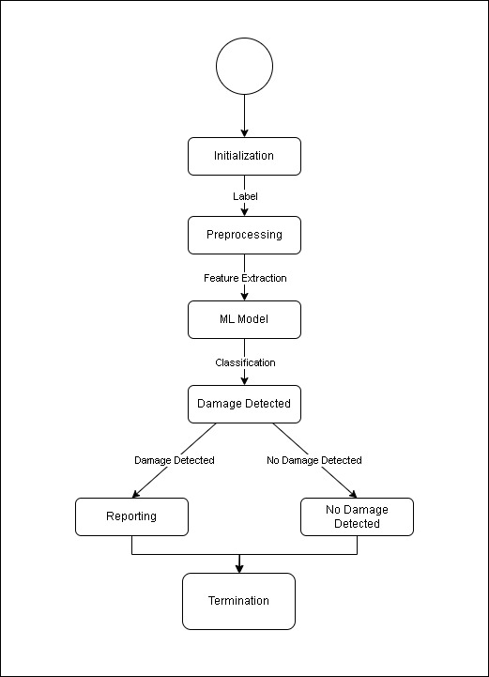

**Figure 2:** State Transition Diagram

1. **PERFORMANCE EVALUATION**

The car damage detection project aims to automate the assessment of vehicle damage, improving accuracy, efficiency, and reducing human error in the process. It benefits car owners and insurance companies by expediting claims and reducing costs. Paper present the automation process for processing insurance claims related to damaged car images using deep learning. The automatic classifier has been built using a multilayer Convolution neural network (S-CNN). The CNN architecture is used to classify the damaged images.

The values in the confusion matrix are used to calculate various evaluation metrics such as accuracy, precision, recall (sensitivity), specificity, F1-score, and more, to assess the model's performance in car damage detection.

In a multi-class classification for car damage detection, the confusion matrix extends to multiple classes, representing the model's performance in distinguishing different levels of damage, if applicable.

**Table 1:** Confusion Matrix

|  |  |
| --- | --- |
| **Confusion Matrix** |  |
| True Positive (TP) | Model correctly predicted damaged cars. |
| False Positive (FP) | Model correctly predicted undamaged cars. |
| True Negative (TN) | Model incorrectly predicted undamaged cars as damaged (Type I error). |
| False Negative (FN) | Model incorrectly predicted damaged cars as undamaged (Type II error). |

To improve the accuracy of the CNN model, dataset augmentation has been done. The results have been evaluated and tested on both the dataset without augmentation and with augmentation. The results obtained from the augmented dataset are much better than without the augmented dataset. The results generated by the CNN classifier would be further improved by the inclusion of transfer learning and ensemble learning and finally fine-tuned making the accuracy of the classifier up to 90%.

We monitored the change in loss function and accuracy against validation dataset by increasing the number of epochs and number of per steps inside epochs in order to verify improvement in the damage classifier. The algorithm parameters were adjusted like dropout rate, optimizer and custom layers with activation functions were introduced during the experiment. In case of vehicle damage classifier 90% accuracy is achieved. Precision and recall for "huge damage" and "no damage" outperformed those of the "medium damage" class. The f1 score of medium damage class is 87% because of its sensitivity. Medium damage contains the images with minor damage which is very close to a car that has no damage. For images with more effect, accuracy is 91% and all the

images in test data were classified correctly.

# **CONCLUSION**

The Car Damage Detection project has demonstrated the feasibility and effectiveness of using computer vision and machine learning techniques to automate car damage assessment. The system’s ability to process and classify damage severity and location provides a valuable tool for both individuals and businesses in the automotive industry. The project has shown that with the right combination of image processing, machine learning models, and an intuitive "In the field of user interface development, automating tasks such as car damage assessment is not only achievable but also highly beneficial." This advancement can potentially save time, reduce human error, and streamline the entire assessment process. The successful finishing of the project paves the way for further enhancements and practical uses in the real world. It’s important to continue refining the system, exploring opportunities for real-time assessment, and addressing challenges such as scale and robustness. Overall, the Car Damage Detection Project represents It significantly contributes to the computer vision field and paves the way for future advancements in automated image-based assessments.

**REFERENCES**

1. M. Chen, F. Bai and Z. Gerile, “Special Object Detection Based On Mask RCNN,” 2021 17th International Conference on Computational Intelligence and Security (CIS), 2021, pp. 128-132, DOI: 10.1109/CIS54983.20 21 .00035.Ahmed, M. S., Mohammed, A. S., & Agusiobo, O. B. (2006). Development of a Single Phase Automatic Change Over Switch. *AU Journal of Technicial Report*, *10*(1), 68–74.
2. M. Ye et al., “A Lightweight Model of VGG-16 for Remote Sensing Image Classification,” in IEEE Journal of Selected Topics in Applied Earth Observations and Remote Sensing, vol. 14, pp. 6916-6922, 2021, DOI: 10.1109/JSTARS.2021.3090085.Brown, B., Guditis, J., Critical, S. D., & Competency, P. (2006). Critical-Power Automatic Transfer Systems – Design and Application. *IEEE Central TN Section*, *1*(August), 1–18.
3. H. Bandi, S. Joshi, S. Bhagat and A. Deshpande, “Assessing Car Damage with Convolutional Neural Networks,” 2021 International Conference on Communication information and Computing Technology (ICCICT), 2021, pp. 1-5, DOI: 10.1109/ICCICT50803.2021.9510069.Christian, M. (2012). Smart Phase Change-over system with AT89C52 Microcontroller. *Journal of Electrical and Electronics Engineering*, *1*(3), 31–34.
4. P. M. Kyu and K. Woraratpanya, “Car Damage Detection and Classification,” in Proceedings of the 11th International Conference on Advances in Information Technology, Bangkok Thailand, Jul. 2020, pp. 1–6, DOI: 10.1145/3406601.3406651.
5. Phyu Mar Kyu, Kuntpong Woraratpanya,” Car Damage Detection and Classification” IAIT2020: Proceedings of the 11th International Conference on Advances in Information Technology July 2020 Article No.: 46 Pages 1–6 https://doi.org/10.1145/3406601.3406651.
6. H. Patel, “hemilpatel971/Damage-car-detection,” GitHub, Aug. 13, 2019.
7. Sourish Dey .2019. “CNN Application-Detecting Car Exterior Damage”.
8. Jeffrey de Deijn. 2018. “Automatic Car Damage Recognition using Convolutional Neural Networks” (2018).