Avighna Daruka

Avighna.117.2027@doonschool.com

Abstract

Graphite was always known to be special   
as it is the sole Allotrope of Carbon that bears  
the property of electrical conductivity. Today, with the help  
of a few common apparatuses we will conduct   
a experiment to measure how this electrical   
conductivity varies with the concentration of   
graphite in a pencil.

How does the concentration of graphite in a mixture of clay affect the electrical resistance

Research Drive 2023

# Introduction:

We are going to understand how the concentration of graphite in a mixture of clay can affect the electrical conductivity of the graphite. The research premise is simply how these findings can be applied into real life as practical applications such as the manufacture of carbon electrodes. Pencils are a common day to day tool that varies the concentration of graphite depending on the hardness and darkness level. And hence for todays experiment we are going to utilize them during the course of the trials.

# Background Theory:

During the course of the experiment I am going to aim to vary the concentration of graphite by using pencils of varying values on the hardness scale. The hardness of a pencil varies from 6B/H all the way till B/H.

The core of a pencil consists of a graphite powder incorporated with the assistance of a clay binder. The casing of this core is done using cedar wood and is being taken constant during the course of the experiment. In pencils wax is also used to make the colors more vibrant.

The hardness scale that was mentioned before depends on the relation between the amount of graphite and clay binder and can be represented with this table.

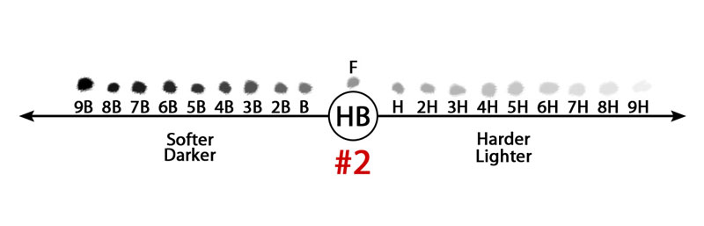

As the pencil gets darker, the concentration of graphite increases. And as the pencil shade gets lighter, we can infer that the concentration of clay binder is more than the graphite pencil.

The "H" pencils are harder and include more clay, leaving lighter markings on paper, whereas the "B" pencils are softer and contain more graphite, leaving darker marks. The firmer the pencil, the higher the number in front of the "H" (e.g., 9H), and the softer and darker the pencil, the higher the number in front of the "B" (e.g., 6B).

The following table documents the exact ratios of graphite, clay binder and wax in a variety of pencils taken from a research conducted by Maria Costa Sousa and John W Buchanan in the year 2000.

|  |  |  |  |
| --- | --- | --- | --- |
| Hardness | Graphite | Clay | Wax |
| 9H | 0.41 | 0.53 | 0.05 |
| 8H | 0.44 | 0.50 | 0.05 |
| 7H | 0.47 | 0.47 | 0.05 |
| 6H | 0.50 | 0.45 | 0.05 |
| 5H | 0.52 | 0.42 | 0.05 |
| 4H | 0.55 | 0.39 | 0.05 |
| 3H | 0.58 | 0.36 | 0.05 |
| 2H | 0.60 | 0.34 | 0.05 |
| H | 0.63 | 0.31 | 0.05 |
| F | 0.66 | 0.28 | 0.05 |
| HB | 0.68 | 0.26 | 0.05 |
| B | 0.71 | 0.23 | 0.05 |
| 2B | 0.74 | 0.20 | 0.05 |
| 4B | 0.79 | 0.15 | 0.05 |
| 6B | 0.84 | 0.10 | 0.05 |
| 8B | 0.90 | 0.04 | 0.05 |

# Key Words:

**1. Conductivity (Electrical):** Electrical conductivity is the measure of a material's ability to conduct electric current, determined by the ease of movement of electric charges within the material.

**2. Graphite:** Graphite exhibits high electrical conductivity due to its unique hexagonal lattice structure, which allows the delocalized electrons to move freely, facilitating efficient conduction of electric current.

**3. Allotrope:** Different forms of an element with the same atoms but varying arrangements, leading to diverse properties.

**4. Pencil Hardness Scale:** The pencil hardness scale measures the scratch resistance of materials using pencils of different hardness levels.

NOTE: As the wax is constant for the entire duration of the experiment and hence any uncertainty caused by its presence is constant for the duration of the experiment. And hence, I have ignored it carrying forward.

Another note is how according to the materials that we have here in school, I could not get access to all of the different pencils and only had hands on experience with 10B – HB pencils and also a 4H pencil.

Methodology:

For the experiment I am going to utilize the following apparatuses:

* A multimeter to measure the electrical resistance.
* Pencils of varying hardness and blackness brought from the art school
* A vernier caliper to measure the dimensions of the pencils.
* 30cm scale

After noting down the dimensions of the varying pencils I can sharpen the graphite core such that they are all equal in length. I have measured this with a 30cm scale and presented three trials to ensure that parallax error is negated.

Next, after ensuring that all the graphite/clay cores are equal we can take the measurement of the cores by utilizing a vernier caliper ensuring that no part of the core is shaved off. If this happens accidentally I can adjust the size to make it proportional and hence negate this error also.

After measuring the graphite cores we can use a multimeter and record the resistance measured. Again, to negate the human error I have conducted 3 trials for every pencil.

After recording all of the data I can plot this into Logger pro and establish a concrete trend. This trend is then analyzed and a conclusion is formed.

Main Theory:

Let:

* Rm= Electrical resistance of the clay-graphite mixture (in ohms, Ω)
* Rc = Electrical resistance of the pure clay (in ohms, Ω)
* Rg = Electrical resistance of the pure graphite (in ohms, Ω)
* Cg = Concentration of graphite in the mixture (as a fraction, not percentage)

Assumptions:

1. When we combine these two materials, we expect their electrical resistances to combine in a simple, linear fashion. This suggests that if we add more graphite to the mixture, the overall resistance will be closer to graphite's resistance. If we add additional clay to the mixture, the overall resistance will be closer to that of clay. In practice the relationship is not completely linear.

Rm = Rc + (Cg * - 106 Ω·m))

In this formula we have taken the resistance of the mixture as Rm which equates to the resistance of the clay plus the concentration of the graphite multiplied with the difference in the pure samples resistance. We have taken this value as -106.

We can also determine a threshold, which means the minimum concentration of graphite particles required to establish a continuous conductive network within the mixture. This point marks the transition of the core into a conductor. This point of concentration will be shown in the raw data.

Variables:

|  |  |  |
| --- | --- | --- |
| **Name** | **Type** | **Method of Combat** |
| Manufacturing company of the Pencils | Control | All the pencils were established to be from the same company. This was checked multiple times during the course of the trial. |
| Graphite Quality | Control | Where possible, all the pencils were from the same package and used for the same amount of time. |
| Layer of Graphite | Control | I would oscillate the pencil on the paper for 5s for every trial to minimize the error in the amount of graphite. |
| Room Temperature | Control | The room taken for all the experiments were at the standard 24 degrees and had zero to no humidity present in the air. |
| Electrical resistance | Dependant | -- |
| Concentration of Graphite | Independent | -- |

Data Collection:

For the experiment the following is a image of the apparatus utilized.

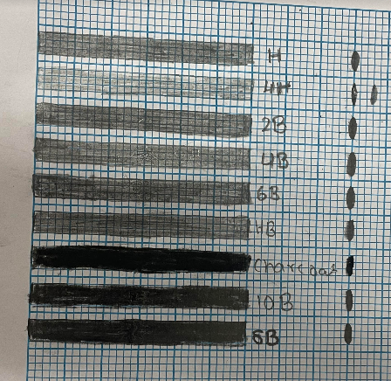

Every Pencil Mark on the Right is measured using standard 2mm squares.

To ensure that the layer of graphite on every pencil mark is equal I have applied the pencil on the paper for 5 seconds every test. This was also mentioned during my variable analysis.

Using a multimeter we can measure the electrical resistivity and put the results in a table.

Raw Data Collection:

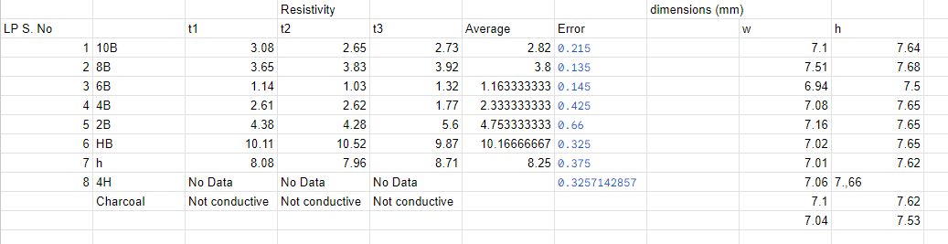

Raw Data Processed

The units for the resistivity is measured in kΩ. When taking the recording of the 4H pencil the multimeter was not showing any recording. This is likely due to the extremely high resistivity or some other external factors.

I have taken three trails for every pencil to make sure that my results have taken into consideration human error.

From the data we have collected we can plot the data using a Logging Software and observe the perfect curve fit.

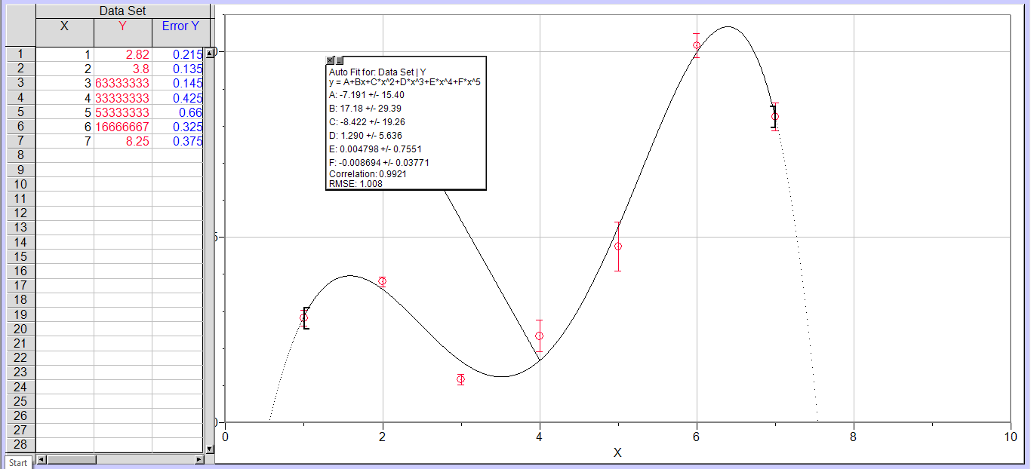

Ideal Curve Programmed into my Data Points

In the graph above I have constructed a ideal curve fit for the data points and also plotted the Error bars in the graph.

Data Analysis and Conclusion:

From the data analyzed we can not establish any concrete trend and hence, the error evaluation will play a crucial role in determining the reasons for why we cant determine a trend.

Error Analysis:

Let us understand why we could not construct a concrete relation. Now, the experiment has a lot of scope for human error in the form of applying uneven amounts of pressure throughout the line, or even the fact that the graphite nano layer will possess micro holes that will affect the electric resistivity. These holes are slightly different for all the different pencils and hence will definitely play a role in the results of the experiment. I believe if I had utilized a piece of scotch tape to retrieve a nano layer of graphite and then measure the electrical resistance the results would have been much more accurate.

To further elaborate this let us understand the basic structure of graphite.

Now graphite has layers of covalently bonded carbon atoms arranged in layers with weak electrostatic forces of attraction, making graphite’s atomic structure look something like this:

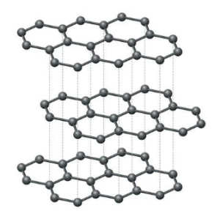

Basic Structure of Graphite

Hence, because these layers are regularly arranged, we can break a group of bonds in a perpendicular line to retrieve a perfect layer of graphite. As mentioned before this could be achieved using a piece of scotch tape instead of simply applying a thick layer of graphite on the paper. Simply applying the graphite on the paper has lead to a messy arrangement of the graphite and hence I believe a concrete trend could not be achieved.

Next, during the data collection I may have altered the position of the multimeter sticks and hence this would also affect the electrical resistivity as different positions would have different amounts of graphite and hence varying resistivities Aswell. The pencils that I had were sharpened at different angles as this would be extremely difficult to keep constant and hence this may have also caused an increase in the error bars displayed.

The formula that I utilized for the data collection may not have been totally accurate and was a generic (MAX-MIN)/2 application.

All in all I have learned a lot during the course of the trials and will apply them into further research projects during my journey in science.

Acknowledgments:

The help provided to the project was truly outstanding. My mentor Hridayam Tusnial helped a lot and the physics lab bhaiyas were also extremely supportive during all the testing. ARM sir also played a crucial role in providing the different types of pencils. Without which the trials would be impossible. At last Svanik played an invaluable role in helping me during every section of the research.

Bibliography:

Woolf, L. D., and Holger H. Streckert. “Graphite Pencil Line for Exploring Resistance.” *The Physics Teacher*, vol. 34, no. 7, American Association of Physics Teachers, Oct. 1996, pp. 440–41. <https://doi.org/10.1119/1.2344515>.

*GRAPHITE RESISTORS*. [www.troelsgravesen.dk/graphite.htm](http://www.troelsgravesen.dk/graphite.htm).

"Experiment on Pencil Resister Effect on Circuit Output." UKEssays. ukessays.com, November 2018. Web. 14 August 2023. <https://www.ukessays.com/essays/physics/experiment-pencil-resister-effect-circuit-9654.php?vref=1>.

Clastify. *IB Physics IA Example: How Does the Proportion of Graphite in a Pencil Affect Its Electrical Conductivity? | Clastify*. [www.clastify.com/ia/physics/6336a1a2d77add00134d85ab](http://www.clastify.com/ia/physics/6336a1a2d77add00134d85ab).

David, Iulia Gabriela, et al. “Pencil Graphite Electrodes: A Versatile Tool in Electroanalysis.” *Journal of Analytical Methods in Chemistry*, vol. 2017, Hindawi Publishing Corporation, Jan. 2017, pp. 1–22. https://doi.org/10.1155/2017/1905968.

*Of Pencils and Diamonds – Everything About Graphite*. [www.sglcarbon.com/en/everything-about-graphite](http://www.sglcarbon.com/en/everything-about-graphite).

Wikipedia contributors. “Graphite.” *Wikipedia*, Aug. 2023, en.wikipedia.org/wiki/Graphite.

Mokhena, Teboho Clement, et al. “Thermal Conductivity of Graphite-Based Polymer Composites.” *InTech eBooks*, 2018, https://doi.org/10.5772/intechopen.75676.