**REACTIVE POWER COMPENSATION ASSESSMENT BY INTEGRATING WIND FARMS INTO THE GRID, CONSIDERING: TECHNOLOGICAL ADVANCEMENT, CURRENT CHALLENGES, AND FUTURE DIRECTION. A REVIEW**

**Aliyu Sabo, Abdulaziz Abubakar**

*Department of Electrical Electronic Engineering Nigerian Defense academy, Kaduna, Nigeria.*

*Department of Biomedical Engineering 461 Nigerian Airforce Hospital Kaduna, Nigeria.*

*{* [*Saboaliyu98@gmail.com*](mailto:Saboaliyu98@gmail.com) *,* [*Axeex090@gmail.com*](mailto:Axeex090@gmail.com) *}*

# Abstract

# This paper deeply presents a comprehensive review on assessment of reactive power compensation on grid-connected wind farms, considering technological advances, current challenges, and proposed future directions. Renewable energy (RE) sources particularly wind energy, have garnered increasing interest in electricity generation. Researchers have undertaken multiple efforts to discover effective solutions for harnessing wind energy, through comprehensive studies and extensive research. The interaction between the power grid and individual units of wind power producers has the potential to disrupt stable operations due to power system instability Among these challenges, the issue of voltage instability within the power system is particularly significant, as it can lead to voltage collapse in the absence of appropriate stability control. To mitigate the challenge, Reactive power compensation is vital ensuring that the system stability is maintained, there are always challenges ranging from technical and environmental challenges among others, but these can always be adequately curbed through technological advancements explorations.

**Key Words** - Reactive power wind farm Static Compensator (STATCOM) Unified power flow controller (UPFC).

# Introduction

The global energy and environmental problems can be overcome by developing clean energy, wind power generation has become a matured and promising energy technology around the world as the technology development grows rapidly [1], [2] . However, the wind farm will always require reactive power support as the capacity and scale of the wind farm integration increases, the voltage impact on the system and the deficiency of reactive power will always manifest if the compensation is not always optimally done, and the grid safety and stability will be challenged, different techniques have been considered in improving the reactive power compensation as the wind farm is integrated into the grid [3] .

However, wind energy integration into the grid comes with many challenges because of the unstable nature of wind resources; therefore, the issue of reactive power compensation cannot be neglected [4], [3] . Wind farm integration into the grid comes with challenges such as reactive power compensation, voltage fluctuations, harmonics, flickers, and power peaks, the wind energy may not be able to supply the needed frequency, and voltage control when exposed to faults as they always absorbed a large amount of reactive power, because of this wind farm with low fault ride through capacity may trip off from the grid [5] .

The reactive power compensation devices are very important in maintaining system stability and power quality in the grid-connected wind farm, compensation devices such as source voltage converters(SVC), Capacitor banks, Series compensators, Shunt reactors, Static Var compensators, Static synchronous compensators (STATCOM), Synchronous condenser (SVC), Phase shifting transformers, among other devices plays important role in mitigating the wind farm grid-connected power compensation challenges to ensure the reliability and stability of the system [6], [7] . This paper is divided into seven sections such as the overview of the wind farm, the need for reactive power compensation, technological advancement, current challenges, the possible solutions, the summary, and the conclusion.

1. **WIND FARM TECHNOLOGY**

A significant increase in insufficient fossil fuel and environmental pollution is on the increase and has become very severe, to reduce environmental pollution and optimize the structure of global energy, renewable sources of energy such as solar, and wind energy have all over the world received global attention as there is a rise in development and investment of clean energy around the world [8], [9] . The exploration of wind energy is deeper than solar energy due to its wide distribution and mature technology advantage, the development of onshore wind turbine (ONWTs) faces challenges because of the noise it produces and the availability of land resources, the global interest of the offshore (OWFs)is on the increase due to better wind regime and the untapped wind resource. The offshore wind turbines are currently developing to large capacity and transmission over long distances, and the grid-connected wind farms have post-technological challenges one of those challenges is the reactive power compensation to sustain a stable power delivery. therefore, there is a need to have continuous technological advancement to curb the challenges [8]. The transmission technologies used in wind farms are high voltage alternating current (HVAC), high voltage direct current (HVDDC), low frequency alternating current (LFAC), or fractional frequency alternating current transmissions. Voltage AC transmission is cost-effective and mostly used for large-scale transmission systems, the transmission system will always be the first choice in wind farm power transmission. Consequently, large reactive power loss is a major issue in HVAC and the transmission distance is always limited. But in the future HVAC and LFAC could become the only solution to ultra-long distance power transmission, the five-topology based on the HVDC system are, line commutated converters HVDC(LCC-HVDC), all direct current (ALL-DC), voltage source converters HVDC(VSC-HVDC) and diode rectifier based HVDC(DR-HVDC), consequently, fault ride through (FRT) techniques are used for large farm integration of OWFs [8] .

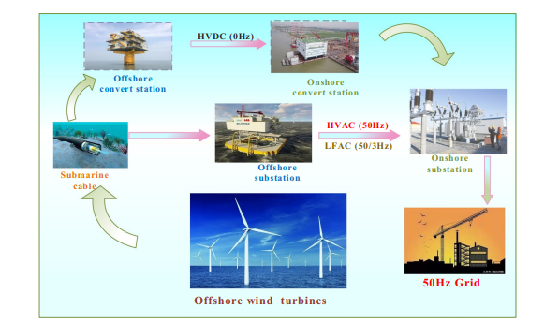 Figure 1. Wind farm [7]

A typical wind farm is equipped with several wind turbines each turbine has a package transformer, the transformer is connected by a parallel cable, and each of the package transformers sends the wind power to the low voltage side bus of the main transformer booster station through the collection line and then transformed to the high-pressure side the wind power will be sent to the outgoing line, the main electrical system in the wind farm consist of a wind turbine, package transformer, collection

line, equipment booster station and the main transformer[10],

[11] .

# .

.

Figure 2. Wind turbine integration diagram [10] .

As shown above, the reactive power loss is experienced in the wind turbine, package transformer, collection line, booster transformer, wind farm outgoing line, and the power grid. The power compensation is important to maintain a stable system [11] .

3. **Reactive power compensations**

Reactive power compensation is very crucial to the entire system of wind farm system to maintain voltage stability and to improve the system’s overall efficiency, wind energy is faced with many challenges such as flickers, frequency fluctuation due to power fluctuation, harmonics emission due to converters, voltage fluctuations due to the aerodynamic nature of the turbines, due to these there is need adequately control the system to improve system stability [9], [12] . Reactive power generated by the AC source is usually stored in capacitors or reactors during one-fourth of a cycle and in the next one-fourth of a cycle as it is sent back to the power source [13] . It always oscillates with twice rated frequency value of (50 or 60HZ) between the capacitor, reactor, and AC source, therefore there is always a need for a reactive power compensator to reduce or to avoid the circulation between the source and the load, the reasons for reactive power compensation are as follows

* To increase system stability
* Voltage regulation
* Improve power factor
* To improve machines and equipment utilization when connected to the system
* To reduce system losses
* To control and prevent voltage sag and collapse [13] .

The transmission line impedance in wind farm need lagging VAR this always result in significant consumption of reactive which can result in instability in the system transmission lines. The figure below shows compensation of reactive power that can also help in better transient response when there is fault and disturbances, the focus on the compensation technologies has been on the increase to have a better system [13], [14] .

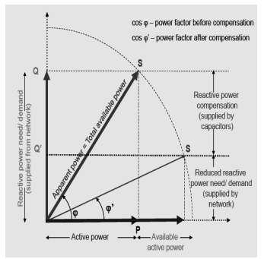

Figure 3. Reactive power compensation is supplied by a capacitor [13]

**Reactive power Technological advancement**

The technological development, advancement, and evolution of wind farms also brought any challenges due to the fluctuations in wind energy and other factors that can lead to poor power delivery. Consequently, the system development to improve frequency, voltage, and power quality is of great importance, the use of DFIG, PMSG, and FACTS devices electronic converters is of utmost importance to be able to maintain system stability [13], [15] . The reactive power compensation in wind consists of various technologies and devices that could help to maintain and manage the reactive power for grid integration of wind farms some of these devices are onload tap changers (OLTC), transformers, capacitor banks, static VAR compensators (SVC), Double fed inductor generator (DFIG), squirrel cage inductor machine (SCIM), FACTS devices among others.

**Flexible AC transmission system (FACTS)**: it is the combination of power system components such as transformers reactors, switches, and capacitors with power electronic components, they have the ability for high power application in tens, hundreds, and thousands of MW with the use of high current rating thyristors, FACTS improve the transient and dynamic stability of the system, the fast switching time than the conventional mechanical switch compensators, the electronic-based switching are flexible and increase transmissions capacities with forty to fifty percent [13], [16] . Different technologies employed in reactive power compensation are as follows

Capacitor banks

Series compensator

Shunt reactor

Static Var compensator

Static synchronous compensator (STATCOM)

Synchronous condenser (SVC)

Phase shifting transformers

**Static VAR compensator (VSC)**: This device makes use of high-power voltages it helps to reduce line loss, improve system stability, and maintain voltage variations within some limits, it consists of shunt reactors and capacitors, the reactors of the shunt and thyristor controlled are used to limit voltages rise at no-load and low load condition, and the static capacitor and thyristor switched capacitors are used to prevent voltages sag at peak load condition [17], [18] . The figure below shows the parallel combinations of a thyristor-controlled reactor and fixed capacitor and the parallel combination of a thyristor-switched capacitor and a thyristor-controlled reactor. The static var generator used (SVG), used fully controlled devices to be able to form a self- commutated inverter to be able to use small energy capacity storage capacity as an auxiliary to be able to perform effectively the corresponding reactive power compensation The controlled is made up of the outer loop controlled and the outer loop controlled layers, the inner loop controls the reference voltage while the outer loop controls the output voltages [13], [15] .

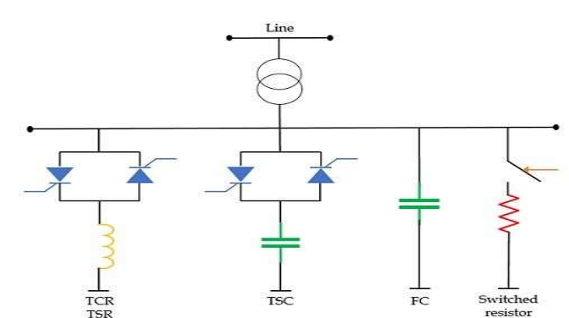

Figure 4. Static Var compensators [17] .

**Synchronous condenser:** synchronous condensers are power device that always produces reactive power that leads to real power in phase by ninety degrees [19] . it has the advantage of generating power that can be controlled in the grid system, it is similar to a synchronous motor that spines freely without any constrain, it does its major responsibility is to regulate the electrical power connected to the grid [20] . A voltage regulator is used to regulate its field as required to regulate and modify field voltage or to make sure that the power factor is considerably increased, it can be used to build up the reactive voltage as the voltage reduces, consequently, they always experience higher losses, most of the condensers used on the grid are hydrogen cooled and are rated between 20Mvarand 200Mvar, as they are used for reactive power compensation before the introduction of electronic based devices [19], [13] . The traditional synchronous is like a motor without mechanical load, the field is regulated through a voltage regulator to be able to draw up electrical power to support the system or to enable a stable power factor, they are also like a big electric motor when the excitation voltage rises the provision for magnetizing power in kvars in the electrical power system is made, it has the advantage of proper regulation and correction in the system.

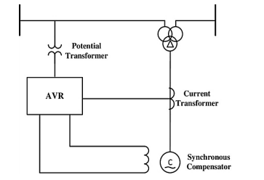

Figure 5. Synchronous condenser[13]

The supper conducting synchronous condenser uses high-temperature conductor winding, it is made up of cold with a cryocooler subsystem to about 35-40k. is a very active shock absorber of an electrical power system when connected to the grid, it effectively draws up reactive power according to the voltage level of the transmission lines [13], [21] .

**Thyristor capacitor bank(TSC);** this is a type of compensator used in wind farm-connected system for reactive power compensation, it consist of a thyristor switch as well as a capacitor, the capacitors are connected in series to the capacitor bank, and also a series circuit with a thyristor witch and also inductor coil is connected in parallel to the capacitor group, it is three phase assembly that is connected either in delta or star connection, it produces no harmonics and does not require filtering compared to other techniques [20], [22] .

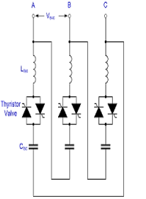

Figure 6. A thyristor switch capacitor bank [13] .

The series compensator consists of a solid-state voltage source inverter that is linked to the transformer and transmission line in series and is a type of flexible current alternating transmission system. It can inject sinusoidal voltage when connected in series to the line, and it is a well-established system for curbing transfer reactance in bulk electricity transmission [20] .

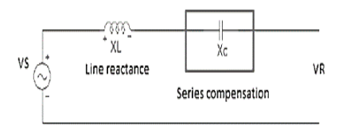

Figure 7. Series compensator [19] .

The thyristor switch capacitor bank series reactors are equally connected to the capacitor in series, they are capable of suppressing harmonics and also prevent overvoltage and current that could be generated through the operation of the capacitors, the series reactors can block the high-frequency signals they can be used to reduce fault current to ensure proper sharing of load in the system when a series reactor is connected to an alternator it is known as line reactors and this can reduce stress in short circuit fault of three phases [20], [19] .

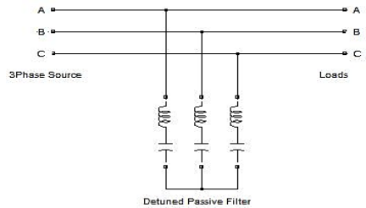

Figure 8. Series reactors

**Static synchronous compensator (STATCOM):** this is a shunt regulating device that is used on the alternating current electricity network, it can be used as a sink based on power electronic voltage source converters, it reduces voltage fluctuations, and provides active alternating current when connected to to the grid, as a voltage source converter, it has the voltage source hidden in the reactors, it also has a little active power capability as the voltage source is a dc capacitor also the capability of the active power can be increased by using energy storage device across it, fast acting, and adjustable quantity of reactive power to the system [19], [20] . STATCOM can regulate the direction of the movement and the quantity of the power trapped in the system, they are applied for dynamic power factor correction which consists of power compensation, in wind farm integration into the grid, they can also be used to multiply the power factor correction of machines, reduce voltage variation, and reduces equipment operation cost, they can be used for voltage compensation at the receiver end of wind farm AC transmission line [23], [24] . Consequently, the STATCOM reactive power terminal is promotional to the amplitude of the voltage source, when the VSC terminal voltage is greater than at the point of connection alternating current voltage, there will be a generation of reactive current which will appear as a capacitor. and, if the voltage amplitude is less than the alternating current voltage the device will absorb reactive power which will appear as an inductor [19] .

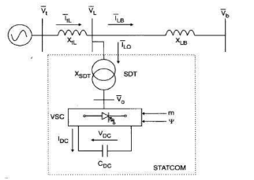

Figure 9. STATCOM [5] .

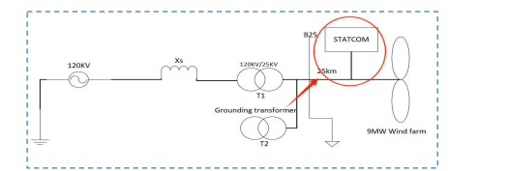

Figure 10. STATCOM connected to the grid-side wind farm [19] .

The figure above shows the STATCOM reactive compensation installed device in the wind farm, the fluctuations of the voltage connected to the grid are fully observed and controlled it provides reactive power compensation to the wind farm as the demand arises, and it stabilizes the system to avoid absolute failure.

**Phase shifting transformers(PST):** The phase shifting transformers are also important to power compensation devices, they use tap changers or thyristor switches for compensation and control, for a reduction in cost most of the units are equipped with parallel inductors, this could also be called interphase power controller [25], [26] but if it is provided with fast switching active device(thyristor switch) it is called thyristor controlled phase shifting transformer and could also be used for power oscillation damping [27] .

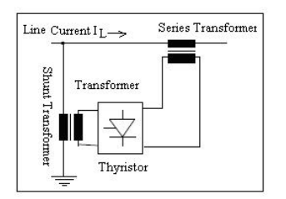

Figure 11. Phase shifting transformers [27]

**Combine series and shunt controllers**: it is a combination of series and shunt controllers that are controlled in a coordinated manner, the system is used to inject current with the shunt part and voltage with the series part, this plays an important role in compensating the system these are as follows: unified power flow controllers (UPPFC), thyristor-controlled phase shifting transformers (TCPST), interphase power controllers (IPC) [20], [28] .

**Unified Power flow controller**: it is made static synchronous compensator(STATCOM) and a static synchronous series compensator(SSSC), the direct current terminal of the two voltage source converters are coupled together and a part of active power exchange is created between the two converters, the series, and the shunt converters supply the active power to the line, the system ensures that the active power of the voltage source converters matches together, consequently, the UPFC can be used to control the flow of active and reactive power compensation in the wind farm connected grid system [29] . The UPFC operating mode consists of the Var control mode, direct voltage injection mode, and automatic power flow control all of these enhance power compensation and the entire system’s stability [27] . The diagram below clearly shows the unified power flow controller.

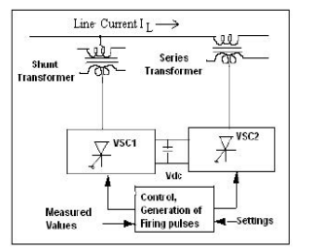

Figure 12. Unified power flow controller [29]

**Static synchronous series compensator (SCCC):** It is part of the FACTS device that is used in wind farm compensation for the entire stability of the grid-connected system, it is capable of providing a reactive or inductive, or capacitive voltage that could be independent of the current, it helps to stabilize both the active and the reactive power for the system, by controlling the angular position of the voltage injected, it can retain simultaneously compensation of the inductive and resistive component of the series line impedance to stabilize the system [15] . It consists of a solid-state voltage source converter that is connected in series with the transmission line through the transformer, this allows effective control of the system for a wide range of applications. The diagram is shown below

Table 1. FACTS devices performance analysis [13] .

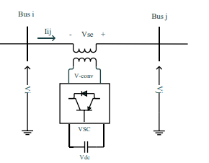

Figure 13. Schematic circuit [29] .

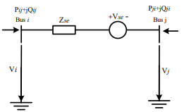

Figure 14. Equivalent circuit [8] .

As shown above, the effective power control and the entire system stability can be maintained by the device

|  |  |  |  |  |
| --- | --- | --- | --- | --- |
|  | COMPARISM BETWEEN DIFFERENT FACTS DEVICES IN WIND FARM | | | |
| FACTS DEVICES | Dynamic stability | Transient stability | Voltage control | Load flow |
| SVC | Medium | Low | high | Low |
| SSSC | Medium | Medium | High | Low |
| TCSC | Medium | High | Low | Medium |
| UPFC | Medium | Medium | High | high |
| STATCOM | Medium | medium | High | Low |

**Current challenges in wind farm compensation:**

Wind energy is one of the fastest growing energy sources around the globe, therefore the technology is on the rise, but the responsibility of generating and integrating the generated power into the grid is tasking, these challenges also affect power compensation to be able to have a robust system some of the challenges are: technical, environmental and financial challenges [30], [29] .

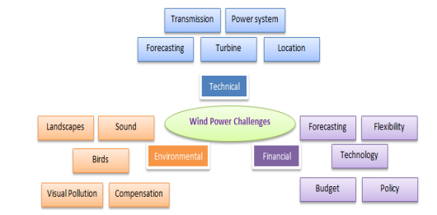

Figure 16. Challenges on wind farm system [30] .

Technical challenges: the technical challenges are always enormous in wind power compensation integration to the grid, consequently, as wind power generation capacity increases there is a need to ensure that technical challenges such as transmission planning challenge, turbine challenge, forecasting challenges, and the power system challenge among others are adequately curbed to ensure system stability [31] . Transmission planning is one of the big challenges in power system stability wind farm based, it is expected that in trying to solve technical problems the system planners should not focus on a single component rather the entire system should be put into consideration. Consequently, in power system challenges, flickers, harmonics, voltage variation, and harmonics among others cause low performance in the system equipment such as programmable logic control, microprocessor-based control system, and adjustable speed drive, among other factors, these could lead to low performance and affect the entire power system as the wind farm is put under threats [31] ,

Wind forecasting is another major challenge, however, real-time wind energy from the plant, physics-used forecasting models, and computational learning systems like support vector machines among others could help to provide better forecasting methods than ordinary forecasts based on historical value or climatology, the forecast accuracy depends on the specific location wind challenge, the terrain, and local climatology [32] . As the wind plants are intentionally located where the wind effects can be amplified as compared to the surrounding environment, it is important to run customized to fine-scale the model forecast and the flow of local model wind and simulate to enhance the effects. The challenge of the wind turbine is another problem, the wind turbine always ensures that the breeze is harnessed over the blades of the turbine and rotates the hub, the hub is connected to the gearbox, to the nacelle, and the generator shaft as energy is being converted from one form to another [30] . An average wind turbine has up to 8,000 parts to be assembled, towers and rotors are the largest and basic parts in the wind farm. Consequently, there are various challenges ranging from manufacturing to placement, and also selection of turbines for specific areas is important as technology for solutions to all these must be carefully put into consideration to curb this challenge [31] .

**Future direction**

To be able to mitigate these challenges’ fault ride-through technology must be used in a robust system that can be able to compensate for reactive power series, shunt, and hybrid controllers can be used to improve the system stability some of these devices are discussed below.

Supper conducting dynamic synchronous condenser (SDSC):one of the possible ways to mitigate reactive power compensation problems in the wind farm is by integrating a superconducting dynamic synchronous condenser into the system it can provide up to forty-five percent dynamic reactive compensation to bust the voltage and reduce significant losses when a fault occurs [33] , it has the advantage of low reactive reactance compared to others having the same ratings, it has that ability to respond to a transient change in voltage through absorbing or injecting reactive power, they can operate with high field current for a longer period through allowing the machine to significantly release reactive during transient low voltage event three times the rated output, the supper conducting dynamic synchronous condenser can assist with voltage regulation in a wind farm grid connected system [34] .

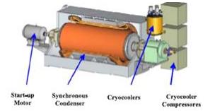

Figure 17. Supper conducting dynamic synchronous condenser [5], [35] .

Static Var Compensation (SVC): To mitigate this challenge of reactive power compensator the use of SVC is very important for reactive power compensation and improvement of transient stability, it is the combination of the thyristor-controlled reactor, along thyristor switch capacitor or MSC as a single compensator connected to the wind turbine terminal, it can provide fast support and LVRT of wind turbines with inductor or synchronous generators. DVR is a nonlinear device that has resistance connected in series with the terminals connected to the grid coupled to the transformer in parallel with the converter’s DC link with energy storage devices [36], [37] . This is very effective in enhancing fault ride-through of wind farm systems, but it always requires converters with high power ratings [38] .

Hybrid system: The hybrid system has been proposed to be one of the effective ways of compensating reactive power and voltage compensation it is an effective technique for fault ride through especially in the wind farm integrated system. The unified power quality controller (UPQC) could be a possible solution to the problem. The unified power quality controller consists of series and shunt converters, and these have been proven to mitigate voltage sag, harmonics, voltage imbalance, dynamic active and reactive power regulation, and compensation, though the capital required for the installation of this system is higher than other devices because of the converters, however, SFCL and UPQC will significantly improve the system [38], [25] .

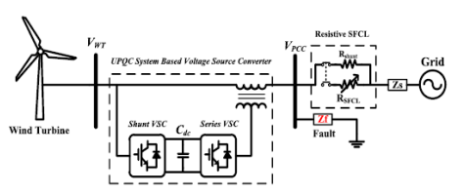

Figure 18. The proposed combination of wind farms UPQC and SFCL is connected to the grid [3] .

The combination topology of series shunt devices to improve power compensation is shown below. In fault conditions, the UCS will instantly switch from the shunt to the series grid connection to compensate for the voltage

and maintain the rated value of the stator to improve the system’s stability.

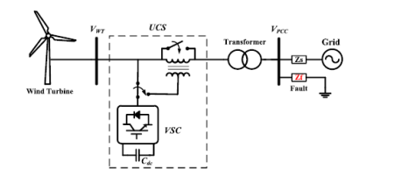

Figure 20. unified compensation system (UCS) connected to the wind turbine terminal [5] .

consequently, the use of energy storage devices ESDs in the grid system will bring balance between the consumption and the generation point, the bidirectional, DC-DC converters will always help to charge and discharge power in ESDs to the duty circle to achieve effective power transfer in two directions to significantly reduce losses in the system [1] .

Advanced control techniques can be used to improve the non-linear performance of the system, this will improve the fault ride through of the system and s well improve the reactive power compensation, it helps to eliminate electromagnetic torque fluctuations, and it is a more robust control system that can improve system performance, artificial intelligence and fuzzy logic controller are suitable for system performance improvements to nonlinear system, because they may not require the exact parameters of the system as does proportional integral, the advanced control techniques can be hybridized for effective performance [5], [38], [39] .

Table 2. Table [12], [40]

|  |  |  |
| --- | --- | --- |
|  | Reactive Power Compensation Devices | |
| Device | Merit | Demerit |
| SVC | Has a simple structure and good reactive power source compensations | High cost, and due to fast response has unstable oscillation |
| STATCOM | Increases the stability of the grid, provides high current and low voltage | Low response time and high mechanical losses |
| UPQC | Fast response and very suitable for active and reactive power compensation | Needs a high rating of DC-link capacitor. |
| DVR | Very effective when used with ESD and restores voltage when faults occur | Needs a higher power rating from the converters. |
| Flywheel | Less maintenance, high response time, not affected by charge and discharge | Short life span and high cost |
| Supercapacitor | High power density, a good source of reactive power, | Less energy density. |
| SMES | Good efficiency, large power density, short response time | High capital cost and suitable power system location must be selected carefully |
| Battery | High efficiency, more effective to store electricity, low maintenance. | Low life cycle if the battery is discharged deeply, may need frequent support. |
| Fuzzy logic and genetic algorithm | Good performance | Cannot track maximum power point |
| Pitch angle control | Protect the WTs from damage | Depending on the generator speed non on power, takes longer time to have a stable condition |

**Summary and Conclusion:**

This paper provided a comprehensive assessment of reactive power compensation on wind farm, the

importance of the wind farm has been discussed as one of the important renewable energy sources around the world. The compensation of reactive power in the grid-connected wind farms cannot be overemphasized, due to the variation of the wind energy resources and other possible challenges, the current and advanced technologies must be properly explored to ensure grid stability, one of the major suggestions is the application of the hybrid compensation technology such as unified power quality controller(UPQC), unified power flow controller(UPFL), Unified compensation system(UCS), among others to give a better performance in the wind farm grid connected system.

REFERENCES

[1] B. Dasu, M. Sivakumar, and R. Srinivasarao, “Interconnected multi-machine power system stabilizer design using whale optimization algorithm,” vol. 6, 2019.

[2] A. Shatil, “Modeling and Simulation of a Synchronous Generator with Rotor Angle Stability and Solve Inter Area Mode of Oscillation in Power System using Power System Stabilizer ( PSS ),” no. May, 2019, doi: 10.53799/ajse.v18i1.20.

[3] N. Khatoon and S. Shaik, “Review of different Fault Ride through ( FRT ) Control Strategies for a DFIG Wind Turbine,” pp. 1571–1587, 2017.

[4] S. H. Memon, Z. A. Memon, and M. A. Uqaili, “Voltage Stability and Reactive Power Compensation of 132kv Grid Integrated 50MW Wind Farm Using Statcom,” vol. 8, no. 1, pp. 232–240, 2018.

[5] F. O. Igbinovia, G. Fandi, J. Švec, Z. Müller, and J. Tlusty, “Comparative Review of Reactive Power Compensation Technologies,” 2015.

[6] X. Xu *et al.*, “Research on Reactive Power Compensation System of Offshore Wind Farm,” *2019 Chinese Control Decis. Conf.*, pp. 5100–5105, 2019.

[7] J. Zhao *et al.*, “Integrated Reactive Power Optimisation for Power Grids Containing Large-Scale Wind Power Based on Improved HHO Algorithm,” 2023.

[8] B. Yang *et al.*, “A critical survey of technologies of large offshore wind farm integration : summary , advances , and perspectives,” *Prot. Control Mod. Power Syst.*, 2022, doi: 10.1186/s41601-022-00239-w.

[9] B. B. Adetokun, C. M. Muriithi, J. O. Ojo, and O. Oghorada, “Impact assessment of increasing renewable energy penetration on voltage instability tendencies of power system buses using a QV ‑ based index,” *Sci. Rep.*, pp. 1–16, 2023, doi: 10.1038/s41598-023-36843-5.

[10] C. Reactive, P. Adequacy, and V. Balance, “Reactive Voltage Control Strategy for PMSG-Based Wind Farm Considering Reactive Power Adequacy and Terminal,” 2022.

[11] T. Ug and M. No, “REVIEW OF REACTIVE POWER,” pp. 978–981, 2012, doi: 10.3850/978-981-07-1847-3.

[12] U. Sts, “Reactive power compensation of the electricity grid with large- scale offshore wind farms in Sweden economic incentives,” 2022.

[13] A. Narain, “An Overview of Facts Devices Used for Reactive Power Compensation Techniques,” vol. 4, no. 12, pp. 81–85, 2015.

[14] A. S. Alkhunaizan, “The Implication of Mobile Phone Charging Stations : A Perspective of Consumer Experience,” vol. 20, no. 1, pp. 132–138, 2020.

[15] Y. Peng, H. Wang, Q. Zhao, D. Nan, and W. Li, “Research and Application of Combined Reactive Power Compensation Device Based on SVG+SC in Wind Power Gathering Area,” *Appl. Sci.*, vol. 12, no. 21, 2022, doi: 10.3390/app122110906.

[16] I. D. Ibrahim *et al.*, “A review on Africa energy supply through renewable energy production : Nigeria , Cameroon , Ghana and South Africa as a case study,” *Energy Strategy. Rev.*, vol. 38, no. October, p. 100740, 2021, doi: 10.1016/j.esr.2021.100740.

[17] “Methods of Reactive Power Compensation in Power Electronics - Electronics Coach”, [Online]. Available: https://electronicscoach.com/methods-of-reactive-power-compensation.html

[18] I. Conference, C. Technology, S. Development, and E. Engineering, “Design and Implementation of a Synchronous Generator with Rotor Angle Stability Control for Damping Interarea Oscillations of Interconnected Power Systems via PSS,” pp. 27–28, 2021.

[19] D. Okojie, P. Kgori, and U. Akuru, “A Review of Power Compensation Techniques : Challenges and Recommendations for Future Investigation,” no. November 2022, doi: 10.20944/preprints202211.0048.v1.

[20] L. U. D-statcom, V. Sharma, and V. Kumar, “Improvement of Grid-connected Reactive Power Compensation for Wind Farms Based on Improvement of Grid-connected Reactive Power Compensation for Wind Farms Based on STATCOM,” 2023, doi: 10.1088/1742-6596/2427/1/012004.

[21] A. Karabiber, “An Overview of Smart Grid Domains and Priority Research Areas,” no. January, 2019.

[22] S. Deb and K. Tammi, “Distribution Network,” pp. 1–25, 2018, doi: 10.3390/en11010178.

[23] M. J. Ghorbani and H. Mokhtari, “Impact of Harmonics on Power Quality and Losses in Power Distribution Systems,” 2015.

[24] I. E. Agency, “World Energy Outlook,” 2022.

[25] J. Liu, M. Yu, J. Zhao, Y. Xia, and W. Wei, “Power Oscillation Analysis of PMSG Wind Power Generation System Considering Power Control Nonlinearity,” vol. 10, no. June, pp. 1–14, 2022, doi: 10.3389/fenrg.2022.910716.

[26] M. Gu, “Rotor Angle Stability Analysis of AC / DC Hybrid Power Systems with a VSC-HVDC Link,” *2018 IEEE PES Asia-Pacific Power Energy Eng. Conf.*, no. 201706830005, pp. 565–570, 2018.

[27] A. Shahdadi, B. Zoghdar-moghadam-shahrekohne, and M. Barakati, “Analyzing Impacts of FACTS Devices in Dealing with Short-Term and Long- Term Wind Turbine Faults Analyzing Impacts of FACTS Devices in Dealing with Short-Term and Long- Term Wind Turbine Faults,” no. May, 2019, doi: 10.22098/joape.2019.5591.1420.

[28] G. Tzounas, R. Sipahi, and F. Milano, “Oscillations Using Time Delays,” pp. 1–11, 2021, doi: 10.1109/TCSI.2021.3062970.

[29] O. Apata and D. T. O. Oyedokun, “Novel Reactive Power Compensation Technique for Fixed Speed Wind Turbine Generators”.

[30] K. Rahaman and Q. Hassan, “Prospects and challenges of wind energy : A comprehensive anatomy ICME11-RE-006 PROSPECTS AND CHALLENGES OF WIND ENERGY : A,” no. May, 2014.

[31] S. E. E. Profile, “Reactive power compensation of wind energy conversion system by using Unified Power Flow Controller Reactive power compensation of wind energy conversion system by using Unified Power Flow Controller Nijaz Dizdarevic * and Matislav Majstrovic,” no. September, 2014, doi: 10.1504/IJETP.2005.007265.

[32] P. S. Georgilakis, N. D. Hatziargyriou, and S. Member, “Technical Challenges Associated with the Integration of Wind Power into Power Systems,” pp. 1–6, 2004.

[33] M. Gryniewicz-jaworska, “Analysis of the Selection of Compensation Devices Determining the Reactive Power Balance of Wind Farms,” vol. 14, no. 4, pp. 30–36, 2020.

[34] H. Gao, S. Yun, J. Choi, and S. Ahn, “Reactive Power Allocation Method in a Wind Farm for Improved Voltage Profile and Loss Reduction,” vol. 11, no. 12, pp. 2167–2182, 2018.

[35] Z. Wang, B. Zhang, M. Mobtahej, and S. Member, “Advanced Reactive Power Compensation of Wind Power Plant Using PMU Data,” vol. 9, 2021, doi: 10.1109/ACCESS.2021.3075966.

[36] A. Singh and A. Tiwari, “FACTS Devices for Reactive Power Compensation of Wind Energy Conversion System,” vol. 2, no. 1, pp. 41–48, 2011.

[37] M. Carter and X. Liang, “Implementation of Power System Stabilizers in a Power Grid : A Case Study,” *2019 IEEE Can. Conf. Electr. Comput. Eng.*, pp. 1–4.

[38] O. Access, “Research on Reactive Power Compensation Configuration of Wind Farm Integration Research on Reactive Power Compensation Configuration of Wind Farm Integration,” 2021, doi: 10.1088/1755-1315/701/1/012083.

[39] A. Sabo, T. E. Odoh, N. Izzri, and A. Wahab, “Artificial Eco-System-Based Optimization Algorithm for Optimal Design of Single-Machine Infinite Bus and Multi-Machine Power System Stabilizers,” vol. 23, no. 3, pp. 522–533, 2023, doi: 10.5152/electrica.2023.22228.

[40] G. M. Tina, G. Maione, and S. Licciardello, “Evaluation of Technical Solutions to Improve Transient Stability in Power Systems with Wind Power Generation,” *Energies*, vol. 15, no. 19, 2022, doi: 10.3390/en15197055.

ISSN (Print): 2456-6403 | ISSN (Online): 2456-6411 **52** JREAS, Vol. 02, Issue 02, July 2020