**Development of Automobile Disk Brake Pads Using Eco- Friendly Fan Palm Shell Materials**

Abubakar muhammad1, Nazir N. Yunusa2

*Department of Mechanical Engineering, College of Engineering, Kaduna Polytechnic, Kaduna, Nigeria*

*Corresponding Author: rgcity9@gmail.com*

**Abstract:** This research was conducted to produce asbestos free automobile disk brake pads using eco- friendly; Fan palm shells materials. The use of asbestos fiber is being avoided due to its carcinogenic nature that might cause health risks. A new brake pad was produced using agro waste materials ( fan palm shells)with thermoset resin as a binder to replace asbestos. Brake pad composites was produced using fan palm particles by varying the particle sizes from 125µm to 710µm. The morphology, physical, mechanical and wear properties of the brake pads were studied. The mechanical properties upon addition of the agro waste improved. The results showed that the uniform distribution of the fan palm particles in the microstructure of the brake pad composites is the major factor responsible for the improvement in the mechanical properties. Hence this research indicates that fan palm particles can be effectively used as replacement for asbestos in the development of automobile disk brake pad indicating 14.28%, 15.5 %, and 33.63 % increase in coefficient of friction, hardness, and compressive strength respectively than that of Mercedes Benz 230E salon

**Keywords:** Composite, Morphology, Brake pads, Fan palm

-------------------------------------------------------------------------------------------------------------------------------------

Date of Submission: XX-XX-2018 Date of acceptance: XX-XX-2018

-------------------------------------------------------------------------------------------------------------------------------------

1. **INTRODUCTION**

Brake pads are important part of braking systems for all types of vehicles that are equipped with disc brakes. They are considered as one of the key components for the overall performance of a vehicle and as heterogeneous materials, they are usually made from more than 10 ingredients. An ideal brake friction material should have constant coefficient of friction under various operating conditions such as applied loads, temperature, speeds, mode of braking and in dry or wet conditions so as to maintain the braking characteristics of a vehicle. In addition, it should also possess various desirable properties such as resistance to heat, low water and oil absorption, low wear rate and high thermal stability, exhibits low noise, and should not damage the brake disc.

According to Anderson (2018), brake pads are steel backing plates with friction material bound to the surface facing the brake disc Brake pads convert the kinetic energy of the vehicle to thermal energy by friction. During the application of brake, friction between brake pads and rotating disc causes a vehicle to stop by converting kinetic energy of the vehicle into heat energy, with a transfer of small amounts of friction material to the disc, (that is w h y a brake disk has dull grey colour).The brake rotor and disk (both now with friction material on), will then "stick" to each other to provide stopping power, and it is this action of friction material against the disk that is responsible for stopping the vehicle.

Abutu et al (2018), Produced brake pads by sourcing the materials locally from seashell as raw materials with epoxy resin (binder), graphite (friction modifier) and aluminum oxide (abrasive). Samples produced by varying the process parameters. Rule of mixture was used for formula and a weight percent of 52% reinforcement, 35% binder, 8% abrasive and 5% friction modifiers were used for production. Grey relational analysis was adopted .Some of the limitations observe ware the use Grey rational analysis.

Abubakar et al(2020) produce brake pad by using coconut shell as reinforcement material together with other materials (epoxy resin, graphite and barium sulphate) with the aim of finding possible replacement for asbestos. Experimental design was carried out in accordance with Taguchi L933 design technique using Minitab. Samples production was done using constant weight percent of 50% reinforcement, 30% binder, 12% abrasive and 8% friction modifier. The mechanical, tribological and physical properties of the composite were also studied. The results showed that sample 7 produced with moulding pressure, moulding temperature and curing time of 12 MPa, 110 ˚C and 11 minutes respectively gave better results in terms of its mechanical, tribological and physical properties. Also, Analysis of Variance (ANOVA) and regression analysis (confirmatory test) results revealed that the percentage errors obtained for individual responses were below 10% which showed that the experimental procedures were conducted under minima noise effects and the developed regression equations can be adopted for prediction of the friction lining performance. In addition, the thermogravimetric analysis (TGA) conducted on the sample 7 showed that the thermal properties of the best samples compared well with commercial sample and can be applied in automobile whose temperature at brake do not surpass 322.3 oC.

1. **MATERIAL & METHODOLOGY**

**Material**

Production of friction linings include preparation of locally sourced Fan Palm shell and graphite powder ,experimental design using Minitab, compression moulding, testing of samples and analysis of results.

**Material Preparation**

Table 1: Composition of Periwinkle Shell The dried fan palm shells consisting of 50 kg each were sun dried for five (5) days, followed by oven drying at 105oC for 5 hours to eliminate most of the moisture as obtained in the industry. These were then charged into a Denver cone crusher and reduced to a size of 3mm to 4mm wide. They were further charged into a roll crusher that further reduced the size of shells between 1mm to 2mm.

**Table 1 Factor levels for the manufacturing parameters**

|  |  |  |  |
| --- | --- | --- | --- |
| Manufacturing parameters | Level | | |
| Low | Medium | High |
| A: Moulding Pressure (kpa) | 41 | 48 | 56 |
| B: Moulding temperature (oC) | 100 | 130 | 160 |
| C: Curing Time (Mins) | 10 | 15 | 20 |
| D: Heat treatment time (Hr) | 1 | 1.5 | 2 |

l

**Method:**

**Procedure for determining physical and mechanical properties of fan palm shell**

The length L (mm),thickness t (mm), volume (mm3), mass (kg), Moisture content (%), Hardness ,Compressive strength (N/mm2, Specific gravity and Density g/cm3 of the Fan palm shells were determined at National Metallurgical Development Centre Jos. These values were obtained by taking the average of three readings. Erik. O, Franklin D. J, Holbrook L. K, and Henry H. R et al(2004)



where:W1= weight after immersion ……………………….1

Wo= weight before immersion

**Composite Preparation**

The fan palm shell sieve sizes of 125µm, 250 µm, 335µm, 500µm and 710µm, were used to produce the brake pads.The choice of the sieve sizes was based on the recommended sieve sizes for brake pads by the Standards Organization of Nigeria (SON) Ref; NIS:1997,andsimilar works by Ibhadode and Dagwa (2012) Test samples were made from optimal composition consisting of 65%wt of Fan Palm shell particles and 35% wt. of resin as shown. Thirty (30) test samples from each of the sieve sizes (Plate 3.2) were then produced using this composition. Each composition was blend(Ahmet 2015).

**Physico-Mechanical Properties Tests of Composites**

Each of the samples was subjected to mechanical properties tests such as Brinell hardness and tensile strength tests as well as physical properties tests such as water absorption and density tests of the developed composites.

**Brinell Hardness Test**

The Brinell hardness values were obtained using a digital hardness tester. Test samples of diameter 22.7mm were used to carry out the tests for the different sieve grades. The hardness values were determined according to the provisions in the American Society of Testing and Materials (ASTM E18-79) using the Brinell hardness tester on “B” scale (Frank Well test Brinell Hardness Tester, model 38506) with a1.56mm steel ball indenter, minor load of 10kg, major load of 100kg and hardness value of 101.2HRB for thestandard block Dagwa, I.M, and Ibhadode, A.O.A. *el.,*(2015).

HBS = $0.102\frac{2 F}{πD(D-√(D^{2}-d^{2})}$…………………... (2)

**Comprehensive Strength Test**

The compression test was conducted on the Avery Denison strength testing machine of 500kN capacity at a strain of 0.002. The test pieces were machined to the standard shape and dimensions specified by the American Society for Testing and Materials (Adewuyi A.P *el.,*2009). The sample was locked securely in the grips of the upper and lower crossbeams of the testing machine. A small load was initially applied to seat the sample in the grips and then the load was increased until failure occurred.

**Wear and Friction Test**

A pin-on-disc test apparatus was used to investigate the dry sliding wear and friction characteristics of the s a m p l e s as per ASTMG99-95 standards for wear test (Anderson *al*, 2018). Wear sample 20 mm in diameter and 40 mm high were made and then polished metallographic ally. Wear tests were conducted for various loads and sliding speeds at 1 5 0 o C to 2 5 0 oC. The loads and speeds ranged from 40 kg to 140 kg and 1.2 to 2.8m/sr e s p e c t i v e l y. The tests were carried out in the University of Witwatersrand, Johannesburg, South Africa.

Wear Rate= $\frac{∆W}{S}$………………..3

**Water Absorption Test**

The water absorption test was conducted according to ISO 62. The mass of the dry samples was measured using an electronic scale and the masses were recorded, after which they were immersed in distilled water at room temperature for 24 hours. The samples were then removed sequentially and partly dried with a clean cloth and reweighed using the same electronic scale, hence the masses were also recorded accordingly. Water absorption is expressed as the increase in weight percent as given by equation 4:

$$\% water absorption=\frac{wet weignt-dry weight}{dry weight} x 100………………(4)$$

**Density Evaluation of Periwinkle-Epoxy Composite**

Density of a material is defined as the ratio of the volume and mass of the material, this is determined mathematically for both the dry and wet masses. The dry masses were measured as well as the corresponding wet masses, which are then evaluated along with their respective determined volumes. These were evaluated using Equation 6.

$ρ=\frac{M (kg)}{V (m^{3})}……………(6)$ where, V = L x W x T,

Thus: L= length of the sample, W= width of the sample, T= thickness of the sample, V= volume, $ρ$ = density of the composite sample.

1. **RESULT & DISCUSSION**

**DENSITY OF THE SAMPLES**

The result of density measurements of fan palm brake samples for the various sieves sizes are shown in Figure and Table A1 (Appendix A). From the Figure 4.3, the density of the samples increased as the sieve size is decreased from 710 to 125µm.

1.3

1.1

0.9

**Density (g/cm3)**

0.7

0.5

0.3

Commercail

FAN PALM

0.1

125µ 250µ 355µ 500µ 710µ

**Sieve size**

**Figure 4.3: Effect of particle size on density of periwinkle and fan palm shel**

**Brinell Hardness Result**

The hardness values of the samples are shown in Figure 4.14 and Table A4 (Appendix A). From the results it is clear that the hardness increased with decrease in particles size. This is in agreement with Blau P*, et al.,* (2015). The sample of 125μm sieve size has the highest hardness values of 116.7 and 95.7HBN for periwinkle shell and fan palm particle brake pads respectively. A sharp drop in hardness was observed in the samples with higher sieve grades (250, 355, 500 and 710μm).

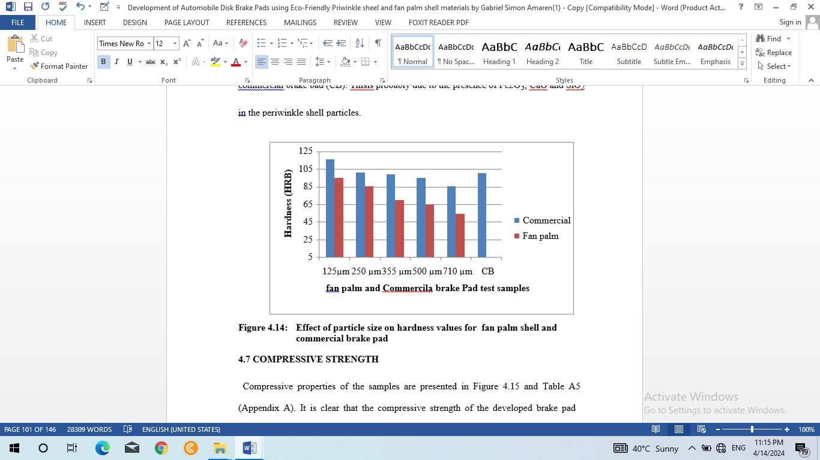

**Comprehensive Strenght Result**

Compressive properties of the samples are presented in Figure 4.15 and Table A5 (Appendix A). It is clear that the compressive strength of the developed brake pad increased as the particle size decreased for both materials.This may be due to the hardening of the resin by particles. Brake pad formulation with 125µm periwinkle shell particles showed the highest compression strength compared to the commercial brake pad (CB), and the other sieve size used. The smaller the pores,the more thecompaction andthehigher the compression strength as shown by the 125µm periwinkle brake pads.

TT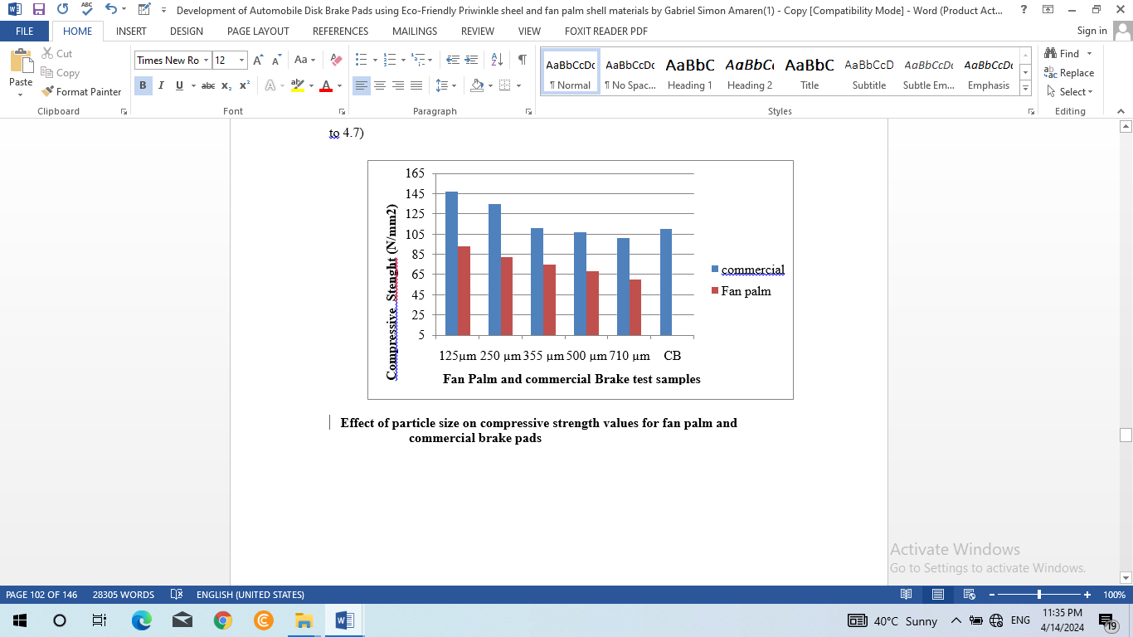

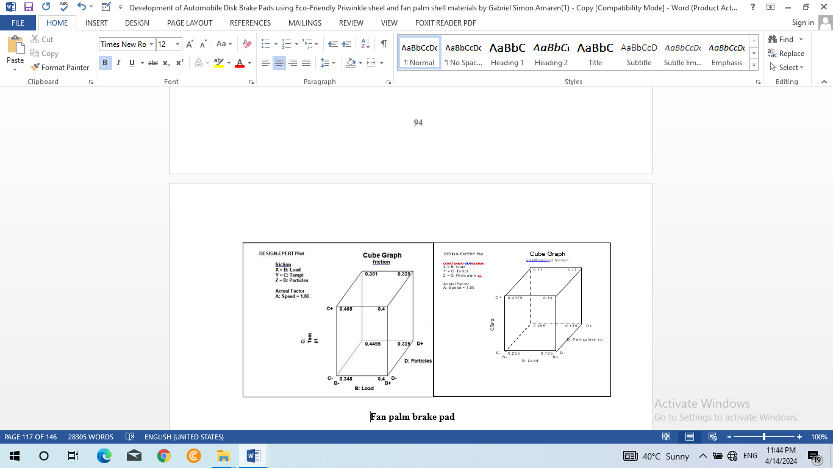

It can be seen that the coefficent of friction is highly influenced by the speed, load, temperature and particles sizes content. For the particle size, the coefficient of friction increases with decrese in the particles size from 710 µm to 125 µm.

# **CONCLUSION**

From the results and discussions in this work the following conclusions can be made:

1. The optimum particle size for the formulation was found to be of 125µm.

2. Taguchi method was employed to determine the optimal formulation of 65 fan palm particles and 35% resin.

3. The automobile disk brake pad was developed from the best formulation

4. The oil/water soak, wear rate and amount of charring decreased with particle size.

6. The values of the coefficient of friction, hardness, compressivestrength, of the 125µm of Fan Palm shells as shown were higher than those of commercial brake pads by 14.28% %, 15.5%, and 33.63% respectively, while the values of the density and the water swell were 40% and 56.67% lower than those of the commercial brake pad.

**FUNDING STATEMENT**

This work is sponsored under the Institution Based Research (IBR) research support scheme grants by Tertiary Education Trust Fund (TETFund) Nigeria.

**ACKNOWLEDGEMENT**

Acknowledgement goes to the Management of Kaduna Polytechnic and Specially the Chairman, Institution Based Research Committee in the Research and Development Section for finding our research worthy of sponsorship

**REFERENCES**

[1]Adewuyi, A.P. and Adegoke, T. (2009), Exploratory Study of Periwinkle Shells as Coarse

Aggregates in Concrete Works. *Journal of Applied Science Research*; 4(12): 1678

– 1681, 2008 Insinet publication,

[2]Amaren S.G, Aku S.Y and Yawas D.S (2013); Effect of Peiwinkle Shell Particle Size on Wear Behaviour of Asbestos Free Brake Pad. Elsevier results in Physics 3 (3013) 109 - 114

[3]Ahmet K. (2012).investigation of using natural zeolite in brake pad. Scientific Research and Essays Vol. 6(23)

[4] Anderson.A. E. (2018),*Friction and Wear of Automotive Brakes*, in ASM Handbook, FrictionLubrication and Wear Technology*,* Volume 18, ASM International, Materials Park, Ohio, pp. 569-577

[5] Blau.P.J(2014), Compositions, Functions and Testing of Friction Brake Materials and their Additives.Being a report by Oak Ridge National Laboratory for U.S Dept. of Energy.www. Ornl.gov/-

webworks/cppr/y2001/rpt/112956.pdf

[6] Borden Packing and Industrial Products, Inc. (1994) Literature on modified resin products, Louisville,KY.*20*

[7] Bush.H. D, Rowson DM, and WarrenS. E. (1972), The Application of Neutron Activation Analysis to the Measurement of the Wear of a Friction Material, *Journal Wear, 20,* pp.

[8] Chapman T. R., NieszD. E., Fox, R. T., and Fawcett, T. (1999),Wear-Resistant Aluminum-Boron CarbideCermetsfor Automotive Brake Applications, Journal Wear, 236, pp. 81-87.

[9]Dagwa, I.M. and Ibhadode, A.O.A. (2005), Design and Manufacture of Experimental Brake Pad TestRig Nigerian Journal of Engineering Research and Development,Basade Publishing Press Ondo, Nigeria, Vol. 4, No. 3. 15-24.

[10] Dagwa, I.M, and Ibhadode, A.O.A. (2006), Determination of Optimum Manufacturing Conditions for Asbestos-free Brake Pad Using Taguchi Method, Nigerian Journal of Engineering Research and Development 5 (4): 1-8.

[11] Dillip, K.AnupK, andBijwe, J. (2008), Analysis of load Speed Sensitivity of Friction

CompositesBased on Various Synthetic Graphite. *Journal of Wear,* Volume 2006

Issues 1-2, pp. 266-274.

[12] El-Tayeb, N.S.M, and Liew, K. W. (2008),Effect of Brass Fibers in increasing amounts on the Friction and Wear Performance of Non-asbestos Organic (NAO) friction composites Wear *Journal. Volume* 256.Issues 1-2: 275-287.

[13] Erik. O, Franklin D. J, Holbrook L. K, and Henry H. R (2004), Machinery Handbook, pp

2465 –2477.Industrial Press

[14] Eriksson.M. and JacobsonS. (2000), Tribological Surfaces of Organic Brake Pads, Tribology International: 817-827, 2000.” 33, pp. 817-827.

[15] Elakhame, Z.U. Alhassan, O.A. and SamuelA.E. (2014); Development and Production of

Brake Pads from Palm Kernel Shell CompositesInternational Journal of Scientific

& Engineering Research, Volume 5, Issue 10, October-2014 735 ISSN 2229-5518

[16] El Zahrea. F.L., Khasaba M.I., El-GlusyM.a., and Ali W.Y. (2003), ₺Friction and wear

of Asbestos Free Friction Material Tribology Journal vol. 50, pp.40-45