**Deaf People Action Recognition System**

Priyanka Raut Unnati Dongare Vishakha Khandar Yogita Dhumale Sanket Pawade

[rautpriyaraut21@gmail.com](mailto:rautpriyaraut21@gmail.com) [unnatidongare@gmail.com](mailto:unnatidongare@gmail.com) [vishakhakhandar2002@gmail.com](mailto:vishakhakhandar2002@gmail.com) [yogitadhumale7@gmail.com](mailto:yogitadhumale7@gmail.com) [sanketpawade91@gmail.com](mailto:sanketpawade91@gmail.com)

Bapurao Deshmukh College of Engineering Sewagram,wardha

Department of Computer Engineering

2020-2024

**ABSTRACT**

We proposed a real-time manual method. Gesture recognition and feature extraction using web camera. In this method, images are taken in the following way: A webcam connected to your system. First, is the input image, it is pre-processed and de-noised using a threshold. Adjust the image and smooth the image. After this apply the area fill to fill holes in a pose or target object.This helps improve classification and diagnosis step then select the largest blob (the largest linked binary object) Remove the inside of the image and all small objects. This is done to remove unnecessary objects and noise. Image After completing the pre-processing, your image will look like this: Moved to feature extraction stage. Here is the test image: This article examines the technological advances applied to signage. Language recognition, visualization and synthesis.We defined several research questions to identify : Basic technological motivation to improve the challenges in this field.

**KEYWORDS:** Convolutional Neural Network, Natural Language Processing, Deep Learning, Long short term memory(LSTM).

1. **INTRODUCTION**

Communication must be universal, without barriers or limit. This project establishes a method for providing equality, conversion of hearing and/or language disabilities people with disabilities and abilities, thereby creating a basis for people with disabilities and able-bodied people to communicate without any barriers. Today, in India, the overall percentage of people with this disability. The disability rate in the population is 6.3%, according to the survey report of the National Bureau of Statistics (76th national sample survey cycle) (NSS)). Sign language is one of the best adaptations for people who are able to speak and hearing loss. It is also known as visual language. There are currently more than 1.5 billion people worldwide with hearing loss in at least one ear. About 430 million people worldwide need rehabilitation due to hearing loss. It is estimated that 700 million people worldwide will be affected by hearing loss by 2050. Most important for the deaf and mute, people depend on their hands and gestures to communicate, so hand gestures are essential in sign language communication. If Computers have the ability to translate and understand hands gesture, it will be a giant leap in the human and computer interaction.

1. **THEORETICAL BACKGROUND**

This chapter provides the theoretical background of D-talk to better understand the techniques to be used in practice. The app can provide a useful tool for communication between deaf people and the outside world. The cognitive processes required to understand sign language have been researched for many years. The purpose of this article is to evaluate and compare the methods used in signing the guarantee, the classification methods used and determine the most promising for this task. Although there have been recent advances in classification, many new studies show specific applications such as deep learning in classification. This article focuses on the classification of techniques used in key analysis techniques for character recognition. Based on our research, HMM-based methods (including their modifications) have been discussed in depth in previous studies.

**2.1 DEEP LEARNING**

2.1 Deep Learning

Compared with traditional algorithms, neural networks can solve some complex problems in a simpler way, considering the complexity of the algorithm. Neural networks can solve some difficult problems of algorithmic complexity at a simple level [26, 30]. Neural networks focus on the neural functions of the human brain but involve mathematics [31, 33, 38]. One type of neural network is a multilayer network, as shown in Figure 1. The input layer modifies the data without changing it. The latent process processes the data and the output process converts the latent process into a distribution. Processing training data takes time [41, 45]. As the number of configurations increases, the number of training models also increases. Many experiences in this world are not equal. An image recognition model using neural networks is shown in Figure 1.

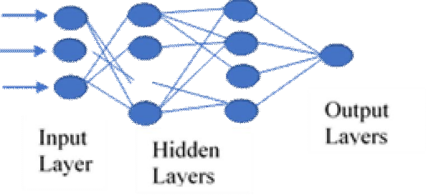

**Figure 1 :**Multilayer Network

**2.2 IMAGE RECOGNITION PROCESS**

Image recognition is a process that enables signatures to be entered into the qualification application. The process requires sign in front of the webcam. The computer captures the logo created by the network camera and stores the different images created. The image from the camera will change and the resolution will change. When editing the image, the color will first change to a gray image and then to a black and white image . There are many methods used to extract images, such as SIFT, SURF, BRISK and HSV algorithms. Scale invariant feature transfer "SIFT" is used to extract vectors describing patches in the image. These properties are not vector scale invariant, but are translation, rotation, and illumination invariant. SIFT annotations have several advantages. For example, This narrator is more accurate than other narrators. Can explain the ,main points in each picture. It allows a feature to be accurately identified with the best in a large data set. It can also cover all scales and areas of the image with near-perfect accuracy.

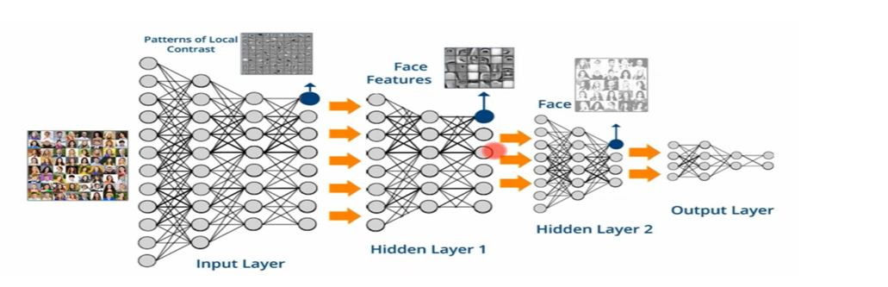

**Figure 2:** Image Recognition using Neural Network

1. **METHODOLOGY**

This article explains how to understand complex movements. A framework based on Hidden Markov Models (HMM) is provided for modeling and analyzing complex signals. departmental follower. This solution is able to recognize online redirection and eliminate applications. Experimental results show that this method can produce better results than traditional hand recognition. Gesture data consists of three parts: palm measurement, hand measurement, and behavior data. Figure 3 provides an overview of the gesture recognition process. The basic algorithm structure of our analysis process is as follows:

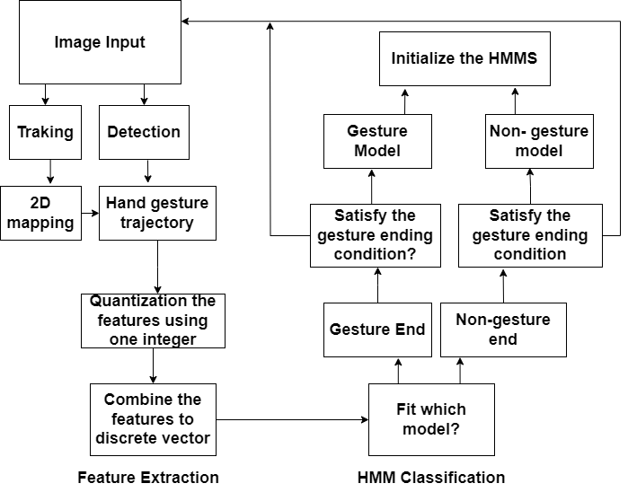

**Figure 3 :** Overview of Hand Gesture Recognition Process

* Detect the palm from the video and initialize the tracker with the template of hand size.
* Track the hand motion using a contour-based tracker and record the trajectory of the palm center.
* Classify the gesture using HMM, which gives the maximum probability of occurrence of observation sequence.

**3.1 Training Phase**

The training phase is based on storing images in the database. The repository contains images of male and female hands. The basis of education is knowing the signs that everyone can do with one hand. For this purpose, 30 different images at different brightness and duration are taken and saved to the file. These images are used as reference visuals to help create the correct sequence for the job. The library contains more than 1000 unique hand and gesture images. Control method: cursor movement and mouse click. Figure 3 shows the gesture recognition process. or a hierarchy of color features at various scales, providing users with hand and color differences in the background color to define the background. Hand detection is a computer tool that tracks the user's hands and distinguishes them from the background or other objects. In D-speak, finger pain, skin color, finger alignment and palm position are taken into account.

**3.2 Gesture Recognition**

We explored one way to identify simple hand gestures and implement two basic gesture controls: cursor movement and mouse clicks. Figure 6 describes the basic hand gesture process recognition.

* Using vision-based recognition, the computer captures character to find gesture acquisition.
* Hand tracking can be done using clustering algorithms that are able to treat each finger as a cluster and remove blank spaces between them or multiple scales a hierarchy of color features that provide users with a hand and different shades of background colors to identify a remove the background. Hand tracking is a computer thing the ability to track the user's hand and separate it from background or other objects.
* Feature extraction depends on the application. On D-talk, finger condition, skin color, finger alignment, and palm position is taken into account.
* After feature extraction they were sent for training and testing classification algorithms to achieve output.

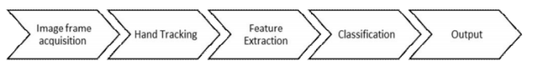

**Figure 4**: Basic steps of hand recognition process.

After the features are extracted, they are sent to the training and evaluation classification algorithms to obtain the output. Figure 5 shows the gesture writing process. Get transactions from the user or the captured image and make a comparison between transaction input and payment transactions. When the gestures match, it moves; if they don't match, it starts making gestures. In this article, we are preparing a model using a compact device for the deaf. Its main advantage is that the device can be removed quickly and weight is lost quickly. Use simple coding language to reduce complexity. If training and test movements match, speech is generated. The indicator appears on the screen. The image will be recognized by the camera network. If the system detects an unknown direction, it will automatically return so the user can navigate in the right direction again. It will create a gesture that will allow every user to read and understand the meaning of the gesture. It is a very important part of the testing phase and proves the effectiveness and functionality of the system in its current implementation. These activities can help deaf people communicate with others. This is a step forward in the development of additional technologies that have proven important in helping people of all races.

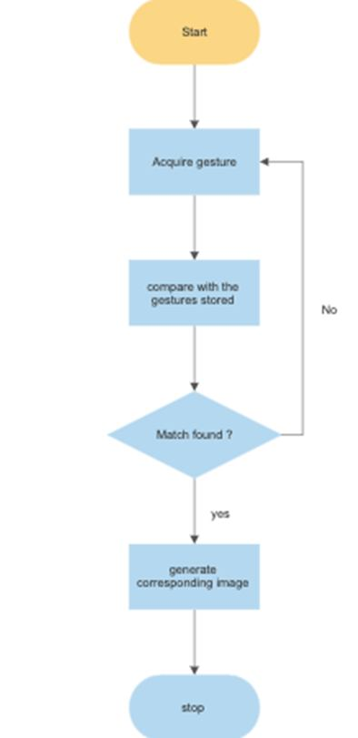

**Figure 5:** Gesture Acquisition Process

**4. IMPLEMENTATION AND RESULTS**

4. Action and Completion

During the project, developers will change some tasks they plan to do. They found that they could set up the system and test the image as planned without planning the training. Directly on the skin and contour to see the true signature. Additionally, the developers have reduced the limitation to a single function that only displays the website. Moreover, the results are accurate and complete according to the methods and tests used; For example, the development of modern technology helps people with disabilities, especially deaf people, during human interaction. Supporting evidence on the measured variables and methodology led this study to conclude that the measures used to measure were widely supported. At the same time, performance and physical activity can provide the best results for affected individuals and, since there is no training or specific details on how to use the technique, it can provide comfort and the ability to make their lives easier and better. Therefore, everyone can identify the intended point and come up with their own interpretation. Therefore, communication between deaf-mute and hearing people is easy and cannot be misunderstood. The app can capture fingerprints using coding. Remove the color from the skin and draw a line around the hand. As a result, the system recognizes everything in the frame. The main screen of the application is shown in Figure 9. The system recognizes all the contents of the box, brightness does not matter. The model is dynamic and has three directions to view the website. All users need to use the system is a WiFi connection and a webcam to capture user movements. It acts as a guide for users. The system is very sensitive. Catches things in the box. Therefore, users should pay attention to the white background. When a user signs an indicator, the result is that the system determines which behavior will affect which web page. > Figure 7: Visualization results

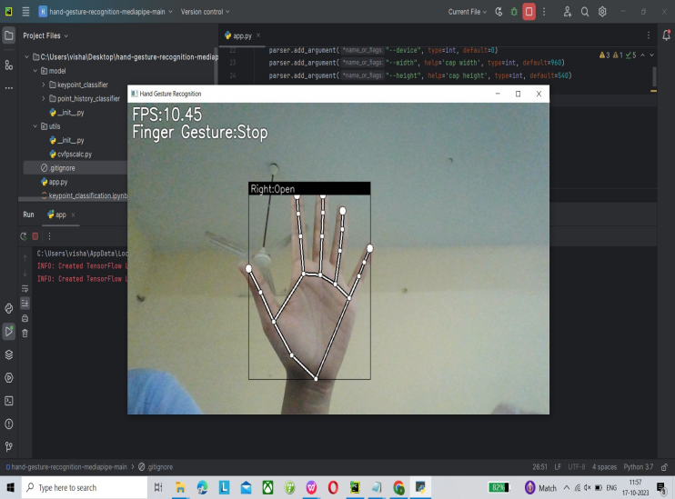

**Figure 6** : Signs being used by system

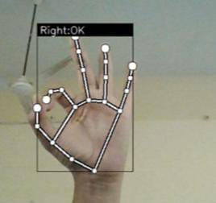

**Figure 7**: Result of sign detection

We conducted two experiments to verify the model mentioned in this article. The first test is human hand region segmentation. We used 50 hand area models and 50 female hand area models with various gestures. We provide 70 samples as test data and 30 samples as proof data. Segmentation accuracy is 60%, making it 6 points out of 10 accurate. In summary, reality testing can be done realistically. The D-language is useful as a computer application because it has its own characters, which are believed to be easy to understand and not as complex as language characters. The system uses the accuracy of machine learning models to determine which model is better from the difference between connections and event instances in the data or planning based on data. The better the model can be extended to “hidden” data, the better predictions and insights it can produce, resulting in more value.

**5. CONCLUSION**

The main purpose of this study has been achieved, it is successful. Hand gestures work best if you are a user who can communicate with someone who understands the language: I'm not used to the language. Voice translation. Sign language is understandable for those who do not know the language. Factors such as room temperature and lighting may play a role in predicting results. Insufficient lighting, too bright or too dark. Incorrect movements depend on the type of error. It occurs in the customer's peripherals, such as a weak website. Microphone performance is good or bad. As a result, it is necessary to develop technology and teach explanations that help improve communication, which is very important not only for deaf people, but also for hearing and speaking people. Additionally, enhance your social life through effective communication by creating career development opportunities. This is worth your time and resources. D-Talk is led by producers. The program may have many tasks, but eventually it reduces its work to a single task. They imagine opening their calendar, eating lunch, and browsing websites in Microsoft Office Word. The final task is to create our website.

**REFERENCES**

1. Abhishek, K. S., Qubeley, L. C. F., & Ho, D. (2016, August). Glove-based hand gesture recognition sign language translator using capacitive touch sensor. In 2016 IEEE International Conference on Electron Devices and Solid-State Circuits (EDSSC) (pp. 334-337). IEEE.
2. https://doi.org/10.1109/EDSSC.2016.7785276
3. Ahmed, M. A., Zaidan, B. B., Zaidan, A. A., Salih, M. M., & Lakulu, M. M. B. (2018). A review on systems-based sensory gloves for sign language recognition state of the art between 2007 and 2017. Sensors, 18(7), 2208.

https://doi.org/10.3390/s18072208

1. Ahmed, M., Idrees, M., ul Abideen, Z., Mumtaz, R., & Khalique, S. (2016, July). Deaf talk using 3D animated sign language: A sign language interpreter using Microsoft's kinect v2. In 2016 SAI Computing Conference (SAI) (pp. 330335).IEEE.https://doi.org/10.1109/SAI.2016.7556002
2. Artemov, M., Voronov, V., Voronova, L., Goncharenko, A., & Usachev, V. (2019). Subsystem for Simple Dynamic Gesture Recognition Using 3DCNNLSTM. In Conference of Open Innovations Association, FRUCT (No. 24, pp. 571-577). FRUCT Oy.
3. Almisreb, A. A., Jamil, N., Norzeli, S. M., & Din, N. M. (2020). Deep transfer learning for ear recognition: A comparative study. International Journal of Advanced Trends in Computer Science and Engineering, 9(1.1 Special Issue), 490-495.[80].

9. Anderson, R., Wiryana, F., Ariesta, M. C., & Kusuma, G. P. (2017). Sign language recognition application

1. systems for deaf-mute people: A review based on input-process-output. Procedia computer science, 116, 441-448.
2. Ansari, Z. A., & Harit, G. (2016). Nearest neighbour classification of Indian sign language gestures using kinect camera. Sadhana, 41(2), 161-182.
3. 8. Aujeszky, T., & Eid, M. (2016). A gesture recogintion architecture for
4. Arabic sign language communication

system. *Multimedia Tools and Applications*, *75*(14), 8493-8511.

9. Badhe, P. C., & Kulkarni, V. (2015, November). Indian sign language translator using gesture recognition algorithm. In *2015 IEEE International Conference on Computer Graphics, Vision and Information Security (CGVIS)* (pp. 195-200). IEEE.

10. Bukhari, J., Rehman, M., Malik, S. I., Kamboh, A. M., & Salman, A. (2015). American sign language translation through sensory glove; signspeak. *International Journal of u-and e-Service, Science and Technology*, *8*(1), 131-142.

https://doi.org/10.1109/CGVIS.2015.7449921

11. Cheng, J., Chen, X., Liu, A., & Peng, H. (2015). A novel phonology-and radical-coded chinese sign language recognition framework using accelerometer and surface electromyography sensors. *Sensors*, *15*(9), 23303-23324.

12. Davydov, M., & Lozynska, O. (2016, September). Linguistic models of assistive computer technologies for cognition and communication. In *2016 XIth International Scientific and Technical Conference Computer Sciences and Information Technologies (CSIT)* (pp. 171-174). IEEE.

13. Darabkh, K. A., Haddad, L., Sweidan, S. Z., Hawa, M., Saifan, R., & Alnabelsi, S. H. (2018). An efficient speech recognition system for arm

isolated words. *Computer Applications in Engineering Education*, *26*(2), 285-301.

14. Gomes, S. L., Rebouças, E. D. S., Neto, E. C., Papa, J. P., de Albuquerque, V. H., Rebouças Filho, P. P., & Tavares, J. M. R. (2017). Embedded real-time speed limit sign recognition using image processing and machine learning techniques. *Neural Computing and Applications*, *28*(1), 573-584.

15. Halim, Z., & Abbas, G. (2015). A kinect-based sign language hand gesture recognition system for hearing-and speech-impaired: a pilot study of Pakistani sign language. *Assistive Technology*, *27*(1), 34-43.

https://doi.org/10.1080/10400435.2014.952845

16. Hiele, T. M., Widjaja, A. E., Chen, J. V., & Hariguna, T. (2019). Investigating students’collaborative work to continue to use the social networking site. *International Journal of Advanced Trends in Computer Science and Engineering*, *8*(1.5 Special Issue), 375

386

https://doi.org/10.30534/ijatcse/2019/6181.52019

17. Hatwar, P. D., Wahile, N. A., & Padiya, I. M. (2017). Home Automation System Based on Gesture Recognition System. *International Journal of Emerging Technologies in Engineering Research (IJETER)*, *5*(3).

18. Jin, C. M., Omar, Z., & Jaward, M. H. (2016, May). A mobile application of American sign language translation via image processing algorithms. In *2016 IEEE Region 10 Symposium (TENSYMP)* (pp. 104-109). IEEE.

19. Kishore, P. V. V., Kumar, D. A., Sastry, A. C. S., & Kumar, E. K. (2018). Motionlets matching with adaptive kernels for 3-d Indian sign language recognition. *IEEE Sensors Journal*, *18*(8), 3327-3337.

https://doi.org/10.1109/JSEN.2018.2810449

20. Koutsouleris, N., Kambeitz-Ilankovic, L., Ruhrmann, S., Rosen, M., Ruef, A., Dwyer, D. B., ... & Schmidt, A. (2018). Prediction models of functional outcomes for individuals in the clinical high-risk state for psychosis or with recent-onset depression: a multimodal, multisite machine learning analysis. *JAMA psychiatry*, *75*(11), 1156-1172.

21. Köse, H., Uluer, P., Akalın, N., Yorgancı, R., Özkul, A., & Ince, G. (2015). The effect of embodiment in sign language tutoring with assistive humanoid robots. *International Journal of Social Robotics*, *7*(4), 537-548.

22. Kumar, P., Saini, R., Roy, P. P., & Dogra, D. P. (2018). A position and rotation invariant framework for sign language recognition (SLR) using Kinect. *Multimedia Tools and Applications*, *77*(7), 8823

8846.

23. Kumar, P., Saini, R., Behera, S. K., Dogra, D. P., & Roy, P. P. (2017, May). Real-time recognition of sign language gestures and air-writing using leap motion. In *2017 Fifteenth IAPR International Conference on Machine Vision Applications (MVA)* (pp. 157-160). IEEE. https://doi.org/10.1007/s11042-017-4776-9

24. Lorah, E. R., Parnell, A., Whitby, P. S., & Hantula, D. (2015). A systematic review of tablet computers and portable media players as speech generating devices for individuals with autism spectrum disorder. *Journal of Autism and Developmental Disorders*, *45*(12), 3792-3804.

25. Lun, R., & Zhao, W. (2015). A survey of applications and human motion recognition with microsoft kinect. *International Journal of Pattern Recognition and Artificial Intelligence*, *29*(05), 1555008.

26. Martins, P., Rodrigues, H., Rocha, T., Francisco, M., & Morgado, L. (2015). Accessible options for deaf people in e-learning platforms: technology solutions for sign language translation. *Procedia Computer Science*, *67*, 263-272.

27. Martins, P., Rodrigues, H., Rocha, T., Francisco, M., & Morgado, L. (2015). Accessible options for deaf people in e-learning platforms: technology solutions for sign language translation. *Procedia Computer Science*, *67*, 263-272.

28. Naglot, D., & Kulkarni, M. (2016, August). Real time sign language recognition using the leap motion controller. In *2016 International Conference on Inventive Computation Technologies (ICICT)* (Vol. 3, pp. 1-5). IEEE.

29. Neiva, D. H., & Zanchettin, C. (2018). Gesture recognition: a review focusing on sign language in a mobile context. *Expert Systems with Applications*, *103*, 159-183.

30. Neidle, C., Opoku, A., Dimitriadis,G., & Metaxas, D.

(2018, May). NEW Shared & Interconnected ASL