PERFORMANCE STUDY OF ENHANCING LOW LIGHT IMAGES USING DEEP VISION NETWORKS

**Monisha.M**Department of Electrical and  
Electronics Engineering  
Sathyabama Institute of Science and TechnologyChennai,India [moneeesaaa@gmail.com**Renuga Devi.B**](mailto:moneeesaaa@gmail.comRenuga%20Devi.B)  
Department of Electrical and  
Electronics Engineering  
Sathyabama Institute of Science and Technology  
Chennai,India   
[renuga2802@gmail.com **DR.M.Sumathi**](mailto:renuga2802@gmail.com%20DR.M.Sumathi)  
 Professor Department of Electrical and Electronics Engineering  
Sathyabama Institute of Science and TechnologyChennai,India

*Abstract*— Improving image quality in low-light conditions is difficult and frequently leads to grainy and noisy photos. Traditional picture restoration approaches suffer due to a lack of visual data. Recent advances in deep learning show potential for addressing this problem. The goal of this research is to create and compare three cutting-edge image restoration techniques that are specifically designed for low-light circumstances. One of these methods employs the MIRNet architecture, a fully convolutional model designed to improve low-light photos by gathering rich contextual information at various scales while maintaining small features. Along with MIRNet, the effectiveness of convolutional neural networks (CNNs) and generative adversarial networks (GANs) for low-light picture restoration are performed using python in pycharm.The efficacy of these methods will be evaluated by means of comprehensive experimentation and evaluation with established criteria for image quality. This study's findings show potential for developing low-light photography in domains such as surveillance, medical imaging, and astronomy, with practical implications for improving image quality in tough lighting circumstances.

Keywords—MIRNet, CNN, GAN, Deep learning, image restoration

# **INTRODUCTION**

Image enhancement is regarded as one of the most significant techniques in image research. Enhancing an image's quality is its primary goal, as is providing a better transform representation for upcoming automated image processing. Numerous photos, including shots taken in real life, satellite, aerial, and medical contexts, have poor contrast and noise levels. aditional methods for improving photos in low light have various drawbacks. These approaches, such as histogram equalization and noise reduction filters, frequently fail to preserve fine details and textures, resulting in over-smoothing or loss of key characteristics. They are also less adaptable to changing lighting conditions and may produce glitches or distortions into improved photographs. Furthermore, human parameter tuning and heuristic modifications reduce these approaches' efficiency and scalability for real-world applications. As a result, more sophisticated techniques, like as deep learning-based approaches, have evolved to effectively handle these problems, providing improved performance and versatility in improving low-light photos.The process of improving satellite image quality without identifying the cause of deterioration is known as image augmentation. When the cause of deterioration is identified, the procedure is referred to as picture restoration. Images are used as input and output in both iconical processes. To enhance images in some way, an array of approaches are employed, most of which are simple and heuristic .Certain known deteriorations in an image are eliminated or reduced through image restoration. Geometrical transformations are useful in many applications of image processing. MIRNet is a fully convolutional neural network architecture that is optimized for low-light image enhancement. It is highly effective in maintaining tiny features while capturing rich contextual information at various scales. Convolutional neural networks have been effectively used for low-light picture enhancement tasks because of their reputation for being able to learn hierarchical features from input. CNNs can effectively learn to improve visibility in low-light conditions and boost image quality by utilizing big datasets and robust computational models. Additionally, GANs can learn to generate visually pleasing pictures with enhanced details and reduced noise by simultaneously training a discriminator network to distinguish between real and generated images and a generator network to make high-quality images. The goal of this research is to further the development of picture enhancing methods designed with low light circumstances in consideration. We want to figure out the difficulties in improving image quality in difficult lighting conditions by utilizing cutting-edge deep learning architectures like convolutional neural networks (CNNs) and generative adversarial networks (GANs) alongside MIRNet.

# **RELATED WORK**

Low Light Image Illumination Adjustment Using Fusion of MIRNet and Deep Illumination Curves proposes a two-phase technique to solve the challenge of improving low-light photographs. Initially, we employ MIRNet to enhance the images' brightness, making up for common problems with color and texture reproduction in deep learning models. In order to optimize illumination, we apply deep illumination curves to pixel-wise tonal curves in the second phase, though there is a chance that this would over-illuminate some places. Lastly, we overcome the drawbacks of conventional techniques by fusing the outputs from both phases using contrast-based fusion, which produces a more effective and consistent high illumination adjustment [2].

The Two-stage Perceptual Enhancement Transformer Network (TPET) improves visibility, noise, and color distortion in low-light images by using CNNs and transformers. Separated into phases for detail fusion and feature extraction, the latter stage uses transformers to expand the receptive region and extract global features, and a Perceptual Enhancement Module (PEM) to enhance the interaction between local and global features. FFBs, or feature fusion blocks, balance feature information to guarantee stability. By distributing local information, a Self-Calibration Module (SCM) improves monitoring in between stages. A Detail Enhancement Unit (DEU) maintains details for high-resolution images throughout the fusion stage. Evaluations that are both subjective and objective support our technique's superiority over others. [1].

A convolutional neural network for low-light image enhancement introduces a CNN-based strategy for improving low-light photos. It includes a specific module that uses multiscale feature maps and addresses gradient vanishing difficulties. To efficiently retain picture textures, the model is trained with the SSIM loss. Our method allows for adaptive augmentation of contrast in low-light photos, outperforming current contrast enhancement techniques.[3]

This paper presents LPRGAN, a framework for recovering license plate images using a lightweight Generative Adversarial Network. In contrast to conventional techniques that concentrate on specific jobs, LPRGAN is engineered to manage numerous recovery tasks within a solitary architecture. It makes use of dual classification networks and an encoder-decoder architecture influenced by autoencoders to improve problem-specific learning. Identification of issues, data recovery, and a fail-safe method that guarantees dependability and efficiency are important characteristics. The system reduces workload overhead by processing only degraded inputs thanks to the integration of anomaly detection. With remarkable performance characteristics including low power consumption and quick recovery, LPRGAN opens the door for further developments in on-device computing applications. [4]

The development of image processing methods is examined in deep learning techniques for image processing, emphasizing the shortcomings of conventional algorithms and the expanding importance of deep learning. It covers techniques including quality evaluation, parallel computation, up sampling, and image super resolution, demonstrating how effectively deep neural architectures perform these functions. The chapter highlights how deep learning techniques can be applied to image processing to gain better performance.[8]

This survey provides a comprehensive assessment of low-light image improvement (LLIE) techniques, focusing on recent advances driven by deep learning methodologies. It addresses a variety of issues, including algorithm taxonomy, network architecture, training data, and open research problems. To evaluate existing approaches, a new low-light picture and video dataset recorded by different mobile phone cameras under varying lighting circumstances is presented. Additionally, an online platform is provided, providing easy access to popular LLIE procedures and their findings. The poll contains both qualitative and quantitative evaluations, such as face detection in low-light circumstances, with the goal of serving as a reference for future study in this area. The proposed dataset, platform, and evaluation metrics are all freely available for future changes and additions[5].

This research contrasts conventional and deep learning-based picture enhancers, concluding that deep learning methods produce less noisy images. While both approaches improve image visibility and detail, deep learning algorithms provide better noise reduction. The findings have ramifications for noise-sensitive applications, such as image retrieval techniques like SIFT and ORB, emphasizing the significance of selecting the right enhancer for best performance[6].

# **PROPOSED METHODOLOGY**

Enhancing the visibility and the clarity of photos taken in low light is essential for activities such as image analysis, scene interpretation, and object recognition. Many methods have been developed to tackle this problem; MirNet, Convolutional Neural Networks (CNN), and Generative Adversarial Networks (GAN) have demonstrated promising performance.

***A.MIRNet***

A deep learning model called MIRNet is used to improve images taken in low light. By retaining minute details while extracting features at different scales, it enhances representation by facilitating information sharing between branches. MIRNet is trained to take into account data from various scales in order to extract and enhance features from low-light photos.

*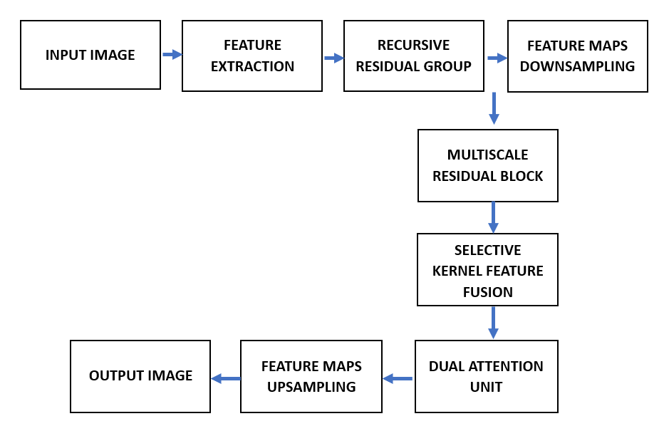Fig.1.Functional blocks of MIRNet system*

The Fig.1 combines multi-scale properties dynamically through the use of a selective kernel network. MIRNet utilizes a sequence of feature extraction blocks, each with a selective kernel fusion (SKF) technique. This SKF method dynamically mixes characteristics at several spatial scales, allowing for the preservation of original feature information while improving representation learning. Furthermore, MIRNet has a Dual Attention Unit (DAU) in its architecture, which improves its ability to capture contextual information. The DAU selectively accentuates useful regions while reducing irrelevant ones, which improves feature representation. MIRNet also has recursive residual blocks. These blocks gradually break down the input signal, simplifying the learning process and allowing for the creation of deep networks. MIRNet excels at improving low-light images, preserving spatial features, and overall image quality by combining SKF, DAU, and numerous residual blocks.

***B.CONVOLUTION NEURAL NETWORK***

Convolutional neural networks in image processing for the restoration of dark-shaded images that have been trained to automatically learn and apply enhancement filters, amplify features in images, lower noise levels, and improve overall image quality. They are made up of several convolutional layers that use convolution operations to extract and improve important information from the input image.

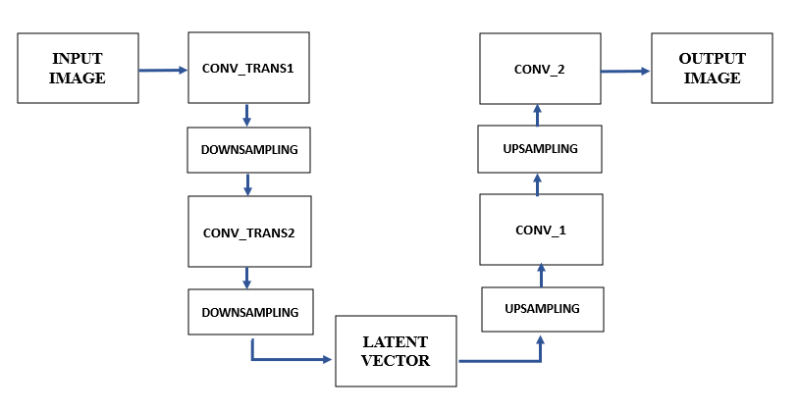

*Fig.2. Process Diagram of the CNN model*

In Fig.2,the down function employs layers.Conv2D, is a convolutional layer in Keras that applies a set of filters to small patches of input, whereas the up function uses layers.Convert2D Transpose for upsampling. The model function defines the overall autoencoder architecture, which includes many downsampling and upsampling blocks. Convolutional layers in the downsampling path (d1, d2,..., d5) lower input spatial dimensions, whereas transposed convolutional layers in the upsampling path (u1, u2,…,u5) increase spatial dimensions. To retain spatial information and capture both low-level and high-level features, the upsampled feature maps are concatenated with the equivalent feature maps from the downsampling blocks at each upsampling block. Eventually, a convolutional layer is used by the model to output the improved image. This design, which is similar to U-Net, uses skip connections between downsampling and upsampling blocks to effectively assist feature extraction and picture enhancement in low-light situations.

***C.GENERATIVE ADVERSIAL NETWORK***

Generic Adversarial Networks, which are used in low-light picture restoration, are made up of two neural networks that have been trained together: a discriminator and a generator to utilize image quality.

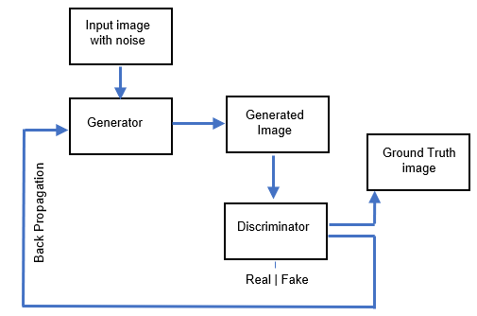

*Fig.3. Flow chart of the GAN*

In Fig 3.The Generator(G) in the Generative Adversarial Network configuration attempts to achieve realism by enhancing low-quality images. In the meantime, the Generator receives feedback from the Discriminator which gains the ability to discern between produced and actual images. Through repeated practice with adversarial training, G and D improve their skills. G aims to generate compelling improvements, testing D's judgment as D improves its ability to distinguish. This procedure is repeated until G produces excellent outputs that are nearly identical to real photos, making it impossible for D to tell them apart.

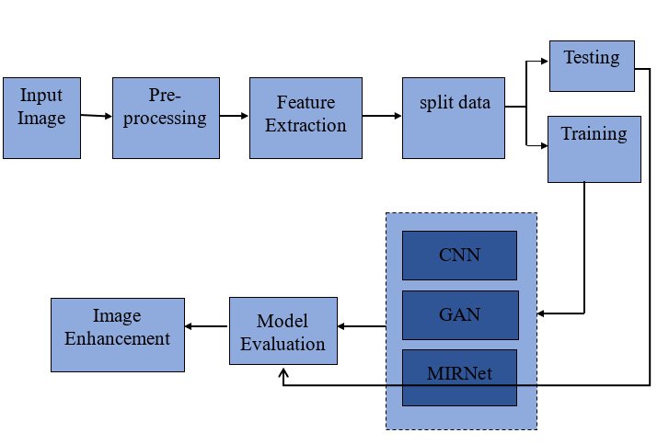

*Fig.4. Block Diagram*

The Fig.4 picture restoration procedure begins with data collection, which involves gathering the LOL dataset, pairs of low-light and their well-exposed photographs. Afterwards, data is pre-processed to shrink photos, normalize pixel values, and divide the dataset into training and testing sets. Following that, train your deep learning models -MIRNet, CNNs, GANs on the training data with predetermined architectures, loss functions, and optimization techniques. Models are then tested on a separate testing subset of the LOL dataset to assess their performance on previously unseen data. Finally, a comparative analysis is performed to establish the success of various image restoration procedures based on conventional image quality assessment criteria and visual inspection.

# **RESULT AND ANALYSIS**

Using the PyCharm tool and the libraries Python (version 3.6.5), Keras (version 2.1.6), and TensorFlow (version 1.7.0), the performance of MIRNet, CNN, and GAN was assessed and the training losses over epochs was monitored.

***A. GRAPHICAL REPRESENTATIONS***

A graph displaying the train and validation PSNR over epochs and train and validation losses is presented below.

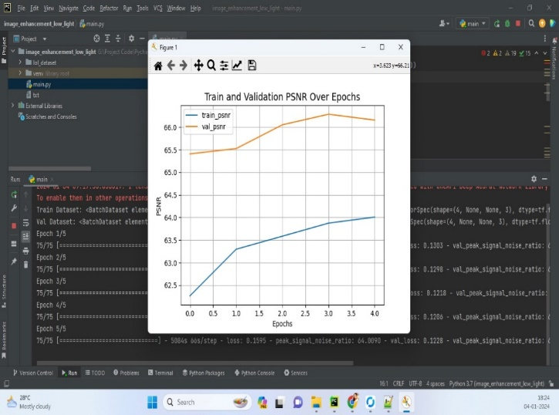*Fig.5. Training and validation graph over epochs*

The training loss curve in a typical loss graph Fig. 5.1 shows a declining pattern over epochs or iterations, indicating the model's progress over time. whereas, the validation loss curve shows a discrepancy between the model's performance on training and validation data. It starts off mirroring the training loss but may stagnate or grow if overfitting appears. The goal of training is to reduce the training loss, which is a measurement of the discrepancy between the actual ground truth labels and the output that the model predicted. A decreasing training loss indicates improved prediction accuracy for the model.

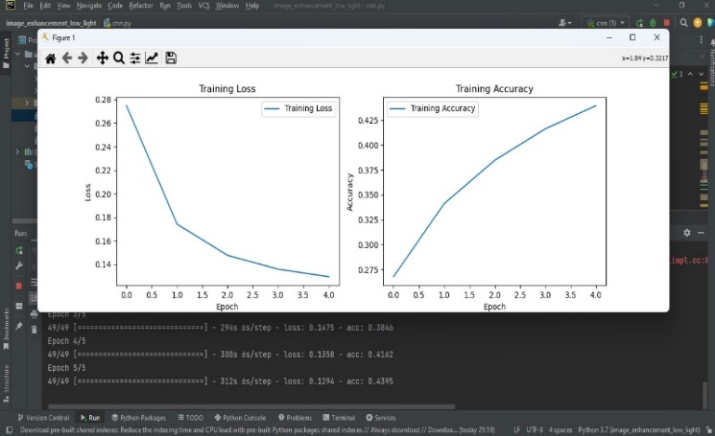

*Fig.6. Training loss and accuracy in CNN*

In a Fig.6 CNN training and validation loss graph, as the model learns to better fit the training data, the training loss usually cuts down over the course of subsequent epochs. On the other hand, the validation loss curve may diverge, stabilizing or growing after initially following the training loss, signifying the model's ability to reduce noise and generalize to previously unseen data. This visual aid offers insights into the model's performance on training and validation datasets as well as the training procedure.

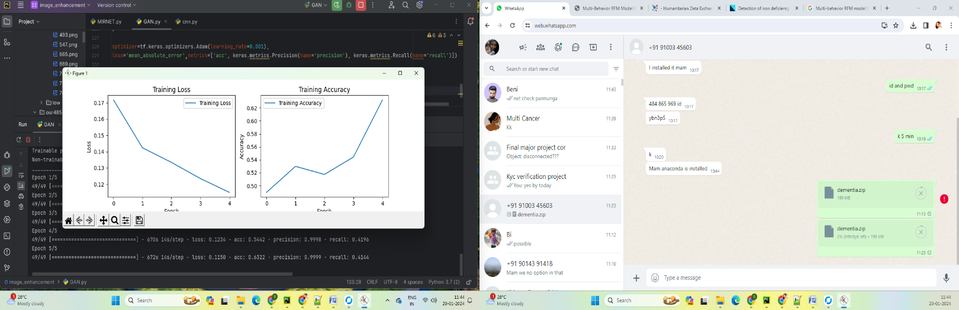

*Fig.7 Loss and Accuracy curve in GAN*

The Fig.7 training loss curve in a GAN depicts the model's progress in producing realistic samples throughout training. It quantifies the difference between generated and actual samples. A declining curve indicates the generator's improvement, as it produces outputs that are very similar to genuine ones, challenging the discriminator. In contrast, a growing curve indicates problems with generating realistic samples or the discriminator's ability to distinguish between actual and phony ones.

***B. COMPARATIVE PERFORMANCE ANALYSIS***

Among these deep learning approaches, MIRNet, Convolutional Neural Networks (CNNs), and Generative Adversarial Networks (GANs) have shown remarkable performance in enhancing low-light images.

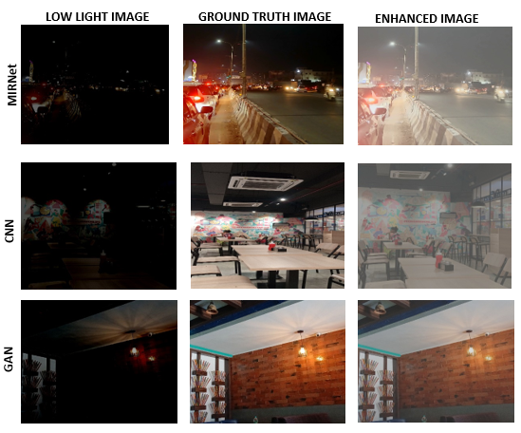

*Fig.8. Comparison of Low light image with its enhanced image*

The Fig.8 represents the comparative analysis of low-light image improvement utilizing cutting-edge deep learning algorithms including CNN, GAN, and MIRNet to highlight the project's findings. According to this research, image quality greatly increased upon augmentation, and this improvement continues as the epochs time grows, producing high resolution images. MIRNet, which is well-known for its capacity to record minute details and worldwide context, shown impressive performance in improving low-light photos, producing outputs that are crisper and more aesthetically pleasing. Moreover, the amalgamation of CNNs and GANs furnished varied methods for improvement, hence augmenting the general quality and authenticity of the visuals. This thorough analysis highlights how well MIRNet, CNN, and GAN handle the difficulties associated with low-light photography, indicating major progress in the area.

***C.MEASUREMENT ANALYSIS***

Fundamental evaluation measures including accuracy, precision, recall, and F1 score are used to evaluate how well deep learning models perform in a variety of tasks like image segmentation, classification, and image enhancement.

* ***ACCURACY***

This quantifies how accurately the model predicts the entire situation in relation to actual data. In low-light image enhancement, accuracy refers to how closely the augmented images match the required features and visual quality.

Accuracy = 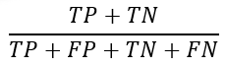 (1)

* ***PRECISION***

Precision refers to the proportion of accurately anticipated positive samples to total positive samples.

Precision = 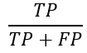 (2)

* ***RECALL/SENSITIVITY/TRUE POSITIVE RATE***

Recall is the ratio of accurately predicted positive samples to total positive samples. A high recall shows that the model successfully recollects significant image content during the enhancement process, resulting in an overall improvement in visual quality.

Recall = 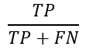 (3)

* ***F1 SCORE***

The F1 score balances precision and recall by computing their harmonic mean. It combines precision and recall into a single rating to provide a comprehensive assessment of the model's performance in low-light picture improvement.

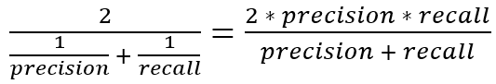 (4)

These calculations are performed within the system itself and the results are shown.

**Table 1. Comparison among MIRNet, CNN & GAN Models**

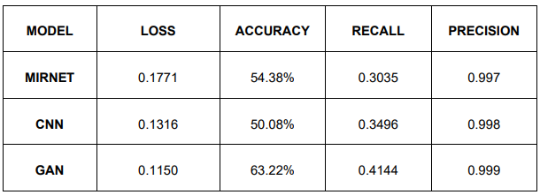An accurate comparative performance analysis of enhancing low-light photos using MirNet, CNN, and GAN models reveals that GAN is the most successful model for this task. From this Table.1 conclusion is taken from observations of loss and accuracy numbers, as well as other pertinent measures. Despite their complexity, GANs can generate images that are more realistic and visually appealing than MIRNet and traditional CNNs.

1. **CONCLUSION**

In this study, we tackled the difficult task of augmenting low-light photos by combining GAN, MIRNet, and CNN architectures. We used a matched dataset of low-light photos and their well-enhanced equivalents. This dataset was rigorously chosen, combining  existing datasets with a unique dataset suited to our specific needs. Through our trials, we effectively established the practicality of our proposed strategy in improving photos in low lighting situations. Our technique not only enhanced image brightness and contrast, but it also demonstrated significant improvements in color accuracy. This is an important consideration since precise color representation is essential for retaining the authenticity of the visual material. Our model works with photos that have a resolution of 256 x 256 pixels at the moment. We do admit that additional advancements may be made if more reliable hardware systems were to become available. Better hardware resources will allow us to investigate higher resolution image processing, which will allow our model to efficiently handle larger and more detailed images. To sum up, our project offers a viable solution to the problems related to improving low-light images. Through the integration of sophisticated deep learning architectures and the utilization of carefully selected datasets, we have proven to achieve notable enhancements in image quality, especially in low-light situations. In the future, we want to keep improving our model and looking into ways to make it more scalable and perform better.

# **REFERENCES**

[1] Hengshuai Cui, Jinjiang Li, Zhen Hua, Linwei Fan,"Two-stage Perceptual Enhancement Transformer Network for Low-light Image Enhancement", in Engineering

Application in Artificial Intelligence ,Vol.116,2022, doi:10.1016/j.engappai.2022.105411

[2] Perla, S., Dwaram, K. (2023). "Low Light Image Illumination Adjustment Using Fusion of MIRNet and Deep Illumination Curves". In: Morusupalli, R., Dandibhotla, T.S., Atluri, V.V., Windridge, D., Lingras, P., Komati, V.R. (eds) Multi-disciplinary Trends in Artificial Intelligence. MIWAI 2023. Lecture Notes in Computer Science, vol 14078. Springer, Cham. doi:10.1007/978-3-031-36402-0_58

[3] L. Tao, C. Zhu, G. Xiang, Y. Li, H. Jia and X. Xie, "LLCNN: A convolutional neural network for low-light image enhancement," 2017 IEEE Visual Communications and Image Processing (VCIP), St. Petersburg, FL, USA, 2017, pp. 1-4, doi: 10.1109/VCIP.2017.8305143.

[4] W. Sereethavekul and M. Ekpanyapong, "Adaptive Lightweight License Plate Image Recovery Using Deep Learning Based on Generative Adversarial Network," in IEEE Access, vol. 11, pp. 26667-26685, 2023, doi: 10.1109/ACCESS.2023.3255641.

[5] C. Li et al., "Low-Light Image and Video Enhancement Using Deep Learning: A Survey," in IEEE Transactions on Pattern Analysis and Machine Intelligence, vol. 44, no. 12, pp.9396,1 Dec.2022,doi:10.1109/TPAMI.2021.3126387.

[6] Michela Lecca and Fabio Poiesi, "Performance comparison of image enhancers with and without deep learning," J. Opt. Soc. Am,Vol. 39, Issue 4, pp.610-620(2022) doi:10.1364/JOSAA.446969

[7] Vipul Narayan, Pawan Kumar Mall, Ahmed Alkhayyat, Kumar Abhishek, Sanjay Kumar, Prakash Pandey, "Enhance-Net: An Approach to Boost the Performance of Deep Learning Model Based on Real-Time Medical Images", Journal of Sensors, vol. 2023, Article ID 8276738, 15 pages, 2023. doi:.1155/2023/8276738

[8] Adate, Amit and Tripathy, B. K.. "Deep learning techniques for image processing", Machine Learning for Big Data Analysis, edited by Siddhartha Bhattacharyya, Hrishikesh Bhaumik, Anirban Mukherjee and Sourav De, Berlin, Boston: De Gruyter, 2019,pp.69-90. doi: 10.1515/9783110551433-003

[9] W. Wang, X. Wu, X. Yuan and Z. Gao, "An Experiment-Based Review of Low-Light Image Enhancement Methods," in IEEE Access, vol. 8, pp. 87884-87917, 2020, doi: 10.1109/ACCESS.2020.2992749.

[10] S. Park, S. Yu, B. Moon, S. Ko and J. Paik, "Low-light image enhancement using variational optimization-based retinex model," in IEEE Transactions on Consumer Electronics, vol. 63, no. 2, pp. 178-184, May 2017, doi: 10.1109/TCE.2017.014847.