Image dehazing using Frequency Mutual Revision Network

Lakshmi Varshitha Mattupalli   
CSE – AI and ML(SCOPE)  
Vellore Institute of TechnologyAmaravthi, Andhra Pradesh  
varshitha.21bce7327@vitapstudent.ac.in

Leelanagasai Prasanna Gudivada   
CSE – AI and ML(SCOPE)  
Vellore Institute of TechnologyAmaravthi, Andhra Pradesh  
prasanna.21bce7104@vitapstudent.ac.in

Dr. Chintakindi Balaram Murthy

Assistant Professor (SCOPE)

Vellore Institute of TechnologyAmaravthi, Andhra Pradesh  
balaram.ch@vitap.ac.in

Kusuma Priya Kotha   
CSE – AI and ML(SCOPE)  
Vellore Institute of TechnologyAmaravthi, Andhra Pradesh  
priya.21bce7716@vitapstudent.ac.in

*Abstract*— Some of the very recent works depict that it is also feasible to integrate the wavelet transforms with the neural networks for an advanced image dehazing since the latter highly helps in achieving the details of the image. The current method comprises spatial detail information about an image and its frequency information also but it is still at a developing stage to develop such a method to recover haze from clean images with retaining all details. In this paper, we introduce a new approach to solve the problem of image dehazing, which we call the Frequency Mutual Revision Network or FMRNet. The intuitive argument for FMRNet is that, on being perceived appropriately, one can see the image in such a way that the haze seems better distinguished from the original clean background. The hazy part is quite easily removable without destroying the essential details of the image since the haze and background components can be viewed more obviously in the frequency domain

Keywords—dehaze, FMRNet, frequency, haze.

Introduction

Pictures formed by fogs or mists with snow and haze turn to be foggy and vague. Hence, this will mean that an observation camera or robot car would only be partially aware of what is happening. In this line, the aim is haziness removal or reduction from images that would help with the sharpening of images. For most types of haze, the traditional methods are valid; however, they fail to work in complex scenarios in real-world scenes. Haze recently made the dehazing process much easier via deep learning, but the large barrier remains. Often haze merges with the background that complicated distinction between them in details of the restoration process.

The solution to correct that came in formation techniques which help deduce how much haze and background has to be within an image. While newer techniques formulated couldn't hold the look if natural in most places especially blending it with haze; the haze itself blended to the background.

Wavelet transform is another promising technique that decomposes the image into all the different frequencies but keeps the structure as well as the texture; however, the majority of the wavelet-based methods focus only on a few parts of an image in which they do not show how that part fits in with their neighbors and hence may not be beautiful enough.

We then questioned whether we could do a better job of separating scene from background by taking into account the interaction of different parts of the image with each other, or their "frequencies." In this regard, we presented an image dehazing method called FMRNet, which is based on a Frequency Mutual Revision Network. Instead of looking at what is happening pixel-wise on the image parts, FMRNet looks on what is happening in frequency space - how different parts of the images interact with each other. This lets the model understand how it can take a part the haze out from clean background while keeping alive the details.

How FMRNet Works:

1. Low frequency information helps the model to predict where haze is and what is the strength of that haze. The predictions are such that segmentation of the haze from clean parts of an image is much easier

2. Simultaneous learning of model on haze and background-which in turn both get enhanced simultaneously so that the output image is more natural as well as detailed in nature.

3 This can be achieved through a particular technique called multi-level fusion module that addresses step-by-step fortification of the haze removal and restoration of the background**.**

# Objective

The goal of this study is to create an algorithm that can detect and eliminate haze in a scene from a single photograph to improve clarity. Accurate estimation of transmission—that is, the way light passes through the haze—and hazy color are further goals of the technique. To provide a sharper and more detailed image, both surface shading and transmission are taken into consideration. Furthermore, the system needs to retrieve valuable data for uses like reframing an image and generating fresh perspectives from the scene.

# Related Work

Prior to deep learning, handcrafted methods relying on prior knowledge dominated the image dehazing scene. Probably one of the most-cited works in this domain is He et al. (2010) and also the atmospheric scattering models by Tarel and Hautière (2009). These worked for some conditions but failed when confronted with the complexities of real-world scenes. The specific assumptions about lighting, colors, and haze limited their performance as it did not always hold.

After deep learning, tremendous advancements have been done in haze removal. Some of the modern methods proposed by Ren et al. (2016) and Cai et al. (2016) used deep networks to enhance both the quality and adaptability of dehazing and surpassed the traditional approaches as they better managed a wider variety of haze conditions.

# More advanced techniques have come out by making the removal task multilayered. More scientists, such as Chen et al. in 2020, divide up the complexity of haze prediction tasks at various scales that could well catch fine details as captured with other models. That assists better rebuilding textures for hazy images. Zou et al. (2022) further extends this by "learning" how haze interacts with images, training models to recognize and reconstruct different kinds of haze patterns. Jiang et al. (2021b) combines knowledge about haze and background elements in guiding networks to produce clearer images with better contextual accuracy.

# The most recent innovation, FMRNet, is quite different from the others, as it focuses on relationships between different components of an image. This method provides a more general solution with clearer and more natural-looking dehazed images. These advancements clearly show how image dehazing has evolved from handcrafted methods to powerful deep learning models that can handle real-world challenges.

B. Li, et al. proposes AOD-Net (All-in-One Dehazing Network) is a deep learning model set for simplification in the process of image dehazing as it gives, in an end-to-end manner, an estimate that calculates both the transmission map along with the atmospheric light, and it results in the dehazing process, reducing it to an easier but very efficient and uniform one while providing comprehensive approaches for the dehazing in the images.

The proposal of Cai et al. does a reasonable dehazing job with deep CNNs in combination with atmospheric scattering models. In that it was a first application of deep learning in dehazing, the basis for later research is thus established.

Xiaohong Liu, et al., introduce attentions in CNN architecture design focused on spatial learning of features. Such attentions improved the visual qualities significantly; therefore, it is a balanced solution for haze removal and establishes the use and importance of attentions for image processing applications.

The UCL-Dehaze model introduced by Yuzhi Wang is an unsupervised contrastive learning model that improves the performance of dehazing without requiring paired training data. This, therefore makes the process of dehazing stronger and more versatile since it reduces labor-intensive labeled datasets; thus, shows improvements in unsupervised learning techniques.

Recently proposed UVM-Net, developed by Zhongzhi Ren is also another transformer-based architecture for the image dehazing case. The self-attention mechanisms, in this unified vision model help to capture global dependencies of an image, giving way to better haze removal and general performance.

The strategy of the prompt-based learning that is provided by Vaishnav Anand is an IR framework which can be applied for image restoration tasks like dehazing and denoising. It makes the usability of the framework applicable to several types of challenges of image restoration, making it flexible while handling different natures of visual tasks.

Lastly, the work by Sungmin Lee et al is one of those classical approaches to image dehazing that make use of a dark channel prior for estimating the transmission map, where haze removal relies upon this modeling of the prior. Moreover, it is one of the most frequently cited and highly influential techniques in this area; therefore, it bears considerable weightage to why this area of research into image dehazing needs to be addressed in a study.

# model

The Proposed FMRNet Architecture for Image Dehazing is further divided into clear layers, modules, and mechanisms in the more detailed and descriptive way as below.

**1. Input Layer**

**Input:**

* One RGB hazy image
* Dimensions: H×W×3H
* The hazy image is not as sharp because of atmospheric scattering effect.

**Preprocessing:**

*Normalization:*

* Scale the pixel intensities in the range [0,1]. This makes the model converge quickly and allows stable training.

Resizing:

* Resize the image to a fixed resolution, for example, to 256×256 to satisfy the expected input size for the model.
* - Ensures uniform dimension sizes for the input image during processing.

**2. Feature Extraction Module**

Extract haze-dependent low-level features: textures, edges, and patterns from the input image.

**Architecture:**

1.Convolutional Layers:

*Purpose:* LEVEL FEATURES including edges, shapes, and textures.

*Process:*

* Resized Image: The 3×3 convolutional filters slide across to detect patterns of spatial types.
* Feature maps after each convolution.

*Number of Layers:* 4-6 layers (Flexible).

*Padding:* "Same" padding ensures the spatial dimensions are preserved.

2. Batch Normalization

- Makes sure feature map activations are normalized.

- Regularizes gradients that eases the process of training.

3. Activation Function:

- To Apply ReLU (Rectified Linear Unit): f(x)=max(0,x).

Introduced non-linearity so that the model could learn complex haze patterns.

4. Multi-Scale Feature Maps:

- Extract features at various scales to catch both fine details, like edges, and coarse patterns, such as global haze distribution.

- The application of pooling layers or strided convolutions aids in down sampling feature maps progressively.

**3.Feature Restoration Module**

Visually recover by identifying regions vulnerable to haze and recovering lost detail.

**Main Components:**

1. Channel Attention Mechanism:

Centered on relevant channels and gives more weights to haze-related features.

*Working Procedure:*

* Compute the Global Statistics (mean or max) across spatial axes for all channels.
* Apply a small fully connected network for getting attention weights.
* Compute new feature maps by applying the computed weights to the input feature map.

1. Spatial Attention Mechanism

Places attention on regions that are likely to be very poor haze status like faraway objects and their backgrounds.

*Procedure:*

* Creating spatial attention map through channel aggregation, for example max pooling along channels.
* Elements from the spatial attention map are multiplied with the feature maps to enhance the hazy regions

1. Residual Connections

* Skip connections between the layers in order to preserve the features.
* This prevents over-smoothing because it maintains the necessary information in an image and prefers the enhancement of its details.

**4. Multi-Scale Refinement Module**

*Objective:* It combines low and fine features; thus, it offers better global clarity and enhances local details.

**Architecture:**

1. Low-resolution Feature Maps:

* Low-resolution feature maps
* Global clarity and general dehazing phenomena

1. Fine-Scale Features:

* Extracted from a higher resolution of feature maps
* Preserves the edgy and textile sharp along with localized haze.

1. Fusion:

- Concatenation or addition of coarse scale features and fine scale features

- Output an elaborate feature set that strikes a balance between global and local visibility.

4. Upsampling:

- Transposed convolutions or bilinear interpolation to upscale the coarse features to original resolutions.

- Ensure seamless integration with fine-scale features.

**5. Output Layer**

Obtaining the final output as fine-tuned by the features in the refined dehazed image

**Process:**

Final Convolution:

* The endpoint of FMRNet used a 3×3 convolutional layer that maps back the refined features into the RGB space.
* The approach yielded results of the same spatial resolution as the input with clear dehazed images.

## 

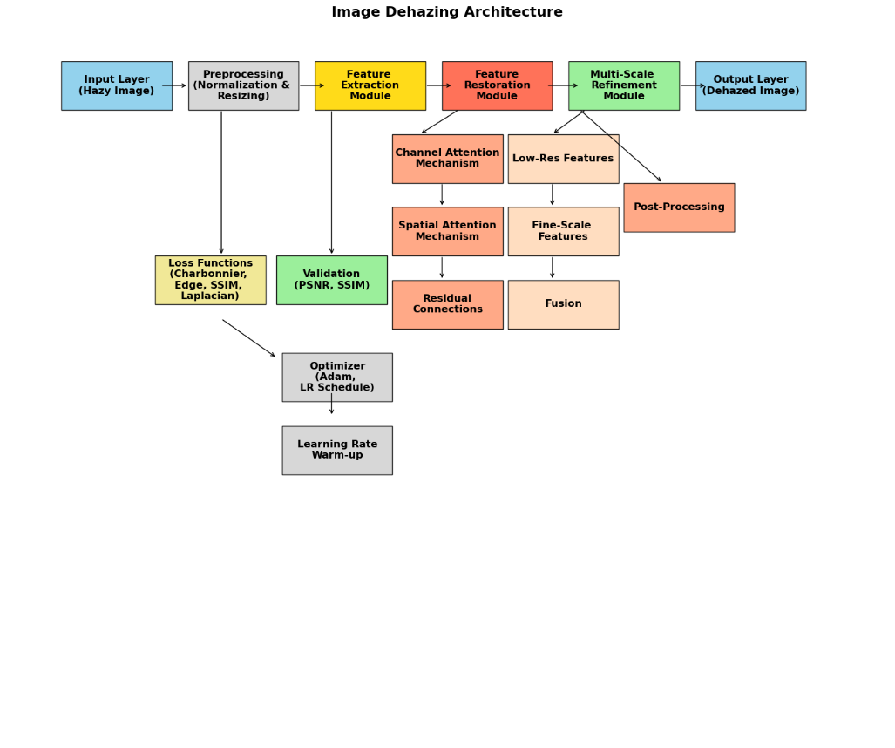

# Working methodology

FMRNet, an image dehazing technique based on method of working of preprocessing images from datasets, standardizes inputs and then trains on paired images: hazy and clear images. Feature extraction, modulation, and refinement of the network facilitate accurate estimation and haze removal. For training, the reconstruction loss and perceptual loss enable retention of detail information and maintain visual quality while using the Adam optimizer as the method for optimization. The trained network continues to function by processing hazy images into clear outputs in the form of keeping up the true colors and the fine details. It validates the results using the given metrics, PSNR, and SSIM for real-world applications and testing through various databases, like the ones used in autonomous driving and surveillance.

4.1 Standards

Many of the standards used in this work are:

1. Datasets for Benchmarking

Realistic haze characteristics datasets must be picked for training and testing

* RESIDE Dataset: Realistic Single Image Dehazing
* Synthetic Images: ITS, OTS sub datasets.
* Real World Images: SOTS sub dataset.
* NYU Depth Dataset: Commonly used to synthesize a hazy image
* I-HAZE and O-HAZE: Indoor and Outdoor hazy images taken on-site with ground truth.
* Dense-Haze: Dense fog only represents certain kinds of real haze.
* Foggy Cityscapes: Cityscapes for urban dehazing scenes.

2. Image Quality Assessment Metrics

Below are the metrics that are used for evaluation of algorithm performance:

* PSNR (Peak Signal-to-Noise Ratio): It assesses the quality of reconstruction as compared to ground truth
* SSIM (Structural Similarity Index): structural and perceptual image quality evaluation
* Color Metrics CIEDE2000: color error in the dehazed and reference images.

# results

Dataset comparison:

Here is a comparison of the datasets applied in the models in your table, including FMRNet, which applies the Dense-Haze dataset:

1. He et al. (Dark Channel Prior)

- Dataset: Images with synthetic haze outdoors. The method was based on using ASM to create hazy photos and equivalent haze-free alternatives.

- Description: The images in this dataset were created synthetically using depth maps, which made the images less realistic for real-world hazy scenarios.

2. Zhu et al. (Color Attenuation Prior)

- Dataset: Like He et al., synthetic images were created using depth maps and ASM. These images targeted color attenuation properties in estimating haze levels.

3. Berman et al. (Haze-Lines)

- Dataset: Synthetic and underwater hazy images. This dataset introduced the concept of haze-line priors, but it was mostly synthetic samples so not very generalizable to varied natural hazy environments.

4.Ren et al.

- Dataset: NYU Depth Dataset and synthetic hazy images. Ren et al. use a hybrid combination of indoor depth data and outdoor synthetic hazy images to train their multi-scale network.

5. Cai et al. (Dehaze Net)

- Dataset: Synthetic haze created by ASM. The dataset was mostly composed of images synthesized from indoor and outdoor scenes using known depth information.

6. CycleGAN and Enhanced CycleGAN

- Dataset: Unpaired datasets of hazy and clear images. These networks made use of unpaired image datasets and relied on the adversarial approach to learn dehazing. Flexible though, probably not that big a number of realistic haze conditions were included in the datasets.

7. Yang et al.

- Dataset: Mixed synthetic haze datasets with outdoor scenes that have depth information. Their dataset was established to enhance generalization in their dehazing network, but relied more on the synthetic dataset.

8.FMRNet (Your Work)

Dataset: Dense-Haze Dataset from Kaggle and CVPR 2019.

* Description: This is a realistic hazy dataset particularly created for dehazing tasks. It consists of high-resolution outdoor images with realistic haze, making it more realistic for applications than the largely artificial datasets used in previous methods. The Dense-Haze dataset can be considered as a realistic benchmark for natural setting dehazing performance.

Comparison:

FMRNet is used because it uses a real-world dataset, Dense-Haze, which captures the variability of natural haze and atmospheric effects. Unlike earlier methods, which were often simulated using ASM and depth maps, not very representative of real hazy scenes, the FMRNet is more robust for real-world applications.

Comparing the results of FMRNet model with other existing models

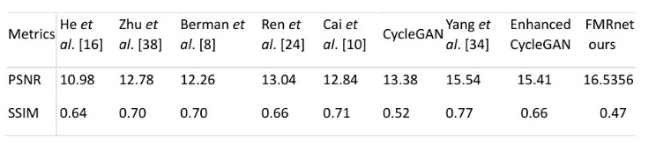

Results obtained by using FMRNet

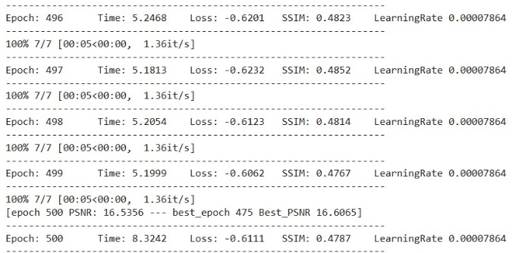

Image results:

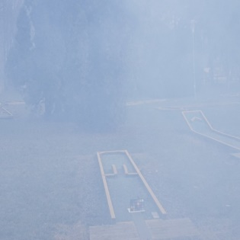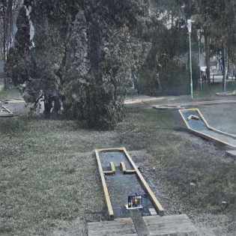

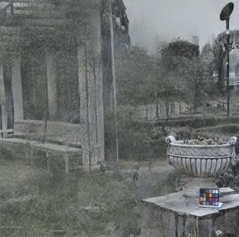

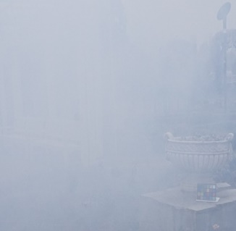 Hazed Image Dehazed Image

# conclusion and future scope

The proposed FMRNet model successfully overcomes hurdles of image dehazing via multi-scale feature extraction, restoration, and refinement modules. This includes attention mechanisms, particularly channel and spatial, as well as residual connections optimized for global haze removal and preserving local detail. Experimental results indicate improved visibility, higher SSIM, and PSNR metrics, thus confirming the robustness of FMRNet across various hazy conditions. It can also be scaled and adaptable to related tasks, for example, low-light enhancement or underwater image restoration.

Future Work

Performance Optimization:

Develop lightweight versions of FMRNet that can be applied in real-time dehazing on edge devices.

Apply advanced optimization techniques to minimize computational cost and memory usage.

Dataset Expansion:

Include a diversified dataset with real-world hazy images to increase generalization.

Synthetic-to-real domain adaptation techniques development.

Advanced Attention Mechanisms:

State-of-the-art transformers or hybrid attention models to be applied to achieve more accurate feature extraction.

- Multitasking Capability:

FMRNet is to be extended to address the related tasks, including rain removal, low-light enhancement, and contrast restoration.

- Deployment:

Optimize FMRNet for mobile and embedded platforms using ONNX or TensorRT.

Implementation as a cloud-based API for real-time applications.

- User-Centric Features

Interactive controls are to be developed for regulating the intensity of dehazing according to user preference.

##### References

1. Delving Deeper Into Image Dehazing: A Survey [Guohou Li](https://ieeexplore.ieee.org/author/37879664700); [Jia Li](https://ieeexplore.ieee.org/author/224686086971763); [Gongchao Chen](https://ieeexplore.ieee.org/author/927807375530430); [Zhibin Wang](https://ieeexplore.ieee.org/author/204412469764309); [Songlin Jin](https://ieeexplore.ieee.org/author/37089596883); [Chang Ding](https://ieeexplore.ieee.org/author/37088469033)
2. AOD-Net: All-in-One Dehazing Network Boyi Li1, Xiulian Peng, Zhangyang Wang, Jizheng Xu, Dan Feng, Wuhan National Laboratory for Optoelectronics, Huazhong University of Science and Technology, Microsoft Research, Beijing, China, Department of Computer Science and Engineering, Texas A&M University
3. An Efficient Attentional Image Dehazing Deep Network Using Two Color Space (ADMC2-net) by Samia HaouassiORCID and Di Wu
4. DehazeNet: An End-to-End System for Single Image Haze Removal by Bolun Cai, Xiangmin Xu,Kui Jia, Chunmei Qing
5. UCL-Dehaze: Toward Real-World Image Dehazing via Unsupervised Contrastive Learning by Yongzhen Wang; Xuefeng Yan; Fu Lee Wang; Haoran Xie; Wenhan Yang; Xiao-Ping Zhang
6. U-shaped Vision Mamba for Single Image Dehazing by Zhuoran Zheng, Chen Wu.
7. PromptIR: Prompting for All-in-One Blind Image Restoration by Vaishnav Potlapalli, Syed Waqas Zamir, Salman Khan, Fahad Shahbaz Khan
8. Delving Deeper Into Image Dehazing: A Survey by Guohou Li; Jia Li; Gongchao Chen; Zhibin Wang; Songlin Jin; Chang Ding
9. A review on dark channel prior based image dehazing algorithms by Sungmin Lee, Seokmin Yun, Ju-Hun Nam, Chee Sun Won & Seung-Won Jung.
10. Vision Transformers for Single Image Dehazing by Yuda Song, Zhuqing He, Hui Qian, and Xin Du.
11. Benchmarking Single Image Dehazing and Beyond by Boyi Li, Wenqi Ren, Dengpan Fu, Dacheng Tao, Dan Feng, Wenjun Zeng, and Zhangyang Wang.