Design of Automatic Irrigation system for yield production using sprinkler in context of Ethiopia
Mr.Begna Asirat Negash^{,1,} , Prof. Yanqiu Che^{,1,} and Prof. Jing Mi ^{,1,}
¹Tianjin University of Technology and Education, Dagu South Road, Hexi District,, Tianjin, China
²School of Automation and Electrical Engineering, Tianjin University of Technology and Education, Tianjin, China
asratneg12@gmail.com
yqche@126.com
1441813046@qq.com

Abstract—Ethiopia is a country with an economy mainly based on agriculture and it has a total arable land of 379,030.00 square kilometer (33.56 %) ^{[2]}. Moreover, the agriculture sector employs more than 80% of the population. However, since the agriculture is mainly traditional and rain based, the crop yield is not enough to achieve food security. Therefore, improving the traditional rain feed agriculture to irrigation based modern system is a critical need. Teff and Wheat is well known crop in Ethiopia for food. Hence Design and construction of Automatic Irrigation system for Teff and wheat by using rotary sprinkler is an immediate necessity for Ethiopian agriculture.
This project deals with system design and implementation of moisture based automatic irrigation system. The control system is done using embedded Assembly programming language and AVR Software. The irrigation system considered is sprinkler based because whet and Teff is very compact seed. For the design of the irrigation system, a YL-69 moisture sensor and 8 bit ATMEL microcontroller ATMEGA 32 are considered. The current status of system is displayed on an LCD screen.
The overall system provides flexibility & accuracy in terms of the operation of sprinkler water pipe lines and water usage as un-planned usage of water is avoided. This is so because the microcontroller decides when the pump should be turned on/off. This allows the farmer to apply the right amount of water at the right time, regardless of the availability of the labor to turn valves or motor ON & OFF. The simulation results show that the irrigation control system improves crop performances and help saving time in all aspects.
Keywords: - Automation, Irrigation, Microcontroller, YL-69 Moisture sensor and AVR Software.
- Introduction
The Federal Democratic Republic of Ethiopia is a landlocked (cannot access/use the river) us of a within side the Horn of Africa. Ethiopia shares borders with Eritrea and Djibouti to the North, Somalia to the East and Northeast, Kenya to the South, South Sudan to the West, and Sudan to the Northwest. Ethiopia has a total area of 1,130,000 Km². From this nearly 34 %( 38.5 million hectares) are used for agriculture ^{[1]}.
Most of Ethiopian people lives in highland areas, which 85 percent being rural and dependent on agriculture with a low level of productivity and the rest lives lowland area^{.[( 3; 4; 5)]}. The economy of Ethiopia is mainly depending upon Agriculture. ^{[(6; 7)]}. My country is endowed with ample water resources with 12 river basins with an annual runoff volume of 122 Billion m³ of water and an estimated 2.6 - 2.65 Billion m3 of groundwater potential ^{[8]}. But still now our agriculture is based on Traditional and there is high scarcity of food. Because of this traditional agricultural system enough yields production (Teff and wheat are mostly used for food in Ethiopia) is not produced and countries economy is not developed. Many countries, especially eastern Africa’s countries like Djibouti, Somalia, Eritrea, and Ethiopia’s food is from Teff and wheat (Enjera is made from Teff and wheat). Especially Ethiopian people food is from Teff and wheat which is based on traditional agricultural method. Due to this traditional agricultural method enough productivity is not obtained.
So to continuous increasing demand of food requires the rapid improvement in food production technology. In a rustic like Ethiopia, wherein the financial system is in particular primarily based totally on agriculture and the climatic conditions are isotropic and still we are not able to make full usage of agricultural resources. The main reason is the our agriculture is traditional based. Another very important reason of this is due to unplanned use of water which a significant amount of water goes waste. In the modern sprinkler irrigation systems, the most significant advantage of sprinkler irrigation is a method of applying irrigation water which is similar to natural rainfall. Water is distributed through a system of pipes usually by pumping see the changes per requirement to which a large quantity of water is saved. At the present era, the farmers have been using irrigation technique in our country through the manual control in which the farmers irrigate the land at the regular intervals. This process consumes more water or sometimes the water reaches late due to which the crops get dried. Water deficiency can be detrimental to plants before visible lifeless occurs. Slowed boom rate, lighter weight fruit follows moderate water deficiency. This problem can be perfectly rectified if we use automatic micro controller based sprinkler irrigation system in which the irrigation will take place only when there will be intense requirement of water.
Soil moisture sensor is used to turn irrigation system ON and OFF. These valves may be easily automated by using Micro controllers and soil moisture sensor. Automating farm irrigation allows farmers to apply the right amount of water at the right time, regardless of the availability of labor to turn valves on and off. In addition, farmers using automation materials are able to reduce runoff from over watering saturated soils, avoid irrigating at the wrong time of day, which will improve crop performance by ensuring adequate water and nutrients when needed. The system also helps in time saving, removal of human error in adjusting available soil moisture
- DESIGN METHOD
There are many types of Designing and Construction of Irrigation Systems. The conventional irrigation methods like the level basin method, furrow irrigation method, and basin irrigation method which supply an un-proportioned level of water and results excessive wastage of water. The whole soil surface is saturated and often stays wet long after irrigation system is completed. The level basin type methods consume large amounts of water and the area between crop rows remains dry and receives moisture only from incidental rainfall.
Sprinkler irrigation method is a method of applying irrigation water to the field which is similar to natural rainfall. Water is distributed through a system of pipes usually by motor pumping. Then it is spread into the air through sprinklers so that it breaks up into small water drops that fall into the ground. The pump supply system and operating condition must be designed to enable a uniform application of water distribution. Generally experimental design method is used to construct the system
  - Block Diagram
LCD Display 16x2
ATMEGA32
Microcontroller
Relay
Soil Moisture
Sensor
AC Motor
Regulated Power Supply

Figure2.1. Block Diagram Automated Irrigation system
- System Design
The overall automated irrigation system for yield production is designed and simulated in Proteus professional 8.5 Simulation software ^{[9]}. Figure 3.1.shows that the overall construction of automated irrigation system for yield production in Proteus professional 8.5 software.
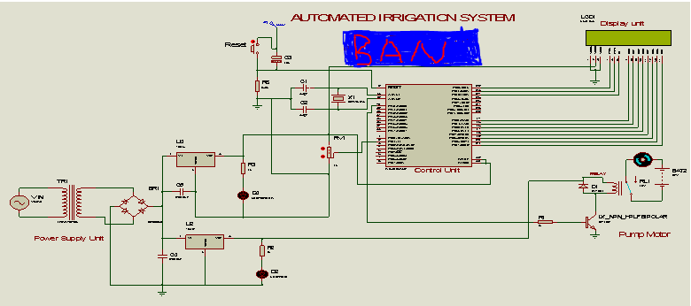
Figure3.1. overall System design

- RESULT AND DISCUSSION
  - Result
The automated irrigation system is designed and simulated in Proteus professional 8.5 Simulation software. Figure 4.1.shows that overall design of automated irrigation system for yield production in Proteus professional 8.5 software and ready for simulation and change it to hardware for end users.
Figure4.1. Overall system design
Figure4.2.Shows when the soil is dry the sensor sends signal to microcontroller ATMEGA 32 and it sends signal to the actuator to run the motor automatically go into ON state and the LCD displays IRRIGATION ON as shown in Figure4.2. Now sprinkler starts to fetch water to the crop.
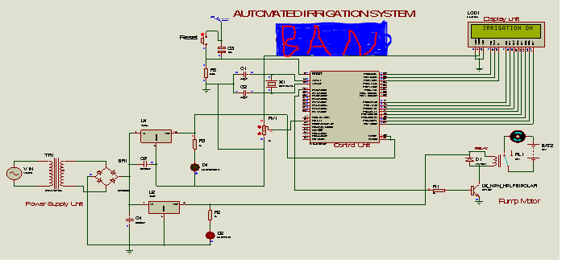
Figure4.2. Motor in ON state
Figure 4.3.shows when the soil get enough water, the sensor sends signal to microcontroller ATMEGA 32 and it sends signal to the actuator stop the motor automatically go into OFF state and the LCD displays IRRIGATION OFF.
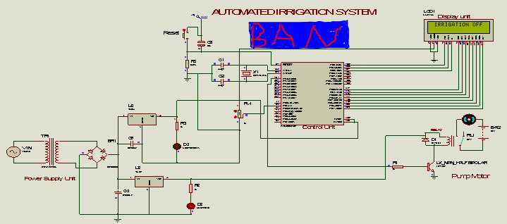
Figure4.3 Motor in OFF state.

4.2. Discussion
In this work, the microcontroller ATMEGA 32 for the design and construction of an automated irrigation system, with feedback, having passed the necessary tests with the other components interfaced with it is hereby presented. With this implemented system, it is possible to monitor the irrigation system in which the soil moisture sensor send an analog signal to the microcontroller (ATMEGA32) then it sends digital signal to the motor and LCD to switch on the water pump when the soil is dry and switch off the same pump when the soil is wet without any need for human intervention. By so doing, the occurrence of water wastage is eliminated. As already highlighted in the previous sections, the microcontroller (ATMEGA32) is the heart of this project work, as all the control signals pass through and are processed by the microcontroller. The LCD was interfaced to the microcontroller in order to show the status of the Irrigation system as it operates. The LCD data port is connected to the port C and D of the microcontroller (ATMEGA32) and through this port the microcontroller is able to send information or instruction codes to the LCD and in the same way read the contents of the LCD’s internal registers. The microcontroller (ATMEGA32) then processes the data received and uses it to control the pump based on the written flow or control algorithm stored in its ROM. The simulated software algorithm began with flow-chart and finally the assembly language program, which is converted to its machine code HEX file by using AVR software and written to the microcontroller’s internal Read Only Memory(ROM) for the appropriate monitoring of the device.
- Conclusion
In Ethiopia, Irrigation Systems are not yet automated system because of a lack of collaboration between the agriculture industry and other technologically, understanding of industries, as well as an inaccurate perception of the industry in general. Automated Irrigation Systems work by continuously monitoring the soil moisture content and activating the actuator to on the motor when the moisture level of soil drops below the minimum threshold for the cultivated crop, causing the land to be irrigated and deactivates the actuator by sending signal to Microcontroller ATMEGA 32 and when the moisture level rises above the maximum threshold, the system deactivates the irrigation system
Designed Automated Irrigation system was found to be working satisfactorily, although some improvements on its performance are still possible. Since the project was a feasibility study, it provided sufficient information for further project in this area, despite limited implementation time. The sap float measurements had been determined to be a likely indicator for triggering irrigation. The Microcontroller based sprinkler irrigation system proves to be a real time feedback control system which monitors and controls all the activities of sprinkler irrigation system efficiently.

ACKNOWLEDGEMENTS
In the name of greatest All mighty GOD who has always bless us with potential knowledge and success. It gives us great pleasure in presenting the project paper of “Design of Automatic Irrigation system for yield production in context of Ethiopia”
Also I would like to thank my families, friends and individuals who directly or indirectly contributed to the completion of this project.

References
[1]. World Bank “data collection of development indicators”, 2021
[2]. HYPERLINK "http://ethiopia.opendataforafrica.org/howisde/ethiopia-fao-stat-land-use-and-agricultural-inputs" http://ethiopia.opendataforafrica.org/howisde/ethiopia-fao-stat-land-use-and-agricultural-inputs ,Accessed 19,June, 2017
[3]. Awulachew SB, Yilma A, Loulseged D, Loiskandl W, Ayana M, Alamirew T, “Water Resources and Irrigation Development in Ethiopia”. Colombo, Sri Lanka: International Water Management Institute. pp. 78, 2007.
[4]. MoA. “Natural Resources Management Directorates. Small-Scale Irrigation Situation Analysis and Capacity Needs Assessment”, Addis Ababa, Ethiopia. 2011a.
[5]. Bekele Y, Nata T, Bheemalingswara K ”Preliminary Study on the Impact of Water Quality and Irrigation Practices on Soil Salinity and Crop Production, Gergera Watershed, Atsbi-Wonberta, Tigray, Northern Ethiopia”, MEJS. 4(1): 29-46. 2012.
[6].World Bank (Ethiopia: “Managing water resources to maximize sustainable growth”. A World Bank water resources assistance strategy for Ethiopia. The World Bank Agriculture and Rural Development Department. Report No. 36000-ET. Washington, DC, USA. 2006).
[7]. Makombe G, Namara R, Hagos F, Awulachew SB, Ayana M, Bossio D “A comparative analysis of the technical efficiency of rain-fed and smallholder irrigation in Ethiopia”. Colombo, Sri Lanka: International Water Management Institute. pp. 37, 2011.
[8].MoA. “Natural Resources Management Directorates. Small-Scale Irrigation Situation Analysis and Capacity Needs Assessment”, Addis Ababa, Ethiopia. 2011a.
[9]. Begna Asirat Negash, Yanqiu Che, Design and Simulation of Vehicle Engine Lock System by Alcohol Detection Sensor for Ethiopia Driver. Journal of Control, Measurement & Instrumentation (2023) Vol. 1: 1-6. DOI: http://dx.doi.org/10.23977/jcmi.2023.010101.

