**ROBOTIC VEHICLE CONTROLLED BY HAND GESTURE USING PIC MICROCONTROLLER : A Review**

1JAGTAP TRUPTI , 2JADHAV SWAPNIL , 3NIGADE SAKSHI , 4SABALE SNEHAL

VPKBIET , Baramati

truptirjagtap2606@gmail.com , swapniljadhav8826@gmail.com,

sakshinigade36@gmail.com , snehalsabale183@gmail.com.

*Abtract* —In everyday life, people use remote controls or joysticks to operate robotic devices, vehicles, or machines. However, these methods can be challenging for individuals with disabilities or in situations where hands-free control is more practical, like in industrial or entertainment environments.

This project uses hand gesture recognition to control a robotic vehicle without the need for traditional controllers. A PIC microcontroller processes data from sensors (like accelerometers or gyroscopes) to detect gestures such as moving the hand forward, backward, or turning. These gestures are then translated into corresponding vehicle actions, such as moving forward, backward, or turning. The goal is to offer a hands-free, intuitive, and accessible way to control robotic devices, making it easier for everyone, including people with disabilities, to interact with technology.Top of Form

1. **INTRODUCTION**

Hand gesture-operated robot car is largely beneficial to the disabled person, as the individual with hand gesture moves in the direction he wants without needing to press any buttons. This system has a hand glove with a receiver circuit that will be placed on top with Atmega microcontroller which is interfaced to the accelerometer and is to be worn by the user while using this machine. The vehicle's circuit has RF receiver, Driver IC and microcontroller to power the motors. The instructions received by a IC on the circuit are forwarded to the RF transmitter which forwards the instruction to the RF receiver. The command of the RF receiver is then forwarded to the microcontroller which decodes command and controls the vehicle in the direction specified by the paritcular user.

Bottom of Form

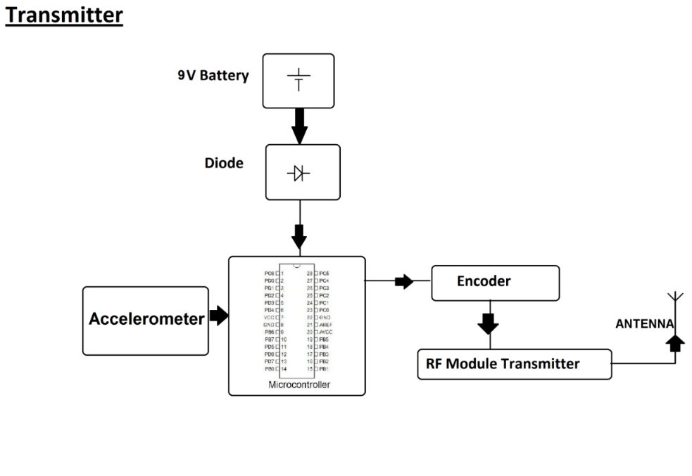

**Fig.No. : 1 Block Diagram of Transmitter System**

This is a block diagram of a wireless sensor system that transmits data using an RF module. Below is an explanation of each block:

1. **9V Battery** **:**Primary power supply is provided for a circuit. It ensures that all components receive the necessary voltage for operating.
2. **Diode** **:** Prevents reverse polarity, ensuring that the circuit does not get damaged if the battery is connected incorrectly.It allows current to flow only in one direction, protecting the microcontroller and other components.
3. **Microcontroller :** Acts as the central processing unit of the system.Receives input from the accelerometer and processes the data.Controls the communication between different components, including the encoder and RF transmitter.
4. **Accelerometer :** Measures acceleration and motion in different directions. Sends the data to the microcontroller for processing.
5. **Encoder :** Converts parallel data from the microcontroller into a serial format. Ensures that the data can be efficiently transmitted over the RF module.
6. **RF Module :** Transmitter:Sends the encoded data wirelessly to a receiver using radio frequency. Works with the antenna to transmit signals over a specific range.
7. **Antenna :** Enhances the transmission of RF signals. Ensures the signal reaches the intended receiver with minimal loss.

This system is typically used for wireless motion detection applications, remote monitoring, or control systems.

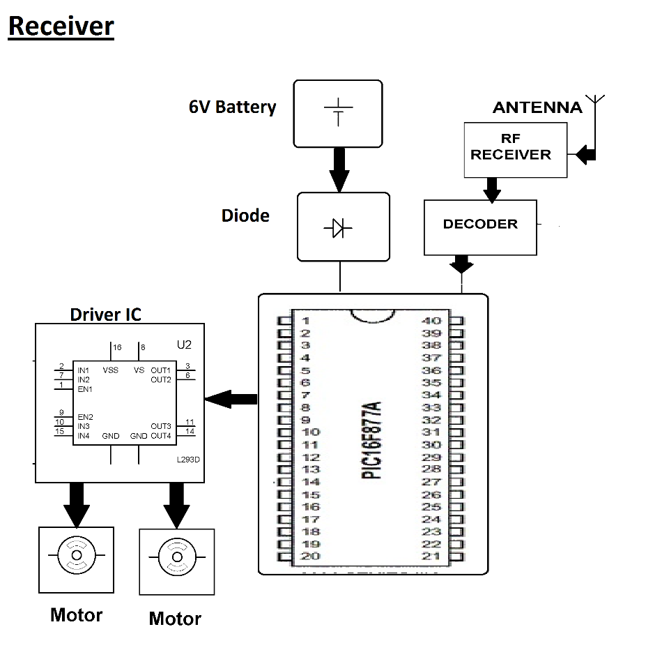

**Fig.No. : 2 Block Diagram of Receiver System.**

This is a block diagram of a wireless motor control system using an RF receiver and a microcontroller. Below is a breakdown of each block:

1. **6V Battery :** Provides power to the entire system, including the microcontroller, RF receiver, decoder, and motor driver.
2. **Diode :** Prevents reverse polarity connections, protecting the circuit from damage. Ensures that current flows in the correct direction.
3. **Antenna :** Captures the RF signal transmitted from the remote control unit. Enhances wireless communication for data reception.
4. **RF Receiver :** Receives the radio frequency signals transmitted by the RF transmitter. Converts the received signal into a format that can be processed by the decoder.
5. **Decoder :** Decodes the received RF signals and extracts the control signals. Sends the extracted data to the microcontroller for further processing.
6. **Microcontroller (PIC16F877A)** : Acts as the central processing unit of the system. Receives decoded signals and processes them to control the motor operation. Sends control signals to the motor driver based on received input.
7. **Driver IC (L293D or L298) :** Acts as interface between the microcontroller and motors. Amplifies low-power control signals from the microcontroller to drive the motors. Allows bidirectional motor control (forward and reverse motion).
8. **Motors :** Represent the actuators of the system. Perform motion-based on the signals received from the motor driver.

The system wirelessly receives control signals via an RF receiver and processes them through a decoder, which provides the data to the PIC16F877A microcontroller . The microcontroller interprets the signals and controls the motor driver IC, which then powers the motors for movement. A 6V battery supplies power, with a diode ensuring circuit protection. This setup is commonly used for wireless robot control and automation application.

1. **PROS AND CONS**

**PROS :**

**1 ]** **Intuitive Control :** Hand gesture control provides a more natural and intuitive method of controlling a robotic vehicle compared to traditional methods like joysticks or buttons. Users can control the vehicle just by moving their hand.

**2 ]** **Wireless Operation :** This system often utilizes wireless communication (e.g., Bluetooth or RF), which allows the user to control vehicle from the distance, enhancing flexibility and convenience.

**3 ]** **Enhanced User Experience :** The gesture-based interface creates an interactive and futuristic user experience. It’s a more immersive way to control devices and can increase the engagement of the user.

**4 ]** **Simpler Interface :** Compared to complex button-based controls, the hand gesture system simplifies the interface. There’s no need for physical controllers, reducing the number of parts and components.

**5 ] Cost-Effective with PIC Microcontroller :** The use of a PIC microcontroller makes the project cost-effective. PICs are inexpensive, readily available, and easier to integrate with various sensors, making them ideal choice for such projects.

**6 ] Potential for Multiple Applications :** This control system can be extended for various applications, such as in healthcare for controlling assistive devices, in industrial robotics, and in entertainment technologies (e.g., gaming or simulation).

**CONS :**

**1 ] Environmental Sensitivity :** External environmental factors such as poor lighting, noise, or interference can impact the performance of the gesture recognition system, making the system less reliable in certain conditions.

**2 ] Complex Calibration :** The system may require periodic calibration to ensure accurate gesture tracking. Any deviation in the setup can result in faulty operation or difficulty in recognizing gestures.

**3 ] Energy Consumption :** Wireless communication (e.g., Bluetooth) and gesture recognition sensors might consume more power than traditional wired systems, potentially reducing the efficiency and battery life of the robot.

1. **CONCLUSION**

This wireless motor control system efficiently enables remote operation using RF communication. By integrating and RF receiver, decoder, motor driver and microcontroller, the system ensures reliable signal processing and precise motor control. The use of battery-powered setup with circuit protection enhances portability and safety. This project is ideal for applications such as wireless robotics, remote vehicle control & automation, offering a cost-effective and practical solution for wireless motion control.

1. **REFERENCES**

[1] B. Keerthikhaa Shree, K.Mohana Varsha,D.Subbulekshmi,“Design of Hand Gesture Controlled Robot using Arduino”, IEEE , August 2024.

[2] Yash Nayak, Dhanashree Wadaye Vishal Yadav, Savita Kulkarni and Maithili Shelar, "Gesture- controlled surveillance car", International Journal for Research in Applied Science & Engineering Technology (IJRASET), vol. 11, 2023.

[3] Bansuri Ubadhyay, Abhyudaya Anurag, Balabheem, Balwant Kumar Singh, Himabindu N “Voice and hand gesture controlled robotic vehicle” , INFORMS, vol .19, ISBN: 1551-7616, Aug 2022.

[4] Olusola Abayomi-Alli, Modupe Odusami, Olaoluwa Oseni, RobertasK, Misra. “Robotics vehicle system using simple hand gesture”,SAE ISBN : 978-3-030-76735-8, ISBN : 2194-5357, Jun 2021.

[5] Asari Radha, Sima Chavda, Prajapati Hina, Ronak Patel, Nikita Makvana, “Hand Motion Control Robotic Vehicle",INFORMS, ISSN: 2347-4718, April 2021.

[6] AC Ramachandra, B Karunakar Rai and Suruchi Poddar, "Hand gesture controlled roboT", International journal of Creative Research Thoughts, vol. 8, 2020.

[7] P. Gopi, R. Palanisamy , M. Arun Noyal Doss, A. Esakkipandi, K. Selvakumar,”Gesture recognition vehicle using PIC microcontroller”, ASME, v19, ISBM:2502-4752, July 2020.

[8] Kaushal, Morbale Jyoti, Tanvi, Kaushal, Kamal, Patil Mangal, “ Robotic vehicle controlled by hand gesture using PIC”, ASME, ISBN :2454-356X, June 2019.

[9] U.Rajkanna, M.Mathankumar, K.gunasekaran, “Hand gesture based mobile robot control using PIC microcontroller”, Springer,Mar 2019.

[10] K. Selvakumar, R. Palanisamy, "Wireless Gesture Control of Robots Using Accelerometer and PIC Microcontroller", 2019.

[11] B.A. Kumar, Saurabh B.Patil, Parab, Sanika Kinalekar, Rohit Chavan , “ A hand gesture based wheelchair for physically handicapped person with emergency alert system ”, IET ,2019.

[12] A. Kumar, S. Agarwal, R. Sharma, "Gesture Recognition for Robot Control Using PIC Microcontroller", Springer,2018.

[13] Hasib Ahmed Prince ,Enamul Hasan Rozin, Khokan Chandra Sazaal, Md. Walid, “ Gesture Controlled wireless Robotic Hand”, IET , June 2018.

[14] Poonam Patil, Sagar Bhagat, Omkar Patil,Badar Shaikh and Vrushab Sakpal, "hand gesture controlled robot using arduino", International Journal of recent trends in Engineering and Research, vol. 3, 2018.

[15]Suryarajsinh T. Vala, "Hand gesture controlled robot using arduino", International Journal of Research In Enginnering Science and Management, vol. 1, 2018.

[16] Jawalekar Prajwal Ashwin , “Robot control by using human hand gestures” International Research Journal of Engineering and Technology, Jan 2018.

[17] Mudit Gupta, Deepesh Darmwal, Deepesh Tewari and A P Cheema, "Study of hand gesture recognition based controlled vehicle", International Journal on Emerging Technologies, vol. 8, Jan 2017.

[18] Rehan Vijay Jain, Deepanshu Dev Bhardwaj, Prateek Gupta, “Gesture Controlled Mobile Robotic Arm Vehicle Using Accelerometer”, IET,ISSN: 2395 -0056 Volume: 04, April 2017.

[19] Tanbir Bakth Nabil, Md.Abu Bakkar Chiddik, Mir Gulam Mohin Uddin , Emad Uddin Ahmed, “Robotic Vehicle Can Be Controlled Using Hand Gesture”, MDPI, ISSN (Online): 2347-3878 Volume 3 , March 2015.

[20] Mu-Chun Su, Xing-Han Wu and Pa-Chun Wang, "A hand gesture based control interface for a car robot", IEEE/RSJ International Conference on Intelligent Robots and Systems, no. 10, Jan 2010.