Smart Home Automatic Sliding Window Using IOT.

Prof. Varsha Dange1, Veersing Pardeshi2, Yash Tadge3, Sohan Bachhav4, Om Kanade5.

1*Assistant Professor Dept. of Mechanical Engineering, Vishvakarma Institute of technology, Pune Maharashtra.*

*2,3,4,5 Student, Dept, Of Mechanical Engineering, Vishvakarma Institute of Technology, Pune Maharashtra.*

1. **ABSTRACT**

Technology has continued to advance quickly in the twenty-first century and has found greater uses in a variety of areas of life, particularly in the management and observation of processes. The automatic sliding window is an example of how controls and appliances have been automated. Automation does reduce human life's stress, which is what engineering as a subject seeks to do. The fundamental goal of the automated sliding window's design was to use sensors to programmed the window's behavior so that it would change periodically depending on the surroundings. This research provides a thorough explanation of the approach, design, implementation, and testing of the system.

**Key words**: automation, technology, control, sliding window

1. **INTRODUCTION**

Automation is the use of different control methods to operate machinery with little or no human involvement [1]. The nineteenth century saw a rise in its popularity after it first appeared in the late eighteenth century [2]. The substantial global study and investigation is due to its numerous benefits over the social or physical functioning of any equipment. It has become vital to include these elements in the design of doors and windows as technology finds numerous uses in the control, automation, and monitoring of numerous equipment [3]. In a few projects, the automated control of windows has been developed. Nevertheless, it has not yet been fully incorporated into society, in contrast to automated doors, which are utilized in practically every area on the planet [5].

Making a tiny hole in a building's wall and covering it with animal hide to keep out undesired things and bad weather gave rise to the idea of having windows [6].

This was unsafe for the locals and ineffective because it could not stop the rain. The size, form, and materials used to make thewindows, as well as the frame that holds them up, have all changed over time [7]. Windows have beenmade from a variety of materials, such as papers, wood, vinyl, steel, aluminum, stained glass, and clear glass [8]. When animal skin started to fail andslowly developed into the subsequent components, the first materials described were utilized.

The frames were also made of steel, fiberglass, aluminum, etc., but aluminum has shown out to bea better material overall since it is less expensive and has a higher corrosion resistance [9]. In this project, automation is used to regulate the window'sopening and shutting times based on the weather [10].

1. **LITERATURE REVIEW**

In the window to this paper, automation applied to Control the opening and dosing time Concerning weather condition.

system design-Hardware component- Temperature Sensor, Rain Sensor, micro controller .H-bridge driver, Lcd and motor, LED Display [1].

Software implementation: Arduino can be Programmed with a range of Coding language such as C, C+, C++.Implementation- framework, Electrical circuity, driving mechanism, Vero board and soldering, microcontroller programming system test [2]. These situations needed ignoring Vary from where the need the atmospheric conditioner is to use the air Conditioner, and so on. The remote will close the window or open it to suit the taste of the user.

The system under consideration facilitates the detection of leaks and the presence of hazardous gases like carbon monoxide, carbon dioxide, and LPG within an enclosed environment. Moreover, the system is capable of responding to ambient conditions surrounding the enclosed facility. It can even identify weather patterns such as rain, sunlight, and high temperatures [3]. The system

alerts users to triggers and takes actions based on air quality measures. It relies on sensor data for air quality monitoring. When hazardous gases are detected, the system enacts vital responses. These actions encompass automatic window control, powering exhaust fans, sounding alarms, and sending mobile alerts. Users can access sensor data and choose manual or automatic modes. In manual mode, users have window control. Beyond safety, it enhances comfort and finds applications in homes, industries, and mining [4].

This paper is useful for detect the leakages of harmful gases like liquefied petroleum gas, carbon monoxide, and dioxide in closed system. With the help of IoT gadgets it can detect variables like rain, sunlight, time of day or night, harmful gases and ask owner to open or close particular window and shows the reason behind that notification. When someone gets alert then that person also able to open close window, on/off exhaust fans, etc. This system is very helpful because of its preventive alterations system that prevent big accident [5].

This paper describes the design, construction, and application of a home automation system that uses internet services to control home appliances. The automation allows the system's environmental conditions to determine the switching states in addition to allowing users to command changes in the states of connected appliances [6]. The system has two working modes: automatic and manual. When the system is in automatic mode, the microcontroller reads information from the light- dependent resistor to determine ambient light levels, checks the PIR sensor [7] to see if a person is in the room to determine whether to turn on or off the interior lighting, and receives temperature information from the temperature sensor to control the fan's speed.

The windows design has varied continuously in the shape. Size and materials Used for its Construction and the frame used to support it most common material Used for windows I frame is fiber, steel & aluminum [9].

These systems usually have a system for detecting and actuator layers made up of sensors, such as webcams for security monitoring, temperature sensors, passive infrared sensors (also known as

motion sensors), and smoke sensors. Similar to connected appliances as well as additional IoT devices, these sensors connect to the World Wide Web via a home gateway [10]. This article describes the development of a low-cost smart door sensor that may notify users of door opening occurrences at their homes or places of business via an Android application. The Raspberry Pi 2 board and the Arduino-compatible Eligo Mega 2560 microcontroller board are used in the suggested design. These components are integrated into the architecture to connect to a web server employing a RESTful API. The system's implementation and its subsequent applications involve the utilization of multiple programming languages [11].

# OBJECTIVE OF PROJECT.

The objective of the project is to design and develop a smart automatic sliding window using IoT technology, which will allow remote control and monitoring of the window's operation. The project aims to enhance convenience, safety, and energy efficiency by automating the opening and closing of the window based on user preferences, environmental conditions, and. The project will also explore the integration of sensors and mechanisms to enable the window to react to changes in the surroundings, such as temperature and rain. The ultimate goal of the project is to provide a cost- effective and reliable solution for smart home automation, promoting sustainable living and reducing energy consumption.

# METHODOLOGY

**Designing the System**: The first stage is to create the smart automated sliding window system. This will entail choosing the right components, such as the rain sensor, temperature sensor, and sliding mechanism. The system should also be built to be energy efficient and cost effective.

**Programming the Microcontroller**: The next step is to programmed the microcontroller that will control the operation of the window. The microcontroller should be programmed to read the rain and temperature sensors and operate the motor to open or close the window as needed.

**Installation of Sensors:** Rain sensor and temperature sensor should be mounted on the window frame in an appropriate location. The rain sensor detects rainfall and closes the window, whereas the temperature sensor detects changes in temperature and opens or closes the window based on pre-set temperature thresholds.

**Installing the sliding Mechanism:** The sliding mechanism should be installed on the window frame, allowing it to move the window sash smoothly and safely.

**Connecting to the IoT**: To enable remote control and monitoring, the smart automated sliding window system needs be linked to the internet of things (IoT). Connecting the microcontroller to a Bluetooth module and configuring the system to interact with a smartphone app will be required.

**Testing and Calibration:** The system's operation is then tested, and the sensors are calibrated to guarantee precise detection and reaction to environmental conditions. To guarantee dependable functioning, the system should be tested in a variety of settings, such as varied rain and temperature ranges.

# HARDWARE COMPONENTS

1. Temperature sensor- lm35
2. Water/ rain sensor
3. Bluetooth module HC05
4. Arduino Uno
5. Rectifier using diodes
6. Capacitor filter
7. Regulator 5V 7805
8. Microcontroller
9. Led, resistors
10. DC motor
11. Wires, reset switch
12. 2 Power supply 12V 2A

# SOFTWARE REQUIRED

1. Arduino 1.8.16
2. Bluetooth Application

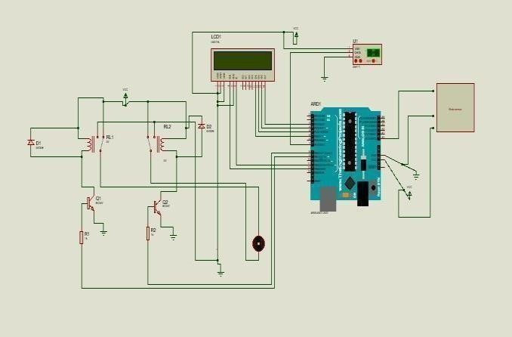Figure 6.1- Circuit Diagram of proposed model.

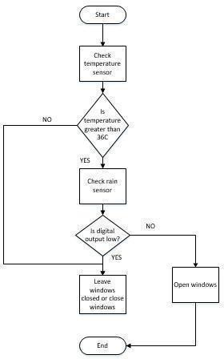

Figure 6.2 - Flowchart showing the control process of an automatic sliding window

Table 6.1: Various switching configurations and the result on a motor

|  |
| --- |
|  |
| sensor1 Sensor2 Sensor3 Sensor4 Result |
| 1 1 0 0 Stop Motor (Brake) |
| 1 0 1 0 Burn Circuit |
| 1 0 0 1 Spin Motor forward |
| 0 1 1 0 Spin motor Backward |
| 0 1 0 1 Burn Circuit |
| 0 0 1 1 Stop the Motor (Brake) |
|  |

# Equations

**Position of the window = (I x D) + ((1 - I) x current position of the window).**

Where:

* + W: Window width (measured in meters)
  + H: Window height (measured in meters)
  + T: Time required to fully open or close the window (in seconds)
  + D: Desired position of the window (in percentage, where 0% is fully closed and 100% is fully open)
  + S: Speed of the window movement (in meters per second)
  + I: Input signal from IoT sensors (in binary, where 0 indicates no signal and 1 indicates a signal)

**Time required = (D - current position) x W x H| / (S x 100)**

Where:

* W: Window width (measured in meters)
* H: Window height (measured in meters)
* S: Speed of the window movement (in meters per second)

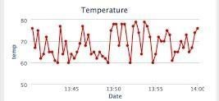

Figure 6.3 – Temperature Graph for window operation.

# SYSTEM RESULTS

To ensure the components receive the necessary voltage, the system was tested by measuring the voltage at each point of the circuit with a mustimeter. In order to guard against and confirm

that there was no element bridging, the continuity was further examined using a mustimeter. The rain sensor was put through its paces in water to simulate raindrops falling on it, and the rise in humidity was measured. The temperature increase was tracked by positioning the temperature sensor close to a heat source.

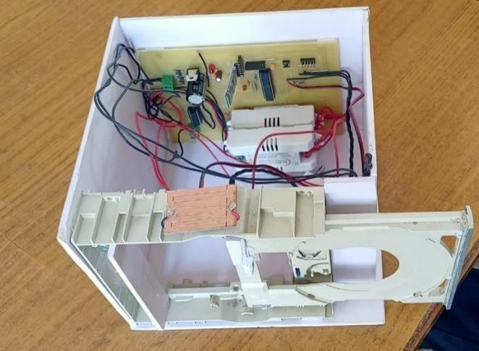

Figure 7.1- Actual system model.

* 1. **Result and discussion**

In this project two sensors are used. Which one is temperature sensor and second is rain sensor.

The function of temperature sensor is measuring the thermal conditions of its surroundings and converts this data into an electrical signal, allowing for temperature monitoring and control in various applications. In this project, when temperature raise to 36 to 40 °C then user will close the window with help of application, but if user can try to open window with help of application, then it cannot give response means cannot open. When temperature goes down to 36 °C, then application allow to open window. There is only one way if somebody wants to open window at higher temperature i.e., opening manually.

According to study, it is published that there is 24 seconds delay to sense temperature. In easy words, Temperature sensor gives response after 24 seconds after recognizing atmospheric temperature.

The second is rain sensor. The function of rain sensor is the function of a rain sensor typically involves detecting changes in the electrical conductivity or resistance caused by the presence of water.

This rain sensor works same as temperature sensor. When water detected by rain sensor user is able to close window but unable to open with help of application. The required time to sense the water by rain sensor is less than 30 seconds. And this sensor takes minimum 10-15 mins to dry sensor automatically. Generally, it depends upon the temperature, atmospheric conditions, etc.

# CONCLUSION

This work achieves the design and building of a straightforward model of an automated sliding window. The microcontroller Arduino Uno serves as the design's control component. By programming the microcontroller in C language to react to signals from various peripherals connected to it, such as rainand temperature sensors, the autonomous control is accomplished. In order to provide window opening and shutting function, a portable dc motor is also attached. For further labor, the remote control can be used for tasks that require overriding the automated process. These circumstances range from needing seclusion while disregarding the weather to needing the air conditioner, among others. The microcontroller will close the window or open it to suit the taste of the user.

# REFRENCES

1. A. Erdman, E. Nelson, J. Peterson, and J. Bowen, “TYPE AND DIMENSIONAL SYNTHESIS OF CASEMENT WINDOW MECHANISMS, “American Society of Mechanical Engineers (Paper), 1980.
2. H.−W. Chen, J.−H. Lee, B.−Y. Lin, S. Chen, and S.−T. Wu, “Liquid crystal display and organic light− emitting diode display: present status and future perspectives, “light: Science & Applications, vol. 7, pp. 17168−17168, 2018.
3. B. Ross and J. Litster, “Potential function and probability distribution of a nonequilibrium system:The ballast resistor, “Physical Review A, vol. 15, p.1246, 1977.
4. D. F. Sendoya−Losada, P. T. Silva, and F. B. Marín, “REMOTE LABORATORIES USING THE TRAINING MODULEM2CI, “2006.
5. D.−K. Yang and S.−T. Wu, Jundamentals ofliquid crystal devices: John Wiley & Sons, 2014.
6. L. Iannaccone, “Vice−principal research: A window on the building, “Education and Urban Society, vol. 18, pp. 121−130, 1985.
7. T.−H. Tsien, “Raw materials for old papermaking in China, “Journal of the American Oriental Society, pp. 510−519, 1973.
8. H.−W. Chen, J.−H. Lee, B.−Y. Lin, S. Chen, and S.−T. Wu, “Liquid crystal display and organic light− emitting diode display: present status and future perspectives, “light: Science & Applications, vol. 7, pp. 17168−17168, 2018.
9. C.−F. J. Kuo and T.−L. Su, “Optimization of injection molding processing parameters for LCD

light−guide plates, “Journal of Materials Engineering and Performance, vol. 16, pp. 539−548, 2007.

1. N. D. Tan, J. Lee, M. R. Yazid, and W. A. F. W. Othman, “Mechatronic System: Automated Window Curtain using LDR, “International Journal of Engineering Creativity & Innovation, vol. 1, pp. 1−7, 2019.
2. S. Miura, T. Makino, and F. Suzuki, “Load drive circuit using flywheel diode, “ed: Google Patents, 2004.
3. N. R. Lynam, “Rain sensor mount for use in a vehicle, “ed: Google Patents, 2003.

P. A. Reddy, G. S. Prudhvi, P. S. S. Reddy, and

S. S. Ramesh, “Automatic rain sensing car wiper, “2018.

1. A. M. K. Mohd, Mohd, A., Nemer, S., “Automatic Closing Window, “unpublished graduation project, 2011.
2. S. P. Patil, J. R. Dhabuwala, and L.

S. Gunputh, A. P. Murdan, and V. Oree, “Design and implementation of a low−cost Arduino− based smart home system, “in 20t7 IEEE 9th International Conference on Communication Software and Networks (ICCSN), 2017, pp. 1491−149.