Fake News Detection Using Machine Learnin

Ms. Ruchi Sharma, Priyam Rajput , Aditya Sharma,

Faculty of Department of Computer Science, Galgotias University, Uttar Pradesh

Students of Department of Computer Science, Galgotias University, Uttar Pradesh

distinguish between false and true information.

***Abstract* –** In this digital age, where the internet is a primary source of information transfer, people increasingly rely on various online platform for news reading. With the rise of social media platforms such as Facebook, Twitter etc. News spreads to millions in mere moments. However, this has also led to a surge in fake news, which can sway public mindset, influence elections, and generate various income through misleading clickbait headlines.

This paper presents a method to detect fake news by applying machine learning algorithms, artificial intelligence, and natural language processing techniques. Our goal is to classify news articles as either real or fake and verify the credibility of the websites from which they originate**.**

Keywords: Social Media, Fake News, Classification, Machine Learning, Artificial Intelligence, Website Verification***..***

# INTRODUCTION

As society progressively interacts through online platforms, a growing number of people now seek out and read news from social media rather than traditional ways. This shift in behavior can be attributed to two main factors: (i) social media offers a more immediate and less costly way to access news compared to traditional journalism, such as newspapers or television, and (ii) social media makes it easier for individuals to share, discuss, and participate with the news. In fact, a study in 2016 showed that 62% of U.S. adults got their news from social media, up from just 49% in 2012. Today, social media surpasses television as a primary news source.

The spread of false information has serious societal impacts. Fake news can disrupt the authenticity of the news as demonstrated when some fake news stories gained more traction on social media than legitimate ones during the 2016 election. Furthermore, fake news can manipulate public perception by promoting biased and inaccurate beliefs. It has been shown that some governments have created fake social media accounts to spread disinformation and influence public.

Addressing the problem of fake news requires automated solutions, especially since the sheer volume of content makes manual fact-checking unfeasible. This paper presents a machine learning-based approach to automatically detect and flag fake news stories.

## EXISTING SYSTEM

Automatic detection of fake news has been a subject of research for several years. Rubin and colleagues, as noted in [1], proposed a hybrid methodology that integrates linguistic characteristics of a language with network analysis techniques. However, this approach may not always be applicable, as access to network information can be limited or unavailable. In [2] as discussed Rubin et al. analyzed rhetorical structures and relationships in fake and truthful news samples from NPR's "Bluff the Listener" using clustering, achieving 63% accuracy. In [3], Mihalcea and Strapparava demonstrated that deep learning can partially

Previous research has primarily concentrated on the lexical patterns of language. Fend et al. [4] utilized syntactic stylometry in their analysis, enabling the classification of deceptive texts through the identification of statistical and syntactic patterns. Text analysis serves as a crucial tool for detecting fake news, owing to the established methodologies available for text examination. Veronica Perez-Rosas et al. [5] conducted a linguistic-based classification for fake news detection, indicating that linguistic features play a more significant role in identifying fake news compared to real news. These methodologies predominantly focus on language-based analysis, which presents certain limitations [6]. To address these limitations, it is essential to integrate additional features related to the news content. By combining metadata from Google, they achieved a 3% improvement in the F1-score for a six-label classification problem.

## PROPOSED SYSTEM

The project begins with the data preprocessing phase, where we explore the use and application of various pre-built Python libraries. Leveraging these pre-existing modules provides more efficient, readable, and maintainable code compared to writing functions from scratch. Some of the key libraries utilized in this stage include Numpy, re, pandas, Nltk, sklearn, matplotlib, and others.

The data preprocessing process involves removing stopwords— words that do not contribute meaningfully to the analysis— followed by creating a DataFrame to organize the dataset. Any missing or null values in the data are replaced with empty strings, and stemming is applied to reduce words to their base forms. The dataset is then split into features and labels, after which the textual data is transformed into numerical form through vectorization. Finally, the dataset is divided into training and testing sets, allowing for proper model evaluation and training .The system can be broken down into several key modules, as outlined below:

# Input Dataset

The input consists of a dataset containing comments or news articles along with align metadata like date, source, and author. This raw dataset is unstructured and needs preprocessing before it can be used for analysis.

# Dataset Overview

The dataset used in this system consists of five key columns that provide essential information about each news article:

* + **id**: A unique identifier for each news article. This column serves as a reference and is not typically used as a feature for machine learning.
  + **title**: The title of the news article, which often provides key information about the content of the article. Titles can serve as an important feature, as fake news articles may use certain patterns or language to attract attention.
  + **author**: The author of the news article. Some fake news sources may repeatedly use the same pseudonyms or lack reputable authors, making this feature potentially informative for distinguishing real from fake news.
  + **text**: The body or content of the news article. This field may contain incomplete or noisy data, but is often the richest source of information for the model. Natural Language Processing (NLP) techniques like word embeddings, TF-IDF (Term Frequency-Inverse Document Frequency), or Bag of Words can be applied to extract meaningful features from the text.
  + **label**: The target label, which marks whether the news article is fake (1) or real (0). This is the dependent variable the system aims to predict during the learning phase.

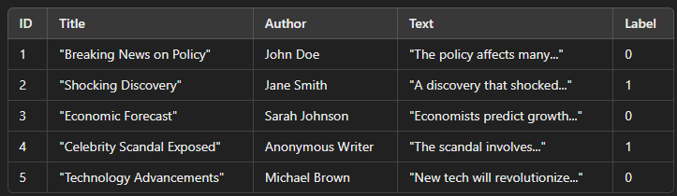

Figure 1. Dataset Overview

# Preprocessing Module

Preprocessing is a critical step that ensures the raw data is cleansed and transformed into a structured format suitable for the learning phase. The preprocessing module performs the following operations:

* + **Cleansing**: This involves removing irrelevant data such as special characters, handling missing values, and dealing with incomplete or noisy data. For example, articles with missing text might need to be flagged or handled separately.
  + **Filtering**: Unnecessary or irrelevant features that do not contribute to the learning process are filtered out. For instance, columns like ID, which only serve as unique identifiers, may not be useful for training the model and thus can be ignored.
  + **Encoding**: Categorical variables (such as the author or the source of the news article) are transformed into numerical values using techniques like one-hot encoding or label encoding, which allow the machine learning model to interpret these features effectively.

This step results in a feature-rich dataset ready for machine learning, where each news article is represented by a set of structured features (e.g., title, author, text).

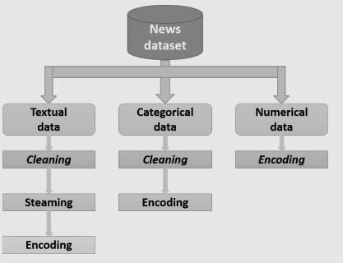

Figure 2. Preprocessing

# Dataset Splitting

The pre-processed dataset is divided into two parts:

* + **Training Set**: This portion is used to train the machine learning model, providing the algorithm with known data points (features and corresponding labels).
  + **Testing Set**: The second part is reserved for testing, which helps to evaluate the performance of the trained model.

The splitting ratio is typically set between 70%-80% for training and 20%-30% for testing, depending on the size and nature of the dataset.

# Learning Module

The core learning module employs a Logistic Regression algorithm, which is well-suited for binary classification tasks like fake news detection (where the output is either "real" or "fake"). During the training phase, the algorithm analyzes the training data and builds a decision model that attempts to predict the label (fake or real) based on the input features (title, author, text, etc.).

* + **Training Phase**: The Logistic Regression algorithm iteratively adjusts its parameters (weights assigned to different features) to minimize the error in predicting the labels. During this phase, the model "learns" patterns in the data that distinguish real news from fake news.
  + **Testing Phase**: Once the model has been trained, it is tested on the reserved test dataset to measure its accuracy. If the model performs well (achieves a high accuracy rate), it is considered a valid model and can be used for predictions on unseen data. If not, the model is refined by adjusting the parameters or employing more advanced preprocessing steps.

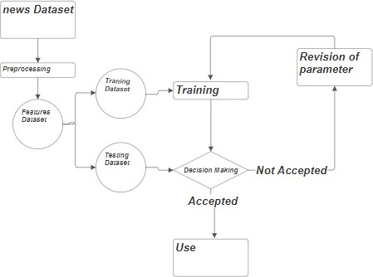

Figure 3. The proposed fake news detection system architecture’s

# Model Validation

The system continually assesses the accuracy of the decision model. If the accuracy falls below an acceptable threshold, the parameters of the logistic regression model are revisited, and the learning process is repeated. This ensures that the system adapts and improves its performance iteratively.

**RESULT**

| Metric | Value | What It Means |
| --- | --- | --- |
| Accuracy | 98% | The model correctly classified 98% of the total 4160 news articles. Excellent performance overall. |
| Precision (class 0 - real news) | 0.99 | Out of all the articles predicted as real news, 99% were actually real — very few false positives. |
| Recall (class 0) | 0.96 | The model correctly identified 96% of real news articles — a small number were missed (false negatives). |
| Precision (class 1 - fake news) | 0.97 | 97% of the articles predicted as fake were truly fake — low false positives. |
| Recall (class 1) | 0.99 | The model successfully caught 99% of fake news articles — almost none were missed. |
| F1-score (both classes) | 0.98 | F1-score is the harmonic mean of precision and recall. A 0.98 score indicates a strong balance between catching fake news and avoiding false accusations. |

**DISCUSSION**

The experimental results demonstrate that the proposed fake news detection system, built using Logistic Regression and TF-IDF feature extraction, is highly effective in classifying news articles into fake and real categories. Achieving an overall accuracy of 98% on a balanced dataset of 4160 samples indicates strong predictive performance.

A closer analysis of the performance metrics shows that the model maintained a high precision (0.99) for real news and recall (0.99) for fake news. This suggests that the system is particularly adept at correctly identifying fake news, which is essential in minimizing the spread of misinformation. The F1-score of 0.98 for both classes confirms that the model achieves a strong trade-off between precision and recall, making it suitable for real-world deployment where both false positives and false negatives must be minimized.

The confusion matrix (not shown here) would likely reveal very few misclassifications, and the near-identical support values for both classes (2077 and 2083) suggest the model benefits from a balanced dataset. This balance helps avoid bias toward one class and ensures fairness in classification.

It is also worth noting that Logistic Regression, while a relatively simple algorithm, performs remarkably well when combined with effective preprocessing and feature extraction techniques. The strong results obtained validate the hypothesis that classical machine learning models, when properly tuned and applied to clean, vectorized data, can yield competitive results even against more complex approaches.

However, the current model still operates on a bag-of-words-based feature space, which may not capture deeper linguistic or contextual meanings. As such, the system might struggle with more nuanced cases such as sarcasm, context-specific references, or articles that mix real and fake information. Future extensions could explore deep learning architectures or transformer-based models (like BERT) to address these limitations and further enhance the system’s accuracy and contextual understanding.

**CONCLUSION**

In summary, logistic regression is a powerful and well-defined machine learning tool that offers a balance between simplicity and efficiency for fake news detection. Logistic regression can classify news as true or false by converting data into digital features using methods such as TF-IDF or Bag of Word. Its binary distribution and decision-making environment make it suitable for this task, especially when the file size is small. While advanced algorithms such as deep learning can provide better performance with larger datasets and more samples, logistic regression is still an attractive option due to its lower cost and ease of use. Regularization methods such as L1 and L2 help prevent overfitting, while hyperparameter tuning ensures that the model generalizes well to new objects. Overall, logistic regression provides a solid foundation for building fake news detection, particularly the interpretation of patterns and functional significance. Further research could explore integrating logistic regression with other modelling or engineering techniques to improve performance in more complex or evolving fake news detection.

**REFERENCES**

1.V. L. Rubin, N. J. Conroy, and Y. Chen, “Automatic deception detection: Methods for finding fake news,” Proceedings of the Association for

Information Science and Technology, vol. 52, no. 1, pp. 1–4, 2015.

2.Rubin, V., Conroy, N. & Chen, Y. (2015)A. Towards News Verification: Deception Detection Methods for News Discourse. Hawaii International

Conference on System Sciences.

3.R. Mihalcea and C. Strapparava, “The lie detector: Explorations in the automatic recognition of deceptive language,” in Proceedings of the ACLIJCNLP 2009 Conference Short Papers, pp. 309–312, Association for Computational Linguistics, 2009.

4.S.Feng,R.Banerjee,andY.Choi,“Syntactic stylometry for deception detection,” in Proceedings of the 50th Annual Meeting of the Association for

Computational Linguistics: Short Papers-vol 2, pp. 171–175, Association for Computational Linguistics, 2012.

5.Verónica Pérez-Rosas, Bennett Kleinberg, Alexandra Lefevre, and Rada Mihalcea. 2017. Automatic Detection of Fake News. arXiv preprint

arXiv:1708.07104 (2017).

6.Olivieri, A., Shabani, S., Sokhn, M., &Cudré-Mauroux, P. (2019, January). Creating Task-Generic Features for Fake News Detection. In Proceedings

of the 52nd Hawaii International Conference on System Sciences.