Tax Fairness in Women Taxpayers' Non Taxable Income (PTKP) and Women's Labor Force Participation Rates
Danang Tri Wijayanto, Andini Dwi Rahayu, Daris Mujib Rachmat, Dr. Dianwicaksih Arieftiara, SE., Ak., M.Ak., CA., CSRS
2210124007@mahasiswa.upnvj.ac.id,2210124010@mahasiswa.upnvj.ac.id,2210124011@mahasiswa.upnvj.ac.id

Abstract

This research aims to analyse the fairness of tax rules for women taxpayers and their relationship to the women work participation rate. This is motivated because in Indonesia there is an imbalance in non taxable income (PTKP) regulations for women and men employees, especially in the formal sector, which in turn has an impact on the low rate of women work participation in the formal sector. The analytical method used in this study is a qualitative method, namely a literature review supported by take-home pay calculation simulation data on women formal sector employees regarding perceptions of tax fairness. This study obtained the result that there is an unfairness in the tax regulations for working women taxpayers compared to men and this is related to the lower level of women working in the formal sector compared to men, so that the work participation rate for women is lower than for men. This research is expected to contribute in the form of policy recommendations to the tax directorate general to review tax rules that accommodate tax fairness for women taxpayers, this is in line with the OECD proposal at the G20 Presidential 2022 regarding Gender- Based Taxation Policies. This is also in line with the Omnibus Law UU Number 2 of 2022 concerning Job Creation, where the Government of Indonesia has paid attention to the rights of working women and provided facilities for example in the form of maternity leave, menstrual leave, etc.

Keywords: Income Tax, Personal Exemption, One Employer, Women

INTRODUCTION
Women in the family have an important role as wives and drivers of the family economy in the broader context of the role of women in assisting Indonesia's state development and taxation. Trihusudo, 2012 states that the large contribution of women in contributing to state revenues is shown by the large role of women in the Indonesian economy, in the Medium, Small and Micro Enterprises (MSMEs) sector, 53.76% of the perpetrators are women and 97% of the workers are also women. Meanwhile, the contribution of MSMEs in the national economy is 61%. In the investment sector, the contribution of women is 60%. The development of the women workforce in Indonesia is seen from participation in the labour market, main employment opportunities, employment status, types of work and forms of protection for the women workforce through legislation. This shows that women have an important role in the economy, especially the family economy. In order to support the family economy, many women are willing to work either as full-time, part-time workers or starting their own businesses.
According to the Central Bureau of Statistics presented on CNBC Indonesia, for three consecutive years from 2021 to 2023, the number of women part-time
participants in Indonesia continues to be the largest number of participants when compared to men part-time participants. From 2021 to 2023, during the first two years, the number of women part-time workers will not change, which means that it will remain with a percentage of 37.10%, then in the third year it will increase to 37.88%. Meanwhile, the number of male participants actually continued to decrease from 20.40% to 20.36% until in the third year it reached 19.32%.
The Industrial Revolution 5.0 is a momentum that can help deconstruct the multi-layered barriers faced by Indonesian women in achieving equal rights, especially access to work, because a number of types of jobs will increase as a result of expansion in several sectors. But until now norms and socio-culture remain a barrier factor that controls women's work participation. This is coupled with a number of policies and institutions that restrict women from achieving equal rights. Nonetheless, there is still a large disparity between the men and women workforce in labour participation.
Furthermore, if we refer to the data released by the Central Bureau of Statistics on the percentage of formal workers in Indonesia in 2022, women will have a percentage of 35.57% while men will be

43.97%, where the men workforce is still more more than women even though the percentage is only 8.4%. These percentages show that overall the number of women is slightly lower than men workers' participation. The type of work done by women is also very diverse and continues to increase both in terms of the amount and type of work performed.
According to the Central Statistics Agency presented in databoks.katadata.id in 2021 as many as 28.6% of women workers in Indonesia are sales force. Then women workers who were agricultural, garden, livestock, fish, forest, and hunting workers reached 24.38%, while women who became production workers, transportation equipment operators, and manual labourers 20.51%. Furthermore, 10.48% of women workers are professionals, technicians and other personnel. Then, women workers in service business positions amounted to 8.65%. As well as a smaller number of women workers who become implementing officials, administrative staff and the like at 6.56%. Meanwhile, 0.7% of women workers are leadership and management personnel, and 0.12% of women workers are in other types of work.
At a glance, the similarity of these roles seems to illustrate the existence of equality between the rights and obligations
received between women and men. But in reality, this equality does not really work where there are still limitations on the work that can be done by women. What is most prominent is the regulation regarding PTKP as a basis for reducing the income of women workers, especially those who are married. Where the PTKP received by married women is not the same as that received by married men even though the obligations they perform as workers are the same.
Based on the phenomena that the authors describe, research is needed to see how the fairness of tax rules for women taxpayers and their relationship to the women work participation rate in Indonesia.

REVIEW OF RELATED LITERATURE
Tax FairnessTheory
In the Big Indonesian Dictionary, fairness is defined as a fair character (treatment, deed, etc.). Fair itself has the meaning of being equal, impartial, impartial. Meanwhile, taxes are defined as mandatory levies, usually in the form of money that must be paid by residents as a mandatory contribution to the state in relation to income, ownership, use and purchase price of goods. So it can be concluded that tax fairness is the nature or

action or treatment that is not arbitrary or not one-sided in the applicable taxation system.
According to Suasa, et al, 2021 one of the criteria in designing a tax system is that it is necessary to apply the principle of fairness. Tax fairness means that the taxpayer contributes a fair share of the cost of government. Tax fairness includes two things, namely vertical fairness and horizontal fairness. Vertical fairness is often explained by the phrase "a person who earns more will pay more taxes". Meanwhile, horizontal fairness is explained by the sentence "two people who have the same income will pay taxes in the same amount". Vertical fairness is viewed from the subject (people who pay taxes) while horizontal fairness is seen from the aspect of the object.
Then, Burnama, 2022 expressed Langen's opinion (1954) revealing the principle of tax fairness under the name of the principle of equality. In the principle of equality, every taxpayer under the same circumstances should be subject to the same tax. so that there should be no discrimination in tax collection.
Thus, in implementing tax collection, both in terms of the amount of levy and tax deduction facilities, there should be no discrimination, especially in terms of gender, bearing in mind that
every worker has the same rights and obligations.

Individual Income Tax Revenue
According to Suparmoko (Nugroho, 2016) tax revenue is government revenue which includes tax revenue, revenue derived from the sale of goods and services owned and generated by the government, government loans. According to John Hutagaol (Meilisa, 2016) tax revenue is a source of revenue that can be obtained continuously and can be optimally developed according to government needs and community conditions. Income tax according to Muljono (2010.78) is income tax which is a direct tax imposed on taxpayers, both taxpayers in their capacity as collectors, as deductors, or as those who have to pay the tax owed. The definition of the level of income tax acceptance in Wella (Nugroho, 2016) is the size of the tax received by the government or the tax authorities that are deposited by the taxpayer to the government that is paid to the KPP according to the area where the taxpayer is located or the bank that receives the tax payment.

Women's Labor Force Participation Rates
Based on data from the Central Statistics Agency (BPS), the increase in the total workforce and labour force participation rate (TPAK) was 0,24 % and the achievement score was 54.27% compared to the previous year's period.
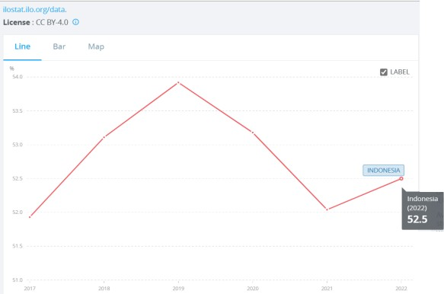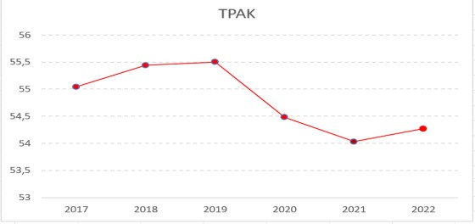

ILOSTAT 2017-2022 BPS TPAK 2017-2022
This indicates that there is economic potential in terms of increased labour supply, while an assessment based on the International Labor Organization "Labor Force Statistics Database (LFS)" ILOSTAT The women labour force participation rate is 52.5%.

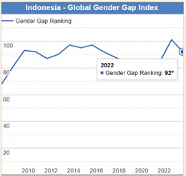

Global Gender Gap Report 2022

According to the world economic forum (WEF) in the global gender gap report 2022, Indonesia in general got a score index of gender inequality 0.697 and was rated 92th out of 146 countries. The data shows that women's contributions to national development programs are not limited to economic sectors, but also provides access to fair and equitable development

The Relationship Between Tax Fairness For women Employees And women Labour Force Participation Rates
Women’s economic empowerment is key for growth both through the direct impact of the size of the labor force on output and the impact on productivity (Cuberes and Teignier 2016) and through higher domestic demand. Greater participation of women in the labour force also brings greater diversity that can foster new ideas for production and management, boosting aggregate productivity (Ostry and

others 2018; Christiansen and others 2016a; Loko and Diouf 2009). A wide range of country and regional case studies provides further support for the positive relationship between women labour force participation and growth. For example, the entry of married women greatly expanded potential GDP in the United States in the 1970s and the 1980s (Juhn and Potter 2006). Tsani et al. (2013) show that removing barriers to women labor force participation could have a significant positive impact on growth in Algeria, Egypt, Israel, Jordan, Lebanon, Morocco, Palestine, Syria, Tunisia, and Turkey. Increased women labour force participation could also support growth in rapidly ageing developed economies such as Japan (Steinberg and Nakane 2012). In addition, the International Labour Organization estimates that reducing the gender gap in participation by 25 percent on 2025 could boost global GDP 52.5 percent (ILO 2022).
They can play an important role in promoting labour market entry due to the link between labour supply and income (IMF 2012). Many fiscal policy reforms aim to boost employment for both women and men, but some are directly focused on boosting women labour force participation. For various reasons, related also to social norms, women face specific barriers to
entering and remaining in the labour market, resulting in low labour force participation. Yet, there is ample evidence that when women can develop their full potential, there can be significant macroeconomic gains (Elborgh-Woytek and others 2013).

METHODOLOGY
The approach used in this study is a qualitative approach, which emphasized the benefits and collection of information by exploring the phenomenon under study. Creswell defines qualitative research as: "A process of inquiry to understand a social or human problem, based on creating a complete holistic picture formed in words, reporting detailed views of informants, and organized in a scientific setting".
The use of a qualitative approach in this study is intended to find a theoretical basis in order to obtain a deep and comprehensive understanding of the issues studied, in this case, Perceptions of fairness in women Taxpayers' PTKP and Women's Work Participation Rates. This type of research is descriptive, descriptive research intends to provide an overview of certain social phenomena, there is already information about social phenomena as referred to in the problem, but not yet sufficient.

According to Moleong, descriptive research is data collection in the form of words, pictures, and not numbers. In addition, everything that is collected is likely to be the key to what has been researched.
This research is strengthened by conducting a take home pay calculation simulation between women and men taxpayers. Where in the calculation simulation, the status of taxpayers, gross income, and employment status are the same as the Gross, and Gross Up methods.
Creswell in his book explains the use of literature, namely:
  - The literature is used to “frame” the problem in the introduction to the study
  - The literature is presented in a separate section as a “review of the literature”
  - The literature is presented in the study at the end it becomes a basic for comparing and contrasting of the qualitative study
In this study, literature studies were carried out through reviewing various literature such as laws and regulations, books, articles in print or electronic media, both written by tax experts or by other sources with the aim of finding concepts and theories related to the subject matter.
existing and will be used as a basis in analyzing the main issues in this study.

FINDINGS AND DISCUSSION

Tax Fairness in women Taxpayers' Non Taxable Income (PTKP)
Fair according to the Big Indonesian Dictionary means equal, impartial, impartial, in favor of what is right and not arbitrary. While fairness is defined as a trait or act or fair treatment. If it is related to taxes, then tax fairness is the nature (action or treatment) that is not arbitrary or not one-sided on the applicable tax system.
Tax fairness can shape how the taxpayer perceives the tax system. Meanwhile, the perception of tax fairness is an interpretation to interpret fairness in the tax system. When there is fairness in the tax system, a positive perception of the tax system will emerge. However, when there is infairness in the tax system, a negative perception of the tax system will emerge.
Tax fairness is a condition when the taxpayer feels that there is a tax burden that is proportional to the income or the ability of the taxpayer to pay the tax burden. Tax fairness can also be felt when there are policies that are made fairly without manipulation by tax officers.

When taxpayers feel that there is fairness in imposing taxes and applicable policies, it will form the perception that taxes are something that is not burdensome and fair.
However, the imbalance between the tax burden and income and the manipulation in the tax payment process can affect the level of trust of taxpayers in the tax system which forms the perception that there is infairness in the tax system. Thus, any tax policies and regulations that apply between groups of taxpayers will shape the perceptions of each group or taxpayer regarding the fairness of the tax from the taxation system.
However, in Indonesia itself the concept of tax administration in a family where in one family consisting of father, mother and children, only one (1) NPWP is sufficient. Mohamad, 2023 in the tax magazine states that this is because the principle of taxation for families in Indonesia adheres to paternalistic principles, namely actions that limit the freedom of a person or group for their own good, with a superior figure in the family who is fully responsible for the family including in including tax obligations. The figure is attributed to the father or husband who in fact is a man or a man.
In the tax regulations in Indonesia, if a woman before marriage already has her own NPWP, then when she gets
married it is recommended to delete the NPWP. The removal of the NPWP is carried out because if there is a married woman who continues to work, the NPWP used is the husband's NPWP so that additional information from a wife will appear as a unit of tax obligations in the family.
However, the removal of the NPWP is of course not absolute. This means that a wife is still allowed to use her own NPWP and not combine it with her husband. However, there will be risks that must be faced when a married woman still wants to use her own TIN. The risk that must be faced is that with two NPWP, each family member has separate tax obligations.
From a tax perspective, a woman with unmarried status gets the same rights as a man. The quota for additional Non- Taxable Income (PTKP) for women and men workers is available in the same number of three (3) people. That is, for the income earned, they can bear each of the 3 people who meet the requirements to become an income deduction component. This did not cause a technical or philosophical polemic, bearing in mind that the principles of fairness in taxation and equality in gender can be fulfilled.
If a married woman wants her NPWP to not join her husband, the PTKP

she can use when choosing to work is TK without dependents or TK/0, status K with dependents (maximum three) can only be owned by the husband because it is in accordance with paternalistic principles. In fact, if we look at it from the workforce perspective, men and women as workers have the same rights and responsibilities, but the PTKP they receive is different. Therefore it is interesting to study, regarding the fairness of the taxes received by women workers, especially those who are married, have different treatment of giving PTKP to their wives and husbands which will affect their take home pay.
Based on the simulation results of the take home pay calculation received from workers who are a husband and a wife who have three children, have the same salary, the same benefits, and the same contribution deductions will generate a take home pay with the gross method as follows:
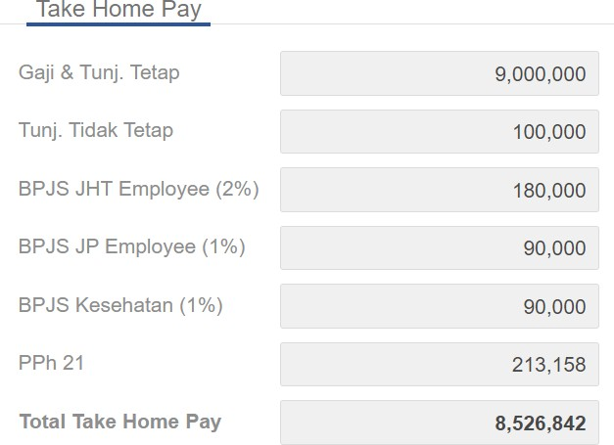

Take Home Pay Women (TK/0)

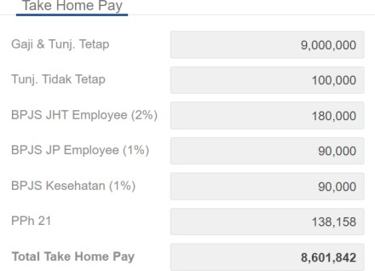

Take Home Pay Men (K/3)
From the simulation results of taking home pay calculations using the SigmaHRIS application, the results show that the take home pay received by women taxpayers and men taxpayers is not the same. The take home pay received by men is greater than that of women, this occurs due to differences in status which result in differences in the amount of PTKP received by each even though the marital status and dependents are in real terms the same.
Women taxpayers only receive PTKP of IDR 54,000,000 as a deduction from taxable income. Whereas Men taxpayers receive PTKP of IDR 72,000,000 as a deduction from annual taxable income, resulting in a difference in the tax that must be paid by the taxpayer.
Furthermore, if using the grossup method, the taxes charged to the taxpayer will be paid jointly by the employer company. If a women worker has tax to pay of IDR 213,158, if using the gross up method, the tax that will be deducted from income is only IDR 106,579. Meanwhile,

if a men worker has tax to pay of IDR 138,158, if using the gross up method, the tax that will be deducted from income is only IDR 69,079. So even though both taxpayers are still subject to withholding tax on their income, the take home pay received by married men taxpayers is still greater than married women taxpayers.
This difference in tax imposition occurs because the Indonesian Income Tax Law views men as the main breadwinners in the family, so there are differences in the allocation of Non-Taxable Income to women taxpayers depending on the marital status of women taxpayers, this can lead to reduced take home pay women taxpayers.

Women's Labor Force Participation Rates
Worldwide, women face lower income opportunities than men. Women tend not to work for income or are actively looking for work. The global labour force participation rate for women is just over 50% compared to 80% for men. Women are less likely to work in formal jobs and have fewer opportunities for business expansion or career advancement. When women work, they earn less.

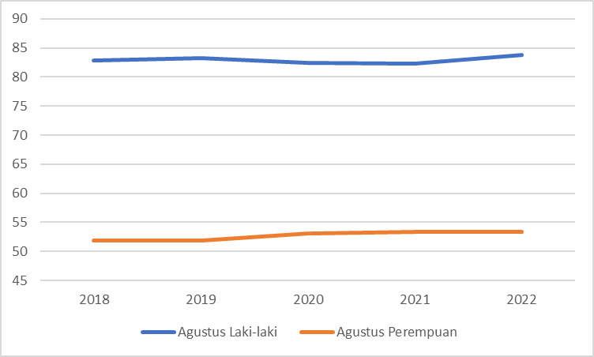
Picture. Labor Force Participation Rate by Gender (2018-2023) Source: BPS, 2023
In Indonesia itself, the women labour force participation rate is still considered low, however, over the last five year period (2018-2022) it has consistently increased. When compared with the Male Labor Force Participation Rate, there is still a fairly large gap, where the Male Labor Force Participation Rate is around 83 percent.
The low rate of women labor participation is due to several challenges, including cases of discrimination and violence in the workplace. Women also have a higher risk of obtaining low-paid jobs in the informal sector, which generally do not have patent standard operating procedures (SOPs).
Furthermore, regarding income, according to BPS data, the wage rate received by women is still below the wage rate received by men. In 2022, it is recorded that men receive wages in the range of Rp. 3.33 million, while women receive wages in the range of Rp. 2.59 million (BPS, 2023). Even though it is still
much lower than men, in some economic

sectors women earn higher incomes than men, especially in the world of work. This is due to an increase in the number of women occupying managerial positions (Angelia, 2022).
Based on the simulation results of the take home pay calculation that has been carried out, it is clear that there is infairness to the treatment received by married women taxpayers and married men taxpayers for the PTKP receipts of each taxpayer. This is reinforced by the formal women labour force participation rate which is still below the men labour force participation rate even though many married women workers continue to work as second earners. This is supported by the labor force participation rate in neighbouring countries, namely ASEAN, in 2021 one of the countries that has a thin gap between men and women workers will be Laos. Male workers make up 78.1% of the total population and 74.8% for women. Only a difference of almost 4% of the two sexes. Second is Vietnam. With a composition of 79.4% men workers and 69.6% women workers, the difference between the two is barely 10% (Santika, 2023).
To overcome the problem of tax infairness and increase work participation rates, especially for women, the OECD proposes to establish a gender-based
(gender wise) tax regulation to be included in the discussion series for the 2022 G20 Indonesia Presidency. This proposed gender taxation policy will provide affirmation for women.
The proposed Gender Based Taxation (GBT), in the form of lower marginal tax rates for women, is a reform to close the gender gap by improving women's status in the labor market and within the family, especially with women's participation and income levels. This policy may appear particularly attractive to G20 member countries, where large gender disparities persist in levels of participation, income, employment, and allocation of family tasks.
The GBT proposal is based on classical results from taxation theory and on empirical evidence that the wage elasticity of labour supply is higher for women than for men. Various studies show that the same tax rate has different implications for women and men workers. This should be taken into consideration in designing tax policies. Tax policies in a country can encourage the achievement of gender equality goals, namely by changing the socio-economic characteristics of society, such as the wage gap. In addition, tax policies can also change behavior, such as participation in the labor force, consumption, and investment.

CONCLUSION
Taxation has great potential to affect women's participation in the economy and increase tax contributions. Opening up wider and safer job opportunities for women can increase tax contributions and contribute to national economic development. There needs to be inclusive and fair tax policies for women, such as lower tax rates and special tax incentives for companies that employ more women, promotion of gender equality in the workplace, and implementation of more transparent and accountable tax practices can also help minimize gender discrimination in the taxation system, this research also support the proposal of OECD on G20 Presidential regarding the need for all G20 countries to consider gender in their taxation regulation and policies, in Indonesia this will be aligned with Job Creation Law that have specific rules for facilities specifically for woman such as maternity leaves, day off- menstruate, etc.
The making of tax policies must also consider the elasticity of wages and inclusive policy in order for women's participation in the economic sector to be improved fairly and easily understood by society.Tax fairness is important in the tax
system and the government is obliged to give the taxpayer a sense of fairness. However, Indonesia's tax regulations still have a PTKP tendency of paternalistics that give a different treatment of husband and wife in terms of PTKP. Income tax in Indonesia also has not been regulated in more detail regarding the reduction of other taxable income as has been done by neighbouring countries so that when compared to the Indonesian Income Tax Law it can be said that it has not fulfilled the principle of fairness.
This research is expected to contribute as one of the government's considerations for reviewing tax regulations, especially for married women who work and play their dual role as housewives as well as second earners. So that it can encourage the rate of women labour force participation in the formal sector.

REFERENCES
Burnama, I. (2022). Aspek Keadilan Aturan Pajak Indonesia Dalam Mengatur Transaksi Ekonomi Digital: Respon Atas Investigasi USTR. Jurnal Kajian Ilmiah Perpajakan Indonesia, Volume 4 No 1, hlm. 69
Christiansen, L., Lin, H, Pereira. J, Topalova P., & Turk, R. (2016). Gender Diversity and Firm Performance: Evidence from Europe. IMF Working Paper 16/50. Washington DC: International Monetary Fund
Creswell, J. W. (1994). Research Design: Qualitative & Quantitative Approaches, London : Sage Publications, Inc.
Cuberes, D., & Teignier, M. (2016). Aggregate Effects of Gender Gaps in the Labor Market: A Quantitative Estimate. Journal of Human Capital 10 (1): 1–32.
Elborgh-Woytek, K., M. Newiak, Kochhar, K., Fabrizio, S., Kpodar, K., Wingender, P., Clements, B., & Schwartz, G. (2013). Women, Work, and the Economy: Macroeconomic Gains from Gender Equity. IMF Staff Discussion Note 13/10. Washington DC: International Monetary Fund
International Labour Organization (ILO) (2017). World Employment Social Outlook: Trends for Women 2017. Geneva: International Labour Office
International Monetary Fund (IMF) (2012). Fiscal Policy and Employment in Advanced and Emerging Economies. Washington DC: IMF Board Paper
Juhn, C., & Potter, S. (2006). Changes in Labor Force Participation in the United States.
Journal of Economic Perspectives 20 (3): 27–46
Loko, B. & Diouf, M. A. (2009). Revisiting the Determinants of Productivity Growth: What’s New. IMF Working Paper 09/225. Washington DC: International Monetary Fund Meilisa (2016). Pengaruh Ekstensifikasi Pajak dan Kepatuhan Wajib Pajak Terhadap Moleong, L. J. (2004). Metode Penelitian Kualitatif. Bandung: Remaja Rosdakarya
Muljono (2010). Panduan Brevet Pajak, Pajak Penghasilan. Yogyakarta : Andi
Nugroho (2016). Pengaruh Ekstensifikasi Pajak dan Tingkat Kepatuhan Wajib Pajak Orang Pribadi Terhadap Tingkat Penerimaan Pajak Penghasilan (Studi Pada Kantor Pelayanan Pajak Pratama Bandung Karees). Bandung: Universitas Pasundan

Ostry, J. D., Alvarez, J., Espinoza, R & Papageorgiou, C. (2018). Economic Gains from Gender Inclusion: New Mechanisms, New Evidence. IMF Staff Discussion Note 18/06. Washington DC: International Monetary Fund
Penerimaan Pajak Penghasilan Orang Pribadi (Studi Pada KPP Pratama di Kota Bandung). Bandung: Universitas Pasundan
Steinberg, C., & Nakane, M. (2012). Can Women Save Japan?. IMF Working Paper 12/248. Washington DC: International Monetary Fund
Santika, E.F. 2023. Tingkat Partisipasi Angkatan Kerja Negara-negara ASEAN (2021). https://databoks.katadata.co.id/datapublish/2023/01/31/tingkat-partisipasi-angkatan-kerja- laki-laki-dan-perempuan-di-negara-asean-berapa-capaian-indonesia
Tsani, S., Paroussos, L., Fragkiadakis, K., Charalambidis, I., & Capros, P. (2013). Women Labour Force Participation and Economic Growth in the South Mediterranean Countries. Economics Letters 120 pg. 323–328

