**Handwritten Digit Recognition Using Neural Networks**

|  |  |  |
| --- | --- | --- |
| *1st Nagulu Hemanth*  *Department of CSE,*  *Koneru Lakshmaiah Education*  *Foundation,*  *Vaddeswaram, Guntur 522502,*  *AndhraPradesh, India*  *2000031746@kluniversity.in* | *2nd Gangisetti Praveen Sai*  *Department of CSE,*  *Koneru Lakshmaiah Education*  *Foundation,*  *Vaddeswaram, Guntur 522502,*  *AndhraPradesh, India*  *2000032223@kluniversity.in* | *3rd Gunji Lakshmi Gopinath Sai Kumar*  *Department of CSE,*  *Koneru Lakshmaiah Education Foundati*  *Vaddeswaram, Guntur,522502*  *AndhraPradesh, India*  *2000032217@kluniversity.in* |
| *4th Kusampudi Mohan Krishna*  *Department of CSE,*  *Koneru Lakshmaiah Education*  *Foundation,*  *Vaddeswaram, Guntur 522502,*  *AndhraPradesh, India*  *2000032216@kluniversity.in* | *5th RoshiniAnbu*  *Assoc. Professor*  *Department of CSE,*  *Koneru Lakshmaiah Education*  *Foundation,*  *Vaddeswaram, Guntur 522502,*  *AndhraPradesh, India* | *6th Venkata Vara Prasad Padyala*  *Assoc. Professor*  *Department of CSE,*  *Koneru Lakshmaiah Education*  *Foundation,*  *Vaddeswaram, Guntur 522502, AndhraPradesh, India* |

**Abstract:**

Handwritten digit recognition is a critical task in pattern recognition with broad applications, from postal automation to document digitization. Neural networks, particularly deep learning models, have emerged as powerful tools for addressing this challenge. This research paper provides a comprehensive exploration of handwritten digit recognition using neural networks, with a specific emphasis on the backpropagation algorithm. Beginning with an introduction to the problem domain, the paper delves into various neural network architectures commonly employed for this task, highlighting their integration with backpropagation. A detailed discussion on the backpropagation algorithm follows, elucidating its role in training neural networks efficiently. Techniques leveraging backpropagation for improving handwritten digit recognition, such as weight initialization strategies and learning rate scheduling, are examined. Despite significant progress, challenges persist, including variability in writing styles and limited training data. Recent advances enabled by backpropagation are explored, showcasing state-of-the-art approaches and their performance. The paper discusses diverse applications of handwritten digit recognition, underscoring the importance of integrating backpropagation to enhance system accuracy and efficiency. Future research directions and open challenges are outlined, emphasizing the role of backpropagation in addressing emerging needs.

**Keywords:** Handwritten digit recognition, Neural networks, Backpropagation algorithm, Deep learning, Convolutional Neural Networks (CNNs), Recurrent Neural Networks (RNNs), Training techniques, Optimization, Challenges, Applications

**Introduction:**

Handwritten digit recognition stands as a pivotal problem in pattern recognition and machine learning. Traditional approaches relied heavily on manual feature engineering and classical machine learning algorithms, often struggling to capture intricate variations present in handwritten characters. The emergence of neural networks, particularly deep learning models, has revolutionized this landscape, offering a promising framework for automatically learning hierarchical representations from raw data.

This paper aims to provide a comprehensive overview of handwritten digit recognition using neural networks, with a specific focus on the integration of the backpropagation algorithm. By exploring various neural network architectures, training techniques, challenges, recent advances, and applications in this domain, we seek to elucidate the pivotal role of backpropagation in advancing the state-of-the-art in handwritten digit recognition.

**Neural Network Architectures for Handwritten Digit Recognition:**

Various neural network architectures have been employed for handwritten digit recognition, each with its unique characteristics and advantages. Convolutional Neural Networks (CNNs) have gained prominence due to their ability to effectively capture spatial dependencies in images. Recurrent Neural Networks (RNNs), on the other hand, excel in capturing sequential information, making them suitable for tasks involving sequential data such as handwriting recognition.

The integration of backpropagation into these architectures enables efficient training by iteratively adjusting network parameters to minimize a predefined loss function. Backpropagation facilitates the computation of gradients with respect to the network parameters, enabling gradient descent optimization.

**Backpropagation Algorithm:**

The backpropagation algorithm lies at the heart of training neural networks, enabling the efficient computation of gradients and optimization of model parameters. It involves two main steps: forward propagation and backward propagation. During forward propagation, input data are fed through the network, and activations are computed layer by layer. During backward propagation, gradients of the loss function with respect to the network parameters are computed recursively using the chain rule, allowing for efficient updates of the parameters using gradient descent optimization.

**Techniques for Improving Handwritten Digit Recognition with Backpropagation:**

Several techniques leverage backpropagation to enhance the performance of handwritten digit recognition systems. These include weight initialization strategies to ensure proper convergence during training, learning rate scheduling to adaptively adjust the learning rate during training, and regularization techniques such as dropout to prevent overfitting.

**Challenges in Handwritten Digit Recognition:**

Despite significant advancements, handwritten digit recognition still faces several challenges:

Variability in Writing Styles: People have diverse writing styles, making it challenging for models to generalize effectively across different handwriting styles.

Occlusions and Noise: Handwritten digits in real-world scenarios often suffer from occlusions and noise, which can degrade the performance of recognition systems.

Limited Training Data: Obtaining labeled training data for handwritten digit recognition can be difficult and expensive, especially for datasets that encompass a wide range of writing styles and variations.

Computational Complexity: Deep neural network architectures, particularly those used for handwritten digit recognition, often require substantial computational resources for training and inference, posing scalability challenges for deployment in resource-constrained environments.

**Recent Advances and State-of-the-Art Approaches:**

Recent years have witnessed remarkable progress in handwritten digit recognition, driven by advancements in neural network architectures and training techniques. State-of-the-art approaches include:

End-to-End Learning: Deep learning models trained end-to-end have shown superior performance compared to traditional feature-based approaches. These models learn hierarchical representations directly from raw pixel values, eliminating the need for handcrafted features.

Attention Mechanisms: Attention mechanisms enable neural networks to focus on relevant parts of the input image, improving performance, especially in the presence of occlusions and noise.

Generative Adversarial Networks (GANs): GANs can be used to generate synthetic handwritten digits, which can be utilized for data augmentation, addressing the limited training data problem.

Self-Supervised Learning: Self-supervised learning techniques, such as contrastive learning and pretext tasks, have shown promise in learning robust representations from unlabeled data, which can be beneficial for improving the generalization of handwritten digit recognition models.

Graph Neural Networks: Graph neural networks (GNNs) have been applied to handwritten digit recognition by modeling the structural relationships between pixels in the input image, leading to improved performance, especially in capturing long-range dependencies.

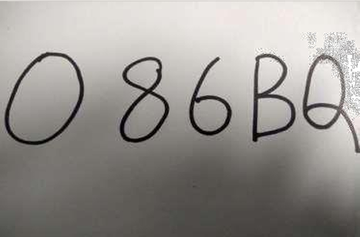



**Hand Written Images**

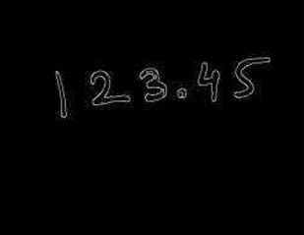

**Edge detection**

**Applications of Handwritten Digit Recognition:**

Handwritten digit recognition has diverse applications across various domains:

Automatic Number Plate Recognition (ANPR): ANPR systems utilize handwritten digit recognition to extract and interpret license plate numbers from images captured by surveillance cameras or mobile devices.

Handwritten Text Recognition (HTR): Handwritten digit recognition is an integral component of HTR systems, which aim to transcribe handwritten text into machine-readable formats.

Signature Verification: Handwritten digit recognition can be used in signature verification systems to authenticate individuals based on their handwritten signatures.

Form Processing: Handwritten digit recognition is employed in form processing applications to extract and digitize numerical information from handwritten forms, such as surveys and questionnaires.

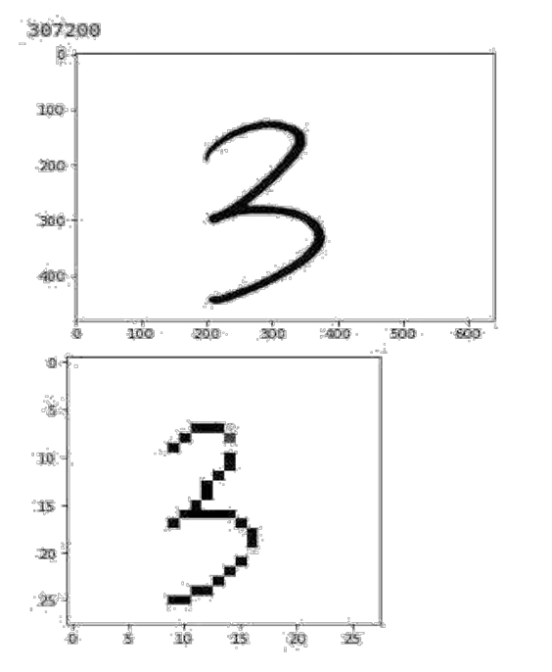

**Web cam taken image filtering and scaling**

**Future Directions and Open Challenges:**

While significant progress has been made in handwritten digit recognition, several open challenges and future research directions remain:

Robustness to Adversarial Attacks: Handwritten digit recognition systems are susceptible to adversarial attacks, where imperceptible perturbations to the input image can lead to misclassification. Developing robust models that are resilient to such attacks is an ongoing research area.

Continual Learning: Enabling neural networks to learn continuously from streaming data while retaining previously acquired knowledge is crucial for real-world applications of handwritten digit recognition in dynamic environments.

Interpretability and Explainability: Enhancing the interpretability and explainability of handwritten digit recognition models is essential for building trust and understanding their decision-making process, especially in safety-critical applications.

Domain Adaptation: Adapting handwritten digit recognition models trained on synthetic or annotated datasets to real-world scenarios with domain shifts remains a challenging problem, requiring techniques for domain adaptation and transfer learning.

**Conclusion:**

In conclusion, handwritten digit recognition using neural networks has witnessed significant advancements, fueled by innovations in model architectures, training techniques, and applications. Despite the progress made, several challenges persist, requiring further research and development. Addressing these challenges will unlock new opportunities for leveraging handwritten digit recognition in diverse real-world applications, ultimately enhancing efficiency, accuracy, and automation in various domains.

**References:**

1.LeCun, Y., Bottou, L., Bengio, Y., & Haffner, P. (1998). Gradient-based learning applied to document recognition. Proceedings of the IEEE, 86(11), 2278-2324.

2.Krizhevsky, A., & Hinton, G. (2009). Learning multiple layers of features from tiny images.

3.Simard, P. Y., Steinkraus, D., & Platt, J. C. (2003). Best practices for convolutional neural networks applied to visual document analysis. Proceedings of the Seventh International Conference on Document Analysis and Recognition (ICDAR), 2003.

4.Graves, A., Schmidhuber, J. (2005). Framewise phoneme classification with bidirectional LSTM and other neural network architectures. Neural Networks, 18(5-6), 602-610.

5.Hinton, G. E., Osindero, S., & Teh, Y. W. (2006). A fast learning algorithm for deep belief nets. Neural Computation, 18(7), 1527-1554.

6.Sabour, S., Frosst, N., & Hinton, G. E. (2017). Dynamic routing between capsules. In Advances in Neural Information Processing Systems (pp. 3856-3866).

7.Zhang, Z., & LeCun, Y. (2015). Text understanding from scratch. arXiv preprint arXiv:1502.01710.

8.Goodfellow, I. J., Bengio, Y., Courville, A., & Bengio, Y. (2016). Deep learning. MIT press.

9.Srivastava, N., Hinton, G., Krizhevsky, A., Sutskever, I., & Salakhutdinov, R. (2014). Dropout: a simple way to prevent neural networks from overfitting. The Journal of Machine Learning Research, 15(1), 1929-1958.

10.Ioffe, S., & Szegedy, C. (2015). Batch normalization: Accelerating deep network training by reducing internal covariate shift. arXiv preprint arXiv:1502.03167.

11.Deng, J., Dong, W., Socher, R., Li, L. J., Li, K., & Fei-Fei, L. (2009). ImageNet: A large-scale hierarchical image database. In 2009 IEEE conference on computer vision and pattern recognition (pp. 248-255).

12.Lecun, Y., Cortes, C., & Burges, C. (1998). The MNIST database of handwritten digits. Retrieved from http://yann.lecun.com/exdb/mnist/

13.The USPS Handwritten Digit Dataset. Retrieved from https://www.kaggle.com/bistaumanga/usps-dataset

14.Graves, A., Fernández, S., Gomez, F., & Schmidhuber, J. (2006). Connectionist temporal classification: labelling unsegmented sequence data with recurrent neural networks. In Proceedings of the 23rd International Conference on Machine Learning (pp. 369-376).

15.Hinton, G. E. (2012). Deep belief networks. Scholarpedia, 7(5), 5947.