**Computer Aided Engineering Performance Analysis of Lathe Machine Spindle using Field Generated Data.**

Ogidiagba, F.I1, Izelu, C.O2, Anaidhuno, U. P3.

Corresponding Author: [francisogidiagba@gmail.com](mailto:francisogidiagba@gmail.com)

1,2,3Department of Mechanical Engineering, Federal University of Petroleum Resources, Effurun, Delta State, Nigeria

# Abstract

This research investigated the computer aided engineering performance analysis of a lathe machine spindle using field generated data. The Excel 360x1000 lathe in the FUPRE workshop has been used for numerous students training and project experiments using non-optimal settings, without evaluation of the spindle performance, productivity, and product surface finishing. This study analyzed the interaction between input [spindle speed, depth of cut and feed] and response [material removal rate and surface roughness of machined part] parameters, as well as evaluates the integrity of the lathe spindle during turning of AISI 1085 work-piece using carbide inserts. RSM was used for the design of the experiment and optimization of the process to obtain maximum material removal rate and minimal surface roughness. The turning process was also to modeled, utilizing maximum generated cutting forces acting on the spindle during machining to ascertain its resilience. Optimization of the dependent and independent variables proffered the best solution based on set constraints with a desirability of 0.788. The conducted Finite element analysis [static, dynamic, and fatigue] yielded spindle maximum deflection of 0.01432mm, maximum von mises stress of 18840000N/m^2, least natural frequency of 898.64Hz, and spindle remaining fatigue life of 100 million cycles. These findings infer that the lathe spindle is robust and optimal responses were achieved at a specific input configuration.

**Key words**: Analysis, Data, Computer, Lathe, Machine, Spindle

## 1.0 Introduction

Machining is the removal of unwanted parts of a workpiece using a cutting tool to obtain a desired shape that is geometrically accurate, meets all required specifications, is aesthetically pleasing, durable, and fit for purpose. There are various machines used for machining such as the lathe machine, milling machine, and drilling machine amongst others.

The lathe machine has gained popularity due to the complex operations and shapes that can be achieved from it. Various machining processes can be carried out on a lathe machine such as turning, boring, drilling, knurling, parting, facing and so on which makes the lathe a versatile machine. There are various part and components of a lathe machine that makes up a unit. There are six major parts of a lathe machine which are the bed, head stock assembly, main spindle, tailstock, carriage, and overload safety device

Turning is a metal cutting technique in which machining is carried out by relative motion between the workpiece and the cutting tool. The rotating workpiece is held by the lathe spindle chuck while the cutting tool is fed in to actualize chip removal. The resulting product's quality is largely determined by machining factors such as spindle speed, depth of cut, feed rate, coolant type, insert type, magnitude of torque, and vibration characteristics of the lathe spindle.

The lathe spindle is the heart of the headstock which transfers rotational torque to the workpiece against the stationary cutting tool to shape the workpiece to a desired geometry. Lathe spindles are critical structures that support and rotate the workpiece against the translating cutting tool in a typical Turning operation (Pham et al., 2022; Rastegari, 2019). A failed lathe spindle can easily translate to a broken-down lathe machine hence the need to ensure optimal use of the lathe machine, when possible, to prevent untimely failure. Lathe spindles are designed with the expectation to work efficiently with a high degree of accuracy throughout the service life of the machine tool.

Since the surface finish of a workpiece and its geometry accuracy is a fine method of estimating a product quality after machining operations (e.g., hard turning), there is a need to study closely the factors that directly or indirectly affect these parameters.

As a case study, the Excel D360x1000 lathe machine at the Mechanical Engineering Workshop at the Federal University of Petroleum Resources Effurun which has been used over the years for teaching students and for experimental projects without much consideration of its performance evaluation, optimal setting configuration, and quality of job since there are no standard working parameters used as guideline nor proper quality checks after production.

This work is aimed at using D360x1000 as a case study during hard turning operation of structural steel (ASTM 1085) to ascertain the optimum independent cutting operating parameters, and spindle performance and to investigate if the non-optimal setting of the lathe machine input parameters (Feed, DoC, Spindle speed) influences the performance of the lathe machine spindle.

This research investigated the computer aided engineering performance analysis of a lathe machine spindle using field generated data.

## 2.0 Literature Review.

The structural dynamics of the lathe machine spindle can be effectively analyzed at the tip of the cutting tool where it makes contact with the workpiece as it directly affects the rate of material removal as observed by(Maeda et al., 2005). The performance of the lathe spindle can be evaluated through static, dynamic analysis, and fatigue analysis via FEA simulation software when parameters like the bearing location, bearing span, and maximum cutting forces during machining operations are measured/calculated from a designed experimental setup.

Cutting forces are generated during turning processes due to the action of the tool on the workpiece. The cutting force has 3 components namely Tangential, radial, and Feed forces (where tangential force is the dominant) which can be measured using a piezo dynamometer and the tangential cutting force can also be calculated using data obtained from turning operation experiments. High cutting forces can lead to tool wear/failure and cause excessive vibration /chatter which can also cause failure of the bearings supporting the spindle thus leading to a geometrically inaccurate part and rough surface finish(Z. Chen et al., 2019; Laghari & Li, 2021; Lalwani et al., 2008; Segonds et al., 2006). Therefore, it is paramount to choose input cutting parameter values that will generate low cutting forces with maximum material removal rate, that will not impair the performance of the lathe spindle/machine tool.

Vibration is an undesired phenomenon, as noted by (Yu, 2013), as far as turning operations are concerned. Unfortunately, they cannot be eliminated but can be kept to the barest minimum by using the right combination of input variables for any machining operation. Forced vibrations can be caused by unbalance in the machine structure and misalignment, while self-excitation vibrations are energized by the cutting process and might lead to chatter. Since the rotating parts are mechanically connected, the failure due to an increase in vibration is caused by dynamic stress of one or more of these parts connected (Çetinkaya et al., 2021; Pham et al., 2022; Ramesh Kannan et al., 2020). Vibration may be caused by the production process, assembly, incorrect greasing, or poor operating conditions which can lead to fatigue of the machine components such as spindle bearings, and lathe spindle, the wear out of other machine parts and a poor finish of the workpiece as illustrated in the study conducted (Panda et al., 2018).

The finite element analysis carried out on the spindle show the dynamic behaviour and vibration characteristics of the spindle(Subbarao & Dey, 2019; S. J. Zhang et al., 2012). Hence we will be able to ascertain if the spindle can withstand the highest possible Cutting force generated during the experiments while varying input cutting parameters such as Feed, depth of cut, and spindle speed.

Customarily, the machinist is responsible for setting the values of input parameters such as depth of cut, feed, and spindle speed during turning operations. He can do this by following guidelines from machining handbooks, personal experience, and intuition earned overtime on the job, but even for an expert machinist, it is difficult to attain optimal settings every time(Aggarwal & Singh, 2005). The machine-independent parameters are directly related to the response parameters and thus the quality characteristics of the workpiece. Other constraints that can affect the productivity and efficiency of the lathe machine turning process are tool geometry, temperature generated at the cutting tool/workpiece interface, forced and unforced vibrations generated during turning, cutting forces and spindle performance(Sabirov et al., 2020; Zerti, Yallese, Meddour, et al., 2019). Hence there is a need for optimization of these parameters to achieve our objective functions which can be lower surface roughness, smaller cutting forces during turning, minimal vibrations at cutting area/spindle bearings, etc. This literature review scrutinizes the optimization of DOC, feed, and spindle speed and their effects on surface roughness, and cutting forces using modeling and prediction tools like RSM, Taguchi, and ANN. Additionally, it examines the modeling and performance of the lathe spindle during hard-turning operations.

Rashid et al. (2013) investigated the hard turning of AISI 4340 steel workpiece (HRC) to achieve more than traditionally obtainable surface finish by applying the surface defect machining technique. This method entails drilling holes (which act as chip breakers) in the workpiece before hard turning begins thereby reducing the contact time, cutting temperatures, and average cutting forces which leads to lower surface roughness than conventional hard turning with all other factors being unchanged. The surface roughness value for hard turning was 0.452µm while that of the defect technique was 0.227µm.

In a study concerning turning operations, Mahmoud et al. (2016) investigated the influence of varied cutting parameters (cutting speed, feed rate, and depth of cut) on cutting force during the dry hard turning process of Inconel 718, using thermally aided turning (TAT). Both orthogonal and oblique turning processes were simulated in 3D using ABAQUS/explicit. By validating the generated results with experimental results, the results showed that 3D FE modeling gives the dependability to estimate cutting forces during the turning process. Furthermore, the results showed that 3D oblique machining models produce more accurate results than orthogonal models, although 3D oblique machining models take longer to compute. Furthermore, the results demonstrate that when the cutting speed and workpiece temperature increase, the cutting force falls dramatically, whereas it increases as the feed rate increases.

During the turning of red brass using HSS insert, Hanief et al. (2017) found out that with an increase in all three input machining parameters, the cutting force increased, the resultant cutting force was found to be most impacted by feed rate and least by the depth of cut. The experiment design was carried out Based on full factorial methodology. It was determined that the ANN model can more accurately forecast cutting forces when compared to the regression model.

Izelu et al. (2016) investigated the effect of tool nose radius, cutting speed and feed rate on machining vibration and surface roughness during hard turning of ﻿41Cr4 alloy structural steel using the CC-DOE(RSM). A quadratic prediction model was developed for both dependent variables and the accuracy of fitness of the models were confirmed using ANOVA. All three input variables were seen to have significant influence on the response parameters studied. Optimization (minimization of surface roughness and vibration) was achieved for the response parameters when﻿ tool nose radius=1.72301 mm, feed rate=0.15 mm/rev and the cutting speed=311.075 rev/min using the desirability function. Surface finish was most affected by the lower and upper range values of the cutting speed range setting, and it was established that it had a nonlinear relationship with the three machining parameters considered. The machining vibration and surface roughness relationship was nonlinear in the study with suggestions that this might not be the case when working outside the limits of the range of input parameter used in their study.

This research investigated the computer aided engineering performance analysis of a lathe machine spindle using field generated data.

## 3.0 Materials and Method.

## 3.1 Materials and Equipment

This study entails dry hard turning of hollow structural steel (A1085) on 2.5kW powered Excel D360x1000 lathe machine with serial number serial J320581, using carbide cutting inserts, primarily to investigate the effect of feed, DOC, and cutting speed on tangential cutting force, vibration at shaft bearing and tool post, surface roughness and evaluation of the lathe spindle performance. Modeling and performance analysis of spindle was carried out using SOLIDWORKS while optimization of the machining input and response interaction was performed using Response surface methodology in Design-Expert 13.0.1.0.

A1085 steel has a minimum yield stress of 50 ksi and can be said to be the holy grail when it comes to structural applications like drilling platforms, bridges, buildings, and towers where significant fatigue support and sometimes seismic design requirements are prerequisites. Each work-piece specimen 70mm long, 61 mm thick with bore diameter of 49mm.

Instruments utilized to measure data were high precision weight scale (Camry electronic digital scale) for measuring mass of material machined off the work-piece, surface roughness tester (Rank Taylor Hobson Surtronic 10 Pocket Surface Roughness Analysis Meter) for ascertaining the degree of surface finish and a stopwatch for noting the time taken to machine a specimen per run.

## 3.2 Design of Experiment (DoE)

Experimentation design was executed using Response Surface Methodology (RSM) based on central composite design in Design-Expert software 13.0.1.0. The RSM CCD Face-centered technique was adopted as opposed to Taguchi L9 DoE with fewer runs to get enough experimental runs to obtain adequate data points to train, test and validate the ANN model whilst the Taguchi L27 DoE was neglected due more experimental runs which translates to more costs.

The 3 independent factors value limits (upper and lower limits) as shown in Table 3.1 when inputted gave rise to 27 experimental runs (see Table 3.2).

Table 3. 1 Independent variable data range

| **INPUT FACTORS** | LOW | HIGH |
| --- | --- | --- |
| Cutting speed(rpm) | 510 | 1170 |
| Feed rate(mm) | 0.15 | 0.5 |
| DoC (mm) | 0.5 | 1.5 |

Table 3. 2 DOE 27 run configurations generated by RSM in Design-Expert 13

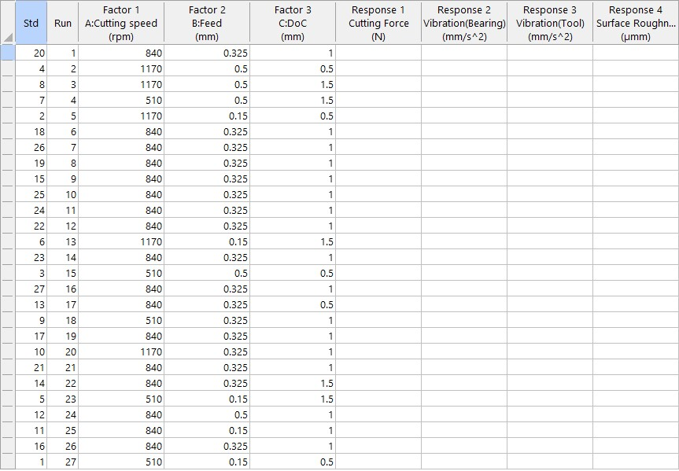

A close look at the factor configurations reveals 13 identical data points thus making the unique experimental runs 15. Furthermore, there will be a preliminary turning of all workpiece specimen with DOC of 0.2mm prior to the main experiments to remove rusts and uneven surfaces thereby promoting a homogenous exterior across specimens which in turn ensures a more accurate experiment response data collation.

The value range of independent parameters used in this design were set close to the maximum allowable limits to obtain viable data (high cutting force and vibration) during critical or extreme machining conditions of the lathe machine tool which will help show the spindle behavior during FEA analysis. Input parameter range values were chosen with respect to advised range as shown in the Excel D360x1000 operation manual with consideration of machine condition (Prior heavy usage) in mind. As earlier mentioned, the quantitative response data we are interested in is surface roughness, Material removal rate, vibration at cutting tool/workpiece interface and tangential cutting force while the vibration data collected from the spindle bearing (chuck end) will be used for the performance evaluation of the lathe spindle system. The experimental setup is shown in Plate 3.1.

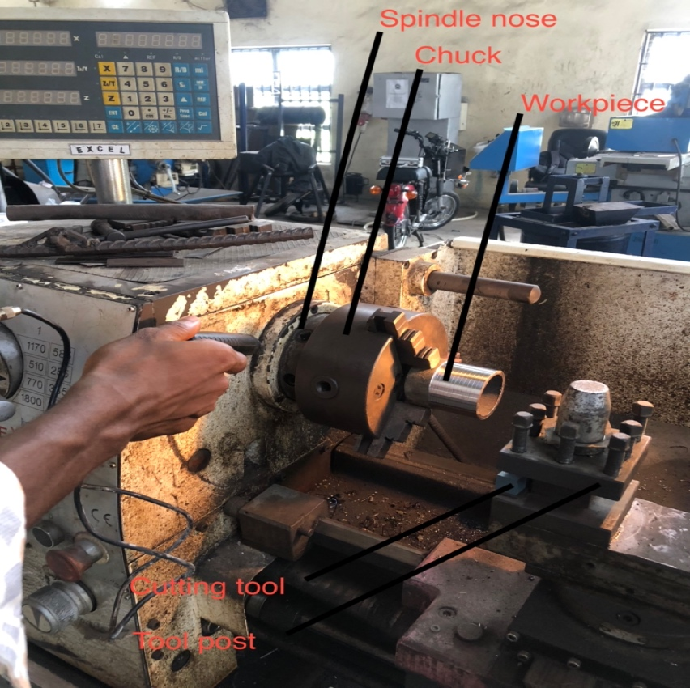

Plate 3. 1 Experimental setup

## 3.3 Surface Roughness $\left(R_{a}\right)$

The surface finish of a machined workpiece/product is a key attribute of its quality. A minimal surface roughness easily translates to more accurate geometry, better tribological properties, higher corrosion resistance and fatigue strength, and good aesthetics.

Surface roughness of each workpiece specimen was taken after hard turning operation was completed using a roughness tester (Rank Taylor Hobson Surtronic 10 Pocket Surface Roughness Analysis Meter). The surface roughness by arithmetic average $\left(R_{a}\right)$ was computed by finding the average of roughness values taken at 4 points around the cross-section of the machined part of the workpiece as shown in equation 1

|  |  |
| --- | --- |
| $Surface Roughness\left(R_{a}\right)$ = $\left(R_{c}+R_{v}+R_{e}+R_{x}\right)$/ $4$ | (3.1) |

The value of surface roughness $\left(R_{a}\right)$ computed from Equation 1 is inputted accordingly

## 3.4 Tangential Cutting force $\left(F_{tf}\right)$

The tangential cutting force is the largest and most influential of the three Force components (Radial, Axial and Tangential) in play during a typical turning process. The tangential force alone is the focus of this study as in (Labidi et al., 2018) during the turning of X210Cr12 hardened steel (Kistler dynamometer/amplifier system was used to measure tangential force real-time), as it is the principal force component during critical turning operation that can lead to failure of the spindle as it greatly influences the magnitude of vibrations/chatter and other performance related response parameters. The computing of Tangential force will be different from that used by (Labidi et al., 2018), in that this study will employ experimental as well as numerical deductions. The tangential cutting force was deduced with the steps shown below.

### 3.4.1 Computing of material removal rate $\left(Q\right)$

|  |  |
| --- | --- |
| $Volume\left({cm}^{3}\right)=mass/(density of workpiece material)$ | (3.2) |

The weight of each workpiece is measured using a high precision weight scale before and after turning to ascertain the mass of material/chips removed from the workpiece specimen during machining. The volume of the material/ chips removed per unit time(Q) was then calculated using the mathematical expression

Thus, the material removal rate (Q) is calculated by using the mathematical expression

|  |  |
| --- | --- |
| $Q\left({cm}^{3}/s\right)=Volume/Time$ | (3.3) |

### 3.4.2 Relating cutting power $\left(P\right)$, Spindle power and material removal rate $\left(Q\right)$

The power(P) required to cut a material during hard turning depends on the material removal rate/ volume of material removed per unit time. This relationship is shown in equation 4-8 below.

|  |  |
| --- | --- |
| Uadjusted  = U * C  P=Q*Uadjusted  Pspindle = P/ E | (3.4)  (3.5)  (3.6) |

Where, *P =*power at the cutting tool; hp, or kW

E = Machine efficiency factor (direct belt drive value is 90 percent)

*Q =* metal removal rate; in 3/min or cm3/s

*C =* feed factor for power constant

*U =* power constant /specific power consumption/in3/min, or kW/cm3/min (U is dependent on the hardness of workpiece material and on the assumption that cutting tool is sharp) for AISI 1085 its constant value is 0.0419 kW/cm3/min.

### 3.4.3 Computing of Tangential Force and Spindle Torque

After estimating the Power at the cutting tool from Equation 5, the tangential force and Spindle torque can then be calculated using Equation 7 and 8 respectively.

|  |  |
| --- | --- |
| $F_{tf}=(DoC*F*P*60000)/Q$ | (3.7) |

T = Pspindle / V (3.8)

Where;

$F_{tf}$-Tangential cutting force; N

*P =*power at the cutting tool; kW

T = spindle torque; Nm

V = spindle speed; rad/s

Computing the Tangential cutting force through the aforementioned steps(indirectly) will help to further evaluate the generic relationship/accuracy of this method to that of direct measurement as in (Isakov, 2004) as it relates to the interaction of the input cutting parameters during the turning process.

## 3.5 Analysis of Data Obtained using RSM

### 3.5.1 Response Surface Methodology (RSM)

This is a mathematical /statistical tool in Design-Expert 13 that was used in showing the relationship/interactions between the machining parameters (DoC, Feed and Cutting speed) and the response parameters (surface roughness and Tangential cutting force and vibration at cutter and workpiece interface) and was used to design this experiment. On filling response value for the three (4) response columns on Table 2, the following actions were taken in Design-Expert,

investigating the type of model that best described the interaction between input and response variables.ie the model with best fit and coefficient of determination and appropriate statistically significant level and low standard deviation.

Analysis of variance (ANOVA) is then performed to show the significance/influence of input parameters on response parameters.

Generation of 3D and contour plots to show interactions of cutting parameters to response parameters

Apply the desirability function to obtain the optimal combination of cutting parameters to obtain minimal surface roughness, material removal rate and Tangential cutting force

## 3.6 Lathe Spindle Performance Analysis

The spindle system of a lathe is the most critical structure of the lathe machine tool in that it has a direct colossal effect on the workpiece geometrical accuracy and surface finish during the turning process. The spindle system is a complex system with mostly nonlinear interactions (mechanical and thermal) between parameters with lots of adverse boundary constraints and conditions that it takes a Finite element analysis to be able to ascertain/describe its dynamic behavior (Lin et al., 2013). The spindle system is basically comprised of the spindle shaft and the supporting bearings. The spindle shaft being the critical element as it supports and rotates the workpiece during turning, needs to be statically and dynamically analyzed to confirm its integrity and reliability after years of usage at non optimal cutting conditions. The performance of the lathe machine spindle is dependent on several parameters such as material type/stiffness of spindle, number, type, and position/span of bearing, morse taper, number of steps on spindle etc.

The spindle of D360x1000 HS Excel lathe machine was modeled using CAD software- SOLIDWORKS 2020 with specifications and details from the machine technical data manual. A simplified design (lacking intricate features) of the spindle was modeled to reduce the complexities involved in carrying out a static and dynamic analysis without hampering the efficiency of the process. A simplified presentation of the spindle system, work-piece and forces can be seen in figure 3.1 below. Shown below are the available technical/specification data as seen in manual.

### 3.6.1 Spindle Data

The Spindle data shown in Plate 3.2 is gotten from d Excel D360X1000 User operation manual

129 taper roller bearing (smaller pulley end) -internal diameter 50mm

136 taper rollers bearing (bigger bearing end)-internal diameter 55 mm

Spindle nose/seat-Camlock ASA D 1 – 4”

﻿Spindle cone – MK5

Spindle thru hole-39mm

The spindle alongside it’s 2D and 3D models can be seen in plate 3.2, Figure 3.1 and Figure 3.2 respectively.

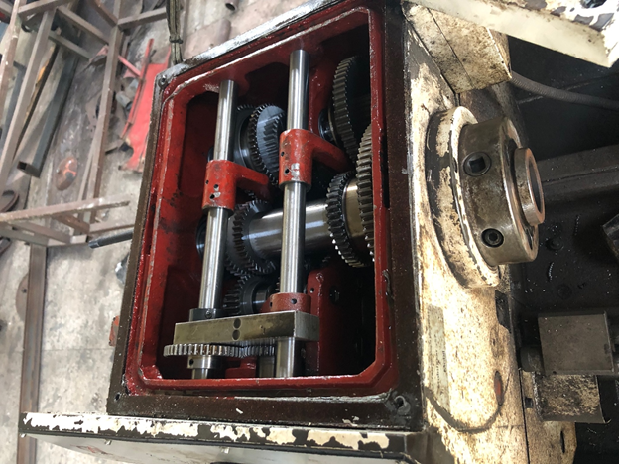

Plate 3. 2 Picture of Lathe spindle under investigation

## 4.0 Test and Discussions.

The results presented offer a comprehensive assessment of the lathe spindle's performance under different loading and dynamic conditions. The spindle exhibits remarkable durability and resilience, with fatigue life estimates of 100 million cycles in all scenarios, with the scenario observed, percentage damage on the highest value is still very negligible. These findings are crucial for assessing the spindle's longevity and planning maintenance or replacement as needed. The dynamic simulation results shed light on stress distribution and displacement patterns in the spindle under various operating conditions. These insights aid in understanding the spindle's structural integrity and its response to dynamic loads. The mode shape frequency analysis provides valuable information for optimizing the spindle's design to minimize vibrations and enhance operational stability.

The RSM optimization study provides a range of solutions for manufacturers to consider, allowing them to balance various performance parameters to meet specific objectives in machining processes. We draw conclusions from the results, discussed their practical implications, and provided recommendations for future research and practical applications in the field of machining technology.



Figure 4. 1 Numerical Optimization Bar Graph

Figure 4.1 illustrates the Numerical Optimization Bar Chart, which showcases the desirability values for the factors and responses considered in our study. The desirability values provide a quantitative measure of the optimization success for each parameter. For the factors—cutting speed, feed rate, and depth of cut—desirability values of 0.437404, 1, and 1 were obtained, respectively. These values indicate the relative importance and optimization success of each factor in achieving the desired machining outcomes.

In terms of the responses, the desirability values for material removal rate, cutting force, bearing vibration, tool post vibration, and surface roughness were found to be 0.704851, 0.765193, 0.893361, 0.860442, and 0.955346, respectively. These values reflect the extent to which our optimization efforts improved these critical parameters. The combined desirability value, calculated as 0.787638, provides an overall assessment of the success of our optimization study, taking into account all the factors and responses. This value underscores the effectiveness of our approach in achieving the desired balance between various machining objectives.

4.3.1 ANOVA For Quadratic Model and Fit Statistics

4.3.1.1 **MRR(Q)**

Table 4. Analysis of Variance for MRR

|  |  |  |  |  |  |  |
| --- | --- | --- | --- | --- | --- | --- |
| **Source** | **Sum of Squares** | **df** | **Mean Square** | **F-value** | **p-value** |  |
| **Model** | 905.66 | 9 | 100.63 | 6.47 | 0.0005 | significant |
| A-cutting Speed | 27.32 | 1 | 27.32 | 1.76 | 0.2026 |  |
| B-Feed | 69.33 | 1 | 69.33 | 4.46 | 0.0499 |  |
| C-DoC | 366.34 | 1 | 366.34 | 23.55 | 0.0001 |  |
| AB | 32.40 | 1 | 32.40 | 2.08 | 0.1672 |  |
| AC | 161.64 | 1 | 161.64 | 10.39 | 0.0050 |  |
| BC | 66.47 | 1 | 66.47 | 4.27 | 0.0543 |  |
| A² | 117.58 | 1 | 117.58 | 7.56 | 0.0137 |  |
| B² | 3.12 | 1 | 3.12 | 0.2003 | 0.6601 |  |
| C² | 1.40 | 1 | 1.40 | 0.0897 | 0.7682 |  |
| **Residual** | 264.51 | 17 | 15.56 |  |  |  |
| Lack of Fit | 264.51 | 5 | 52.90 |  |  |  |
| Pure Error | 0.0000 | 12 | 0.0000 |  |  |  |
| **Cor Total** | 1170.17 | 26 |  |  |  |  |

Table 4. 12 MRR Fit statistics

|  |  |  |  |  |
| --- | --- | --- | --- | --- |
| **Std. Dev.** | 3.94 |  | **R²** | 0.7740 |
| **Mean** | 20.58 |  | **Adjusted R²** | 0.6543 |
| **C.V. %** | 19.16 |  | **Predicted R²** | -2.3221 |
|  |  |  | **Adeq Precision** | 12.9952 |

The following information is depicted in Table 4.11 and 4.12 which shows a summary of the analysis of variance and fit statistics analysis for MMR response. P-value: The p-value for the model is 0.0005, indicating that the model is statistically significant. It means that at least one of the factors (A, B, C, AB, AC, BC, A², B², C²) has a significant impact on the response variable MMR(Q). R²: The R² value is 0.7740, which represents the proportion of the variation in the response that can be explained by the model. In this case, approximately 77.4% of the variability in MMR(Q) is accounted for by the factors in the model. Predicted R²: The predicted R² value is -2.3221, which is negative. This suggests that the model may not be suitable for making predictions beyond the range of the observed data. Negative predicted R² values can indicate issues with model fit or over-fitting. Model Significance: The F-value of 6.47 for the model is statistically significant, indicating that the model is meaningful for explaining the variation in MMR(Q). Individual Factors: Among the individual factors, C-DoC stands out with a very low p-value of 0.0001, indicating its strong influence on MMR(Q).

The results of the Response Surface Methodology (RSM) analysis reveal critical insights into the factors affecting surface roughness, which is a fundamental aspect of our goal to optimize manufacturing processes. In the case of surface roughness (Response 5), the highly significant model (p-value < 0.0001) and the remarkable R² value of 0.9671 signify that the developed quadratic model effectively explains approximately 96.7% of the variability in surface roughness. This implies that the selected factors (B-Feed, AC, A²) have a substantial influence on surface roughness. Notably, the positive effects of B-Feed and AC and the negative effect of A² on surface roughness are evident from their respective p-values and coefficients.

The high predicted R² value of 0.7543 suggests that this model is suitable for making reliable predictions within the observed data range. Therefore, manufacturers aiming to optimize surface roughness can confidently utilize this model to make informed decisions regarding cutting feed rate (B-Feed), the interaction between factors A and C (AC), and the quadratic effect of factor A (A²). By controlling and adjusting these factors based on the model's insights, manufacturers can achieve improved surface finish, reduced defects, and enhanced product quality, aligning with the overarching goal of process optimization and delivering products that meet or exceed customer expectations.

Figure 4.32 further shows the surface contour which plots the two dominant factors that affect the response which is feed and cutting speed which are the major factors that affect Surface Roughness as shown by the graph.



Figure 4. 2, 3D surface response graph for Surface Roughness

Table 4. 1 Final equation of coded factors

|  |  |
| --- | --- |
| **Response Variable** | **Equation** |
| **MMR(Q)** | 22.328 + 1.653A + 2.633B + 6.053C - 2.013AB - 4.495AC - 2.882BC - 6.467A² + 1.053B² + 0.705C² |
| **Cutting Force** | 445.221 - 0.001A + 117.817B + 221.120C - 3.729B² + 0.001A² + 0.006C² |
| **Surface Roughness** | 1.396 + 0.110A + 0.840B - 0.040C + 0.150AB - 0.250AC + 0.100BC + 0.167A² + 0.317B² + 0.117C² |
| **Bearing Vibration** | 1.758 + 1.241A + 0.801B + 0.301C - 0.411AB - 0.061AC + 0.439BC + 1.255A² + 0.355B² + 0.955C² |
| **Tool Post Vibration** | 2.904 - 2.720A - 5.930B - 0.890C + 7.925AB + 2.775AC + 4.225BC + 7.606A² + 2.456B² + 4.056C² |

Show cases the comprehensive set of equations representing the relationship between the coded factors A, B, and C, and their corresponding response variables in the context of engineering parameters. The table comprises equations for various critical parameters, including MMR(Q), Cutting Force, Surface Roughness, Bearing Vibration, and Tool Post Vibration. Each equation demonstrates the impact of different factor combinations on the respective engineering parameters, providing a clear understanding of how changes in cutting speed (A), feed (B), and depth of cut (C) influence the studied responses. These equations serve as a valuable reference for predicting and optimizing the outcomes of engineering processes by manipulating the key factors within the coded space.

We examine the spindle's behavior under different dynamic operational conditions as shown.

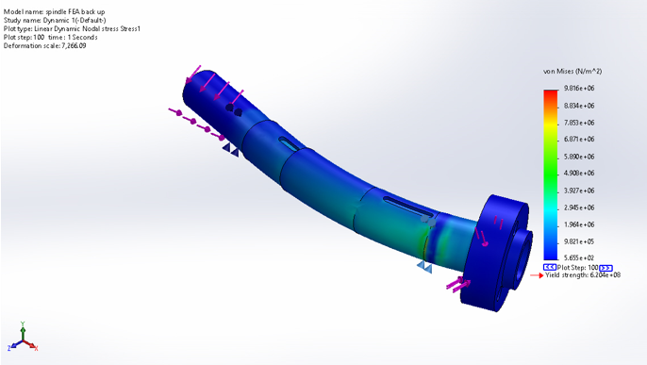

Figure 4. 3 Von mises stress result due to dynamic loading in scenario

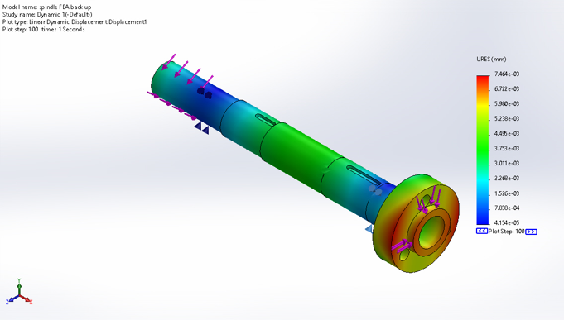

Figure 4. 4 Displacement result due to dynamic loading in scenario

This scenario assesses the lathe spindle's structural response to dynamic loading as shown in figure 4.3 and figure 4.4. The minimum von Mises stress observed is 5.655e+02 N/m^2, indicating areas with relatively low stress levels. The maximum von Mises stress reaches 9.816e+06 N/m^2, signifying regions of the spindle experiencing significantly higher stress. The minimum displacement for Scenario 3 is 4.154e-05 mm, indicating minor deformation, while the maximum displacement is 7.464e-03 mm.

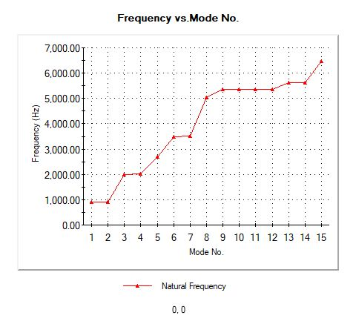

Figure 4. 5 Frequency vs Mode Number graph

presents the dynamic simulation results, specifically focusing on the mode shapes and corresponding frequencies of the lathe spindle. Each mode number corresponds to a specific vibration mode of the spindle during dynamic operation, with frequencies expressed in Hertz (Hz). For instance, Mode 1 vibrates at a frequency of 898.64 Hz. The table also provides insights into the normalized mass participation of the spindle in the X, Y, and Z directions for each mode, indicating its involvement in vibrations along each axis. At the bottom of the table, you'll find the sums of the normalized mass participation values for each direction (X, Y, and Z), offering an overall representation of the spindle's participation in vibrations along each axis. These results are instrumental in comprehending the spindle's dynamic behavior and aiding engineers in optimizing its design to minimize vibrations and ensure stable performance during machining processes.

Optimal settings deduced from this study will help increase the productivity, machine life and finishing/Surface roughness of machined parts.

## 5.0 Conclusion

In this research investigation, an in-depth analysis of machining processes was successfully carried out, focusing on the performance of a lathe spindle under various Loading scenarios while optimizing the turning process for maximum productivity and least surface roughness. We utilized Finite Element Analysis (FEA) to evaluate the spindle's fatigue life, structural rigidity/stiffness, and dynamic behavior to different loading conditions. Emphasis was on Maximum cutting force to ascertain the resilience and performance of the spindle. In summary, the study conducted a thorough analysis of the Excel D360x1000 Lathe spindle's performance using static, fatigue, and dynamic simulations whose loading conditions were derived from the experimental values gotten during the research. The findings suggest that the spindle design is safe, structurally robust, with low stress and ample fatigue life under worst-case loading conditions. It demonstrates resilience and suitability for machining operations, offering valuable insights for design optimization and enhanced performance. Additionally, we employed data-driven approaches, including Artificial Neural Networks (ANN) and Response Surface Methodology (RSM), to optimize machining parameters and predict critical performance indicators. The findings and insights contribute significantly to the understanding of the lathe machining process and offers practical implications for machinists as regards knowledge of the machine capability and optimal setting range for best product outcome.

In conclusion, this study bridges the gap between theoretical analysis and practical implementation, providing valuable insights and recommendations for optimizing machining processes in ensuring the long-term reliability of critical components like the lathe spindle. These findings empower engineers and manufacturers to make informed decisions, improve machining efficiency, and maintain the highest quality standards in their operations.

**References**

Aggarwal, A., & Singh, H. (2005). Optimization of machining techniques-A retrospective and literature review. In *S¯ adhan¯ a* (Vol. 30).

Çetinkaya, M. B., Esim, E., & İşci, M. (2021). Analysis of the Vibration Characteristic of an Experimental Turning Lathe Using Artificial Neural Networks. *Arabian Journal for Science and Engineering*, *46*(3), 2597–2611. https://doi.org/10.1007/s13369-020-05162-6

Cheng, T., Xiang, S., Zhang, H., & Yang, J. (2023). New machining test for identifying geometric and thermal errors of rotary axes for five-axis machine tools. *Measurement: Journal of the International Measurement Confederation*, *223*. https://doi.org/10.1016/j.measurement.2023.113748

Chen, X., Li, C., Tang, Y., Li, L., Du, Y., & Li, L. (2019). Integrated optimization of cutting tool and cutting parameters in face milling for minimizing energy footprint and production time. *Energy*, *175*, 1021–1037. https://doi.org/10.1016/j.energy.2019.02.157

Christopher Okechukwu Izelu, Samuel Chikezie Eze, Festus Ifeanyi Ashiedu. (2016). Modeling and Optimization of Hard Turning Operation on 41Cr4 Alloy Steel Using Response Surface Methodology. *International Journal of Mechanical Engineering and Applications*, *4*(2), 88. https://doi.org/10.11648/j.ijmea.20160402.18

Hanief, M., Wani, M. F., & Charoo, M. S. (2017). Modeling and prediction of cutting forces during the turning of red brass (C23000) using ANN and regression analysis. *Engineering Science and Technology, an International Journal*, *20*(3), 1220–1226. https://doi.org/10.1016/j.jestch.2016.10.019

Isakov, E. (2004). *ENGINEERING FORMULAS FOR*.

Izelu, C. O., Essien, E. I., Okwu, M. O., Garba, D. K., & Agunobi-Ozoekwe, C. N. (2021). Lathe boring operation on ASTM A304 steel parameter optimization using response surface methodology. *Australian Journal of Mechanical Engineering*, *19*(5), 544–558. https://doi.org/10.1080/14484846.2019.1662534

Labidi, A., Tebassi, H., Belhadi, S., Khettabi, R., & Yallese, M. A. (2018). Cutting Conditions Modeling and Optimization in Hard Turning Using RSM, ANN and Desirability Function. *Journal of Failure Analysis and Prevention*, *18*(4), 1017–1033. https://doi.org/10.1007/s11668-018-0501-x

Laghari, R. A., & Li, J. (2021). Modeling and optimization of cutting forces and effect of turning parameters on SiCp/Al 45% vs SiCp/Al 50% metal matrix composites: a comparative study. *SN Applied Sciences*, *3*(7). https://doi.org/10.1007/s42452-021-04689-z

Lin, C. W., Lin, Y. K., & Chu, C. H. (2013). Dynamic models and design of spindle-bearing systems of machine tools: A review. *International Journal of Precision Engineering and Manufacturing*, *14*(3), 513–521. https://doi.org/10.1007/s12541-013-0070-6

Maeda, O., Cao, Y., & Altintas, Y. (2005). Expert spindle design system. *International Journal of Machine Tools and Manufacture*, *45*(4–5), 537–548. https://doi.org/10.1016/j.ijmachtools.2004.08.021

Mahmoud, A. K., Nasralla, K., & Shihab, S. K. (2016). Shihab 3d Fe-Simulation of Thermally Assisted Turning of Inconel-718 for Cutting Forces Prediction. In *International Journal of Design and Manufacturing Technology (IJDMT* (Vol. 9, Issue 3).

Okechukwu Izelu, C., Chike Eze, S., & David Samuel, O. (n.d.). Modeling and Optimization of Surface roughness and Machining Induced Vibration in 41cr4 Alloy Structural Steel Turning Operation Using Design of Experiment. *The International Journal Of Engineering And Science (IJES) ||*, 2319–1805. Retrieved December 7, 2023, from www.theijes.com

Panda, A., Olejárová, Š., Valíček, J., & Harničárová, M. (2018). Monitoring of the condition of turning machine bearing housing through vibrations. *International Journal of Advanced Manufacturing Technology*, *97*(1–4), 401–411. https://doi.org/10.1007/s00170-018-1871-7

Pham, V. H., Pham, M. T., & Nguyen, T. D. (2022). A Method to Evaluate Wear and Vibration Characteristics of CNC Lathe Spindle. *Tribology in Industry*, *44*(2), 352–359. https://doi.org/10.24874/ti.1206.10.21.04

Ramesh Kannan, C., Manivannan, S., Vairamuthu, J., Velmurugan, P., Manohar, N. J., & Stalin, B. (2020). Vibration Analysis of Cutting Tool insert in Turning of 42CrMo4 alloy steel. *IOP Conference Series: Materials Science and Engineering*, *988*(1), 1–12. https://doi.org/10.1088/1757-899X/988/1/012105

Rashid, W. B., Goel, S., Luo, X., & Ritchie, J. M. (2013). An experimental investigation for the improvement of attainable surface roughness during hard turning process. *Proceedings of the Institution of Mechanical Engineers, Part B: Journal of Engineering Manufacture*, *227*(2), 338–342. https://doi.org/10.1177/0954405412464217

Rastegari, A. (2019). Vibration analysis of machine tool spindle units. In *Lecture Notes in Mechanical Engineering*. Springer International Publishing. https://doi.org/10.1007/978-3-319-95711-1_51

Sabirov, F. S., Bogan, A. N., & Mikhaylov, I. S. (2020). Investigation of dynamic characteristics of spindle units of CNC lathes batch. *IOP Conference Series: Materials Science and Engineering*, *747*(1). https://doi.org/10.1088/1757-899X/747/1/012060

Segonds, S., Cohen, G., Landon, Y., Monies, F., & Lagarrigue, P. (2006). Characterising the behaviour of workpieces under the effect of tangential cutting force during NC turning: Application to machining of slender workpieces. *Journal of Materials Processing Technology*, *171*(3), 471–479. https://doi.org/10.1016/j.jmatprotec.2005.08.015

Subbarao, R., & Dey, R. (2019). Selection of Lathe Spindle Material Based on Static and Dynamic Analyses Using Finite Element Method. *Materials Today: Proceedings*, *22*, 1652–1663. https://doi.org/10.1016/j.matpr.2020.02.182

Yu, Y. M. (2013). Finite element analysis on mechanical properties of lathe spindle. *Applied Mechanics and Materials*, *378*, 97–101. https://doi.org/10.4028/www.scientific.net/AMM.378.97