**Alcohol and Drowsiness Detection in Smart Transportation System**

**Sai Jyothsna Velagapudi1, Harshitha Karumanchi2, Sai Bhavani Konda3, Kavitha Cheruku4, Chandra Teja Gorrela5, Ananya Aluri6**

*1Assistant Professor,2,3,4,5,6 Students Department of Computer Science & Engineering, Dhanekula Institute of Engineering and Technology, A.P., India*

***ABSTRACT: Drunk driving is a major contributing factor in the rising number of unintentional deaths that occur in the modern day. Drunk driving is an extremely dangerous practice that can result in car accidents and injuries on the road. Numerous preventative actions had been implemented, including license suspension, fines, and the seizure of motor vehicle permits. Notwithstanding the numerous measures implemented, the proportion of collisions caused by intoxicated drivers continues to rise. The purpose of this module is to shield people from needless deaths brought on by intoxicated and sleep-deprived drivers in traffic accidents. This module includes a Wi-Fi module and an alcohol detection sensor (MQ-3) based on the Raspberry Pi model 3. We are incorporating an automated drowsy driver monitoring and accident prevention system as part of the design of our major project.***

1. **INTRODUCTION**

Feeling fatigued or drowsy is the state of being drowsy. The following three factors affect a driver's ability to drive safely: coordination problems, delayed reaction times, and poor judgment. According to recent figures, collisions connected to driver fatigue cause 76,000 injuries and 1200 fatalities annually. Given the risks that sleepiness poses when driving, an effective system that can function in low light conditions and at a higher speed is required. Some parts of the country have the highest rates of drunk driving. Because so many people drink alcohol these days and drive over the legal limit, drunk driving is a major contributing factor in many traffic accidents. Drivers who drink and drive cause a great deal of accidents on the roads today.

1. **LITERATURE SURVEY**

• An eye-blink count-based method for identifying driver drowsiness was proposed by Sharath Kumar A J, Sanjana P, Sanjay N, Sanjay K Y, and Shreya U Kodgi in the literature survey in 2022. As stated in this article,

The shape prediction algorithm, which draws attention and determines blinking levels in real time to detect drowsiness in real time, can be used to identify tiredness.

• Authors: Priyanka B, Prof. Sharath H. A., Nithya Deepak, Harshitha T.S., Akshara M. C., and 2022

The IoT-based driver drowsiness and health parameter detection system is introduced in this paper. This system has a buzzer to warn the driver when he is getting sleepy and a USB camera for the Eye-Blink Monitoring System. Additionally, a GPS is included to track the driver's location.

• The authors are Sarika Irlapalle, Smita Khot, Swapnali Gajarmal, and Shivani Pawtekar.

The current methods for drowsiness detection are categorized into three groups in A Survey on State-of-the-Art Drowsiness Detection Techniques: behavioral, vehicular, and physiological parameters-based techniques; top supervised learning techniques are also reviewed, along with their benefits and drawbacks, as well as a comparative analysis of the various approaches.

1. **EXISTING SYSTEM**

In criminal arraignments, breath alcohol content (BAC) verification is applied in two distinct ways. If the head of the vehicle whose BAC is being examined shows a BAC over what many would consider to be legal for driving, the defendant will be charged with presenting an illegal offense at a very basic level. An example of this is in the area of Wisconsin, USA, where a first offense of alcoholic driving is a common law encroachment. The proposed framework must include a powerful liquor locator inside the vehicle. This is the internal framework to interface with the driver at the start of the vehicle. We add a “Liquor Sensor” to differentiate whether or not a driver is tanked. If the driver is smashed, the vehicle doesn’t start and can’t move and we send SMS to the approved person via GSM. We also add a stage to put away and examine the liquor content and vehicle record. Here, the collected data can also be stored using the ThingSpeak platform. Further analysis can be easily done using this platform. We also use this platform for sending alert messages. The existing system uses a variety of methods to determine a driver's level of fatigue, including deep learning, FPGA-based, eye or facial movements, ECG, EEG, or EOG, and steering movement of the vehicle. However, the use of IoT-based techniques makes it possible to track the location of accidents with ease, send emails or messages to the owner as a warning, and automatically sound an alarm to help manage the various issues related to driver drowsiness.

1. **PROPOSED SYSTEM**

Eye tracking and monitoring can be done using a variety of algorithms and techniques. The majority of them have something to do with the features of the driver's eye in a video image. In this project, we are utilizing the retinal reflection to detect when eyes are closed and the absence of this reflection to identify eyes on the face. The eye closure duration can potentially be determined by applying this algorithm to continuously captured video frames. When driving while sleepy, the duration of eye closure exceeds that of regular blinking. There would be a major impact if the eye closure duration exceeded the designated threshold. The system will alert the driver if it detects drowsiness or closed eyes.

1. **RESULTS**

When we run the code on Raspberry pi the device starts working. It will start detecting the presence of alcohol in the

surroundings and continuously detects the eyes if the driver is feeling any dizzy.

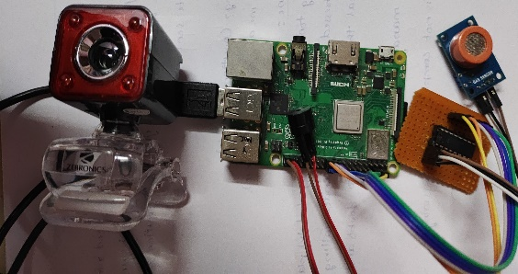

Fig. Hardware Setup of the device

The alcohol detection sensor will detect the alcohol and displays the readings on the screen and if the levels are more than the given threshold alert will be given. Same is the case for drowsiness. Whenever the driver’s eyes are closed for a certain period of time the buzzer will get activated.

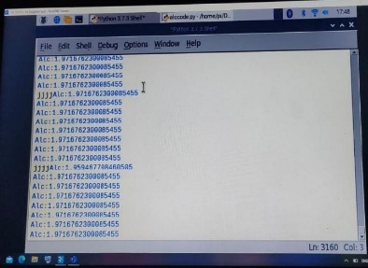

Fig. Readings of Alcohol Detector Fig. Eye detection using live camera

1. **CONCLUSION**

All over the world many accidents are occurring. Only in India the no. of deaths per day is 25,649. Deaths that occur due to road accidents is 462 per day. Majority of the reasons for road accidents is drunk driving or feeling dizzy while driving. To overcome and prevent this from occurring we have come up with an IoT implementation to detect the alcohol and drowsiness of the driver. This system senses the alcohol levels and if it crosses the specified threshold it gives an alert sound. Also if the driver feels dizzy while driving the vehicle , then the camera captures the movement of the eyelids and if the eyes are closed for more than a certain number of times it gives an alert sound and sends alert messages to the registered numbers. This setup will be active whenever the car starts or in motion. It will continuously detects both alcohol presence and drowsiness. Using MQ3(analog gas sensor) alcohol will be detected and using a live camera drowsiness will be detected. These devices will be connected to Raspberry pi. As the problem, increase in the rate of deaths due to road accidents is globally present this device would aid in preventing the same and we hope that this would be helpful for everyone.

**REFERENCES**

1.Jesudoss, A., R. Vybhavi, and B. Anusha. "Design of Smart Helmet for Accident Avoidance." In 2019 International Conference on Communication and Signal Processing (ICCSP), pp. 0774-0778. IEEE, 2019.

2. Bhone, Rahul Atul. "Computer Vision based drowsiness detection for motorized vehicles with Web Push Notifications." 2019 4th International Conference on Internet of Things: Smart Innovation and Usages (IoT-SIU). IEEE, 2019.

3. Seelam, Kalpana, and Ch Jaya Lakshmi. "An Arduino based embedded system in passenger car for road safety." 2017 International Conference on Inventive Communication and Computational Technologies (ICICCT). IEEE, 2017.

4. Charniya NN, Nair VR (2017) Drunk driving and drowsiness detection. In: International conference on intelligent computing and control (I2C2), Coimbatore.

5. Sharma, P., & Sood, N. (2020). Application of IoT and Machine Learning for Real-time Driver Monitoring and Assisting Device. 11thInternational Conference on Computing, Communication and Networking Technologies(ICCCNT).

6. Viola, Paul & Jones, Michael. (2004). Robust Real-Time Face Detection. International Journal of Computer Vision.

7. Babu, T., Ashwin, S., Naidu, M., Muthukumaaran, C., & Ravi Raghavan, C. (2019). Sleep Detection and Alert System for Automobiles. Advances in Manufacturing Technology. 113-118. Springer, Singapore, 2019.

8. Ram Kumar S., Shripriyam S., Vinithraja R., Manikandan G., & Sandeep M (2021). A Study on the Efficacy of Alcohol Detection in the prevention of Drunken Driving. 2021 International Conference on Chemical, Mechanical and Environmental Sciences (ICCMES).