**SEVA: A Real-Time solution for Food Donation and Hunger Alleviation**

**Vikas Kumar1  Sonal Raj2**

[**vikasthakur4705@gmail.com**](mailto:vikasthakur4705@gmail.com)[**singh2001monty@gmail.com**](mailto:singh2001monty@gmail.com)

Lovely Professional University Lovely Professional University

Phagwara, India Phagwara, India

**Abstract**

**Food is the most primary need for every individual. On an average 10% of the world population goes to bed hungry each night which is around 828 million people. On the other hand, only household across the world wastes more than one billion meals per day. AS we know waste of food is a global misfortune and this study focus on to overcome with this misfortune by creating an application named SEVA, which will help to reduce the hunger levels and control food waste. This application will help both community receiver as well as doner. With the help of this application doner community (NGOs, Charities, Local citizens, Restaurants etc.) can list there left over foods and needy one can receive food and will not have to sleep hungry. This application will not only help in normal days but will be more effective during pandemics and crisis – the most recent example is COVID-19. This application also focuses on how use of modern technology can help millions to have a good health and we can save our environment too. With the help of login/Registration facility this application will provide security and interest of people.**

*Key words – food insecurity, doner, modern technology, NGOS, hunger level, a real-time solution, pandemics, crisis.*

**1.Introduction**

**In the current landscape of India, hunger remains a persistent challenge, particularly evident in marginalized communities and rural areas. Despite the nation's advancements, millions of individuals continue to face food insecurity and malnutrition, reflecting a high hunger index that demands urgent attention. Factors such as poverty, unequal resource distribution, and disruptions like the COVID-19 pandemic exacerbate this issue, necessitating effective solutions to alleviate the plight of those affected. [4].**

**The Seva app emerges as a beacon of hope amidst these challenges, offering a multifaceted approach to tackle both hunger and food waste. Leveraging technology, Seva serves as a bridge between surplus food sources such as homes, restaurants, and events, and individuals or communities in need. [11] By connecting surplus food to those facing hunger, Seva addresses the immediate concerns of food insecurity while also combatting the wastage of edible resources.**

**At the household level, Seva enables** users to contribute to hunger alleviation by donating excess food, thereby **reducing food waste within their own homes. This simple yet impactful action not only ensures that edible items do not go to waste but also provides essential nourishment to those who need it most. Additionally, Seva extends its reach to restaurants, empowering businesses to minimize food wastage by donating unsold items to charitable organizations or community kitchens. This not only reinforces social responsibility but also fosters a sense of collective action in addressing societal challenges.**

**Furthermore, Seva plays a crucial role in managing food surplus during large events such as weddings and parties. By facilitating the coordination of food donations, the app ensures that excess food from these gatherings is redirected to individuals in need, rather than being discarded. This not only reduces food waste but also ensures that surplus resources serve a meaningful purpose in supporting vulnerable populations.**

**Beyond its immediate impact on hunger alleviation, Seva also contributes to broader environmental sustainability efforts. “Sustainability means meeting our present need without any compromising the ability of future generations to meet their own needs”. By reducing food waste, the app minimizes methane emissions from landfills and conserves resources used in food production, aligning with principles of responsible consumption and environmental stewardship. As Seva continues to expand its reach and impact, it holds promise for significantly mitigating hunger and food insecurity in India. Moreover, by fostering a culture of responsible consumption and waste reduction, Seva paves the way for a more equitable and sustainable future for all.[2]**

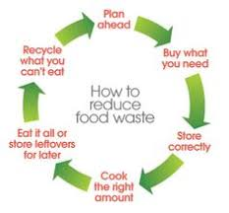

**Fig.1.SustainableFuture [9]**

**The Seva app serves as a mediator between food suppliers (example-vendors) and consumers, facilitating communication and transactions between the two parties. Within the app, a knowledge base (KB) is established to enable users to interact and exchange information. Both suppliers and consumers can create accounts by providing relevant details to tailor their profiles. For instance, suppliers can input information regarding the type of food they intend to donate, quantity, expiry date, perishability, and other pertinent details. These entries are mandatory to ensure transparency and allow consumers to make informed decisions about the food.**

**Geographic and temporal parameters are incorporated into the app to ensure the freshness of food upon delivery. Certain foods have short shelf lives, so distance and time constraints are factored in based on addresses and availability times [2]. Principles from constraint satisfaction problems in artificial intelligence (AI) guide the execution of these constraints, ensuring efficient and effective matching between suppliers and consumers.**

**The app's name, SEVA, is derived from the Sanskrit word meaning "selfless service," reflecting the ethos of compassion and care for others above oneself, prevalent in many South Asian cultures. This concept is particularly relevant in light of the COVID-19 crisis, which has exacerbated food-related issues. Seva embodies the practice of placing the needs of others above our own, emphasizing health, safety, and community support.**

**In response to food wastage resulting from restaurant closures during the pandemic, initiatives like SEVA have emerged to convert surplus food into opportunities to serve essential workers and support local businesses. By connecting surplus food with those in need, Seva contributes to efforts to alleviate food waste and hunger, particularly during times of crisis.**

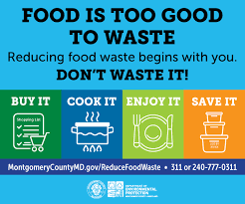

**Fig.2.Reduce/Avoid food waste [10]**

**In addition to the functionalities outlined, the SEVA app incorporates various other concepts and methodologies to enhance its effectiveness and user experience.**

**Metaphors play a crucial role in the app's design, as they are used to create intuitive user interfaces and facilitate understanding. For instance, the concept of a "bridge" metaphorically represents the app's role as a connector between food suppliers and consumers, making the interface more relatable and easier to navigate.**

**Clear affordances are integrated into the app's design to guide users on how to interact with it. Buttons, menus, and prompts are designed to intuitively suggest their functions, enhancing usability and ensuring a seamless user experience.**

**Throughout the design and development process, the needs and perspectives of all stakeholders are carefully considered. This includes food suppliers, consumers, and potential beneficiaries. By incorporating stakeholder feedback, the app is tailored to meet their requirements and expectations effectively.**

**Ethnographic research methods may be employed to gain insights into users' behaviors, preferences, and cultural contexts. These insights inform design decisions and feature prioritization, ensuring that the app resonates with its target audience and addresses their specific needs.**

**Wireframing techniques are utilized to create low-fidelity prototypes of the app's user interface. This allows for iterative design refinement and feedback collection from stakeholders before proceeding to full development, ensuring that the final product meets user expectations.**

**Principles from constraint satisfaction problems are applied to ensure that the app's functionalities meet specified constraints and requirements. For example, geographical and temporal limitations for food donation transactions are carefully considered to optimize the user experience and ensure efficient operation.**

**Additionally, the app incorporates commonsense knowledge about food safety, hygiene practices, and cultural sensitivities. This ensures that all interactions and transactions conducted through the app are responsible and ethical, maintaining the integrity of the platform and fostering trust among users.**

**Moving forward, the design, development, and evaluation of the Seva app will proceed iteratively. The current prototype will undergo enhancements based on user feedback and usability testing, with the goal of a full release to the public. The roadmap includes further refinements to the app's features, performance optimizations, and usability improvements, ensuring a successful and impactful launch.**

**2. Literature review**

1. In 2023 Yash Nand Kumar Patil et al.[1], proposed Donate Bite: Food Donation Application, a mobile based application to help and address food insecurity and reduce food waste. This application aims to reduce food waste and user can easily donate their surplus food by posting information about the food items, their location and their availability. This paper also mentioned about community involvement and social impact as this will encourage more and more people to get involved in saving and using them for needy one.

**2. In 2023 Saurav Sushil et al.[2], proposed FEED-Food Enduetion and Donation, a mobile based application for connecting food doner to individual as well as organizations helping those who are in need. This application was basically for practical purpose on hostels. This paper also pays attention on their future goals to modernize their application with the help of AI and focus on reducing poverty and improving public health.**

**3. In 2021 Christina Varghese et al.[3], developed an app (mobile based ) called SeVa: A Food Donation App for Smart Living, which basically focus on to provide a platform from which anyone can see the availability of food resources in their local areas where doner can be restaurants, stores, as well as food distribution centers and solve two major issues, i.e hunger and food waste. With the help of AI (smart cities) it makes a positive impact in both field environment and healthcare.**

**4. In 2022 Aashish Khandkar et al.[4], focus on developing an app (mobile application) which will be providing a platform to have access of food resources available as well as for doners too for donating food and resolve to major problem which is hunger and food insecurity and improves the health quality of poor people.**

**5. In 2023 Sakshi S. Sorate et al[5], focus on developing a mobile app known as Zero Hunger whose aim is to eliminate food waste with the help of leftover food items in restaurants, stores, distribution centers. This paper focus on how this mobile application will solve two major problems which is hunger and food waste by gaining the access of food resources available in local community.**

**6. In 2021 John Amiel R. Morilla et al.[6], proposed a mobile and web application for sharing food to those who are in need and help them to figure out there poor nutrition and early death which is known as Foodernity. This paper focus on how this application will help low-income people in normal as well as in crisis like situation example is COVID-19 pandemic.**

**7. In their WASTE FOOOD MANAGEMENT APPLICATION, MSV Kamble, et al [7], had said about rapidly increasing food waste so they had offered a platform to connect hotels/restaurants, charities and individuals so that they will get an information about leftover food and can have access to that.**

**8. In their android application Arvind Kumar Pandey et al [8], which is known as Donatify, had proposed an application for linking of two community hunger people and food donors. And most interesting thing is that they had focused on android system as it is mostly and commonly used.**

**3. Objective**

**1. Addressing Food Waste and Hunger: Seva’s primary goal is to combat food waste and hunger by creating an efficient platform for the redistribution of surplus food resources. By connecting food suppliers with consumers in need, Seva ensures that edible items are utilized rather than wasted, thereby alleviating food insecurity.**

**2. Facilitating Food Redistribution: Seva serves as a seamless intermediary between food suppliers (vendors) and consumers, providing a user-friendly platform for the donation and acquisition of surplus food items. This facilitates the efficient redistribution of food resources, ensuring that no edible item goes to waste.**

**3. Promoting Community Support: Seva fosters principles of compassion and community support by encouraging individuals, businesses, and organizations to contribute to the well-being of others through food donation. By facilitating acts of kindness and generosity, Seva strengthens social bonds and promotes a culture of solidarity.**

**4. Embracing Sustainable Practices: Through its focus on reducing food waste, Seva contributes to broader sustainability efforts by minimizing the environmental impact of discarded food items. By promoting responsible consumption and resource utilization, Seva aligns with principles of environmental stewardship and conservation.**

**5. Empowering Users: Seva empowers both food suppliers and consumers by providing them with a platform where they can actively participate in addressing food waste and hunger. By facilitating direct engagement and collaboration between stakeholders, Seva enables individuals to make a tangible impact on their communities and contribute to positive social change.**

**6. Enhancing Food Security: By ensuring that surplus food reaches individuals and communities facing food insecurity, Seva plays a vital role in enhancing food security. Through its efficient redistribution mechanism, Seva helps to bridge the gap between food surplus and food scarcity, ensuring that everyone has access to nutritious meals.**

**7. Reducing Economic Burden: For food suppliers, Seva offers a cost-effective solution for managing surplus food inventory. By donating excess food through Seva, suppliers can reduce disposal costs and potentially qualify for tax benefits, thus alleviating the economic burden associated with food waste.**

**8. Promoting Health and Well-being: Access to nutritious food is essential for maintaining health and well-being. By facilitating the donation of surplus food items, Seva ensures that individuals and families in need have access to wholesome meals, thereby promoting better health outcomes and overall well-being.**

**9. Fostering Collaboration: Seva encourages collaboration and partnership among various stakeholders involved in the food supply chain, including suppliers, consumers, non-profit organizations, and government agencies. By bringing together diverse perspectives and resources, Seva enhances the collective impact of efforts to address food waste and hunger.**

**10. Catalyzing Social Change: Ultimately, Seva aims to catalyze social change by raising awareness about the interconnected issues of food waste and hunger and inspiring action at the individual, community, and societal levels. Through its innovative approach and collaborative ethos, Seva seeks to create a more equitable and sustainable food system for all.**

**4. Flow of Methodology**

4.1 Data Collection Methods for Assessing the Novelty of the SEVA Project

Surveys:

Designing surveys targeted at donors, recipients, and other stakeholders involved in the SEVA project.

Including questions to assess their experiences with the platform, perceived effectiveness of its features, and suggestions for improvement.

Utilizing Likert scales, open-ended questions, and demographic inquiries to gather diverse feedback.

Interviews:

By Conducting semi-structured interviews with key stakeholders, including developers, administrators, donors, and recipients.

By Exploring qualitative insights into the usability, functionality, and impact of the SEVA platform.

By Tailoring questions to delve into specific aspects such as user satisfaction, challenges faced, and suggestions for enhancements.

Observation:

Observe real-time usage patterns and interactions on the SEVA platform.

Track metrics like posting frequency by donors, response times from recipients, and overall engagement levels.

Note any user behaviors or platform dynamics that indicate the effectiveness of its features.

Platform Metrics Analysis:

Analyze quantitative data collected from the SEVA platform.

Examine metrics such as user demographics, donation frequency, geographical distribution of donations, and temporal trends.

Use statistical tools to identify patterns and correlations that indicate the platform's impact and reach.

Comparative Analysis:

Compare the features and functionality of the SEVA platform with existing food donation platforms.

Review documentation, conduct user testing, and analyze user feedback from other platforms.

Identify unique selling points and innovative aspects of the SEVA project through this comparative assessment.

Case Studies:

Explore specific case studies or success stories from the SEVA platform.

Highlighting instances where real-time functionality, centralized management, user-friendly interface, and sustainable practices have made a significant impact.

Provide qualitative narratives to complement quantitative data, showcasing the tangible benefits of the SEVA project

.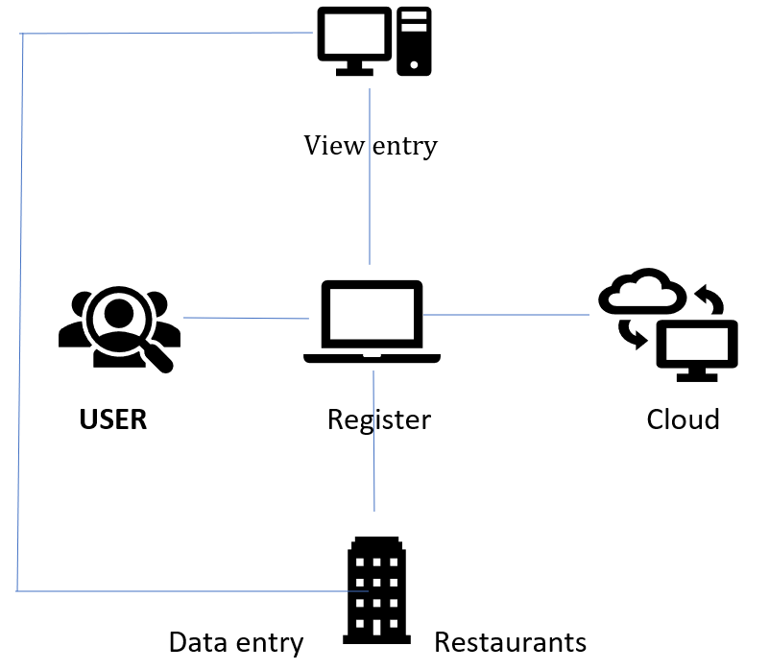

Fig 3. Basic working / Structure

4.2. Techniques for Assessing the Novelty of the SEVA Project

Qualitative Analysis:

Thematic Analysis: Analyzing qualitative data from interviews and open-ended survey responses to identify recurring themes related to the SEVA platform's novelty and effectiveness.

Content Analysis: Examine textual data, such as user feedback and case studies, to identify patterns and insights regarding the platform's innovative features and their impact on food sustainability and social welfare.

Quantitative Analysis:

Descriptive Statistics: Summarize quantitative data collected from surveys and platform metrics, providing key numerical indicators such as mean donation frequency, user satisfaction scores, and distribution patterns.

Comparative Analysis:

Compare quantitative metrics between the SEVA platform and other food donation platforms to identify statistically significant differences in performance, usability, and impact.

Correlation Analysis: Explore relationships between different variables, such as user demographics and platform engagement metrics, to understand factors influencing the adoption and effectiveness of the SEVA project.

Mixed-Methods Analysis:

Triangulation:

Integrate findings from both qualitative and quantitative analyses to provide a comprehensive understanding of the SEVA platform's novelty and impact.

Convergence: Identify areas of convergence or divergence between qualitative themes and quantitative metrics to validate findings and draw robust conclusions about the platform's effectiveness in addressing food sustainability and social welfare.

Comparative Evaluation:

Feature Comparison: Conduct a detailed comparison of the SEVA platform's features with those of existing food donation platforms, highlighting its unique innovations and advantages.

Performance Benchmarking: Benchmark the SEVA project against industry standards and best practices in food donation technology, assessing its performance in terms of efficiency, user satisfaction, and sustainability outcomes.

Feedback Analysis:

Sentiment Analysis: Analyzing sentiment in user feedback collected through surveys, interviews, and platform interactions to gauge overall satisfaction and identify areas for improvement.

Feedback Clustering: Group similar feedback into clusters or categories based on themes or topics, facilitating a structured analysis of user perceptions and experiences with the SEVA platform.

Impact Assessment:

Outcome Evaluation: Assess the tangible outcomes and impact of the SEVA project on food sustainability and social welfare indicators, such as reduction in food waste, increase in food access for vulnerable populations, and promotion of sustainable consumption practices.

Cost-Benefit Analysis:

Evaluate the costs associated with implementing and maintaining the SEVA platform against the benefits accrued in terms of societal welfare and environmental sustainability, providing insights into its cost-effectiveness and long-term viability.

4.3. Evaluation Criteria for Assessing the Novelty of the SEVA Project:

Efficiency:

Measure the SEVA platform's efficiency in facilitating food donations by analyzing factors such as transaction processing times, resource utilization, and operational costs.

Assess how efficiently the platform matches donors with recipients in real-time, minimizing delays and maximizing the utilization of available resources.

Effectiveness:

Evaluate the effectiveness of the SEVA project in achieving its objectives, such as reducing food waste, increasing food access for vulnerable populations, and promoting sustainable consumption practices.

Analyze quantitative metrics, such as the number of successful donations facilitated through the platform, and qualitative feedback from users to assess the platform's overall impact.

Scalability:

Assess the scalability of the SEVA platform in accommodating growth in user base and transaction volume over time.

Evaluate the platform's ability to handle increasing demand without compromising performance or user experience, considering factors such as system architecture, infrastructure scalability, and resource allocation.

User Satisfaction:

Measure user satisfaction with the SEVA platform through surveys, interviews, and feedback analysis.

Assess users' perceptions of platform usability, functionality, reliability, and responsiveness, as well as their overall satisfaction with the donation experience provided by the platform.

Contribution to Food Sustainability Goals:

Evaluate the extent to which the SEVA project contributes to broader food sustainability goals, such as reducing food waste, promoting equitable food distribution, and fostering sustainable consumption practices.

Analyze the platform's impact on key indicators of food sustainability, such as the diversion of surplus food from landfills, the redistribution of excess food to food-insecure populations, and the promotion of sustainable food production and consumption habits.

By using these evaluation criteria, researchers can assess the novelty and effectiveness of the SEVA project in addressing food sustainability and social welfare challenges, providing valuable insights to stakeholders and informing future enhancements and interventions in the field of food donation technology.

Technology:

The SEVA project incorporates a diverse array of technologies spanning frontend and backend development, cloud services, and database management systems to streamline food donation processes and address food sustainability and social welfare concerns.

Frontend Technologies:

UI Design: Pretty buttons for easy software use.

SEVA prioritizes a user-friendly interface to enhance accessibility and usability for donors and recipients alike.

HTML/CSS/JavaScript: HTML is for structuring web content, CSS is for styling that content, and JavaScript is for adding interactivity and behavior to web pages.

Standard web technologies are employed for front-end development to create interactive and responsive user interfaces.

C (ASP.NET Core): ASP.NET Core is an open-source, cross-platform framework for building modern, cloud-based, and scalable web applications using the C programming language.

This backend framework is utilized for server-side logic, managing user requests, data operations, and facilitating real-time interactions.

Backend Technologies:

C (ASP.NET Core): ASP.NET Core is an open-source, cross-platform framework for building modern, cloud-based, and scalable web applications using the C programming language.

The core backend logic of the SEVA application is developed using ASP.NET Core, a versatile framework for building web applications and services with C#.

Cloud Technology: Cloud technology refers to the use of remote servers hosted on the internet to store, manage, and process data, providing on-demand access to computing resources and services.

SEVA leverages cloud services like Microsoft Azure or Amazon Web Services (AWS) for hosting, ensuring scalability, reliability, and accessibility from anywhere.

Database Management: Database management involves overseeing the storage, retrieval, and manipulation of data within a structured system for efficient data handling.

A robust database management system (DBMS) is integral to storing and managing data related to food donations, user profiles, and transactional information.

MySQL: MySQL is an open-source relational database management system (RDBMS) that utilizes SQL (Structured Query Language) for managing and querying data.

As a popular open-source relational database management system, MySQL may be utilized for efficient data storage and management within the SEVA application.

Real-Time Functionality: Real-Time Functionality involves instant data updates.

Signal R: Signal R is an ASP.NET library facilitating real-time communication between server and client.

SEVA integrates Signal R, a library enabling real-time web functionality, facilitating immediate communication and updates between donors and recipients.

Web Sockets: Web Sockets enable real-time bidirectional communication between a client and a server over a single, persistent connection.

Real-time features may be implemented using Web Sockets, establishing bidirectional communication channels between clients and the server.

Other Frontend and Backend Technologies:

Bootstrap or other CSS frameworks:

These are employed for responsive and mobile-friendly UI design within the SEVA application.

Entity Framework Core: Offering an object-relational mapper (ORM), Entity Framework Core enables seamless interaction with the MySQL database within the ASP.NET Core application.

JWT (JSON Web Tokens): JWT (JSON Web Token) is a secure way to send info online. Imagine a tiny, signed note carrying data! Used for authorization, it lets users access things without always logging in.

Used for secure authentication and authorization, JWT ensures the integrity of user access to the SEVA platform.

RESTful APIs: RESTful APIs are like menus for apps. They use simple commands (GET, POST, PUT, DELETE) to request data (like ordering food) from a server in a way different apps can understand.

SEVA may expose RESTful APIs to facilitate integration with external systems or services, enabling data exchange and functionality extension.

Additional Technologies and Tools:

Version Control:

Tools such as Git with GitHub or Azure DevOps are employed for collaborative development and code management.

IDE (Integrated Development Environment):

Developers may opt for Visual Studio or Visual Studio Code, offering robust capabilities for writing, debugging, and testing code.

Unit Testing Frameworks:

Utilized to ensure code quality and reliability through automated testing, options include N Unit or MS Test for C.

By integrating these frontend and backend technologies, alongside cloud services and robust database management systems like MySQL, the SEVA project aims to provide a scalable, user-friendly platform facilitating food donations, addressing food sustainability challenges, and promoting social welfare.

We explain the design of our Seva app that deploys several principles from HCI. A good interaction design must incorporate targeted users’ needs and concerns. Thus, our app design entails the following steps.

1. Stakeholder Identification: In the context of Human-Computer Interaction (HCI), stakeholders refer to individuals or organizations directly or indirectly influenced by the system and who can impact its requirements. For Seva, stakeholders include NGO managers, café and grocery store owners, reflecting a diverse demographic mix, primarily from the NJ-NY area for accessibility.

2. Social Interaction for Interface Design: Stakeholder interviews are conducted during interface design to gather suggestions and opinions, shaping app usability. Ethnographic studies involve direct observation and comprehension of stakeholders' work processes, informing app layouts with data like leftover food quantities and food attributes.

3. Conceptual Design Construction: Wireframes, initial mock up designs serving as blueprints, are created for Seva based on creative ideas, stakeholder suggestions, and ethnographic study data. Entry fields like "storage method" for suppliers and "allergy/dietary restrictions" for consumers are included to address critical issues.

4. Design Evaluation by Stakeholders: Stakeholder feedback on wireframes guides design refinement. Questionnaires and discussions facilitate feedback collection, leading to revisions such as the inclusion of descriptive icons for quick

comprehension, reflecting stakeholder input.

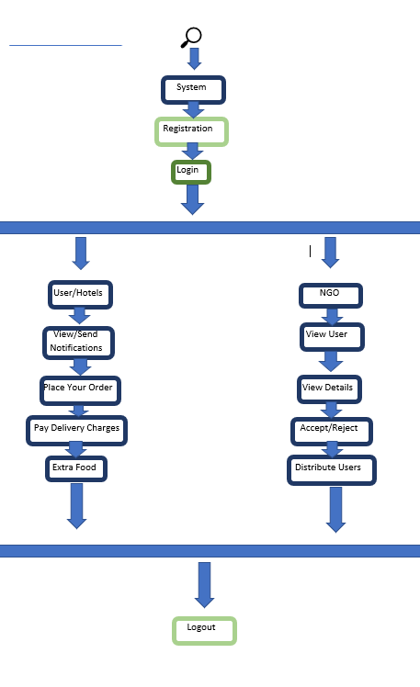

fig (4)

Working of the application

5. Final App Design: The final app design, often iterative in HCI, proceeds with one iteration due to Seva’s prototype phase and focused target region. Stakeholder cooperation and satisfactory evaluations contribute to this streamlined process. The design adheres to HCI principles like affordance, ensuring functions are evident through appearance, akin to common sense knowledge in AI, fostering intuitive user interaction.

**5.Future Scope**

The main aim of this project is to tackle food insecurity through a comprehensive approach. We'll leverage a mobile application, names as SEVA, to connect surplus food with those in need. SEVA will expand its reach to new areas, ensuring wider accessibility. Collaboration with different doners will play a key role – we will also partner with government and private agencies to amplify our impact. Recognizing the knowledge gap, we will launch awareness campaigns to educate the public on food waste reduction strategies. This app itself will undergo continuous improvement with the help of future needs and people reviews. New features will prioritize food distribution based on user needs and availability. User feedback will be actively incorporated to enhance SEVA's functionality. Sustainability is a core value. We'll utilize eco-friendly packaging and innovative waste management techniques. Finally, we'll build a strong team with experts specifically chosen to address the challenges at hand. Through these combined efforts, we strive to create a more efficient and sustainable solution to food insecurity with the help of modern technology.

**6. Conclusion**

The SEVA app will solve the world (India) struggles of hunger and food waste through a user-friendly platform. It connects donors with leftover edible food, such as restaurants and households, to individuals in need. This tech-driven solution tackles both sides of the issue: reducing food insecurity by ensuring access to meals, and promoting environmental well-being by reducing food waste. By incorporating features like secure logins, food safety guidelines, and potentially a map-based system for efficient distribution, SEVA has the potential to be a powerful tool. Further development focusing on user experience, logistics, and potential volunteer opportunities can solidify SEVA's impact in creating a world (India) free from hunger and excessive food waste.

**7.References**

1. Pati, Y. N., Srinivasan, S., Shrike, S. R., & Patil, M. Donate Bite: Food Donation Application.

2. Sushil, S., Fernandes, N., Daga, P., & Shaikh, S. (2023, December). FEED-Food Enduetion and Donation. In *2023 6th International Conference on Advances in Science and Technology (ICAST)* (pp. 400-404). IEEE.

3. Varghese, C., Pathak, D., & Varde, A. S. (2021, January). SeVa: a food donation app for smart living. In *2021 IEEE 11th Annual Computing and Communication Workshop and Conference (CCWC)* (pp. 0408-0413). IEEE.

4. Khandkar, A., Gawali, P., & Aswar, A. FOOD WASTE MANAGEMENT USING ANDROID.

5. Sorate, S. S., Dhumal, P. P., Girigosavi, Y. S., Pharande, P. S., & Pawar, A. ZERO HUNGER.

6. Morilla, J. A. R., Bagsic, F. C., Cruz, M. K. D., Patio, C. D. A., & Yabut, E. R. (2021, December). Foodernity: A Mobile and Web Application for Food Sharing. In *2021 1st International Conference in Information and Computing Research (ICORE)* (pp. 90-95). IEEE.

7. Kamble, M. S. V., Patil, M. S. V., Bhadake, M. A., & Kokane-Pawar, M. C. WASTE FOOD MANAGEMENT APPLICATION.

8. Pandey, A. K., & Patel, P. (2023, May). An Android Application Development for Food Donation: A Geographical Location Based Approach. In *2023 3rd International Conference on Advance Computing and Innovative Technologies in Engineering (ICACITE)* (pp. 2137-2140). IEEE.

9.**https://www.pinterest.com/mrmasoodtariq1/brochure/ [Fig1].**

10.**https://wtop.com/sponsored-content/2023/04/small-changes-can-have-a-big-impact-on-food [Fig2]**

**11.** Veenoth, A., Shankarvelu, L., Hakimi, H., Marlia, Z., & Octaviani, D. (2023). Food Donation Application to Improve the Distribution and Verification Process Within Selangor: Feedback. *Journal of Applied Technology and Innovation (e-ISSN: 2600-7304)*, *7*(3), 7.

.

.

.

.