**Two-Elements MIMO Antenna with Inverted**

**F-Shaped Stubs for UWB Applications**

**Merlyn Sylvester1, Alok Kumar Rastogi (FIETE)2, Pragyesh Kumar Agrawal3**

*1Department of Physics & Electronics, Institute for Excellence in Higher Education, Bhopal, India*

*2Department of Physics & Electronics, Institute for Excellence in Higher Education, Bhopal, India*

*3 Institute for Excellence in Higher Education, Bhopal, India*

*Contact:9074410868, E-mail: merlynsheena19@gmail.com*

**Abstract:**

*A MIMO (Multiple input multiple output) antenna system with two elements, which are designed with coupled grounds for UWB application is presented. The MIMO antenna system consists of Butterfly shaped patches with circular slots at the centre and a defected ground structure (DGS) with inverted F-shaped stub to enhance antenna impedance matching. The operating frequency is taken from 2 to 14 GHz. This antenna’s area is 35mm × 50mm and is mounted on single layer substrate of FR-4 with 1.6mm thickness and dielectric constant ↋r =4.4. The observations of antenna are showcased with the help of S11, ECC, VSWR, DG and TARC. The results are analysed which shows that the designed two element MIMO antenna array can effectively be utilized for UWB applications.*

***Keywords:*** *MIMO antennas, Ultra-Wideband (UWB) Defective Ground Structure (DGS), Envelop Correlation Coefficient (ECC), Voltage Standing Wave Ratio (VSWR), Diversity Gain (DG), Total Active Reflection Coefficient (TARC).*

1. **Introduction**

Recent researches indicate that UWB technology has become popular in the wireless transmission world. It has many benefits when compared with old narrowband technology such as availability of multipath diversity, high data rate and low power consumption [1]. UWB technology is the prospective applicant for wireless communication ever since the FCC (Federal Communication Commission) approved band of 3.1 to 10.6 GHz (unlicensed frequency band) for some UWB devices applications [2]. MIMO technology can boost the capacity of the channel with the use of many antennas, which create the effectiveness of the antennas in overpopulated zones by giving high efficiency and data rates in Gigabits/s [3]. Additionally, the technique of MIMO can effectively utilize the inter-element coupling and also correlation of antenna is minimum. The utilization of more than one antenna in a device brings minimum spacing between the elements and results in very less isolation [4]. A suitable method is to use a planar antenna with slots that gives bandwidth enhancement [5].

The bandwidth impedance of monopole printed antenna by the length of the ground. And cutting slots of different structures and sizes on the back of ground can substitute the distribution of surface current of a monopole antenna which can alter the impedance bandwidth. This kind of slotted geometry of the ground plane is called the DGS [6], [7]. In any MIMO; mutual coupling is a major requirement. Many researches have been done to diminish the mutual coupling. By utilizing the slots in the defected ground structure, the mutual coupling and channel capacity can been boosted in MIMO system [8]. DGS is utilized to maximize the impedance bandwidth and these types of antenna are energized by the co-axial probe [9], [10]. To acquire wide bandwidth impedance, a patch with a radiator of circular-shape which is coupled with reformed ground plane was utilized. This radiator does not radiate so as to approach each other directly, which gives high quality isolation. As a part of literature review some of the design considerations that came up are listed as: To boost the isolation the inverted L-shaped stubs and CSRR was created on the back of antenna [11]. On the T-shaped stub ground plane a vertical slit was created, an F-shaped ground and an inverted L-shaped stub were utilized in the 2 element antenna array UWB-MIMO to maximize the isolation [12]-[14]. The developed 2 element MIMO antenna array is kind of 2 inverted L-shaped stubs and CSRR which are utilized to achieve isolations between the antennas [15].

A 2- element MIMO antenna array is designed and analyzed with all the characteristics of MIMO in this paper. The presented antenna consists of a Butterfly shaped patch with a single circle-shaped slot in the middle with common DGS on the back of antenna. The DGS is an inverted F-shaped stub on the back of antenna. A 2 port antenna is constructed on a layer of FR-4 material with 35x74 (WxL) mm2. The presented 2 element MIMO antenna array have a less mutual coupling (|S21/S12| < -15 dB) between the two ports.

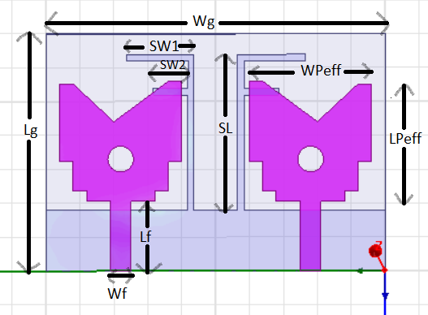

**Fig.1: The proposed Two element MIMO Antenna system with inverted F stub in ground plane**

1. **Designing of an Antenna**

The proposed geometry and configuration of two element MIMO antenna array is presented in Fig. 1. The design includes a substrate with dimensions 35 mm × 50 mm for two element MIMO antenna. Dielectric thickness of substrate is 1.6 mm and 4.4 is the dielectric constant of FR-4 with a dielectric loss tangent of 0.025. The feed line length and width for the both the ports are same. The feed line length is 10.3mm and 3mm is the width of the feed line with 50 ohms input impedance. Two identical monopole antennas are utilized to make the MIMO antenna system. The designed antenna shares a common DGS in the back of antenna. Although the isolation of the monopoles is a consideration in the suggested design, the proposed antenna also provides significant DG, ECC, VSWR and TARC, which are essential characteristics for any MIMO antenna. Table No.1 and 2 shows the design specifications of the proposed 2- element MIMO antenna system.

**Table No.1: Design specifications of the Antenna Front**

|  |  |  |  |
| --- | --- | --- | --- |
| **Parameters** | **Dimension**  **(mm)** | **Parameters** | **Dimension**  **(mm)** |
| **Lg** | **35** | **LPeff** | **17.27** |
| **Wg** | **50** | **WPeff** | **16.08** |
| **Lf** | **10.3** | **c (slot radius)** | **1.9** |
| **Wf** | **3** | **d (distance between patches)** | **6.44** |

**Table No.2: Design specifications of the Antenna Back**

|  |  |
| --- | --- |
| **Parameters** | **Dimension (mm)** |
| **SL** | **23** |
| **SW1** | **10** |
| **SW2** | **5** |

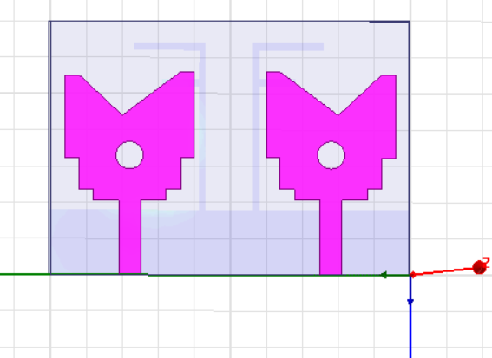 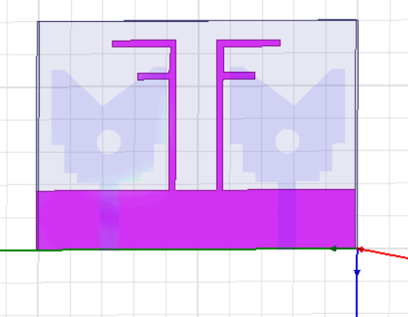

1. **(b)**

**Fig.2: (a) Front View (b) Back View of the proposed Two element MIMO Antenna.**

Fig.2 shows the front and back view of the designed antenna, where the single patch antenna is constructed with a mixture of a symmetrical shape and a circular slot with radius of 1.9mm. Moreover, the designed antenna has common DGS. Furthermore, the MIMO antenna is modified to enhance the isolation by utilizing the inverted F-shaped stubs technique in the ground. Every element is fed with 50 ohms feedline to gain the flawless impedance matching. The distribution of surface current of the constructed MIMO antenna array system is shown in Fig.3 When the port is activated, the monopoles attain high mutual coupling as current is paired with the other radiator. Mutual coupling is decreased by the addition of an inverted F-shaped stubs in the ground of the substrate. The MIMO antenna performance is satisfactory because the stubs are mounted on the plane of ground to maximize the isolation.

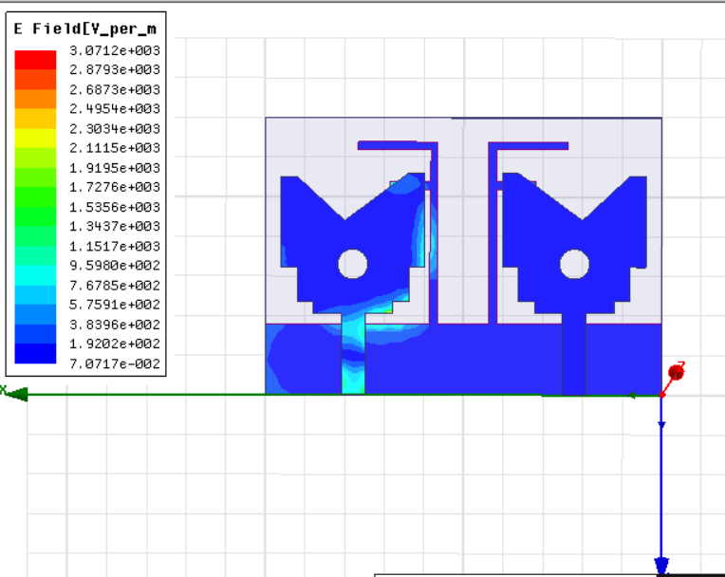

**Fig.3: Surface current distribution of the proposed Two element MIMO Antenna**

1. **Results and Discussion**

The presented antenna is designed on FR-4 substrate material which is having ↋r = 4.4 (dielectric constant) and hs = 1.6 mm (height). HFSS is used for the design and simulation.

**Return Loss:** The simulated S-parameters of the designed MIMO antenna through HFSS Software, is shown in Fig.4 The simulated antenna covers from 2 GHz to 14 GHz bandwidth with S11/S12<-10 dB and S21/S22<-20 dB, which is applicable for the UWB applications.

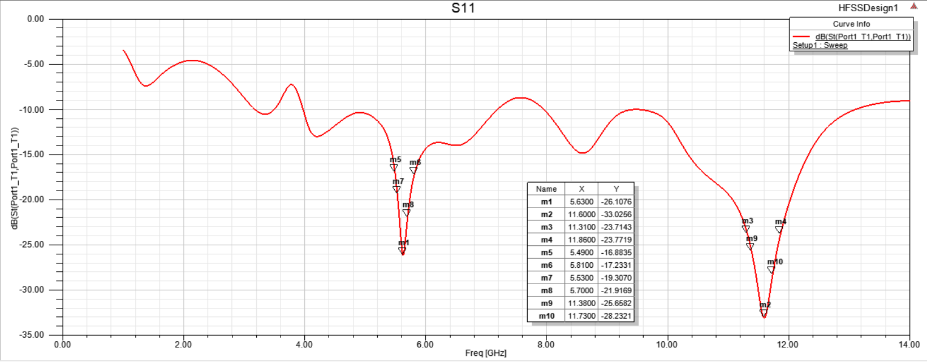

**(a)**

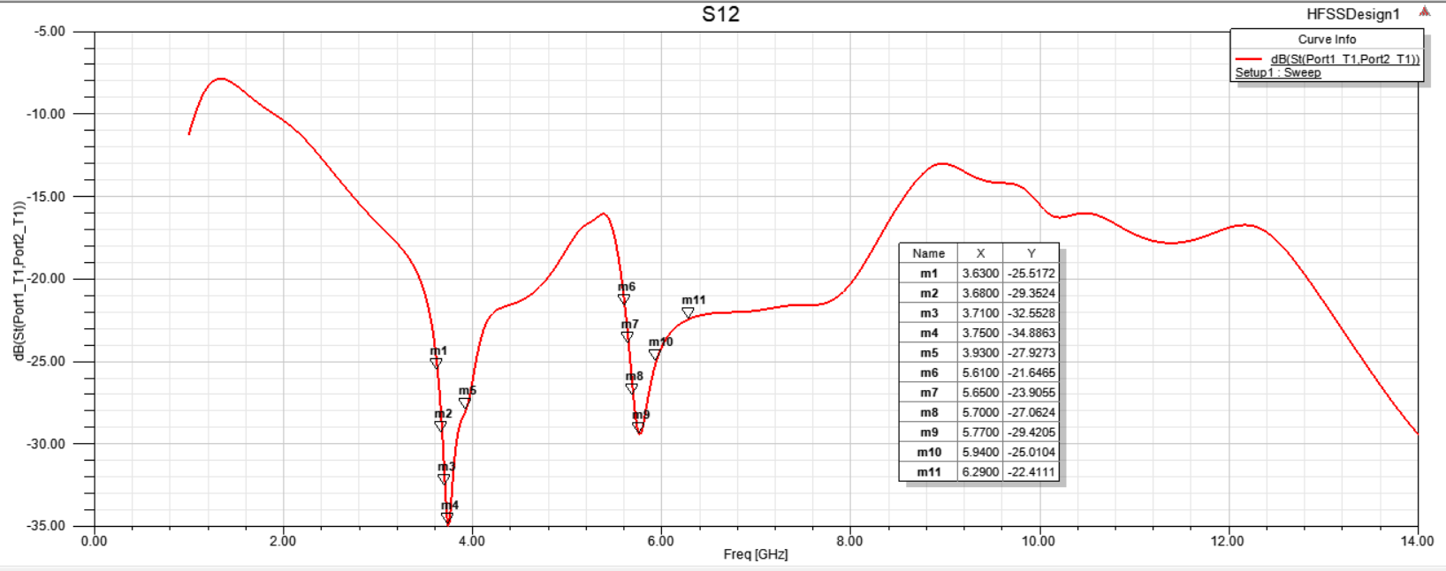

**(b)**

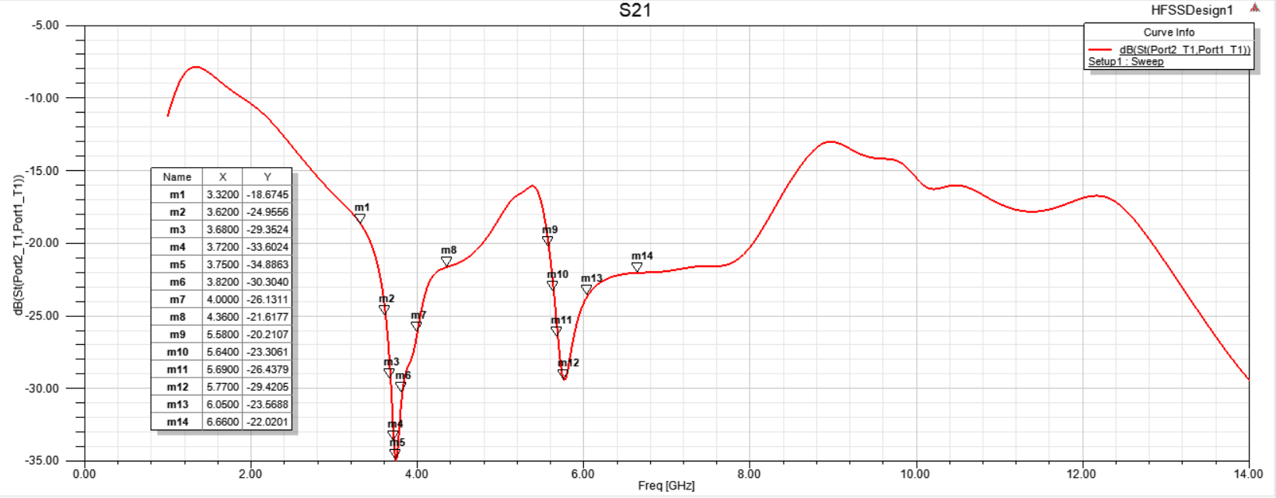

**©**

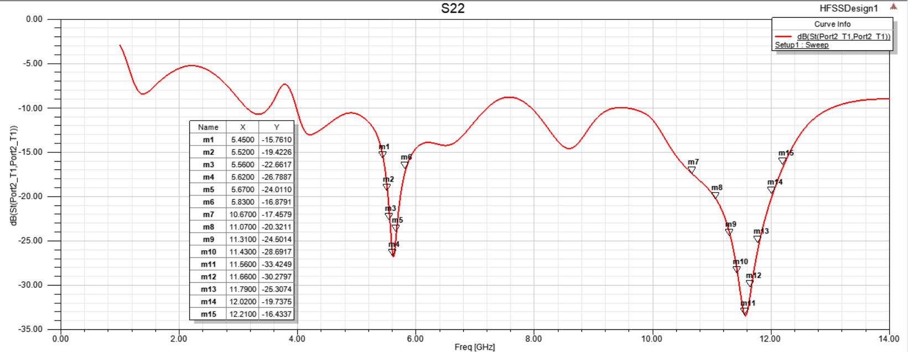

**(d)**

**Fig. 4: Simulated S-parameter (a) S11, (b) S12, (c) S21 and (d) S22 characteristics of the realized two element MIMO Antenna**

**VSWR:** Voltage Standing Wave Ratio (VSWR), often referred as Standing Wave Ratio, is an important antenna parameter. The reflection coefficient, which specifies the power radiated from the antenna, is a function of VSWR. The VSWR results observed through simulation of the MIMO antenna system are presented in Fig.5. The VSWR is described by the following formula if the reflection coefficient is given by the equation-

$VSWR=\frac{1+|Γ|}{1-|Γ|}$**………………..(1)**

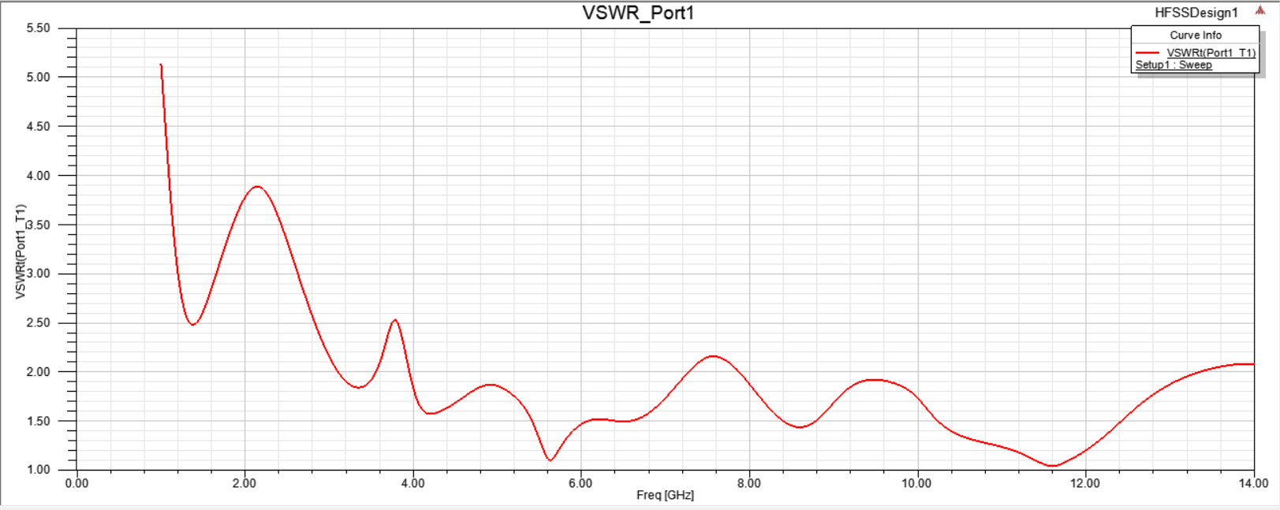

**(a)**

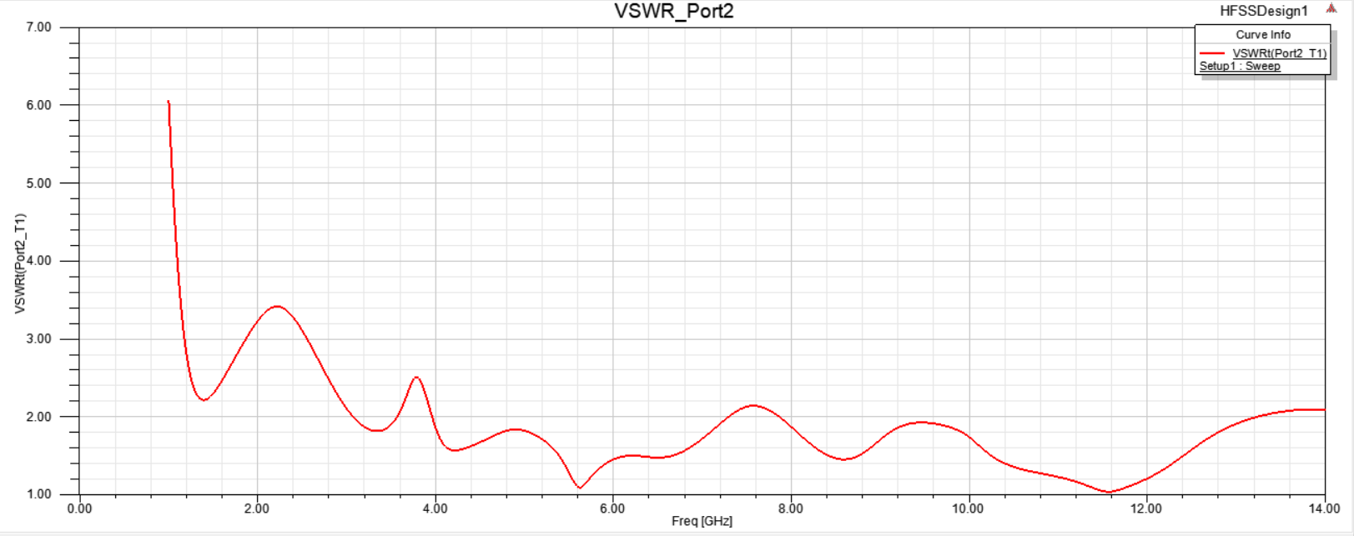

**(b)**

**Fig.5: Simulated VSWR for (a) Port 1 and (b) Port2 of the proposed two element MIMO Antenna.**

**Radiation Pattern:** Fig. 6 and Fig. 7 show the radiation pattern for the two element MIMO antenna at 90 degree and 180 degrees. The simulated and measured 2D radiation characteristics are mapped on two axis planes XZ and XY at 7.5 GHz. The observed result presents the simulated graph through HFSS software, which clearly shows that the proposed antenna design is horizontally polarized.

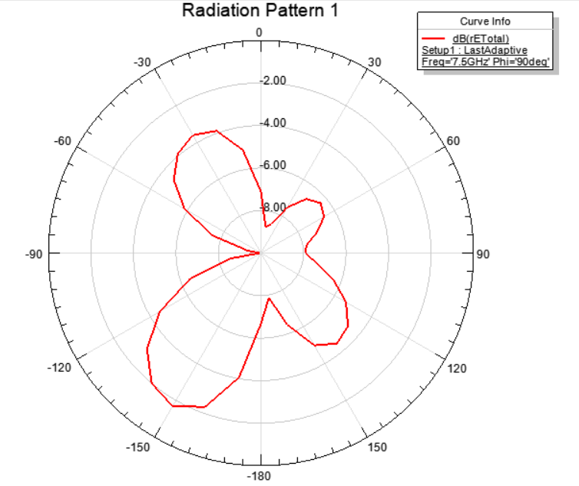

**Fig. 6: The Radiation pattern of the MIMO Antenna at 90 degree for 7.5 GHz.**

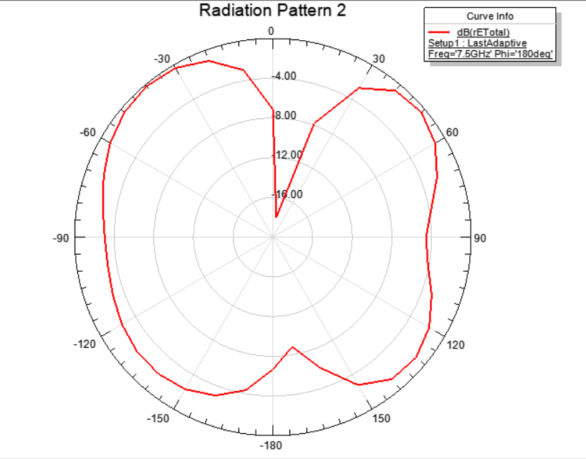

**Fig. 7: The Radiation pattern of the MIMO Antenna at 180 degree for 7.5 GHz.**

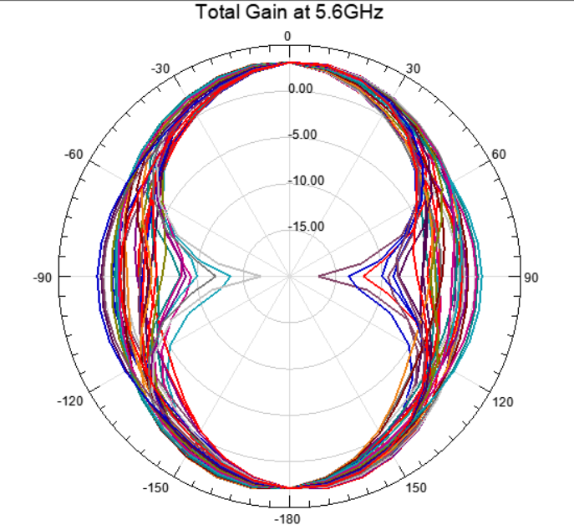

**Fig. 8: The Radiation pattern for total gain of the MIMO Antenna at 5.6 GHz.**

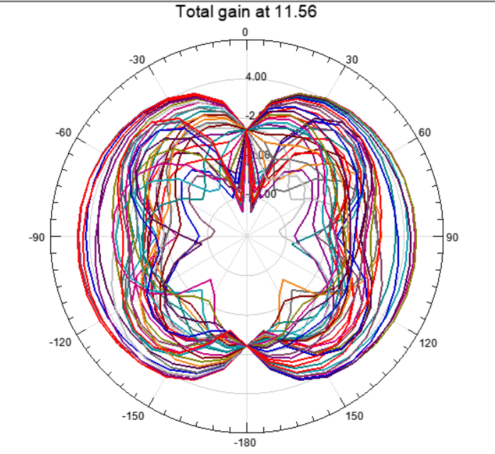

**Fig. 9: The Radiation pattern for total gain of the MIMO Antenna at 11.56 GHz.**

Fig. 8 and Fig. 9 illustrate the total gain of the 2- element MIMO antenna for the two resonant frequencies of 5.6 GHz and 11.56 GHz.

**Envelope Correlation Coefficient (ECC):** For the validation of 2- element MIMO antenna, it is necessary to have the ECC very low. Under ideal conditions, the highest acceptable threshold of ECC is 0.5 for communicating devices. The ECC can be determined by utilizing the relations between S-parameters which is given as follows;

***ECC = |S11*S12+S21*S22|2/(1-|S11|2-|S21|2) (1-|S22|2-|S12|2)* …………(2)**

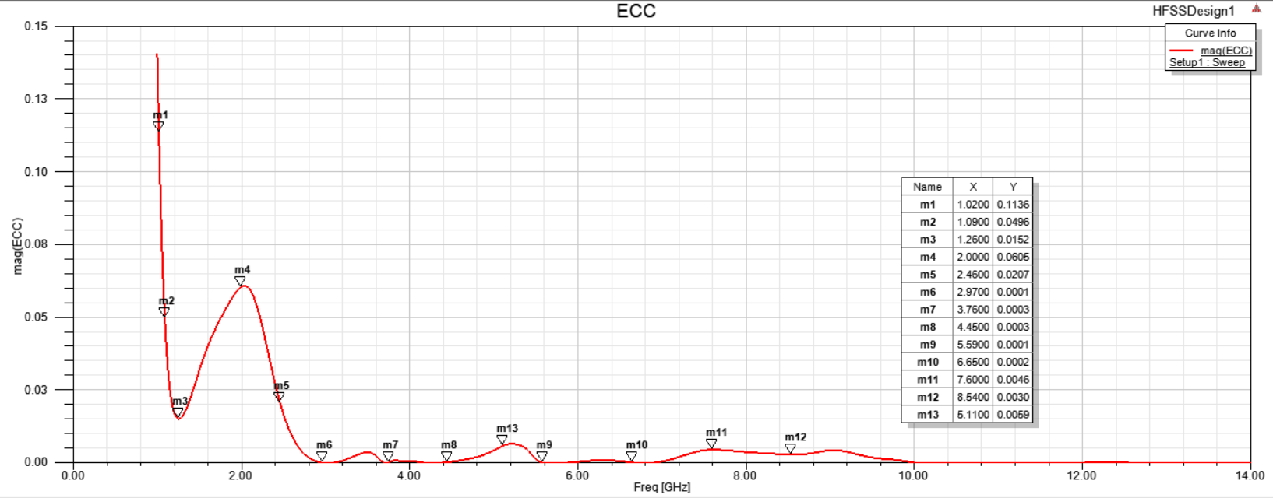

**Fig. 10: The ECC parameter of the MIMO Antenna**

Ideally the value of ECC have to be zero but realistically the limit for the MIMO antenna is ECC<0.5 mag. The 2 element MIMO antenna has the ECC < 0.15 for the overall frequency range of the developed MIMO antenna as shown in Fig 10.

**Diversity Gain (DG)**: There is one more required characteristic for the MIMO antenna performance which is its DG. Due to increased ECC performance, the S-band range has a diversity gain of almost 0.1dB.Fig.11 presents the diversity gain graph of the MIMO antenna. The DG of the MIMO antenna is computed by the given equation;

***DG*=10 $\sqrt{1-{(ECC)}^{2}}$…………(3)**

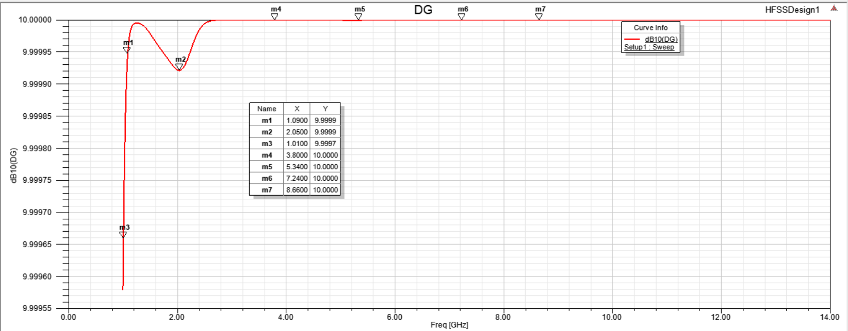

**Fig. 11: Diversity Gain of the MIMO Antenna.**

**TARC:** The scattering matrix is unsuitable to effectively determine the efficiency and spectrum of the MIMO antenna [16]. TARC is defined in a multiport antenna system as the fraction of the square root of entire reflected power divided by the square root of overall incident power [17].

$Г=\frac{√\sum_{i=1}^{N}{|bi|2}}{√\sum_{i=1}^{N}{|ai|}2}$**…………….(4)**

Where *ai* indicates the incident signals and *bi* indicates the reflected signals. The optimal TARC is typically required to remain below 0dB.These signals can be estimated based on the observed S parameters. The relation of incident and reflected waves in a multiple port network with impedances which are same at all ports [18].Fig.12 shows the evaluated TARC curve of MIMO antenna, which is below 0dB for the entire range of frequencies analyzed.

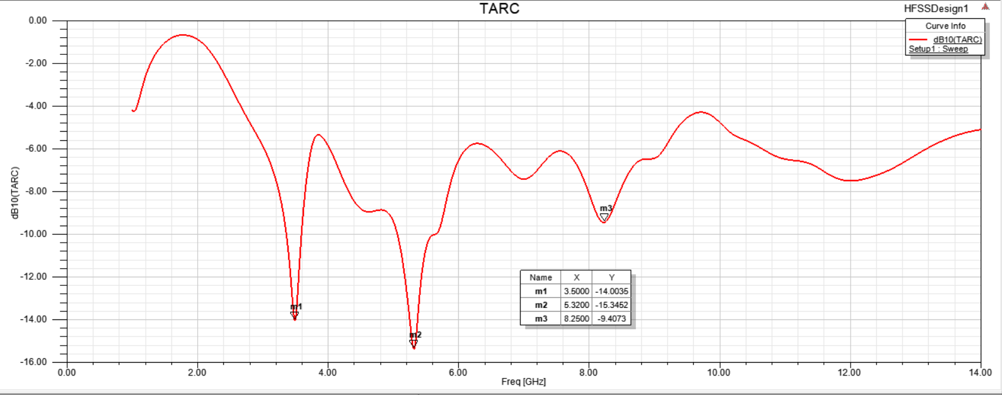

**Fig. 12: The TARC curve of Two element MIMO Antenna.**

**Channel Capacity Loss (CCL):** For a MIMO Antenna system CCL exhibits a maximum value of 0.5dB. Fig. 13 shows that the 2- element MIMO designed has a CCL less than 0dB for the entire simulated frequencies.

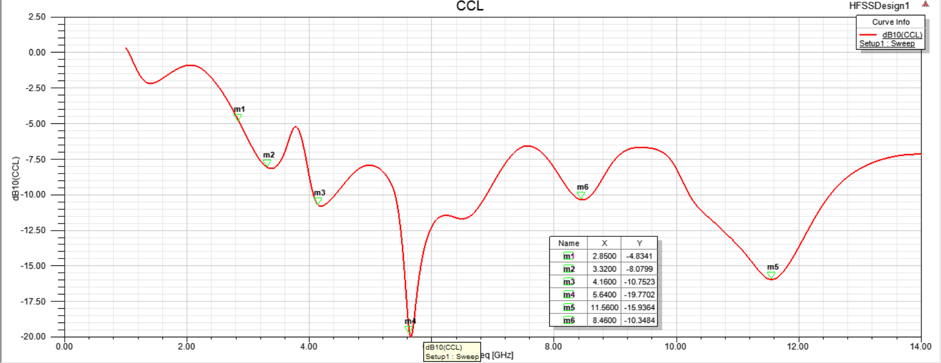

**Fig. 13: The CCL curve of Two element MIMO Antenna.**

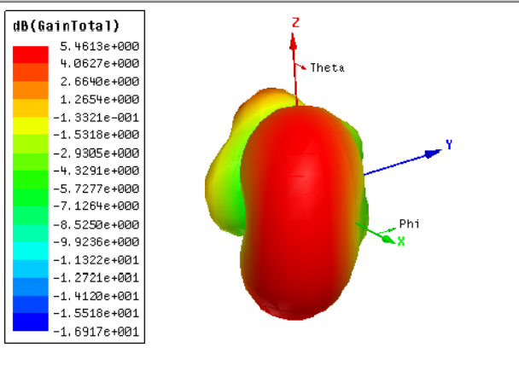

**Fig. 14: Total Gain in dB for two element MIMO antenna**

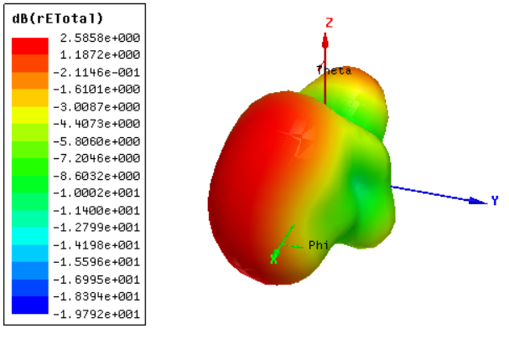

**Fig. 15: Total rE in dB for two element MIMO antenna**

1. **Conclusion**

The designed two element MIMO antenna with inverted F-stubs has a total gain of5.5 dB and rE of 2.6dB, shown in Fig 14 and 15. The antenna resonates at two frequencies 5.6 GHz and 11.6 GHz having S11 upto -33dB. All the parameters for the two elements MIMO antenna system for the UWB applications are evaluated and analyzed in this paper. The presented antenna can operated from 2 GHz to 14 GHz frequency respectively. To suppress the mutual coupling DGS with inverted F stubs is utilized. Although there is certainly some scope for improvement in the future, with some other techniques such as increasing the number of stubs and orthogonal placement of the MIMO elements, etc. The ECC of the designed MIMO antenna array is determined to be less than 0.15 at resonant frequencies. TARC, DG and the radiation pattern of the designed antenna are analyzed which justifies the utility of the antenna in UWB applications with the capabilities of diversity.

**References**

[1] Wu, A; Zhao, M; Zhang, P; Zhang, Z. “A Compact Four-Port MIMO Antenna for UWB Applications”,

*Sensors*,22,5788, 2022. <https://doi.org/10.3390/s22155788>.

[2] “Federal Communications Commission Revision of Part 15 of the Commission’s Rules regarding Ultra-

Wideband Transmission System from 3.1 to 10.6 GHz in federal Communications Commission Washington,

*DC: ET Docket*, pp. 98-153, FCC, 2002.

[3] Kaiser, T; Zheng, F; Dimitrov, E “An Overview of ultrawide-band systems with MIMO”. *Proceedings, IEEE*,

97, 285-312,2009.

[4] Sipal D, Abegaonkar MP, Koul SK “Compact band-notched UWB antenna for MIMO applications in portable

wireless devices” *Microwave optical Technology Letters*., 58: 1390-1394, 2016.

[5] C.Y, Huang and W.C Hsia, “Planar Elliptical antenna for Ultra-wideband Communications”, *Electronics letter*

Vol. 41, No. 6, pp. 40-41, 2005.

[6] John M, Ammann MJ, “Optimization of impedance bandwidth for the printed rectangular monopole antenna”,

*Microwave optical technology Letters*, 47(2):153-154, 2005.

[7] Khandelwal MK, Kanaujia BK, Kumar S, “Defected ground structure: fundamentals, analysis and applications in

modern wireless trends.” *Int J Antennas Propag*., 2017:2018527, 2017.

[8] Srivastava Gunjan, Mohan Akhilesh “Compact MIMO slot antenna for UWB applications” *IEEE Antenna*

*Wireless Propagation Letters*, 15: 1057-60, Oct 2016.

[9] Kumar C, Guha D, “Defected ground structure (DGS)-integrated rectangular microstrip patch for improved

polarization purity with impedance bandwidth” , *IET Microwave Antennas Propag.*, 8(8); 589-596, 2014.

[10] Baudha S, Yadav MV, “A novel design of a planar antenna with modified patch and defective ground plane for

ultra-wideband applications.” *Microwave Optical technology Letters*, 61:1320- 1327, 2019.

[11] Khan, M.S.; Caobianco, A.D.; Asif, S.M.; Anagnostou, D.E.; Shubair, R.M.; Braaten, B.D, “A compact CSRR-

enabled UWB diversity antenna” *IEEE Antennas Wireless Propagation Letters*, 16, 808-812, 2016.

[12] Liu L, Cheng SW, Yuk TI, “Compact MIMO antenna for portable UWB applications with band-notched

characteristics” *IEEE Trans Antennas Propagations*, 63(5):1917-1924, 2015.

[13] Iqbal A, Saraereh OA, Ahmad AW, Bashir S, “Mutual coupling reduction using F-shaped stubs in UWB-

MIMO antenna” *IEEE Access*, 755-1070, 2018.

[14] Chandel R, Gautam AK, Rambabu K, “Tapered fed compact UWB MIMO-diversity antenna with dual band-

notched characteristics” *IEEE Trans Antennas Propagation*, 66(4):1677-1684, 2018.

[15] M.S. Khan, A.-D. Capobianco, S.M. Asif, D.E. Anagnostou, R.M. Shubair and B.D. Braaten, “A compact

CSRR-enabled UWB diversity antenna”, *IEEE Antennas Wireless Propagation Letters*, Vol. 16, pp. 808-

812,2017.

[16] Sung Ho Chae, Se-Keun Oh and Seong-Ook Park, “Analysis of Mutual Coupling, Correlations and TARC in

WiBro MIMO Array Antenna”, *IEEE Antenna and Wireless Propagation Letters*, 6, pp. 122-125, 2007.

[17] M. Manteghi and Y. Rahmat-Samii, “Multiport Characteristics of a Wideband Cavity Backed Annular Patch

Antenna for Multipolarization Operations”, *IEEE Transactions on Antenna and Propagation* , AP-53, 1, pp.

466- 474, January 2005.

[18] D.M. Pozar, “Microwave Engineering, Second Edition”, New York, John Wiley, 1998.