**Abstract— This article provides the improvement of a Smart Vehicle Event Data Recorder (SVEDR) with the aid of using the Internet of Things (IoT) to increase site visitors’ safety and preparedness. The gadget integrates diverse sensors inclusive of an inertia size unit (IMU), GPS, alcohol, ultrasound, fire and temperature sensors to display large using parameters and actual-time environmental situations. The origin of the machine is constructed round an Arduino Uno microcontroller, which processes the enter from the sensor and coordinates responsibilities which includes notification generation and facts transfer. A NodeMCU Wi-Fi module enables real-time communique with cloud services or cell applications. When a nonconformity together with collision, fireplace or alcohol phase, the gadget immediately triggers through a Summer and SOS button, whilst transmitting the vicinity and sensor facts for precise contacts or emergency services. A liquid crystal show (LCD) provides live comments on the place of the sensors and increases the person interplay. The proposed machine affords several advantages, together with active monitoring, speedy emergency signals, smooth implementation of low charge and without difficulty. It acts as a realistic answer for people, shipping offerings and fleet operators to improve the safety and accountability of the vehicle. In addition, records gathered can support analysis below the regulation, prison evidence and coverage necessities. This venture indicates how IoT era can be correctly taken to overcome real global troubles in delivery safety. The assignment not simplest facilitates reduce the effect of injuries, however also lays the inspiration for smart, related motors.**

**SMART VEHICLE EVENT DATA RECORDER USING IOT**

Santhi K1 $, Senthil K2 &, Thejjashvi TV3*, Jaishree G3 #, Gokulapriya T3 %, Gayathri M3@

1HOD & Professor, 2Associate Professor, 4Scholar

$hod_eee@adhiyamaan.in, &senthilmeped79@gmail.com, *thejjashvisundar24@gmail.com, #jaishreekrishh29@gmail.com, %tgokulapriya056@gmail.com, @gayathrimadhappan2525@gmail.com

Department of Electrical and Electronics Engineering,

Adhiyamaan College of Engineering, Hosur -635130,

Krishnagiri (Dt), Tamil Nadu, India

**Keywords**

**Smart Vehicle, Event Data Recorder, IoT, Arduino, Accident Detection, Real-Time Monitoring, Emergency Response, IMU Sensor, GPS, Vehicle Safety**

1. **INTRODUCTION**

The increasing number of traffic accidents worldwide has become a major concern for authorities, transport agencies and vehicle manufacturers equally. According to recent studies, many deadly and injuries in traffic confrontation [1] [4] are due to delayed emergency response reactions and lack of real -time data on the vehicle's behavior and environmental conditions at the time of the accident. Traditional vehicle safety system -like airbags, braking systems against lock and electronic stability are controlling reactive and are limited to the protection of living during and after an event. However, they do not offer opportunities for monitoring real-time, vigilance or subsequent analysis of later phenomena. In this context, the Internet of Things (IoT) provides transformation ability by enabling continuous data collection, communication and intelligent control through interconnected devices. IoT has already contributed significantly to areas such as health care, agriculture and industrial automation [3] [8]. In transport, IoT provides smart traffic management, vehicle-to-some (V2X) communication and future diagnosis. The integration into traffic safety systems enables tracking of true time on vehicles, driver behavior analysis and immediate response to unusual events [2] [5].

To detect active phenomena and address the difference as a response, we suggest a smart vehicle incident data recorder (SVEDR) -an IoT -Adaptive System designed to monitor important vehicle parameters, record important events and transfer real -time notifications. It uses a series of sensors including an inertia measurement unit (IMU) to detect built -in system acceleration and power, a GPS module for accurate site tracking, a liquor sensor to check the driver's restraint, an ultrasound sensor to detect an obstacle [6] [6]. The origin of the system is an Arduino Uno microcontroller that treats the sensor data and coordinates the reactions. A NodeMCU (ESP8266) activates the Wi-Fi module sky connection, so that data mobile applications or emergency contacts. Additional components such as Bajer, SOS button and an LCD screen users provide immediate notice and real -time response [7] [10].

1. **OBJECTIVE**

The objective of this project is to design and implement a Smart Vehicle Event Data Recorder (SVEDR) using Internet of Things (IoT) technology to enhance road safety, accident response, and vehicle monitoring. The system aims to continuously track critical driving parameters and environmental conditions using sensors such as an Inertial Measurement Unit (IMU), GPS, alcohol detector, fire sensor, ultrasound sensor, and temperature sensor. It utilizes an Arduino Uno for data processing and a NodeMCU module for real-time wireless communication with cloud platforms or mobile applications. In the event of anomalies like collisions, fire, or alcohol detection, the system triggers instant alerts via buzzer and SOS notifications, transmitting location and sensor data to predefined contacts or emergency services. This project seeks to provide an affordable, user-friendly solution for individual drivers, transport operators, and fleet managers to improve safety, accountability, and data-driven decision-making in transportation.

1. **PROPOSED SYSTEM**

The proposed system aims to create a Smart Vehicle Event Data Recorder (SVEDR) that enhances road safety and emergency responsiveness through the integration of Internet of Things (IoT) technologies. This system is designed to monitor real-time driving conditions, detect abnormal vehicle events, and send immediate alerts to emergency services or relevant stakeholders. The core concept is to develop an intelligent embedded system that continuously gathers sensor data, processes it locally using a microcontroller, and communicates actionable information wirelessly via the internet.

ARDUINO UNO

POWER SUPPLY

5V

ALCOHOL SENSOR

FIRE SENSOR

ULTRASONIC SENSOR

SOS BUTTON

BUZZER

IOT

TEMPERATURE SENSOR

IMU SENSOR

GPS MODULE

**Fig 1: Block Diagram**

At the heart of the system is the Arduino UNO microcontroller, which serves as the central processing unit responsible for interfacing with various sensors and executing control logic. A NodeMCU module based on the ESP8266 chip provides wireless connectivity to enable data transmission to cloud servers or mobile applications. Together, these components allow for seamless integration of sensing, processing, and communication functionalities. The entire system is designed to be compact, low-cost, and efficient, making it suitable for wide-scale deployment in both private and commercial vehicles.

The SVEDR includes a set of carefully chosen sensors that monitor critical parameters. An Inertial Measurement Unit (IMU) sensor, specifically the MPU6050, detects acceleration, orientation, and movement patterns. It is capable of identifying sharp turns, sudden braking, or impacts, which are indicative of accidents. The GPS module provides continuous location tracking, enabling real-time mapping of the vehicle’s position. This becomes essential when an emergency alert is triggered, as it helps responders reach the exact site of the incident quickly. The alcohol sensor is integrated to measure the concentration of alcohol vapors in the driver’s breath. If a threshold level is exceeded, the system classifies the driver as intoxicated and activates warnings. The ultrasonic sensor is employed for obstacle detection and distance measurement. It monitors the surroundings of the vehicle to prevent collisions and is also used in innovative ways such as monitoring for battery swelling by detecting dimensional changes near the battery casing.

Additional safety enhancements include a temperature sensor (DHT11) to detect overheating conditions in the engine or cabin, and a fire sensor that identifies the presence of flames or smoke. Both of these sensors contribute to early detection of potentially catastrophic situations. A buzzer and SOS button are incorporated to serve as immediate alert mechanisms. The SOS button allows the driver or passenger to manually send a distress signal, while the buzzer provides an audible warning in case of sensor-triggered emergencies. Furthermore, an LCD display offers visual feedback on system status and sensor readings, enhancing user interaction and awareness.

**Data Flow and System Operation**

When the system is powered on, the Arduino continuously receives input from all connected sensors. The logic within the Arduino firmware analyzes this input and determines whether any of the readings exceed predefined safety thresholds. For instance:

* If a sudden impact is detected by the IMU sensor, or the ultrasonic sensor registers a dangerously close obstacle, an emergency is assumed.
* If the alcohol sensor detects alcohol vapor, the system alerts that the driver may be intoxicated.
* High temperature readings or fire detection trigger fire-related alerts.

Upon detecting any critical event:

* A buzzer is activated to alert the driver and nearby individuals.
* The GPS module retrieves the current location of the vehicle.
* The NodeMCU module sends sensor data and the location coordinates to a remote server or designated contact via Wi-Fi.
* The LCD display shows real-time messages like “Accident Detected,” “Alcohol Alert,” or “Fire Warning.”

**Advantages**

The proposed system is designed to be:

* Real-Time and Responsive: Quickly detects and responds to unsafe conditions.
* Low-Cost and Scalable: Uses affordable and widely available components.
* User-Friendly: Easy to operate and maintain, with clear visual and audible alerts.
* Highly Reliable: Provides accurate data that can be used in investigations and insurance claims.

1. **RESULTS AND DISCUSSION**

The Smart Vehicle Event Data Recorder (SVEDR) system was developed and tested to validate its functionality in detecting critical vehicle events and transmitting real-time alerts. This section presents the results obtained during the implementation and evaluation phase of the project. Multiple test cases were designed to assess the responsiveness, accuracy, and reliability of the system under simulated emergency conditions. The performance of each sensor, as well as the integration of components within the IoT framework, was also analyzed.

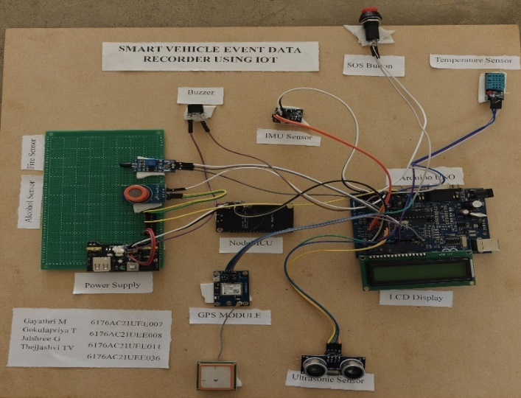

**Fig 3: Hardware Kit**

**Sensor Test Results**

Each sensor in the system was evaluated for its ability to detect specific events. The ultrasonic sensor (HC-SR04) was tested for proximity detection. When placed in front of obstacles at varying distances, the sensor accurately detected objects within a range of 2 to 30 cm. For example, when an object was placed 3 cm from the sensor, the system triggered an alert and updated the LCD display with a warning. At 8 cm, no alert was triggered, validating the predefined distance threshold for safe operation.

|  |  |
| --- | --- |
| **INPUT** | **OUTPUT** |
| 8 | No alert |
| 3 | Alert |
| 1 | Alert |

**Tab 1: Ultrasonic Sensor**

The alcohol sensor was tested by exposing it to controlled amounts of alcohol vapor. Under normal ambient conditions (no alcohol), the sensor output remained within the safe range, and no alert was generated. When alcohol was introduced into the environment near the sensor, the system detected the increased vapor concentration and immediately triggered an audible alert through the buzzer. The LCD displayed the message "ALCOHOL DETECTED," and the GPS coordinates were logged and sent to the connected platform.

|  |  |
| --- | --- |
| **Input Condition** | **Output** |
| Normal | No Alert |
| Drunk | Alert |

**Tab 2: (Alcohol Sensor**

For fire detection, the fire sensor was exposed to a heat source. Under normal temperature, no alert was issued. Upon exposure to a flame or heated object, the sensor output exceeded the predefined threshold, resulting in both a visual (LCD alert) and audible (buzzer) response. The same methodology was applied to the temperature sensor (DHT11). In low-temperature conditions, no action was triggered. When the ambient temperature exceeded 50°C, simulating engine overheating or internal fire, the system responded with appropriate alerts.

|  |  |
| --- | --- |
| **INPUT** | **OUTPUT** |
| Normal | No Alert |
| Fire | Alert |

**Tab 3: Fire Sensor**

|  |  |
| --- | --- |
| **INPUT** | **OUTPUT** |
| High | Alert |
| Low | No Alert |

**Tab 4: Temperature Sensor**

The IMU sensor (MPU6050) was tested to detect sudden vehicle movements and orientation changes. Sharp movements, such as sudden tilting or abrupt stops, were accurately captured as spikes in the accelerometer and gyroscope readings. The system was configured to detect these as potential collisions. Upon reaching the threshold values, an alert was generated, GPS data was retrieved, and the NodeMCU transmitted the incident information to a remote server.

**Integrated System Testing**

After individually validating the sensor modules, the entire system was tested in an integrated form on a prototype vehicle platform. A series of simulated accident scenarios were created to trigger multiple sensors simultaneously. In one test case, a sudden deceleration event coupled with an object approaching rapidly (simulated obstacle) was detected by both the IMU and ultrasonic sensors. The system successfully recorded the event, activated the buzzer, displayed a warning on the LCD, and transmitted the data through the NodeMCU via Wi-Fi.

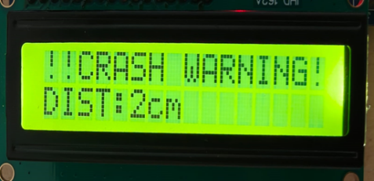

**Fig 4: LCD Display**

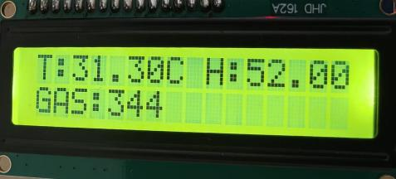

**Fig 5: Before trigger**

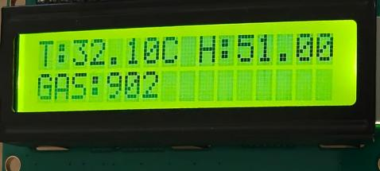

**Fig 6: After trigger**

The SOS button functionality was also evaluated. When pressed during normal operation, the system bypassed the sensor logic and directly initiated an emergency alert. This manual override was useful in situations where the driver identified danger before the system detected it. The response time from button press to data transmission was measured to be under 3 seconds.

The GPS module consistently provided accurate coordinates with a minor error margin of approximately ±3 meters. This accuracy was sufficient for real-time location tracking and for emergency responders to identify the vehicle’s position. The system's transmission performance via NodeMCU was stable within Wi-Fi range (approximately 50 meters in open space). Data packets including event type, time, and GPS location were received reliably on the remote server.

**Result Visualization and Data Logging**

The system displayed all alerts on a 16x2 LCD, which served as an effective immediate feedback mechanism for the driver. For each event, a corresponding message such as "FIRE DETECTED," "ALCOHOL ALERT," or "OBSTACLE CLOSE" was printed, helping the user quickly interpret the situation. At the same time, data was logged to a cloud dashboard using IoT protocols. Although the current version used HTTP-based transmission, the system is adaptable for MQTT, Firebase, or mobile app integration. The data generated during tests was logged and analyzed for consistency. Each alert contained a timestamp, sensor status, and GPS coordinates. In accident simulations, the time between sensor trigger and alert dispatch was consistently under 5 seconds, which is acceptable for real-time safety systems.

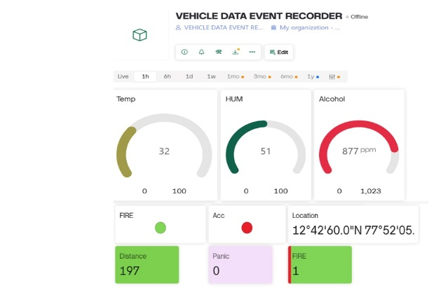

**Fig.7.4 (When Sensors triggered)**

The testing and validation of the SVEDR demonstrated that the system could effectively detect various hazardous conditions and provide timely alerts. The integration of multiple sensors ensured that a wide range of events—collisions, intoxication, overheating, fires, and proximity threats—could be identified. The ability to transmit this data to remote users in real time makes the system highly valuable for both personal safety and fleet management applications.

Some limitations were noted, including the dependence on Wi-Fi availability for data transmission and the limited GPS accuracy in indoor environments. These limitations can be addressed in future versions by incorporating GSM modules for cellular communication and advanced GPS/GLONASS hybrid modules for improved positioning.

1. **CONCLUSION**

The development of the Smart Vehicle Event Data Recorder (SVEDR) utilizing IoT technology successfully demonstrates an innovative approach to enhancing road safety and emergency response. By integrating multiple sensors with real-time data processing and communication capabilities, the system provides timely alerts and critical information during hazardous events such as collisions, fires, or alcohol detection. The use of an Arduino UNO combined with the NodeMCU Wi-Fi module ensures a cost-effective yet efficient platform for continuous vehicle monitoring and instant notification to relevant parties.

This project highlights the potential of IoT in creating smarter, more connected vehicles that not only improve driver safety but also assist in accident analysis, legal processes, and insurance claims. The SVEDR system's proactive and real-time monitoring features offer a practical solution adaptable for personal vehicles, public transport, and fleet management. Ultimately, this work contributes to the ongoing efforts to reduce road accidents’ severity and lays the groundwork for future advancements in intelligent transportation systems.

1. **REFERENCES**

1.IoT-enabled Drowsiness Driver Safety Alert System with Real-Time Monitoring Using Integrated Sensors Technology – B. Muiz, A. Hasib, M. F. Ahmed, A. A. Zubaer, R. Hossen, M. D. Khushi, and A. Rahman, arXiv preprint, Feb. 2025.

2.Muiz et al., “IoT-enabled Drowsiness Driver Safety Alert System with Real-Time Monitoring Using Integrated Sensors Technology,” arXiv preprint, Feb. 2025.

3.R. J. Ghilzai et al., “An Enhanced Novel IoT-Based Car Accident Detection and Alert System,” International Journal of Innovations in Science & Technology, Feb. 2025.

4.An Enhanced Novel IoT-Based Car Accident Detection and Alert System – R. J. Ghilzai, A. Qadir, U. Bibi, and M. Afzal, International Journal of Innovations in Science & Technology, Feb. 2025.

5.Advancements in IoT Technology: A Comprehensive Approach to Accident Detection and Emergency Response – T. V. V. P. Kumar, V. Tiwari, V. Lakshmi, and G. Gupta, MATEC Web of Conferences, vol. 392, 01087, 2024.

6.T. V. V. P. Kumar et al., “Advancements in IoT Technology: A Comprehensive Approach to Accident Detection and Emergency Response,” MATEC Web of Conferences, vol. 392, 01087, 2024.

7.J. S. Ramírez et al., “Application of IoT Technologies Oriented to a Vehicle Safety System,” Lecture Notes in Networks and Systems, Springer, pp. 195–209, 2024.

8.T. Tahemeen and R. Patil, “IoT Based Solutions for Accident Detection and Intimation,” Journal of Scientific Research and Technology, vol. 2, no. 9, pp. 1–6, 2024.

9.E. V. Ciji et al., “IoT-Powered Emergency Vehicle System: Rapid Accident Response in Cities,” International Journal of Progressive Research in Science and Engineering, vol. 5, no. 5, pp. 88–92, 2024.

10.V. V. Anusuy et al., “An IoT Based Accident Detection and Rescue System,” International Research Journal on Advanced Engineering and Management, vol. 1, no. 1, pp. 10–15, 2023.

11.Application of IoT Technologies Oriented to a Vehicle Safety System – J. S. Ramírez, B. P. Corrales, D. P. Corrales, and C. M. Manzano, Lecture Notes in Networks and Systems, Springer, pp. 195–209, 2024.

12.IoT Based Solutions for Accident Detection and Intimation – T. Tahemeen and R. Patil, Journal of Scientific Research and Technology, vol. 2, no. 9, pp. 1–6, 2024.

13.IoT-Powered Emergency Vehicle System: Rapid Accident Response in Cities – E. V. Ciji, A. Xavier, A. A. Hussain, D. Soman, J. Joy, and D. George, International Journal of Progressive Research in Science and Engineering, vol. 5, no. 5, pp. 88–92, 2024.

14.An IoT Based Accident Detection and Rescue System –V.V. Anusuy, B. Jasmith, P. Sugasini, and M. J. Dharshini, International Research Journal on Advanced Engineering and Management, vol. 1, no. 1, pp. 10–15, 2023.

15.Smart Ambulances for IoT Based Accident Detection, Tracking and Response – A. Ayesha and K. Chakravarthi, Journal of Computer Science, vol. 19, no. 6, pp. 677–685, 2023.

16.A. Ayesha and K. Chakravarthi, “Smart Ambulances for IoT Based Accident Detection, Tracking and Response,” Journal of Computer Science, vol. 19, no. 6, pp. 677–685, 2023.

17.IoT-Based System for Improving Vehicular Safety by Continuous Traffic Violation Monitoring – Y.-A. Daraghmi, M. A. Helou, E.-Y. Daraghmi, and W. Abu-ulbeh, Future Internet, vol. 14, no. 11, pp. 1–14, 2022.

18.M. Dhanasekar et al., “IoT Based Framework for Accident Prevention in Highways,” International Journal of Emerging Trends in Engineering Research, vol. 10, no. 2, pp. 52–57, 2022.

19.Y.-A. Daraghmi et al., “IoT-Based System for Improving Vehicular Safety by Continuous Traffic Violation Monitoring,” Future Internet, vol. 14, no. 11, pp. 1–14, 2022.

20.IoT based car accident detection and notification algorithm for general road accidents – S. Sharma and S. Sebastian, International Journal of Electrical and Computer Engineering, vol. 9, no. 5, pp. 4020–4026, 2021.

21.R. J. Ghilzai et al., “An Enhanced Novel IoT-Based Car Accident Detection and Alert System,” International Journal of Innovations in Science & Technology, Feb. 2025.

S. Dashora et al., “IoT Based Framework for the Detection of Vehicle Accident,” International Journal of Scientific Research in Engineering and Management, vol. 5, no. 7, pp. 112–116, 2021.