**Determining the time for harvesting grapes from small areas in the Karlovska rose valley**

**Ivan Zahariev**

*Department of Agricultural Mechanization, Agricultural university – Plovdiv, Bulgaria*

*E-mail:* [*i_zahariev@au-plovdiv.bg*](mailto:i_zahariev@au-plovdiv.bg)

**Abstract:** Growing grapes as a hobby and for the production of home-made alcohol on a small scale is deeply rooted in the everyday life and folk psychology of Bulgarians. Since time immemorial, alcoholic beverages - wine and [rakia](https://bg.pons.com/%D0%BF%D1%80%D0%B5%D0%B2%D0%BE%D0%B4/%D0%B0%D0%BD%D0%B3%D0%BB%D0%B8%D0%B9%D1%81%D0%BA%D0%B8-%D0%B1%D1%8A%D0%BB%D0%B3%D0%B0%D1%80%D1%81%D0%BA%D0%B8/rakia) ([Bulgarian](https://bg.pons.com/%D0%BF%D1%80%D0%B5%D0%B2%D0%BE%D0%B4/%D0%B0%D0%BD%D0%B3%D0%BB%D0%B8%D0%B9%D1%81%D0%BA%D0%B8-%D0%B1%D1%8A%D0%BB%D0%B3%D0%B0%D1%80%D1%81%D0%BA%D0%B8/Bulgarian) [strong](https://bg.pons.com/%D0%BF%D1%80%D0%B5%D0%B2%D0%BE%D0%B4/%D0%B0%D0%BD%D0%B3%D0%BB%D0%B8%D0%B9%D1%81%D0%BA%D0%B8-%D0%B1%D1%8A%D0%BB%D0%B3%D0%B0%D1%80%D1%81%D0%BA%D0%B8/strong) [brandy](https://bg.pons.com/%D0%BF%D1%80%D0%B5%D0%B2%D0%BE%D0%B4/%D0%B0%D0%BD%D0%B3%D0%BB%D0%B8%D0%B9%D1%81%D0%BA%D0%B8-%D0%B1%D1%8A%D0%BB%D0%B3%D0%B0%D1%80%D1%81%D0%BA%D0%B8/brandy)) - have been consumed in the evening (and not only). There is an expression for part of the day - "on rakia time". The areas with vineyards are on different scales - large areas for industrial production and small family vineyards. There is no data on the time of picking the small family plots. The duration of harvesting the grapes from a 1.2 da vineyard by 6 pickers is one calendar day.

**Keywords:**Grape, harvesting grapes, times, technology

---------------------------------------------------------------------------------------------------------------------------------------

Date of Submission: XX-XX-2024 Date of acceptance: XX-XX-2024

---------------------------------------------------------------------------------------------------------------------------------------

1. **INTRODUCTION**

In the Republic of Bulgaria, there is an area with the most suitable conditions for growing oil rose, which is one of the symbols of the country. This valley extends over the territory of several municipalities in different districts. One of the mentioned municipalities is Karlovo municipality, Plovdiv region. It is located in the “Podbalkanska Valley” and the valley is named after it - "Karlovska Rose Valley", wine grape variety Red Misket "Karlovski Misket", meat delicacy "Karlovska lukanka" and others. In addition to oil-bearing roses, areas with grapes are also grown.

According to Popov & Arnaudova (2010) this is a typical Bulgarian region for the production of quality white wines mainly from the local Misket red variety.

According to data from the website https://divino.bg/encyclopedia/ … Misket red is an old Bulgarian variety that has been cultivated in our lands since time immemorial. It is hardly found in other countries and its foreign names and synonyms are not known.

It is found in all wine-growing regions, but is mainly distributed in the “Podbalkanska Valley”. In the Plovdiv region, it is grown in Karlovsko and Brezovsko, where its name comes from.

The cultivation of the heritage vineyard is done by hand or with small family-owned equipment, mostly during weekends or holidays. During the rest of the week, people go to work, except for pensioners. The whole family and friends participate in the grape harvest of small plots, in a different ratio of men / women. In this organization, pickers are part of the family - grandfathers, fathers, brothers, sons-in-law, cousins, etc. The most common are: father, son/sons, daughter-in-law/s, cousin/cousins and 1-2 family friends. The picking of the bunches is done manually with the help of vine shears. In recent years, manual electric scissors with a rechargeable battery have been introduced, but due to their still high price, they have not been widely distributed.

Buckets or crates are used for harvesting vessels.

Depending on the purpose of the harvested grapes, there are three types of transport packages: the already mentioned crates; thick plastic bags.

When the grapes are harvested for sale or the owners of the vineyards are solvent, the crates have solid walls. In the small massifs grown for the home production of wine and brandy for own consumption, the common standard sizes of crates or thick plastic bags are used. One of these case sizes is of the type shown in Fig.1. This is due to the fact that they are often used in the country (Republic of Bulgaria) by producers, traders and importers of various agricultural products. They meet in markets and fairs, and from there - in the villages. The author of this article also owns mostly cases of these sizes.

а) 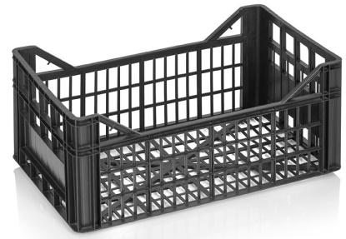 b) 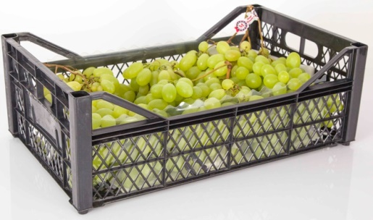

**Figure 1:** Case dimensions a) 500 x 300 x 220 mm; b) 500 x 300 x 175 mm

(source: https://www.enko-plastics.com/bg ... )



**Figure 2:** Sacks LD 60 cm /90 cm 100 μm black for grapes (source: https://www.plastic-sofia.com/... )

According to Zahariev (2023) dense crates are not overfilled, but 80-86% of their volume is used so that they can be loaded on top of each other. This finding is also valid for other types of cash registers.

The characteristics of the crates shown in Fig. 1. according to the manufacturer's data are (source: https://www.enko-plastics.com/bg... ):

For Fig. 1.a. -external dimensions 500 x 300 x 220 mm; internal dimensions 475 x 280 x 210 mm; mass of empty crate *m0k* = 0.600 kg ± 5%; capacity 28 *l* (*q* = 0.028 m3); Products on a euro pallet – 66 pieces;

For Fig. 1.b. - external dimensions 500 x 300 x 175 mm; internal dimensions 480 x 280 x 165 mm; mass of empty crate *m0k* = 0.420 kg ± 5%; capacity 22 *l* (*q* = 0.022 m3); Products on a euro pallet - 84 pieces.

According to ORDER No. 16 of 31.05.1999 on physiological norms and rules for manual work with weights, the weight of the load does not exceed 15 kg for women and 50 kg for men for a single load when lifting, supporting, moving and carrying a distance of 2 m and 4,000 kg for women and 10,000 kg for men - total for change (https://www.gli.government.bg …).

According to https://eurocode.bg/... in properly arranged forms, packages or piles, the bulk weight for grapes is *γ* = 5.0 kN/m3 = ~ 500 kg/m3. When picking wine varieties, placing the grapes in the packages is not in a certain order, but chaotic. According to Vezirov & Kozlev R. (2002; 2006) grapes have a volume density of 220 to 300 kg/m3. According to data from 2023, the average value of the volumetric weight of grapes is *γ* = 407.2 kg/ m3 (Zahariev, 2023).

The times for picking the grapes for the large massifs are calculated in advance. The harvesting of grapes is mechanized with modern grape harvesters.

The times for harvesting the grapes from small plots grown for the production of home-made alcohol under family and friendly agreements remain unspecified.

1. **MATERIAL AND METHOD**

The aim of the present study is to determine the timing of grape harvest from small family vineyards up to 10 da.

The owners of this type of vineyard own private cars. Most of them have single-axle car trailers up to 750 kg total weight and/or motor cultivators with implements. In the last 10 years, a small number of owners or users bought low-power tractors (up to 20-25 HP), second-hand, mainly imported from Asian countries.

For this type of vineyards, where the grapes are mainly used for the home preparation of alcoholic beverages, the technology of manually plucking the grapes from the vine is used; placing the plucked bunches in plastic crates; removal of the full crates from the interrows to a predetermined place at the end of the massif; transportation to the place of temporary storage or processing, mainly by private cars and trailers.

There are three options for the movement and distribution of the pickers in the vineyards: in each row, one picker Fig.3.a, across the row, two next to each other Fig.3.b. picking all the grapes from the vines in the rows entrusted to them and in each row, two next to each other Fig.3.c. picking the grapes from one side of the vines. The other side is picked by another picker in the adjacent row.

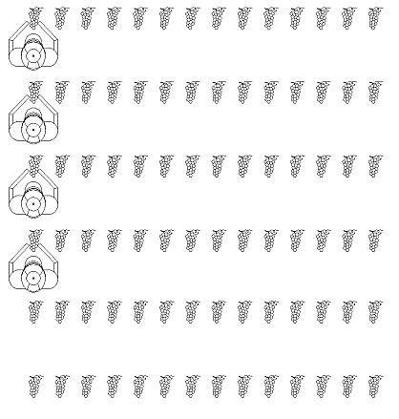 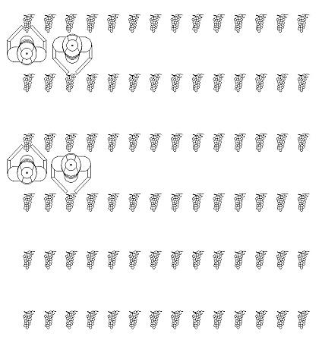 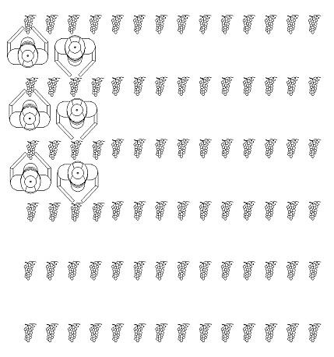

1. b) c)

**Figure 3:** Movement of pickers in a vineyard

In the first version, Fig. 3.a. picking starts at one end and the pickers walk between each row. After the end of the row, a new row is started from the end to the beginning.

In the second option, Fig. 3.b. picking is similar to option 1, with the difference that the pickers are placed two in a row and two rows are picked.

In the third version, Fig. 3.c. picking is similar to option 2, with each picker, except for the end rows, plucking the grapes from one side of the row. The other side of the row is picked by the picker in the adjacent row. In this way of organization there is an opportunity for conversations and mutual assistance between the pickers. Due to the already mentioned fact that the pickers are from the family or family friends of different ages, it happens that some picker has pain in the back or joints. Because of this, it is difficult to bend down to pluck the grapes at the bottom of the vines. This is done by the opposite picker. As a disadvantage, the increased risk of injury should be noted.

The choice of one of the three options depends on the size of the massif, its location, the slope of the field, the number of pickers, the equipment available to the owner of the vineyard, the possibility of access to the equipment between the rows, the period of harvesting and others.

The low-power tractor or motor cultivator with the attached trailer moves in the interrows according to the selected movement option and distribution of the pickers. Dense cassettes are placed close to the roots of the vines to allow mechanization to pass through.

A stopwatch is used to determine times. A control plucking of the grapes is done from three randomly selected rows. Record the start and end picking time of each line. When picking is interrupted, the time of the interruption is measured with the stopwatch and the reason is recorded. The total time of interruptions for various reasons is subtracted from the detected time. The net time is obtained. The reasons for interruption are divided into 2 groups and their coefficients are calculated. The ratios are the ratio of the clear time plus the total time of breaks for each group to the clear time.

- Time to harvest grapes from 1 row Tr, min:

Tr = nL . TL1 . ξ1 . ξ2 (1)

where: nL – number of vines in the row, pcs; . TL1 – time to harvest grapes from one vine, min; ξ1 – lag factor for cigarette smoking; ξ3 – delay factor for talking on the phone, checking social networks and taking selfies.

According to Aaron van Dorn (2014), incredibly high smoking rates are indicative of the difficulties Bulgaria has had with integrating into the EU community. This is also true today.

- Time to harvest the grapes in one working day TL:

TL = (Tr . nR . / (nВ . γВ). + Tc . nc + TP1 + TP2 + TP3 + TP4) . ξR (2)

where: nR – number of rows of the vineyard, pcs; nВ – number of pickers working in the vineyard during the day, pcs; γB – coefficient taking into account the time of presence and work of the pickers throughout the day (when it comes to work carried out on a family and friendly basis, it happens that family members suddenly stop their work or go home for various reasons, especially in the presence of young children); Tc - dwell time of the pickers to transport the picked grapes, min; nc – number of stays for loading the harvested grapes, pcs; TP1 – total time for breaks and lunch, min; TP2 – preparatory time before the start of harvesting, min; TP3 – closing time after the end of harvesting, min; TP4 – time for unplanned downtime, min; ξR – generalized coefficient of use of time by pickers during the day.

- Times for the motor cultivator with the trailer.

According to Kehayov & Zyapkov (2005), for the calculation of operational indicators, the necessary times for:

- execution of working moves T1, min;

Auxiliary time T2, min:

T2 = T21 + T22 (3)

- for maintenance T21, min;

- for turns T22, min;

- for idle runs T23, min;

Time for preparation and bringing the motor cultivator with the trailer from transport to working position and back T3, min:

T3 = T31 + T32 (4)

- for technical maintenance of the vineyard T31, min;

- to bring the machines into working position and vice versa T32, min;

Troubleshooting time T4, min:

T4 = T41 + T42 (5)

- to eliminate technological malfunctions T41, min;

- to eliminate technical malfunctions T42, min;

- organizational losses of time (stand by to wait) T5, min.

- operating time T02, min:

T02 = T1 + T21 + T22 + T23 (6)

- production time T04, min:

T04 = T02 + T31 + T32 + T41 + T42 (7)

- total working time T8, min:

T8 = T04 + T5 (8)

1. **RESULTS AND ANALYSIS**

The object of the research is a vineyard of a wine variety, located in the Karlovska Rose Valley, between the cities of Karlovo and Sopot, on the southern slope at the foot of "Stara Planina", with characteristics: Grape variety "Karlovski Misket" area - S = 1.2 yes row spacing – b = 1.30 m; inter-row distance – ***b1*** = 0.9 m; number of rows – *nR* = 24 pcs.; average length of rows – ***Lr*** = 38.7 m; average number of vines in a row – ***nL*** =43 pcs; average amount of grapes harvested from one vine for the last year - ***mloza*** = 7.42 kg.

The vineyard in question is located 1.48 km from the city of Sopot.

The equipment available to the owner of the vineyard is a minivan 6+1 seats, a car trailer with a total weight of 750 kg and a load capacity of 550 kg, a motor cultivator with a trailer with a load capacity of up to 600 kg.

There are three pickers on the vineyard all day - the two brothers of the owner and the author of the article.

A fourth picker plucks grapes, but also drives the motor cultivator with the trailer, delivers the empty packaging.

During the day, two more are involved in the picking for half a day - a woman and a man. Their time is ½ that of the others.

The selected grape picking technology is option 1 (Fig. 3a), due to the fact that pickers arrive and depart at different times. To know who has reached where and where to continue. After each session (one row length - from end to end) there is a stop to load and transport the harvested grapes.

The grapes are plucked and placed in a bucket. After filling, the bucket is poured into plastic bags. The sacks are two in number – one inside the other to ensure that there will be no breach and the grape juice will leak out. The bags are filled up to 40 kg. Over 40 kg are difficult to handle.

Using timing and the dependencies developed in the MATERIAL AND METHOD section, the following were calculated:

Average number of vines in the row ***nL*** = 43 pcs;

Average number of vines ***nL4*** = 5.4 pcs;

Number of bags in a row ***n4R*** = 8 pcs;

Time to harvest grapes from one vine ***TL1*** = 2.3 min;

Dwell time when smoking one cigarette – 3 min (detected time for smoking one cigarette is from 5 to 6 min, but the remaining time of 2 - 3 min is not counted due to the fact that the picker smokes and picks at the same time);

Average number of cigarettes smoked per line 2.5 pcs.

Lagging coefficient for cigarette smoking ***ξ1*** = 1.076;

Time for talking on the phone, checking social networks and taking selfies – 2.7 min;

Average number of talking on the phone, checking social networks and taking selfies – 3.34 pcs;

Delay coefficient for talking on the phone, checking social networks and taking a selfie ***ξ2*** = 1.091;

Time to pluck grapes from 1 row ***Tr*** = 116.1 min;

Number of pickers in the vineyard during the day ***nB*** = 6 pcs;

Coefficient considering the pickers' working time throughout the day ***γB*** = 0.75;

Dwelling time of the pickers to transport the harvested grapes ***Tc*** = 12 min;

Number of stays for loading the harvested grapes ***nc*** = 5 pcs;

Total time for breaks and lunch ***TP1*** = 72 min;

Preparatory time before the start of harvesting, ***TP2*** = 5 min;

Final time after the end of harvesting, ***TP3*** = 16 min;

Time for unexpected stops, ***TP4*** = 15 min;

General coefficient of use of time during the working day ***ξR*** =1.01;

Time to harvest the grapes from the entire vineyard ***TL*** = 795.07 min (13.25 h);

The retraction scheme is given in Table 1 and illustrated in Fig. 4.

One session is picked with the currently available pickers. After the end of the rows, there is a break to remove the harvested grapes. New rows begin to be picked. The sessions are repeated until the last vine of the last row is harvested.

**Table 1.** Schematic of harvesting and picking of grapes

|  |  |  |  |  |  |  |
| --- | --- | --- | --- | --- | --- | --- |
| Session | І | ІІ | ІІІ | ІV | V | VІ |
| Line numbers processed at the same time (total are 24 pcs) | 1; 2;  3 | 4; 5;  6; 7 | 8; 9; 10;  11; 12; 13 | 14; 15; 16;  17; 18; 19 | 20; 21;  22; 23 | 24 |
| Number of pickers working simultaneously, pcs | 3 | 4 | 6 | 6 | 4 | 3 |
| Number of pickers in the session | N1;  N2;  N3 | N1; N2; N3; N4 | N1; N2; N3; N4; N5; N6 | N1; N2; N3; N4; N5; N6 | N1; N2; N3; N4 | N1;  N2;  N3 |
| Coefficient accounting for how long the line falls on a picker | 1 | 1 | 1 | 1 | 1 | 0,33 |
| Session time, ***Tr***  min | 116,1 | 116,1 | 116,1 | 116,1 | 116,1 | 38,7 |

Table 1 shows that pickers N1, N2 and N3 process 5.33 rows of the vineyard; N4 – 4 rows, and N5 and N6 – only 2 rows. In sessions I to V, each row is picked by one picker independently. In session VI (last row) three pickers take turns and the time is 1/3 of the other sessions

**Figure 4:** Distribution of the pickers' time

It can be seen from Fig. 4 that pickers N1, N2 and N3 used 100% of their time to harvest the grapes. Picker N4 has been on all day, but its picking percentages are 75.05%. This is due to the fact that he managed the motor cultivator and was engaged in organizational activities. The percentages of N5 and N6 pickers were 37.52%, even though they attended half a day.

The distribution of times during the day for the given picking scheme is shown in Fig. 5.

**Figure 5:** Distribution of times during the day

Times for the cultivator with the trailer.

According to the chosen variant of picking the vineyard by the pickers, the motor cultivator moves in the interrows in a zig-zag fashion (Fig. 6.). Starts in the first interrow, from where the picking started. Makes 8 stops to load a full sack. After the end of the row, a turn follows and returns back to the next row.

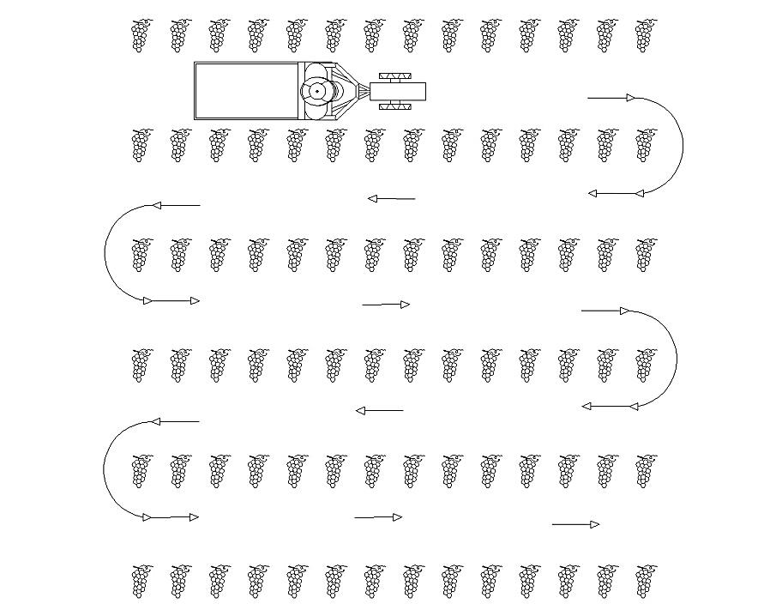

**Figure 6:**. Movement of the motor cultivator with the trailer in a vineyard

Execution of working moves ***T1*** = 65.82 min;

Auxiliary time ***T2*** = 16.18 min

- For maintenance ***T21*** = 5 min;

- For turns ***T22*** = 5.8 min;

- For idle moves ***T23*** = 5.38 min;

Time to prepare and bring the motor cultivator with the trailer from transport to working position and vice versa ***T3*** = 6.69 min;

- For technical maintenance of the vineyard ***T31*** = 4.65 min;

- To bring the motor cultivator with the trailer into working position and vice versa ***T32*** = 2.04 min;

Troubleshooting time ***T4*** = 15 min;

- To eliminate technological malfunctions ***T41*** = 5 min;

- To eliminate technical malfunctions ***T42*** = 10 min;

Organizational time losses (stand by to wait) ***T5*** = 691.2 min.

Operating time ***T02*** = 81 min:

Production time ***T04*** = 103.87 min;

Total working time ***T8*** = 795.07 min;

**Figure 7:**. Production time (T04) to stand by to wait (T5)

Figure 7 shows that with this organization of work, the motor cultivator waits for technological reasons 87% of the total time.

**IV. CONCLUSION**

Based on the above, the following conclusions can be formulated:

1. Picker N4 is in the vineyard all day, but his time compared to pickers N1, N2 and N3 is 75.05%. The smaller percentages of picking time are due to the fact that he is driving and in charge of the tractor with the trailer.

2. Pickers N5 and N6 are half a day in the vineyard, but the percentages in picking compared to N1, N2 and N3 are 37.52%. The rest of the time they were at the vineyard was used to prepare lunch and rest.

3. It was found that at the start of harvesting and after each break, the pickers rested and performed the operations faster by 5 to 15 s. Before a break, operations are performed more slowly at the same rate. These time periods last 15 - 20 min.

4. The time for harvesting the grapes from small massifs grown as a hobby and for the production of home alcohol is determined. The duration of the considered example is over 8 hours. This is true, but with this type of organization of the grape harvest, it is evident that there are great losses of time. The time spent in these vineyards is an opportunity for meetings and rest during the weekend.

5. A conclusion was made about the possibility of optimizing the working time of the tractor with the trailer-platform.

6. From the calculations made for the considered example, it is clear that the vineyard is harvested by 6 pickers in one calendar day.

**REFERENCES**

[1]. Popov, K., Arnaudova J. (2010), GIS determination of viticultural sub-districts in Karlovsko, Selskostopanska Nauka (Agricultural Science) 2010 Vol.43 No.5, PP 40–44;

[2]. <https://divino.bg/encyclopedia/%D0%BC%D0%B8%D1%81%D0%BA%D0%B5%D1%82-%D1%87%D0%B5%D1%80%D0%B2%D0%B5%D0%BD>, 28.12.2023;

[3]. <https://www.enko-plastics.com/bg/markets/1-%D1%81%D0%B5%D0%BB%D1%81%D0%BA%D0%BE%D1%82%D0%BE-%D1%81%D1%82%D0%BE%D0%BF%D0%B0%D0%BD%D1%81%D1%82%D0%B2%D0%BE-%D0%BF%D0%BB%D0%BE%D0%B4%D0%BE%D0%B2%D0%B5-%D0%B8-%D0%B7%D0%B5%D0%BB%D0%B5%D0%BD%D1%87%D1%83%D1%86%D0%B8/1370-%D0%BF%D0%BB%D0%B0%D1%81%D1%82%D0%BC%D0%B0%D1%81%D0%BE%D0%B2%D0%B0-%D0%BA%D0%B0%D1%81%D0%B0-0122>, 19.12.2023;

[4]. <https://www.plastic-sofia.com/garbage-bags-ld-6090-100mk-black-for-greep-20%D1%8510-pcsbag>, 28.12.2023;

[5]. Zahariev I. (2023), Determination the volume of transport operations when harvesting wine grapes from small areas, IOSR Journal of Engineering (IOSRJEN), www.iosrjen.org, ISSN (e): 2250-3021, ISSN (p): 2278-8719, Vol. 13, Issue 12, December 2023, Series -I, PP 67-74;

[6]. <https://www.gli.government.bg/sites/default/files/upload/documents/2020-09/NAREDBA_16_ot_31051999_g_za_fiziologicni_normi_i_pravila_za_rycna_rabota_s_tejesti.pdf>, 21.09.2023;

[7]. <https://eurocode.bg/index.php?title=%D0%9E%D0%B1%D0%B5%D0%BC%D0%BD%D0%B8_%D1%82%D0%B5%D0%B3%D0%BB%D0%B0_%D0%BD%D0%B0_%D0%BC%D0%B0%D1%82%D0%B5%D1%80%D0%B8%D0%B0%D0%BB%D0%B8_%D0%B8_%D0%BF%D1%80%D0%BE%D0%B4%D1%83%D0%BA%D1%82%D0%B8_%D0%B7%D0%B0_%D1%81%D1%82%D1%80%D0%BE%D0%B8%D1%82%D0%B5%D0%BB%D0%BD%D0%B8_%D0%BA%D0%BE%D0%BD%D1%81%D1%82%D1%80%D1%83%D0%BA%D1%86%D0%B8%D0%B8_%D0%BF%D0%BE_%D0%9D%D0%B0%D1%80%D0%B5%D0%B4%D0%B1%D0%B0_%E2%84%96_3>, 19.06.2023;

[8]. Vezirov Ch., Kozlev R. (2002). Technological service in agriculture, Part I -Transport service, Ruse;

[9]. Vezirov Ch., Kozlev R. (2006). Technological service in agriculture, Ruse;

[10]. Aaron van Dorn (2014), Bulgaria lags behind Europe in pollution and smoking targets, Country in focus, volume 2, issue 3, PP 182-183, march 2014, DOI:https://doi.org/10.1016/s2213-2600(14)70056-6;

[11]. Kekhayov D., Zyapkov D. (2005), Basic tillage of sloping terrain - performance indicators. NT AU-Plovdiv, item 1, book 2, PP 265-268.