**DESIGNING AND MODELING OF A FLOOR-MOUNTED JIB CRANE**

**BY**: **Mr**. **BERISSO WOYESSA BEKELE**

**ICE M.Tech**

**In**

**Industrial Automation**

**NATIONAL INSTITUTE OF TECHNOLOGY TIRUCHIRAPPALLI-620015**

**SEPTEMBER 2024**

# Declaration

I solemnly affirm that this project represents my original work and intellectual effort. Any ideas, information, or materials derived from external sources have been appropriately cited and referenced, ensuring that due credit is given to the respective authors. I have adhered to the highest standards of academic integrity throughout the development of this project.

# Acknowledgement

I am grateful to individuals and organizations that have helped me in different but valuables ways in the preparation of this project. I first and foremost owe a special debt of gratitude to Prof. Dr. Krishnaraj R, who helped me by giving some wise comments and ideas.

# ABSTRACT

*A jib crane is a type of crane with a cantilever beam, hoist, and trolley that is either attached to a building column or cantilevers vertically from an independent floor-mounted column. This study will primarily focus on floor-mounted jib cranes, in which the trolley hoist moves down the length of the boom and the boom spins, allowing the hoisted load to be skillfully moved in a generally circular area. When building a jib crane, numerous aspects must be considered. The most essential are the crane's own weight and the weight of the items.*

*The purpose of this thesis is to carry out detailed design and analysis of a jib crane. This study studies the stress regions in the jib crane using various materials, and the job is completed by designing reinforcement to overcome such stresses in the component. Models are created in modeling software using the analytical design dimensions, and the models are analyzed using a finite element solver under appropriate conditions, with the results compared.*

*Key Words: JIB CRANE, PRO-E/CREO, ANSYS.*

Contents

Declaration i

Acknowledgement ii

ABSTRACT iii

List of Figures v

CHAPTER ONE 1

Introduction 1

1.1 Overview of Thesis 1

1.2 Problem Statement 3

1.3 Objective. 3

Chapter Two: Literature Review 4

2. Introduction 4

2.2 Pivoting Jib Cranes. 8

2.3 Types of Jib Cranes. 8

2.4 Working with Jib Cranes 12

Chapter Three: Design Analysis 13

3.1. Conceptual Design Major Components of Jib Crane 13

3.2 Structure Design of Jib Crane 14

3.2.1 Design of Tie Rod 14

3.2.2 Design of Jib 16

3.2.4 Hoisting Drum 19

3.2. 5 Design of Rope Sheave 20

3.2.6 Design for the Hook 20

3.2.5 Design of Gear Box 22

3.2.6 Design of Shaft 27

3.2.7 Design of Cross-Travel 28

3.2.8 Design of Column 30

Chapter Four: Result and Discussion 32

4.1 Result 32

4.2 Discussion 32

Chapter Five: Conclusion and Recommendation 33

5.1 Conclusion 33

5.2 Recommendation 33

References 34

# List of Figures

Figure 1: Fabricated Floor mounted jib crane [4] 4

Figure 2: Column mounted jib crane [11] 6

Figure 3: suspended boom jib crane [11]. 7

Figure 4: cantilever boom jib crane [11]. 7

Figure 5: wall mounted jib crane [5] 9

Figure 6: Wall-mounted cantilever jib crane [11]. 10

Figure 7: tie rod supported wall mounted Jib crane 10

Figure 8: General Floor mounted Jib crane [11]. 11

Figure 9: articulating jib crane [11] 12

Figure 10: A Model of FMJC 0.5ton 14

Figure 11: Jib 17

Figure 12: Wire rope 19

Figure 13: Hook 22

Figure 14: Pinion 24

Figure 15: Gear 27

Figure 16: Shaft 28

**List of Tables**

Table 1: Specification of 0.5 Ton FMJC 13

Table 2: Specification of ISMB 250 16

Table 3: ISMB with tapered flanges actual load carried by the boom 16

# CHAPTER ONE

# Introduction

Jib cranes are versatile lifting machines with three degrees of freedom: vertical, radial, and rotating. However, they are limited to particular positions and cannot reach corners. The lifting capacity ranges from 0.5 to 200 tons, with an outreach of up to 50 meters. Jib cranes are often utilized at ports, construction sites, and other elsewhere areas.

Jib cranes with grabbing facilities typically have a capacity of 3 tonnes and operate at 50 to 100 cycles per hour. Lifting heights may be 30 meters or more. Jib cranes used in shipyards to lift heavy mechanical machinery weighing 100 to 300 tons are often positioned on pontoons. These cranes are frequently outfitted with two main hoisting winches that can be used to lift a load either separately or in tandem. Hand auxiliary arrangements, such as those found in machine shops, can be used to handle light weights. Column mounted jib cranes have a common use in the packaging business. These cranes have the ability of lifting loads of up to one ton [1].

Jib cranes are either fixed to a building column or cantilever vertically from a separate floor-mounted column. Figure 1 depicts a column-mounted jib crane. A jib crane is just a boom that includes a mobile trolley hoist. The trolley hoist runs down the length of the boom, which swivels, allowing the lifted cargo to be moved around in a relatively compact semi-circular region. Jib crane pulls and trolleys are usually slow moving and can be handled manually or by radio. The arc swing is usually carried out manually, however it can be mechanized as necessary.

Typically, column-mounted jib booms come in two varieties. The primary distinction between the two is how the vertical column force is distributed. The suspended boom shown is examined as if it transfers 100% of the vertical load to the column at the top hinge. The cantilevered boom evenly distributes the vertical stress between the two hinges [10].

* 1. Overview of Thesis

The purpose of this study is to investigate a solution to challenges linked to materials handling during heavy load raising to a specific height or hoisting procedure in industries such as automobile manufacturing, automotive upkeep, and other lifting large objects such as engines.   
According to the literature study and prior studies, repetitive and heavy lifting activities can lead to ergonomic injuries. Ergonomics refers to the selection and design of informed decisions, tasks, environments, tools, and equipment to accommodate the fundamental constraints and talents of humans. The dimensions that define the ergonomics discipline are philosophy, theory, technology or environment, oversight, design, practice, and education.

According to Ergonomics, manual handling of loads (MHL) includes any of the following operations performed by one or more workers: lifting, holding, putting down, pushing, pulling, carrying, or transferring of a weight. The burden may be animate (a person or animal) or inanimate (an object). Manual handling of loads can result in cumulative disorders due to the gradual and cumulative breakdown of the musculoskeletal system caused by constant lifting/handling tasks, such as low back discomfort and acute injuries such as cuts or fractures from accidents [8].

To avoid or remove such problems in a company that is subjected to repeat lifting of big loads, it is vital to use machinery since it can increase the performance of weight handling operations and reduce labor fatigue when lifting the loads. Aside from improving the performance of lifting or hoisting operations in those organizations, it will foster faith and confidence in the design and implementation of machinery in our country among consumers and companies.

Most of the time, this is due to the high cost of purchasing and installing machinery from countries capable of designing and manufacturing those machines, as well as the shipping or transit costs, which add to the total cost of the machinery. Attempting to build and produce these devices in our own country will help us overcome the challenges we have in the lifting and hoisting industry.

To solve these problems, we looked for a way to help design a machine that could lift, hoist, and move heavy objects that were causing back pain in businesses. For this study, we chose the Floor mounted jib crane because of its lifting capacity, ease of installation, and outstanding performance during the lifting and hoisting processes.

## Problem Statement

Efficient material handling and hoisting are essential to improving manufacturing operations and ensuring worker safety. Numerous companies still use manual methods, which can result in lower production, injuries, and damaged employee well-being.

Workers confront severe health risks while handling big materials such as automotive engines. The weight and awkwardness of these devices can strain the body and raise the risk of injury. The absence of mechanized lifting devices forces physical labor, exposing workers to hazards.

To conquer these issues, it is critical to construct novel material handling and lifting devices that improve efficiency, reduce injuries, and promote a safer work environment. These devices should be able to raise and lower huge weights with precision and dependability, while decreasing physical strain on personnel.

1.3 Objective.  
1.3.1 General Objective.  
The overall purpose of this project is to build and model a floor-mounted jib crane.  
1.3.2: Specific Objective  
The study aims to develop study parts, demonstrate them in 3D using software, and assemble them using software.

# Chapter Two: Literature Review

# 2. Introduction

In today's industry, material handling equipment must be versatile, efficient, and cost-effective. It should also provide flexibility and boost productivity to save money. The necessity for continuous development in material handling technology is a recurrent theme in many modern engineering projects. Engineering structures currently comprises a diverse set of technologies, including structural creation, analysis, design, testing, production, and maintenance. Advances in material handling technologies have been substantially responsible for significant performance gains in many engineering structures, and they continue to play an important role in determining their dependability, performance, and effectiveness.

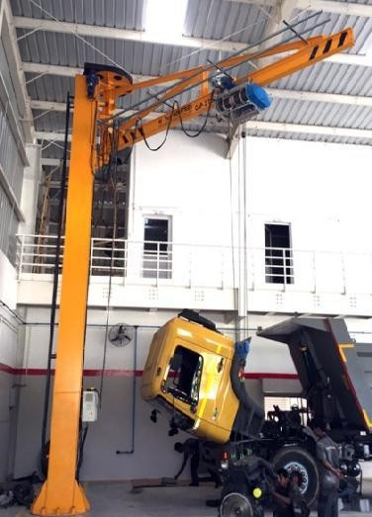

Figure 1: Fabricated Floor mounted jib crane [4]

Jib cranes are possibly one of the most versatile pieces of lifting equipment. The primary components of a jib crane are the column or post, the jib, the tie rod, and the hoist. The column supports the jib. The hoist lifts and transfers the cargo on the jib. Jib cranes are either wall or column mounted, depending on available space. The jib crane supports overhead cranes on production lines and maintains workstations, machining cells, and warehouses operational. Jib cranes are widely utilized in all client segments, from small workshops to assembly lines, docks, and even nuclear reactors, due to their ease of installation and lack of structural limits compared to other material handling equipment.

(Krunal Gandhare, Prof. Vinay Thute, et al., 2015) Discovered that optimizing the jib crane is a nonlinear problem; if this problem is solved using the classical method under the Kuhn-Tucker condition, it becomes too complex and difficult to solve, necessitating the use of automated programming. In this research, it was discovered that the evolutionary method produces excellent results and may be utilized to generate the optimum parameters for the crane, as well as parameter values that are possible and within constraints. There are some limitations to the provided optimization model, such as the weight applied being fixed, which really changes with changes in the cross sectional area of the boom, which when removed may yield positive results [1].

(Amit S. Chaudhary, 2015) Conducted a promising structural analysis of a jib crane's cantilever beam. A new beam shape design approach is proposed to address the issues of cantilever beam deflection, shear capacity, and lateral tensional buckling caused by loading. The discussions in this work demonstrate how the web tapered cantilever beam is better capable of resisting lateral torsional buckling and bending with high shear capacity for a given load when compared to the normal I section cantilever beam [2].

(Chirag A. Vakani, Shivang S. Jani, et al, 2014). Conducted an evaluation of jib crane utilization for radius-type operations. Two planar degrees of freedom each demand a different amount of force input. Fibers are elasticity, and some additional load cases not contemplated in the norm have been established, and they have a strong interest in the correct design of the mechanical set, primarily because they simulate some maneuvers that, while discouraged or prohibited, can occur during the use of the crane jib [3].

(K Suresh Bollimpelli, V Ravi Kumar, et al. , 2015) Performed static, model, and harmonic analyses of a column-mounted jib crane under the appropriate load circumstances. The static analysis on the jib crane gave a maximum von-Misses stress of 156.8N/mm2, which is the material's yield stress limit (250MPa). The manual calculations, which assume a simpler model, are likewise compatible with the program results. Analysis provides information about the jib crane's inherent frequencies. The frequency value is low, therefore it is not stiff and is regarded steady in operation. Ansys was utilized for the analysis, and Von-Misses stresses and displacement along the z-direction were determined. The maximum Von-Misses stress is 60 MPa, and the maximum displacement is 5mm.

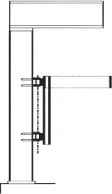

Figure 2: Column mounted jib crane [11]

Column-mounted jib crane stresses have an impact on the overall building frame and bracing systems, as well as local effects on the columns to which they are attached. The effects on the building can be mitigated by placing point loads on the column(s) in the proper positions and combining them with the load combinations specified by the building code. The local consequences must be addressed independently.

2.1 Global jib crane loads

Jib cranes apply vertical gravity loads and horizontal thrust loads to the supporting column. Hinge forces supplied by the crane manufacturer should be used when available. If statics are lacking, the loads can be approximated from them, as demonstrated in Figures 2 and 3. lacking, 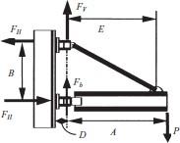

Figure 3: suspended boom jib crane [11].

$$F_{v}=W_{Lifted}+\frac{1}{2}W_{Boom}+W\frac{Trollf}{Hoist}J\frac{A}{E}$$

Acting @top hinge only

$$F_{H}=W_{Lifted}+\frac{1}{2}{vv}_{Boom}+vv\frac{Trollf}{Hoist}I\frac{A}{B}$$

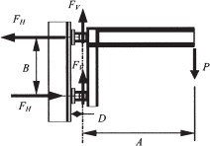

Figure 4: cantilever boom jib crane [11].

If the weight of the boom and trolley is unknown, the situation is suggested that a 15% factor be applied to the lifted load. Impact factors are required for jib crane column and linkage strength design, but impact need not be included for serviceability checks. Jib crane loads on columns will result in a horizontal thrust at the top and bottom of the supporting column, which must be resisted by the frame action or the structure pushing system.

It is not required to assume that all jib cranes are functioning in the most severe potential combination at the same time while doing structural analysis of building frames or bracing. Unless plant operations require otherwise, the structure should be constructed with the net impact of any two jib cranes acting to produce the greatest critical effect at a given cross section of the frame and/or the largest column responses.

2.2 Pivoting Jib Cranes.

A study about jib cranes would be incomplete devoid mentioning the pivoting type jib crane. This device is made up of a vertical column (generally a WF form) with a thrust bearing at the bottom and a ring-type rollers or ball bearing, or a bearing, at the highest point, as well as one or more horizontally arms (often a conventional beams section for supporting the trolley's wheels). The pivot jib's characteristics include the following:

* **Easy assembly:** Components can be assembled in most fabricating shops.
* **No hinge assemblies:** Direct attachment of boom to jib column flange.
* **Reduced friction:** Bearings enhance ease of swinging.
* **No axial load:** Upper bearing/bushing eliminates axial load.
* **No torsional considerations:** Single boom simplifies design.
* **Full 360-degree swing:** Unlike hinge-mounted jibs.
* **Multiple jib arms:** Can service multiple machines.
* **Direct bracing:** Braces jib column to building columns without torsion or axial forces.

2.3 Types of Jib Cranes.

There are hundreds of different jib crane types available, depending on the crane manufacturer. However, for the sake of this blog, they all differ to match the needs of your business. Furthermore, each jib type has a unique collection of sub-characteristics that can be tailored to a given application. These make creating the ideal solution for your application simple and efficient. We'll look at three common jib cranes.

A. Wall-mounted jib crane

B. Floor-mounted jib crane.

C. Jib articulates.

All three jib kinds can be divided into distinct installation categories and tailored to your requirements. Overhead cranes can be used to support particular workplaces, supporting larger cranes to provide circular coverage in a small region of a facility. The cranes' standard configurations include a trolley and a crane, both of which have a step-less frequency converter control system and are broken reliably.

**A. Wall-mounted jib crane**

Rotate 270° for a circular coverage area. With capacities of up to 5 tons, these systems are not lightweight. However, they are not equally strong as a freestanding system. Wall-mounted jibs require no floor space.

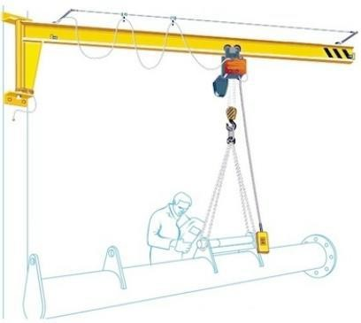

Figure 5: wall mounted jib crane [5]

This system is reinforced with an overhead mount and a tie rod-supported boom. To overcome the problem about off-centered launching, the design features a standard I, T-beam and a single tie rod. Wall-mounted jib cranes are an ideal material handling option for busy industries because they maximize space efficiency and allow for simple installation of individual workstations. However, if you want a device that offers excellent lift flexibility and precision, articulating jib cranes may be the answer. There are two major types of wall-mounted jib cranes:

* + Cantilever
  + tie rod supported

The cantilever wall-mounted design provides the most clearance above and below the boom. It also transmits less direct stress to building columns, making it simple to place on nearly any wall or column in your structure.

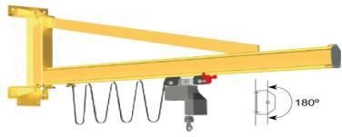

Figure 6: Wall-mounted cantilever jib crane [11].

The **tie rod-supported** wall-mounted jib crane is exceptionally cost-effective. It has no support structure under the boom, allowing the trolley hoist to simply travel the entire length of the boom.

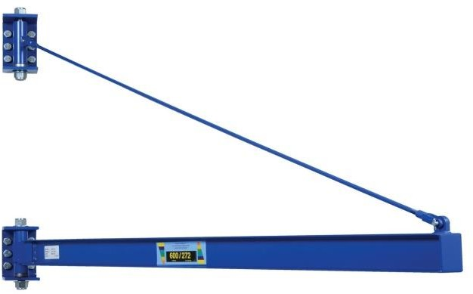

Figure 7: tie rod supported wall mounted Jib crane

###### **Floor-mounted Jib Crane**

###### Floor-mounted jib cranes are classified into several varieties, each of which serves a distinct purpose. For example, a freestanding (also known as a stand-alone) jib crane is foundation-mounted, allowing it to be erected practically anyplace inside or outside. Freestanding systems have bigger capacities, longer spans, and 360° and 270° rotation to cover a vast circular area of your business.

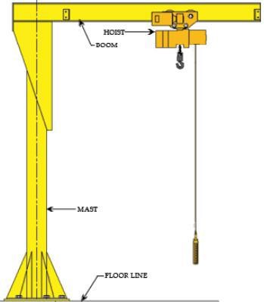

Figure 8: General Floor mounted Jib crane [11].

1. **Articulated Jib Crane**

These adaptable material handling solutions can lift and move items around corners and columns, reach into machinery, and serve almost any place between the pivot anchor and the boom's long reach. They provide a variety of installation choices, including floor mounting, wall mounting, ceiling mounting, and even bridge mounting. Articulating jib cranes are equipped with an inner and outer arm, allowing them to actually articulate around various areas of a facility, in and out of machinery, and over and under virtually any other impediment. The inner arm offers 270° of rotation, while the outside arm offers 360° of revolution.

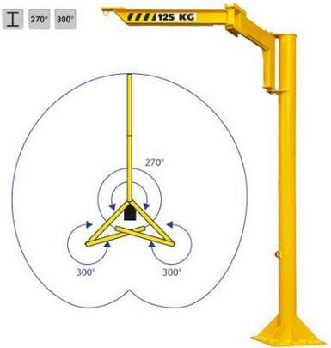

Figure 9: articulating jib crane [11]

## 2.4 Working with Jib Cranes

The underlying design of a jib crane is a sturdy boom chained to a fixed pivot point. This pivot is then securely affixed to a wall or the top of a freestanding column. This pivot can rotate 180 or

360 degrees and has a large operating range. The hoisting is done with an integrated pulley or motorized chain hoist that can glide along the book and has a broad operational area. Jib cranes, both freestanding and mast-type, can rotate 360 degrees. Wall-mounted options provide 200 degree rotation.

# Chapter Three: Design Analysis

**3. INTRODUCTION**

The performance parameters of the Floor Mounted Jib Crane are dependent on its movement. Here, we cover mathematical calculations and an investigation of the performance of a floor-mounted jib crane with a practical capacity of 0.5 tons. Jib cranes have a variety of performance characteristics; in this case, we are considering experimental research of a 0.5ton floor mounted jib crane.

Table 1: Specification of 0.5 Ton FMJC

|  |  |
| --- | --- |
| TYPE | Floor mounted |
| SWL | 0.5Ton |
| Height of Lift | 6000mm |
| Span | 5000mm |
| Angles of swivel | 270 |
| Lifting speed | 4m/min.(HT) and 18m/min.(LT) |

Where: *SWL = Safe Working Load, *HT = Hoisting Travelling, *CT = Cross Travelling

3.1. Conceptual Design Major Components of Jib Crane

A floor mounted jib crane is made up of the following parts: (a) the jib, (b) the column, (c) the base plate, and (d) the tie rod. Figure depicts the various components of a jib crane. The jib crane has a base that is fastened to the ground at the bottom. A fixed support connects the bottom of the column to the ground. The trolley's motion is powered by an electric motor positioned inside the trolley. The wheels run on the flanges of the "I" sectioned jib along its length. The trolley is made up of hoisting machinery that lifts and lowers the weight using a hook. The load hook has three different motions: lifting, longitudinal traverse of the trolley, and crane swiveling through 270°. Each motion is controlled independently of the others by separate controllers located in a control cage.

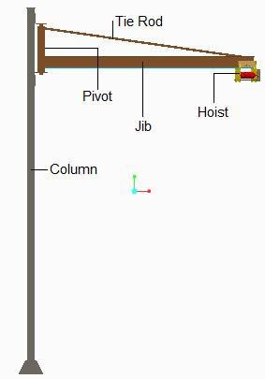

Figure 10: A Model of FMJC 0.5ton

## 3.2 Structure Design of Jib Crane

3.2.1 Design of Tie Rod

The tie is inclined at an angle of 80 degrees to the jib and secured at a location 5 meters from the center line of the crane column, giving a clear radius of 5 meters from the buckle for ease of erection and to make any necessary changes due to defective workmanship. It is also believed that the crane post exerts no fixing moment on the jib, which would be exceedingly minor in this configuration. The greatest load in the tie will occur when the hook block is at the extreme of our position, which is a radius of 5 meters. Drawing the triangle of forces yields tension in the tie of 10,000N and compression in the jib of approximately 8660N.

The weights of the jib, tie rod, and trolley have been ignored for the time being; actual loads will be evaluated later, once certain measurements have been allocated to these components. A round tie bar of M.S. with the top end forged into the shape of an eye for pin joint is proposed for attachment to a crane post. In slow motion hand cranes, an essential allowance of 15% to 22% must be made. As part of the course work, the following problem design is included as project work. In other words, all actual operating loads and stresses in various structural elements should be increased by 30% to 40% to achieve their static equivalents. To calculate the maximum acceptable working stress, a factor safety equal to four should be added to these static values based on the maximum possible stress.

Assume the actual working load in particular parts is 1000N. The static number after applying a 40% impact factor would be 1200N. M.S. tensile strength is approximately 350N/mm2 (static) and 62.5N/mm2 (dynamic), assuming simple calculations without the impact factor.

Cross sectional area of the bar is required. $\frac{30000}{62.5}=480mm$

$A=482{mm}^{2}$ 𝑎𝑝𝑝𝑟𝑜𝑥𝑖𝑚𝑎𝑡𝑒𝑙𝑦

$$=\frac{π}{4}D^{2}=480{mm}^{2}$$

𝐷 = 24. 72mm*,* Therefore ***D*** ~ **25*mm***

This diameter is at the bottom of the thread.

Core diameter = **25*mm***

$$full diameter=\frac{25}{0.85}mm=29.411mm$$

Therefore, the diameter of the tied rod needed to be $\sim 30mm$.

### 3.2.2 Design of Jib

The maximum bending moment on the jib occurs when the load is at the free end of the jib which is 5 meters from the fixed end. The shearing force will be 3334*N* only and may not be taken in to consideration.

Maximum bending moment $=9467*5000=47.34*106$  
Allowing a maximum allowed bending stress of $250N/{{mm}^{2}}$

Section modules of jib required $=\frac{47.34}{165}*{10}^{6}=28.7*{10}^{6}$

A rolled steel joist is best suited for this design. The load trolley will go along the inner tapered surface of the bottom flange. When designing electric and hand-operated cranes, crane gantries, and runways, it is critical to verify the deflection of the beams and girders to ensure that they do not exceed a specified limit.

If the deflection of a girder (on which the trolley runs) exceeds the permissible limit, the trolley will be hindered in their passage or, more likely; the slope of the track to the horizontal will be increased, requiring extra force to drag the load trolley down the girder length.

Table 2: Specification of ISMB 250

|  |  |  |  |  |
| --- | --- | --- | --- | --- |
| Designation | Area (𝑐𝑚2) | Depth (𝑚𝑚) | Width (𝑚𝑚) | Web Thk. (𝑚𝑚) |
|  | Ar | D | B | Tw |
| ISMB 250 | 47.5 | 250 | 125 | 25.5 |

Table 3: ISMB with tapered flanges actual load carried by the boom

|  |  |  |  |  |
| --- | --- | --- | --- | --- |
| Designation | Root Thk.(𝑚𝑚) | Root Radius (𝑚𝑚) | Toe Radius (𝑚𝑚) | MI (𝑐𝑚4) |
|  | Tw | R | r | Iz |
| ISMB 250 | 6.9 | 13 | 6.5 | 5131.6 |

Dead load: (𝐷𝐿) = 315𝐾𝑔

Hoist Load: (𝐻𝐿) = 150𝐾𝑔

The lifted load is (𝐿𝐿) = 500𝑾𝑔.

The entire load upon the boom has been determined as 𝑷𝑿 + 𝑻𝑿 + 𝑿𝑿 = 315 + 150 + 500 = 965 𝑾𝑐. Dead load (DL): The weight of the beam plus any other fixed item supported by it.

Hoist load (HL) refers to the weight of the hoist and any other equipment attached to it. Lifted load (LL): The weight of the item being lifted, including any accompanying lift devices such as slings and shackles.

The column and boom of the self-supported jib crane should be designed so that the overall support of the jib boom does not go over the following limit, whenever the lifting mechanism with full load is at the extreme boom radius:

$\frac{column height H+boom length l}{300}43.33$ To get maximum deflection

A reference to hand book for structural engineers, “Structural Steel Section” shown that depth of nearest standard beam is either 225*mm*or 250*mm*. We select **250x125.**

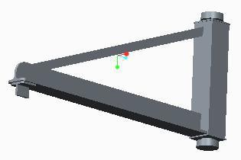

Figure 11: Jib

#### 3.2.3 Design of Rope

Z = No. Of ropes = 1

Q = Lifting capacity = 500𝑘𝑔 (IS∶ 2266 − 1963)

 = pulley efficiency = 0.94% (IS∶ 2266 − 1963)

*Breaking Strength of Rope, $P=\frac{W}{0.94\%*Z}=5319N$*

Choice of rope∶ As per IS 3938∶ 1967 for D/d = 16

Selecting the Rope

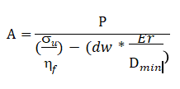

Where

s𝑢 = Tensile of the wire = 1600 𝑁 / 𝑚𝑚2 (IS∶ 2266 − 1963)

$$Er=Corrected modulus of elasticity =8*{10}^{4}N/{mm}$$

𝑓 = Design factor = 4



𝐷 = Diameter of drum

𝑑 = Diameter of wire rope

𝑑𝑤 = Diameter of wire = 0.045 𝑑

𝑃 = Breaking strength of rope = 5319𝑁

Now, all values are put in this equation,

$$Now, A=\frac{5319N}{\frac{1600}{4}-0.04d*\frac{8*{10}^{4}}{16*d}}$$

𝐴 = 30. 39𝑚𝑚2

𝐴 = 0.4𝑑2

30.39 = 0.4𝑑2

𝑑 = 8𝑚𝑚 As per IS∶ 2266 − 1963, acceptable standard rope diameter is 8𝑚𝑚.

So, the selected rope is 6x37 - 8 - 1600.   
Here, 6 = strands. 37 = wires.   
8 = rope diameter.

1600 = bending strength (𝑁⁄𝑚𝑚2).



Figure 12: Wire rope

Minimum diameter of pulley = 16𝑑 (5) = 128𝑚𝑚

It is recommended to take pulley diameter = 27 (5) = 216 𝑚𝑚.   
Compensating pulley   
𝐷1 = 0.6 * 216 = 129. 6𝑚𝑚   
𝐷1 = 130𝑚𝑚

### 3.2.4 Hoisting Drum

Hoisting drum with one coiling rope has only one helix, while the drums with two coiling ropes are provided with helices, right hand & left hand. A design procedure of hoisting drum is as under:

* + - * 1. Number of turns on a drum for one rope member

$$n=\frac{hi}{πd}+2_{PSG_{9.2}}=\frac{6000*2}{π*200}+2$$

$$n=21.01turns=22turns$$

Where,

h = height of load to which it is raised

i = ratio of pulley system = 2(𝑃𝑆𝐺_9.3)

𝐷 = drum diameter = 25𝑑 = 25(8) = 200 𝑚𝑚

* + - * 1. Length of drum

$$L=\left(\frac{2Hi}{πD}+7\right)*{Pi}_{PSG}=(\frac{2*6000*2}{π*200}+7)*9.5$$

𝐿 = 429.37mm = 430𝑚𝑚   
the pitch of two rope grooves (𝑝) equals 9.5 𝑚𝑚   
 C. Drum thickness is calculated as

𝑡 = 0.02D + 10(𝑃𝑆𝐺_9.3) = (0.02 * 200) + 4 = 14𝑚𝑚.  
D. Outside diameter of drum   
𝐷𝑜 = D + 6𝑑(𝑃𝑆𝑺_9.3) = 200 + 6(8) = 248 mm   
E. Drum inner diameter   
𝐷𝑖 = D − 2t = 200 − 2(14) = 172𝑚𝑚

### 3.2. 5 Design of Rope Sheave

Sheaves are usually made of steel, grey cast iron. Small sheaves are made by casting. Sheaves are mounted on axles with antifriction bearings or bronze bushes.

1. Sheave diameter (D = 27d = 216 mm).

2. 𝑤𝑖𝑑𝑡ℎ that 𝑠ℎ𝑒𝑎𝑣𝑒 = 2.75𝑑 = 22𝑚𝑚 = 2 * 𝐻𝑜𝑙𝑒𝑑𝑖𝑎𝑚𝑒𝑡𝑒𝑟 = 2.7𝑑 𝑡𝑜 3.6𝑑

3. 𝐷𝑒𝑝𝑡ℎ for the 𝑔𝑟𝑜𝑜𝑣𝑒 = 1.6𝑑 = 12.8𝑚𝑚

4. 𝑅𝑎𝑑𝑖𝑢𝑠 for the 𝑔𝑟𝑜𝑜𝑣𝑒 = 0.53𝑑 = 4.24𝑚𝑚

5.𝑇ℎ𝑖𝑐𝑘𝑛𝑒𝑠𝑠 for the 𝑤𝑒𝑏 = 0.75𝑑 = 6𝑚𝑚

6. 𝑤𝑖𝑑𝑡ℎ for the 𝑔𝑟𝑜𝑜𝑣𝑒 𝑎𝑡 𝑡ℎ𝑒 𝑡𝑜𝑝 = 2.1𝑑 = 16.8𝑚𝑚

7. 𝑅𝑎𝑑𝑖𝑎𝑙 𝑡ℎ𝑖𝑐𝑘𝑛𝑒𝑠𝑠 = 0.4𝑑 = 3.2𝑚𝑚

8. 𝐵𝑜𝑠𝑠 𝑑𝑖𝑎𝑚𝑒𝑡𝑒𝑟 = 2 (Hole diameter) = 2.7 to 3.6

### 3.2.6 Design for the Hook

General purpose cranes that carry loads that have different shapes carry the loads via chains or rope slings attached to hooks. Standard (single) ram hooks are the most commonly utilized design for this function. Solids are sometimes used to construct triangle hooks, which can be flat-die or closed-die forged, or composed of a sequence of shaped plates.

$$C=\sqrt[k]{W}$$

𝑤 = 𝑙𝑜𝑎𝑑 𝑡𝑜 𝑏𝑒 𝑙𝑖𝑓𝑡𝑒𝑑 = 5000 𝑁

𝑘 = 12

$$C=\sqrt[12]{\frac{5000}{1000}}=26083mm$$

𝑡𝑎𝑘𝑒 𝑖𝑛𝑛𝑒𝑟 ℎ𝑜𝑜𝑘 𝑑𝑖𝑎𝑚𝑒𝑡𝑒𝑟 𝑜𝑓 ℎ𝑜𝑜𝑘 (𝐶) = 26. 83

𝐷𝑒𝑝𝑡ℎ, 𝐻 = 0.93 * 𝐶 = 0.93 * 26.83 = 24. 95𝑚𝑚

𝐵𝑎𝑠𝑒 𝑠𝑒𝑐𝑡𝑖𝑜𝑛, 𝑀 = 0.6 * 𝐶 = 0.6 * 26.83 = 16𝑚𝑚

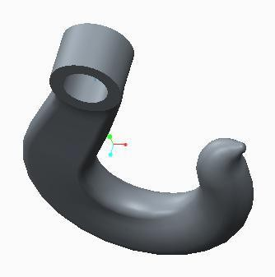

Figure 13: Hook

### 3.2.5 Design of Gear Box

Design for both the pairs is similar in fashion as per the design for first gear and hence the dimensions or both pairs are same.

$$speed ratio=pinion \frac{RPM}{Gear RPM}=\frac{387}{54}=7.$$

Material referring to the standard table given in P.S.G. Data –Book for *i* = 8 *(PSG _8.4, Table_5)*

(Surface hardness HB ≤ 350) For Pinion C45

For Wheel C35Mn75

$$For =C45 σ_{1}$$

$=270N/{mm}^{2}$

**(I) For Pinion,**

𝜎1 = 𝐸𝑛𝑑𝑢𝑟𝑎𝑛𝑐𝑒 𝑠𝑡𝑟𝑒𝑛𝑔𝑡ℎ = 270 𝑚𝑚2 (𝑃𝑆𝐺_8.18).   
𝐾𝑏1 = 𝑙𝑖𝑓𝑒 𝑓𝑎𝑐𝑡𝑜𝑟 = 1(≤ 350𝐻𝐵 𝑠𝑢𝑟𝑓𝑎𝑐𝑒 ℎ𝑎𝑟𝑑𝑛𝑒𝑠𝑠)(𝑃𝑆𝐺8.17, 𝑇𝑎𝑏𝑙𝑒17)   
𝐾𝑠 = 𝑠𝑢𝑟𝑓𝑎𝑐𝑒 𝑓𝑖𝑛𝑖𝑠ℎ 𝑓𝑎𝑐𝑡𝑜𝑟 = 1. 6 𝑃𝑆𝐺_8.15)   
µ𝑓 = 𝑓𝑎𝑐𝑡𝑜𝑟 𝑜𝑓 𝑠𝑎𝑓𝑒𝑡𝑦 = 2 (𝑃𝑆𝐺8.19, 𝑇𝑎𝑏𝑙𝑒20, 𝑁𝑜𝑟𝑚𝑎𝑙𝑖𝑠𝑒𝑑)   
  
𝑌𝐼 = 𝑓𝑜𝑟𝑚 𝑓𝑎𝑐𝑡𝑜𝑟 = 0. 3 (𝑃𝑆𝐺8.19, 𝑇𝑎𝑏𝑙𝑒18)

$$Y_{1}*σ=\frac{0.3*270*1*1.4}{1.6}=35.43N/{{mm}^{2}}$$

Table 3. Dimension of 2nd Pinion

|  |  |
| --- | --- |
| No. Of Teeth (Z) | 23 |
| Module (m) | 2.0 mm |
| P.C.D | 46 mm |
| O.D | 50 mm |
| Addendum | 2.0 mm |
| Dedendum | 2.5 mm |

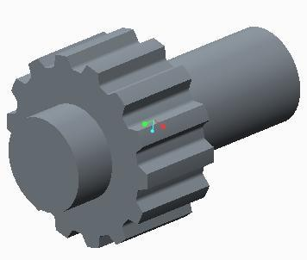

Figure 14: Pinion

**(II) For Gear**

µ𝑓 = 2(𝑃𝑆𝐺8.19, 𝑇𝑎𝑏𝑙𝑒20, 𝑁𝑜𝑟𝑚𝑎𝑙𝑖𝑠𝑒𝑑)

𝐾𝑠 = 1. 6(𝑃𝑆𝐺8.15)

𝑌2 = 0.05(𝑃𝑆𝐺8.18, 𝑇𝑎𝑏𝑙𝑒18)

𝐾𝑏 = 1(≤ 350𝐻𝐵 𝑠𝑢𝑟𝑓𝑎𝑐𝑒 ℎ𝑎𝑟𝑑𝑛𝑒𝑠𝑠) (𝑃𝑆𝐺8.17, 𝑇𝑎𝑏𝑙𝑒17)

ℎ𝑒𝑟𝑒, 𝑌2 * 𝜎𝑏2 > 𝑌1 * 𝜎𝑏1

𝑠𝑜, 𝑔𝑒𝑎𝑟 𝑖𝑠 𝑠𝑡𝑟𝑜𝑛𝑔𝑒𝑟 𝑡ℎ𝑎𝑛 𝑝𝑖𝑛𝑖𝑜𝑛 𝑎𝑛𝑑 ℎ𝑒𝑚𝑐𝑒 𝑝𝑖𝑛𝑖𝑜𝑛 𝑖𝑠 𝑡𝑜 𝑏𝑒 𝑑𝑒𝑠𝑖𝑔𝑛𝑒𝑑 𝑐𝑒𝑛𝑡𝑒𝑟 𝑑𝑖𝑠𝑡𝑎𝑛𝑐𝑒

$$a≥\left(i±1\right)\sqrt{\frac{{0.74}^{2}}{σ_{e}}}*\sqrt{\left(\frac{E*M_{i}}{i*∈}\right)}\left(PSG8.13 , Table8\right)$$

$E = Modulus of elasticity =2.15*{10}^{5}N/{{mm}^{2}}$ (𝑃𝑆𝐺8.14, 𝑇𝑎𝑏𝑙𝑒9)

Number of teeth on pinion = 23

Number of teeth on wheel = 11 * 𝑖 = 23 * 7.1 = 163

𝑍1 = 𝑛𝑢𝑚𝑏𝑒𝑟 𝑜𝑓 𝑡𝑒𝑒𝑡ℎ 𝑜𝑛 𝑝𝑖𝑛𝑖𝑜𝑛 = 23

𝑍2 = 𝑛𝑢𝑚𝑏𝑒𝑟 𝑜𝑓 𝑡ℎ𝑒𝑒𝑡ℎ 𝑜𝑛 𝑔𝑒𝑎𝑟 = 163

𝑓𝑎𝑐𝑒 𝑤𝑖𝑑𝑡ℎ, 𝑏 =∈* 𝑎 = 0.2 * 93 = 18. 6𝑚𝑚

$$now checking in bending stress, σ_{b1} =\frac{i+1}{a*m*b*Y}*M_{I}({PSG}_{8.18})$$

$$=\frac{7.1+1}{93*2*18.6*0.3}*734022=5728N/{{mm}^{2}}$$

𝑜𝑡ℎ𝑒𝑟 𝑑𝑖𝑚𝑒𝑛𝑠𝑖𝑜𝑛𝑠 𝑜𝑓 𝑝𝑎𝑖𝑟 𝑀𝑜𝑑𝑢𝑙𝑒 𝑚 = 2𝑚𝑚

𝑐𝑒𝑛𝑡𝑒𝑟 𝑑𝑖𝑠𝑡𝑎𝑛𝑐𝑒 𝑎 = 93𝑚𝑚

𝑡𝑜𝑜𝑡ℎ 𝑑𝑒𝑏𝑡ℎ ℎ = 2.25 * 2 = 4. 5𝑚𝑚 (𝑃𝑆𝐺 _ 8.22, 𝑇𝑎𝑏𝑙𝑒 _ 26)

Pitch diameter, 𝑑2 = 𝑚 * 𝑍1 = 23 * 2 = 46𝑚𝑚(𝑃𝑆𝐺 _ 8.22, 𝑇𝑎𝑏𝑙𝑒 _ 26)

𝑑2 = 𝑚 * 𝑍2 = 163 * 2 = 326𝑚𝑚(𝑃𝑆𝐺 _ 8.22, 𝑇𝑎𝑏𝑙𝑒 _ 26)

𝑇𝑖𝑝 𝑑𝑖𝑎𝑚𝑒𝑡𝑒𝑟, 𝑑𝑠1 = (𝑍1 + 2) * 𝑚 = 50 * 2 = 100𝑚𝑚(𝑃𝑆𝐺 _ 8.22, 𝑇𝑎𝑏𝑙𝑒 _ 26)

𝑑𝑠2 = (𝑍2 + 2) * 𝑚 = 165 * 2 = 330𝑚𝑚 (𝑃𝑆𝐺 _ 8.22, 𝑇𝑎𝑏𝑙𝑒 _ 26)

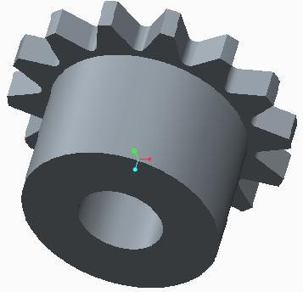

Figure 15: Gear

### 3.2.6 Design of Shaft

###### Table 4. Force on Shaft

|  |  |  |  |
| --- | --- | --- | --- |
| Shaft No. | Torque  (𝑀𝑡) | Tangential Force  (𝑃𝑡) = 𝑀𝑡/𝑑 | Radial Force  (𝑃𝑟) = 𝑃𝑡 * 𝑇𝑎𝑛𝛼 |
| A | 734022 *N* /*mm* | 101.19 *N* | 36.83 *N* |
| B | 734022 *N* /*mm* | 715.6 *N* | 260.48 *N* |

𝛼 = 𝑃𝑟𝑒𝑠𝑠𝑢𝑟𝑒 𝐴𝑛𝑔𝑙𝑒 = 200

𝑅𝑥 + 𝑅𝑦 = 869.20 𝑁

𝑇𝑎𝑘𝑖𝑛𝑔 𝑚𝑜𝑚𝑒𝑛𝑡 𝑎𝑏𝑜𝑢𝑡 𝑥; (170.68 * 11.5) + (761.52 * 21.5) = 33 * 𝑅𝑦

𝑅𝑦 = 555.62 & 𝑅𝑥 = 313.58/8

𝑀𝑜𝑚𝑒𝑛𝑡 𝑎𝑡 𝐴. 𝑀𝐴 = 313.58 * 11.5 = 3606. 17 𝑁/𝑚𝑚

𝑀𝑜𝑚𝑒𝑛𝑡 𝑎𝑡 𝐵. 𝑀𝐵 = 555.62 * 115 = 6389.63 $N/{mm}$

𝑠𝑜 𝑚𝑎𝑥𝑖𝑚𝑢𝑚 𝑚𝑜𝑚𝑒𝑛𝑡 𝑖𝑠 𝑎𝑡 𝐵, 𝑀𝑚𝑎𝑥 = 6389. 63 $N/{mm}$

𝑇𝑜𝑟𝑞𝑢𝑒, 𝑇𝑞 = 734022 $N/{mm}$

𝑠𝑜 𝑒𝑞𝑢𝑣𝑎𝑙𝑒𝑛𝑡 𝑡𝑜𝑟𝑞𝑢𝑒 = √ ((𝐾𝑏 * 𝑀𝑚𝑎𝑥) 2 + 𝐾𝑡 * 𝑇)

𝐾𝑏 = 1.3 𝑎𝑛𝑑 𝑇𝑒𝑞. = √ ((6389.63 * 1.5)2 + (734022 * 1.3)2) = 954276. 73 $N/{mm}$

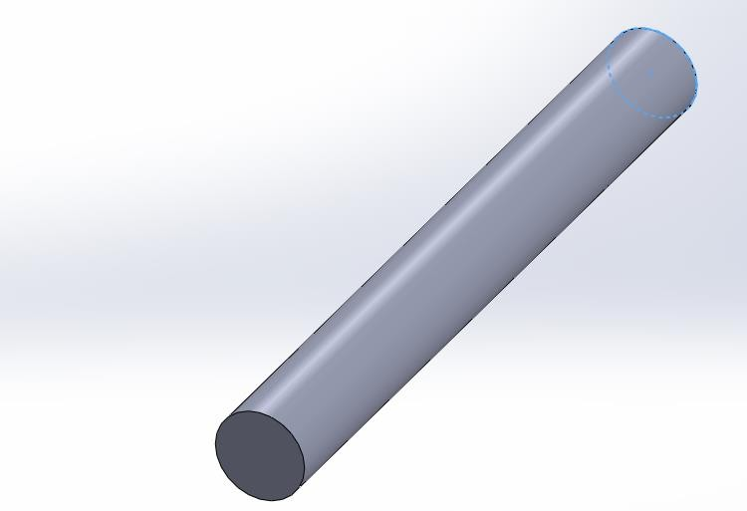

Figure 16: Shaft

### 3.2.7 Design of Cross-Travel

Cross travel consists of wheel and motor.

* d = Journal diameter
* D = Outer race diameter First consider friction at inner race

𝑇𝑜𝑡𝑎𝑙 𝑙𝑜𝑎𝑑 𝑜𝑛 𝑤ℎ𝑒𝑒𝑙𝑠 𝑜𝑓 𝑐𝑟𝑜𝑠𝑠 𝑡𝑟𝑎𝑣𝑒𝑙 = 9467𝑁

9467

𝐹𝑜𝑟 𝑜𝑛𝑒 𝑤ℎ𝑒𝑒𝑙 𝑃 = 4 = 2367 𝑁

𝑑

𝐹𝑟𝑖𝑐𝑡𝑖𝑜𝑛𝑎𝑙 𝑟𝑒𝑠𝑖𝑠𝑡𝑎𝑛𝑐𝑒 𝑚𝑜𝑚𝑒𝑛𝑡 𝑎𝑡 j𝑜𝑢𝑟𝑛𝑎𝑙, = $p*\frac{d}{2}*f$

𝑓 = 𝑐𝑜𝑒𝑓𝑓𝑖𝑒𝑖𝑒𝑛𝑡 𝑜𝑓 𝑓𝑟𝑖𝑐𝑡𝑖𝑜𝑛 𝑓𝑜𝑟 𝑏𝑒𝑎𝑟𝑖𝑛𝑔 𝑓𝑟𝑜𝑚 𝑠𝑡𝑎𝑛𝑑𝑎𝑟𝑑 𝑡𝑎𝑏𝑙𝑒 𝐴𝑙𝑒𝑥𝑎𝑛𝑑𝑟𝑜𝑣

𝑓 = 0.015 (𝑓𝑜𝑟 𝑏𝑎𝑙𝑙 𝑎𝑛𝑑 𝑟𝑜𝑙𝑙𝑒𝑟 𝑏𝑒𝑎𝑟𝑖𝑛𝑔)

10

𝐹𝑟𝑖𝑐𝑡𝑖𝑜𝑛𝑎𝑙 𝑟𝑒𝑠𝑖𝑠𝑡𝑎𝑛𝑐𝑒 𝑚𝑜𝑚𝑒𝑛𝑡 = $2367*\frac{10}{2}*0.015=178N/{mm}$

𝐹𝑟𝑖𝑐𝑡𝑖𝑜𝑛𝑎𝑙 𝑟𝑒𝑠𝑖𝑠𝑡𝑎𝑛𝑐𝑒 𝑚𝑜𝑚𝑒𝑛𝑡𝑎𝑡 𝑐𝑜𝑛𝑡𝑎𝑐𝑡 𝑓𝑎𝑐𝑒 𝑜𝑓 𝑤ℎ𝑒𝑒𝑙 𝑎𝑛𝑑 𝑝𝑙𝑎𝑡𝑒, = $p*\frac{35}{2}*μ$

µ = 𝑐𝑜𝑒𝑓𝑓𝑖𝑐𝑖𝑒𝑛𝑡 𝑜𝑓 𝑓𝑟𝑖𝑐𝑡𝑖𝑜𝑛 𝑏𝑒𝑡𝑤𝑒𝑒𝑛 𝑐𝑜𝑛𝑡𝑎𝑐𝑡 𝑠𝑢𝑟𝑓𝑎𝑐𝑒 = 0.03(𝑓𝑜𝑟 𝑟𝑜𝑙𝑙𝑒𝑟 𝑠𝑡𝑒𝑒𝑙)

$Frictional resistance=2367*\frac{35}{2}*0.03=1243N/{mm}$

$$Total moment of resistance =2367+178=1421N/{mm}$$

$$Speed of cross travel (linear velocity) =18m/{min}=0.3m/s$$

$$Angular speed w = linear \frac{velocity}{radi of wheel}=\frac{0.3*2}{0.035}=17.14{rad}/{sec}$$

$$No. of revolutions =\frac{w*60}{2π}=\frac{17.14*60}{2π}=163.75=164RPM$$

### 3.2.8 Design of Column

For the case at hand, the column represents an important crane number. It has been observed that when a column or strut is subjected to a progressive rise in compressive load, a point occurs at which the column is subjected to ultimate load. Beyond this, the column will fail due to crushing, and the load will be referred to as the crushing load. It has also been observed that a compression member may fail by bending rather than crushing. Beam columns are well named because they can sometimes act fundamentally like restrained beams, producing plastic hinges, and under other conditions fail by buckling in a similar fashion to axially loaded columns or by lateral tensional buckling in the same way that uncontrolled beams do.

According to basic material mechanics, only extremely short columns can be loaded up to their yield stress. Buckling happens in lengthy columns before the member has its maximum material strength. Columns must be constructed for both compressive and bending loads. In a bending moment-based design, the moment owing to total load 9467N is communicated to the column's base.

The weight of beam = 367.87N Hence total moment,

M = Eccentric moment + Moment due to load

$$=\left(0.25*367.887\right)+(5*9467)=47426.96N/{mm}$$

The maximum bending moment for column fixed at one end and other end free with eccentric loading is given by,

$$M=w*e*\sec\left(L/2\right)\sqrt{\frac{w}{EI}}$$

Where

* M = Load on column
* e = Eccentricity of load
* L = Equivalent length of column = L/4
* E = Module of elasticity $=0.215 N/{mm}$
* I = Moment of inertia

$$M=5000*5*Sec\left(\frac{5}{4}\right)\sqrt{\left(\frac{5000}{0.125}\right)I}=6.48*{10}^{-2}m^{4}$$

Then choose the section for the column, and the dimensions are as follows:   
𝑏 = 125𝑚𝑚, ℎ = 75𝑚𝑚   
𝑟𝑥(𝑐𝑚) = 410 , 𝑟𝑦(𝑐𝑚) = 2.65 𝑍𝑥(𝑐𝑚3) = 410, 𝑍𝑦(𝑐𝑚3) = 53.5

# Chapter Four: Result and Discussion

## Result

The design parts of the floor mounted jib crane components and show the parts 3D modeling using solid work software, assemble the parts of the jib crane and show an animation of the working of the floor mounted jib crane using solid work software, we found the lifting height to be up to 6 meters, lifting load to be up to 0.5 tons, degree of rotation to be from 180 to 270, and lifting speed to be 4 m/min up to 18 m/min.

## 4.2 Discussion

The components of the floor mounted jib crane were designed and selected to comply with the specifications provided in the literature review, and the results were assessed and verified.   
The designed components required for the machine were identified, their availability and manufacturability were checked, and the appropriate materials for the components were selected.   
We analyzed the strength of each component, modeled them using Solid Work, and assembled them in order.

# Chapter Five: Conclusion and Recommendation

## 5.1 Conclusion

More study will result in the automation of all lifting and hoisting firms, allowing for higher production quality and quantity while also ensuring the well-being and safety of workers. We feel that the floor mounted jib crane we built is better suited to heavy lifting up to 0.5 tons of weight and can raise automobile engines in workshops to a maximum height of 6 meters. I prepared 3D models using Solid Works.

## 5.2 Recommendation

For lifting and hoisting enterprises, atomizing the manufacturing line will improve production quality and quantity. The equipment we built is well-suited to our country and has additional functions for heavy lifting enterprises. Furthermore, if the studies provided in this paper are carried out, they will answer more problems in heavy lifting and hoisting organizations, and more research and analysis will increase the machine's performance.

# References

[1]. Krunal Gandhare, Prof. Vinay Thute. (2015 April). Design Optimization of Jib Crane Boom Using Evolutionary Algorithm. *International Journal of Scientific Engineering and Research*, Volume 3, Issue 4, ISSN (Online): 2347-3878.

[2]. Amit S. Chaudhary, Subim N. Khan. (2015, May-June).A review paper on structural analysis of cantilever beam of jib crane. *International Journal of Engineering Research and General Science*, Volume 3, Issue 3, ISSN (Online) 2091-2730.

[3]. Chirag A. Vakani, Shivang S. Jani. (2014). Analysis and Optimization of 270° Jib Crane Deflection: A Review. *International Journal for Scientific Research and development.* Volume 2, Issue 10. ISSN(Online):2321-0613, pp.471-473.

[4]. Sunil R. Kewate, Charudatta A. Simpi, D.R. Choudhari and J.H. Atole, “Design Analysis of Cantilever I- Type Beam for Jib Crane” International Journal of Applied Engineering Research, ISSN: 09734562, 2014.

[5]. Dieter GE. Mechanical metallurgy, 3rd edition, McGraw Hills, Singapore. 1988; 277:333-334. 4. Robert C.

[6]. Salvendy G 2012 Handbook of human factors and ergonomics (New Jersey: John Wiley & Sons, Inc.)

[7]. Juvenall. Fundamentals of machine components design. Knanah Publishers. 1978; 444-473.

[8] "Safety and Health Topics_ Ergonomics_ Occupational Safety and Health Admini*_*28 March 2019.

[9]. Design Data, PSG college of Technology, 1978, Coimbatore 1978.

[10]. Raymond A. Kulwiec, Editor-in-chief, Material Handling Handbook, 2nd [Edition](https://www.osha.gov/SLTC/ergonomics/) Volume 1, sponsored by The American Society of Mechanical Engineers and the International Material Handling Society, 2009.

[11] International Research Journal of Engineering and Technology (IRJET) e- ISSN: 2395 -0056 Volume: 03 Issue: 12 | Dec -2016