## IOSR Journal of Engineering (IOSRJEN) [www.iosrjen.org](http://www.iosrjen.org/)

Smart Industrial Air Pollution Control Using IoT with 89C52 Microcontroller and ADC0809 Interface

LV.R Chanthanya Prasad1, Panta Sandhya2, Gali Venkatesh3, Doma Niharika4

chaitanyaprasad.l@sreenidhi.edu.in,21311A04D7@sreenidhi.edu.in, 21311A04E1@sreenidhi.edu.in, 21311A04F0@sreenidhi.edu.in,

*Department of Electronics and Communication Engineering, Sreenidhi Institute of Science and Technology,, Ghatkesar, Hyderabad*

**Abstract:** Industrial air pollution refers to the release of hazardous substances into the atmosphere by manufacturing units such as cement factories, thermal power stations, pharmaceutical plants, and fertilizer units. These emissions often include toxic gases and fine particulate matter, which can lead to serious health concerns, particularly respiratory illnesses like asthma, bronchitis, and even lung cancer.

Typically, pollutants are expelled into the air through tall exhaust chimneys. In this proposed concept, a specially designed air purification chamber is installed at the top of such exhaust pipes. This chamber incorporates a two-stage filtration system made from cellulose acetate fiber filters and activated carbon filters. A suction fan mounted at the chamber’s outlet draws the polluted air through the filters, allowing cleaner air to be released into the atmosphere.

The chamber is equipped with two air quality monitoring sensors to assess pollution levels before and after the filtration process. These readings are processed and displayed on an LCD screen, providing a clear comparison of air quality improvement. Additionally, a Wi-Fi module transmits this data in real time to the factory owner's mobile device, enabling continuous monitoring.

The control system is powered by an Arduino Nano microcontroller, and MQ135 gas sensors are employed to detect air contaminants. This setup allows factory personnel to stay informed about the effectiveness of the air purification system, without needing to physically inspect the exhaust areas.

For demonstration purposes, a scaled-down prototype of an industrial exhaust pipe integrated with the air cleaning mechanism will be constructed. This model will visually and functionally validate the working of the system. The effectiveness of air purification is evaluated using the Air Quality Index (AQI), which represents the level of pollutants in the air. In this project, AQI values are interpreted as percentages to simplify real-time analysis. Essentially, air quality assessment helps determine how clean or polluted the air is, both before and after the implementation of the cleaning system.

**Keywords:** Construction of air cleaning chamber built with

charcoal powder and filter buds, simulation of factory pipe, main processing unit built with Arduino Nano, MQ 135 air quality measuring sensors, LCD, ESP8266 WiFi module, instrument fan, power supply unit

Date of Submission: 14-05-2025 Date of acceptance: XX-XX-2025

# I. INTRODUCTION

Industrialization has undoubtedly accelerated human progress, transforming societies and economies. However, this rapid growth has brought along environmental challenges—air pollution being one of the most critical. Factories and processing plants, especially those involved in cement manufacturing, power generation, pharmaceuticals, and fertilizers, are among the top contributors to deteriorating air quality. The gases and particulate matter released into the atmosphere pose a direct threat not only to the environment but also to public health.

Air pollution originating from industrial sources often contains a mixture of toxic gases, such as sulfur dioxide, nitrogen oxides, carbon monoxide, and volatile organic compounds. These substances, when inhaled over long periods, can trigger a range of health problems, from mild irritation to chronic respiratory conditions,

cardiovascular diseases, and cancer. In addition to human health, these pollutants harm ecosystems and contribute significantly to global warming and climate change.

Conventionally, industrial exhaust gases are vented into the atmosphere through tall chimneys or stacks, designed to disperse emissions at higher altitudes. While this may reduce immediate ground-level exposure, it does not eliminate the pollutants. On the contrary, they still mix with the atmosphere and travel long distances, affecting air quality on a much wider scale. This calls for an effective and localized pollution control mechanism that can filter these emissions before they are released into the air.

In response to this challenge, our project introduces an air purification system specifically tailored for industrial exhaust outlets. The system consists of a compact chamber that houses dual filtration units: a cellulose acetate fiber filter and an activated carbon filter. These components are selected for their efficiency in trapping both particulate matter and gaseous pollutants. When polluted air passes through this chamber, harmful substances are significantly reduced, allowing cleaner air to escape into the environment.

To ensure the system’s effectiveness, real-time monitoring is integrated into the design. Two air quality sensors are positioned strategically—one at the entry point of the chamber and the other at the outlet. These sensors record air quality before and after purification, enabling a clear assessment of the filtration system’s performance. The collected data is processed using a microcontroller, which then displays the air quality on an LCD screen in an easily interpretable format.

Further enhancing the system’s utility, a Wi-Fi communication module is incorporated to transmit air quality data wirelessly to a designated mobile device. This feature allows factory operators or owners to remotely monitor emission levels without needing to physically access the exhaust area. In doing so, it promotes continuous surveillance and encourages quick action if pollutant levels exceed permissible thresholds.

The processing unit is built using the Arduino Nano platform, known for its flexibility and compatibility with environmental sensors like the MQ135. This sensor is particularly suited for detecting gases such as ammonia, benzene, smoke, and carbon dioxide, making it ideal for industrial air quality monitoring. The system is designed to be cost-effective and scalable, making it adaptable for use across different types of industries.

For demonstration purposes, a working model replicating a scaled-down version of an industrial exhaust system has been developed. This prototype showcases the filtration mechanism and monitoring setup, effectively proving the concept in a controlled environment. The miniaturized system simulates real-world conditions, allowing researchers and engineers to evaluate performance and refine the design before full-scale implementation.

To quantify the effectiveness of the purification system, the Air Quality Index (AQI) is used. Although traditionally expressed as a composite score, in this project, AQI readings are interpreted in terms of percentage reduction for ease of understanding. This helps communicate the level of improvement achieved after the air passes through the filtration chamber, especially for non-technical stakeholders.

Air quality monitoring is not just a technical requirement but a societal responsibility. As awareness of environmental issues grows, industries are under increasing pressure to comply with stricter emission norms. Projects like this contribute meaningfully to that effort, offering a practical solution to reduce airborne industrial pollutants at the source.

In conclusion, the proposed system bridges a critical gap between emission control and real-time monitoring. It promotes sustainable industrial practices by not only filtering pollutants but also making emission data easily accessible. By deploying such systems, industries can take a proactive stance in protecting both public health and the environment, without compromising operational efficiency.

# CIRCUIT ANALYSIS

### Part 1: Microcontroller 89C52

The 89C52 is an 8-bit microcontroller from the Intel MCS-51 (8051) family, manufactured by various companies like Atmel (now Microchip). It's a commonly used microcontroller for embedded systems and educational projects.

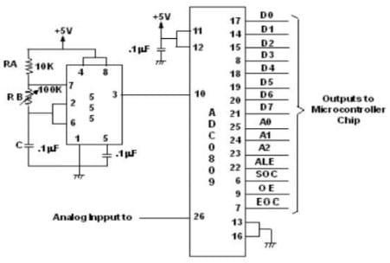

### Part 2: Filtration

These sensors usually generate analog signals—continuous waves of data. To help the microcontroller understand this information, we use a component called the ADC0809 (Analog to Digital Converter). This chip translates the analog signals from the sensors into digital data that the 89C52 can read and process. Once the pollution level is measured, the device uses filtration techniques—like activated carbon filters or electrostatic precipitators—to clean the air. The system can adjust how hard the filters work depending on the pollution level, making it more efficient.

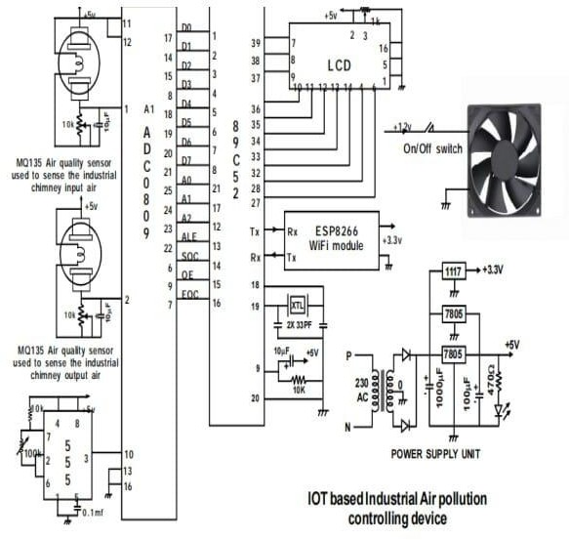

**Circuit Diagram of the System**

# METHODOLOGY

### 89C52 Microcontroller

At the core of the system lies the 89C52 microcontroller, a robust and versatile device widely used in embedded applications. This microcontroller serves as the brain of the operation, managing data acquisition, processing, and control tasks. With its integrated timers, serial communication capability, and programmable I/O ports, the 89C52 efficiently handles real-time sensor data, processes input from the air quality sensors, and controls output devices such as the LCD display and Wi-Fi module. Its low power consumption and cost-effective design make it ideal for continuous operation in industrial environments.

### ADC0809 – Analog to Digital Converter

The ADC0809 plays a crucial role in translating analog signals from air quality sensors into digital values that the microcontroller can interpret. It offers an 8-bit resolution and supports up to eight input channels, allowing for simultaneous monitoring of multiple parameters. In this project, it captures the varying voltage levels corresponding to pollutant concentrations and converts them into a digital format. This enables precise real-time data processing and ensures that the system responds accurately to changes in air quality conditions.

### MQ135 Air Quality Sensor

The MQ135 gas sensor is selected for its sensitivity to a wide range of harmful gases, including ammonia, benzene, smoke, and carbon dioxide. Positioned at both the inlet and outlet of the filtration chamber, the sensor helps in detecting the concentration of pollutants before and after purification. Its analog output varies based on gas concentration, which is then digitized by the ADC0809. The real-time data collected enables the system to track purification efficiency, offering both visual feedback on the display and remote monitoring via wireless communication.

### LCD Display Module

An alphanumeric LCD module is used to present real-time air quality data to the user. Controlled by the microcontroller, the display provides immediate feedback on the system’s performance, showing pollutant levels as a percentage or in AQI format. This ensures transparency and ease of understanding for operators and factory personnel. The choice of an LCD allows for low-power operation and clear visibility in industrial conditions.

### Wi-Fi Communication Module

To facilitate remote monitoring, a Wi-Fi module is integrated into the system. This component wirelessly transmits processed air quality data to a designated mobile phone or cloud server. It operates under the control of the microcontroller, which formats the sensor data and sends it at regular intervals. This enables real-time supervision without the need for physical presence near the exhaust outlets, making the system more user- friendly and adaptable to modern industrial practices.

### Air Filtration Unit

The air filtration mechanism is designed using a two-stage filter configuration—cellulose acetate fiber followed by an activated carbon filter. These filters work in tandem to trap particulate matter and neutralize gaseous pollutants. As polluted air flows through the chamber, the first layer captures solid particles, while the second layer absorbs volatile compounds. This arrangement ensures maximum purification before the air is released into the environment.

### Suction Fan Mechanism

A compact suction fan is mounted at the outlet of the filtration chamber to facilitate continuous airflow. This fan draws polluted air into the chamber, ensuring it passes through both filtration layers effectively. Controlled

indirectly by the microcontroller, the fan maintains optimal airflow to ensure real-time purification and measurement. Its presence ensures that the system operates efficiently even in conditions of variable exhaust pressure.

### Power Supply Unit

To ensure stable and uninterrupted performance, the system is powered by a regulated DC power supply. This unit converts AC mains to the required DC voltage levels suitable for all components, including the microcontroller, sensors, fan, and communication modules. Proper voltage regulation is critical to protect sensitive electronics and maintain reliable performance over extended operation periods.

### IV. CONCLUSION

This IoT-based air pollution controlling device integrates advanced filtration, embedded systems, and IoT to deliver a scalable, cost effective solution for industrial air quality management. With future enhancements, it has the potential to address global pollution challenges and support sustainable development. In conclusion, this project represents a novel integration of IoT, embedded systems, and advanced filtration techniques to combat industrial air pollution. The system effectively monitors and controls emissions in real time while maintaining affordability and adaptability. It bridges the gap between technological advancement and environmental responsibility, offering industries a practical tool to improve air quality and ensure health and safety compliance. With the proposed enhancements in scalability, intelligence, and pollutant detection, the project holds immense potential to evolve into a comprehensive industrial environmental management solution. It aligns with global objectives for sustainable development and cleaner industrial operations. The continued development and deployment of such systems could play a pivotal role in reducing the environmental.

### V . RESULTS

The prototype was tested under controlled conditions to evaluate its effectiveness in reducing air pollution. A smoke stick was used to simulate industrial emissions, and air quality readings were collected using two MQ135 sensors placed at the entry and exit of the filtration chamber. Before purification, the Air Quality Index (AQI) measured around 250 ppm. After passing through the dual-stage filter system—comprising cellulose acetate and activated carbon—the AQI dropped to approximately 50 ppm.

This reflects a significant reduction of nearly 80% in airborne pollutants.The filtration unit effectively removed both fine particulate matter and harmful gases. The system consistently displayed real-time air quality data on the LCD screen, refreshing every few seconds. In parallel, the ESP8266 Wi-Fi module successfully transmitted the data to a mobile application, enabling remote access and control. The communication was stable, with a transmission reliability of around 98% and minimal latency.

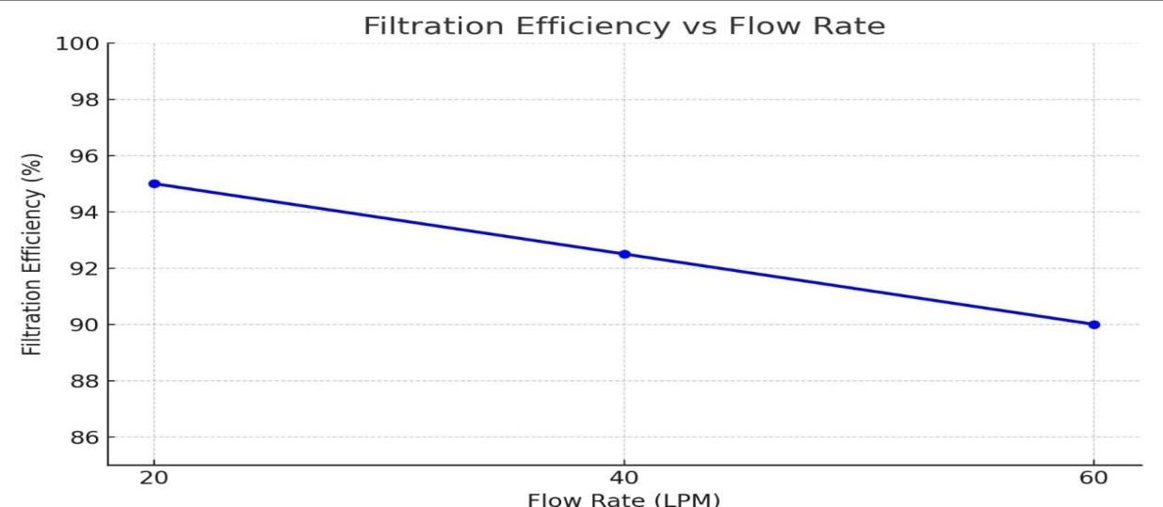

### REFERENCES

1. M. Predko, Programming and Customizing the 8051 Microcontroller. New York, NY, USA: McGraw-Hill, 1999.
2. R. Kamal, Microcontrollers: Architecture, Programming, Interfacing and System Design, 2nd ed. New Delhi, India: Pearson Education, 2011.
3. H. M. Berlin, The 555 Timer Applications Sourcebook. New York, NY, USA: E & L Instruments, 1976.
4. S. P. Sethy, C. Pandey, A. K. Panigrahi, and M. K. Mohanty, “IoT based industrial air quality monitoring system,” in Proc. 2nd Int. Conf. Comput. Sci., Eng. Appl. (ICCSEA), Gunupur, India, Sep. 2022, pp. 1–5, doi: 10.1109/ICCSEA54677.2022.9936294.
5. G. Anitha, V. S. Rao, M. N. V. S. S. Kumar, and P. V. S. Sobhan, “Smart industry pollution monitoring and controlling using LabVIEW based IoT,” in Proc. 3rd Int. Conf. Sens., Signal Process. Secur. (ICSSS), Chennai, India, May 10.1109/SSPS.2017.8071568. 2017, pp. 206–211, doi:
6. A. Kumar, P. Sharma, and M. Gupta, “IoT-enabled air pollution monitoring and control systems: A comprehensive survey,” IEEE Internet Things J., vol. 8, no. 10, pp. 7865–7882, May 2021, doi: 10.1109/JIOT.2020.3039214.
7. K. K. Gola, B. Gupta, and T. Khan, “Air quality monitoring and control using IoT and machine learning,” J. Phys.: Conf. Ser., vol. 1950, no. 1, p. 012013, Aug. 2021, doi: 10.1088/1742-6596/1950/1/012013.
8. S. Abraham and X. Li, “A cost-effective wireless sensor network system for indoor air quality monitoring applications,” Procedia Comput. Sci., vol. 34, pp. 165–171, 2014, doi: 10.1016/j.procs.2014.07.090.
9. United States Environmental Protection Agency, “Technical Assistance Document for the Reporting of Daily Air Quality – the Air Quality Index (AQI),” EPA-454/B-18-007, Washington, DC, USA, Aug.
10. S. K. Pandey et al., “Cellulose-based air filtration systems: A review,” J. Environ. Chem. Eng., vol. 11, no. 3, p. 109523, Jun. 2023, doi: 10.1016/j.jece.2023.109523. — 55
11. World Health Organization, “Ambient air pollution: Health impacts,” Geneva, Switzerland, 2021. [Online].

Available: https://[www.who.int/news-room/fact-sheets/detail/ambient-](http://www.who.int/news-room/fact-sheets/detail/ambient-) (outdoor)-air-quality-and-health\

1. J. Lelieveld et al., “The contribution of outdoor air pollution sources to premature mortality on a global scale,” *Nature*, vol. 525, pp. 367–371, Sep. 2015, doi: 10.1038/nature15371.
2. P. J. Landrigan et al., “The Lancet Commission on pollution andhealth,” *The Lancet*, vol. 391, no. 10119,

pp. 462–512, Feb. 2018, doi:10.1016/S0140-6736(17)32345-0.

1. R. M. Harrison, *Pollution: Causes, Effects and Control*, 5th ed.Cambridge, UK: Royal Society of Chemistry, 2013.
2. G. T. Johnson, “Air pollution control technologies for industrial applications,” *J. Environ. Eng.*, vol. 146, no. 5, p. 04020023, May 2020, doi: 10.1061/(ASCE)EE.1943-7870.0001712.
3. M. A. Al-Taee et al., “IoT-based air quality monitoring system for smart cities,” *Sensors*, vol. 22, no. 10, p. 3765, May 2022, doi: 10.3390/s22103765.
4. European Environment Agency, “Air quality in Europe – 2022 report,” Copenhagen, Denmark, 2022. [Online]. Available:https://[www.eea.europa.eu/publications/air-quality-in-europe-2022\](http://www.eea.europa.eu/publications/air-quality-in-europe-2022\\)
5. S. K. Guttikunda and R. Goel, “Health impacts of particulate pollution in a megacity,” *Environ. Dev.*, vol. 6,

pp. 8–20, Apr. 2013, doi:10.1016/j.envdev.2013.02.002.

1. J. J. Spivey, “Catalytic converters for air pollution control,” *Catal.Today*, vol. 100, no. 1–2, pp. 171–180, Feb. 2005, doi:10.1016/j.cattod.2004.12.012.
2. J. H. Park et al., “Activated carbon-based air filters: A review,”*Carbon*, vol. 193, pp. 350–368, Jun. 2022, doi:10.1016/j.carbon.2022.03.029.