**Material Properties Prediction of Cellulosic Fibre for Wind Turbine Blade Using Artificial Neural Network**

Abdussalam Mamoon1, Hayatuddeen A. Ibrahim2

*Department of Foundry Engineering Technology, Kaduna Polytechnic, Kaduna, Kaduna State, Nigeria*

*Corresponding Author: abdmamoon2056@gmail.com*

**Abstract:** The potential of using ANN for predicting the mechanical properties of natural fiber for wind turbine blade application has been studied and reported in the present work. Experimental data from reported research on the studies of a variety of natural fibers was collected and stored in the MySQL database. This database was split into training and testing sets and was subsequently used in the development of the predictive model. Back-propagation neural network was developed to predict mechanical properties of fiber and was found to be capable of prediction with an overall regression of 0.98717, which indicated that ANN can be attractive as mechanical properties of fiber predictor.

**Keywords:** ANN, Mechanical Properties, Natural Fibre, Wind Turbine Blade

---------------------------------------------------------------------------------------------------------------------------------------

Date of Submission: XX-XX-2018 Date of acceptance: XX-XX-2018

---------------------------------------------------------------------------------------------------------------------------------------

1. **INTRODUCTION**

Wind energy, which is one of the most feasible renewable energy sources is of significance to achieve carbon reduction and the wind turbine blade plays an irreplaceable role in the process (Li et al., 2023). Wind turbine blades play a crucial role in converting wind energy into mechanical energy. However, these wind blades fail due to many factors which include mechanical failure, high stress, and creep formation (Reddy et al., 2021). Modern turbine blade materials are expected to provide high energy yield, low weight, low cost, environmentally friendly, and extended durability (Miliket et al., 2022). They are made of materials such as fiberglass or carbon fiber-reinforced polymers. However, there has been growing interest in using natural fibers, such as flax, hemp, jute, or bamboo as reinforcements in polymer composites for wind turbine blades. Natural fiber composites offer several advantages including less cost, lightweight, eco-friendly renewable nature, and good mechanical properties (Pradeep et al., 2019). The mechanical properties of these natural fiber composite materials are critical for ensuring the structural integrity and performance of wind turbine blades. These properties include high strength, low weight, high fatigue resistance, and stiffness (Kalagi et al., 2018).

The mechanical behavior of natural fiber composites is influenced by various factors, which can impact their overall performance and reliability. These factors primarily relate to the interaction between the polymer and fiber. Many of these factors are associated with the mechanical properties of cellulosic fibers, which can be affected by factors such as extraction methods, harvesting time, age, climate, and fiber treatment. These parameters significantly impact the chemical composition of the fibers, with cellulose and moisture content being particularly important in determining the mechanical properties. Since the mechanical properties of cellulosic fibers are determined experimentally and can vary between fibers, it is crucial to develop a prediction method based on cellulose and moisture content. Such a method would improve the mechanical performance of natural fiber-reinforced composites and provide valuable information from limited experimental data. Currently, there is limited research on predicting the mechanical properties of natural fibers, but understanding and predicting these properties are crucial for designing efficient and reliable wind turbine blades.

Artificial neural networks (ANN) are computational models inspired by the structure and functioning of the human brain. ANNs consist of interconnected nodes or artificial neurons that process and transmit information. They can learn from input-output data patterns and make predictions or classifications based on that learning. ANNs have proven to be effective in various fields, including materials science, where they are used for predicting material properties based on input parameters. ANN techniques can be utilized in predicting complex experimental problem. Nirmal, (2010) used ANN to predict the friction coefficient of treated betelnut fiber-reinforced polyester composites. The hand-layup technique was used to fabricate the treated betelnut-reinforced composite and the experimental data obtained from the friction test was used to develop the ANN model. Results obtained from the developed ANN model were compared with the experimental results and showed good accuracy. Similarly, Parikh & Gohil, (2019) developed a model to predict the tribo-behavior of fiber-reinforced composites using ANN. A wear test was conducted on polyester cotton fiber reinforced composite developed in different proportions. The test data from the wear test were used to model the ANN to estimate the wear behavior of the composite materials. The validation of the proposed ANN showed a fair agreement with the actual experimental results. Pramanik et al., (2023) used Bi-layer ANN to predict the mechanical properties of PVA and cellulose bio-composites. The ANN model has successfully predicted the bio-composite bulk and shear modulus values. Similarly, Bonnar Anak Jores et al., (2023) studied the behavior of post-cured banana-fiber HDPE through experimental works and subsequently developed an ANN predictive model to forecast the stress-strain graph of the composite. The developed model was able to predict the stress-strain values accurately.

Kazi et al., (2020) developed an ANN model to predict the optimal filler content for cotton fiber polypropylene composite based on mechanical properties. The experimental data on the investigation of the effect of filler content on the mechanical properties of cotton fiber by Mahdi et al. 2020 was used and the predictive ANN model was developed in the TensorFlow backend using the Keras library. The developed model was successful in predicting the desired optimum filler content and can be used as a tool that allows users to conduct sensitivity analysis. Singhal et al., (2023) used ANN to simulate the mechanical properties of stir-cast Aluminum matrix composite. Datasets of varying weight percentages of Al6061 alloy with different reinforcements were sourced from research papers where experiments and trials were carried out in these studies to generate data points. MATLAB neural network toolbox was deployed to implement the proposed ANN. The trained model was used to simulate mechanical properties on random data and gave satisfactory results. (Al-Jarrah & and Al-Oqla, 2022) developed a double-integrated ANN to perform novel prediction and classification of the intrinsic mechanical properties of natural fibers. The accuracy of the BPNN model was evaluated by mean square error, mean absolute percentage error, and correlation coefficient. The BPNN model was found to have great accuracy and can predict the mechanical properties very well. The objective of this work is to propose a double approach for the prediction of the mechanical properties of natural fiber and natural fiber composites using ANN. Here, a first ANN model will be developed to predict the mechanical properties of a variety of natural fibers. The predicted properties will be used to develop a second neural network for the prediction of some properties of the natural fiber composites.

1. **METHODOLOGY**

A back-propagation neural network approach was proposed and implemented for the prediction of the properties of a variety of natural fibers. Several experiments have been reportedly done to investigate the properties of these natural fibers and these were collected from the literature and analyzed to have a better understanding. Three criteria for physico-chemical properties namely cellulose, moisture content, and density, and three criteria for mechanical properties namely tensile strength, young modulus, and elongation at break respectively were collected from contemporary literature in the field and stored as cellulosic data in MySQL. The results of these experiments were carefully collected from the literature and tabulated in Table 1.

ANN Prediction Model Development

The ANN models were developed using MATLAB 2016 environment with three connected layers, namely the input, hidden, and output layers. The dataset collected from the literature was divided into training, and validating sets. After the training phase, the trained ANN model was validated using the testing dataset. The performance of the ANN model was evaluated by observing both the training loss function and the validation loss function. Three distinct features (cellulose, density, and moisture content) of various fibers obtained from the literature are identified to predict the mechanical properties of the fiber materials. These datasets of fibers were gathered and preprocessed by normalizing the data, thereby making it free from anomalies. Therefore, the input layer has three input nodes and the output layer has three nodes. The output nodes are tensile strength, elongation at break, and Young’s modulus.

The input and output datasets were normalized in the range of –1 and +1 using the following formula to facilitate data training, testing, and validation:

*X*n = [2(*X* − *X*min)/ (*X*max − *X*min)] – 1 (1)

where *X*n is the normalized value of the parameters and *X*min – *X*max are the minimum and maximum values of variable *X*, respectively.

The network started with initialization and data extraction from the MySQL database. The below-mentioned command was used to import the data stored in MySQL workbench to the MATLAB environment:

conn = database('cellulosic_database','root','Bappah1287.');

curs = exec(conn,'SELECT * FROM cellulosic_database');

curs = fetch(curs);

curs.Data

After the importation of the data to the environment, the import and target data had to be segregated and preprocessed in the form of matrices that can be used in neural networks. This is done by the following commands:

x = Input;

t = Target;

The next step is the selection of the training function, where Levenberg-Marquardt backpropagation was selected using the following command:

trainFcn = 'trail';

To create a fitting neural network, the size of the hidden layer is arbitrarily selected, using the following command to create the network:

hiddenLayerSize = 10;

net = fitnet(hiddenLayerSize,trainFcn);

After the creation of the fitting network, the imported data is divided into training, validation, and testing sets using the following command:

net.divideParam.trainRatio = 85/100;

net.divideParam.testRatio = 15/100;

net.divideParam.valRatio = 0/100;

To train and test the network created, the following commands were used:

[net,tr] = train(net,x,t); (Train the network)

y = net(x); (Test the network)

e = gsubtract(t,y);

performance = perform(net,t,y);

Again, the following commands were used to view and enable various plots of the network such as the performance, training state, histogram, and regression:

view(net) (view the network)

figure, plotperform(tr) (plots of the network)

figure, plottrainstate(tr)

figure, ploterrhist(e)

figure, plotregression(t,y)

figure, plotfit(net,x,t)

Finally, the created network is used to predict the mechanical properties of a test dataset (Xtest) of fiber using the following command:

outputPred = sim(net,Xtest);

1. **RESULT AND DISCUSSION**

A back-propagation feedforward neural network was created with three (3) neurons in one input layer, ten (10) neurons in one hidden layer, and three neurons in one output layer were created. The created network is illustrated in Figure 1 below.

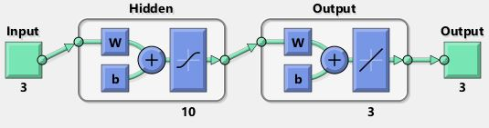

Figure 1*: Created Neural Network*

The network is selected for predicting the mechanical properties of some fibre with the coefficient of determination attained as R = 0.99867, 0.90601, 0.98717 for comprehensive training, testing, and overall, as presented in Figure 2 below. The regression value of the training data indicates a strong correlation between the predicted and actual values. This suggests that the model can accurately capture the relationship between the input features and the output. Similarly, the test accuracy of the model indicates that the model performs well on unseen data. Although the test accuracy is slightly lower than the training regression, it still demonstrates the model's ability to generalize to new data. Finally, the overall performance of the model is evaluated by combining the regression values of both the training and test data. The combined regression value indicates a high level of accuracy in predicting the mechanical properties of natural fiber.

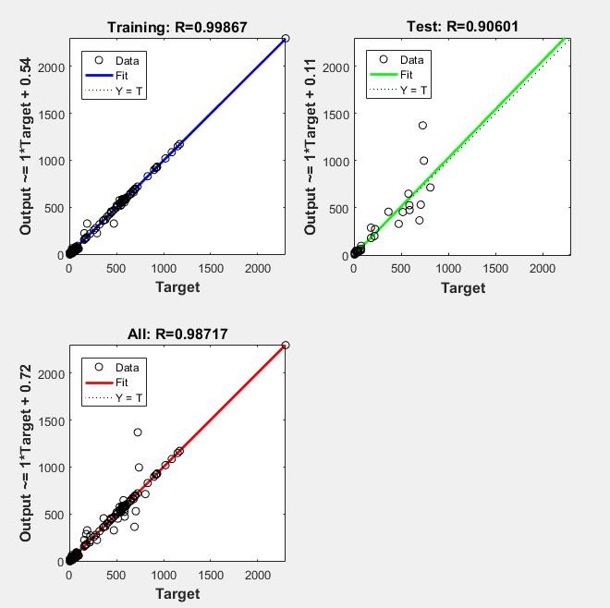

*Figure 2: Regression Plot for the Developed Model*

The performance graph exhibiting how the errors appear in the network drop is illustrated in Figure 3. These errors were automatically computed with the progress of every epoch explained best as a concluded cycle of the complete neural network dataset, and training is automatically stopped at the attainment of the lowest error. The best training performance achieved by the model is [273.8447](tel:273.8447) at epoch [1000](tel:1000). This indicates that the model has gone through several iterations and has reached a good level of performance.

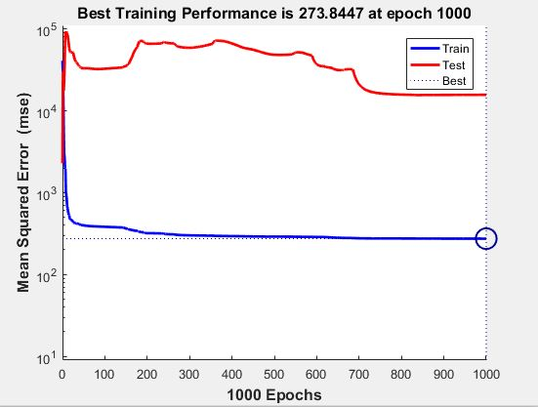

*Figure 3: ANN Performance for Predicting Mechanical Fibres*

The gradient value at epoch [1000](tel:1000) is [1240.1626](tel:1240.1626) as shown in Figure 4. The gradient represents the rate of change of the model's parameters concerning the loss function. A higher gradient value indicates a steeper slope, which suggests that the model is actively learning and making adjustments. The value of Mu at epoch [1000](tel:1000) is [0.01](tel:0.01). Mu is a parameter in the training algorithm that controls the step size during optimization. A smaller Mu value indicates smaller steps and slower convergence. The validation checks at epoch [1000](tel:1000) indicate that no issues were found during the validation process. This suggests that the model is stable and performing well.

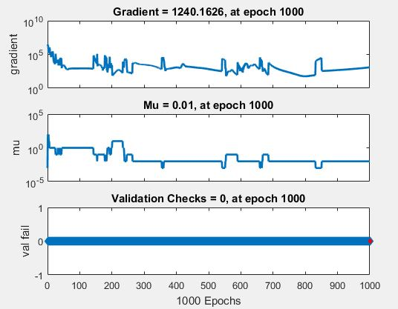

***Figure 4****: ANN Training State Plot*

# **CONCLUSION**

In conclusion, the developed ANN model for predicting the mechanical properties of natural fiber shows excellent performance with high regression values and good accuracy. The model has undergone extensive training and optimization, resulting in accurate predictions and stable performance. The Levenberg Marquardt training function has been effective in training the model and achieving these impressive results.

**FUNDING STATEMENT**

This work is sponsored under the Institution Based Research (IBR) research support scheme grants by Tertiary

Education Trust Fund (TETFund) Nigeria.

**ACKNOWLEDGEMENTS**

Acknowledgement goes to the Management of Kaduna Polytechnic and Specially the Chairman, Institution

Based Research Committee in the Research Innovation and Technology Transfer Office (RITTO) Section for

finding our research worthy of sponsorship.

**REFERENCES**

Al-Jarrah, R., & AL-Oqla, F. M. (2022). A novel integrated BPNN/SNN artificial neural network for predicting the mechanical performance of green fibers for better composite manufacturing. *Composite Structures*, *289*, 115475. https://doi.org/https://doi.org/10.1016/j.compstruct.2022.115475

Bonnar anak Jores, J., Jayamani, E., Sie Ming Lai, T., Subramanian, J., & Rejeesh, C. R. (2023). Evaluation of mechanical property of banana HDPE composite through experiment and artificial neural network (ANN). *Materials Today: Proceedings*. https://doi.org/https://doi.org/10.1016/j.matpr.2023.08.351

Kalagi, G. R., Patil, R., & Nayak, N. (2018). Experimental Study on Mechanical Properties of Natural Fiber Reinforced Polymer Composite Materials for Wind Turbine Blades. In *Materials Today: Proceedings* (Vol. 5). www.sciencedirect.comwww.materialstoday.com/proceedings

Kazi, M.-K., Eljack, F., & Mahdi, E. (2020). Predictive ANN models for varying filler content for cotton fiber/PVC composites based on experimental load displacement curves. *Composite Structures*, *254*, 112885. https://doi.org/https://doi.org/10.1016/j.compstruct.2020.112885

Li, S., Cheng, P., Ahzi, S., Peng, Y., Wang, K., Chinesta, F., & Correia, J. P. M. (2023). Advances in hybrid fibers reinforced polymer-based composites prepared by FDM: A review on mechanical properties and prospects. *Composites Communications*, *40*, 101592. https://doi.org/https://doi.org/10.1016/j.coco.2023.101592

Miliket, T. A., Ageze, M. B., Tigabu, M. T., & Zeleke, M. A. (2022). Experimental characterizations of hybrid natural fiber-reinforced composite for wind turbine blades. *Heliyon*, *8*(3). https://doi.org/10.1016/j.heliyon.2022.e09092

Nirmal, U. (2010). Prediction of friction coefficient of treated betelnut fibre reinforced polyester (T-BFRP) composite using artificial neural networks. *Tribology International*, *43*(8), 1417–1429. https://doi.org/https://doi.org/10.1016/j.triboint.2010.01.013

Parikh, H. H., & Gohil, P. P. (2019). 13 - Experimental determination of tribo behavior of fiber-reinforced composites and its prediction with artificial neural networks. In M. Jawaid, M. Thariq, & N. Saba (Eds.), *Durability and Life Prediction in Biocomposites, Fibre-Reinforced Composites and Hybrid Composites* (pp. 301–320). Woodhead Publishing. https://doi.org/https://doi.org/10.1016/B978-0-08-102290-0.00013-1

Pradeep, A. V, Prasad, S. V. S., Suryam, L. V, & Kumari, P. P. (2019). A comprehensive review on contemporary materials used for blades of wind turbine. *Materials Today: Proceedings*, *19*, 556–559. https://doi.org/https://doi.org/10.1016/j.matpr.2019.07.732

Pramanik, J., Pradhan, S., & Kumar Samal, A. (2023). Artificial neural network-based mechanical properties prediction of cellulose polyvinyl alcohol bio composite. *Materials Today: Proceedings*. https://doi.org/https://doi.org/10.1016/j.matpr.2023.07.220

Reddy, S. S. P., Suresh, R., Hanamantraygouda, M. B., & Shivakumar, B. P. (2021). Use of composite materials and hybrid composites in wind turbine blades. *Materials Today: Proceedings*, *46*, 2827–2830. https://doi.org/10.1016/j.matpr.2021.02.745

Singhal, S., Ahmad Khan, S., Muaz, M., & Ahmed, E. (2023). Simulation of mechanical properties of stir cast aluminum matrix composites through Artificial Neural Networks (ANN). *Materials Today: Proceedings*, *72*, 1102–1109. https://doi.org/10.1016/j.matpr.2022.09.174