**A Case Study for Optimization of Power System Load Flow Analysis using ETAP Software**

**Prof. Vishal . V . Mehtre, Mr. Abhinav Dubey**

**Department of Electrical Engineering Bharati Vidyapeeth (Deemed to be University) College of Engineering, Pune**

**Abstract**

This research report explores the optimization of power system load current analysis by integrating Electrical Transient Analyzer Program (ETAP) software and Single Line Diagram (SLD) representation. Load current analysis is essential for the reliable and efficient operation of power grids, and the use of advanced software tools such as ETAP offers significant opportunities to improve analysis capabilities. The integration of SLD with ETAP enables more intuitive and comprehensive visualization of energy system elements and their connections, improving the modelling and analysis process. The article presents a case study that demonstrates the practical application of this integrated approach using a typical power system model to estimate load current characteristics under various operating conditions. The methodology involves building a powerful system model in ETAP and includes SLD representations to improve system visualization and analysis. The system simulation experiments evaluate the performance and accuracy of the integrated ETAPSLD approach, focusing on key parameters such as voltage profiles, current flows, enabling more efficient load current analysis and providing valuable information for power system engineers and operators. Overall, this study contributes to the field of energy system analysis by using advanced software tools for advanced modelling and optimization.

Keywords:

**Introduction**

Load flow studies, also called power flow analysis or load flow analysis, are critical to the planning, design, and operation of electrical systems. This research provides important insights into the steady-state behaviour of energy systems and enables engineers to ensure reliable and efficient power supply to consumers. Here is some general information about load flow studies:

1. Definition: Load flow studies analyse the flow of electrical energy in a grid system under steady-state conditions. They determine voltages, currents and energy flows in the network, considering factors such as generation, transmission, distribution and loads.
2. Objective: The main objective of load flow studies is to determine the operating conditions of the electrical system and to ensure that all electrical quantities meet certain limits and criteria. The aim is to keep voltage levels within acceptable ranges, minimize power losses and ensure sufficient capacity to meet demand.
3. Components: Load flow studies consider various components of a power system, including generators, transformers, transmission lines, distribution lines, loads (real and reactive), and control devices such as voltage regulators and capacitors.
4. Mathematical Formulation: Charge flow analysis involves solving a series of nonlinear algebraic equations derived from network topology and electrical laws (Ohm's law, Kirchhoff's law). These equations represent the balance between active and reactive power at each node and the power flow equations along the transmission lines.
5. Methods: Several numerical techniques are used to solve nonlinear equations in charge flow studies, including the Gauss-Sade method, the Newton-Rawson method, and the fast-decoupling method. These methods iteratively lead to a solution that meets certain constraints and criteria.
6. Applications:

* Planning: Load flow studies are essential for planning expansion and modification of energy systems and for determining optimal locations for new power plants, substations and transmission lines.
* Operations: During normal operations, load flow studies help operators maintain system stability, balance generation and demand, and optimize network performance.
* Contingency Analysis: Load flow studies are used to assess the impact of equipment failures or emergency events on system reliability and to develop contingency plans to mitigate risks.
* Voltage Stability Analysis: Load flow studies play a key role in evaluating voltage stability margins and identifying conditions that may lead to voltage instability or collapse.
* Challenges: Load flow studies face challenges such as computational complexity, particularly in large energy systems, uncertainty in load and generation forecasting, and the need for accurate modelling of system components[1].

Precise power system analysis is crucial for several reasons:

1. Reliability: To provide the constant demand for electricity, power systems must function dependably. Operators can reduce the danger of blackouts and interruptions by taking preventative action and identifying possible problems like as overloads, voltage variations, and equipment breakdowns with the use of accurate analysis.
2. Efficiency: Reducing operating costs, maximizing resource usage, and minimizing energy losses all depend on power systems operating efficiently. Precise evaluation facilitates the identification of chances to enhance system effectiveness via ideal scheduling of generation, distribution of load, and arrangement of the network.
3. Safety: Personnel and equipment safety are guaranteed by power system analysis. Engineers can create systems that meet safety regulations and reduce the possibility of electrical dangers like fires, shocks, and equipment damage by evaluating factors including fault currents, voltage levels, and device ratings.
4. Stability: Under both regular and unusual operating conditions, power system stability is crucial for keeping voltage and frequency within allowable bounds. Precise analysis aids in determining probable stability problems, evaluating system stability margins, and creating control plans that strengthen the system's resistance to disruptions.
5. Integration of Renewable Energy: Operating and controlling power systems can face difficulties when integrating renewable energy sources like wind and solar energy. Precise examination is necessary to assess the consequences of variable generation, handle problems related to grid integration, and guarantee the stability and dependability of the grid in an environment abundant in renewable energy sources.
6. Grid Modernization: Accurate analysis becomes even more important as we move toward smart grids and technological developments. To improve grid resilience, flexibility, and efficiency, it makes it possible to implement advanced grid control and monitoring systems—such as demand response mechanisms, phasor measurement units (PMUs), and synchro phasors—effectively.
7. Economic Viability: Thorough power system analysis is necessary to make well-informed choices about grid growth, infrastructure spending, and policy. Stakeholders can prioritize investments, manage resource allocation, and guarantee the power system's long-term viability by measuring the economic effects of various scenarios.
8. Environmental Impact: When evaluating the effects of energy generation and consumption on the environment, power system analysis is essential. Policymakers and planners can create plans to reduce environmental pollution and lessen the effects of climate change by examining emissions, energy losses, and the effectiveness of generating technologies[1].

**Relevance of integrating ETAP software simulation with SLD for enhancing load flow analysis capabilities.**

The following are some benefits of integrating Single Line Diagram (SLD) representations with ETAP (Electrical Transient Analyzer Program) software simulation to improve load flow analysis capabilities:

* Improved Visualization: SLDs offer a condensed graphical depiction of the power system that shows the linkages between various parts, including loads, transformers, generators, and transmission lines. Engineers can more easily see the topology of the power system in the simulation environment by integrating SLDs with ETAP. This improved visualization helps in the interpretation of load flow findings by facilitating a better knowledge of the system setup and layout.
* Better Model Representation: SLDs are a high-level abstraction of the power system that succinctly represent the key elements and their interactions. Engineers may quickly convert this schematic representation into intricate simulation models within the program by integrating SLDs with ETAP. This reduces the time and effort needed to create intricate power system models for load flow analysis by streamlining the model-building process.
* Effective Workflow for Analysis: When SLDs are integrated with ETAP, a smooth workflow for load flow analysis is produced. SLDs can be immediately imported by engineers into the ETAP environment, where they are transformed into simulation models by default. This guarantees consistency between the simulation model and the schematic representation and removes the need for human data entering. Engineers are therefore free to concentrate more on system performance optimization and result analysis than on building models and manipulating data.
* Scenario Evaluation and What-If Analysis: Engineers can carry out scenario evaluation and what-if analysis more skilfully thanks to the integration of SLDs with ETAP. Engineers may rapidly evaluate the influence on load flow metrics including voltage levels, power flows, and system losses by altering the SLD representation to reflect various operating situations or system configurations. This competence is crucial for researching different operating situations, spotting possible problems, and assessing solutions.
* Multidisciplinary Cooperation: SLDs provide as a common language for the various parties engaged in the planning, designing, and operating of power systems. Integrating SLDs with ETAP gives engineers, planners, and operators a single interface to engage with the power system model, facilitating interdisciplinary collaboration. Better collaboration and decision-making are encouraged as a result, which produces more practical solutions for maximizing system dependability and performance[1].

**Methodology**

SLD description

**Figure 1**

1.Busbar: A metallic strip or bar that conducts electricity in a power distribution system is called a busbar. Within a building or system, it acts as the hub for the distribution of electricity to different circuits and equipment. Busbars are frequently installed in electrical switchgear, distribution boards, and substations because of their superior electrical conductivity. They are usually composed of copper or aluminium.

2.Generator: A generator is a device that converts mechanical energy into electrical energy. It accomplishes this by applying the electromagnetic induction principle, which asserts that when a conductor moves through a magnetic field, electricity is generated. Generators are widely employed in a variety of applications, ranging from small portable machines used to power homes during blackouts to big industrial generators used in power plants.

3.Grid: A power grid or an electrical grid is referred to by the vernacular term "grid" frequently. It is an interconnected system of transmission lines, substations, transformers, and other infrastructure that makes it easier for power plants to generate, transmit, and distribute electricity to end users.

4.Motors: Motors are machines that change electrical energy into mechanical energy. They power everything from cars and household gadgets to industrial machines and other devices. There are several kinds of motors, including stepper motors, DC motors, AC motors (including synchronous and induction.

5.Transformer: An electrical transformer uses electromagnetic induction to move electrical energy between two or more circuits. It is composed of one or more iron or steel cores with two or more insulated wire coils coiled around them.

6.Wind turbine: One tool for converting wind energy into electrical energy is a wind turbine. Wind is a plentiful and unrestricted resource, making wind turbines a sustainable and renewable energy source. They are frequently employed in wind farms, which are installations of several turbines in windy regions with the goal of producing sizable amounts of power. As we move toward a more ecologically friendly and sustainable energy system, wind energy is thought to be one of the essential elements.

7.SPDT: The acronym for Single Pole Double Throw is SPDT. This kind of electrical switch includes three terminals: a common terminal that is attached to the input or output, and two other terminals that are connected to the common terminal in two distinct ways and are frequently called "throw" terminals.

8.Cables: Cables are essential components of power systems because they move electrical energy from generation sources, like power plants or renewable energy installations, to distribution networks and, eventually, end users. Power cables are made to transport high-voltage electrical currents across short or large distances in a safe and effective manner.

**Ratings**

1.Grid

**Figure 2**

2.Transformer

2.1 Transformer T1

**Figure 3**

2.2 Transformer T3

**Figure 4**

Transformer T1 and T3 have same rating2.3 Transformer T9

**Figure 5**

3.Busbar

Busbar 1-33Kv

Busbar 10-33Kv

Busbar 24-8.4Kv

4.Motor

4.1 Motor-1

**Figure 6**

4.2 Motor 2

**Figure 7**

Rating of Motor-1 and Motor-2 are same

5.Generator

5.1 Generator 3

**Figure 8**

5.2 Generator 4

**Figure 9**

6.Wind turbine generator

**Figure 10**

7.Cables

7.1Cable 1

**Figure 11**

7.2 Cable 5 similar as cable 1

**Figure 12**

7.3 Cable 7 similar as cable 1

**Figure 13**

7.4 Cable 12 similar as cable 1

**Figure 14**

Based upon the given data we develop different cases and perform load flow studies to determine that what are the best conditions and ratings which led to the optimization of the power system based on active and reactive power flow we determine best circumstances for the optimized power system this allows better understand

Case-1 Rating of the transformer T9 is given below

Fig-15 T9 Ratings for the first case

Here we have kept the rating of the transformer T9 to 6.7 MVA

Case-2

Fig- 16 T9 Ratings for the second case

Here we have kept the rating of the transformer T9 to 5 MVA

Case-3

Fig-17 T9 Ratings for the third case

Here we have kept the rating of the transformer T9 to 4 MVA

**Result**

Case-1

Fig-18

Fig 19

MVA – 6.7

Active power - -7.945

Reactive power – 6.412

Case-2

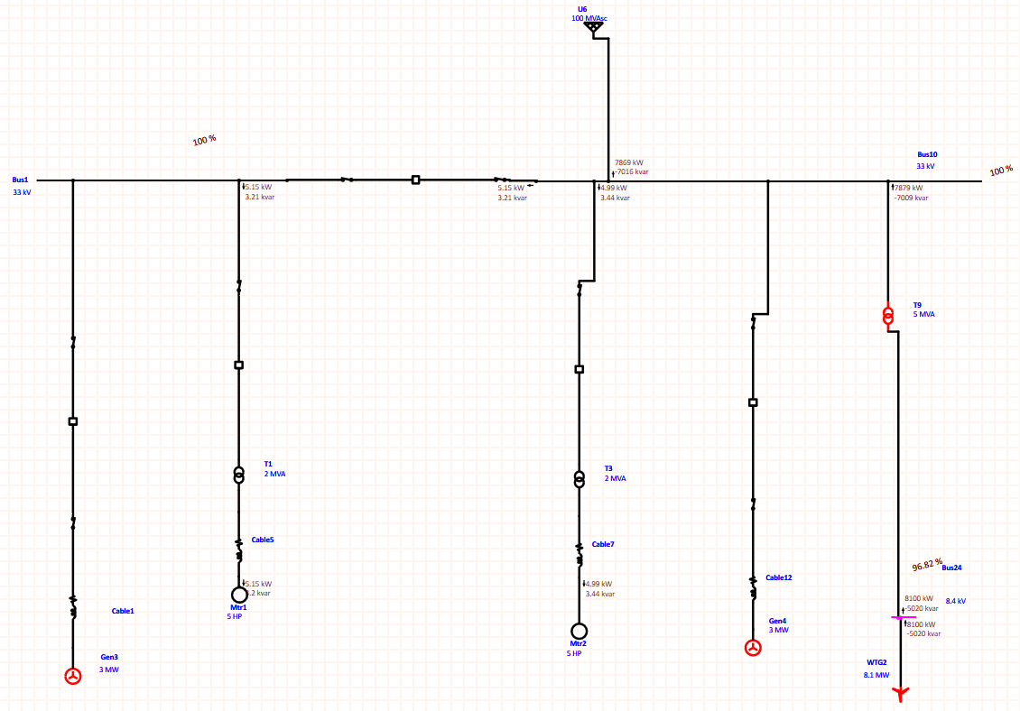

Fig 21

Fig 21

MVA – 5

Active power - -7.879 MW

Reactive power – 7.009 MVar

Fig 22

Fig 23

KVA – 4

Active power - -7.801 MW

Reactive power – 7.710 MVar

In each case we see that as the voltage of transformer T9 is decreased the reactive power increases this is because :

Reactive power is required to establish and maintain the electromagnetic fields in devices such as transformers. In an ideal transformer, the ratio of voltage to current (i.e., the impedance) remains constant regardless of the transformer's MVA (mega-volt-ampere) rating. However, in real-world scenarios, transformers have resistive and reactive components to their impedance.

When the MVA rating of a transformer decreases, it often implies that the transformer has a higher impedance. Higher impedance means that for the same load, more voltage drop will occur within the transformer itself. This increased voltage drop results in a higher reactive power requirement to maintain the necessary electromagnetic fields and compensate for the phase shift caused by the transformer's impedance.

In essence, as the MVA rating decreases, the impedance increases, leading to a higher reactive power demand to maintain the necessary operating conditions. Therefore, reactive power increases as transformer MVA rating decreases.

In the similar manner we can alter the ratings of the different components and notice changes in the system at different points and also that whether the ratings resulting in the optimum performance or not

**How MVA Rating of transformer can be controlled**

A transformer's design parameters, which include the insulation, cooling systems, winding size, core material, and other elements, determine its MVA (Mega Volt-Ampere) rating. Nonetheless, a transformer's MVA rating can be affected or managed in the following ways:

1. Core Design: A transformer's MVA rating is greatly influenced by its core design. Manufacturers can modify the MVA rating of the transformer by modifying the core design, for example, by employing alternative core materials or topologies. For instance, utilizing amorphous metal or premium silicon steel in the core can raise the transformer's efficiency and, consequently, its MVA rating.
2. Winding Design: The MVA rating is influenced by the winding design, which includes the number of turns and the size of the conductors. Manufacturers can alter the transformer's MVA rating by changing the winding design, which will change the transformer's impedance and current-carrying capability.
3. Cooling System: A transformer's MVA rating is largely dependent on its cooling system. Effective cooling systems, like forced air or oil cooling, help disperse heat produced during operation, enabling the transformer to tolerate larger loads and ultimately obtain a higher MVA rating.
4. Insulation System: A transformer's MVA rating is influenced by its insulation system, which also impacts the transformer's capacity to tolerate high voltages and currents. Manufacturers can increase the insulation capabilities of the transformer and allow it to handle greater MVA ratings by utilizing sophisticated insulation materials and procedures.
5. Operating circumstances: A transformer's MVA rating is also affected by its operating environment, which includes temperature, frequency, and environmental circumstances. The transformer's MVA rating may be increased by maximizing the operating conditions while staying within predetermined bounds.
6. Load Management: By using effective load management techniques, transformer consumption can be maximized, and overloading can be avoided. Transformers' effective MVA rating can be maintained by distributing loads evenly among them in a network and avoiding heavy loads.
7. Parallel Operation: The system's overall MVA rating can be raised by running multiple transformers in parallel. Higher MVA ratings are possible by increasing the total capacity using parallel connections between transformers.

**Effects of mismanagement transformer’s MVA rating**

The following are some negative effects that mishandling a transformer's MVA (Mega Volt-Ampere) rating can have on both the transformer and the power supply as a whole:

* + Overloading: When a transformer is operated above its rated MVA, overloading may occur. Overloading can result in the insulation and windings of the transformer becoming overheated, which can shorten the insulation's lifespan and perhaps cause the transformer to fail.
  + Diminished Efficiency: A transformer's efficiency may be diminished if it is loaded above its rated MVA. Increased losses in a transformer, such as copper and core losses, result from operating at higher than rated loads. This reduces efficiency and raises energy expenses.
  + Voltage Regulation Problems: When a transformer's MVA rating is improperly managed, the power system may experience problems with voltage regulation. Increased voltage drops in overloaded transformers can result in voltage variations at the load terminals that are greater than permissible. This may have an impact on the linked loads' quality of power supply and result in equipment damage or malfunction.
  + Higher repair Costs: When transformers are operated above their rated MVA, they age more quickly and require repair more frequently. Because overloaded transformers are more likely to experience mechanical strains, overheat, and insulation deterioration, they require more regular inspections, replacements, and repairs, which raises the cost of maintenance.
  + System Instability: Voltage collapse in the power system and system instability can result from overloading transformers. Overloading transformers can result in voltage fluctuations, sags, and instability, which can impair the power system's overall performance and dependability.
  + Risks to Personnel and Equipment: Improper handling of a transformer's MVA rating might result in potential safety risks. Transformers that are overloaded run a greater danger of overheating, insulation failure, and catastrophic failures. These events can cause fire hazards, damage to nearby equipment, and safety issues for nearby workers.
  + Problems with Regulatory Compliance: Using transformers beyond their rated MVA might lead to infractions against rules and regulations. Regulators frequently impose stringent standards on transformer operation and maintenance to guarantee the dependability, security, and effectiveness of power systems.

**Conclusion**

To sum up, the project on the use of ETAP software to optimize power system load flow analysis has yielded important insights into improving power systems' performance, efficiency, and dependability. Many areas of power system management, such as load flow analysis, voltage stability evaluation, and equipment size, have been adjusted to solve the difficulties faced by contemporary power networks by utilizing ETAP's sophisticated simulation capabilities.

In conclusion, there are several advantages to optimizing power system load flow analysis with ETAP software, including increased system performance, efficiency, and reliability. Power utilities, engineering firms, and research institutions can improve their capacity to assess, plan, and manage power systems in a sustainable and economical way, guaranteeing a dependable and reasonably priced supply of electricity for future generations, by utilizing the sophisticated simulation capabilities of ETAP.

**References**

* + 1. Barn L, Jewell W (2005). Review: power system analysis software tools. IEEE.
    2. ETAP 7.0.0 User Manual (2009).
    3. Jan de K, Kobus S (2004). Power Distribution for Industry. IDC Technologies., p. 151.
    4. Nikhil G, Anil S, Niazi KR (2011). A Novel Strategy for Phase Balancing in Three-Phase Four-Wire Distribution Systems. IEEE.
    5. Osama A, Ahmad KA (2011). Impact of Power Factor Correction on the Electrical Distribution Network of Kuwait – A Case Study. Online Journal on Power and Energy Engineering (OJPEE), 2: 1.
    6. Holm RMU, Chopade PV, Prornod J (2010). Optimal Placement of Capacitor for Power Loss Reduction Using ETAP Software. ICSES' 10 International Conference on Science. Engineering & Spirituality.
    7. Studies and Documentation Branch in Technical Administration of Gaza Electricity Distribution Corporation GEDCO (2010).
    8. William HK (2002). Distribution System Modeling and Analysis. CRC Press LLC, 39: 269.