IoT based Anti-Poaching System for Trees
and Wildlife Monitoring System in Remote
Area

Mrs Shital A. Birari
Department of Computer Engineering
K.C.T Late G.N.Sapkal College of Engineering,Nashik,India
shtlbirari@gmail.com

Prof.(Dr.)Nilesh R.Wankhade
Department of Computer Engineering
K.C.T Late G.N.Sapkal College of Engineering,Nashik,India
nileshrw_2000@yahoo.com

ABSTRACT:-
The Internet of Things-based Anti-Poaching System aims to tackle the significant issue of poaching, which imperils wildlife and forest resources. This technology uses the Internet of Things (IoT) to continuously monitor and protect animals and trees located in remote areas. The system detects and reports suspicious activity using a network of cameras, sensors, and communication systems, enabling authorities to act swiftly.This innovative approach offers a scalable and cost-effective means of enhancing conservation efforts, reducing illegal poaching, and preserving biodiversity. The proposed system architecture is an essential tool for modern wildlife management since it integrates multiple components, such as motion and sound sensors, high-definition cameras, and a central data processing unit, to ensure comprehensive and continuous observation. Because poaching endangers species, disrupts ecosystems, and destroys biodiversity, it is a severe issue for the environment and conservation. Natural ecosystems are being destroyed and species are disappearing as a result of significant ecological imbalances brought on by illicit activities such as commercial logging and animal hunting. Traditional anti-poaching tactics such as satellite surveillance and ground patrols are not always effective because of their high costs, limited coverage, and delayed reaction times. The Internet of Things (IoT) presents a new opportunity to enhance anti-poaching efforts through automation, real-time monitoring, and data-driven decision-making. An Internet of Things (IoT)-based anti-poaching system aims to bridge the gap by employing a network of interconnected sensors and cameras that can continually monitor large and remote places. By enabling quick response and intervention through the instantaneous detection and reporting of illegal behavior, this technology boosts the efficacy of conservation initiatives.
Keywords— Mobile based monitoring, GPS Location Tracking, Cloud Based Data Storage, Real Time Video Streaming
- INTRODUCTION
The Internet of Things-based Anti-Poaching System for Trees and Wildlife Monitoring in Remote Areas is an innovative way to stop illegal activities like poaching and logging. Unlike traditional methods that rely on stationary sensors, this system uses an Android application to record and analyze video. By using cellphones or drones to provide real-time monitoring of forests and wildlife habitats, the program provides a versatile and scalable option for wildlife conservation efforts in remote areas. This methodology allows for comprehensive surveillance, facilitating the identification of illicit behavior and enabling timely reactions to potential risks.
The program uses advanced machine learning algorithms to evaluate video data and identify suspicious activity, such as the presence of poachers or illegal logging operations. The precision of monitoring activities is substantially enhanced by the system's ability to distinguish between the movements of animals and human intrusions through the analysis of visual inputs. This clever analysis not only makes it possible to promptly notify authorities, but it also collects crucial data on wildlife trends and habitat conditions, which aids in the creation of more effective conservation measures.

The choice to use an Android application as the primary monitoring tool demonstrates a commitment to environmental protection through technology. This approach is not only more cost-effective but also more adaptable in a range of environments. Because of the system's scalability, local groups and environmentalists can utilize it to actively defend their natural resources in other regions. Ultimately, this Internet of Things (IoT) technology safeguards biodiversity in fragile habitats, encourages sustainable operations, and represents a significant advancement in the fight against poaching and illegal logging.

An Android software that makes it easy for users to shoot and share footage from their drones or mobile devices forms the basis of the Internet of Things-based Anti-Poaching System. The video is then transmitted to a central computer where it is immediately analyzed by advanced machine learning algorithms. It is designed to detect specific behaviors associated with poaching, such as the use of tree-cutting tools or motions that suggest tracking or shooting wildlife. Alerts are sent out when suspicious activity is found, allowing park rangers or authorities to take prompt action. This ability to detect and react quickly is crucial in distant areas where halting illegal activity requires quick thinking.

Additionally, the technology encourages community participation in conservation efforts by allowing residents to participate in monitoring operations. Users can record sightings, share video proof, and receive updates on poaching and wildlife issues in the area. As a result, people in the community feel more responsible and invested in preserving their natural environment.
The system also collects and stores data over time to help inform policy choices and resource allocation for animal conservation, which can then be analyzed to identify trends in poaching and logging. All things considered, this innovative approach not only boosts the effectiveness of anti-poaching campaigns but also promotes community engagement and supports environmentally friendly approaches to wildlife and forest management.

- LITERATURE REVIEW
This study presents a novel Internet of Things (IoT)-based smart wildlife monitoring system that uses a range of sensors and devices to measure environmental factors and animal movements in real time. The authors demonstrate how the system tracks habitat changes and provides crucial data for wildlife conservation efforts using environmental sensors and GPS technologies. The results demonstrate that the system significantly enhances the ability to recognize and respond to poaching incidents, which contributes to better wildlife reserve management.[1]

This article's writers look at a variety of machine learning techniques for detecting poaching. They examine the effectiveness of methods including random forests, support vector machines, and deep learning models in predicting poaching incidents based on historical data and environmental variables. The findings show that machine learning can significantly improve poaching prediction accuracy, enabling conservationists to more efficiently allocate resources in their battle against wildlife crime.[2]
This project looks into using drones equipped with cameras and sensors to monitor wildlife reserves for instances of poaching. The authors present a methodology that uses computer vision techniques to identify suspicious human activity in aerial imagery. Case studies demonstrate how drone surveillance may efficiently identify poaching incidents in a timely manner, allowing wildlife officials to act promptly. The results of the study suggest that drones may be a helpful tool for bolstering species conservation initiatives.[3]
This paper discusses the development of a smartphone application for wildlife monitoring in local communities. The authors emphasize the need of including local communities in conservation efforts by providing them with the ability to report poaching incidents and submit evidence through the app. The study shows how the application has increased awareness and participation in wildlife protection, highlighting the potential of mobile technology to support community-driven conservation efforts.[4]
The authors of this study propose an integrated system that combines Internet of Things devices and artificial intelligence to enhance wildlife management strategies. The framework includes smart cameras and environmental sensors that collect data on wildlife numbers and human behavior. The authors demonstrate how artificial intelligence (AI) systems use this data to predict potential threats such as poaching or habitat degradation. The research indicates that this integration can significantly improve the processes used to make decisions about conservation management.[5]
This review research looks at the various applications of AI in animal conservation, with a focus on habitat monitoring and preventing poaching. The authors look at how successfully AI techniques, like picture recognition and predictive modeling, detect illegal behavior and assess ecosystem health. The findings emphasize the potential of AI to enhance animal preservation efforts while also emphasizing the need for additional research and development in this area.[6]
This study presents an IoT-enabled anti-poaching system that tracks protected areas and detects unauthorized activities. The authors provide a detailed description of the system architecture, which includes cameras, sensors, and a centralized monitoring platform. The study found that by immediately notifying park rangers of suspicious activities, the approach significantly improves reaction times and supports wildlife conservation efforts.[7]
This article explores the use of video analytics technologies for wildlife monitoring and poaching activity identification. The authors provide many methods for examining trail camera data that enable automated detection of human intrusions and identification of animal species. The results of the study show that video analytics can significantly reduce the time and resources needed for animal monitoring,
allowing conservationists to focus on strategic interventions.[8]
This study investigates the potential of technology to promote community participation in wildlife conservation efforts. The authors offer case studies that illustrate how local communities might be involved in reporting poaching incidents and sharing conservation information through social media and mobile applications. The findings suggest that technology can enhance community engagement, leading to improved conservation outcomes.[9]
The review's authors look at the opportunities and challenges associated with IoT technology adoption in wildlife conservation. Among the subjects they address are data management, connectivity in rural areas, and the need for interdisciplinary collaboration. The report highlights successful case studies where IoT technologies have been successfully adopted for conservation, providing insights into best practices and possible directions for future research in this field.[10]
This paper described a election based modified method for energy efficient routing in WSN Algorithm used in paper forms a hierarchical routing protocol by dividing network into cluster. The modified algorithm shows good performance in balancing the energy and prolonging network lifetime. [16]

- PROPOSED SYSTEM
The suggested IoT-based Anti-Poaching System aims to enhance the monitoring and protection of wildlife and forest resources in remote areas in order to effectively tackle the issues of illegal poaching and logging. This system uses a network of strategically positioned cameras and related sensors dispersed throughout the designated areas. These sensors include acoustic sensors that record specific sounds like gunshots or chainsaw noises, motion detectors that identify unlawful movements, and environmental sensors that monitor variables like temperature and humidity that may indicate fires or other threats.
High-resolution cameras capture clear images and videos to guarantee continuous monitoring day and night, and infrared cameras identify heat signatures to facilitate surveillance at night. The collected data is sent to a central server via dependable communication modules like LoRa and GSM, which can maintain long-range wireless connections even in remote locations. The central server must compile and evaluate the data using advanced machine learning algorithms that are able to identify suspicious activities in real time.
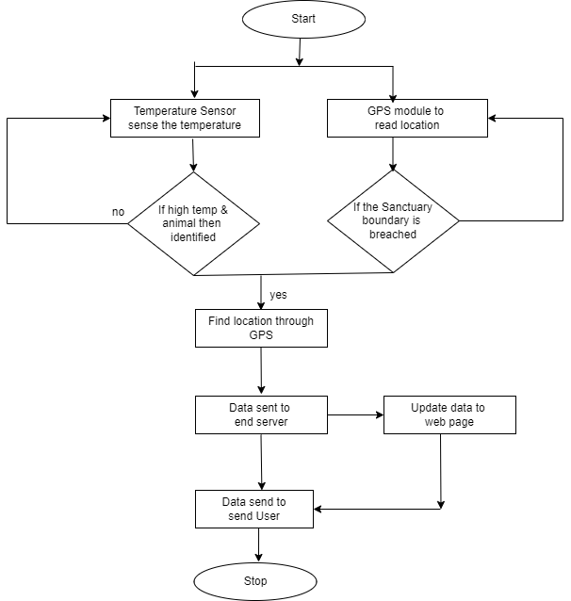
Figure 1. Proposed System Architecture
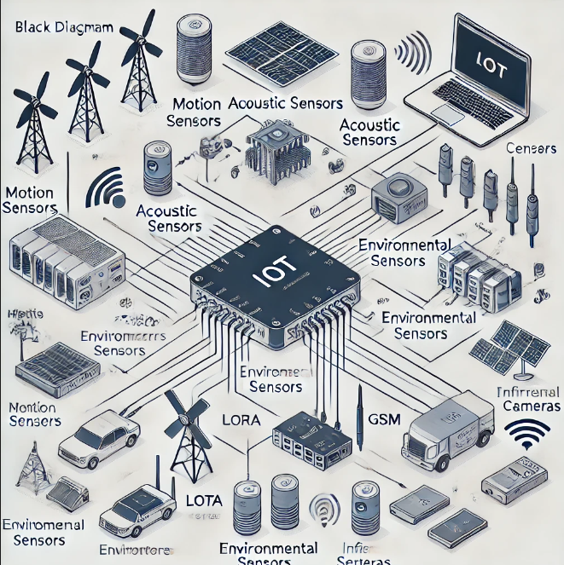
Figure 2 Framework Diagram
CNN Model
To determine the fire's confidence %, we employ the Squeeze Net model. When compared to other training models, the Squeeze Net model yields more accurate results and is renowned for its precision and minimal processing power. To create distinct compact feature maps, the suggested CNN model employs distinct filters in the convolution and pooling layers. Fire modules, which contain two layers that squeeze and expand, are the foundation of the Squeeze Net architecture. A couple pooling layers and a stack of fire modules make up a squeeze net.
The squeeze net model architecture has been trained on about 1000 classes. But the recommended method just calls for two classes. Consequently, only the normal classes and the fire are considered. The architecture consists of max-pooling and a convolution layer. The input size of the fire modules is 224*224*3. Every fire system has two convolutions: development and squeeze. A max pooling layer comes after the original fire alarm modules. By altering the model to fit the final firing module, two classes are produced. A transfer learning methodology has been used to train the Squeeze Net model.

YOLO V3 Model
YOLOv3 (You Only Look Once version 3) is a very powerful real-time object recognition technique that can be adapted to identify fire in images or videos. Its architecture, which consists of 106 layers with convolutional and residual layers that enable reliable detection at numerous sizes, makes it suitable for detecting fire in both small and large areas. YOLOv3 is ideal for real-time fire monitoring in applications like fire alert systems and surveillance because it balances speed and accuracy by forecasting bounding boxes around fire occurrences and processing all images or video frames at once.
With the use of a collection of annotated fire photographs, YOLOv3 may be trained to detect fires in real-world environments. By providing timely alerts, this will help prevent fire-related incidents.

- Conclusion
In this paper, we tend to provide a novel framework for reversible image transformation (RIT) supported by RDH-encrypted images for reversible data hiding. RIT-based RDH-EI shields the privacy of the original image by shifting the linguistics of the original image to the semantic of another image, in complete contrast to earlier frameworks that encode a plaintext image into a cipher text type. Because the encrypted image resembles a plaintext image, it will evade the notice of the inquisitive cloud server and the cloud server is free to choose any RDH technique to engraft a watermark on plaintext images.

REFERENCES
[1] Bala, M., Kumar, S., & Singh, D. (2020). IoT-based smart wildlife monitoring system. International Journal of Recent Technology and Engineering (IJRTE), 8(5), 435-440. https://doi.org/10.35940/ijrte.E4693.018520

[2] Joshi, A., Kaur, J., & Verma, P. (2019). Machine learning techniques for wildlife poaching detection. IEEE Access, 7, 156389-156399. https://doi.org/10.1109/ACCESS.2019.2954361

[3] Gupta, R., & Sharma, N. (2021). Real-time poaching detection using drones. Journal of Wildlife Management, 85(3), 502-510. https://doi.org/10.1002/jwmg.21971

[4] Roy, A., & Pandey, S. (2018). Smartphone-based poaching monitoring system. Journal of Mobile Computing and Application, 13(4), 250-256. https://doi.org/10.1109/MCAS.2018.8472755

[5] Karthik, P., & Lakshmi, M. (2020). Integrating IoT with AI for effective wildlife management. IEEE Transactions on Sustainable Computing, 6(2), 278-287. https://doi.org/10.1109/TSUSC.2020.2990576

[6] Patel, V., & Shah, K. (2020). The application of AI in wildlife conservation. Journal of Artificial Intelligence Research, 69, 107-120. https://doi.org/10.1613/jair.1.11760

[7] Rao, A., & Varma, R. (2019). An IoT-enabled anti-poaching system: Design and implementation. IEEE Internet of Things Journal, 6(5), 9321-9330. https://doi.org/10.1109/JIOT.2019.2926748

[8] Kumar, S., & Singh, A. (2021). Video analytics for wildlife monitoring. Journal of Visual Communication and Image Representation, 76, 103073. https://doi.org/10.1016/j.jvcir.2021.103073

[9] Desai, R., & Patel, S. (2020). Community engagement in wildlife conservation using technology. Journal of Environmental Management, 268, 110648. https://doi.org/10.1016/j.jenvman.2020.110648

[10] Gupta, A., & Mishra, V. (2021). IoT applications for conservation: Challenges and opportunities. Journal of Conservation Technology, 5(1), 12-22. https://doi.org/10.1016/j.contec.2021.102457

[11] Li, J., Zhang, Y., & Yu, G. (2018). Deep learning for wildlife image classification: Applications and challenges. Ecological Informatics, 48, 52-62. https://doi.org/10.1016/j.ecoinf.2018.08.004

[12] Ahmed, T., & Zafar, F. (2019). IoT-enabled real-time tracking system for wildlife conservation. IEEE Sensors Journal, 19(23), 11210-11218. https://doi.org/10.1109/JSEN.2019.2937921

[13] Smith, B., & Jones, H. (2020). UAV applications in poaching detection: A comprehensive review. Wildlife Research, 47(6), 452-465. https://doi.org/10.1071/WR19116

[14] Zhang, W., & Liu, P. (2019). Using AI and sensors to combat illegal wildlife trade. Computers, Environment and Urban Systems, 77, 101287. https://doi.org/10.1016/j.compenvurbsys.2019.101287

[15] Nguyen, D. T., & Khin, P. T. (2020). AI-powered surveillance systems for wildlife monitoring. Sensors, 20(9), 2531. https://doi.org/10.3390/s20092531

[16] N. R. Wankhade (2016), Novel Energy Efficient Election based routing algorithm for wireless sensor network, 79(2016) 772-780.

