**Development of modeling of distribution of wagon flows**

Zadorozhniy V.1, Kolesnikov M.2 , Bakalov M. 3

*1Department of Stations and cargo work, Rostov State Transport University, Rostov-on-Don, Russia*

*2Department of Economics and Management, Rostov State Transport University, Rostov-on-Don, Russia*

*3Department of Management of Maintenance Works, Rostov State Transport University, Rostov-on-Don, Russia*

*Corresponding Author: Zadorozhniy V.*

**Abstract:** The focus of this study is to devise a mathematically robust and practically viable model for managing wagon flows along a railway segment, particularly for port wagon departure stations. This model is rooted in a revised method of economic and geographical delineation of «areas of influence» of transport actors, previously developed by the authors. A key innovation in this model is the introduction of the route non-linearity coefficient. This coefficient is designed to capture the specific geographical and infrastructural idiosyncrasies of the transport network relative to potential destination stations, allowing for a more accurate and efficient routing of wagons. The primary output of this research is the development of a geometric routing model that addresses the territorial oligopolistic market of services for transporting empty wagons.

**Keywords:** wagon flow, port transport system, road non-straightness coefficient, modeling, areas of influence, higher-order algebraic curves.

---------------------------------------------------------------------------------------------------------------------------------------

Date of Submission: XX-XX-2024 Date of acceptance: XX-XX-2024

---------------------------------------------------------------------------------------------------------------------------------------

1. **INTRODUCTION**

The economic and geographical reorientation of freight flows within the Russian Federation has maintained robust levels of freight transportation, underpinning the ongoing criticality of managing empty wagon flows. This challenge remains pronounced, particularly as the transportation modalities diversify and the complexity of logistic operations increases. The effective and rational distribution of these empty wagons is vital not only for operational efficiency but also for enhancing the sustainability of the entire railway network, especially within multimodal systems.

The issue of empty wagon management has spurred a variety of research efforts aimed at developing sophisticated mathematical models and algorithms to optimize this process. These studies address several key facets of the logistical challenges, integrating both theoretical frameworks and practical applications to improve efficiency and reduce operational overheads.

In (Rakhmangulov, 2021, Rakhmangulov, 2019), mathematical models are considered that make it possible to find the distribution of empty wagon flows, which reduce labor intensity and decrease the total time of wagon stay in the system. The main attention is paid to the constraints in optimization problems considered for railway junctions.

The mathematical model proposed in (Cheng, 2010) has a theoretical-probability content that makes it possible to take into account the a priori uncertainty in the distribution of empty wagons that occurs in practice. To solve the problem under consideration, random constraints in the model are transformed into corresponding deterministic equivalents, which represents a new approach in the specified area of research. In (Guo, 2009), a linear programming model is proposed for finding optimal distributions of empty wagons in railway junctions using an algorithm for finding minimum costs and maximum flow. In (Liu, 2019), a fuzzy model for the distribution of empty cars and a two-stage genetic algorithm for minimizing the mileage of empty cars are proposed.

In (Shatokhin, 2022), a number of problems arising in the management of empty wagon flows as a result of choosing a non-optimal direction of their movement were identified. As a result, the number of trips that are not justified in terms of their economic feasibility increases, which also leads to increased loads on the railway infrastructure. A calculation was performed aimed at finding optimal directions of movement of empty wagons that ensure increased operational efficiency and economic incentives.

In (Zhu, 2007), the issues of quantitative distribution and coordination of flows in the network are positioned as one of the main ones that create problems arising in the distribution of empty wagons. As a solution, a model containing an ant colony optimization (ACO) algorithm was developed, which shows that some limitations in the problem do not affect its optimal solution.

Summarizing the review, we can conclude that the use of mathematical models (which are quite different among the sources indicated) allows us to find solutions to the corresponding optimization problems in relation to the distribution of empty wagon flows. Namely, the problem of finding rational distributions of wagon flows in railway junctions and port transport and technological systems does not lose its relevance. We also note that in the conditions of active reconfiguration of transport and logistics flows, the practical significance of research results increases, which are new transport and logistics schemes that are substantiated in mathematical terms and, when implemented, create opportunities to improve the efficiency of the wagon flow handling market.

Optimal distribution of wagon flows and the choice of the most suitable transportation routes allow us to reduce the time and costs of cargo delivery, increase the efficiency of using railway resources and improve the overall performance of the transport system. The key factors in making decisions on transportation optimization are their cost and delivery time, the capacity of the transport infrastructure, the reliability and safety of transportation.

The search for alternative transportation routes becomes especially relevant in cases where existing transportation routes cannot provide optimal conditions for cargo transportation. This happens, for example, due to overloads, infrastructure limitations or, in general, due to geographical features. In such cases, it is necessary to look for new routes that can offer equally effective and cost-effective delivery options.

Another problem that not only operators, but also Russian Railways face is competition with other modes of transport. Therefore, joint efforts by all entities in the transportation process are important in creating the most attractive conditions for customers. To adapt to their requests, it is also necessary to quickly respond and make decisions on tariffs.

The last 5-7 years have seen fluctuations in the operator market, but the overall number of players has remained stable. Mostly, there has been a redistribution of the wagon fleet between existing companies. This is due to the high cost of new wagons and the complexity of technologies in the field of rail freight transportation in general.

Currently, the situation has changed, since freight flows are now mainly directed to the East. However, there is also a surplus of wagons and gondola cars that are idle in the network, which creates risks for the market. For operators, it is important to improve the technology of transportation, expand the number of routes and be able to influence the carrier's operational decisions.

A high degree of uncertainty and complexity of market conditions requires flexibility and the ability to adapt to change.

Sustainable growth and long-term sustainability of operator companies in the transport industry largely depend on their competitiveness. In the context of the rapid development of the digital economy, traditional business models are being replaced by innovative technological approaches that are changing the dynamics of the market and the requirements of participants. The adoption of digital technologies offers operators significant opportunities to improve operational efficiency, reduce costs and enhance service quality. However, this shift also creates a number of challenges, including increased competition, the need to quickly adapt to technological changes and new customer demands.

The importance of approaches and methods, the development of which is based on new mathematically sound logistic ideas, is growing. The previously proposed approaches do not lose their importance, provided that they are developed, modified and adapted to the ongoing economic and geographical changes occurring in relation to the transportation process as a whole. At the same time, the results of studies that represent theoretically sound transport and logistics schemes of a general nature, the implementation of which allows activating the mechanism of market functioning (for the direction considered in the article, this is, first of all, the market for operating wagons), are of practical importance. Paying attention to the multimodality of the overwhelming majority of economically significant freight transportation, we note that, due to the very design of the modern transportation process, the objects that are especially in demand in conducting the above studies are port transport and technological systems.

The objective of this study is to develop a mathematically sound and practically feasible approach to transport and logistics modeling of the process of regulating wagon flows on a railway polygon (or on the part thereof under consideration).

The theoretical basis is a modification of the method of economic and geographical delineation of the «areas of influence» of the subjects of the transportation process, previously developed by the authors. The main component of the new model is the coefficient of road non-linearity introduced for the considered port stations of wagon departure. This coefficient allows taking into account the specifics of the location of the transport network in relation to possible destination stations. The result of the study is a geometric routing model of the territorial oligopolistic market of services for the transportation of empty wagons, formed by the considered departure stations. The model is implemented in its full form in the environment of the Maxima (Free Ware) computer mathematics system.

1. **METHODOLOGY**

It should be noted that over the past few years there have been various fluctuations in the market of non-traction rolling stock operators, although the players have remained the same for the most part. To a greater extent, the changes have been manifested in the redistribution of the wagon fleet between competing companies, which is due to the high cost of new wagons and the complexity of the entire organizational and technological complex of transportation, accompanied by the corresponding tariff policy of the operating companies (Fig. 1).

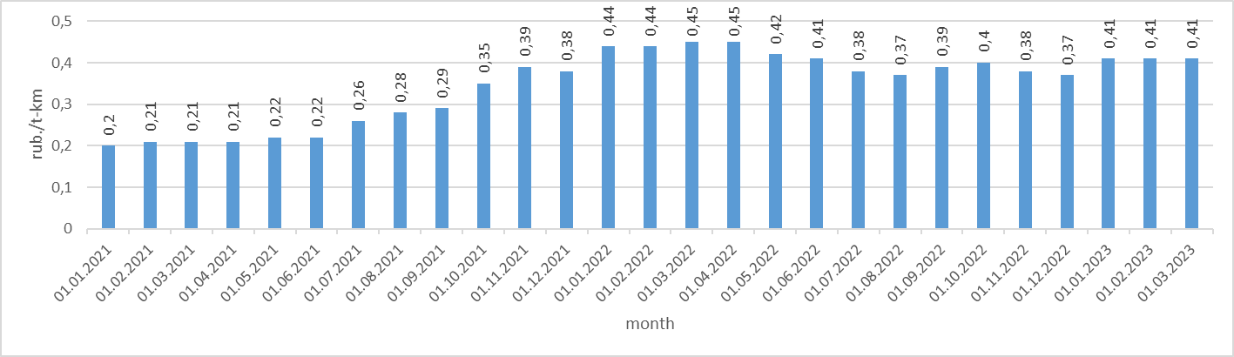

**Figure 1:** *Dynamics of changes in the rate for the provision of a gondola car in 2021-2023, RUB/t-km*

We will consider not the Euclidean, but the railway (tariff) distance between loading stations and unloading stations. Let us proceed to constructing a geometric routing model (GRM) of the oligopolistic market for empty wagon transportation services on the considered part of the railway polygon. As in constructing the geometric Euclidean model GEM, we turn to the economic and geographical method of delimiting the «areas of influence» of the subjects of the transportation process (see, for example, (Chislov, 2019), (Chislov, 2021)). The main difference between these models is that when constructing the GRM, not the Euclidean, but the railway (tariff) distance is considered between departure and destination stations. Namely, for each departure station included in the model, a coefficient of road non-linearity is introduced, by means of which the specificity of the location of the road network in relation to this station is taken into account.

Let us move on to constructing territorial schemes for the efficient use of rolling stock. The real transport situation in the geometric Euclidean (GEM) model is «idealized» in the sense that the Euclidean distances between their beginnings and ends are taken as route lengths. Then the line delimiting their “territories of influence” is written by the equation:

 (1)

Equation (1) defines an algebraic line on the plane, generally speaking, of the fourth order. This line is a Descartes oval with foci located at the points O (0,0) and A (L,0).

The result of constructing a geometric Euclidean model (GEM) serves as a theoretical basis for creating a real geometric routing model (GRM) using the coefficient of non-linearity of routes (*ki*). As a result, it is possible to identify zones within whose boundaries transportation is most effective, taking into account geographical, economic, and infrastructure factors. As in the GEM, the «areas of influence» of the duopolists are delimited by a line that is determined by the cost of freight transportation from their locations to destinations. The equation of this line in the GRM has the form:

 (2)

It should be noted that the construction of the GMM of the oligopolistic market for services for the transportation of empty wagons on the considered part of the railway polygon is based on the corresponding numerical data regarding departure stations and destination stations (Table 1).

1. **RESULT AND DISCUSSION**

Numerical data for modeling are presented in Table 1.

**Table 1:** Numerical data for departure stations

|  |  |  |  |
| --- | --- | --- | --- |
| Steps | Contactor M | Contactor P | Contactor G |
| Zarechnaya | 494,564 | 27,120 | 1,425 |
| Azov | 542,506 | 27,196 | 1,504 |
| Vyshestebliyevskaya | 1255,5 | 24,87 | 1,384 |
| Kavkaz | 1321,57 | 24,71 | 1,495 |
| Novorossiysk | 1122,61 | 24,93 | 1,332 |
| Temruk | 1584,891 | 24,291 | 1,484 |

We perform analytical procedures and graphical constructions in the Maxima and Python.

Figure 2 and 3 shows the territorial picture obtained on the basis of the GEM, reflecting the zones of efficient use of rolling stock for port departure stations. The lines delimiting the "areas of influence" of stations in duopolistic situations are highlighted in different colors from the point of view of visual perception.

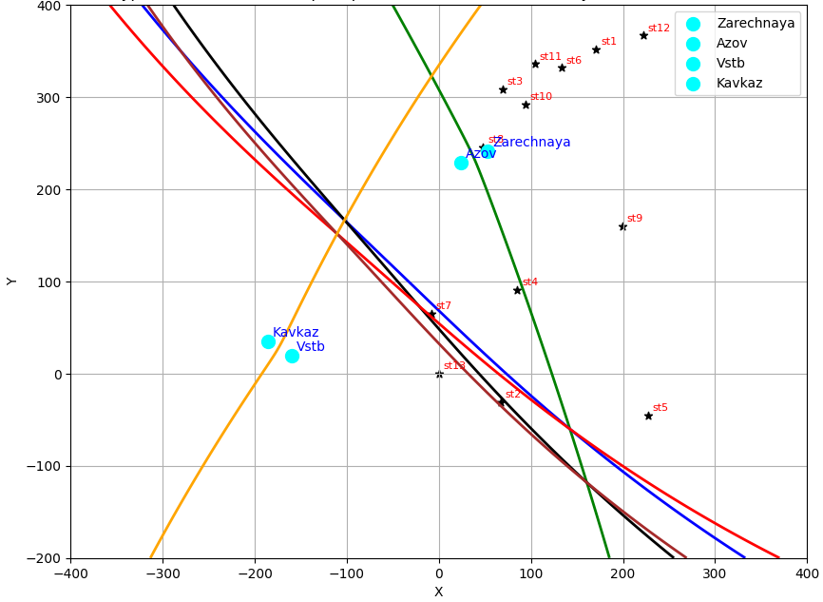

Figure 2: Depiction of the "areas of influence" of departure stations in an oligopolistic situation under GEM (1 modeling option)

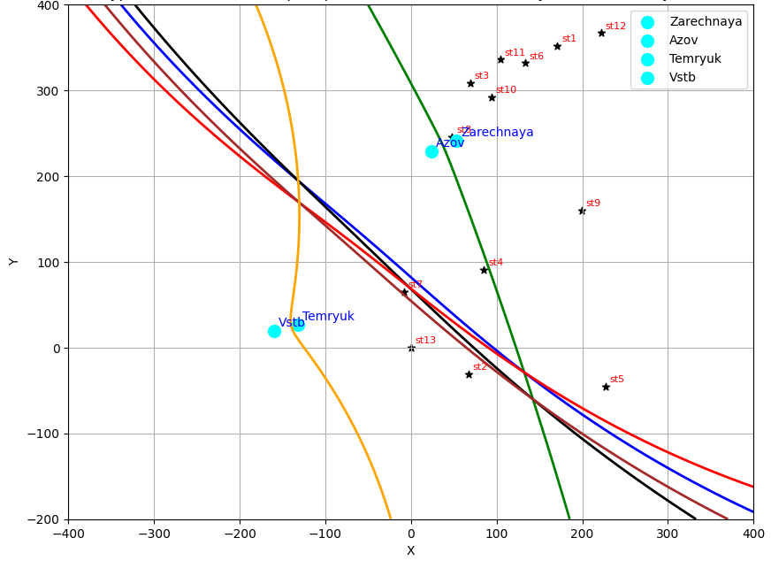

**Figure 3:** Depiction of the "areas of influence" of departure stations in an oligopolistic situation under GEM (2nd modeling option)

The resulting geometric routing model (GMM) (Fig. 4 and 5) takes into account the factors of non-linearity of routes, which is reflected by the change in the configurations of algebraic curves and thus the "areas of influence" of departure stations. The model allows for a more accurate reflection of the real transport network and the specifics of the movement of car flows.

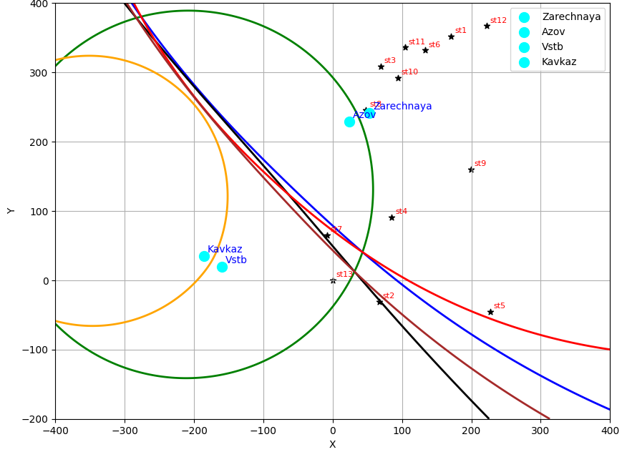

**Figure 4:** Depiction of the "areas of influence" of departure stations in an oligopolistic situation under GRM (1 modeling option)

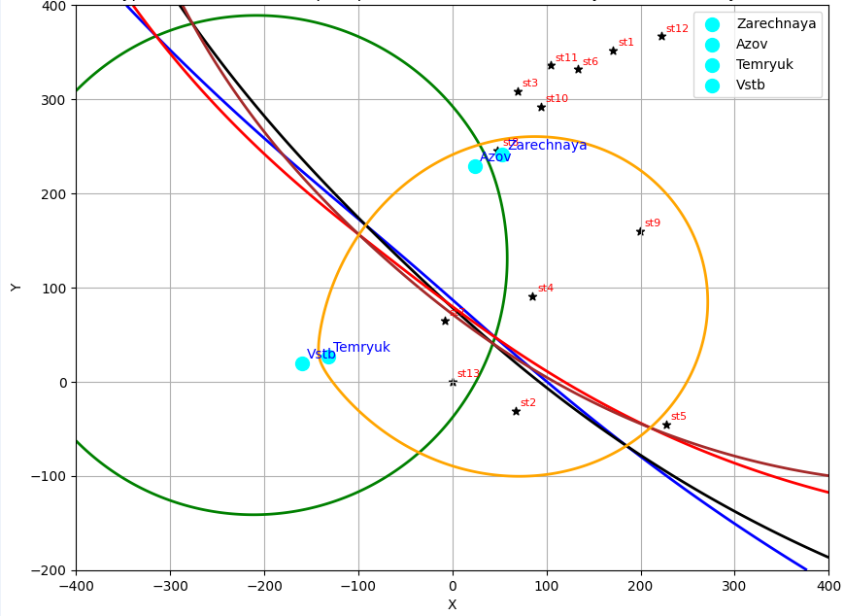

**Figure 5:** Depiction of the "areas of influence" of departure stations in an oligopolistic situation under GRM (2nd modeling option)

# **CONCLUSION**

The introduction of the route non-linearity coefficient significantly improves the method used for economic-geographical boundaries of the "influence zones" of departure stations in transport and logistics studies. Using the recently developed geometric routing model (GEM), which includes this coefficient, it is possible to more accurately define these influence zones around railway stations, reflecting the unique layout of the transport network. This leads to a fairly accurate depiction of the oligopolistic transportation market on the railway network, which is influenced by specific freight departure stations.

**ACKNOWLEDGEMENTS**

The research was supported by the Russian Science Foundation grant No. 24-29-00869, https://rscf.ru/project/24-29-00869/

**REFERENCES**

1. Chislov O.N, Bogachev V.A., Zadorozhniy V.M, Bogachev T.V. (2019). Economic-geographical method delimiting wagon flows in the region considered: model and algorithm. Transport Problems. Vol. 13. 39-48.
2. Chislov O. N., Zadorozhniy V. M., Bogachev V. A., Kravets A. S., Bogachev T. V., Bakalov M. V. Mathematical modeling of cargo flow distribution in a regional multimodal transportation system // Transport Problems. 2021. Т. 16. № 2. С. 153–165.
3. Cheng X., Tang R., Tang Z. (2010). Probability model and solution of railway empty car distribution. International Conference of Logistics Engineering and Management (ICLEM). URL: https://trid.trb.org/view/1271489.
4. Guo Q., Li C., Chen D. The minimum-cost and maximum-flow algorithm for railway empty cars distribution // Second International Conference on Transportation Engineering. 2009. C. 2821–2826.
5. Liu L., Yang X. A model and an algorithm for empty car distribution in railway transportation // International Conference on Natural Computation, Fuzzy Systems and Knowledge Discovery. 2019. № 1074. С. 123–131.
6. Rakhmangulov A., Muravev D., Hu H., Mishkurov P. (2021). Multi-agent optimization of the intermodal terminal main parameters by using AnyLogic simulation platform: Case study on the Ningbo-Zhoushan Port. International Journal of Information Management. Vol. 57. 102-133.
7. Rakhmangulov A., Osintsev N., Muravev D., Legusov A. (2019). An optimal management model for empty freight railcars in transport nodes. Operational Research in Engineering Sciences: Theory and Applications. T. 2. № 1. 51–71.
8. Shatokhin, A, et al., 2022. Optimization of Empty Wagon Flows in the Formation of the Technical Work Plan for the Railway Network 61, 361365. DOI: 10.1016/j.trpro.2022.01.058.
9. Zhu, Jianmei & Tan, Yunjiang & Yan, Haifeng. (2007). Model and Ant Colony Optimization Algorithms for Railway Empty Wagons Distribu-tion. 3041-3047. 10.1061/40932(246)499.