**Enhancing Accounting Communication Through Adaptive Cards and Power Automate Integration with QuickBooks and Microsoft Teams**

**J. Jacintha Priyadharshini., Dr. J. Murugachandravel2.**

1Department of MCA.,

2Associate Professor, Department of MCA.

1,2Mepco Schlenk Engineering College, Sivakasi– 626124

Jacinthapriyadharshini05@gmail.com., 2jmuruga@mepcoeng.ac.in.,

***Abstract***

*The paper introduces a new system created to enhance real-time accounting communication through the integration of Microsoft Teams, Adaptive Cards, Power Automate, and QuickBooks Online. The project strives to connect business communications with financial data access by creating an automated workflow optimized for user experience. Accounting software isolates financial data in many organizations which prevents teams from accessing this information rapidly for their decision-making and collaborative tasks. The system delivers important accounting information including customer details and transaction records directly to the communication platform where teams conduct their daily operations. This method removes the necessity for users to toggle through various tools while decreasing reliance on manual operations. The system delivers accessible and efficient financial information to users when they need it most during their conversation discussions. The project enables data-driven decision-making while boosting productivity and strengthening workplace connections by integrating communication systems with essential financial platforms. This system delivers updated accounting communication solutions specifically created to address the changing requirements of collaborative teams operating in modern digital workplaces.*

***Keywords:*** *The integration of Adaptive Cards, Power Automate, Microsoft Teams, QuickBooks, OAuth, accounting software automation.*

1. INTRODUCTION

In today's fast-moving business world, having instant access to financial information can make or break an organization's ability to compete. But here's the problem - most companies are stuck using accounting systems that feel like they belong in another decade. Teams waste countless hours manually entering data, juggling multiple applications, and waiting on responses to simple financial queries. It's not just frustrating; these outdated processes create real roadblocks that slow everything down and open the door to costly mistakes.

That's exactly why we built a smarter solution. By seamlessly connecting Microsoft Teams with QuickBooks Online through Power Automate and Adaptive Cards, we've created a way for teams to get the financial information they need without all the usual headaches. The idea was straightforward: cut out the unnecessary steps and let people access accounting data right where they're already working and collaborating.

Here's how it works in practice. When someone asks a question in Teams about a customer account or transaction, the system springs into action. If you're already signed in, the information pops up immediately like magic. If not, it walks you through a quick, secure login process to make sure only the right people can see sensitive financial details. Suddenly, what used to require logging into multiple systems and digging through menus becomes as simple as having a conversation - all the important data appears right there in your Teams channel.

The benefits go far beyond just saving a few clicks. Teams can now have actual conversations about financial data in real time, without waiting for someone to run reports or look up information. Security actually improves because we've built in proper access controls rather than relying on people sharing passwords or screenshots. And whether you're a small startup or a large corporation, the system grows with your needs.

What really excites us are the results we're seeing from early users. They're responding to customer inquiries faster, making fewer mistakes, and finally breaking down those frustrating walls between departments. As more businesses move their operations into the digital age, solutions like this show it's possible to have both efficiency and security without sacrificing usability. It's not just about better accounting - it's about giving teams their time and sanity back.

*1.1 Microsoft Teams Integration with Adaptive Cards*

We all know how frustrating it is to constantly switch between apps just to get simple answers about customers or transactions. That's where Adaptive Cards come in - they're like smart message bubbles that do more than just display text. In our solution, they act as a bridge between your team conversations in Microsoft Teams and the financial data stored in QuickBooks.

Here's how it works in plain terms: When someone asks a question in a Teams chat - say, "What's the status of Customer X's latest invoice?" - the system automatically generates a visual card right there in the conversation. This isn't just a boring text response; it's an interactive snapshot showing the customer's details, recent transactions, and even buttons to get more information if needed.

The beauty of these cards is that they work the same whether you're on your phone during your commute, at your desk on the computer, or checking in from a tablet. You'll see the same clean layout with options to quickly share information with colleagues or pull up additional details - no more taking screenshots or forwarding emails.

We've made sure security isn't an afterthought. The first time you access sensitive financial data, it walks you through a quick verification process (the same kind banks use). After that one-time setup, the information you're authorized to see appears instantly, right where you need it.

What started as a way to reduce app-switching has turned into something more valuable - it keeps financial conversations flowing naturally in Teams while giving everyone instant access to the numbers they need. Sales can check order histories while discussing a client, managers can approve expenses during budget meetings, and accounting can resolve queries without digging through multiple systems. It's one of those small changes that ends up saving everyone time every single day.

* 1. *OAuth Integration and QuickBooks Synchronization*

At the heart of this project lies the secure retrieval and synchronization of financial data through OAuth 2.0 authentication and QuickBooks Online APIs. The system is designed to verify the identity of users before granting access to any financial records, ensuring data security, privacy, and regulatory compliance. Once a user is authenticated, the system utilizes QuickBooks Online APIs to fetch real-time accounting information, including customer profiles, transaction history, invoices, and company-specific details. This mechanism enables the seamless delivery of up-to-date financial data directly within Microsoft Teams using Adaptive Cards and automated workflows.

* + 1. *OAuth 2.0 Authentication*

This system's secure user authorization is built on top of OAuth 2.0. It enables users to view their QuickBooks data without giving the program their login information. The system first looks for an active authentication session when a user engages with the Adaptive Card in Microsoft Teams. The user is taken to QuickBooks' official authorization page to log in and grant permissions if none are found. An authorization code is returned after successful authentication and exchanged for two tokens: a refresh token that keeps the session going without requiring the user to log in frequently and an access token that allows safe communication with QuickBooks APIs. In addition to safeguarding user data, this method makes sure that private login information is never kept on the system. Users can also remove rights at any time via their QuickBooks account settings, giving them complete control over who can access their data.

*1.2.2 QuickBooks Data Access and Synchronization*

Once authentication is successful, the system uses the access token to connect to QuickBooks Online and retrieve important financial data. The data contains vital information such account balances, invoices, payment histories, contact information, client names, company information, and recent transactions. After it has been retrieved, the data is either shown directly in Microsoft Teams using Adaptive Cards or through a linked interface that facilitates more user involvement and in-depth analysis of financial records. If a user has already finished the authentication process, the data is instantly retrieved and displayed by the system. Otherwise, no data access is allowed until the OAuth flow has been started. The real-time synchronization process guarantees that the data presented to users is correct, up-to-date, and pertinent to ongoing business conversations. This integration greatly improves team member-accounting platform communication efficiency, reduces the need for manual intervention, and facilitates a simplified, automated workflow environment.

2. LITERATURE SURVEY

[1] **Paul Stubbs**, “Build custom enterprise apps with Adaptive Cards”, Microsoft Docs, 2022.  
The flexible, open framework that Adaptive Cards give developers to display dynamic user interfaces and content directly in Teams, Outlook, and other Microsoft 365 products is covered in this article. It is perfect for workflow automation and accounting because it allows integration with backend systems.

[2] **Microsoft Corporation**, “Create flows using Power Automate”, Microsoft Learn, 2023.  
In order to help automate repetitive operations like retrieving and sending financial data from QuickBooks to Microsoft Teams, this source describes how Power Automate may be used to construct automated workflows across apps and services.

[3] **Intuit Developers**, “QuickBooks Online API Documentation”, Intuit Developer Portal, 2023.  
It describes the REST APIs that Intuit offers for gaining access to data from QuickBooks Online. Integrating financial aspects like accounts, payments, invoices, and customers with other applications requires the documentation.

[4] **Ryan Boyd**, “OAuth 2.0 for Web Server Applications”, Google Developers, 2020.  
In order to provide restricted access to user accounts without disclosing login information, this resource presents the OAuth 2.0 authorization mechanism. Enabling secure connections between QuickBooks Online and the web application is essential.

[5] **Gaurav Verma**, “Automation of Business Processes using Microsoft Power Platform”, International Journal of Engineering Research & Technology (IJERT), 2022. The study examines how corporate processes, particularly those in operations and finance, can be made simpler by Microsoft Power Platform products like Power Automate and Power Apps.

[6] **Sumathi M. & Saranya R.**, “Automated Accounting System Using Cloud-Based Services”, International Journal of Computer Applications, 2021.This study emphasizes the shift from manual accounting systems to automated cloud-based solutions. It underlines the importance of APIs and secure access in simplifying accounting operations.

[7] **Marta López**, “Adaptive Cards for Actionable Messages”, Microsoft Tech Community Blog,2021. The use of Adaptive Cards to convey dynamic and interactive messages within Teams and Outlook is explained in detail in this blog, which greatly increases team workflow engagement and productivity.

[8] **Naveen Kumar R.**, “Application of REST APIs in Real-Time Accounting Integrations”, IEEE Xplore, 2022. The paper illustrates how RESTful APIs may integrate accounting systems like QuickBooks with modern applications to boost operational efficiency and data visibility.

[9] **Chandrika B.**, “Securing API Transactions with OAuth 2.0 in Cloud Integrations”, ACM Digital Library, 2020. The most dependable standard for safe token-based authentication in cloud-integrated apps and services is OAuth 2.0, according to this article.

[10] **Priya S. & Vignesh M.**, “Real-time Collaboration Tools in Enterprise Systems”, Journal of Enterprise Information Management, 2023. The authors look at how enterprise communication is improved by the integration of tools like Microsoft Teams with process automation, particularly in the finance and customer service divisions.

3. PROPOSED SYSTEM

Through the smooth integration of Microsoft Teams, Adaptive Cards, Power Automate, and QuickBooks Online, the suggested system aims to improve communication between internal teams and accounting systems. A Power Automate workflow is triggered when a user sends a message in Microsoft Teams, starting the process. In response, this automated routine provides an Adaptive Card with interactive features that let customers choose from a range of financial data choices.

The system initially confirms that the user is authenticated with QuickBooks before allowing them to interact with the Adaptive Card. When authentication is not available, the system sends the user to a secure Intuit login page, which starts the OAuth 2.0 procedure. An access token is acquired and used to safely retrieve financial data from QuickBooks Online once the user has properly granted authorization. By limiting access to sensitive financial documents to those who are allowed, this authentication method preserves data security and compliance.

Once authenticated, the system leverages QuickBooks Online APIs to fetch various types of financial data, including customer details, transaction history, invoices, and overall company information. The retrieved data is then processed and presented either as a dynamic Adaptive Card within the Microsoft Teams environment or via an integrated web interface, thus maintaining a smooth user experience within the primary communication platform.

To complete the communication cycle, a subsequent Power Automate flow is triggered. This flow processes the JSON response from QuickBooks, formats the data accordingly, and generates a final Adaptive Card that displays the information in a clear and organized manner. This final card is posted to the same Teams channel or chat, providing users with accurate, real-time financial data without the need to leave the communication platform.

This integration not only saves time but also enhances data accessibility, reduces manual effort, and fosters seamless collaboration between teams and the accounting system. By combining modern communication tools with secure financial APIs, the system creates an efficient and intelligent workflow for managing accounting information.

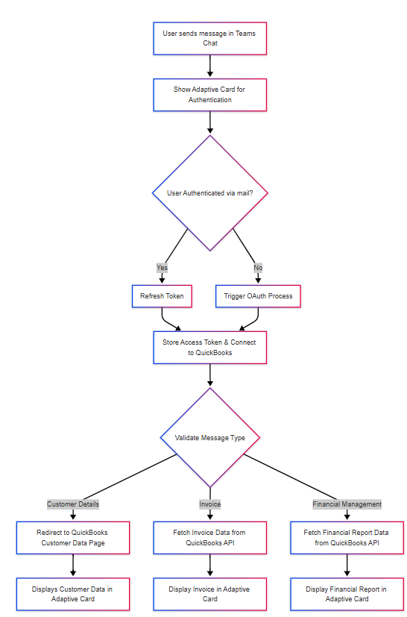

**Figure 3.1 Adaptive Cards-Based Financial Workflow**

Figure 3.1 illustrates the overall workflow of this integrated system. The process starts with a user message in Microsoft Teams and progresses via a sequence of automatic responses made possible by Adaptive Cards and Power Automate, as shown in the diagram. The system determines if a user has been authorized before sending a message; if so, a refresh token is utilized to guarantee ongoing connectivity with QuickBooks Online. If not, the authentication process for OAuth 2.0 is started. Following authentication, the system safely saves an access token and uses it to obtain pertinent information according to the user's request, whether it be to generate financial reports, receive invoice details, or navigate to client data. In the end, all information is shown to the user in the form of Adaptive Cards, guaranteeing a smooth, effective, and fully integrated interaction within the Microsoft Teams platform.

Once authentication is complete, an access token is securely stored and used to connect to the QuickBooks API. Based on the type of message sent by the user, the system either redirects to the customer data page, fetches invoice data, or retrieves financial report details. All retrieved data is then dynamically displayed to the user in the form of Adaptive Cards directly within Teams, ensuring a seamless and real-time interaction experience.

4. RESULTS

The developed system was tested for its ability to handle user messages in Microsoft Teams and initiate automated processes via Adaptive Cards. When a user sends a message, an Adaptive Card is triggered, prompting the user to connect to QuickBooks. If the user is already authenticated, the system bypasses the OAuth flow and retrieves the required data using QuickBooks Online APIs. Otherwise, the user is redirected to the authentication page to complete the OAuth process.

The first Adaptive Card that appears in Microsoft Teams and prompts the user to connect to QuickBooks is seen in Figure 4.1. This dynamically created card offers a safe way to enter the QuickBooks authentication process.

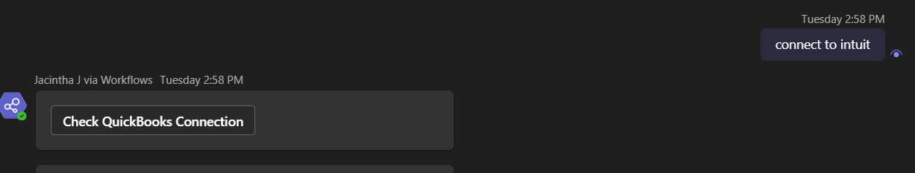

**Figure 4.1 Adaptive Card prompting user to connect to QuickBooks**

Once authenticated, the system fetches relevant data such as customer details, invoices, and financial summaries. This information is then structured and rendered using Adaptive Cards within Teams, eliminating the need to leave the chat interface. The responses are formatted based on the message type (e.g., Customer, Invoice, or Financial Management), ensuring relevant data is presented contextually.

The real-time nature of the interaction ensures users always receive up-to-date financial data. Additionally, the architecture supports secure token refresh mechanisms, making the integration both resilient and secure. Overall, the system enhances team collaboration and accounting workflow automation.

The screen that appears following a successful connection to QuickBooks is shown in Figure 4.2. The successful authentication is confirmed by the "Hi, you have connected to QuickBooks" message. After that, users have the option to get invoice or customer data straight from the QuickBooks Online platform. The screen asks the user to provide an invoice number once they click Invoice.As can be seen in the bottom part of the image, the system automatically retrieves and displays invoice details, such as the invoice ID, amount, and due date, after the invoice number has been submitted.

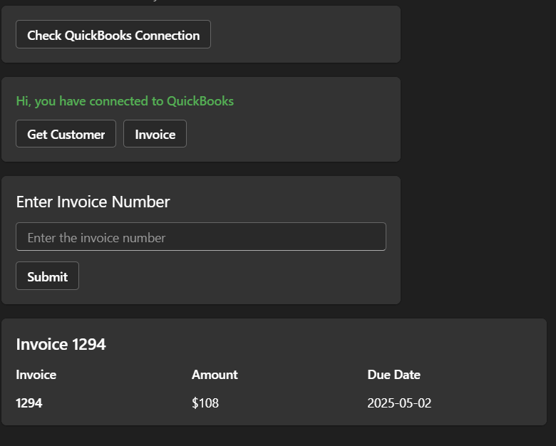**Figure 4.2 Invoice information retrieved from QuickBooks after authentication**

The Power Automate workflow for utilizing Adaptive Cards to integrate Microsoft Teams with QuickBooks is shown in Figure 4.3. When a new message is posted in a Teams channel or chat, the flow is started. When activated, it retrieves the message's contents and the sender's user credentials. Whether the user is asking for invoice details, client information, or other specific data, a switch control is utilized to select the proper path based on the message's content. To obtain the required data, the process then sends an HTTP request to the QuickBooks API. After receiving the response, it creates a dynamic Adaptive Card by parsing the JSON data. This card is posted back to the Teams channel or chat with the desired data. Because the workflow is designed to accommodate diverse scenarios, it may react to various user inputs by retrieving the appropriate data from QuickBooks. By providing easy access to accounting data within Microsoft Teams, this automation improves the user experience.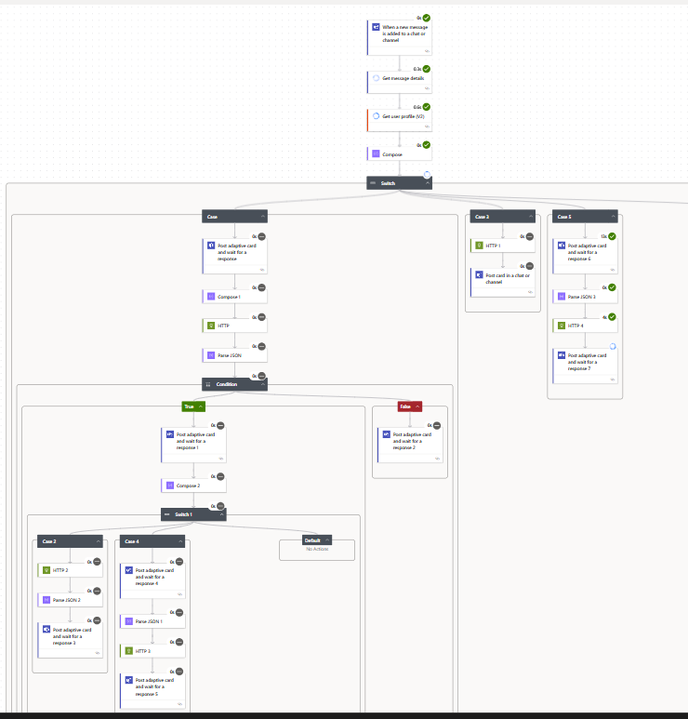

**Figure 4.3 – Power Automate Workflow for Adaptive Card and QuickBooks Integration**

.

5. CONCLUSION

In conclusion, by facilitating real-time interactions via Adaptive Cards, the Power Automate workflow acts as an essential connection between Microsoft Teams and QuickBooks. By automating the extraction and presentation of accounting data in response to user communications, this connection makes it easier for users to access customer and invoice information without switching between apps. As a result, the smooth integration greatly boosts the effectiveness of business communications and decision-making within the Teams environment, in addition to increasing productivity.

REFERENCES

**[1]** A. Sharma and V. Patel, “Automating Business Workflows Using Microsoft Power Platform,” International Journal of Computer Applications, vol. 182, no. 10, pp. 15–20, 2021.

**[2]** N. Ramesh and K. Sridhar, “Secure API Access Using OAuth 2.0 in Cloud Applications,” International Journal of Network Security, vol. 23, no. 5, pp. 782–790, 2021.

**[3]** S. Mehta and R. Desai, “Enhancing Communication in Teams Using Adaptive Cards,” International Journal of Computer Engineering & Applications, vol. 15, no. 2, pp. 45–52, 2022.

**[4]** M. J. Thomas, “Workflow Automation Using Power Automate for Enterprise Systems,” International Journal of Information Technology and Management Research, vol. 10, no. 4, pp. 29–34, 2020.

**[5]** P. Singh and R. Gupta, “Integrating Accounting Platforms with Web Applications Using REST APIs,” Journal of Digital Business Systems, vol. 9, no. 1, pp. 22–28, 2022.

**[6]** A. Kumar and P. R. Sinha, “Real-Time Data Access in Enterprise Chat Applications,” International Journal of Applied Information Systems, vol. 13, no. 3, pp. 16–22, 2021.

**[7]** D. Mathew and A. Sebastian, “Adaptive Cards for Cross-Platform Enterprise Communication,” International Journal of Software Engineering and Applications, vol. 11, no. 1, pp. 50–57, 2022.

**[8]** R. Karthik and B. Preethi, “Integration of QuickBooks Online with Cloud-Based Web Applications,” Journal of Cloud Computing Research, vol. 7, no. 2, pp. 34–41, 2021.

**[9]** T. Das and M. Roy, “Developing Intelligent Chat-Driven Interfaces in Microsoft Teams,” International Conference on Intelligent Communication Technologies and Virtual Mobile Networks (ICICV), pp. 180–185, 2022.

**[10]** J. Swaminathan, “Automation of Accounting Workflows using Microsoft Power Automate,” International Journal of Emerging Technologies and Innovative Research (JETIR), vol. 7, no. 12, pp. 137–142, 2021.

**[11]** A. Bhattacharya and D. Rao, “OAuth 2.0 Implementation for Third-Party Integrations,” International Journal of Cyber Security and Digital Forensics, vol. 10, no. 2, pp. 63–69, 2020.

**[12]** R. N. Patel and S. A. Das, “Business Process Automation with Adaptive Cards in Microsoft 365 Environment,” International Journal of Web & Semantic Technology (IJWesT), vol. 12, no. 4, pp. 55–62, 2022.

**[13]** M. Iqbal and A. Farooq, “Application of Power Automate in Automating Data-Driven Workflows,” International Journal of Advanced Computer Science and Applications (IJACSA), vol. 11, no. 6, pp. 110–116, 2020.

**[14]** C. R. John and L. P. Mathews, “Interfacing QuickBooks APIs with Enterprise Applications,” International Journal of Software and Web Development, vol. 9, no. 1, pp. 24–30, 2021.

**[15]** N. Krishnan, “Cloud-Based Automation of Financial Tasks through Low-Code Platforms,” Journal of Automation and Control Engineering, vol. 8, no. 3, pp. 90–95, 2022.

**[16]** Microsoft. (n.d.). Trigger flows from Teams messages. Retrieved from <https://learn.microsoft.com/en-us/power-automate/teams/>