The SWAT model for modelling hydrological characterization and water balance for the Ndarugu-Thririka sub-catchment.

1/2 Kagiri Moses, 2 Murimi Shadrack, 2 Makhoha Mary, 3 Njihia Paul

*1 School of Engineering and Technology, Technical University of Mombasa, 2 School of Pure and Applied Science, Kenyatta University and 3 School of Pure and Applied Science, Technical University of Mombasa.*

**Abstract**

A healthy watershed should provide for nutrient cycling, carbon storage, erosion/sedimentation control, increased biodiversity, soil formation, wildlife movement corridors, water storage, water filtration, flood control, food, timber, and recreation. Therefore, their management is crucial using the appropriate tools (hydrologic models). These models provide accurate information but must be calibrated and validated. In this study, the Soil and Water Assessment Tool (SWAT) model successfully determined water balance and characterization for the Ndarugu -Thiririka sub-catchments.

The analysis showed that evapotranspiration rates accounted for over 75% of the total water balance, which equals 571.06 mm. The annual surface runoff was estimated at 82.46, making up 11% of the entire water balance. The lateral flow was 1.5% or 11.77 mm after the validation of the SWAT model. Also, results showed the highest flows were recorded in May and June, while the lowest flows were in February and OctoberThe statistical indicators and graphs indicate that the model performs satisfactorily for the daily streamflow.

For the calibration period of the SWAT model, the statistical analysis showed R2 = 0.96, p = 0.93, r = 0.11, NSE = 096 and PBIAS = - 0.8. The validation results were R2 = 0.98, p = 0.92, r = 0.15, NSE = 098 and PBIAS = - 1.8. The graphical values of NSE and R2 indicated the substantial predictive ability of the SWAT model after the calibration and validation processes.

**1 Introduction**

Water is crucial for human survival, food security, environmental stability, social and economic growth, and energy generation. However, water scarcity is a global concern due to a lack of clean water, poor environmental quality, restrictions, and long-term planning. Increased water demand for industrial, commercial, and agricultural activities is causing a decline in water quality and quantity, making it difficult to find cost-effective strategies to enhance water supplies. At the basin level, water resources management is affected by biological, physical, and social factors. Water quality and quantity are declining due to increased water demand, posing a problem in finding a cost-effective strategy to enhance water supplies (Ruey *et al*., 2017)

As water demand for industrial, commercial, and agricultural activities increases, accessible water decreases (Okello *et al.,* 2015). The decline of water resources globally, is causing economic imbalances and necessitates an efficient water allocation system. Catchments in Kenya suffer from human activities such as coal burning, poorly developed tourism facilities, water pollution, and unregulated water abstractions, thus causing significant damage to them. According to Sarkar (2022), these challenges have led to a decrease in the water supply in Kenya, with only 2% of total surface water being accessible. These issues may be solved using various models such as SWAT, ModSIM, MIKE BASIN, and WEAP 21.

The hydrologic models help scientists determine hydrological parameters and offer the best solutions for water resource management and planning. The models use personal computers for efficient planning and decision support systems. The models aim to evaluate the hydrological parameters and water balance. The SWAT model was employed to determine water balance and hydrologic characterization for the Ndarugu - Thiririka sub-catchments.

The SWAT model is a semi-distributive model that divides basins or watersheds into sub-catchments based on drainage patterns. The SWAT model accurately simulates, pesticides, sediments, transportion of the nutrients and flows into the watershed (Bhatt and Tiwari, 2019). The other elements modelled by the SWAT model are groundwater, water quality and climate change. The model divides watersheds into tiny sub-basins known as “Hydrological Response Units” based on groundwater regime, surface area and soil type (Wang *et al.,* 2010).

**2 The study area**

**2.1 The Ndarugu – Thiririka sub-catchments**

The sub-catchments, located 30 kilometers south of Nairobi city, span an area of 1360.241 km2 and have a population of 653,365 people. The sub – catchment is located to the south at 1° 45' 0" south and to the east at 36° 49' 48" east (Fig. 2.1). The area starts from Kamwangi town and ends at the Kirohi stream. The Ndarugu River, a tributary of the Athi River, provides fresh water to Juja and Ruiru towns, local institutions, and irrigated farms. Besides, the river receives industrial effluent and raw agrochemicals.

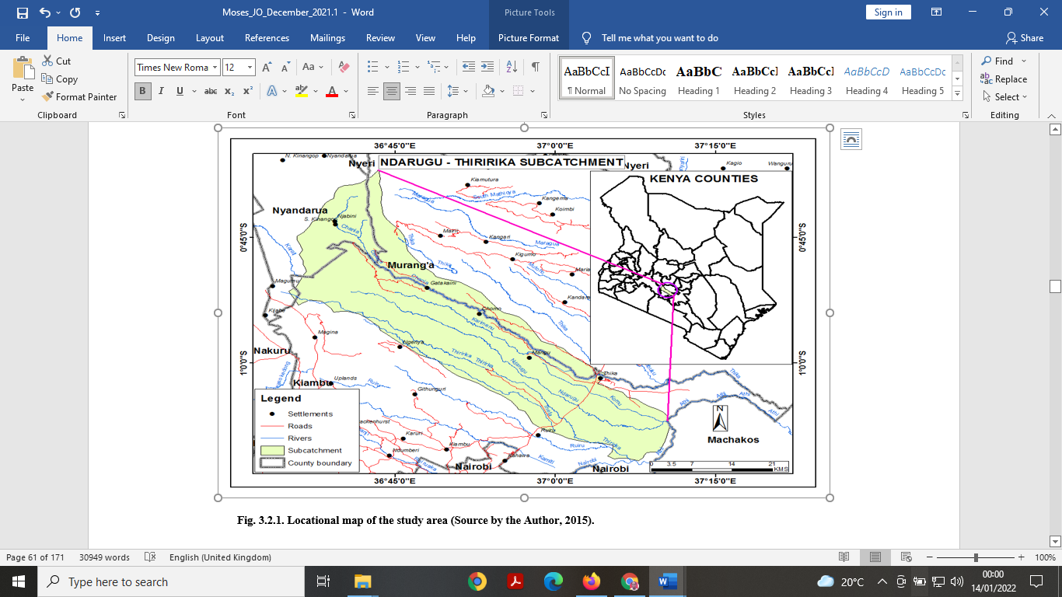

Fig. 2.1. Locational map of the study area (Source by the Author, 2015).

**2.2 Physical characteristics of the Ndarugu – Thiririka sub-catchments**

The Ndarugu - Thiririka sub-catchments experience a highland climate with abundant rainfall and moderate temperatures that increase with altitude. The sub-catchments are situated between 1500 and 2000 meters above sea level.

Climate change has caused the rainy seasons to occur outside their usual timeframe, leading to shifts and fluctuations in the rainfall patterns (Wambugu, 2017). In forested areas, the annual minimum average, and maximum temperatures are 7.5°C, 12.9°C and 18°C respectively.

According to Mungai (2015), soil fertility ranges from high to low, with the mountain soils consisting of olivine basalts and old volcanic ash. These soils are acidic, shallow, and leach quickly. They are categorized as Humic Andosols, which are moderate to highly fertile in the lower elevations and are dark, red, well-drained nitisols with over 30% clay content and blocky structure.

**3.1 The structure of the SWAT model**

The Soil & Water Assessment Tool (SWAT) is a small-scale model for simulating the quantity and quality of surface and groundwater and the environmental effects of land use, land management practices, and climate change. The model is employed to simulate anything from a river basin to a watershed. Besides, the model frequently evaluates soil erosion prevention and control, non-point source pollution control, and water (Maforikan *et al*., 2023). resources management in watersheds

The SWAT model forecasts the effects of land management decisions on sediment levels, agricultural chemical usage, and both the quality and quantity of water, employing quasi-physical principles (Ullrich and Volk, 2009). Usually, the simulations' output is analyzed and generated using the ArcSWAT interface of the SWAT model. The ArcSWAT is licensed to run on the ArcGIS platform and is available to the general public.

Besides, the SWAT model analyzes data and simulates surface runoff, canopy storage, and drainage systems, water allocation, soil profiles, consumptive use, return flow, and recharge from surface water bodies, ponds, and tributary channels. Because the model is computationally efficient and physically based, the SWAT model may be used to examine long-term effects on land and soil management (Olivera and Srinivasan, 2004). According to Tanguy *et al*. (2022), the SWAT model divides catchments or basins into small sub-catchments and tiny spatial units called Hydrological Response Units (HRUs).

The HRUs are defined by specific characteristics related to soils, slopes, and land use within a subbasin (Poblete *et al.,* 2020). The SWAT model's primary driving force is water balance, which influences the flow of nutrients, pathogens, pesticides, sediments, and plant growth (Al-Kubaisi and Al-Kubaisi, 2023).

The model simulates essential hydrological components such as surface runoff, percolation, evapotranspiration, flow through shallow and deep aquifers, infiltration, and channel routing (Srinivasan *et al.,* 1998).

**3.2 The elements of the sub-basins in SWAT model**

As described below, these important elements of the sub-basin included soil hydrology, surface runoff, and evapotranspiration:

**3.2.1 Soil hydrology**

The SWAT model simulates the hydrologic cycle based on the water balance equation. According to Neitsch *et al.* (2011), the model’s description of the hydrological process is based on the following derived equation of the water balance:

$$S_{t}={SW}_{o}+\sum_{i=1}^{t}{R_{day}-Q_{surface}}-E_{a}-W_{seep}Q_{gw})_{i…………………………………………………….…………….} 1$$

**Where:**

${SW}_{t} is the final water content of the soil (mm)$, ${SW}_{O} is the final water content of the soil (mm)$

$$t is the period of time in days, R_{day} is the amount of precipitation in a day, i ( mm)$$

$$Q_{surf} is the amount of surface runoff in a day (mm water)$$

$$E_{a }is the amount of evapotranspiration in a day (mm)$$

$$W_{seep} is the amount of water entering the vadoze zone from the soil in a day (mm)$$

$$Q_{gw} is the amount of return flow in a day, i (mm)$$

**3.2.2 Surface runoff in SWAT model**

The SWAT model divides precipitation into infiltration, which reaches a stream through flow channels, and overland runoff using the Curve Number (CN) approach (Neitsch *et al.*, 2011). The surface runoff volumes for each Hydrologic Response Unit is computed using the SCS – CN (curve number) approach. The following is the CN equation for estimating the total depth of runoff (Q) in mm of a watershed:

$$Q=\frac{{\left(P-0.25\right)}^{2}}{\left(P+0.8S\right)}…………………………………………………………………………….2$$

$$Where Q=0, if P<0.2S$$

$$S is given by:$$

$S=\frac{1000}{CN}-10…………………………………………..………………………………………..3$

***Where:***

$$Q=is the volume of the runoff in mm$$

$$P=Rainfall or the precipitation (mm)$$

The values of CN increase with an increased runoff potential, and ranges between 30 to 100. The coefficient of variation (CN) is empirically estimated using the soil categories, surface characteristics such as vegetation cover, impervious surface, and antecedent soil moisture conditions, The SCS curve number serves as a tool for determining soil permeability, land use, and antecedent soil water conditions.

According to Sharma *et al.,* (2020), the three antecedent moisture conditions defined by the SCS curve number are 1- dry (wilting point), 2 - average moisture, and 3 - wet (field capacity). Curve no.1 curve number is the lowest value that the daily curve number can have. The curve numbers for moisture conditions 2 and 3 are computed from equations 4 and 5.

${CN}_{1}= \frac{20 (100-CN)}{(100-{CN}_{2}+\exp\left(2.533-0.0636\right).(100-{CN}_{2})}……………………..…………4$

${CN}_{3}={CN}_{2}. exp⁡[(0.00673.(100- {CN}_{2})]…………..…………………....…,,,,,,,,,……………5$

In the SWAT model, the moisture condition 1 curve number is CN 1, the moisture condition 2 curve number is CN 2, and the moisture condition 3 curve number is CN 4. In tables, typical curve numbers for moisture condition 2 are presented, which are adequate for slopes less than 5%. The slopes of the Ndarugu – Thiririka sub-catchment, on the other hand, were greater than 5% and as such equation 6 is important for the altering the curve number for higher slopes.

$${CN}_{2s}= \frac{\left({CN}_{3}- {CN}_{2}\right)}{3}[1-2.\exp\left(-13.86.slp\right]+{CN}_{2}………………..….………………..6$$

**3.2.3 Evapotranspiration**

The Penman-Monteith equation approximates net evapotranspiration (ET) from meteorological data as a replacement for direct measurement of evapotranspiration.

The equation is widely used, and was derived by the United Nations Food and Agriculture Organization for modeling reference evapotranspiration ET0. to estimate evapotranspiration. The equation is given as follows:

$$ET=\frac{∆\left(R_{n}-G\right)+ρ_{a}c_{p}g_{aδ_{e}}}{∆L_{V}γ(1+\frac{g_{a}}{g_{s}})}…………..………………….……………….7$$

**Where:**

$R_{n}is the net irradiance \left({Wm}^{-1}\right)$, $ρa is the density of dry air ({Kg}^{-3})$

$$c_{p} is the specific heat capacity \left({JKg}^{-1}K^{-1}\right), g_{a} is the conductivity of the air \left({ms}^{-1}\right),$$

$$g_{s} is the conductivity of the plant stoma\left({ms}^{-1}\right), δ_{e }is the specific humidity \left(Pa\right),$$

$$L_{v} is the volumetric heat of vaporization (2453 {MJm}^{-3} for the water)$$

$$γ is the pschometric constant (-66{Pa}^{-1})$$

$$∆ is the rate of change of saturation of specific humidity with air temperature ({PaK}^{-1})$$

The following equation gives the evaporative demand when the soil layer's depth below the surface Zs is taken into account:

$$ETj=ETx\frac{{Zs,}_{j}}{{Zs,}_{j}+e^{2374-0.00713Zs,j}}…………………….……………………………8$$

Since the evaporative demand at the lower and higher soil layer boundaries differs, the actual evapotranspiration is calculated as follows:

$${ET}_{act,j}= {ET}_{J,1}-{ET}_{J,u}.esco……………………………………………………….9$$

$${ET}_{J,1}and{ET}_{J,u} are the evaporative demand at the lower and upper soil boundaries,$$

$$repesctively and esco is the unit less soil evaporative compensation coefficient,$$

$$which range between 0 to 1.$$

**3.3. The Spatial Input data for the analysis**

The SWAT model was employed to assess hydrologic characteristics and compute the water balance of the Ndarugu - Thiririka sub-catchments. The SWAT model required spatially distributed data such as the DEM (Digital Elevation Model), soil data, land use and land cover map, and weather data (precipitation, solar radiation, relative humidity, wind speed).

**3.3.1 Digital Elevation Model**

The Digital Elevetion Model (DEM) data was generated from the topographical maps obtained from the Survey of Kenya (SOK). The scale of these maps, sheet nos. 148/2 and 149/2, of formerly the Kiambu and Thika districts, was 1:50,000. Using the Ground Control Points (GCP) of the study area, the topographic maps were georeferenced using the ArcGIS 10.4.2 platform after being mosaicked using the ERDAS Image 9.1 image processing program.

**3.3.2 LULC (Land Use and Land Cover) data**

According to Astite *et al*. (2023), land use and land change (LULC) is essential in a watershed since they influence the hydrological characteristics of watersheds or catchments. The LULC influence ground flows, groundwater storage, and water demand.

In this study, the map for the LULC was derived from LANDSAT ETM + imageries of 30 m resolution obtained from the US Geological Survey's path 168 and row 6 acquired on January 29, 2018. Satellite imageries were processed using the maximum likelihood of the supervised classification approach in ArcGIS version 10.4.2. The formed classes were transformed into **Traverse WGS UTM_ Zone_ 37°S**for further analysis in the model.

**3.3.3 Soil data**

The SWAT procedure relied heavily on the physical and chemical properties of the soil. The essential parameters for each horizon included texture, hydrologic soil group, bulk density, soil texture, soil depth, organic carbon, accessible water content, hydraulic conductivity, and fractions of sand, silt, and clay. The data was obtained from Kenya's FAO Digital Soil Map (Nachtergaele, 2002) and then projected to the Traverse WGS 1984 UTM _Zone_ 37°S coordinate system using the SWAT data editor module.

**3.3.4 Weather data**

The weather data for the study spanned eight years, from 2006 to 2013 and was obtained from the Global Meteorological Services and the Kenya Meteorological Department's Thika and Nairobi offices. The data included precipitation (mm), temperature (°C), solar radiation (MJm-2s-2), wind speed (ms-1), and humidity (%) were for the model. After the analysis, the weather data then was converted to a text file for use in the SWAT model for ease of analysis.

**3.3.5 Streamflow data**

The streamflow data needed for the calibration, and validation of the SWAT model was obtained from the Water Resources Management Authority (WRMA), Kiambu offices in Kenya. The data had been recorded at the Ndarugu Gauging station namely **3 CB 5**.

**3.4 Research Methodology**

The SWAT model was used to assess the impact of sub-basin discretization on the Ndarugu – Thiririka sub-catchment, with SUFI-2 algorithm for calibration, validation, and sensitivity analysis. According to Liu and Yao (2017), the performance of the SWAT model was evaluated using the Percent Bias (PBIAS), Nash Sutcliffe Efficiency (ENS) and the Coefficient of Determination (R2).

The DEM data from the topographical maps obtained from the Survey of Kenya (SOK). These maps, whose sheet nos. were 148/2 and 149/2, respectively, were of the Kiambu and Thika districts at the scale of 1:50,000. They were mosaicked using the ERDAS Image 9.1 image processing program and then georeferenced using the ArcGIS 10.4.2 platform through the Ground Control Points (GCP) of the Ndarugu - Thiririka sub-catchments.

The ArcGIS 10.4.2 was used to digitize contours (polylines of equal elevation at 25-meter intervals). The overshoot and undershoot errors were fixed on the map. Using ArcGIS 10.4.2, the corrected map was converted to a Triangulated Irregular Network (TIN) and subsequently to a Digital Elevation Model.

**3.4.1 Setting up of the SWAT model**

It is essential to predict SWAT parameters and understand the water cycle to manage water resources in a particular area. The study employed the SWAT method to assess the hydrological characteristics and water balance within the Ndarugu - Thiririka sub-catchments. The analysis is summarized as follows: data preparation, discretization of the subbasins, description of the HRU, simulation, and running of the SWAT model.

The final phase of the analysis included calibration, validation, and sensitivity analysis. The SWAT model was used to analyze data for the Ndarugu – Thiririka sub-catchments, dividing the watershed into sub-catchments based on the slope direction of the Digital Elevation Model and description of the outlet locations.

The model generated Hydrologic Response Units (HRUs) with unique land use and soil combinations after adding the soil maps and the land use and land cover use maps to the model. The analysis involved reclassifying LULC category and soil types using lookup tables to ensure their compatibility with the SWAT model.

A "User Soil" database table for the Ndarugu – Thiririka sub-catchments was developed to reclassify the soil data. Besides, the SOTER WISE soil data were reclassified to SWAT coded data using lookup table for further analysis. The weather data of the daily precipitation and temperature were modified into text format for the analysis in SWAT model and added in to project database.

The additional weather data such as humidity, solar radiation, and wind velocity, which were crucial for hydrologic processes such as evapotranspiration, lateral flow, base flow, and surface runoff were added to the project database of the SWAT model. The model was run to calculate hydrologic characteristics and water balance for the Ndarugu – Thiririka sub-catchments after preparing necessary datasets for simulation.

**3.5 Performance Evaluation of the SWAT model**

The modelling of watershed hydrology inherently errors due to uncertainties related to the model's structure, parametric parameters, and measurements (Gupta and Govindaraju, 2019). Structural uncertainty is the most challenging to define among these uncertainties because it arises from the simplified representation of reality in the models (Wu *et al.,* 2024).

Consequently, the parameters of the SWAT model need adjustment by comparing the simulated and observed streamflow values. The SWAT model was calibrated using the streamflow data record between 2006 and 2013 and validated using data from 2011 to 2013, including a warm-up phase from 2007 to 2008. A total number of 16 parameters related to water balance were used. The data was analyzed using the SUFI-2 algorith in the SWAT – CUP version of 5.1.6. The SUFI - 2 algorithm.

The algorithm evaluates uncertainty in a wide range of models, from simple to complex. In the study, five hundred iterations were run to obtain reasonable results. The parameters for the SWAT model are adjusted to the simulated streamflow values to compare with observed streamflow values.

The uncertainties in the conceptual model, input data, actual data, and other factors that characterize watershed models were corrected through the P-factor and R-factor. Theoretically, the P factor's value ranges between 0% and 100%, and the R factor's value ranges between 0 and infinity. The sensitivity analyses and the objective function are evaluated using Latin hypercube sampling. The 95% prediction uncertainty (95PPU) is obtained by calculating the uncertainties at the 2.5% and 97.5% levels of the cumulative distribution of all outcome variables. Additionally, the study employed the Nash-Sutcliff Efficiency (ENS) and the Coefficient of Determination (R2), and the equations are stated below

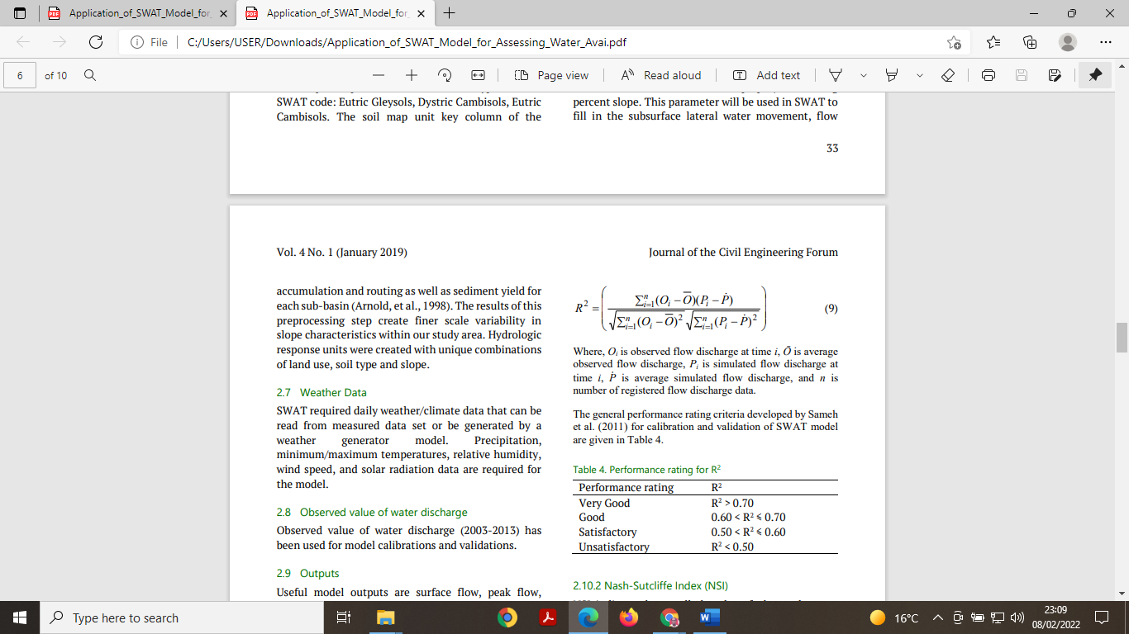

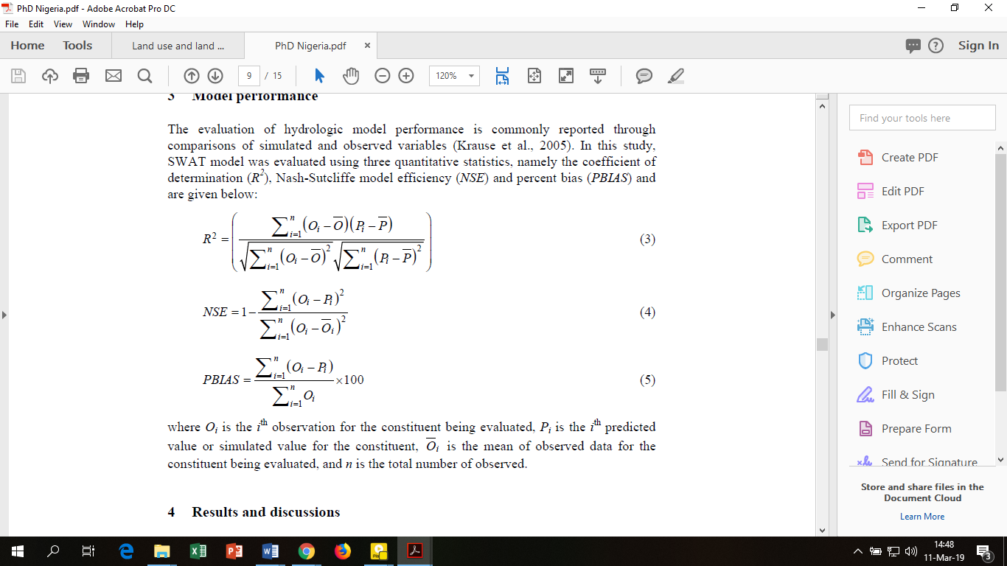



Where:

$$R^{2} = is the Coefficient of Determination$$

$$PBIAS=is the coefficient of percent bias between observed data and the best simulation$$

$$NSE is a normalised dimentionless statistic that implement the comparative size of$$

$$the distinct compared to the measured variance$$

$P_{I} is the simulated flow discharge at time i$

$P is the average simulated flow discharge$

$n is the number of registered flow discharge data$

$$O_{i}=is the observed flow discharge at time i$$

$$\overline{O}=is the average observed flow discharge$$

**4. Results from the watershed delineatio**

The discretization of the sub-catchment was limited to 1360.241 km2 and the results were 116 HRUs and 18 sub-basins. During the 13-year calibration period (2006–2013), the first two years (2006 – 2008) were used as warm-up period for the SWAT model. The results included the hydrolical characteristics of the sub-catchment, water balance, calibrate and validate the SWAT model. Following analysis, results were shown as tables, percentages, and graphs. The results are described below.

**4.2 Hydrologic characteristics of the Ndarugu – Thiririka sub-catchment**

The SWAT model generated eighteen sub-basins and one hundred and sixteen Hydrologic Response Units (HRUs). It modified the sub-catchment's hydrological components, slope, land use, and soil in the analysis. In the sub-catchments, loam predominated (60.39%), followed by sandy loam (5.88%), clay loam (19.18%) and clay (14.4%). The land use and land cover types were dense forest (22.15%), dense agriculture (46.26%), sparse agriculture (0.43%), plantations (39.43%), and built-up area (39.43%) in Table 1.

**Table 1. Simulation results**

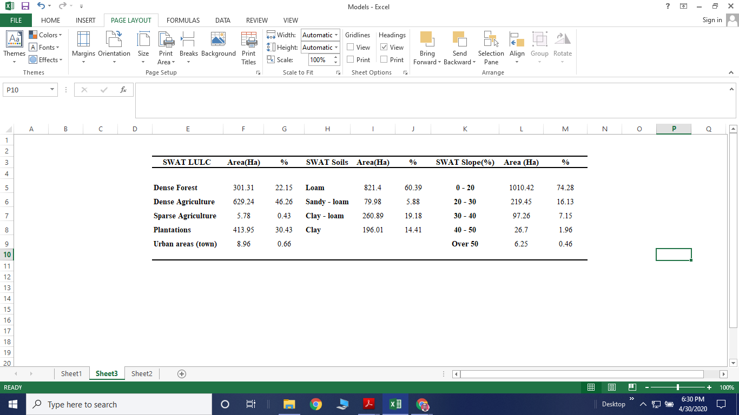

**4.3** **Water balance results for sub-catchments**

The research found that the sub-catchment area's topography between 1425 to 2650 mm above sea level. The The high altitude in the area suggested that the sub-catchment area had potential of runoff. In the analysis, the SWAT model generated nine parameters of the water balance, as shown in Table 2. Even so, in determining the water balance, only was only four parameters that were needed namely the lateral (LAT Q), groundwater (GW Q), evapotranspiration (ET) and surface runoff (SUR Q). The entire water balance was over 75% of evapotranspiration rates, or 571.06 mm, according to the research findings (Table 2).

11% of the overall water balance, or 82.46 mm, was generated annually by the SWAT model. Following model validation, the model produced a 1.5% lateral flow of the water balance. The months of May and June saw the largest flows, while February and October saw the lowest amounts. The modified LULC in the research area resulted in a significant increase in evapotranspiration.

**Table 2. The components of the water balance**

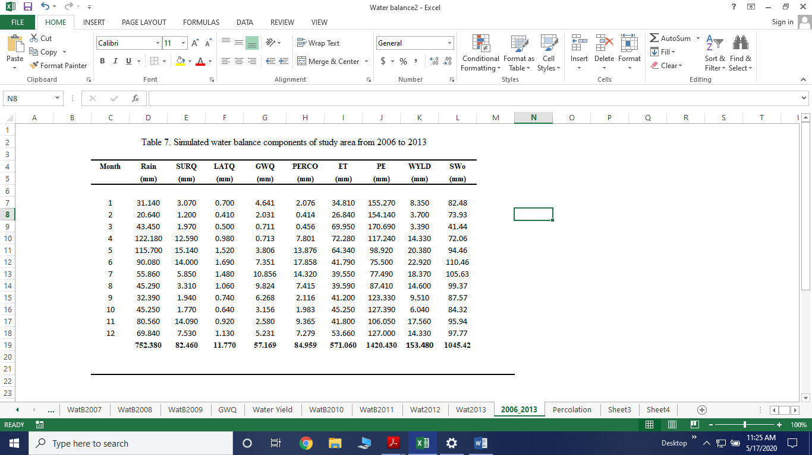

**4.4 The Performance of the SWAT model**

Prior to the hydrological water balance, the SWAT moel was calibrated and validated to ensure accurate findings from the analysis. The model was calibrated for eight years (2006-2013) and validated for three years (2011-2013). Statistical indices, inclusive of Nash-Sutcliffe (ENS), Coefficient of Determination (R2), r-factor and p-factor, as well as Percentage Bias (PBIAS) (Table 4), supplied the information crucial overall performance for the SWAT model.

Statistical analysis of the calibration procedure showed a strong NSE of 0.96 and an R2 of 0.96 (Table 4). The validation results of NSE were 0.98 while R2 was 0.92. After the analysis, the graphical values of NSE and R2 suggested that the SWAT model had a significant analytical capacity (Moriasi *et al.,* 2007). Given the uncertainty, the *p – factor* was almost ONE, this indicated that the *r –factor* was near-ZERO factor indicates a perfect model simulation and correlates with the measured data (Abbaspour *et al.,* 2015).

**Table 4. The Performance of the SWAT model**

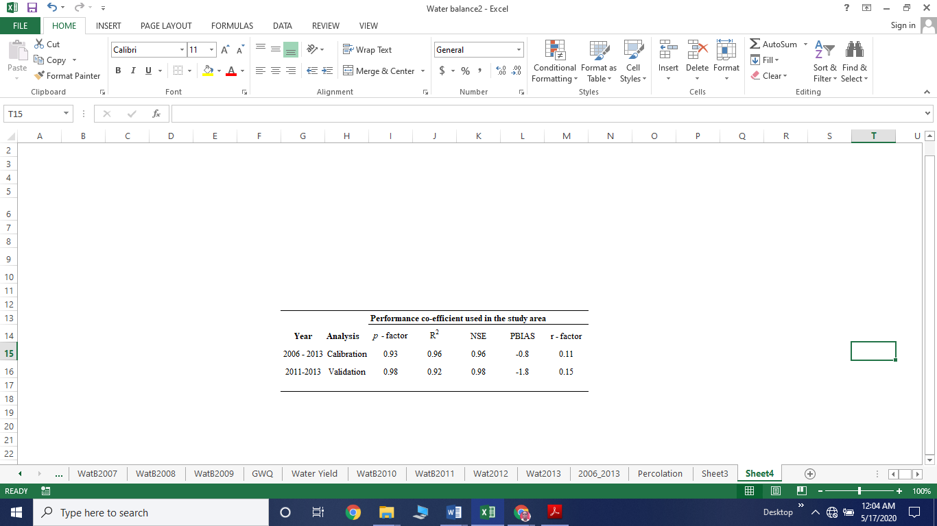

## When comparing results simulated and observed flows for the model, SWAT model was sufficient for the analysis of the water balance in the area.

**5 Conclusion**

The SWAT model has predictive ability for the Ndarugu - Thiririka sub-catchments, as evidenced by high values of the Coefficient of Determination (R2) and the Nash-Sutcliffe Efficiency (ENS) during the calibration and validation periods for the monthly flows. The calibration and validation R2 values were 0.96 and 0.92 for the calibration, and 0.96 and 0.98 for the validation of the ENS.

The SWAT model effectively estimated water balance components and hydrological characterization of Ndarugu - Thiririka sub-catchments, aiding policymakers in managing water resources and planning challenges. However, more studies are needed to incorporate models like the Water Evaluation And Planning system (WEAP) to understand the dynamics of the administration of water resources in the sub-catchments.

**References**

Abbaspour, K., Rouholahnejad, E., Vaghefi, S., Srinivasan, R., Yang, H., and Kløve, B. (2015). A continental-scale hydrology and water quality model for Europe: Calibration and uncertainty of a high-resolution large-scale SWAT model. Journal of Hydrology, 524, 733-752.

Al-Kubaisi, M. H., and Al-Kubaisi, Q. Y. (2023). undefined. Iraqi Journal of Science, 1254-1267.

Astite, S. W., Kermani, S., and Djediat, Y. (2023). The influence of the land use land cover (LULC) changes on hydrological response in urbanized watersheds. Case study of wadi Koriche and wadi Kniss watersheds, northern Algeria. Arabian Journal of Geosciences, 16(4).

Bhatt, V., and Tiwari, A. (2019). SWAT model and its application. Watershed Hydrology, Management and Modeling, 142-151.

Bizhanimanzar, M., Leconte, R., and Nuth, M. (2020). Catchment-scale integrated surface water-groundwater hydrologic modelling using conceptual and physically based models: A model comparison study. Water, 12(2), 363.

Escobar, M., Huber-Lee, A., Sieber, J., Young, C., Doreen, S., and Brian, J. (2023). WEAP (Water evaluation and planning system): A tool for sustainable water analysis.

Gupta, A., and Govindaraju, R. (2019). Propagation of structural uncertainty in watershed hydrologic models. Journal of Hydrology, 575, 66-81.

Lin, F., Chen, X., and Yao, H. (2017). Evaluating the use of Nash-Sutcliffe efficiency coefficient in goodness-of-Fit measures for daily runoff simulation with SWAT. *Journal of Hydrologic Engineering*, *22*(11).

Maforikan, E. S., Hammani, A., Ahouansou, M. D., and Anthony-Krueger, C. (2023). Estimating water balance at Beterou watershed, Benin using soil and water assessment tool (SWAT) model.

Mungai, A. (2017). A framework for investigating the potential to explore new markets in smallholder farmers in Kenya’s Kiambu west district.

Nachtergaele, F. O. (2002). The future of the FAO legend and the FAO/UNESCO soil map of the world*. Soil Classification, 147-156.*

Neitsch, S., L., Arnold, J., R. Kiniry, and Williams, J., R. (2011). User Manual of Soil and Water Assessment tool, theoretical documentation Version 2009. *Grassland, Soil and Water Research Laboratory, Blackland Research Centre, Texas, AgriLife 145 Research*.

Okello, C., Antonellini, M., Greggio, N., and Wambiji, N. (2014). Freshwater resource characterization and vulnerability to climate change of the Shela aquifer in Lamu, Kenya. Environmental Earth Sciences, 73(7), 3801-3817.

Olivera, F., Valenzuela, M., and Srinivasan, R. (2004). ArcGIS-SWAT: A GIS interface for the soil and water assessment tool (SWAT). Critical Transitions in Water and Environmental Resources Management,

Poblete, D., Arévalo, J., Nicolis, O., and Figueroa, F. (2020). Optimization of the hydrologic response units (HRU) using gridded meteorological data and spatially varying parameters.

Ruey Luo, E. C. (2017). Water supply-demand: Quantity, quality and price of the water conjunctive use. International Journal of Hydrology, 1(7).

Sarkar, A. (2022). Access to affordable, safe water supply in urban Kenya: A macro analysis. Water Insecurity and Water Governance in Urban Kenya, 63-89.

Sharma, I., Mishra, S., and Pandey, A. (2020). Estimation of antecedent soil moisture using soil conservation service curve number (SCS-CN) method utilizing the experimental data of a small Indian watershed.

Srinivasan, R., Ramanarayanan, T. S., Arnold, J. G., and Bednarz, S. T. (1998). Large area hydrologic modeling and assessment part II: Model APPLICATION. JAWRA Journal of the American Water Resources Association, 34(1), 91-101.

Strauch, M., and Volk, M. (2013). SWAT plant growth modification for improved modeling of perennial vegetation in the tropics. Ecological Modelling, 269, 98-112.

Tanguy, G., Sichoix, L., and Bouvier, C. (2022). Adapting an event-based, distributed and conceptual model to the hydrological response of small catchments in the island of Tahiti.

Ullrich, A., and Volk, M. (2009). Application of the soil and water assessment tool (SWAT) to predict the impact of alternative management practices on water quality and quantity. Agricultural Water Management, 96(8), 1207-1217.

Wambugu, M., Nyandega, I., and Kıthiia, S. (2017). Spatio-temporal dynamics of land use practices on rivers in tropical regions: A case study of Ruiru and Ndarugu basins, Kiambu County, Kenya. African Journal of Environmental Science and Technology, 11(8), 426-437.

Wang, Y., Zhang, W., and Liu, X. (2010). Hydrological watersheds model researching based on digital elevation model. 2010 18th International Conference on Geoinformatics. Wang, Y., Zhang, W., & Liu, X. (2010). Hydrological watersheds model researching based on digital elevation model. 2010 18th International Conference on Geoinformatics.

Wu, S., Yang, Y., and Zhao, J. (2024). Effects of conceptual model structure uncertainties on actual evapotranspiration simulation.