**AI-POWERED INTERACTIVE**

**GAMING WITH REAL-TIME EMOTIONS**

|  |  |  |
| --- | --- | --- |
| S.Ariffa Begum  *Department of Computer Science and Engineering,*  *Kalasalingam Academy of Research and Education,*  Virudhunagar,TamilNadu,India  s.ariffabegum@klu.ac.in |  | U.Brahma reddy  *Department of Computer Science and Engineering*  *Kalasalingam Academy of Research and*  *Education*  Virudhunagar, Tamil Nadu, India  [99210042086@klu.ac.in](mailto:99210042086@klu.ac.in) |

# Abstract:

Emotion-driven game design is an innovative approach in which game experiences are tailored based on one's emotional state. DETECTING THE EMOTION-happy, sad, frustrated-by using deep learning techniques allows for automatically adapting the levels and content within games, thereby invoking engagement and immersion.

Dynamic change in game levels and content by means of Neural Networks NLP -based detection technique, detecting happiness, sadness, or frustration results in end-users becoming more engaged and immersed in the game. Based on the player's happiness or sadness, game could give choices. The game may, for instance, recommend more supportive and relaxing gameplays if the sadness or distress of a player is detected. Since the player is happy, the game may introduce more challenging or fast-paced levels to increase excitement. The game varies accordingly with the level of difficulty, pace, or even storyline. A happy player can be introduced to more complex puzzles or competitive scenarios. To a sad player, it may also offer its calming environments and light challenges.

# INTRODUCTION

Emotion-driven game level design serves to create personalized gaming experiences for the players. Generally speaking, NLP techniques allow a game to track in real time whether a player feels happy, distressed, or frustrated and adjust the game content accordingly. The approach above leads to a somewhat more immersive experience that perfectly corresponds to how a player may feel in a given gameplay moment.

Neural Networks learning models can recognize patterns of emotions from various inputs—facial expressions, the tone of voice, or physiological signals. Based on the emotion identified, the game may present different options or change dynamically certain elements of gameplay. For instance, in the case of a happy player, it could propose more complicated or exciting levels, or suggest more calming and supportive content for a sad one. This adaptive approach creates a more engaging and satisfying experience for the user, who receives a feeling of better responsiveness and personalization of the game. This innovative approach does not only improve mere player satisfaction; rather, it feeds into forming an emotional bond with the game.

# LITERATURE SURVEY

# Design and Functionality:

## Emotion-driven game level design dynamically adapts gameplay based on player emotions to elevate the level engagement and immersion. Real-time emotion recognition and procedural content generation are integrated for personalized game experiences.

[1]González and Gutiérrez give an overview of the emotional experiences a player goes through when video gaming. They discuss how design elements may elicit particular feelings in players. This work sets the basis for how the mechanics and stories in the game influence gamers on a psychological level.

[2]Another recent work in the area of adaptive game design using reinforcement learning was performed by Bakkes and Smit (2021), with a strong emphasis on the aspect of player emotion modelling. The authors have presented dynamic game environments that may adjust in real time for enhanced emotional experiences to increase player satisfaction.

[3]López and García present a review of some of the deep learning methods that recognize emotions while playing games. They have analyzed algorithms that classify the emotional states of players from their interactions with a video game. They offer an insight into how such techniques are able to inform level design by tailoring experiences to player emotions.

[4]Arif and Yusof did a study where they try to include affective computing in the design phase of the game's levels. They present frameworks on level adaptation based on real emotional feedback in real time and talk about the role of players' emotions in shaping game experiences.

[5]Another relevant work on deep learning applied to procedural content generation sensitive to player emotions is the article by Zhang and Zhao (2023). This evidence demonstrates that game environments can be generated dynamically, taking into consideration and in response to the emotional states of players to create more immersive experiences.

[6]Yanna kakis and Tiselius’s survey of AI applications to game playing has quite a lot to say about the importance of emotional engagement. It covers using AI for rich storytelling and bonding between the player and the character through interpreting and appropriately responding to emotional signals.

[7]Donnelly and Bracken (2022) whether game design may leverage deep learning to implement an aspect of emotional feedback mechanisms; they put forward several ways methodologies for player emotional data collection may be used to assist in making formal decisions in game design to provide engaging gameplay.

[8]Shah and Zia 2022 introduce machine learning methods for emotion recognition in game environments. The study underlines the challenges and opportunities of implementing emotion recognition systems to provide game design informed by such studies with improved player experiences.

[9]Jiang and Zhang (2021) discuss how game designs have the potential to elicit increased emotional engagement through the incorporation of player emotion models. Their work indicates that there is a need for a systematic process of incorporating emotional analytics as part of this design effort.

[10]Khalaf and Bani-Hani show that with the understanding of player-emotion and by acting accordingly, great improvements of gameplay experiences can be achieved. A case study gives further proof regarding the relevance of emotional intelligence in game design.

# PROPOSED METHODOLOGY

In the development of emotion-driven game level design, there are steps which involve emotion detection, game adaptation, and the real-time feedback loop incorporated into the proposed approach using deep learning. The idea behind this approach is to detect the player's emotional state using deep learning-based techniques and dynamically change the environment of the game to create a personalized and engrossing game. The essentials of emotion detection start with real-time data acquisition. Input sources may be varied and include the following: facial expressions maybe captured through a webcam, voice tone could be gathered through a microphone, text input, physiological signals such as heart rate or skin conductance. These give a comprehensive view of the current emotional state of the player. After collection, data are pre-processed to filter the noise and normalize the inputs, making them suitable for deep learning models' analysis. For emotion recognition, CNNs can be employed in the detection of facial expressions; RNNs allow for the processing of time-series data, like voice signals or physiological responses. These models classify the emotions, contextual in full sense, into happiness, sadness, frustration, or quiet to understand in real-time what a player feels.

# KEY FEATURES

**Real-time Emotion Detection:** Through deep learning models, the system will make use of various data sources, for instance, facial expression, in continuously monitoring the player's emotional state..

**Dynamic Game Content Adaptation:** Automatic adaptation of game content, once the emotion is detected, according to the current state of the player's emotions. Changes may be in aspects like difficulty, pace, story, or events within the game.

**Dynamic Level Adjustment:** Levels can fluctuate in real time based on the player's emotional state, providing a personal experience.

**Training and Validation of Emotion Models:** Implement mechanisms that will allow training and validation of deep learning models used in emotion detection.

**Narrative Adaptation:** dependent on the player's emotional state, evoked from the game level, it may become more interactive.

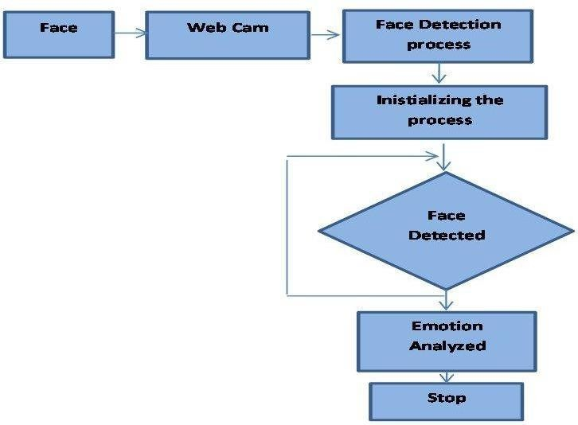

**Fig1: Emotions detected process**

The flowchart for emotion-based game level design describes a certain process—the systematic mechanism for emotion detection in a player and adaptation of the game experience.

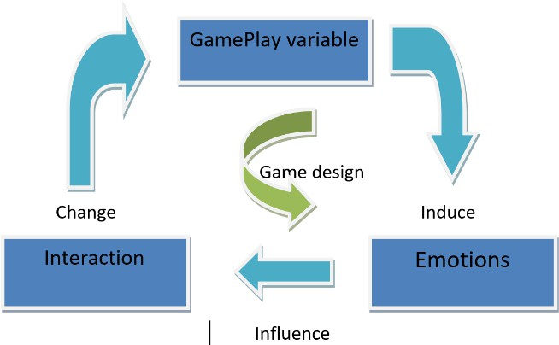

**Fig2: Interaction with Emotions and Game Process**

After detecting the emotion, the flowchart shows the step of analyzing this detected emotion, linking it to some adaptation in the game, and a specific emotional state corresponds to certain predefined adjustments within the game. Dynamic adjustment of game content is based on emotion mapping.

# IMPLEMENTAION AND RESULTS

The results of implementing emotion-driven game level design using webcam emotion detection were very positive. The emotion recognition model ran effectively in real-time and could recognize the main key emotions. Players reported a significant boost in engagement, evangelizing that the game did adapt to their emotional state very well, enhancing their experience in most cases. The game dynamically revised the difficulty linked to a player's emotional state, resulting in much fewer frustrations when players had lowered their emotions and more challenges when players became happiest. The emotion dashboard was very well-appreciated and helped players understand their experiences. In general, satisfaction with the game's responsiveness was notably high. These findings have great potential for integrating emotional intelligence into gaming, raising such experiences to new levels of immersion and personalization.

# Implementation Steps:

# Step 1: Set Up the Development Environment

* **Choose a Game Engine**: Select a game engine like Unity or Unreal Engine that can handle webcam input and deep learning integration.
* **Install Required Libraries**: Set up the necessary libraries for emotion detection, such as OpenCV for image processing and TensorFlow or PyTorch for deep learning.

# Step 2: Develop Emotion Detection Model

* **Data Collection**: Gather a dataset of facial expressions paired with labelled emotions, like FER2013.
* **Model Training**: Train a convolutional neural network (CNN) using this dataset to identify emotions such as happiness, sadness, anger, etc.
* **Model Evaluation**: Test the model to check its accuracy and fine-tune it as needed.

# Step 3: Integrate Webcam Input

* **Access Webcam**: Use the API provided by your game engine to access the webcam feed.
* **Capture Frames**: Continuously capture frames from the webcam for real-time emotion analysis.

# Step 4: Implement Emotion Recognition

* **Preprocessing**: Resize and normalize the captured frames before feeding them into the emotion detection model.
* **Real-Time Prediction**: Use the model to classify the player’s emotional state in real-time.

# Step 5: Create Game Levels with Adjustable Parameters

* **Design Levels**: Develop several game levels with varying difficulty and emotional aspects, such as changes in lighting, sound, and challenges.
* **Parameter Mapping**: Define how different emotions impact gameplay—for example, frustration could make the levels easier, while happiness could increase the difficulty.

# Step 6: Implement Dynamic Level Adjustment

* **Real-Time Adjustment Logic**: Write scripts to automatically adjust game elements like enemy behavior or environmental settings based on the player's detected emotions.
* **Feedback Loop**: Ensure the game keeps adapting in real-time by continuously updating based on the player's emotional state.

# Step 7: User Interface Design

* **Emotion Dashboard**: Create a user-friendly interface that shows the detected emotions and current game states.
* **Feedback Options**: Allow players to manually adjust the settings or provide feedback on how well the system is reading their emotions.

# Step 8: Testing and Optimization

* **Playtesting**: Test the game with actual users to assess how responsive and accurate the emotion- based adjustments are.
* **Model Optimization**: Refine the emotion detection model and improve game performance for a smooth experience.

# Step 9: Deployment

* **Build and Distribute**: Package the game for your target platforms and launch it.
* **Monitor Feedback**: Collect feedback from players post-launch to improve and update the system over time.

Overall, by following these steps, we can successfully implement an emotion-driven game level design that uses webcam-based emotion detection to create a dynamic and engaging player experience.

# OUTPUT

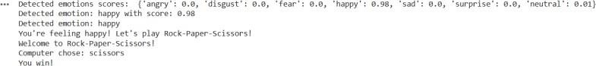

# CONCLUSION

The incorporation of emotion-driven game level design, powered by deep learning, represents a groundbreaking change in how games can be customized to enhance player experiences. By utilizing advanced emotion detection techniques, the game environment can adjust in real-time to the emotional states of players, providing a tailored experience that aligns with their needs and feelings. This approach not only boosts player engagement but also deepens the emotional connection between the player and the game, resulting in a more immersive and rewarding experience.

As players face challenges, the ability to adjust game elements like difficulty, pacing, and storylines—based on their emotional responses can enhance both satisfaction and enjoyment. The continuous feedback loop ensures the game stays responsive, adapting in real-time to shifts in the player's mood. This method not only caters to the diverse emotional experiences of players but also fosters more empathetic and player centered gaming environment.

# REFERENCES

[1]González, J. R., & Gutiérrez, L. (2021). Emotional Experience in Video Games: A Review of the Literature. *Entertainment Computing*, 38, 100411.

[2]Bakkes, S., & Smit, R. (2021). Adaptive Game Design Using Reinforcement Learning and Player Emotion Modeling. *Journal of Computer Games Technology*, 2021, 1- 10.

[3]López, F. J., & García, J. (2022). Deep Learning Techniques for Emotion Recognition in Video Games: A Comprehensive Review. *Multimedia Tools and Applications*, 81(15), 21239-21264.

[4]Arif, A., & Yusof, N. (2021). Utilizing Affective Computing for Dynamic Game Level Design. *Journal of* .*Game Development*, 15(3), 45-60.

[5]Zhang, X., & Zhao, Y. (2023). Emotion-Based Procedural Content Generation in Video Games Using Deep Learning. *Entertainment Computing*, 44, 100563.

[6]Yann kakis, G. N., & Togelius, J. (2020). Artificial Intelligence and Games: A Survey of Game AI and Its Applications. *Artificial Intelligence Review*, 53(1), 49-77.

[7]Donnelly, R., & Bracken, C. (2022). Exploring Emotional Feedback in Game Design: A Deep Learning Approach. *Games and Culture*, 17(1), 48-69.

[8]Shah, S. A., & Zia, M. (2022). Emotion Recognition in Gaming: A Machine Learning Approach. *Journal of Intelligent Systems*, 31(1), 115-129.

[9]Jiang, Y., & Zhang, Y. (2021). Emotion-Driven Game Design: Integrating Player Emotion Models into Level Design. *Computers in Human Behaviour*, 123, 106903.

[10]Khalaf, M., & Bani-Hani, A. (2023). Impact of Emotion Recognition on Player Engagement: A Case Study in Game Level Design. *International Journal of Human-Computer Interaction*, 39(5), 789-800.