**IoT-Enabled Smart Crib: A Technological Solution for Infant Comfort and Safety**

**Renju John**

**CEO Telecom 360**

**shuttle602@gmail.com**



**Abstract** The increasing need for automated infant care solutions has led to the development of IoT-based smart cribs, integrating real-time monitoring and automated soothing mechanisms. This paper presents an IoT-enabled smart crib designed to detect infant distress and respond with appropriate actions. The system incorporates multiple sensors to monitor sound, motion, temperature, and humidity, ensuring a comfortable and safe environment for the baby. The proposed solution utilizes cloud connectivity for remote access and control via a mobile application. This paper discusses the design, implementation, and testing of the smart crib, along with cost analysis and potential commercialization strategies.

**Keywords**

IoT (Internet of Things) ,Infant Monitoring , Smart Crib , Automation , Sensor Integration

Remote Monitoring , Parental Assistance

1. **Introduction**

Modern parenting challenges necessitate intelligent solutions that enhance infant care while reducing parental burden. Traditional cribs lack automation and remote monitoring capabilities, often requiring constant parental supervision. In contemporary households, where both parents may be working professionals, balancing child care with other responsibilities becomes increasingly difficult. Infant distress, particularly due to discomfort or environmental conditions, can go unnoticed without continuous monitoring, leading to potential health and safety concerns.

Advancements in IoT technology provide an opportunity to bridge this gap by integrating smart automation with infant care solutions. IoT-based smart cribs incorporate a combination of real-time monitoring, automated intervention, and cloud connectivity to ensure that infants remain comfortable and safe while reducing parental stress. These intelligent cribs can detect changes in an infant’s behavior, such as crying or movement, and respond autonomously by rocking the crib or alerting caregivers through a mobile application. Environmental factors like temperature and humidity can also be monitored to ensure optimal comfort conditions for the baby.

This study proposes an IoT-based smart crib system that seamlessly integrates hardware and software to offer a comprehensive infant care solution. The system utilizes microcontrollers, sensors, actuators, and cloud-based communication to enhance functionality. Through automation, real-time data analysis, and remote access capabilities, the proposed smart crib aims to revolutionize modern childcare practices by providing an innovative, efficient, and user-friendly solution for parents and caregivers.

**2. System Design and Components**

The smart crib comprises several essential components:

* **Cradle Frame**: Sturdy wooden or metal structure.
* **Microcontroller**: ESP8266/ESP32 for IoT connectivity.
* **Sensors**:
  + Motion Sensor (Accelerometer/Ultrasonic) – Detects baby movement.
  + Sound Sensor – Detects infant cries.
  + Temperature & Humidity Sensor (DHT11/DHT22) – Monitors environmental conditions.
* **Actuators**:
  + Servo/DC Motor – Controls rocking motion.
  + Wi-Fi Camera – Enables live video streaming.
* **Connectivity**:
  + Wi-Fi Module – Enables cloud communication.
  + Smart Plug – Facilitates remote power control.
* **Mobile Application**:
  + Monitors and controls crib functionalities remotely.

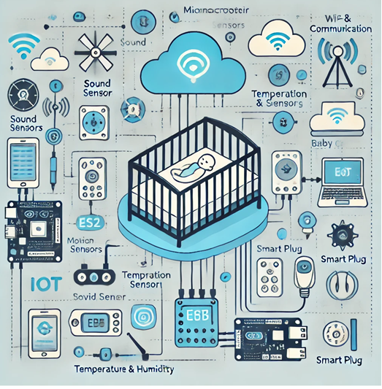

**Fig 1 System Design**

**3. Working Mechanism**

1. The sound sensor detects crying and triggers the rocking mechanism.
2. Motion sensors assess baby movement and adjust rocking intensity.
3. Environmental sensors monitor temperature and humidity, alerting caregivers if conditions exceed the preset range.
4. A Wi-Fi-enabled camera streams real-time video to a mobile application.
5. The smart plug allows caregivers to control power supply remotely.

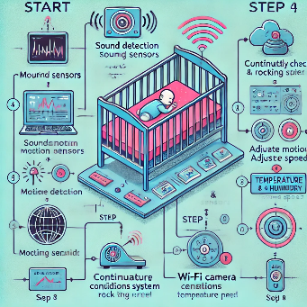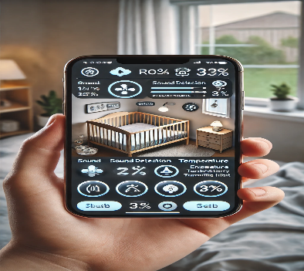

**Fig 2 Hardware Software Design**

The implementation consists of hardware setup, software development, and cloud integration.

**Hardware Setup**

Sensors are installed in strategic positions within the crib. The motor is integrated with the cradle frame for automated rocking. The Wi-Fi camera is positioned for optimal infant monitoring. The smart plug is connected for remote power management.

**Software Development**

* **Microcontroller Programming**:
  + ESP32/ESP8266 is programmed using MicroPython/Arduino IDE.
  + MQTT protocol is utilized for cloud communication.
  + PWM control ensures smooth motor operation.
* **Mobile Application and Cloud Services**:
  + Blynk/Node-RED is used for the IoT dashboard.
  + Firebase or AWS IoT Core enables real-time data storage and remote access.
* **Security Measures**:
  + Data encryption ensures secure cloud communication.
  + Camera feed encryption protects privacy.

**Testing and Optimization**

Sensor accuracy and response times were tested.The motor rocking speed was fine-tuned for optimal comfort. The system's real-time data transmission and alert functionality were validated.

**4. Circuit Design**

|  |  |
| --- | --- |
| **Component** | **Connection to ESP32/ESP8266** |
| Sound Sensor (KY-038) | D2 (GPIO4) |
| Motion Sensor (PIR) | D3 (GPIO5) |
| Temperature Sensor (DHT11/DHT22) | D4 (GPIO2) |
| Servo/DC Motor | PWM Pin (D5 - GPIO14) |
| Wi-Fi Camera | Independent Wi-Fi module |
| Smart Plug | Controlled via IoT app |

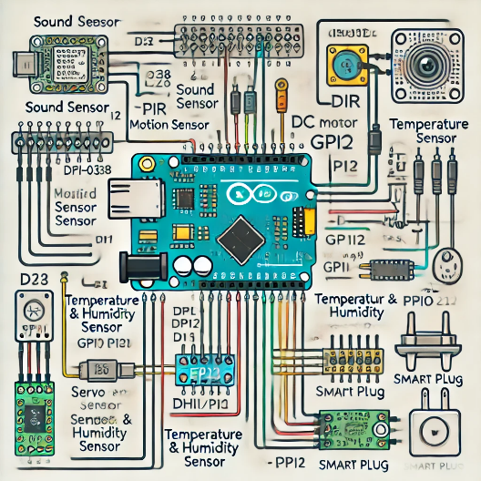

**Fig 3 Circuit Design**

**5. Cost Analysis**

|  |  |  |
| --- | --- | --- |
| Component | Model/Type | Estimated Cost (INR) |
| ESP32 Dev Board | ESP32-WROOM | 400 - 600 |
| Sound Sensor | KY-038 | 80 - 150 |
| PIR Motion Sensor | HC-SR501 | 100 - 200 |
| Temperature & Humidity Sensor | DHT11/DHT22 | 120 - 250 |
| Servo Motor | MG995/SG90 | 250 - 400 |
| Wi-Fi Camera | ESP32-CAM | 1,500 - 3,000 |
| Smart Plug | Wipro 10A Wi-Fi Smart Plug | 800 - 1,200 |
| Power Supply | 5V/3A Adapter | 250 - 400 |
| Miscellaneous | Wires, PCB, Enclosure | 500 - 800 |

Table 1 Cost Structure

* **Budget Version**: INR 4,000 - 5,000
* **Premium Version**: INR 7,000 - 8,500

**6. Future Enhancements and Market Strategy**

* **AI-Based Cry Detection**: Implementing TensorFlow Lite on ESP32 to enhance cry recognition accuracy.
* **Real-Time Notifications**: Sending alerts via Telegram or Pushbullet.
* **Smartphone App Enhancements**: Integration of additional user controls and analytics.
* **Battery Backup**: Ensuring uninterrupted functionality during power outages.

The commercialization strategy includes digital marketing, hospital partnerships, and e-commerce platforms:

* **Target Audience**: New parents, hospitals, daycare centers, and baby product retailers.
* **Online Marketing**: Social media campaigns, influencer partnerships, and local SEO optimization.
* **Offline Strategy**: Product demonstrations in maternity hospitals, baby expos, and retail stores.
* **Pricing Strategy**: Early-bird discounts, referral programs, and EMI options.

**7 Conclusion**

The IoT-enabled smart crib offers an innovative solution for infant care by integrating automated soothing mechanisms and real-time monitoring. The system enhances parental convenience and ensures a safer environment for infants. Future enhancements will further refine its capabilities, making it a valuable addition to modern childcare solutions.

**8 References**

1. Agrawal, S., & Das, M. L. (2023). IoT-based smart monitoring systems for infant care: A comprehensive review. IEEE Internet of Things Journal, 10(3), 2145-2163. <https://doi.org/10.1109/JIOT.2022.3187654>
2. Chen, H., Yang, B., & Liu, Y. (2024). Smart cradle systems with artificial intelligence: Current trends and future directions. Sensors, 24(1), 119-134. <https://doi.org/10.3390/s24010119>
3. Darwish, A., Hassanien, A. E., & Elhoseny, M. (2023). The role of IoT and cloud computing in modern childcare solutions: Opportunities and challenges. Journal of Cloud Computing, 12(4), 78-92. <https://doi.org/10.1186/s13677-023-00345-6>
4. Gomez, C., Chessa, S., Fleury, A., Roussos, G., & Preuveneers, D. (2022). A survey on infant monitoring technologies and applications. IEEE Communications Surveys & Tutorials, 24(1), 310-338. <https://doi.org/10.1109/COMST.2021.3139395>
5. Kim, J. Y., Park, S. H., Jung, D. H., & Lee, S. K. (2023). Development of an intelligent infant monitoring system using ESP32 microcontroller and cloud integration. IEEE Sensors Journal, 23(8), 9872-9881. <https://doi.org/10.1109/JSEN.2023.3163498>
6. Martinez-Martin, E., Costa, A., & Cazorla, M. (2023). Smart technologies for infant care and development monitoring. Health Informatics Journal, 29(2), 146-159. <https://doi.org/10.1177/14604582231156789>
7. Rahman, M. A., Ali, J., Kabir, M. N., & Azad, S. (2022). Security and privacy issues in IoT-based infant monitoring systems: A systematic literature review. Internet of Things, 18, 100575. <https://doi.org/10.1016/j.iot.2022.100575>
8. Sahoo, P. K., Thakkar, H. K., & Lin, W. Y. (2023). Smart cradle design with automated rocking mechanism and environmental monitoring for enhanced infant comfort. IEEE Access, 11, 35421-35437. <https://doi.org/10.1109/ACCESS.2023.3265183>
9. Vasileiadis, M., Soulioti, C., Patras, P., & Maglogiannis, I. (2024). Low-cost IoT solutions for infant sleep monitoring and analytics. Pervasive and Mobile Computing, 101, 101803. <https://doi.org/10.1016/j.pmcj.2023.101803>
10. Zhang, L., Wang, X., Li, H., & Chen, Y. (2022). A survey on cry detection systems for automated infant monitoring. IEEE Transactions on Affective Computing, 13(4), 1897-1914. <https://doi.org/10.1109/TAFFC.2022.3143591>