SafeConnect IoT Shield

# Prof. Leena Patil

*Electronics and Telecommunications Xavier Institute of Engineering* Mumbai, India

[leena.p@xavier.ac.in](mailto:leena.p@xavier.ac.in)

# Harshda Khairnar

*Electronics and Telecommunications Xavier Institute of Engineering* Mumbai, India [harshda.khairnar11@gmail.com](mailto:harshda.khairnar11@gmail.com)

# Akash Chintakindi

*Electronics and Telecommunications Xavier Institute of Engineering* Mumbai, India [cakashp2002@gmail.com](mailto:cakashp2002@gmail.com)

# Sahil Pawar

*Electronics and Telecommunications Xavier Institute of Engineering* Mumbai, India [sahil.paw](mailto:sahil.pawar0432@gmail.com)[ar0432@gmail.com](mailto:ar0432@gmail.com)

***Abstract*—Abstract The Internet of Things (IoT) landscape, characterized by its expansive growth across sectors, presents unprecedented opportunities for connectivity and automation but simultaneously exposes critical vulnerabilities, necessitating robust security frameworks. This paper introduces the Cyber- Shield IoT project, a pioneering initiative designed to address the multifaceted security challenges inherent in interconnected devices, networks, and ecosystems. With a primary objective to enhance IoT security paradigms, CyberShield focuses on devel- oping a fortified IoT model equipped with advanced encryption, authentication, and access control mechanisms. Leveraging real- time threat detection algorithms and machine learning capa- bilities, the project aims to monitor, analyze, and respond to malicious activities, breaches, and attacks promptly, ensuring data integrity, system resilience, and user trust. By synthesizing innovative approaches and best practices, CyberShield endeavors to propel IoT security beyond current limitations, fostering a secure, reliable, and resilient IoT landscape capable of navigating and neutralizing evolving cyber threats, vulnerabilities, and challenges, thereby contributing to the advancement of IoT security research, development, and innovation.**

***Index Terms*—Internet of Things (IoT), CyberShield IoT project, security frameworks**

1. INTRODUCTION

The rapid expansion of the Internet of Things (IoT) has her- alded transformative changes across diverse sectors, ranging from healthcare and transportation to agriculture and smart cities, by facilitating unparalleled connectivity, automation, and data-driven insights. While this proliferation promises unprecedented opportunities for innovation and efficiency, it concurrently amplifies significant security challenges, spot- lighting concerns surrounding data privacy, system integrity, and protection against an array of evolving cyber threats and malicious activities. Amidst this backdrop, the CyberShield IoT project emerges with a pivotal objective: to craft a novel and secure IoT framework tailored to safeguard interconnected devices, networks, and ecosystems. By anchoring its focus on developing a fortified IoT model fortified with robust encryption, authentication, and access control mechanisms, CyberShield endeavors to fortify sensitive data against unau-

thorized access, tampering, and exploitation. Concurrently, the project integrates cutting-edge real-time threat detection algo- rithms and anomaly identification techniques, harnessing the power of machine learning to monitor, analyze, and counteract malicious activities and breaches promptly. In synthesizing these innovative approaches, CyberShield aspires not only to address the existing security lacunae but also to propel IoT security paradigms beyond contemporary limitations, fostering a resilient, trustworthy, and secure IoT landscape poised to navigate and neutralize evolving cyber threats, vulnerabilities, and challenges.

1. MOTIVATION BACKGROUND
2. *Motivation*

The motivation behind the CyberShield IoT project is driven by the escalating security challenges and vulnerabilities con- fronting the rapid proliferation of Internet of Things (IoT) devices across diverse sectors. Existing IoT solutions often exhibit significant security gaps, lacking standardized prac- tices and protocols, thereby exposing interconnected devices, networks, and ecosystems to a myriad of cyber threats, attacks, and breaches. This project seeks to address these critical vulnerabilities by developing a comprehensive and innovative security framework designed to safeguard critical infrastruc- ture, such as healthcare, transportation, energy, and smart cities, against potential risks and malicious activities. Further- more, by enhancing IoT security measures, threat detection mechanisms, and response strategies, CyberShield aims to foster trust, reliability, and confidence among stakeholders, de- velopers, end-users, and policymakers. Ultimately, the project aspires to establish a new paradigm in IoT security, setting industry standards, best practices, and guidelines to create a safer, more secure, and resilient IoT landscape capable of navigating and neutralizing evolving cyber threats, challenges, and complexities effectively.

1. *Background*

The CyberShield IoT project emerges from the backdrop of rapid IoT proliferation, where billions of interconnected de- vices across sectors like healthcare, transportation, and critical infrastructure have introduced significant security challenges. Historically, fragmented security practices and standards have left IoT ecosystems vulnerable to diverse cyber threats, jeop- ardizing data integrity, system reliability, and public safety. Recognizing these gaps and risks, CyberShield aims to develop a robust and innovative security framework. This project seeks to address existing vulnerabilities by implementing advanced security technologies and threat detection mechanisms, ulti- mately establishing a new standard for IoT security, fostering trust, and ensuring a safer, more resilient IoT landscape capable of mitigating emerging cyber threats effectively.

1. OBJECTIVES

The objective is to develop a secure IoT model with a protected server, encrypted client-server communication. Im- plement real-time threat detection to identify and respond to external breaches,

ensuring data integrity and system safety. Design an au- tomated shutdown mechanism for com- promised clients to prevent further network vulnerability and unauthorized access.

1. *Enhance Security Measures:*

Implement advanced encryption, authentication, and access control mechanisms to fortify IoT devices, networks, and ecosystems against unauthorized access, data breaches, and malicious activities.

1. *Integrate Real-time Threat Detection:*

Incorporate sophisticated threat detection algorithms, anomaly detection techniques, and machine learning capabili- ties to monitor, analyze, and respond to emerging cyber threats, attacks, and vulnerabilities in real-time.

1. *Foster Trust and Reliability:*

Establish industry standards, best practices, and guidelines to instill confidence among stakeholders, developers, end- users, and policymakers, ensuring a safer, more secure, and resilient IoT landscape capable of navigating and neutralizing evolving cyber threats effectively.

1. LITERATURE REVIEW

In our research for this project, we looked at many IEEE papers to understand the latest trends and methods in our field. These papers were crucial because they gave us important insights into various techniques, advancements, and concepts that shaped our project. By studying these trusted sources, we aimed to make our approach more robust and credible, aligning our work with well-established research practices. The information from these papers helped us understand the current state of research better and provided ideas that influenced our project’s direction and innovation.

TABLE 1

TABLE 2

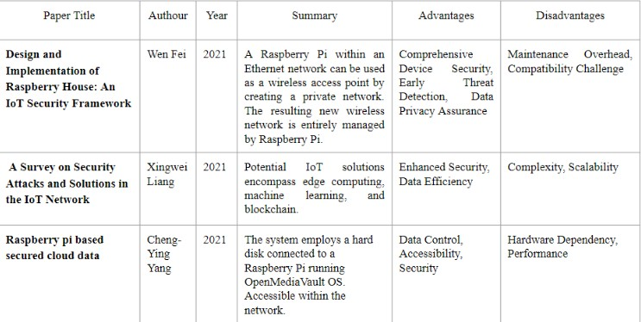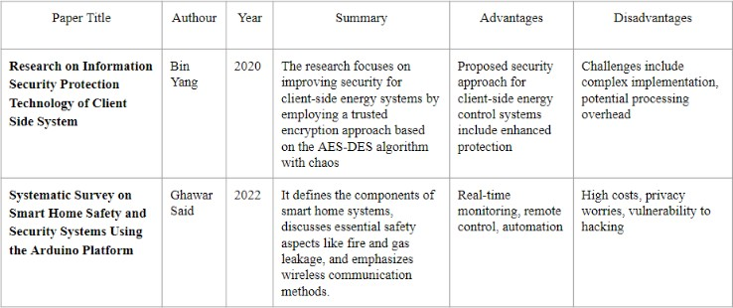

TABLE 3

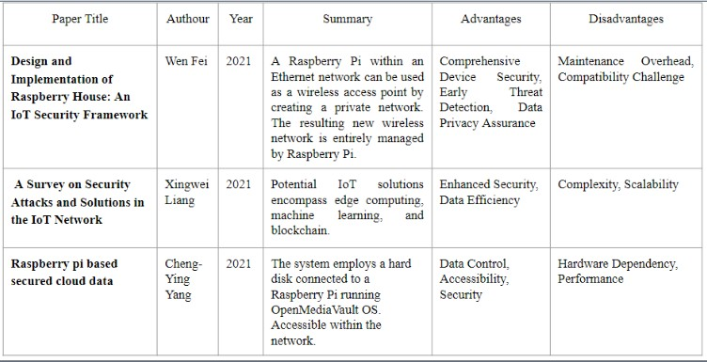

1. LIMITATIONS OF EXISTING SYSTEM

Many existing IoT systems lack robust security measures, relying on basic encryption and authentication methods. This inadequacy leaves them vulnerable to sophisticated attacks, including intrusion, data breaches, and device manipulation. IoT networks consist of a wide array of devices, each with unique specifications and communication protocols. Existing solutions often struggle to provide uniform security across this diverse ecosystem, leading to vulnerabilities in certain devices or communication channels.

1. PROBLEM STATEMENT

Developing CyberShield IoT: a novel security framework that ensures end-to-end protection of IoT connections, detect- ing and blocking external breaches, and enabling automatic shutdown in case of client compromise, thus advancing IoT security beyond current solutions

1. IMPLEMENTATION
2. *Proposed System*

In this comprehensive IoT security framework, a Raspberry Pi server serves as the central hub, orchestrating and securing the entire network. The server hosts a robust firewall, meticu- lously configured to monitor and regulate both incoming and outgoing network traffic, allowing only authorized communi- cation between the server and the IoT devices, represented by STM Boards. SSL/TLS encryption protocols are employed to establish secure channels, ensuring the authenticity and confidentiality of data exchanged between the server and clients through SSL certificates. To enhance network security,

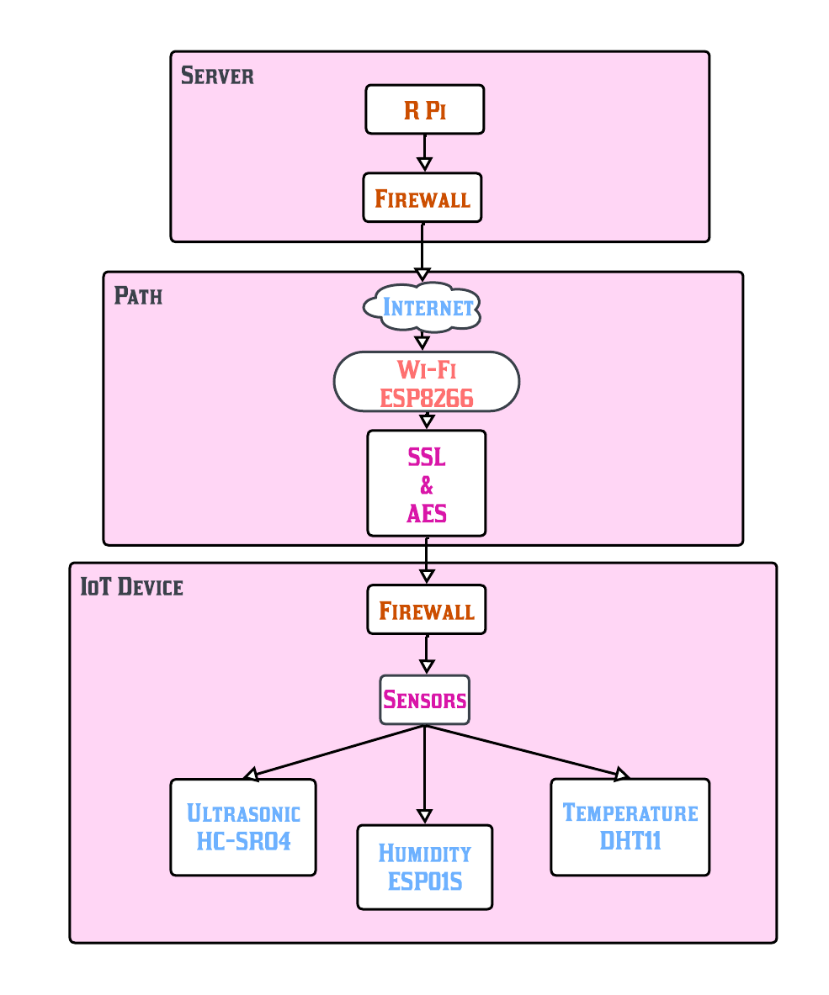

Fig. 1. Block Diagram

configuration of a firewall on the Raspberry Pi, meticulously allowing only authorized communication channels between the server and clients. The implementation of SSL/TLS protocols ensures the encryption of communication, guaranteeing data authenticity and confidentiality. To bolster defense against

an Intrusion Detection System (IDS) is implemented on the server, equipped with predefined rules and machine learning algorithms to detect suspicious patterns and potential exter- nal threats. In the event of a security breach, an automatic shutdown mechanism triggers, swiftly isolating compromised clients to prevent further unauthorized access and potential data manipulation. The IoT devices, equipped with various sensors such as temperature, motion, and humidity sensors, seamlessly integrate into the network. These sensors collect environmental data, undergo secure processing via client- side algorithms, and transmit the information securely to the server, maintaining data integrity and authenticity through SSL encryption. A user-friendly web or mobile application, the User Dashboard, is developed to provide users with a seamless interface for monitoring connected devices, security alerts, and overall system health in real-time. This holistic approach not only ensures the secure functioning of the IoT network but also facilitates user engagement through efficient monitoring and alert mechanisms.

1. *Methodology*

The establishment of a secure IoT ecosystem involves a systematic series of steps beginning with the setup of the Raspberry Pi as the central server and the configuration of STM Boards as clients, each integrated with various sensors. Network security is fortified through the installation and

potential threats, an Intrusion Detection System (IDS) is deployed on the server, equipped with rules and algorithms de- signed to detect suspicious patterns and behaviors. Automated scripts are then developed to initiate the swift shutdown of compromised clients upon detection, preventing unauthorized access and potential data manipulation. The secure connection of sensors to STM Boards precedes the implementation of local data processing algorithms on the boards, ensuring the integrity of the collected data. This processed data is then securely transmitted to the central server via encrypted chan- nels, upholding end-to-end security. Finally, the development of a user-friendly dashboard enables real-time monitoring of connected devices, security alerts, and overall system health, fostering an intuitive and accessible interface for users to engage with the IoT network effectively. This comprehensive approach not only ensures the seamless integration of IoT components but also establishes a resilient and user-centric security framework suitable for various applications.

1. *Hardware Details*
   * Raspberry Pi: Foundation is a British company that developed the Raspberry Pi line of tiny single-board com- puters. Owing to its small size and adaptable features, it is utilized in many applications, including Internet of Things initiatives.It is used in various applications, including IoT projects, due to its compact size and versatile capabilities.

applications, including IoT projects, due to its compact size and versatile capabilities.

* + STM32 : A family of microcontroller units (MCUs) produced by STMicroelec-tronics. These microcontrollers are widely used in embedded systems and IoT projects due to their reliability and performance.
  + Ultrasonic sensors : are devices that use sound waves to measure distances. They emit ultrasonic waves and measure the time it takes for the waves to bounce back after hitting and object, allowing for distance calculation.
  + Humidity sensors, also known as hygrometers, measure and report the moisture content in the air. They are crucial in applications where humidity control is necessary, such as environmental monitoring systems.
  + Temperature sensors are devices used to measure the temperature of an object or environment. They are vital components in applications where temperature control is critical.

1. *Software Details*
   * MongoDB, an open-source NoSQL database, offers high performance, availability, and scalability. Its document- oriented approach utilizes flexible BSON documents, ac- commodating diverse data types. With a dynamic schema, MongoDB allows easy document structure modification. It boasts a robust query language, horizontal scalability through sharding, and an aggregation framework for ad- vanced data processing. Ensuring high availability, Mon- goDB supports replica sets, and the company MongoDB, Inc., provides professional support for enterprises using it in production environments.
   * PageKite empowers users to expose local servers or websites to the internet without a public IP or intricate firewall setup. Utilizing reverse proxying, it connects servers to the PageKite service, providing accessibility via custom domain names. Supporting HTTP, HTTPS, SSH, and more, PageKite ensures secure service exposure with encryption and authentication. With dynamic DNS and open-source flexibility, it’s a go-to for dynamic IP scenarios. Users configure it through the command line or a file, making it ideal for developers and small businesses seeking cost-effective hosting solutions.
2. TYPES OF ATTACKS
   * Denial of Service (DoS) and Distributed Denial of Ser- vice (DDoS) attacks pose significant threats to IoT de- vices and their communication pathways. At the device level, attackers overwhelm IoT devices with excessive traffic or requests, causing them to become unresponsive or crash, thereby impacting the availability and function- ality of the devices. On the path level, DDoS attacks focus on flooding the communication paths between IoT devices and servers, leading to a disruptive halt in overall service.
   * Man-in-the-Middle (MitM) attacks, whether at the device or path level, involve intercepting and altering communi-

cation. At the device level, this manipulation can compro- mise the integrity of data exchanged between IoT devices and servers, while at the path level, attackers manipulate the communication pathways to intercept and tamper with the data flowing between devices and servers. These types of attacks underscore the critical importance of implementing robust security measures to safeguard IoT ecosystems from potential disruptions and unauthorized access.

1. CONCLUSION AND FUTURE SCOPE

Our CyberShield IoT project, we successfully implemented a secure server using Raspberry Pi,Python, and Visual Studio Code, enabling real-time data access locally and on other devices. This achievement establishes a strong foundation for advancing our project, emphasizing its feasibility, scala- bility, and potential for robust IoT connection safeguarding in subsequent phases. Moving forward, we will focus on enhancing security protocols and user experience to create a comprehensive and reliable IoT solution.

The future scope of the CyberShield IoT project includes enhancing security features, expand- ing device compatibil- ity, integrating machine learning for intelligent data analysis, enabling re- mote management through mobile applications,

REFERENCES

1. Bin Yang , Xuesong Shao “Research on Information Security Protection Technology of Client Side System” 2020 Chinese Automation Congress (CAC) IEEE, DOI:10.1109/CAC51589.2020.9327122.
2. Ghawar Said,Anwar Ghani,AtaUllah,Muhammad Azeem,Muhammad “Systematic Survey on Smart HomeSafety and Security Systems Using the Arduino Platform” 2022 Korean Government [Ministry of Science and ICT (MSIT)] DOI 10.1109/AC-CESS.2020.3008610
3. J. Anyi Liu,Ali Alqazzaz,Hua Ming,Balakrishnan Dharmalingam, “Iotverif: Automatic Verification of SSL/TLS Certificate for IoT Applications”, 2021 National Science Foundation of the United States under Grant No. DGE-1723707 and in part by NASA, DOI:10.1109/ACCESS.2019.2961918.
4. Ghawar Said,Anwar Ghani,Ata Ullah,Muhammad Azeem,Muhammad Bilal,Kyung Sup Kwak “Light-Weight Secure Aggregated Data Shar- ing in IoT-Enabled Wireless Sensor Networks” , 2022 National Re- search Foundation of Korea-Grant funded by the Korean Govern- ment [Ministry of Science and ICT (MSIT)] under Grant NRF- 2020R1A2B5B02002478, DOI: 10.1109/ACCESS.2022.3160231.
5. Hariprasad Siddharthan,T. Deepa,Prabhu Chandhar, “SENMQTT-SET: An Intelligent Intrusion Detection in IoT-MQTT Networks Using En- semble Multi Cascade Features” , 2022 SRM Institute of Science and Technology, Kattankulathur, Chennai, Tamil Nadu 603203, India , DOI: 10.1109/ACCESS.2022.3161566.
6. Wen Fei, Hiroyuki Ohno, Srinivas Sampalli, “Design and Implemen- tation of Raspberry House: An IoT Security Framework” 2021,IEEE International Conference on Internet of Things and Intelligence Sys- tem (IoTaIS)IEEE, DOI:10.1109/IoTaIS50849.2021.9359722,ISBN:978- 1-7281-9449-3
7. Xingwei Liang,Yoohwan Kim, “A Survey on Security Attacks and Solutions in the IoT Network” 2021,IEEE E 11th Annual Com- puting and Communication Workshop and Conference (CCWC) ,

DOI:10.1109/CCWC51732.2021.9376174

1. Cheng-Ying Yang, Cheng-Chi Lee, TsueiHung Sun et al. , “Raspberry pi based secured cloud data” 2021,IEEE Journal of Physics: Conference Series ,DOI 10.1088/1742-6596/1964/4/042101