**Modeling and Development of a Magnetically Levitated Vertical axis Wind Turbine.**

Asuzu, E.A1, Izelu, C.O2. Anaidhuno U.P3.

Corresponding Authors: [**ebube.eric@yahoo.com**](mailto:ebube.eric@yahoo.com)**,** [**anaidhuno.ufuoma@fupre.edu.ng**](mailto:anaidhuno.ufuoma@fupre.edu.ng)

1,2,3Department of Mechanical Engineering, Federal University of Petroleum Resources, Effurun, Delta State, Nigeria

# Abstract

This research investigated the modeling and development of a magnetically levitated vertical axis wind turbine (LVAWT). The goal of the research was to generate power using LVAWT, which was achieved by harnessing repulsive forces within permanent magnets, the wind turbine's vertically oriented vanes can be levitated, to minimize frictional losses by eliminating contact between the shaft and frictionless bearings. The Computer Aided Design (CAD) model was achieved and simulated. The turbine assembly maintains optimal blade rotation. The shaft, connected through its normal axes, links to the alternator via a direct drive connection between the generator and turbine shafts. Stationary guide vanes (chutes) were incorporated into the prototype to effectively direct wind toward the turbine blades to enhance speed and optimize wind capture. Performance testing conducted on the prototype indicates its electricity generation capacity at different wind speeds. At a maximum wind velocity of 12.5 m/s, the wind turbine produces a voltage of 23.18V and a current output of 2.84A. The resulting power output is deemed suitable for applications such as battery charging. This design enhances efficiency by reducing losses and the implementation of this turbine system allows for power generation from the kinetic energy of moving wind, applicable for residential and commercial use with capability to generate renewable, clean, and environmentally friendly power, contributing to sustainable energy solutions.

Key words: Development, Levitation, Magnetic, Modeling, Turbine, Wind

## 1.0 Introduction

Energy is a key instrument in accelerating economic growth, alleviating erratic poverty and creating employment opportunities. Epileptic power failure has resulted in an over-dependence on generators driven by fossil fuel. Apart from this, fossil fuel is non-renewable and fast depleting and current to ecological degradation. Due to the endemic power shortage in the country and unstable power supply, researching the utilization of wind for turbine rotation is highly relevant.

An important factor in the development of human resource is the Energy. Presently, conventional energy sources are exhausting rigorously leading to the development of inexhaustible and renewable energy resources. Renewable energy is generally electricity supplied from sources, such as wind power, solar power, geothermal energy, hydropower and various forms of biomass. These resources are termed as renewable because they are consistently replenished and can be utilized repeatedly. The surge in the popularity of renewable energy in recent times is attributed to the depletion of conventional power generation methods and a growing awareness of their detrimental impact on the environment. (Chinnu et al., 2016).

Wind is a source of energy which is created from the atmosphere of the sun causing areas of uneven heating. In conjunction with the uneven heating of the sun, rotation of the earth and the rockiness of the earth’s surface winds are formed. The terms wind energy describes the process by which wind is used to generate mechanical power or electricity. The wind turbine is used for conversion of kinetic energy of wind into electrical energy. The wind turns the blades, which spin a shaft, which connects the generator and generates electricity (Chinnu et al., 2016).

The levitated vertical axis wind turbine (LVAWT) design is a vast departure from conventional propeller designs (Chinnu et al., 2016). The merits for levitated vertical-axis wind turbine can be noted such as requirement of minimum cost, reduced losses to friction, easy installation, easy maintenance, and the capability to collect wind from all directions. The distinctive operational concept of this design revolves around the use of magnetic levitation.

The vertically axis wind turbine (VAWT) with magnetic levitation is engineered to capture sufficient air to rotate the stator efficiently at both low and high wind speeds, maintaining stability by positioning the center of mass closer to the base. In this design, the wind turbine's rotors and stator are magnetically levitated using permanent magnets, ensuring smooth rotation with minimal friction. Compared to conventional wind turbines, the magnetic levitation VAWT exhibits superior performance due to its lower starting wind speed. It attains higher rotational speeds, and the time taken for it to stop rotating is longer, making it more suitable for power generation applications.

The ideal placement for the magnetically levitated vertical axis wind turbine is in residential areas, where it can be mounted on rooftops, operating efficiently to extract free and clean energy. This not only reduces utility costs for homeowners but also contributes to the growing awareness of "Green Energy." The future prospects of this project involve creating opportunities in low-speed areas, with starting speeds as low as 1.5 m/s and a cut-in speed of 3 m/s. The configuration allows for the capture of wind from any direction, converting it into energy with high efficiency. Magnetic levitation not only reduces friction but also eliminates the need for bearings.

In the current landscape, wind turbines stand out as the most advanced form of renewable energy technology, delivering clean and green power with fewer resources per kilowatt-hour. This new technology is cost-effective with low operating expenses and produces less noise compared to conventional wind turbines.

This research investigated the modeling and development of a magnetically levitated vertical axis wind turbine (LVAWT).

## 2.0 Literature Review.

Wind turbines represent the contemporary iteration of windmills. They harness energy from the wind, primarily for generating electricity, by rotating a set of blades resembling a propeller. These blades, in turn, drive a generator through designated shafts and gears.

Magnetic levitation is a technique wherein an object is suspended in the air, significantly reducing the impact of gravity on the object without any support other than magnetic fields. In this method, magnetic pressure is primarily employed to counteract the gravitational forces (Santoshkumar & Mahesh, 2014). This system proves highly efficient for harnessing wind energy, operating on the repulsion properties of permanent magnets. While this technology has been widely applied in the rail industry, particularly in maglev trains, ongoing research is elevating its popularity to new heights. Achieving magnetic levitation is feasible using a pair of permanent magnets, such as neodymium magnets, and robust support. Placing these magnets on top of each other with like polarities facing each other creates a strong magnetic repulsion that keeps the magnets at a distance. The force generated from this repulsion can be utilized for suspension purposes and is potent enough to counterbalance the weight of an object based on the magnets' threshold.

According to an article on britannica.com, Hero of Alexandria (circa 1st century CE) detailed the earliest known wind device in scientific history. Inspired by a water-powered paddle wheel, it drove a piston pump that directed air through a wind instrument to create auditory effects. While windmills may have been used earlier, references to wind-driven grain mills date back to the 9th century in Arabic sources, mentioning a Persian millwright from 644 CE, with the mills located near the modern Iran-Afghanistan border. These mills featured a structure with opposing holes for wind entry and exit and a vertical shaft with outward-extending paddle-like sails. Each mill, without gearing, powered a single set of stones. By the 13th century, similar mills were known in China (Kamkwamba, 2023).

Kaldellis et al. (2018) state that wind turbines are consistently used in conjunction with an electric power source to stabilize the output. Wind speed fluctuates significantly throughout each hour, but the average wind speed remains consistent daily, making it the basis for performance and output power calculations.

Usman (2018) on wind turbines, it is noted that the USA and China have invested substantially in the onshore wind industry, leading to the growth of the onshore wind sector and the subsequent development of the offshore wind industry. The emergence of offshore wind has resulted in a decrease in onshore wind capacity additions, dropping to 10% in 2017 (Global Statistics by GWEC, 2017).

Higher altitudes experience increased wind speeds, significantly impacting the overall output power of wind turbines. The trend since 2016 shows a rising maximum overall height of installed wind turbines, reaching measurements up to 230 m (Usman, 2018).

From 2004 to 2010, wind turbine prices experienced continuous increases; however, a reduction in cost has been observed since 2010. This decline is attributed to improved design and overall performance of turbine components, along with reductions in steel and carbon prices in the global markets (Ferhan , 2016).

Hansen's (2002) work is indicative of future developments in the wind industry. He presents a model for a hypothetical 3.5 MW variable speed, variable pitch turbine, providing a clear structural model with 16 degrees-of-freedom. The blades incorporate a modal expansion of the bending modes with a Rayleigh damping model. The primary focus is on reducing torsional stiffness and determining the region of negative damping.

In a subsequent work in 2004, Hansen (2004) introduces a different model for a hypothetical 5-MW turbine. This structural model employs finite-elements, but unlike the earlier model (Hansen 2002), the rotational speed is fixed instead of variable.

Lobitz contributes two submissions in 2004, one for the Wind Energy Journal (Lobitz 2004a) and the other for the ASME conference (Lobitz 2004b), with the latter essentially being a subset of the former. He discusses prior experiences with studies on a Darrieus-style vertical axis turbine intentionally brought into flutter. The current work addresses concerns related to new blade designs incorporating bend-twist coupling for load reduction. Previous experiments with 9-meter-long blades showed a flutter speed six times the rotor speed, with no identified causes for concern.

In Lobitz's review in 2005, he examines past research, noting a reduction in the theoretical flutter speed ratio to the rotor speed with increasing blade length. An intriguing claim is made that the flutter speed should remain constant with simple scaling of dimensions without altering materials or structure.

Jayawant B. V. (1988) stable, static magnetic levitation or suspension requires the presence of diamagnetic material or a superconductor in addition to a system of permanent magnets. 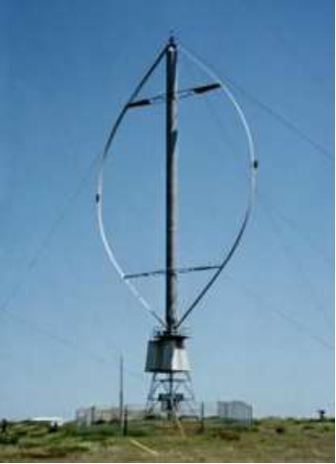Bachelet utilized the Braunbeck extension and Earnshaw's theorem to stabilize magnetic force by varying the strength of the current and turning the electromagnets' power on and off at specific frequencies. Although the original purpose of his design was to serve smaller postal delivery systems, it is clear that it may also be used for larger trains-like vehicles.

Worldwide wind generated power is totaling more than 74223 megawatts. In Denmark's electricity sector wind power produced the equivalent of 47% of Denmark's total electricity consumption in 2019, an increase from 43.4% in 2017, 39% in 2014, and 33% in 2013. According to Guardian online news website, in 2012, the Danish government adopted a plan to increase the share of electricity production from wind to 50% by 2020, and to 84% by 2035. In ancient times, wind power was only used as a source of mechanical power to pump water and grind cereals. It was one of the earliest sources of energy with its use dating back to early civilization mainly in the banks of river Euphrates and Tigris.

This research investigated the modeling and development of a magnetically levitated vertical axis wind turbine (LVAWT).

## 3.0 Materials and Method.

The basic prototype was made as per the calculations by using the components available in local market. Vertical axis wind turbines can be broadly categorized into two main types: the Darrieus model and the Savonius model. While the fundamental principle of operation in vertical axis wind turbines aligns with that of horizontal designs, the key distinction lies in the vertical arrangement of the rotors and generator on a shaft for support and stability. This orientation leads to a unique response of the turbine blades to the wind, setting it apart from the characteristics observed in horizontal configurations.

The engineering design methodology employed in this project is discussed sequentially in the following phases;

### 3.1.1 Specification Development / Planning Phase

In this phase, the goal was to determine the objectives and engineering requirements of this project as well as develop a project plan. To achieve this, a background study was done on wind power generation systems and wind turbine systems. The theories, principles and systems design that have been developed was deduce to get the engineering requirements of the project. The limitation and objectives of the project was then established within the premise of the project specifications given by the department of Electrical and Electronics Engineering.

### 3.1.2 Generation of Conceptual Design Phase

One important step taken in this phase was breaking down the design into core functional blocks to simplify the rest of the design and construction process. By allowing a more in-depth study of these functional blocks, the system as a whole can better be understood. This is often called the Input to output approach. The functional blocks are; Blade system, Rotor, Magnet and Generator.

Building upon the concepts outlined during the specification development/planning stage, the objective in this phase was to create and assess ideas for implementing and connecting the functional blocks. Through a thorough examination of various options, with due consideration given to factors such as component availability, cost, and other relevant aspects, the aim was to choose the most optimal design.

The result of this phase was a simple low-cost vertical axis wind turbine system-based design.

### 3.1.3 Detailed Design Phase

In this phase, the specifications of the functional blocks are documented and the components for the execution and interfacing of the functional blocks are selected. Here, a more detailed block diagram drawn through analytical modeling of the system.

Figure 3.1: Block Diagram of Wind Power Generator

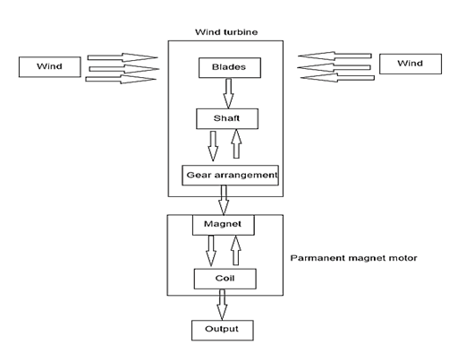

## Table 3.1 Material Descriptions

|  |  |  |  |
| --- | --- | --- | --- |
| **S.N** | **DESCRIPTION** | **MATERIAL USED** | **DIMENSIONS (mm)** |
| 1 | Stator | Ply wood | Outer Diameter - 220 |
| 2 | Rotor Disc | Mild Steel | Outer Diameter - 200 |
| 3 | Blades and Wings | Stainless Steel Sheet | Height of the blade - 45 |
| 4 | Solid Shaft | Mild Steel | Diameter - 30 |
| 5 | Triangular plate | Mild Steel | Side - 260 |
| 6 | Base Assembly | Mild Steel | Base surface area - 150 |
| 7 | Fasteners | Standard | M6 |

**3.2 Design Analysis**

Wind power is directly proportional to the cube of the wind velocity, and this power can be computed based on both the area exposed to the wind and the wind speed. In the presence of wind, the available energy is kinetic, originating from the motion of the wind, and as such, the power of the wind is associated with its kinetic energy.

$Kinetic Energy= \frac{1}{2}MV^{2}$ 3.1

The volume of air passing in unit time through an area A, with speed V is AV and its mass M is equal to the Volume V multiplied by its density ρ so:

$M=ρAV$ 3.2

(World Energy Association , 2009) (American Wind Energy Association , 2009) (Nagarkarand & Dr. Khan, 2013) (Nagarkarand & Khan, 2013; Thomas & Varghese, 2016)

$Kinetic Energy= \frac{1}{2}(ρAV)V^{2}$ 3.3 $Kinetic Energy= \frac{1}{2}ρAV^{3}$ 3.4

To convert the energy to kilowatts, a non-dimensional proportionality constant k is introduced where,

$K= 2.14×{10}^{-3}$

Therefore,

$Power in kW (P)= 2.14ρAV^{3}×{10}^{-3}$ 3.5

Where:

$Air density(ρ)= 1.2kg/m^{3}/2.33×{10}^{-3}slugs/{ft}^{3}$

$Area\left(A\right)= area swept by the blades of the turbine$

$Velocity \left(V\right)= Wind speed in miles per hour (mph)$

The process of designing of a wind turbine begins by estimation of the wind resource. The estimation of wind resource is done using statistical methods to find frequent wind speed and law of conservation of energy which states that energy cannot be created or destroyed it can only be changed from one form to another to find available power in wind. Combining this law with the continuity equation of fluid mechanics the mass flow rate is a function of air

Density $δ$, air velocity *U* and swept area *A* and is given by:

$\frac{dm}{dt}= δUA$ 3.6

Where $\frac{dm}{dt}$ is the elemental mass flow rate

Therefore, the K.E or kinetic energy per unit flow is given as

$\frac{1}{2}M^{o}V^{2}$ 3.7

Where $M^{o}$ is the mass and *V* is the velocity

Therefore, $\frac{1}{2}×\frac{dm}{dt}×U^{2}=$*K.E per Unit of flow*  3.8

Substituting $\frac{dm}{dt}= \frac{1}{2}×AδU× U^{2}$ 3.9

= $\frac{1}{2}AU^{3}δ$ 3.10

Wind power per unit area = $\frac{K.E }{A}= \frac{1}{2}\frac{δAU^{3}}{A}= \frac{1}{2}U^{3}δ$ 3.11

### 3.2.1 Blade Design

The turbine used in this prototype is a turbine ventilator. A different approach was employed in the blade design. The turbine is made up of 24 blades with the base and top diameter of 300mm. The height of the blade hub is 648mm with a diameter of 360mm. Total height of the shaft is 637mm. Figure 3.2 and 3.3 shows the 3D design of the wind turbine. The turbine blades used for this design has the following specifications:

3.2.1.1 Blade and Hub Specification

Blade type: J-type (drag)

Blade number: 12 (Determined from Solid Works model, optimal given turbine dimension)

Blade material: Pvc materials

Hub material: iron rod with iron plate

Blade height (bh): 569 mm

Blade diameter (bd): 300 mm

Blade thickness (bt): 2 mm

Hub height (h): 648 mm

Hub diameter (d): 360 mm

Figure 3.2: 3D View of the Blade Design

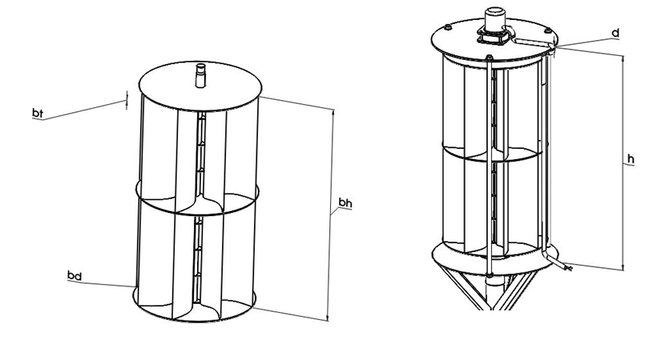

### 

### 3.2.2 Magnet

There are two magnets (neodymium) of grade N52 of outer diameter 85 mm, inner diameter 20 mm and thickness 12 mm were used in this project. One magnet is fixed on base stand is known as lower magnet over which another magnet is arranged in such a way that the principle of magnetic levitation is accomplished. The shaft (Delrin shaft) is inserted into the two magnets and connected to the generator coil. Blade holder plates are used to hold the blades, the unit is known as wind turbine and this wind turbine is mounted on upper magnet when the turbine rotates by the wind sources upper magnet also rotates

## 4.0 Test and Discussions.

## 4.1.1 Fabrication of Turbine Blades and Disc Plate

The turbine blades were fabricated using a 3mm diameter PVC pipe with thickness of about 2mm. The PVC pipe was cut to a height of 569mm and a sector of the pipe circumference was cut out. A total of 8 single blades of same height, thickness and diameter were fabricated from the PVC pipe and housed together on the blades disc plate fabricated from a medium density fiber board with a thickness of 2mm and a diameter of 300mm. on complete assembly of the turbine blades on the disc plate, the edges of the sectors were then filled to ensure smooth edges. The figure 4.1 shows the fabricated turbine blades and disc plate.



Figure 4.1: Fabricated Turbine Blades and Disc Plate

## 

## 4.2 Test

A vertically levitated wind turbine has been created, conceptualized, and applied for outdoor practical use. Experimental analysis was conducted on the wind turbine to assess its anticipated electricity generation capacity relative to wind speed. A wind blower was employed to adjust the wind speed, while a multimeter was utilized to gauge the output voltage and current. Figure 4.2 illustrates the testing setup and the outcomes for voltage and current output at the highest wind speed.



Figure 4.2: Voltage and Current Output at the Maximum Wind Speed

Table 4.1, shows the voltage and current output of the wind turbine at different wind speed. A comparative analysis on velocity to current and velocity to voltage is presented using a graphical representation.

**Table 4.1:** Wind velocity, Voltage output and Current output

|  |  |  |
| --- | --- | --- |
| Velocity (m/s) | Voltage (V) | Current (I) |
| 2.5 | 10.65 | 0.93 |
| 5.0 | 14.06 | 1.02 |
| 7.5 | 17.47 | 1.90 |
| 10 | 21.58 | 2.22 |
| 12.5 | 23.18 | 2.84 |

Figure 4.3, shows a graphical representation on the comparative analysis of the current output to wind velocity.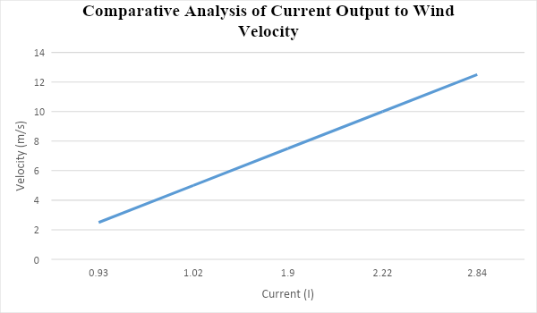

Figure 4.3: Comparative Analysis of Current Output to Wind Velocity

Figure 4.4, shows a graphical representation on the comparative analysis of the current output to wind velocity.

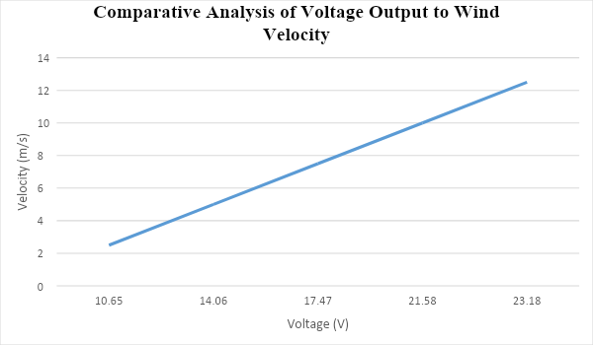

Figure 4.4: Comparative analysis of voltage output to wind velocity

## 4.3 Cost Benefit Analysis

Cost/benefit analysis provides the nature of expense and benefit accruable from a project in monetary terms as is common practice in traditional feasibility studies, and hence enables easy understanding and aids decision making tremendously for potential end-users. With respect to this project, we see below analysis; Total cost of production: #243,600. Proposed selling price of model per unit: #350,000. Cost benefit (CB): #106,400. This is deemed affordable compared to the current prevalent fossil fuel power generation sources.

## 4.4 Simulation

The blade's angle has a key role in how well the rotor converts the wind speed that hits the rotor blades into rotational force. By varying the angle of the turbine rotor blade (13o,20o and 27o), this simulation report compares the result of the rotational force generated by each angle to obtain the optimal angle suitable for the design. This force is used to compute the torque (rotational work in Nm) which will be responsible for driving the alternator attached to the rotor via gear or pully system. The simulation will also compare the result with and without the stationary guide. The computed torque will then be used to run a finite element analysis to determine the stresses acting on the turbine rotor.



Figure 4.5: 2D Turbine Dimension

Figure . Blade Details showing the Blade Angle (a)

**4.5.1 Mesh Resolution and Domain**

The chosen mesh size affects both the computation time and the numerical accuracy. In this analysis, two mesh size categories were developed., the global mesh control of 15cm for entire domain except regions of specific interest which are the turbine blades and the stationary guide blades having a mesh size of 5cm (local mesh control). The domain used is such that the geometry of the turbine blades (and/or the stationary guide blades) is covered with considerable space for the CFD solver to calculate. A domain size of 2.15m x 0.4m x 1.05m (length x breath x height) was use for both with and without the stationary guide blades, see figure 4 and 5 for descriptions:



Figure Fluid Domain of Model with Stationary Guide Blades

Figure 4.6: Static mesh simulation

4.5.2 Initial and Boundary Conditions

The initial boundary condition is such a wind speed of 2.5m/s is applied in the direction of x axis as shown.

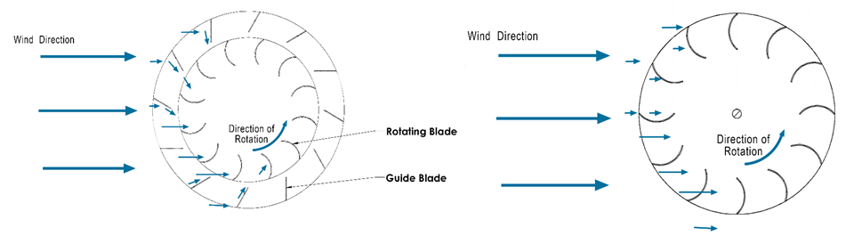

Figure 4.7: 2D Turbine simulated wind direction

**4.5.3 Simulation Goals**

The CFD solver was configured to solve the following goals: Average velocity within the turbine blades as a result of the 2.5m/s wind speed, maximum dynamic viscosity, maximum turbulent viscosity, normal force acting on the rotor blades, force acting on the rotor blades



### 

Figure 4.8 Graph of Iterations against Force acting on the Blades

It can be deduced that the result obtained with the stationary guide active are far preferable to the ones without the guide hence proving the relevance of the stationary guide. The optimal blade angle from the simulation analysis is 20o, generating a rotor torque of 0.781Nm (enough to effectively overcome the starting torque of the selected alternator = 0.1Nm) (Electric Generator 600w 300w Low Speeds 24v 12v 3 Phase Gearless Permanent Magnet Ac Alternators for Wind Water Turbine Home Use - Alternative Energy Generators – Ali Express, n.d.). The maximum stress acting on the rotor blade is far less than the yield strength of the material used for the rotor with negligible displacement, hence the rotor will survive the working condition with reasonable factor of safety (FOS).



Figure 4.9 Wind velocity simulation contours

A slight increment in wind speed is observed in the centre of the turbine rotor in figure (red contour).

Figure 4.10: 3D Turbine blade shear strain/stress analysis



Figure Pressure Distribution on the turbine blade due to wind speed of 2.5m/s

Figure Pressure Distribution on the turbine blade due to wind speed of 2.5m/s

## 5.1 Conclusion

Small-scale wind turbines present an appealing option for various remote applications, such as rural electrification, water pumping, or telecommunication. They also offer a potential solution for energy conservation and greenhouse gas reduction in grid-tied scenarios. In this project, a magnetically levitated vertical axis wind turbine was developed, modeled, and implemented. Performance tests were conducted on the wind turbine to assess its expected electricity generation in relation to wind speed, yielding the following results: at a maximum wind velocity of 12.5 m/s, the wind turbine produced a voltage of 23.18V and a current output of 2.84A. A comparative analysis of these results with performance test values obtained from a normal vertical axis wind turbine (without magnetic levitation) in a study by Ogunoh C. C et al. (2017) revealed that, at a maximum turbine rotation speed and equivalent wind speed of 12.5m/s, the corresponding voltage generated was 13V and 1.54A. This indicates the advantageous impact of magnetic levitation in reducing or eliminating frictional losses in turbine rotational energy, leading to an increased voltage generation in the turbine system. The power output of the prototype is well-suited for battery charging applications. Implementing this power generation technology on a larger scale in Nigeria's power sector offers a sustainable, long-term approach to achieving energy self-sufficiency and promoting economic development.

**References**

Chinnu , S. T., Dhanya, V., Jayalakshmi , Sonu Savy, & Rini , V. (2016). Magnetically Levitated Wind Turbine for Power Generation. International Journal of Advanced Research in Electrical, Electronics and Instrumentation Engineering, 5 (3).

Ferhan Öztürk 2016, "Finite Element Modelling of Tubular Bolted Connection of a Lattice Wind Tower for Fatigue Assessment".

Hansen, M. H. (2002). "Vibrations of a Three-Bladed Wind Turbine Rotor Due to Classical Flutter". 2002 ASME Wind Energy Symposium, Reno, Nevada, 14-17 January 2002. American Society of Mechanical Engineers; pp. 256-266.

Hansen, M. H. (2004). "Stability analysis of three-bladed turbines using an eigenvalue approach". 2004 ASME Wind Energy Symposium, Reno, NV, 5-8 January 2004. American Society of Mechanical Engineers; pp. 192-202.

Jayawant B. V. (1988) Review Lecture. Electromagnetic Suspension and Levitation Techniques

Proceedings of the Royal Society of London. Series A, Mathematical and Physical Sciences

Vol. 416, No. 1851 , pp. 245-320, Published By: Royal Society.

Kaldellis JK, Zafirakis D. (2018) The Wind Energy (r)evolution: A Short Review of a Long History. Renewable Energy: <http://linkinghub.elsevier.com/retrieve/pii/S0960148111000085>

Lobitz, D. W. (2004a). "Aeroelastic Stability Predictions for a MW-seized Blade." Wind Energy 7: pp. 211-224.

Lobitz, D. W. (2004b). "Ramifications of aeroelastic analysis approximations as blade designs approach stability boundaries". 2004 ASME Wind Energy Symposium, Reno, NV, 5-8 January 2004. American Society of Mechanical Engineers; pp. 203-210.

Nagarkarand, D. N., & Dr. Khan, Z. J. (2013). Wind Power Plant Using Magnetic Levitation Wind Turbine. International Journal of Engineering and Innovative Technology (IJEIT).

Ogunoh C. C., Ezemmuo D. T. , Ani M. C.(2017) Design and Construction of Vertical Axis Wind Turbine. Saudi Journal of Engineering and Technology, Vol-2, Iss-2 : 65-72, DOI:10.21276/sjeat.2017.2.2.1

Santoshkumar , J. C., & Mahesh , M. U. (2014). Maglev Wind Generator: An efficient form of vertical axis wind turbine. 3rd The International Conference on Renewable Energy Research and Applications (ICRERA).

Thomas, C. S., & Varghese, D. (2016). Magnetically Levitated Wind Turbine for Power Generation. International Journal of Advanced Research in Electrical, Electronics and Instrumentation Engineering, March.

Usman Z. (2018) , Literature Review of Wind Turbine, Special Project submitted by Usman Z. and supervised by Prof. H.T. Wichtman , Chair of Geotechnical Engineering Bauhaus Universität, Weimar, 1-41.

Wind and Hydropower Technologies. (2009, April 29). Wind and Hydropower Technologies Program: How Wind Turbines Work. Retrieved from EERE: EERE Server Maintenance: <http://www1.eere.energy.gov/windandhydro/wind_how.html> ["Environmental Capital of Europe"](https://web.archive.org/web/20070706184255/http:/www.cece.dk/EE0911AA-D9A1-49E8-9CA2-332E37BBA568). Copenhagen, Environmental Capital of Europe. Archived from [the original](http://www.cece.dk/EE0911AA-D9A1-49E8-9CA2-332E37BBA568) on 2007-07-06. Retrieved 2009-01-05.