**A Critical Examination of the Potential Applications and Future Prospects of IDD Technology in Small and Medium-sized Projects in Yunnan Province**

Junyuan Yang1, Fuxia Zhang1, *

*1 International College, Yunnan Agricultural University, Kunming,650201*

*\*Corresponding Author: [842400742@qq.com](mailto:842400742@qq.com)*

*--------------------------------------------------------ABSTRACT----------------------------------------------------------------*

*In light of the current downturn in the CREM market, there is an urgent need to introduce new technologies to improve operational efficiency and thus reduce development costs. Concurrently, it is imperative to adopt advanced management concepts and technologies to effectively address the numerous challenges inherent to engineering projects. Based on the aforementioned considerations, this paper seeks to examine the potential applicability of IDD technology in small and medium-sized projects in Yunnan Province, China. A comprehensive review of the literature was conducted to identify the advantages and disadvantages of the current construction project information. A relevant model was then constructed to simulate the IDD technology and compared it with the current technology. A review of the current state of informatics in Yunnan Province revealed a general level of digitization, accompanied by a lack of familiarity with emerging management technologies. In the model comparison, a BIM model was produced to facilitate a comparison between the new management software and the traditional model. It was determined that the implementation of IDD technology could enhance efficiency in comparison to traditional management techniques. Although the current IDD technology is not without certain defects, the future of Yunnan IDD technology is promising and holds significant value for promotion.*

***KEYWORDS;*** *Integrated Digital delivery, Building Information Modelling, Whole-life Cycle Management*

---------------------------------------------------------------------------------------------------------------------------------------

1. **INTRODUCTION**

**Background**

Over the past two decades, China's real estate sector has played a pivotal role in the country's economic growth. As a significant contributor to the economy, it has been a crucial component in the restructuring of the economy. Between the 1990s and 2008, a shift in housing policy from welfare allocation to marketization commenced, driving rapid real estate development. Concurrently, the growing demand for housing also increased the process of urbanization. During this period, the supply of the real estate market was primarily oriented toward consumer demand, and the real estate market was stimulated to develop rapidly by the government's favorable policies (Lu, 2017, Huang, 2022). Since 2000, China's housing prices have exhibited a gradual upward trend, even during the 2008 global financial crisis, as illustrated in Figure 1.1.

Nowadays, the China Real Estate Market (CREM) is changing. Huang Qifan (Huang, 2022) illustrated the change from massive lodging demand of intrinsic causes to accuracy demand and CREM’s need to change management mode after changing point. Meanwhile, the National Bureau of Statistics showed the CREM investment development peaked at $1,476.02 billion (Statistics, 2022) from $1,202.64 billion (Statistics, 2019) but showed a downward trend in 2022, dropping by 10.0% to $1,328.95 billion (Statistics, 2023) compared to 2021. Furthermore, Xinhua Net reported that CREM is stable and needs to focus on the downward trend. Also, policies.

Figure1.1 Investment in real estate development from 1990 to 2023(Statistics, 2023)

In its 2023 report, Goldman Sachs observed that while housing starts have declined by two-thirds from their peak and are approaching a trough, future guaranteed housing and urban village renovation will help narrow the year-on-year decline in real estate investment (SACHS, 2023b, SACHS, 2023a). The most significant causes of the CREM problem are the high point of the total area of property stock and the near saturation of housing space per capita. Huang Illustrates the current backlog of over 600 million square meters of primary housing inventory in China's real estate enterprises, representing approximately 35% of China's real estate each year and nearly 1.7 billion square meters of new housing completion scale (Huang, 2022). A recent report from the National Bureau of Statistics of China indicates a 10% decline in real estate investment in the country during the 2023 fiscal year in comparison to the previous year (Statistics, 2023). The challenges currently facing real estate developers are not merely short-term difficulties. The bankruptcy of a company will have a cascading effect, leading to the loss of numerous companies in the industry chain.

**Significance**

In 2020, the Ministry of Housing and Urban-Rural Development of China proposed the "Ministry of Housing and Urban-Rural Development and other departments on the promotion of intelligent construction and construction industrialization of the synergistic development of the guiding opinions." This document identified seven key points for accelerating the industrialization of the construction industry. To strengthen technological innovation, enhance the level of information technology, cultivate the industrial system, actively implement green construction, expand application scenarios, and innovate industry supervision and service modes. It was also noted that the current production mode of the construction industry is still relatively inefficient (Development et al., 2020).

Furthermore, the construction management of high quality plays a pivotal role in ensuring the effectiveness and safety of real estate projects for subsequent use. Gong observed that large-scale construction projects with substantial investments, extended lead times, numerous stakeholders, far-reaching impacts, and promising long-term outcomes must contend with a multitude of challenges, including a shortage of personnel, compressed schedules, elevated risks, and so forth. However, the dearth of experience in digitization within the construction industry and the current disparate paths to digitization, such as data inconsistency, render project management more intricate and unwarranted (Gong et al., 2023). Du shows that the integration of Building Information Modeling (BIM) technology effectively reduces the frequency of safety and production liability accidents, concomitantly enhancing the overall efficiency of engineering construction (du et al., 2022).

Integrated Digital Delivery (IDD) technologies, which focus on the whole lifecycle and stakeholders and are enabled by digital technologies, are a new technology in civil engineering from Singapore (B.C.A., 2018, Hwang et al., 2020b, Liu et al., 2021, Yujie et al., 2023). The IDD covers four stages, including digital design, digital manufacturing and fabrication, digital construction, and digital asset delivery and management (B.C.A., 2018, Hwang et al., 2020b, Yujie et al., 2023). The IDD cooperates with the Integrated Project Delivery (IPD), Virtual Design and Construction (VDC), Prefabrication Prefinished Volumetric Construction (PPVC), and so on. It is a significant technology that can change civil engineering progress and the benefit of the project, which includes time, cost, profit, safety, and quality, and stakeholders who involve five related interests (B.C.A., 2020a). IDD is a brand-new thing in civil engineering, and China has enough opportunity to utilize IDD to change the original methods and issues, The Singapore Building and Construction Authority (BCA) has proclaimed a guidebook about how IDD works in 2020, and there are some examples of IDD， for instance, the JTC CleanTech Two project applicated by IDD technologies(B.C.A., 2020b).

Over the past decade, BIM technology has been consistently promoted globally. The popularization of this technology has further facilitated the application of virtual design and construction, and ultimately the development of IDD. IDD is still a relatively new management methodology, and therefore research on IDD under the current construction and management direction in the building industry is still limited (Hwang et al., 2020a, Yujie et al., 2023). Although the implementation of IDD would be considered a significant change to current project engineering, there are currently no studies on the efficiency gains of IDD technology(Hwang et al., 2020a).

1. **Literature Review**

**IDD Technology Definition**

IDD is the use of digital technology to integrate workflows and connect stakeholders working on the same project throughout the construction and building lifecycle (B.C.A., 2018, Hwang et al., 2020b, Liu et al., 2021, Yujie et al., 2023). IDD technology is one of the key enablers in the Built Environment Industry Transformation Map (BEITM), which aligns with the current direction of improvement in the built environment industry by creating a modern, highly skilled workforce trained in architecture, engineering, construction, and operations technologies. IDD breaks down project work into four phases through a variety of digitization technologies - Digital Design, Fabrication, Construction, Operations, and Maintenance (B.C.A., 2018, Hwang et al., 2020b, Liu et al., 2021, Yujie et al., 2023). IDD focuses on the digitalization of project delivery and the integrated management of the entire process. By applying new information technology, the IDD model enhances the traditional project delivery process and realizes the digital delivery of the four phases: design phase, manufacturing phase, construction phase, and O&M phase.

**Design Phase**

In the design phase, digital technology is used to achieve efficient stakeholder communication, reduce non-essential design changes, shorten coordination time, satisfy client oversight, and subsequently optimize various processes and coordinated design. For example, Geographic Information System (GIS) and BIM technologies are used for geological surveys, spatial planning, sustainability analysis, and regulatory review (Yujie et al., 2023). Then, the design was carried out through BIM to create a thematic model and multi-party integration to generate the final construction drawings. In the subsequent multi-party collaborative review, the BIM model and Virtual Reality / Augmented reality technology were used to visualize the scheme review and collaborative modifications and finally passed the constructability review and analysis (B.C.A., 2018, B.C.A., 2023, Hwang et al., 2020a, Yujie et al., 2023).

**Manufacturing Phase**

The digitization of the manufacturing phase focuses on creating a smart factory for automation in the built environment. This phase of digitization focuses on the production, storage, and transportation of assembled components to achieve economy, efficient manufacturing, and just-in-time delivery (Hwang et al., 2020a, Yujie et al., 2023). Prefabrication is now a mature approach where individual components are manufactured in a factory and then shipped to the job site for assembly. Components are digitally modeled and then digitally ordered to complete an automated procurement process where parts are manufactured in a controlled environment, reducing waste and improving quality. However, prefabricated components require a lot of storage space, so timely delivery to the job site is critical and transportation arrangements must be made. Automated procurement based on a material supply system ensures that the supply chain operates efficiently. At the same time, intelligent scheduling based on multiple factors such as order demand, inventory status, and plant efficiency enables collaboration and real-time adjustments between multiple plants to ensure a smooth production process. In addition, production optimization based on the BIM model enables prefabricated components to be adapted to the assembly line, enabling standardized mass production and improving production efficiency (Chen and Cheng, 2023). During component production, the data center is used to drive automated production and ensure product quality and accuracy. At the same time, quality inspection certificates are entered into the production information code to realize the integrated acceptance of one item, one code to ensure that each product meets the quality standards. Finally, build the warehouse management system, real-time control of order shipment, and tracking of transportation, to provide customers with timely and accurate logistics services. Its key technologies mainly include: build prefabrication, Radio Frequency Identification project material tracking, digital ordering, digital modeling and manufacturing, central control, robotics, intelligent sensor networks, and Just-In-Time delivery.

**Construction Phase**

The digital construction phase aims to optimize the lean construction process during the construction phase through the use of digital means, enhance prenatal training, and improve the efficiency of on-site management activities, thereby achieving a significant increase in productivity. By combining virtual reality technology and BIM models, digital prenatal training is conducted to enable construction personnel to intuitively understand the construction process and details to improve construction efficiency and safety. At the same time, intelligent site layout technology is used to build a BIM model of the construction site layout, scientifically divide the field area, reduce the secondary handling of materials, and optimize the construction layout. In addition, the intelligent site system integrates data on various construction elements, including personnel, machinery, materials, construction methods, and the environment, to realize intelligent management and ensure the smooth progress of the construction process. Together, these initiatives raise the level of digital construction and provide strong support for lean construction and efficient management.

In addition, virtual construction planning and sequencing should be implemented to ensure conflict-free field workspaces, thereby optimizing the construction process. With the help of advanced technologies such as 4D progress monitoring, laser scanning, photogrammetry, and drones, the automation of construction monitoring data collection has improved the consistency and accuracy of progress reports, further expanding the scope and capability of construction monitoring. Together, these initiatives have raised the level of construction management intelligence and provided a strong guarantee for the smooth progress of the project.

Key technical support includes progress monitoring, Radio Frequency Identification tagging of precast components, virtual construction planning and sequencing, Quality Assurance/Quality Control inspection, 3D laser scanning, virtual construction and collaboration, co-location, drones, and construction planning photogrammetry for management.

**O&M Phase**

The O&M phase of digitization is dedicated to comprehensively monitoring the overall performance of the building through data integration and visualization technologies, with the goal of increasing asset value and optimizing overall operational efficiency. The core process of this phase includes First, developing a special delivery program to realize the online synchronous display of BIM model and live images to ensure the accuracy and efficiency of cloud acceptance; Second, integrating the detailed information of electromechanical equipment into the BIM model to realize the real-time monitoring of the building's operating status, thus realizing the visualization and accuracy of the operating process; Second, integrate the information of the whole project cycle to build an efficient data asset storage, management and retrieval system to support decision making. In addition, integrate the information of the whole project cycle and build an efficient data asset storage, management, and retrieval system to provide strong support for decision-making; finally, collect owners' demand and evaluation data by establishing service touch points and use advanced algorithms to perform intelligent real estate services to meet owners' diversified needs and improve service quality. Together, these processes form the key aspects of digitization in the O&M phase, providing strong support for the sustainable development of the construction industry. Key technologies involved include BIM-based defect management systems, BIM for asset management, digital progress reporting and claims, building management systems, and intelligent facility management technologies.

**Project value analysis**

In the Digital Manufacturing and Fabrication phase, contractors can order the components they need from the manufacturer using digital models, enabling digital transformation of the manufacturing process. RFID material tracking and a centralized coordination mechanism ensure that the manufacturer delivers the components on time, improving the efficiency and accuracy of the entire fabrication process.

In the digital construction phase, project managers and contractors can use the BIM model to simulate the construction process and 4D progress monitoring technology to ensure the project is on schedule. On-site workers can conveniently access drawing plans and perform related inspections through the BIM-to-field mobile application, greatly improving site management efficiency and construction quality. In addition, construction workers use biometric access controllers to clock in and out, enabling intelligent and accurate employee access management.

During the digital asset delivery and management phase, facilities management personnel can rely on the facility information obtained from BIM, which is transferred from the digital design and digital construction phases, to access detailed information on building elements and components, and monitor the performance of the facility in real-time, so as to realize the efficient management and maintenance of building assets.

The application of this set of digital tools not only improves the efficiency and accuracy of management in all aspects of the construction industry but also injects new vitality into the sustainable development of the industry.

At the value creation stage, the IDD model has significant advantages. First, by facilitating efficient collaboration between designers and stakeholders, the IDD model effectively improves design quality and efficiency, thus creating significant value for project design activities. Second, the IDD model actively advocates digital and standardized assembly component manufacturing, successfully overcoming the traditional prefabricated component manufacturing process that is overly dependent on manual labor and difficult to realize assembly operations, thus promoting the upgrading and transformation of the manufacturing industry. In addition, during the construction phase of the project, IDD mode realizes the fine management of labor, equipment, material resources, and technical index library, and effectively guides the implementation of green construction through the collection and analysis of on-site environmental data, making positive contributions to the sustainable development of the industry. In summary, the multifaceted application of the IDD model in the value creation stage not only improves the efficiency and quality of project management but also provides strong support for the innovative development of the construction industry.

**Enterprise value analysis**

The IDD model not only shows significant advantages in the design, manufacturing, and construction phases but also brings different degrees of empowerment and value-added effects in various supporting activities of the enterprise. In the area of organizational management, the IDD model can provide basic empowerment for enterprises, helping them to establish a standardized management system and achieve efficient cooperation within the organization. In the areas of investment and finance management and marketing planning, the IDD model also plays a fundamental role in helping enterprises optimize capital allocation and marketing strategies.

At the level of scientific and technological research and development, and strategy and performance management, the IDD model shows a medium empowering effect. Through the introduction of digitalization and standardization, the IDD model can enhance the innovation capability and strategy implementation of the enterprise, thus achieving sustainable performance improvement.

In addition, the IDD model plays a high-level empowering effect in key areas such as human resource management, technical business management, financial capital management, and risk control. It helps enterprises to optimize resource allocation, enhance risk prevention capability, and achieve rational utilization of human, material, and financial resources, thus creating greater value for the enterprise.

To sum up, the wide application of the IDD model in the supporting activities of enterprises not only helps to improve the overall operational efficiency and management level of enterprises but also can strongly support the sustainable development of enterprises.

**Enterprise value analysis**

The Construction Management (CM) model is a project management methodology that emphasizes the introduction of a CM unit or manager with extensive construction experience at the beginning of a project, i.e., the "design and build" approach. The approach is closely integrated with the fast-track methodology and aims to view construction as a coherent and complete process. By involving the CM unit or manager, they can provide practical construction advice to the designers and take responsibility for managing the subsequent construction process. The goal is to integrate the design and construction elements to ensure that the project is completed and operational in the shortest possible time, at the most economical cost, and to quality standards.CM models are categorized as either agent-based or non-agent-based. In agent-based CM, the CM unit establishes a coordinating relationship with the design unit, provides streamlining suggestions, and promotes effective communication and collaboration to ensure the smooth progress of the project. (jin and cao, 2010).

**Advantages and disadvantages of the CM**

During the project implementation stage, the owner will construct a governance structure with the CM unit as the core, i.e., a construction management organization system, with a corresponding contract system. The advantages of this management mode are considerable. Firstly, this approach can significantly reduce the construction cycle of the project. Secondly, the early intervention of the management unit allows for the provision of rationalization suggestions for the project, which can further optimize the project program. Thirdly, the use of value engineering can effectively reduce the cost risk of the project. Fourthly, the integration of the design and construction phases can enhance the overall quality of the project. Fifthly, the integration of design and construction at an early stage can facilitate more effective control of design changes, thereby reducing unnecessary waste. Finally, this model ensures that the owner can exercise direct and effective control over the project (li, 2020).

Nevertheless, the CM model is not without its shortcomings. Firstly, the utilization of sub-bidding may result in elevated overall contracting costs for individual items of work, thereby increasing the total cost of the project. Secondly, the CM model necessitates a high degree of specificity in the model contract. The CM model typically employs a "cost plus fee" contract, which necessitates a model contract that is both comprehensive and precise to effectively address the diverse scenarios and risks that may arise. Inadequate contracts may give rise to legal risks and disputes. Finally, the difficulty of organizational coordination and target control increases. In comparison to the traditional project management model, the difficulty of organizational coordination and target control during the implementation of the CM model may be considerably greater. For instance, the likelihood of design alterations may increase, and the frequency of collaboration between the design team and construction professionals may intensify. This could potentially result in a decline in the efficacy of engineering construction (Jin and Cao, 2010, li, 2020).

**A comparison between the CM and the IDD is presented**

In comparison to the CM model, the IDD model exhibits a more sophisticated management concept and the application of advanced technology. In the IDD model, the CDE (data core) and BIM (model core) collectively constitute the infrastructure. This model facilitates efficient communication and coordination among all project parties through digital technology, thereby reducing the probability of errors. In contrast to the CM model, the IDD model not only prioritizes time efficiency but also incorporates safety, productivity, quality, time, and cost as key performance indicators, thereby achieving a more comprehensive project management approach (B.C.A., 2024).

Another significant aspect of the IDD model is its incorporation of digital technology. The use of digital technology facilitates communication and coordination among all project stakeholders, enabling them to intervene effectively before the task begins. This improves overall project execution efficiency. This represents a significant advantage over the CM model.

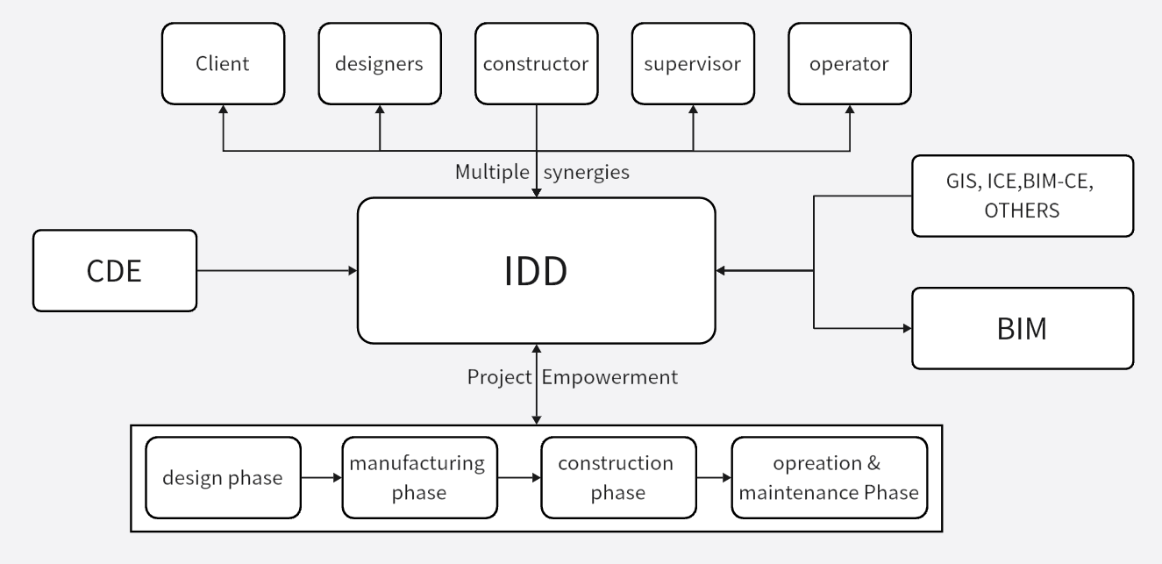Figure2.1 IDD Model Introduction

Furthermore, the IDD model is particularly adept at facilitating organizational coordination. The IDD model facilitates the coordination process, reduces the difficulty of coordination, and provides effective control of costs. Nevertheless, despite the evident advantages of the IDD model in several areas, there is a notable shortcoming: the absence of standardized contract templates. In comparison to the CM model, which is already supported by a well-established contract system, the IDD model still requires further improvement in this area.

In conclusion, the IDD model exhibits clear advantages over the CM model in the domains of data core, model core, key indicator management, application of digital technology, and organizational coordination. However, further efforts are still required in the area of contract standardization.

1. **Case Study**

The selected field model is Building D of the Zhengde Building of Yunnan Agricultural University, situated on the new campus of Yunnan Agricultural University in the northeast of Heilongtan, Panlong District, Kunming. The building has a total area of 6975.85 m2, a footprint of 1774.16 m2, a height of 21.2 m, and a multi-story public building. It specifies the fire resistance levels for the second and first levels of the basement. The first level is to be waterproofed to the P6 concrete seepage grade. The site is located in a seismic zone III in China, which is unfavorable for construction. The design life of the building is 50 years, and the construction site seismic intensity is 8 degrees. The design's basic seismic acceleration value is 0. The design seismic grouping is the third group, and the preliminary design estimate total investment is 15.145 million yuan.

The Revit 2020 software of BIM is selected as the fundamental software. This provides decision support and novel research avenues for the operational and maintenance phases throughout the entire life cycle of the building. BIMcollab is a software platform that enables the creation and sharing of BIM-based building or infrastructure data. BIMcollab facilitates model-based collaboration through a range of platforms, including BIM Coordination, Model Checking, Issue Management, Document Management, and Asset Management. It can source data for the entire lifecycle of a structure and enables the creation and use of Digital Twins (DT), covering design, build, maintenance, and maintenance phases.

**Modelling Analysis in Design Phrase**

In the traditional technology and management mode, numerous issues arise during the design stage. These include inaccurate calculations of the amount of work, incomplete site conditions, variable owner needs, and other management problems. These issues are discussed in detail by Zhou in his paper on the quality of design and bidding, and by Ke in his elaboration on the same topic (Ke et al., 2023, Zhou, 2014). The primary reasons for this phenomenon can be attributed to the traditional design process, which adheres to a conventional "tandem" model. This model prioritizes coordination over collaboration, necessitating that the various disciplines extract quantities in a fixed chronological order. This process is largely dependent on the transfer of information in the form of design documents and text (Ke et al., 2023). However, when problems arise, changes in the optimization process of the design figure or the transmission of information encounter obstacles, which can lead to interruption or delay in the flow of information. This, in turn, has a direct impact on the continuity and accuracy of the design results, which in turn negatively affects the accuracy of the results of the project cost. Currently, PKPM, CAD, and Tianzheng architectural software are primarily utilized during the design phase, replacing the initial hand-drawn design drafts. Ye noted that this software, such as CAD, is capable of rapidly and accurately handling a substantial amount of data. However, during the design and modification process, they often prioritize the local aspects of the design, limiting their ability to consider the overall perspective (Ye et al., 2011).

In the absence of a BIM model, the structural model will be constructed through CAD drawings initially for structural modeling. As illustrated in Figure 4.1, this model was created using BIM software, and the structural model was developed based on the original CAD drawings for Zone D of the Zhengde Building, which represents the structural model of Zone D of the Zhengde Building. The build location can be viewed based on this model.

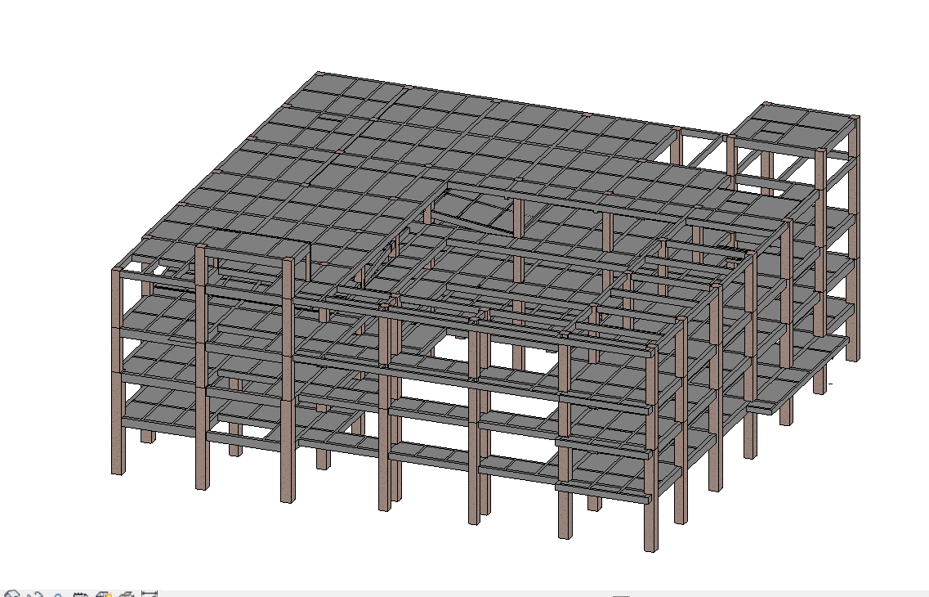Figure4.1 Structural Modelling in BIM

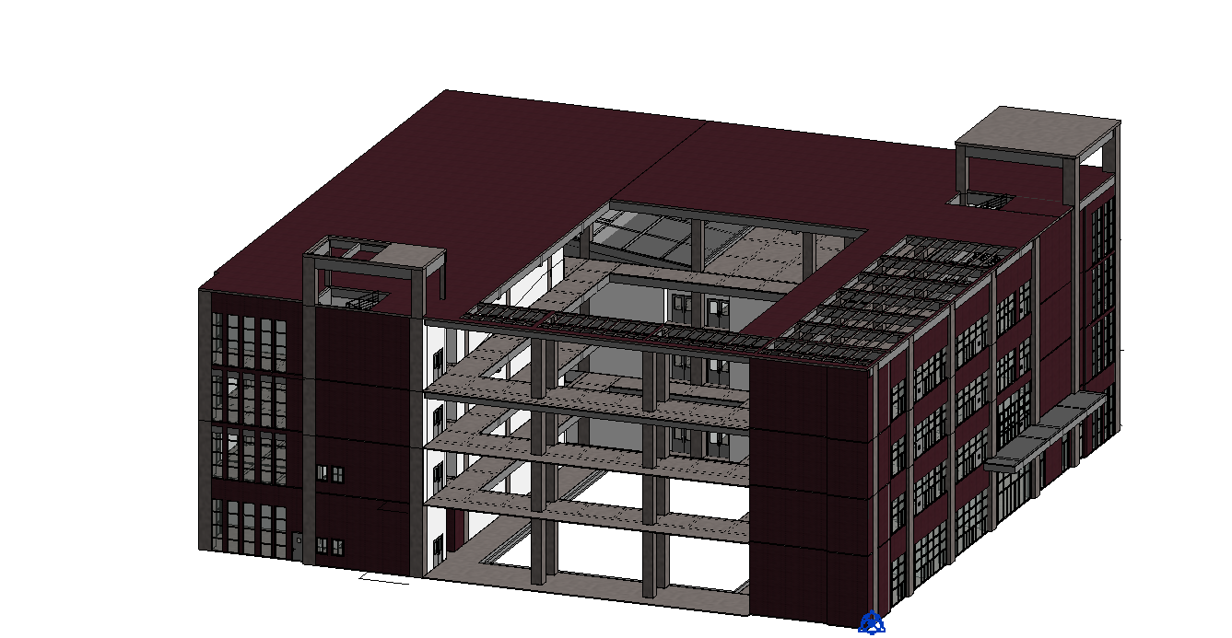Figure4.2 Figure of BIM architectural model in Zhengde Building D

Figure 4.2 shows the architectural model of Zhengde Building D, Figure shows the building model of Zhengde Building D. This figure shows the building model in a more complete way, including the wall facade materials, doors, windows, curtain walls, etc.

The plan view of the BIM model of the beams and slabs in Zone 5.400 of Zhengde Building D, the figure can visually show the location of the beams and slabs.

In contrast to the floor plan, the positional relationship of the beams, slabs, and columns in the BIM model is more intuitive. This eliminates the need to associate the overall model through multiple CAD drawings, which is more meaningful for the implementation of more difficult construction scenarios, such as the Beijing Daxing International Airport and other complex or large-scale projects.

IDD provides a collaborative working platform for multiple parties based on BIM, which allows designers, supervisors, and constructors to update and share real-time data on the same platform, thereby improving efficiency and reducing the cost of communication and coordination. During the design phase, IDD can optimize based on key technical indicators. For example, it can provide the intent and direction to streamline the process in terms of time or cost or provide key optimizations that help to streamline the process. Additionally, key optimizations can be made during the design phase using IDD projects. Furthermore, it is possible to utilize IDD projects in a manner that defines the anticipated outcomes after implementation. This may be achieved by utilizing a specific optimization of the results desired by the client.

IDD technology facilitates collaborative design, the approval of construction drawings through the BIM model, and the implementation of the latest proposed ICE information standards for BIM models and construction drawings based on BIM coordination. It also streamlines the ICE process and digital submissions and approvals, eliminating the need to print out the plans again and reducing waste. Additionally, it performs collision checking and additional optimizations for piping that collides with the building. Furthermore, it is possible to perform performance analysis within the BIM model, including advanced analysis of the building's energy consumption, daylighting, and ventilation. The implementation of IDD technology enables the reduction of time, minimization of documentation issues, and reduction of paperwork. Timely responses to issues can be facilitated through the use of RFI and real-time surveillance cameras, which provide real-time monitoring of the status.

Although the specific implementation process of IDD technology is unknown, it is evident that BIM technology is not highly skilled. Consequently, it is not possible to use IDD technology at the design stage. However, any CAD drawings may be required to provide relevant drawings and additional instructions for practitioners who are unable to use BIM technology or to supplement the BIM model with CAD figures.

**Modelling Analysis in Construction Phrase**

Zhang elucidates the principal function of the construction site layout. The construction site layout constitutes a pivotal foundation and prerequisite for the construction process. A judicious and efficacious site layout plan can enhance site utilization, diminish the necessity for temporary buildings, and reduce the necessity for secondary handling, thereby exerting a profound impact (Zhang, 2017). Liu elucidated the advantages of employing BIM5D, including the capacity to identify issues at an early stage, reduce the necessity for rework, maintain precise control over progress, and expedite the completion of projects while maintaining accuracy and reducing costs (Liu et al., 2017). Furthermore, Song posited that when alterations arise during the execution of the project, the configuration of the construction site must also be modified and adapted. Frequent alterations not only result in a considerable amount of wasted resources, including, but not limited to, the waste of materials, manpower, and time, but also impede the normal progression of the construction process, which in turn affects the efficiency of construction production (Song, 2017).

To achieve these objectives, the optimized site layout facilitates the transportation of materials and effectively avoids interference between tower cranes, thereby accelerating construction progress. Ultimately, these advantages will collectively contribute to a reduction in production costs and an enhancement of the overall economic efficiency of the project. Therefore, in the construction preparation stage, the construction site layout should be given sufficient attention to ensure the smooth progress of the project.

BIM technology can be employed on the construction site before construction to facilitate the planning of specific site uses. For instance, it can be utilized to plan the position of the tower crane, arrange the crane position in advance, optimize the utilization rate of the tower crane, and reduce the secondary costs associated with the subsequent movement of the tower crane position.

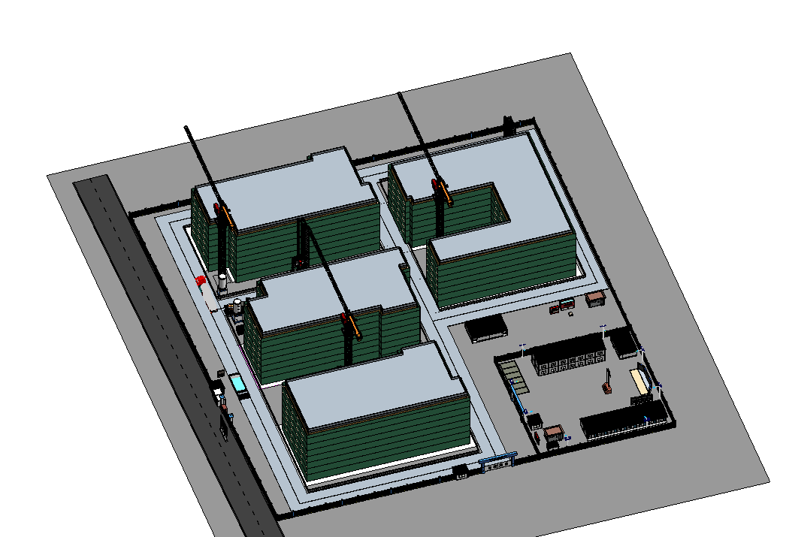Figure4.3 Construction site layout production in BIM

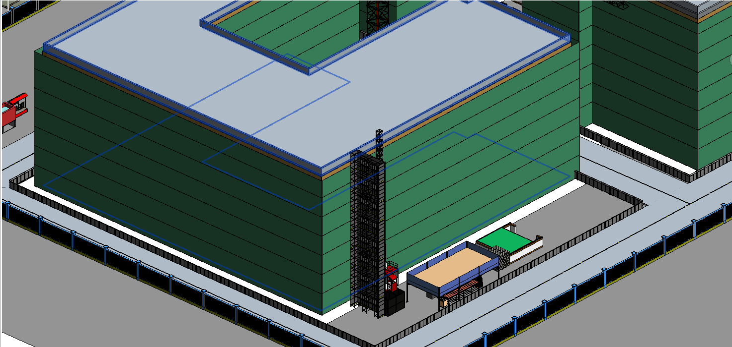Figure4.4 Construction site layout location view in BIM

As illustrated in Figures 4.3 and 4.4, this figure depicts the construction site layout, which was designed by our team by the CAD master plan of the Zhende Building. The layout encompasses the design of roads, the setting of the construction manager's office, the design and layout of the crane position, the design of nine diagrams and five signs, and other fundamental requirements of the construction site design. Figure 4.4 depicts the construction simulation model of Zhengde Building D, which encompasses the construction lift, construction yard, scaffolding, and other pertinent elements. The construction drawings permit the construction party to participate in the project at an earlier stage. Based on the relevant experience of the construction unit, it can be indicated in the virtual construction simulation that the proposed solution is not optimal. Furthermore, Yang proposed a comparison of the optimization results obtained through the fuzzy screening method in order to identify the optimal solution for the site layout (yang et al., 2019).

The architectural design of this edifice is characterized by a concave and irregular plan. For this reason, it is necessary to set up joints. In the construction of the building, it is necessary to deal with the joints individually. In this model, the sides are placed together with the scaffolding, and not specialized in the treatment of the joints.

Analyzing the Figure, it can be found that, compared with the traditional no-advanced layout simulation, or plane layout through CAD drawings, the 3D model can simulate the relative position of facilities more clearly, and can find relevant problems earlier in the simulation of construction, such as the current layout is unreasonable, and can be further optimized promptly. Therefore, to maintain efficient construction and rational use of resources, it is necessary to pay close attention to engineering changes and plan the layout adjustment strategy of the construction site in advance, so as to reduce unnecessary waste and improve construction efficiency.

**Modelling Analysis in Project Management**

The traditional project management model of ICE meeting after the end of the problem report and RFI still necessitates the manual compilation of records and tracking, as elucidated by Li. This is due to the specialization of the various phases of the project, whereby participants typically focus on their responsible phase and have limited support for the other phases. The necessity for extensive communication and negotiation among project participants when a problem arises results in significant time and effort being expended, which in turn impedes the acquisition of technical support and reduces the efficiency and quality of project management. This, in turn, hinders the achievement of the overall objectives of the project (li, 2017).

The implementation of IDD technology enables the capture of RFIs and issues through a cloud-based platform, thereby eliminating the need for manual recording and the subsequent updating of issue resolution status in real-time. Furthermore, all issues are tagged with key information for tracking and data analysis. BIMcollab is capable of providing full-process informatics support for IDD technology as well as DT support. Additionally, IDD is designed to manage the entire process of a project through informatics means. For this reason, IDD technology can be managed through BIMcollab.

The software allows users to add new matters to an existing project in either an app or a website. To do so, users must first enter the matter's title, description, deadline, type, electronic signature, picture, and other relevant information. This information is then used to manage the matter electronically. Users can select from a variety of types of matters, including requests, conflicts, errors, problems, notes, requirements, and more. These types are designed to accommodate different project needs. Figure 4.5 and Figure 4.6 illustrate the types of matters that can be added to a project.

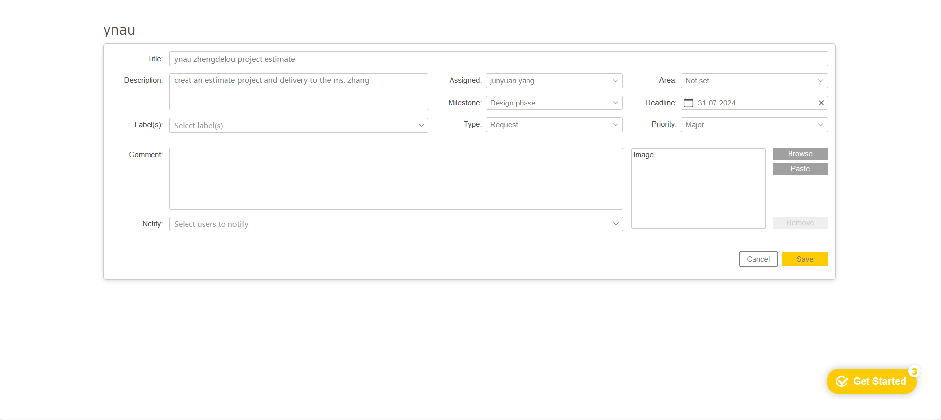Figure4.5 BIMcollab Issue Upload Screen

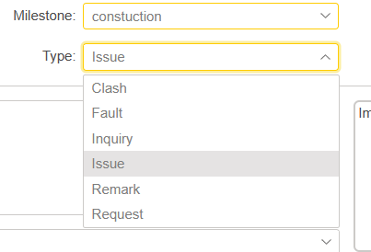Figure4.6 BIMcollab Phase and Problem Type Selection

Being able to upload and collect information promptly in information management is one of the key factors in improving efficiency. In addition, the current exchange of project information is viewed through the software's dashboard, as shown in Figure 4.7.

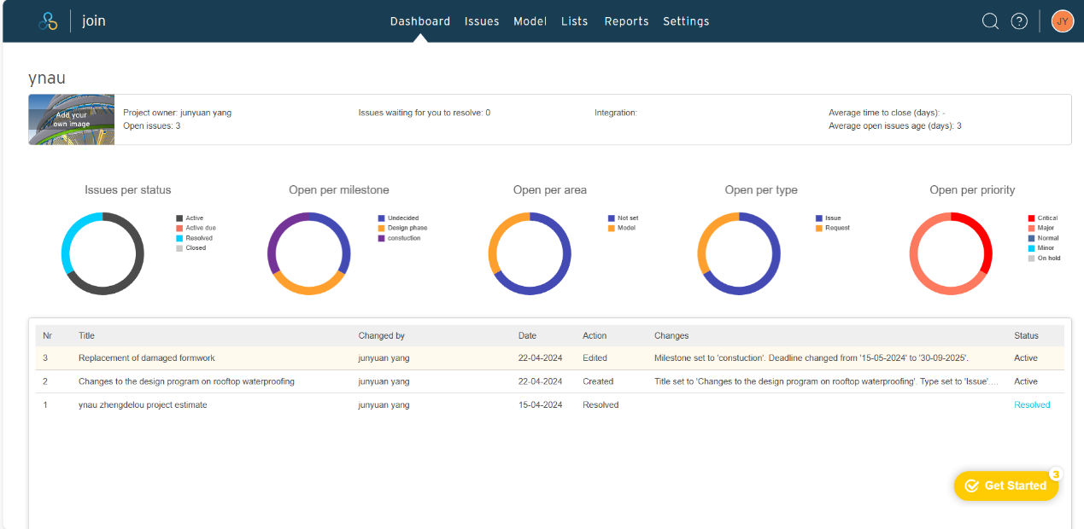Figure4.7 BIMcollab Dashboard

Furthermore, the current state of construction can be taken into account, as can the on-site construction staff, on-site problem requests for reporting, and management to analyze the problem, determine and solve it, improve the efficiency of information transfer, and reduce unnecessary waste of time and money. The use of information management can improve the efficiency of communication between upper and lower levels, increase the degree of information equivalence, and facilitate better mutual understanding between upper and lower levels, as shown in Figure 4.8.

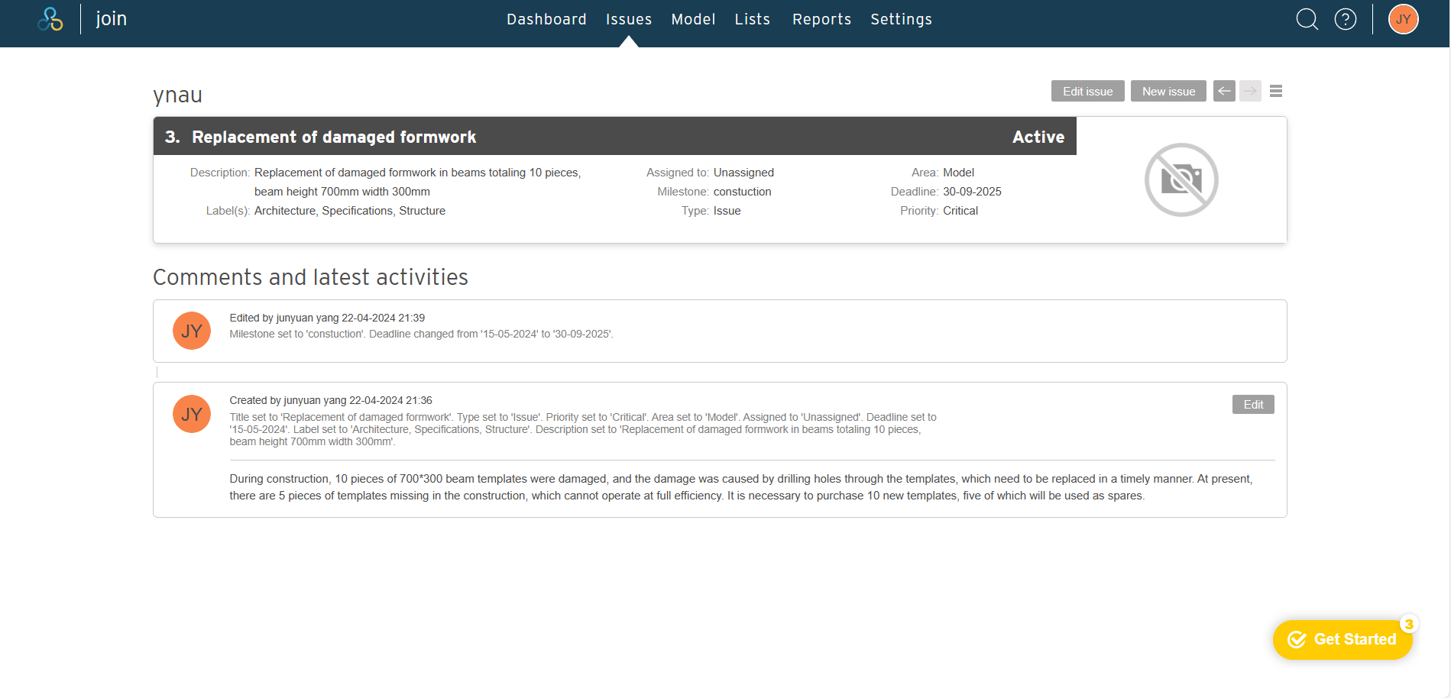Figure4.8 BIMcollab issues check

In contrast to the conventional management paradigm, the novel delivery technology is capable of optimizing the process in question. However, the use of IDD technology allows for improvements in the processing efficiency of the system, as illustrated in Figure 4.9. In the same change, the use of IDD technology enables the completion of five steps with two meetings. Initially, after the construction unit proposes a change, the three parties involved in the construction, design, and building conduct a program change meeting. Subsequently, a coordination meeting is held between the construction, design, building, and supervisors to discuss the plan review and complete the plan review in a single meeting. Once the audit is complete, the construction unit must consider whether to implement the changes. If the implementation is approved, the line sends the instruction sheet and a legally effective electronic signature, which is then used to adjust the contract price. In comparison to the traditional model, which requires multiple meetings, the use of this technology can improve efficiency. Despite the integration of web conferencing into the traditional model, the process remains constrained by the necessity for multiple approvals and the continued reliance on paper documents as the primary medium of information transfer. This is insufficient to achieve optimal efficiency.

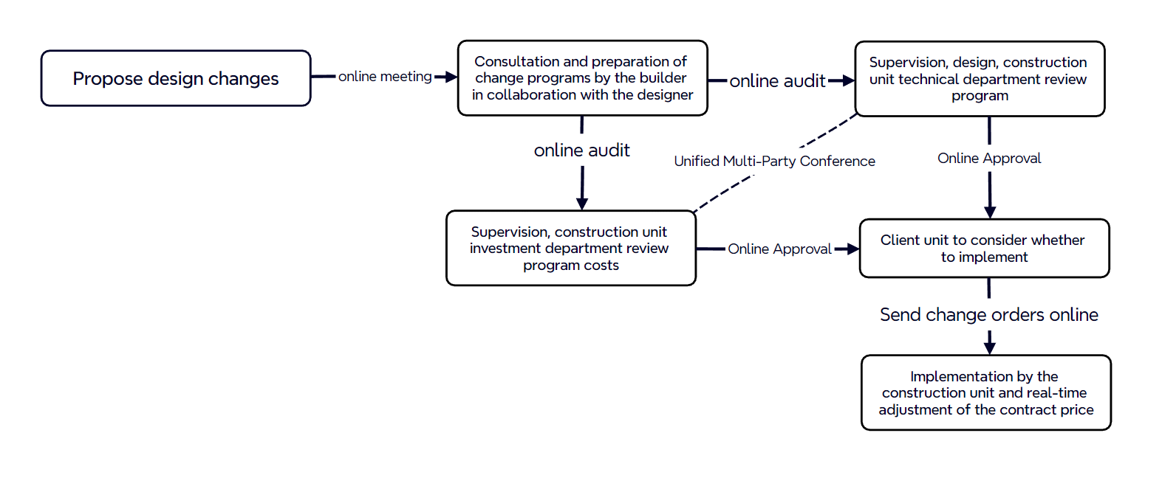Figure4.9 IDD Technical Design Change Flowchart

1. **Discussion**

The data analysis facilitated the determination of the extent of comprehension regarding the advancement of BIM technology, the evolution of science and technology within Yunnan's construction industry, and the grasp of emerging technologies. For instance, the Yunnan ‘Four on’ enterprise development report from 2020 indicates that there are 166 enterprises in the construction industry that meet the qualification criteria, and 3,200 in the real estate development and operation industry. In Yunnan, and the states of Kunming, Qujing, Yuxi, Chuxiong, and Honghe in the Central Yunnan Economic Circle, 61.6% of the total number of enterprises in the province can be found (Statistics, 2021). For this reason, IDD technology in Yunnan has certain possibilities to explore its promotion value and possible promotion programs.

**The Value of IDD Technology in Yunnan**

As an extension of BIM, IDD has the potential for a wide range of future applications. In terms of potential applications, it is anticipated that IDD will revolutionize the traditional collaboration model in the construction industry, facilitating the seamless integration of all parties involved in the entire project lifecycle. The real-time sharing and updating of data can significantly enhance the efficiency and quality of design, construction, operation, and maintenance. The advent of IDD will facilitate the digital transformation of the construction industry, leading to more efficient resource utilization and reduced costs. Furthermore, IDD can facilitate the development of sustainable buildings by optimizing their performance and energy efficiency through the analysis of accurate data. In conclusion, the prospective application of IDD is promising and is anticipated to transform the construction industry and related fields.

Currently, there is a possibility of promoting IDD in Yunnan, which could bring value to project works. This is mainly reflected in the policy and technical advantages. In terms of policy, the Yunnan Housing and Construction Bureau is currently promoting the application of information technology in construction projects and the integration of green building and new technologies(Province, 2020b). With policy support, traditional construction projects will be guided by policy to gradually move towards project Informationlization to reduce costs and improve efficiency.

From a technical standpoint, the implementation of IDD technology has the potential to offer several advantages over traditional civil engineering management technology. These advantages include enhanced multi-party management capabilities, improved multi-party collaboration, more timely reporting and handling of multi-party problems, the standardization of data and information, and more efficient problem handling. Furthermore, the integration of BIM technology can facilitate the management of the entire life cycle of a project, ensuring the seamless and accurate exchange of information among all relevant parties(ji et al., 2013). The implementation of IDD technology in the field of problem reporting and processing has resulted in a notable increase in the speed of multi-party processing. This technology enables the use of electronic responses and signatures, thereby enhancing the credibility of the company. Consequently, the degree of information technology is elevated, multi-party collaboration is more efficient, the degree of information delay is minimal, and the necessity for on-site communication, paper records, and the production of documents is eliminated.

Secondly, the current construction engineering industry in Yunnan Province has identified significant potential for the development of information technology. The results of the survey indicated that respondents were more optimistic about the degree of tolerance for information technology. In Yunnan universities, such as Yunnan University, Kunming University of Science and Technology, Yunnan Agricultural University, Kunming University of Science and Technology Jinqiao College, Yunnan University Dianchi College, and others, BIM courses have been established to promote IDD technology. These institutions aim to provide a solid technical foundation for the relevant field.

In Yunnan, the current focus of information technology construction is to promote the application of BIM technology. Nevertheless, it is important to acknowledge that the knowledge of IDD technology in Yunnan is still inadequate. This may be attributed to the relatively closed nature of regional information, as well as limited exposure to and understanding of emerging technological knowledge. Additionally, the popularization and acceptance of new technologies are relatively slow due to the limited educational resources and development rate in Yunnan.

Further analysis indicates that with the more extensive implementation of BIM technology in Yunnan, the units will gradually recognize the significance of multi-party coordination. In this context, the promotion of IDD technology will become particularly important, as it can serve as a key supplement to the subsequent development of BIM technology. Once the benefits of BIM technology have been realized, units will inevitably seek to employ new technical means to optimize the project management process. Consequently, the promotion of IDD technology at this juncture not only garners considerable societal attention but also achieves a promotion effect with minimal effort. The implementation of this strategy is expected to facilitate the accelerated advancement of Yunnan in the domain of emerging technologies.

The promotion of IDD technology in Yunnan aligns with the current policy mainstream direction and, at this stage, there is a lack of understanding of IDD technology in Yunnan. Therefore, the promotion of IDD technology in Yunnan has value. Consequently, the technology in Yunnan is of significant value, with high feasibility and potential for enhancement and empowerment.

**IDD Technology Promotion Programme in Yunnan**

The promotion of this technology in Yunnan is primarily influenced by four key factors: policy, the subjective application possibilities of market companies, personnel quality improvement, and education improvement. In light of the aforementioned considerations, this paper proposes a strategic diffusion plan. Following the successful diffusion of BIM technology, IDD technology is introduced immediately afterward. The strategy is based on the premise that the successful application of BIM technology, which is one of the core technologies of IDD, will lay a solid foundation for the promotion of IDD technology. Moreover, given Kunming's central position within Yunnan Province, it can be utilized as a hub to gradually expand the influence and application of new technology throughout the entire province. This approach will not only enhance the efficiency of the promotion process but also leverage the demonstration effect of Kunming to accelerate the market's acceptance of the new technology.

At the policy level, in 2023, the Ministry of Housing and Construction will carry out a pilot project on the digital management of the whole life cycle of the project for a period of one year, which mainly includes advancing the digital process of construction approval, establishing the coding of building units as well as the mechanism of dropping Figures, and setting up the lifecycle data sharing and other seven aspects, among which advancing the whole process of digital construction approval and perfecting the mechanism of hierarchical data sharing is a mandatory task, and Kunming is also among the pilot cities of this project(Development, 2023). The technology has the capacity to provide comprehensive coverage of the digital pilot content of the entire life cycle of the project. This is expected to be supported by the policy and implemented, which in turn will facilitate the wide dissemination of the technology project at the policy level. Furthermore, due to the lack of data standards, the current BIM technology and software are predominantly foreign software. In order to promote the policy, it is necessary to synchronize software information standards, which include the definition of suitable software standards, technical specifications, and so forth.

At the enterprise level, if the application of the policy push results in significant improvements in cost, schedule, staffing, and security performance, it is anticipated that the technology will be sustained and further extended to other enterprises. It is anticipated that this process of technology diffusion will be spearheaded by large state-owned enterprises and centralized enterprises, with smaller enterprises gradually adopting the technology.

In terms of education and training, tertiary institutions will play a pivotal role in equipping high-level talents with professional knowledge and skills for this technology, thereby establishing a robust foundation of talents for its widespread dissemination. Furthermore, tertiary education can also enhance the professionalism of practitioners and provide higher-end talents for engineering projects, thereby ensuring the smooth implementation of the entire technology process and the continued advancement of the technology.

In terms of individual career planning, as the demand for this technology grows in society, practitioners will respond positively to the development trend of enterprises and society by learning and mastering the new technology as an important way to enhance their personal career development. This will, in turn, improve the professional level of the entire industry. In conclusion, the coordinated advancement of multiple avenues is anticipated to facilitate the appropriate implementation and long-term advancement of this technology in projects.

A preliminary investigation suggests that the current surge in BIM education may be attributed to the growing prevalence of BIM courses in colleges and universities. A survey of academic institutions with civil engineering programs revealed that nearly all of them offer BIM courses and teach BIM technology. Secondly, the national policy advocates the use of BIM technology throughout the project engineering cycle, including the implementation of pilot cities. Moreover, BIM technology can facilitate efficiency gains, such as enhanced visualization during the design and construction phases. Other technologies have not yet reached a sufficient level of understanding due to the current lack of promotion and lack of policy advancement. Secondly, the lack of understanding of the technology impedes the opportunity to test it. While it may lead to efficiency or revenue and expenditure advantages, the lack of testing still has a relevant impact on the new technology. Finally, a lack of relevant research funding for the firm or company results in less investment in new technology, which prevents the firm from tapping into the efficiency potential of the new technology. Consequently, the firm does not adopt the technology. The lack of efficiency gains requires more investment at the managerial or other levels, which results in a positive feedback loop of negative inputs.

However, two significant challenges currently exist in the promotion of technology. These challenges are related to the limitations of current technology and the difficulties in its dissemination. Currently, there are several challenges in the promotion of IDD technology in Yunnan. These include a lack of sufficient IoT, BIM, and other core information technology, which hinders the effective promotion of IDD technology. Additionally, there is a limited understanding of IDD technology, with less knowledge of it than BIM. Furthermore, there is a skeptical attitude among relevant practitioners of the technology. Finally, Yunnan's economic development is relatively backward, which may result in less investment in new technology and a need for government financial support for the promotion of IDD technology. Yunnan's economic development is relatively underdeveloped, with a correspondingly lower level of investment in new technology and a greater need for government financial support to promote its use. These issues will constrain the advancement of IDD technology. These issues will impede the advancement of IDD technology in Yunnan. The underlying cause may be the substandard quality of university-level practitioners, who are ill-equipped to effectively disseminate BIM and other information technology education. Enhancing the caliber of personnel may prove instrumental in effecting a transformation.

In addition, IDD itself also has some problems, such as the specific implementation process is not clear, the lack of clear cases to guide; the lack of clear technical specifications, only throughout the whole process of information technology software connect; the lack of construction industry specifications for the domestic construction industry in China, so that the IDD technology is not able to efficiently and appropriately develop in China; in addition, the lack of IDD technology in the application of small and medium-sized projects, the lack of specific data to prove the advantages of the application of IDD technology in small and medium-sized projects. In addition, there is a lack of application cases of IDD technology in small and medium-sized projects and a lack of concrete data to prove the advantages of IDD technology in small and medium-sized projects.

1. **Conclusion**

The rise and development of the CREM market has undoubtedly been a striking phenomenon during the transformation of the CREM's economic system. The transition from a centrally planned economy to a market economy has created a vast expanse for the CREM market to flourish, while the marketization of housing policies has infused the sector with considerable vigor. This transformation has not only facilitated urbanization but also underscored the far-reaching impact of industrial and capital growth on the CREM market. It has further reinforced the pivotal role of the real estate industry in the national economy. Nevertheless, it is essential to acknowledge the challenges currently facing the CREM market, including high property prices in certain regions and the lack of enforcement of market control policies. The existence of these problems necessitates the collaborative efforts of the government, enterprises, and all sectors of society to identify solutions through measures such as strengthening policy guidance, optimizing the market environment, and enhancing consumer confidence. In parallel, the rapid development of information technology, including the integration of technologies such as big data, cloud computing, and AI, has provided substantial technical support for the digital transformation of the CREM industry. The application of these advanced technologies not only enhances the efficiency of project management but also reduces operational costs, thus effectively improving market competitiveness.

In light of these considerations, the advent of emerging management technologies such as IDD and BIM offers new prospects for the sustainable and healthy development of the CREM industry. IDD technology has demonstrated significant advantages over traditional management models in a number of ways. BIM technology provides comprehensive information and data support for the full life cycle of a project, while BIMcollab promotes collaborative work between all project participants. BIMcollab has the potential to facilitate collaborative work between all project participants, thereby promoting synergistic co-operation among them. The application of these new management technologies is not only expected to enhance the overall profitability of the project but also to promote the transformation of the construction industry in the direction of digitalization and intelligence.

Although IDD technology is still facing some challenges in the process of promotion and application, such as the lack of clarity of the specific implementation process and the lack of technical specifications, it is reasonable to believe that these problems will be effectively solved as the research continues to deepen and the technology continues to progress.

In conclusion, IDD technology can facilitate project engineering by optimizing existing processes based on key performance indicators (KPIs), optimizing processes prone to delays and rework, and optimizing processes specifically designed to optimize key indicators for time, cost, or quality. Ultimately, this approach can reduce the overall process time, the number of design changes, and the time required for delays, among other benefits. Furthermore, the definition of information standards can be refined to facilitate the seamless exchange of crucial data, such as the comprehension of drawings by multiple parties and the streamlining of their own information. Furthermore, the simplification and standardization of key information exchanges can be identified for information standards, such as multi-party understanding of drawings, multi-party simplification of their own information, by following standard information rules, targeting issues, automated multi-party extraction of information, multi-party collaboration, and including new delivery models, new figure formats, new core information, and new quality standards in the new data standards. The discussion was limited to small and medium-sized projects in Yunnan, where the application of the simulation was compared to the traditional management model. While the CDE platform was not utilized, there was a notable discrepancy between the complete IDD technology process and the aforementioned model. Furthermore, the promotion of IDD technology from small and medium-sized projects to large-scale projects and the enhancement of the aforementioned process is contingent upon the results of a subsequent study.

Acknowledgements

This paper is an output from the author’s undergraduate dissertation and the Project of Yunnan International Joint R&D Centre of Smart Environment (202303AP140013) and First-class undergraduate curriculum construction (A2012022052, A2012024062, A2020400003060, A2020400003123) etc. We acknowledge with lots of thanks the involvement of the participants in the study.

**REFERENCE**

1. B.C.A. 2018. BCA-IMDA Call for Subimssion-Constraction Digital Platforms (CDP). Singapore: B.C.A.
2. B.C.A. 2020a. Benefits of Adopting IDD [Online]. Singapore Government Agency Website: B.C.A. Available: https://www1.bca.gov.sg/buildsg/digitalisation/integrated-digital-delivery-idd/benefits-of-adopting-idd [Accessed].
3. B.C.A. 2020b. PROJECT- JTC CleanTech Two Block B @ CleanTech Park [Online]. Singapore Government Agency Website. Available: https://www1.bca.gov.sg/buildsg/digitalisation/integrated-digital-delivery-idd/idd-projects/project-jtc-cleantech-two-block-b-@-cleantech-park [Accessed].
4. B.C.A. 2023. IDD Requirement [Online]. Singapore Government Agency Website: B.C.A. Available: https://www1.bca.gov.sg/buildsg/digitalisation/integrated-digital-delivery-idd/idd-requirements [Accessed].
5. B.C.A. 2024. Integrated Digital Delivery (IDD) Requirements [Online]. Available: https://www1.bca.gov.sg/docs/default-source/idd/generic_idd_requirements_draft.pdf?sfvrsn=82e78e51_2 [Accessed April 2024].
6. CHEN, Y. & CHENG, Y. 2023. Progress of BIM-based assembly building research. Laboratory Research and Discovery, 42, 235-242.
7. DEVELOPMENT, G. O. O. T. M. O. H. A. U.-R. 2023. Notice of the General Office of the Ministry of Housing and Urban-Rural Development on the Pilot Reform of Digital Management of the Whole Life Cycle of Engineering and Construction Projects. In: DEVELOPMENT, G. O. O. T. M. O. H. A. U.-R. (ed.).
8. DEVELOPMENT, M. O. H. A. U.-R., COMMISSION, D. A. R., TECHNOLOGY, M. O. S. A., TECHNOLOGY, M. O. I. A. I., SECURITY, M. O. H. R. A. S., TRANSPORTATION, M. O. E. A. E. M. O., RESOURCES, M. O. W., TAXATION, M. O., SUPERVISION, G. A. O. M., COMMISSION, G. A. O. B. A. I. R., BUREAU, R. & ADMINISTRATION, C. A. 2020. Guiding Opinions of the Ministry of Housing and Urban-Rural Development and Other Departments on Promoting the Synergistic Development of Intelligent Construction and Construction Industrialization. In: DEVELOPMENT, M. O. H. A. U.-R. (ed.). Ministry of Housing and Urban-Rural Development website.
9. DU, Y., ZHAO, G. & ZHANG, L. 2022. Combination and Exploration of BIM Technology and Safety Management in Construction Engineering Project Management. People's Yellow River 44, 288-290.
10. GONG, Z., WANG, Y. & LIAO, S. 2023. Digitization of construction project management based on digital twins. Journal of Civil Engineering, 1-15.
11. HUANG, Q. 2022. Chinese real estate market: Past, present and future. Management modernization, 42, 1-8.
12. HWANG, B.-G., NGO, J. & HER, P. W. Y. 2020a. Integrated Digital Delivery: Implementation status and project performance in the Singapore construction industry. Journal of Cleaner Production, 262, 121396.
13. HWANG, B. G., NGO, J. & HER, P. W. Y. 2020b. Integrated Digital Delivery: Implementation status and project performance in the Singapore construction industry. Journal of Cleaner Production, 262, 11.
14. JI, Y., ZHOU, X. & LI, X. 2013. Application of BIM technology in new building industrialization. construction economics, 14-16.
15. JIN, D. & CAO, Q. 2010. Discussion on the application of the CM model of construction engineering organization and management in water conservancy projects in our province. Heilongjiang Water Science and Technology, 38, 113-114.
16. KE, Y., LI, W. & HU, H. 2023. Application of Engineering Cost Management in the Design Stage of Water Transportation Projects Based on BIM Technology. Construction Economics, 44, 332-335.
17. LI, J. 2017. BIM technology brings about a shift in the traditional project management model. China Engineering Consulting, 53-55.
18. LI, Y. 2020. Exploring the Feasibility Study of Supervision Enterprises Using CM Model to Participate in PPP Project Management. Construction Supervision, 9-12.
19. LIU, D., PENG, X., LIU, S., ZHOU, X., ZHANG, X. & CHEN, G. 2017. Application of BIM5D in engineering project management. Construction technology, 46, 720-723.
20. LIU, Z. W., LU, Y. J., SHEN, M. & PEH, L. C. 2021. Transition from building information modeling (BIM) to integrated digital delivery (IDD) in sustainable building management: A knowledge discovery approach-based review. Journal of Cleaner Production, 291.
21. LU, J. 2017. A study of the impact of CREM's real estate industry development on economic growth. Doctor.
22. NET, X. 2022. Promoting the steady and healthy development of the Real Estate Market -- Implementing the spirit of the meeting of the Political Bureau of the Central Committee to do a good job in the current economic work series of comments [Online]. Bei Jing: Xinhua Net Available: https://www.gov.cn/xinwen/2022-05/06/content_5688769.htm [Accessed May 6th 2022].
23. PROVINCE, D. O. H. A. U.-R. D. O. Y. 2020a. Yunnan Provincial Department of Housing and Urban-Rural Development Approval of the Preliminary Design of Yunnan Agricultural University Engineering Teaching Comprehensive Training Center Construction Project. In: PROVINCE, H. A. U.-R. D. O. Y. (ed.). No.3 Hongta East Road, Kunming.
24. PROVINCE, D. O. H. A. U.-R. D. O. Y. 2020b. Yunnan Provincial Department of Housing and Urban-Rural Development Yunnan Provincial Development and Reform Commission Yunnan Provincial Department of Industry and Information Technology Yunnan Provincial Department of Education Yunnan Provincial Office of the People's Bank of China Kunming Central Sub-branch Yunnan Provincial Administration of Public Organizations Yunnan Banking and Insurance Supervision Bureau on the Issuance of the Implementation Plan for the Action of Creating Green Buildings in Yunnan Province. In: PROVINCE, H. A. U.-R. D. O. Y. (ed.). No.3 Hongta East Road, Kunming.
25. SACHS, G. 2023a. Goldman Sachs View | China Macroeconomic Outlook 2024 [Online]. Available: https://www.goldmansachs.com/worldwide/greater-china/insights/2024-China-macro-outlook.html [Accessed DEC. 2023].
26. SACHS, G. 2023b. The Tale of 2023 in 10 Charts [Online]. Available: https://www.gspublishing.com/content/research/en/reports/2023/12/17/7e30caa9-30d8-40b7-90c1-6ddd758de9d1.html [Accessed Dec. 17th 2023].
27. SONG, X. 2017. Study on dynamic arrangement of construction site based on BIM technology. master's degree.
28. STATISTICS, T. N. B. O. 2019. National real estate development investment and sales from January to December 2018 [Online]. Bei Jing: The National Bureau of Statistics. Available: https://www.stats.gov.cn/sj/zxfb/202302/t20230203_1900208.html [Accessed January 21st. 2019].
29. STATISTICS, T. N. B. O. 2022. Investment in real estate development will increase by 4.4% in 2021 [Online]. Bei Jing: The National Bureau of Statistics Available: https://www.stats.gov.cn/xxgk/sjfb/zxfb2020/202201/t20220117_1826440.html [Accessed January 17th 2022].
30. STATISTICS, T. N. B. O. 2023. National real estate development investment will drop by 10.0% in 2022 [Online]. Bei Jing: The National Bureau of Statistics Available: http://www.stats.gov.cn/sj/zxfb/202302/t20230203_1901712.html [Accessed January 17th 2023].
31. STATISTICS, Y. P. B. O. 2021. Report on the Development of Yunnan's “Four Top” Enterprises in 2020 [Online]. Available: https://stats.yn.gov.cn/Pages_23_2642.aspx [Accessed 1st. Feb. 2021].
32. YANG, B., YANG, C., XIAO, J. & PAN, Y. 2019. BIM-based construction site arrangement and optimization technology for assembled buildings. building structure, 49, 921-925.
33. YE, L., LIU, M. & LI, X. 2011. A study of the application of CAD technology in civil engineering. Manufacturing automation, 33, 153-156.
34. YUJIE, L., JIAHUI, L., SHUO, W., YE, M. & QILONG, Z. 2023. Establishment of an integrated digital delivery (IDD) system under the perspective of new construction industrialization. J Tsinghua Univ (Sci& Technol), 1-10.
35. ZHANG, Z. 2017. Construction site layout and optimization based on BIM information technology. Tianjin Construction Technology, 27, 34-36.
36. ZHOU, X. 2014. Problems and Countermeasures in Engineering Design Management of Construction Projects. China Internal Audit, 79-80.