Vibration Analysis of a Rotating Shaft

A Mini Project Report Submitted
In

Partial fulfillment of requirement for award of

Master of Technology
In
Computer Aided Design and Manufacturing Engineering

Submitted By
Chetan K Changale

Under the Guidance of

Prof (Dr.) Anil R Sahu
( Faculty In-Charge)
(Times new Roman 16)



Department of Mechanical Engineering
G H Raisoni College of Engineering and Management, Pune
(An Empowered Autonomous Institute Affiliated to Savtribai Phule Pune University)
(Times new Roman 16 /12)

May-2025

G H Raisoni College of Engineering and Management, Pune
(An Empowered Autonomous Institute Affiliated to Savitribai Phule Pune University)

C E R T I F I C A T E

This is to certify that the Mini Project report entitled “ Vibration Analysis of a Rotating Shaft” submitted by Mr. Chetan K Changale for partial fulfillment of the requirement for the award of the degree of Master of Technology (M.Tech.) in Computer Aided Design and Manufacturing Engineering (CADME), has been carried out under my supervision at the Department of Mechanical Engineering, G H Raisoni College of Engineering and Management , Pune an empowered Autonomous Institute affiliated to Savitribai Phule Pune University, Pune. The work is comprehensive, complete and fit for evaluation .

Prof (Dr.) Anil Sahu Prof (Dr.) Dipak Patil Prof (Dr.) Adik Yadao
Faculty In-Charge P.G. Coordinator Head of Department

Dr. R. D. Kharadkar
Director

External Examiner

G H Raisoni College of Engineering and Management, Pune
(An Empowered Autonomous Institute Affiliated to Savitribai Phule Pune University)

DECLARATION BY THE CANDIDATE

I the undersigned hereby declare that the Mini Project report entitled“ Vibration Analysis of a Rotating Shaft”submitted by me for the for partial fulfillment of the requirement for the award of the degree of Master of Technology (M.Tech.) in Computer Aided Design and Manufacturing Engineering (CADME), is the record of work carried out by me in the Department of Mechanical Engineering, G H Raisoni College of Engineering and Management Pune. The work is original and has not been submitted earlier as whole or in part for the award of any degree/ Diploma at this or any other Institution/ University.
I further declare that the material obtained from other resources has been duly acknowledged in the report.

Date:
Place: Pune

Mr.Chetan K Changale
Name of the Candidates
Acknowledgement

Firstly I would like to express my heartfelt gratitude to my research guide Prof. (Dr.) Anil Sahu for his unwavering support and expert guidance during this voyage. His tenacity and excellent standards aided in completing this research work promptly.
I would also like to express my heartfelt gratitude to Dr. R. D. Kharadkar, Director G H raisoni College of Engineering and Management, Pune for his continuous support and providing all facilities to complete this mini project work.
I extend my sincere thanks to Dr. Adik yadao, Head of Mechanical Engineering Department and Dr. Dipak Patil (PG. Coordinator) for their support, guidance and motivation throughout my research work..
Furthermore, I would like to thank all teaching & non-teaching staff of the Mechanical Engineering Department who helped me from time to time in all respects. I express my special thanks to the librarian for providing me all the reference books and material needed for completion of my Mini Project work.
Finally, I want to thank all of my friends for their support & suggestions. Last but not the least I would like to express my sincere thanks to my family members for their motivation and inspiration throughout this Mini Project work.

Chetan K Changale
Name of Candidate

Index

1. Introduction (Synopsis)
1.1 Project Objective
1.2 Background and Theory
1.3 Steps for Integration
1.4 Types of Vibrations
1.5 Materials and Equipment
1.6 Modal Analysis
2. Methodology
3. Performance Analysis
4. Results and Discussion
5. Conclusions

1.Synopsis of Vibration Analysis of a Rotating Shaft

1. Objective:
- The goal is to study the vibration behavior of a rotating shaft and identify the causes of vibrations, whether they are due to unbalanced loads, misalignment, or resonance. By analyzing the vibrations, you can predict failure modes and improve the design and operation of machinery.
- 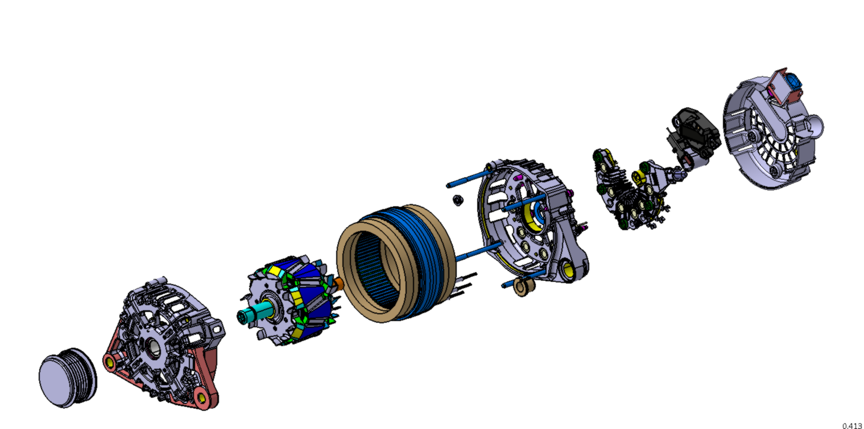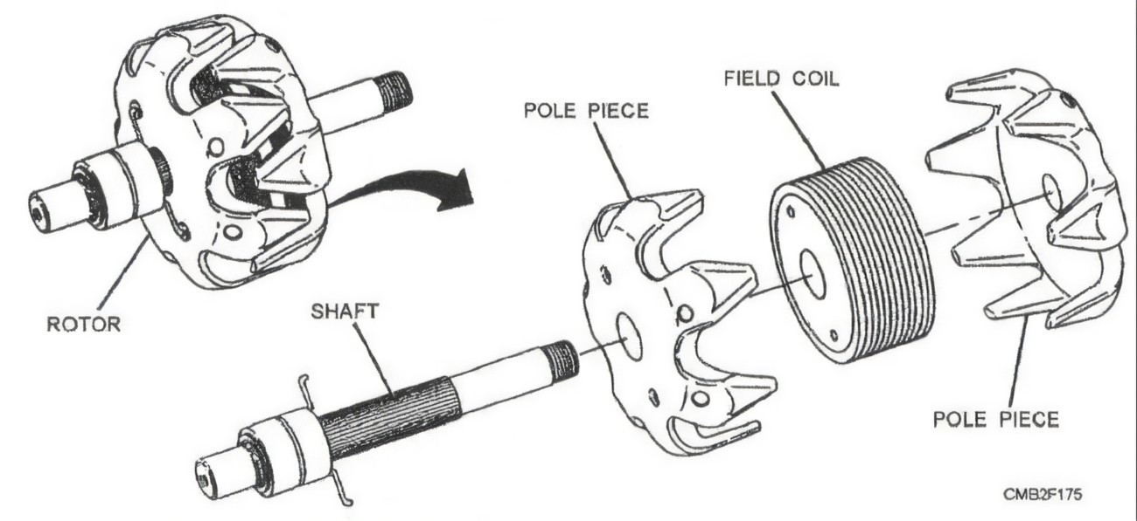

2. Background and Theory:
- Vibration in Rotating Shafts: When a shaft rotates, various factors can cause it to vibrate, such as:
  - Imbalance: If the shaft is not uniformly distributed in mass, it will generate centrifugal forces during rotation.
  - Misalignment: If the shaft is misaligned with its supporting bearings, vibrations will occur.
  - Bearing Faults: Damaged or worn-out bearings can introduce vibrations.
  - Resonance: If the shaft’s natural frequency coincides with the rotational frequency, resonance may occur.
- Types of Vibrations:
  - Free Vibration: Occurs without external excitation once the shaft is displaced.
  - Forced Vibration: Caused by external forces such as unbalanced masses or misalignments.
- Analysis Techniques: Vibration analysis involves detecting and analyzing the frequency spectrum of the vibrations. Key methods include:
  - Time Domain Analysis
  - Frequency Domain Analysis (using FFT)
  - Modal Analysis

3. Materials and Equipment:
- Shaft Model: A simple rotating shaft setup can be used, possibly with varying lengths or masses added to create imbalance.
- Vibration Sensor/Accelerometer: To measure the vibrations at various points along the shaft.
- Data Acquisition System (DAQ): To collect and analyze vibration data.
- Motor: To rotate the shaft and simulate operational conditions.
- Oscilloscope/FFT Analyzer: For visualizing the frequency spectrum of the vibrations.
- Software: You can use software like MATLAB or LabVIEW for analysis and signal processing.

4. Methodology:
- Step 1: Setup the Experiment
  - Install the rotating shaft in the system with appropriate bearings and motor.
  - Mount vibration sensors at different positions along the shaft.
- Step 2: Vibration Measurement
  - Run the motor to rotate the shaft at different speeds (RPM).
  - Measure the vibrations at multiple speeds and load conditions. Record the time-domain data.
- Step 3: Data Analysis
  - Use Fast Fourier Transform (FFT) to analyze the frequency spectrum of the vibration data.
  - Identify any dominant frequencies and correlate them with the shaft's operating speed.
- Step 4: Identification of Causes of Vibration
  - Look for abnormal peaks in the frequency spectrum that could indicate problems like unbalance, misalignment, or resonance.
  - Compare the measured vibration levels with acceptable limits to determine if corrective actions are needed.
- Step 5: Conclusion
  - Summarize the findings and suggest improvements, such as balancing the shaft, improving alignment, or redesigning the system to avoid resonant frequencies.

5. Results and Discussion:
- Interpret the results from your vibration data. Did you observe any unusual vibration patterns? Did the vibrations change with speed? Was there evidence of resonance or imbalance?
- Discuss potential solutions to minimize vibrations, such as:
  - Balancing the shaft.
  - Aligning the shaft properly.
  - Using vibration dampeners.

6. Conclusion:
- Reflect on the importance of vibration analysis in real-world applications. How does vibration affect the lifespan and efficiency of rotating machinery?
Applications : Alternators ,Generator ,Starter Motor

Name :- Chetan K Changale
Roll.No :- 12
Registration No :- 24ACAD2121012
Class: MTech CAD M.E

1.1 Project Objectives :

Analysis of Shaft Misalignment in Rotor-Bearing Systems Using Vibration Spectrum Prediction
Mechanical systems, including motors, pumps, engines, and turbines, are integral to numerous industrial applications and rely heavily on rotating shafts to perform their functions. These shafts often operate under varying rotational speeds, depending on the system's intended application and design. However, the dynamic nature of these systems exposes them to diverse operational challenges, leading to potential faults such as cross-sectional cracks, structural looseness, and shaft misalignment. Among these, shaft misalignment is a critical factor, as it not only diminishes system performance but can also cause irreversible damage, reducing the overall lifespan of the system.
This research paper presents an experimental investigation into the vibration characteristics of a rotor-bearing system subjected to shaft misalignment. The study aims to predict the vibration spectrum associated with misalignment conditions to better understand its impact and develop potential mitigation strategies. For this purpose, a rotor-bearing setup was designed and subjected to controlled misalignment scenarios under various operational conditions. A key instrument employed in this experimental framework was an accelerometer, a device capable of capturing high-frequency vibrations, thereby providing real-time insights into the system's dynamic behavior.
Complementing this setup, the Fast Fourier Transform (FFT) Analyzer was utilized to process the vibration data collected. The FFT Analyzer is an essential tool in vibration analysis, as it translates complex time-domain data into the frequency domain. This transformation enables the identification of dominant vibration frequencies, harmonics, and patterns that signify shaft misalignment. The collected frequency spectrum was analyzed to identify trends and deviations caused by varying degrees of misalignment, shedding light on how such faults manifest in the system's vibration signature.
The findings from this research contribute significantly to the field of machinery diagnostics and prognostics. By accurately predicting the vibration spectrum resulting from shaft misalignment, the study provides valuable insights into early fault detection mechanisms. This early intervention can prevent further escalation of damage, minimizing downtime and maintenance costs. Additionally, the research underscores the importance of routine condition monitoring and the role of advanced diagnostic tools in enhancing the operational efficiency and reliability of mechanical systems.
From an application perspective, the results hold immense promise for industries relying on alternators and similar machinery. By incorporating the findings into design and maintenance protocols, manufacturers and operators can enhance the efficiency, durability, and reliability of these systems. Specifically, addressing shaft misalignment at its onset can improve energy transfer, reduce wear and tear, and extend the service life of critical components.
Overall, this study not only highlights the detrimental effects of shaft misalignment but also offers a practical approach to its detection and mitigation through experimental analysis. The integration of accelerometers and FFT Analyzers proves to be a robust methodology for identifying misalignment, making it an invaluable contribution to the field of rotor dynamics and machinery health monitoring. Future research can build upon these findings by exploring other fault scenarios, integrating machine learning algorithms for automated fault detection, and enhancing the scalability of the proposed methodologies for diverse industrial applications.
1.2 Background and Theory : Vibrations in Alternator Rotor Shafts:
1. Single plane imbalance - It is also known as static imbalance and is usually the easiest problem to diagnose. Generally produced by non-uniform radial surface wear on rotors in which its length is negligible compared to its diameter. The source of the vibration is a centrifugal force which causes a displacement of the axis of rotation in the radial direction. In the absence of other problems the imbalance generates a pure sinusoidal waveform and therefore the spectrum presents dominant vibration with a frequency equal to 1xRPM of the rotor.
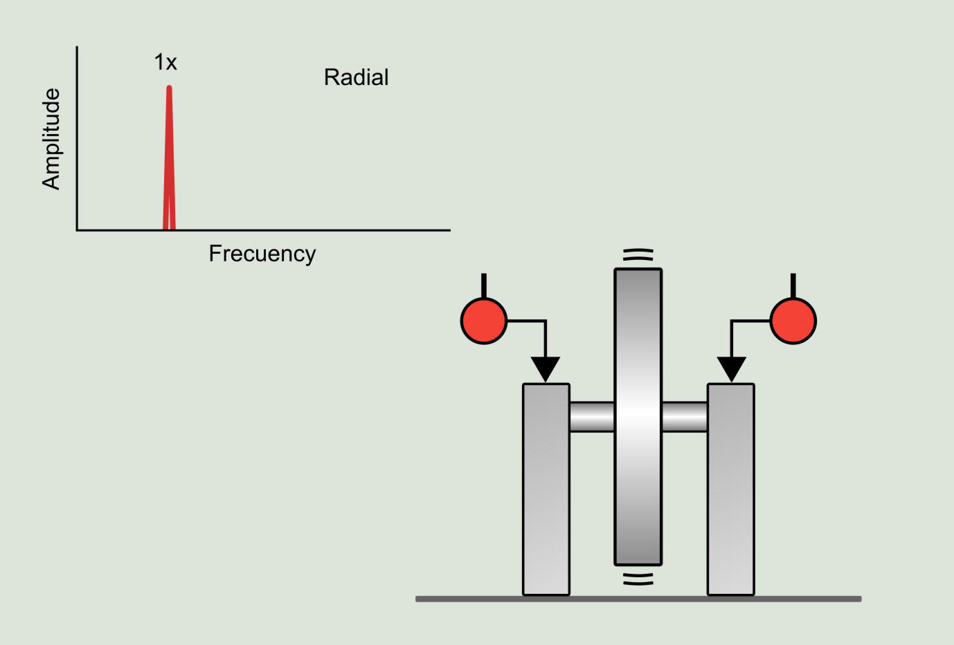

2. Two plane imbalance -In this case the origin of the imbalance is not a force, but a pair of forces. That is, two forces of equal magnitude and opposite direction. The dynamic imbalance occurs in medium and long rotors and it is mainly due to simultaneous radial and axial wear on the rotor surface. The spectrum exhibits dominant vibration and simultaneous sway at a frequency equal to 1xRPM of the rotor.
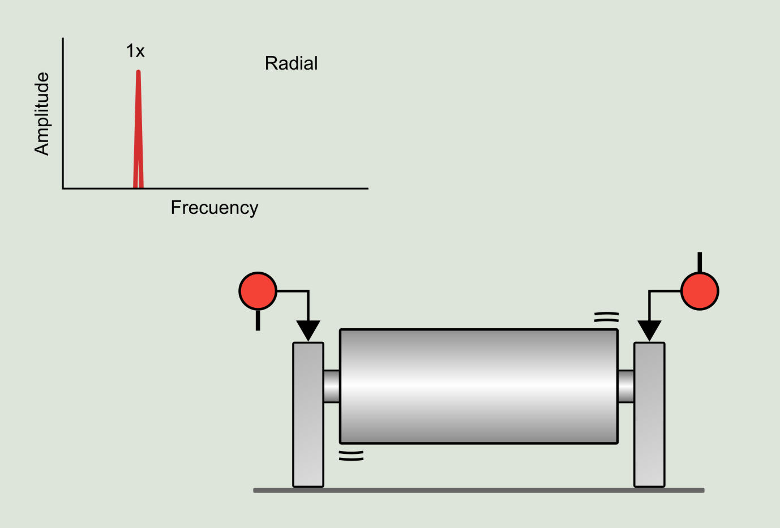

3. Overhung rotor - It occurs in rotors at the end of a shaft. It is produced by wear on the rotor surface and bending of the shaft. The spectrum presents dominant vibration at 1xRPM of the rotor, very notorious both in axial and radial directions.

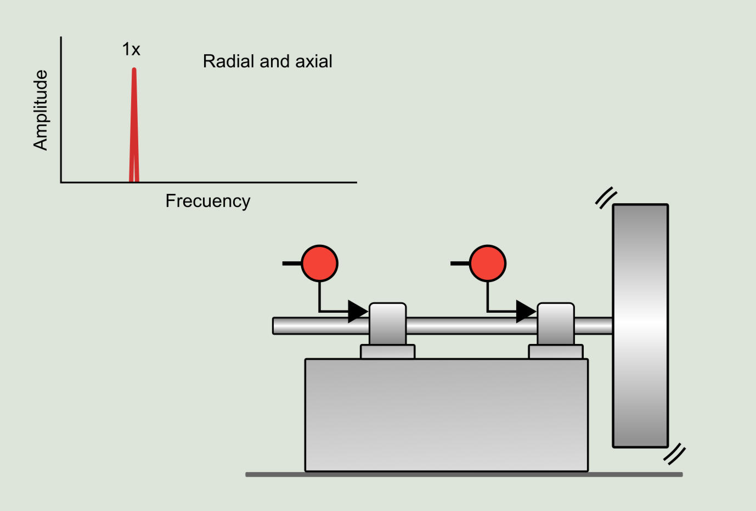

Misalignment: If bearings are not installed correctly, such as being misaligned or improperly tightened, they can experience excessive loads or uneven forces. This can lead to premature wear, overheating, and eventual failure.

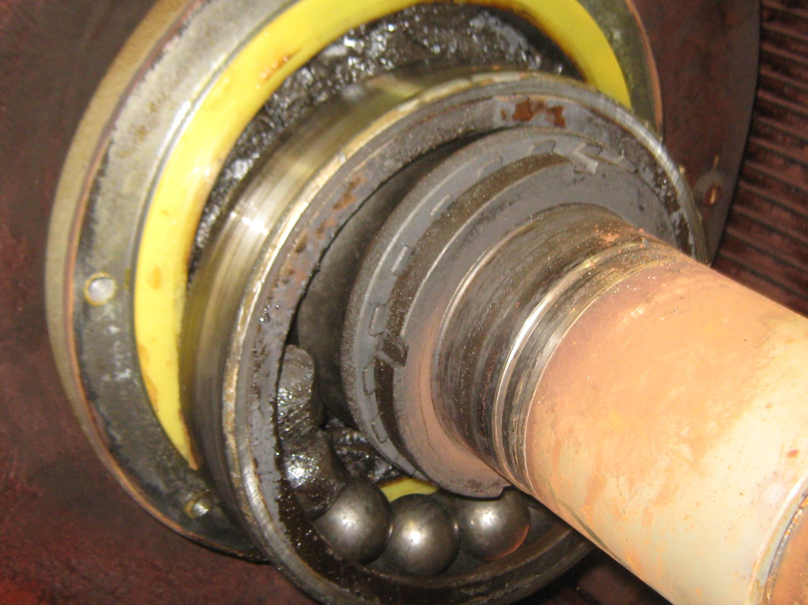

3. Overhung rotor - It occurs in rotors at the end of a shaft. It is produced by wear on the rotor surface and bending of the shaft. The spectrum presents dominant vibration at 1xRPM of the rotor, very notorious both in axial and radial directions.

Misalignment: If bearings are not installed correctly, such as being misaligned or improperly tightened, they can experience excessive loads or uneven forces. This can lead to premature wear, overheating, and eventual failure.

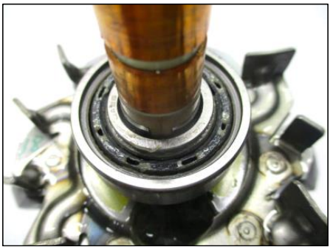
Bearing Faults: Worn or damaged bearings contribute to
instability.

1.3 Steps for Integration:

- Connect the Accelerometer: Wire the accelerometer to the microcontroller's analog/digital input pins. If it’s an I2C/SPI interface, set up the communication protocol.
Signal Conditioning:
Use a low-pass filter to reduce noise.
Amplify the signal if needed for better readability.
Data Collection:
Write a program to read real-time data from the accelerometer.
Convert the raw output (e.g., g-force) into meaningful vibration data.
Storage and Visualization:
The charge amplifier output is connected to a data acquisition system to acquire the signal and to carry out the frequency analysis using FFT (Fast Fourier Transform) software.
Data Analysis:
Perform basic statistics like RMS (Root Mean Square) to assess vibration magnitude.
Apply FFT for frequency-domain analysis to identify key vibration patterns or anomalies.

1.4 Types of Vibrations :

Static vibrations test
Dynamic vibrations test
Static Vibrations Test: This test evaluates how a system or structure responds to vibrational forces under steady or non-varying conditions. Typically, it involves applying a fixed or slow-changing force to study deflection, damping properties, or resonance behavior without involving time-dependent changes.
Dynamic Vibrations Test: This test examines a system's behavior under time-dependent or varying forces. It focuses on how the system handles real-world vibrations, such as oscillations, shock loads, or cyclic forces, and measures parameters like natural frequency, mode shapes, and dynamic response.
1.5 Materials and Equipment :

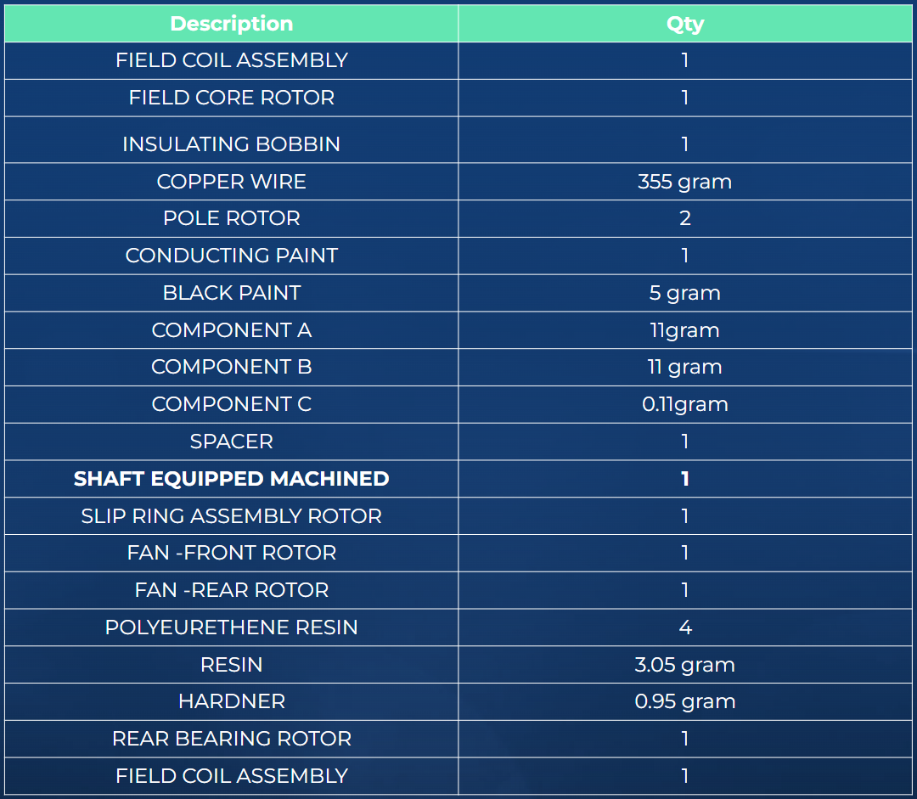
1.6 Model Analysis :
Vibration Sensor/Accelerometer: is a device used to measure and analyze the vibrations of machinery, structures, or components. It converts mechanical vibration into an electrical signal that can be analyzed to understand the behavior and health of the system being monitored.
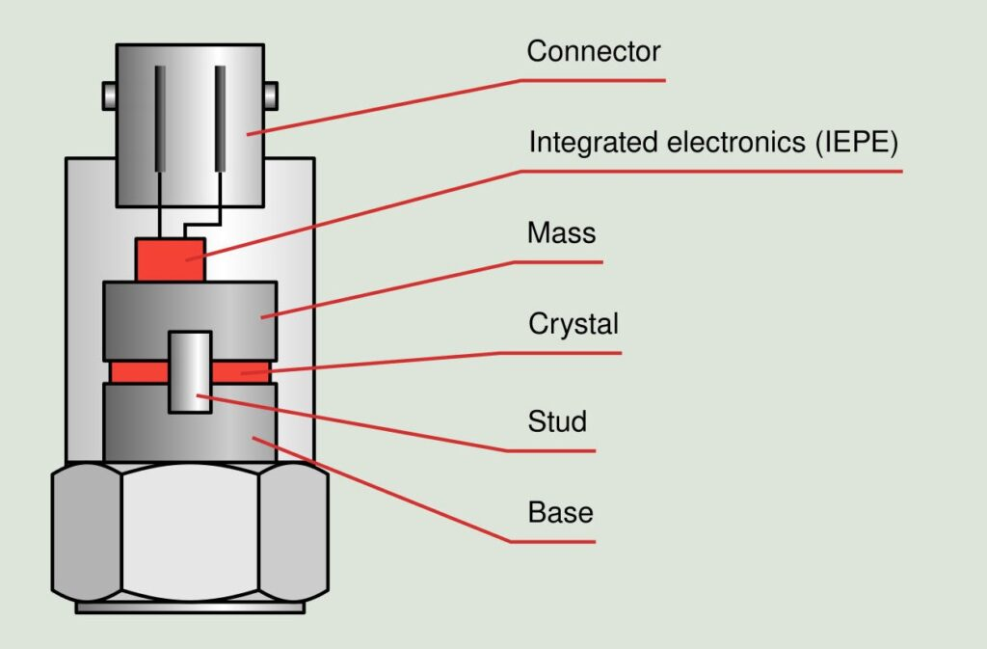
Data Acquisition System (DAQ): The charge amplifier output is connected to a data acquisition system to acquire the signal and to carry out the frequency analysis using FFT (Fast Fourier Transform) software. And another output is connected to a vibration meter for measuring RMS acceleration (m/s2 ).
Analysis Techniques:
Time Domain Analysis:
This method analyzes vibration data in the time domain, providing insights into the raw time-series signal.
Metrics like peak amplitude, root mean square (RMS) value, and crest factor can be extracted to detect faults like imbalance or misalignment.
Tools : Oscilloscopes and data acquisition systems can capture time-domain signals.
Frequency Domain Analysis (using FFT) :
This converts time-domain data into the frequency domain using the Fast Fourier Transform (FFT).
It helps identify dominant frequencies associated with faults, such as unbalance (at the rotational frequency) or bearing defects (higher harmonics).
Tools : FFT analyzers or software like MATLAB, LabVIEW, or Python libraries such as NumPy and SciPy.
This examines the dynamic behavior of the rotor shaft by identifying its natural frequencies and mode shapes.
It's useful for ensuring that operating speeds don't coincide with natural frequencies, which could lead to resonance.
Methods: The parallel misalignments have been created by moving both bearing 1 and 2 simultaneously ranging from 0 mm to 1 mm in step of 0.2 mm. Similarly the angular misalignments are created moving the bearing 2 and keeping the bearing 1 fixed. The different values of angular misalignment ranging from 0 degree to 2.5 degrees were created. The dial indicator having a list count micrometer is used for measurement of moving distance of bearing support blocks.
Motor: To rotate the shaft and simulate operational conditions.
Oscilloscope/FFT Analyzer: Many modern devices integrate both oscilloscope and FFT capabilities into one instrument, providing a comprehensive tool for both time-domain and frequency-domain analysis. These tools are particularly useful in troubleshooting and improving the performance of rotating machinery.
Software:
MATLAB:
Offers powerful tools for signal processing, including FFT analysis and time-domain data visualization.
Great for customizing scripts and generating detailed graphs and reports.
LabVIEW:
Ideal for real-time data acquisition and analysis.
Provides a user-friendly interface to design virtual instruments (VIs) for vibration
2. Methodology :

Step 1: Setup the Experiment This step involves conducting two distinct experiments:
Simulating and analyzing conditions of misalignment.
Testing the performance of a properly functioning rotor under these conditions.
1. Simulating and analyzing conditions of misalignment.
The parallel misalignments have been created by moving both bearing 1 and 2 simultaneously ranging from 0 mm to 1 mm in step of 0.2 mm. Similarly the angular misalignments are created moving the bearing 2 and keeping the bearing 1 fixed. The different values of angular misalignment ranging from 0 degree to 2.5 degrees were created. The dial indicator having a list count micrometer is used for measurement of moving distance of bearing support blocks.
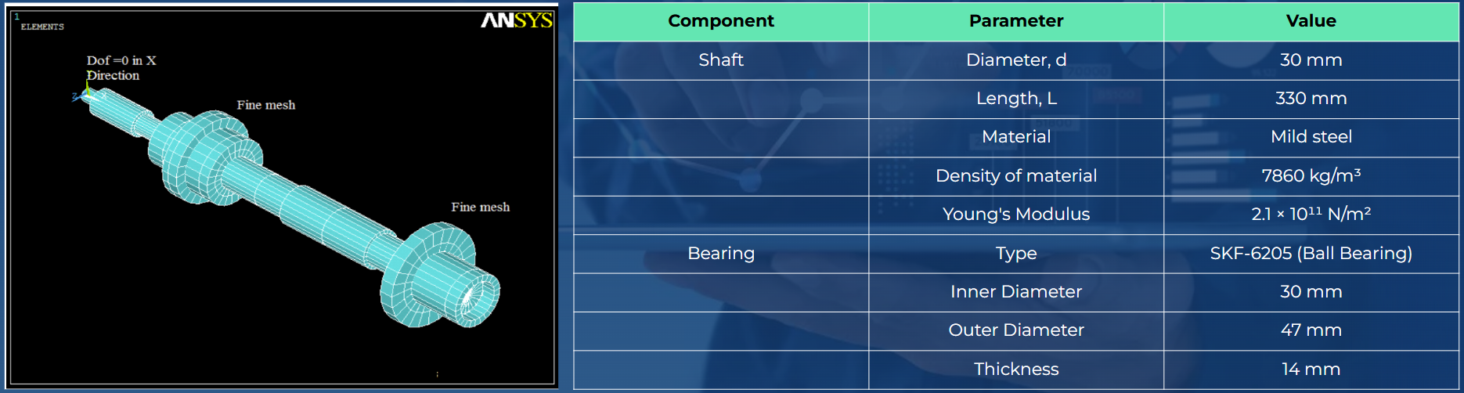
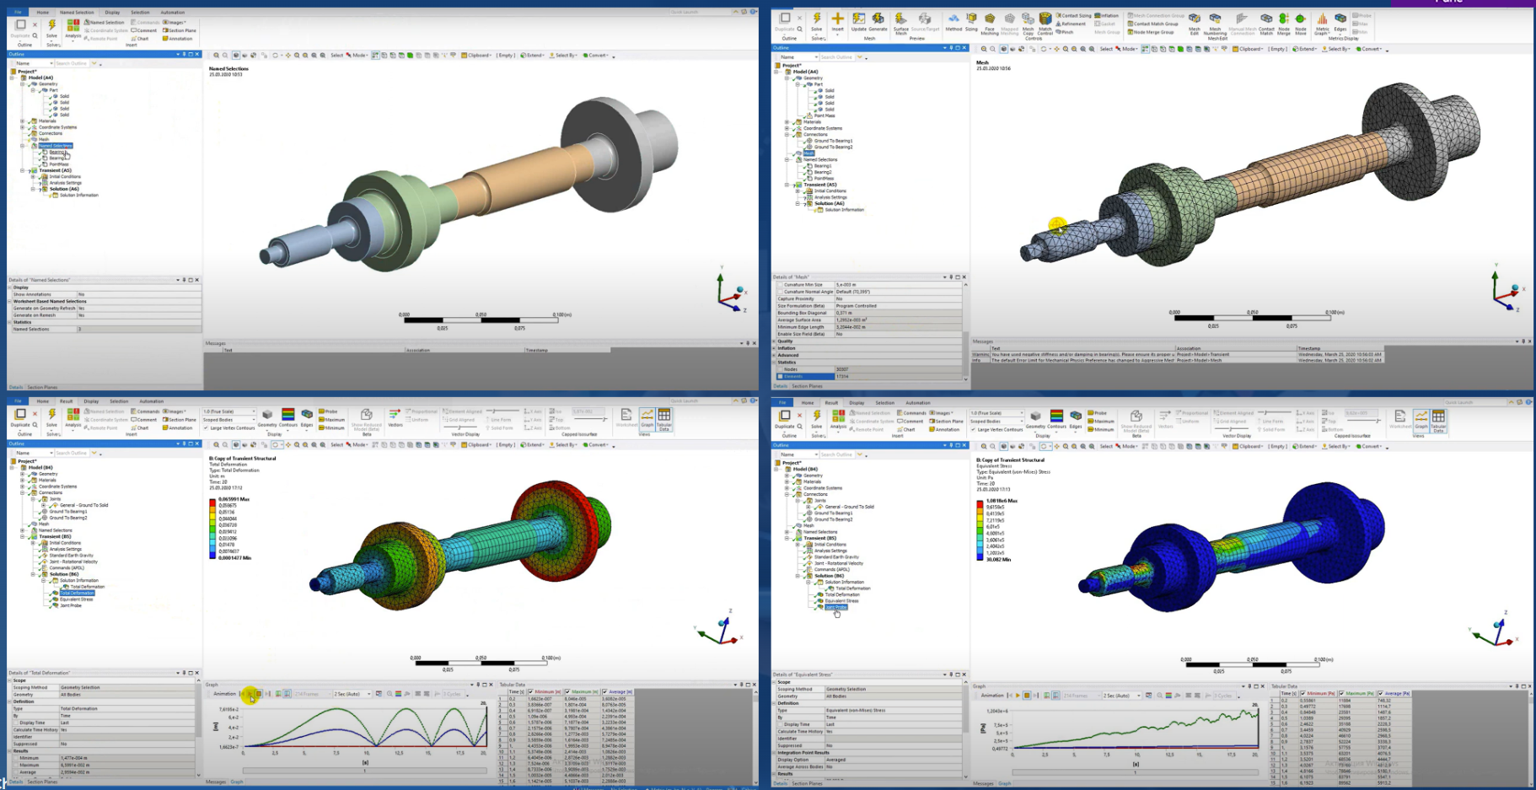
3.Performance Analysis : Vibration Measurement & Data Analysis of Simulating and analyzing conditions of misalignment.
Parallel Misalignments : The experimental results and FEA results for parallel misalignment are tabulated in table 4.1and 4.2 for bearing support 1 and bearing support 2 respectively . It is observed, the amplitude of vibration in RMS acceleration is higher in horizontal direction than that of amplitude in vertical direction in case of parallel misalignment at bearing no-01 which is nearer to the motor.
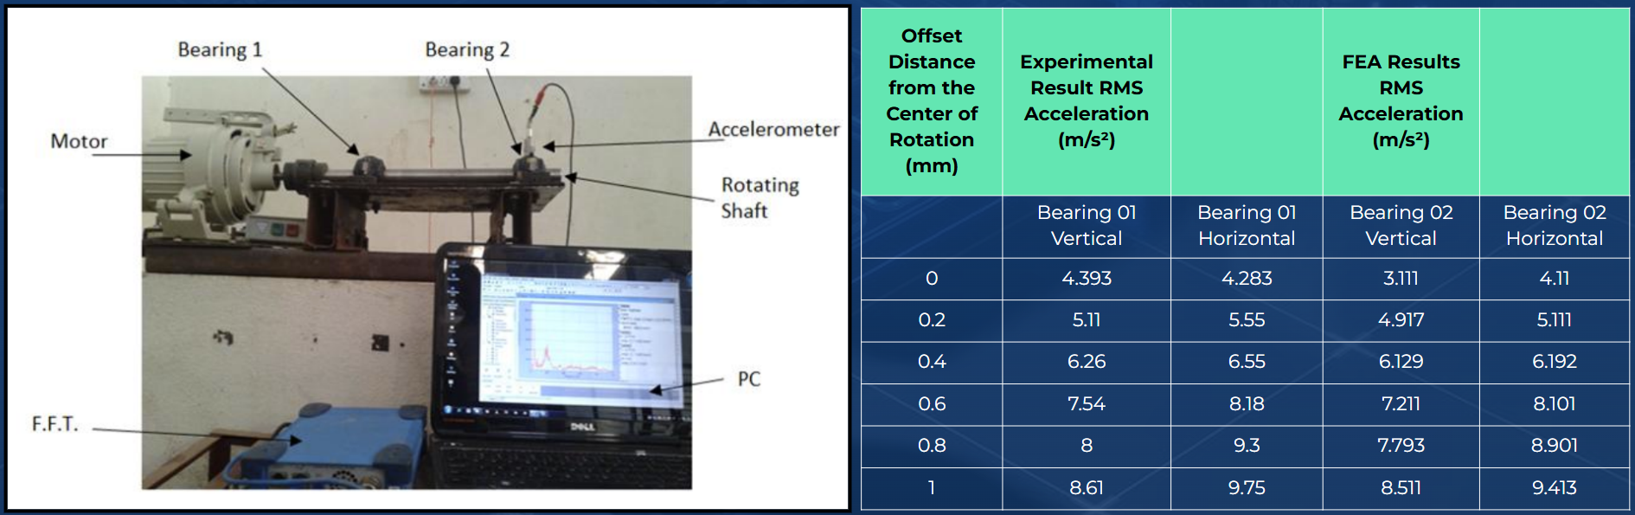
Parallel Misalignments :
It is observed, the amplitude of vibration in RMS acceleration is higher in horizontal direction than that of amplitude in vertical direction in case of parallel misalignment at bearing no-01 which is nearer to the motor.
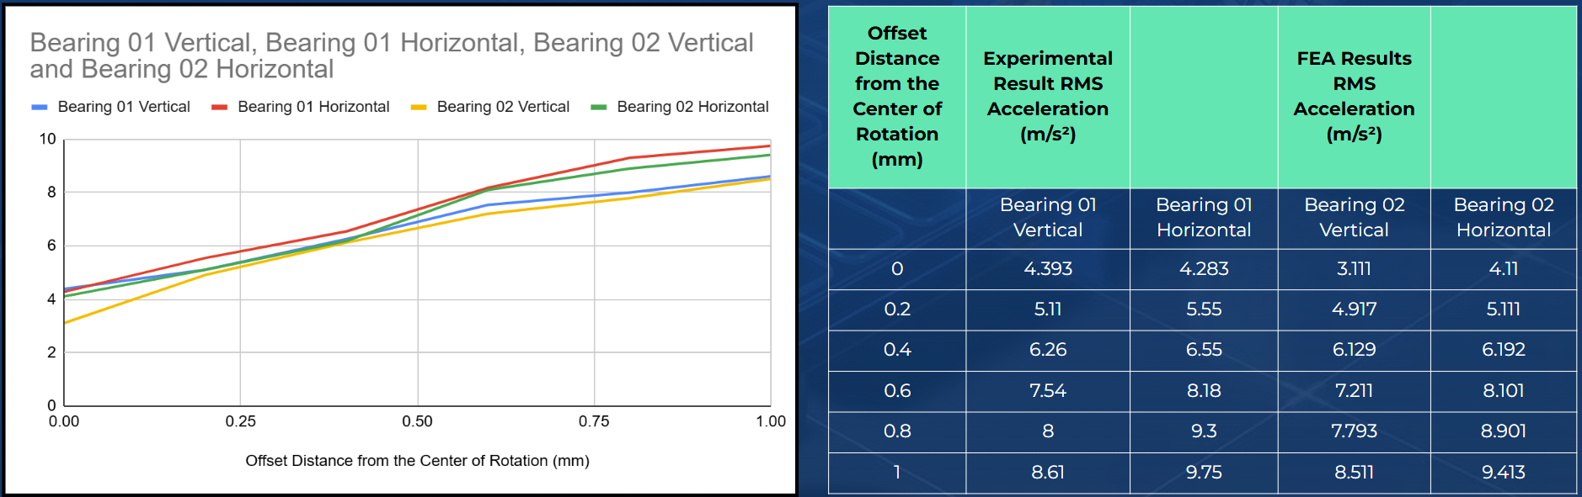
RMS Acceleration for parallel misalignment at Bearing no: 2
It is observed,RMS Acceleration Vs Offset distance from the center of rotation at bearing no: 02 From fig. 4 it is observed, the amplitude of vibration in RMS acceleration is higher in horizontal direction than that of amplitude in vertical direction in case of parallel misalignment at bearing no-02 which is away from the motor. From above fig. 3 and fig. 4 it is observed that in case of parallel misalignments the RMS values of acceleration are higher at bearing support 2 (away from the motor) and it is found lesser at bearing support 1 (near to the motor) in both horizontal and vertical directions. The highest value of overall RMS accelerations is obtained at bearing support 2.
The experimental results and FEA results for angular misalignment are tabulated in table 4.3 and 4.4 for bearing support 1 and bearing support 2 respectively.
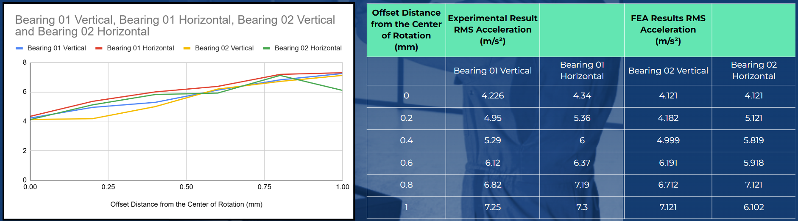
Angular Misalignments :
The experimental results and FEA results for angular misalignment are tabulated in table 4.3 and 4.4 for bearing support 1 and bearing support 2 respectively.
It is observed that in case of angular misalignment the amplitude of vibration in RMS acceleration is higher in horizontal direction than that of amplitude in vertical direction at bearing no-01 which is nearer to the motor.
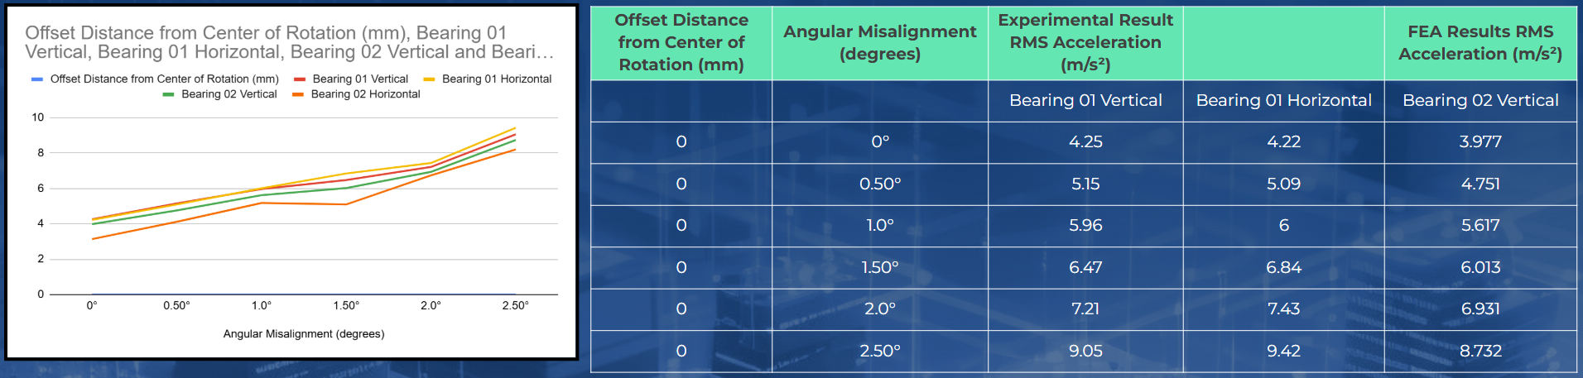
RMS Acceleration for angular misalignment at Bearing no: 02
The experimental results and FEA results for angular misalignment are tabulated in table 4.3 and 4.4 for bearing support 1 and bearing support 2 respectively.
it is observed that amplitude of vibration in RMS acceleration is higher in horizontal direction than that of amplitude in vertical direction in case of angular misalignment at bearing no-02 From above fig. 5 and fig. 6 it is observed that in case of angular misalignments the RMS values of acceleration are higher at bearing support 2 and it is found lesser at bearing support 1 in both horizontal and vertical directions. The highest value of overall RMS accelerations is obtained at bearing support 2.
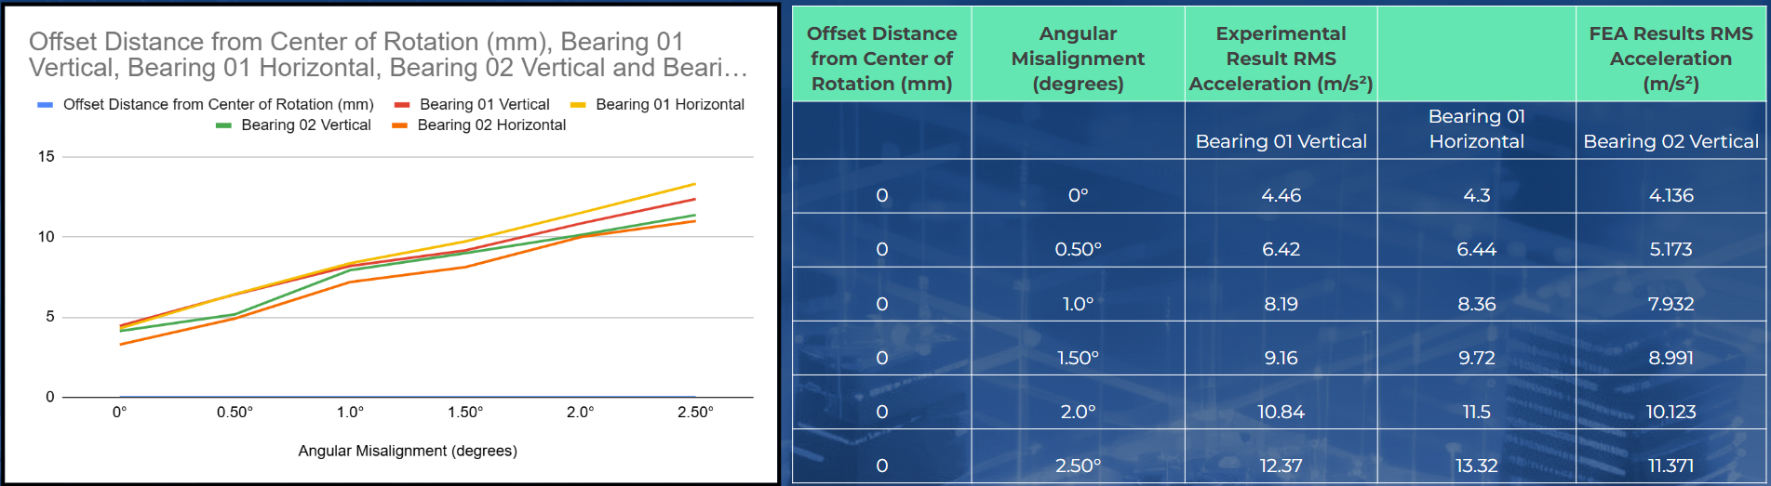
Identification of Causes of Vibration
Based on the data provided, the causes of vibration in the misaligned rotating shaft are as follows:
Parallel Misalignment:
Cause: Uneven load distribution due to parallel misalignment creates lateral forces. This results in higher vibrations, especially in the horizontal direction. The farther bearing (Bearing 02) experiences more pronounced vibrations because the load effects increase with distance from the motor.
Angular Misalignment:
Cause: Tilting forces caused by angular misalignment lead to asymmetric shaft vibrations. These forces amplify at Bearing 02 (farther from the motor), causing it to exhibit higher RMS acceleration values, particularly in the horizontal direction.
Step 5: Conclusion
In this research paper, from experimental results as well as from FEA results we can see that the overall magnitude of vibration in RMS values of acceleration for various misalignment conditions such as parallel misalignment, angular misalignment and combination of parallel and angular misalignment are found higher at bearing housing 2 (away from the motor) and lesser at bearing housing 1 (near to the motor) in both the horizontal and vertical directions. Also it is found that the highest value of overall RMS accelerations for vibration is higher in horizontal direction in case of both bearing supports, and increases when misalignments increase.
4. Results and Discussion : Testing the performance of a properly functioning alternator and rotor under these conditions :
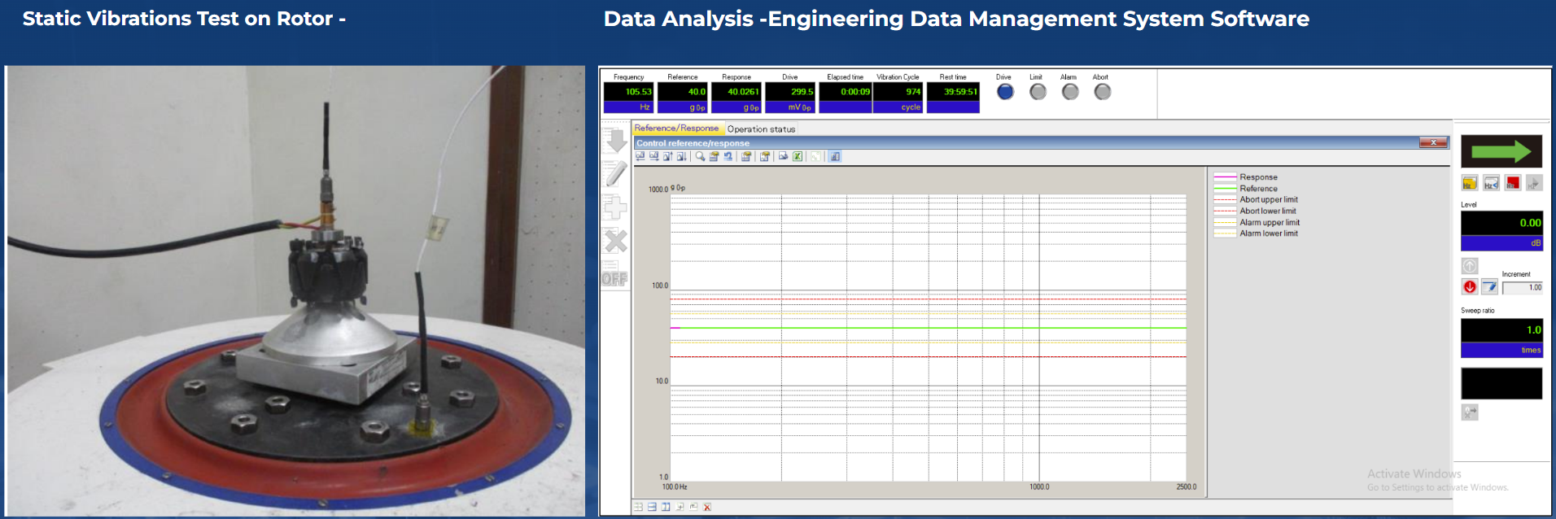
Key Elements of above result
Numerical Data (Top Section):
Frequency: 105.53 Hz – The frequency at which the rotor is being analyzed.
Reference Vibration Level: 40.0 gp – The target or desired vibration level, likely in units of gravity (g).
Measured Response: 40.0261 mV0p – The actual measured vibration level during the test.
Drive: 299.5 – Represents the power or intensity of vibration, though the exact units are unspecified.
Elapsed Time: 00:09 – The duration of the test so far (minutes and seconds).
Vibration Cycles: 974 – The number of vibration cycles completed.
Rest Time: 39:59:51 – Time remaining before the next cycle.
Graphical Representation (Middle Section):
Red Line (Response): Shows the measured vibration across the frequency range.
Blue Line (Reference): Indicates the target vibration level, which remains constant in this test.
Green Line (Abort Upper Limit): A threshold to stop the test for safety if exceeded.
Purple Line (Abort Lower Limit): A lower threshold for safety (rarely crossed).
Orange Line (Alarm Upper Limit): A warning level for high vibration.
Brown Line (Alarm Lower Limit): A warning level for low vibration.
X-Axis: Frequency range (100 Hz to 2500 Hz).
Y-Axis: Vibration magnitude (likely in "g0p" or "mV0p").
Step 5: Conclusion
Close Matching Between Reference and Response: The measured vibration levels (response) are very close to the target vibration levels (reference), indicating that the system is performing as expected at the analyzed frequency (105.53 Hz). This demonstrates the accuracy of the vibration test and the stability of the rotor system under the given conditions.
Safe Operating Conditions: The response line stays well within the safety thresholds (abort and alarm limits), showing that the vibrations are not excessive and the system is operating safely.
The considerable distance between the response and limit lines highlights that the rotor is unlikely to reach critical levels during the test.
Stable Vibration Parameters: The constant reference and limit values across the analyzed frequency range (100 Hz to 2500 Hz) suggest a well-controlled testing setup. This ensures reliability and consistency in results.
Analysis Accuracy: With numerical data and graphical representation, the test effectively captures the rotor's vibration behavior and ensures no major deviations or anomalies.
Dynamic Vibrations Test on Alternator :
Temperature: Tested at room temperature as ambient temperature
Rotation speed: 7200 rpm
Vibration Frequency: from 50 Hz to 500 Hz Excitation axis:X, Y & Z
Sweeping time: One way - 5 min & both way - log sweep Acceleration:98 (m/S^2)
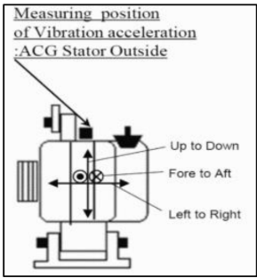
5. Overall Conclusion:
The vibration test indicates that the rotor system is functioning properly within safe limits. The close alignment between measured and reference vibrations reflects a stable setup, and there are no signs of dangerous conditions or significant deviations during the test. This highlights the system’s reliability and suitability for the operating conditions tested.
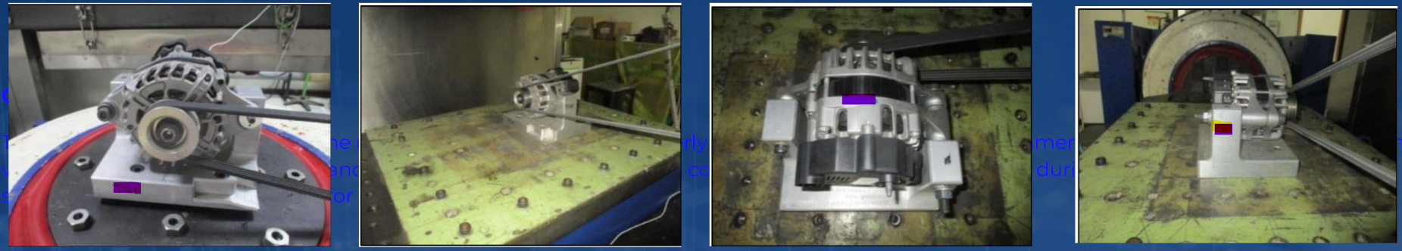

Thank You !

