**Skyscraper structure systems**

**By**

**Ar. Sameer Sharma, kartik jadhav**

**SOA, IPS ACADEMY, INDORE**

1. **Introduction**

Skyscrapers have captured the imagination of architects, engineers, and the public alike, standing as testament to human ingenuity and ambition. From the historic Flatiron Building in New York City to the futuristic Burj Khalifa in Dubai, these towering structures have defined urban landscapes and posed unique engineering challenges. This research paper aims to comprehensively examine the structural systems that underpin skyscrapers, tracing their historical development, understanding the core engineering principles, addressing challenges associated with gravity, wind, and seismic forces, and exploring innovative design solutions. By analyzing case studies and considering future trends, we gain insights into the evolution and future of skyscraper construction. The paper is organized as follows: Section 2 discusses the historical evolution of skyscraper structure systems. Section 3 explores the critical structural components of skyscrapers. Section 4 delves into the engineering principles and challenges. Section 5 highlights structural innovations in skyscraper design. Section 6 presents case studies of iconic skyscrapers, and Section 7 discusses future trends and concludes with the role of skyscrapers in sustainable urban development.

1. **Historical Evolution of Skyscraper Structure Systems**
   1. Early skyscraper: load- bearing masonary:

In the late 19th century, iconic structures like the Flatiron Building and the Monadnock Building relied on load-bearing masonry walls. These early skyscrapers were limited in height due to the compressive strength of masonry materials. Engineers faced challenges in achieving both height and stability. [the skyscraper and the city.

* 1. modern material and innovations:

Advancements in construction materials, including reinforced concrete and composite structures, have further pushed the boundaries of skyscraper design. The Burj Khalifa in Dubai, standing at 828 meters, exemplifies this evolution, featuring a combination of high-strength concrete and a structural system of Y-shaped reinforced concrete shear walls.

1. **Structural components of skyscraper**
   1. Foundations:

Skyscrapers require robust foundations to distribute their immense weight to the ground. In modern skyscraper construction, deep foundations like caissons or piles are commonly used. The Burj Khalifa, for instance, rests on a massive mat foundation that spreads the load evenly.

* 1. Vertical Columns and Beams:

The vertical load-carrying components, typically constructed from steel or reinforced concrete, provide the building's primary structural support. Steel's ductility allows for flexibility, while reinforced concrete provides strength and fire resistance.

* 1. floor system:

The floor system carries the gravity loads during and after construction. It should be able to accommodate the heating, ventilating and air conditioning systems, and have built in fire resistance properties. these could be classified as two-way systems, one-way systems and beam and slab systems.

Two-way systems include flat plates supported by columns, Hat slabs supported by columns with capitals or drop panels. Large shears and moments will be carried by the latter. Slabs of constant thickness are also used. Stabs with waffles are also used. Two-way joists are also used. One-way systems include following - slabs of constant thickness, with spans of 3m to 8m. Closely spaced joists could also be used. Beam and slab systems use beams spaced of 1m to 4m. Lattice floor joists and girders are useful to have ductwork inside of them. Floors of small joists are also used, in addition to integral Door slabs which house piping.

The IBM Mutual Benefit Life building, in Kansas City. MO illustrates the one way and two way joist systems. It also has shear walls for lateral resistance.

1. **Engineering Principles and Challenges:**
   1. gravity loads:

Gravity places immense pressure on skyscrapers, necessitating meticulous design to ensure load paths are efficient and foundations are capable of supporting the building's weight without excessive settlement.

* 1. wind load

Tall and slim building slowly became a prominent solution to accommodate increasing density of population in major cities. However as the materials became light the buildings became prone to vibrations, which becomes both discomforting to the users as well as cause structural failure. These tall buildings need to withstand various external forces such as earthquakes and strong winds [7]. Thus, motion control of buildings was given due consideration taking into account both static and dynamic loads. Two solutions were thought of, first to increase the structural stiffness and second to damp the external vibrations while keeping the material quantity minimum. As the buildings became taller, they got exposed to a formidable enemy that exploited all of their weaknesses. In 1970 while the architects designed the 442 meters tall Sears tower in Chicago (Fig. 7) they faced a great challenge. The windy city ensured a huge wind load on the 100 stories tall planned tower. Traditional steel skeletons failed at this height as such wind force would cause them to bend and sway. Such movements would cause sea sickness like physical problems and dread among the people. The architects of the Sears Towers invented the technology to beat the wind. They shifted the internal skeletal frame and merged them with the external frame which formed an exoskeleton. This framework was very hard for the wind to bend [8]. The Sears Tower was built by interlocking such 9 exoskeletons which made it wind proof. Thus, the concept of exoskeleton was invented which is still the best way to minimize wind sway. Besides the problem of bend and sway, the shape of the building also plays a critical factor in determining the impact of the wind load on the structure. As the path of the wind is obstructed by a building it goes around and flows again in its normal path creating suction in the leeward direction. Thus, the total wind load becomes the summation of windward pressure and leeward suction. of prototypes in wind tunnels, and use of aero dynamic designs (Fig. 8) to reduce this suction effect of wind. Another development that went on parallel was the research on dampers and their probable use in infrastructure. Damping systems were initially used by the mechanical industry and experimentation with damping in construction industry started in 1950s. The first application of damping system in tall buildings was in 1969 with the erstwhile World Trade Centre, New York. Then the use of damping systems increased extensively in 1980s as part of retrofits in old buildings. Currently available damping systems can be divided into two broad categories: passive system and active system. Passive system is recognized by fixed properties while the property of active systems change based on the load demand, and is activated by an external source of energy

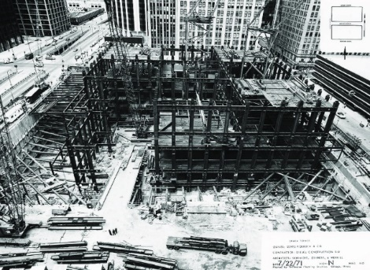

Fig 7 Sears tower exoskeleton

* 1. earthquake

With such developments in the tall structures, Asian countries began to desire them. However, Asia experienced a natural disaster that European skyscrapers didn’t face before – Earthquakes. With the knowledge of earthquake and their impact on buildings, earthquake resistant structures were designed which depended on wind bracings. Tests and calculations showed that they were able to resist the jerking effect of earthquakes. In 1999, the architects were designing Taipei 101 in Taiwan (Fig. 9) faced the problem of earthquakes. Taiwan is located near the Pacific Ring of Fire and experiences an average of 2 earthquakes every year. They had to find way to prevent the earthquake waves from shaking the building. Engineers found out that the building had to be elastic enough to absorb the energy from the earthquakes. The engineers of Taipei 101 planned an ingenious way to create an earthquake proof structure [9]. The whole building was made around 36 rigid steel tube columns filled with concrete to provided strength. The rest of the structures were made elastic such that they would flex and move with the waves. Halfway during construction, the building was hit by an earthquake and the design proved to be true to its needs. It is built to withstand the typhoon winds and earthquake tremors common to the region. The unique design makes the building both flexible to prevent structural damage and structurally resistant which ensures comfort for the occupants. The Taipei 101 was finally completed in 2004 and has a height of 509 meters. Earthquake engineering is one of the most significant research areas that the scientists are working on. No building can be made earthquake proof however we can reduce its effect by using materials and foundations that can absorb shocks from seismic waves [10].

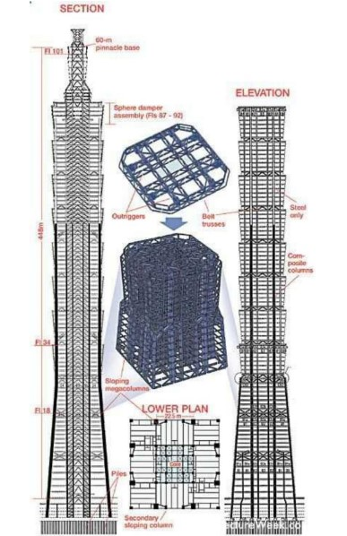

Fig 9 frame of taipei 101 with its interlock steel tubes[image courtsey: pintrest]

* 1. evacuation

As the building rose higher it became increasingly difficult to evacuate the residents during disasters. People are not allowed to use elevators during fire or other such emergencies. As the buildings shelter huge number of people, in case of emergencies the rush might cause further casualties. The final problem faced by the engineers was evacuation. After the attacks of 9/11, it was high time for the engineers to find a solution. Burj Dubai’s design uses one of the prominent solutions; it has built in fire protection. Evacuating huge number of people takes long time and involves a huge risk, so architects of Burj, Dubai decided to create fail safe within the building the itself. The building has 9 very special refuge rooms made from reinforced concrete layers and fire proof sheeting; these rooms withstand fire for 2 hours. They have special supply of air from fire resistant pipes and sealed fire proof doors to prevent smoke. There’s 1 room in every 30 floors to shelter people in terms of need until emergency services come for rescue. In order to prevent smoke from blocking the vision, a set of high powered fans are fitted on the stairways. In case of fire they get triggered and force in fresh air through ducts into the building. The air pushes the smoke away from the stairs and keeps it clear. Completed in 2008 Burj Khalifa currently holds the record of being world’s tallest building with a height of 828 meters.

1. **Structural Innovations in Skyscraper Design**
   1. diagrid systems:

the diagrid structure is a modified braced tube system and has recently gained popularity. In a braced tube, which is a very stiff system, perimeter columns are present and large braces are also used. In diagrids, however, many lighter diagonal elements on the exterior crisscross at nodes in which the columns are eliminated, creating a lattice- like appearance. The exterior system effectively behaves like a shell creating immense in – plane stiffness rendering the tall building to approach the behaviour as a solid tube (Ali and moon 2007, pp. 205-223). The Hearst building of 2003 in New York city and 30 St. mary axe (gherkin) of 2004 in London are the earliest tall building that used the diagrid system. [19,20].

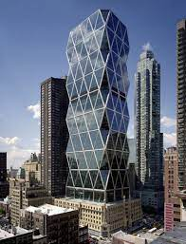

The hearst tower 2003 in New York city.

* 1. tuned mass damper:

Tuned mass dampers (TMDs) are mechanical systems that are widely used to reduce the amplitude of dynamic vibrations transmitted by the support to machines or structures in order to guarantee their correct functioning or avoid damages. In the field of construction, a TMD is usually placed on the top floors or on the rooftop of buildings to reduce their swaying due to wind forces. However, the seismic response of buildings can also benefit from TMDs [**17**,[**18**](https://www.mdpi.com/2076-3417/13/11/6815#B2-applsci-13-06815)], as they can be used as passive supplemental energy dissipation devices. In this case, the TMD frequency is designed to be tuned with the frequency of the main vibrational mode of the building in order to resonate out of phase with the building structure. Therefore, the effects of the main vibrational mode of the building during seismic behaviour are mitigated, and the inertial forces arising in the structural members due to seismic forces are reduced.

In analytical applications, the mechanical behaviour of TMDs is represented by a mass connected to the main structure by a spring and a dashpot arranged in parallel. In this schematization, the TMD’s behaviour is described by its mass, frequency and damping, which are designed on the basis of the main vibration modes of the building. In these applications, the TMD can be any device that behaves like such a system, e.g., a pendulum with dampers or a concrete slab on rubber isolators.

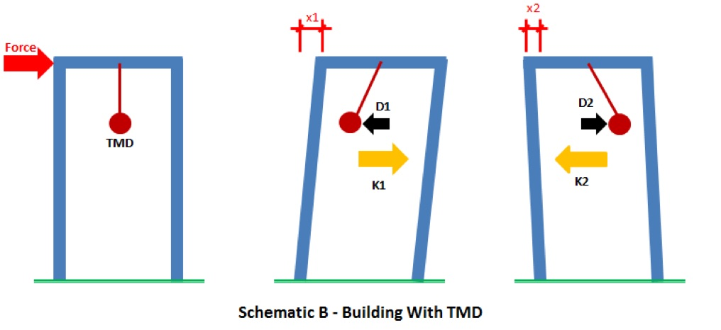

* 1. Ultra-high strength concrete

The Mix Design of K1340 Kg/cm2has been confirmed by shear wall calculation as per ACI 318-11 clause 11.2 to bear the critical straining action on the core wall and limit the wall thickness, where the client could have more space on floor, which could increase the floor rent to the client. It is significant from the financial perspective for such an ultra-high sky scraper building. Therefore, to meet the design requirements and needs in the sky scraper tall buildings the high rich ultra-high strength concrete is unavoidable [3,4]. Further to make a mix design and pump into 600 m tall for such an ultra-high strength concrete, to define the mix configuration, pump pressure, concrete properties, friction loss, hydrations, air – entering, temperature, humidity and water cement ratios…. etc. are indispensable, as a guide line there is mix design in Figure 5 has been given for the high strength concrete, however trial site mix is necessary on site to make sure the crucial influences in high grade concrete prior to pour.

* 1. steel connection design

The connection designs have been performed in LIMCON software by taking the straining actions/forces from the ETABS model, where the fabrication and erection facilitations are considered such as moment connection on columns with beams, bracings, base, splice connections by taking the high grade bolts ASTM A490, plates ASTM A992 Gr 70 and weld as 70XX, further the heavy nodal connections are designed in Ansys software to facilitate the heavy as well as complicated connections to make sure the firm connectivity and their stress passing ratios Further the steel connections and members nano behaviours have been carefully studied in particular the brace buckling deformation and fracture due to cyclic elastic loadings as per AISC-14 edition, AISC360. The appropriate currective actions are taken in connection design to avoid any minor consequences on Glass aluminum curtain wall envelope, which could eliminate or minimize the client maintenance cost and non- panic situation of engineering consultant in case of failure during the building in service.[5]

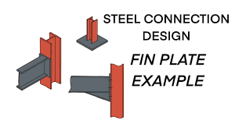

1. CONCLUSION

skyscraper structure systems have evolved significantly over time, enabling the construction of iconic buildings that shape modern cityscapes. Advances in materials, engineering principles, and sustainability are driving the future of skyscraper design, promising even more impressive and environmentally friendly structures. Skyscrapers will play a vital role in addressing urbanization challenges by maximizing land use efficiency and reducing carbon footprints. Skyscrapers will increasingly incorporate smart technologies for energy efficiency, security, and occupant comfort.

1. References
2. [7] H. H. Quimby, Wind Bracing in High Buildings, The Engineering Record, November, pp. 394-395, 1892
3. [8] The Wind Bracing of Buildings, CONDIT,C. Scientific American, vol. 230, no. 2, 98,1974
4. [9] D. Poon, et al. “Structural design of taipei 101, the world’s tallest building”, CTBUH 2004, October 10-13, Seoul, Korea, 2004, pp, 271- 278.
5. [10] D. N. M. Lee, “Application of tuned liquid dampers for the efficient structural design of slender tall buildings”, CTBUH Journal Issue, vol. 4, pp. 30-36, 2010
6. [19] Ali, M.M.; Moon, K.S. Advances in Structural Systems for Tall Buildings: Emerging Developments for Contemporary Urban Giants. Build. J. 2018, 8, 104.
7. [20] Al-Kodmany, K.; Ali, M.M. An Overview of Structural Developments and Aesthetics of Tall Buildings Using Exterior Bracing and Diagrid Systems. Int. J. High-Rise Build. 2016, 5, 271–291
8. [17] Soto, M.G.; Adeli, H. Tuned Mass Dampers. *Arch. Compute. Methods Eng.* **2013**, *20*, 419–431. [[**Google Scholar**](https://scholar.google.com/scholar_lookup?title=Tuned+Mass+Dampers&author=Soto,+M.G.&author=Adeli,+H.&publication_year=2013&journal=Arch.+Comput.+Methods+Eng.&volume=20&pages=419%E2%80%93431&doi=10.1007/s11831-013-9091-7)]
9. [18] Yang, F. Vibration suppression of structures using tuned mass damper technology: A state-of-the-art review. *Struct. Multidisc. Optim.* **2022**, *27*, 7–8. [[**Google Scholar**](https://scholar.google.com/scholar_lookup?title=Vibration+suppression+of+structures+using+tuned+mass+damper+technology:+A+state-of-the-art+review&author=Yang,+F.&publication_year=2022&journal=Struct.+Multidisc.+Optim.&volume=27&pages=7%E2%80%938&doi=10.1177/1077546320984305)]
10. [3] Ernst L, Sohn S (2010) model code for concrete structure.
11. [4] Noguchi T, Tomosawa F, Nemati KM, Chiaia BM, Fantillia AP (2009) A Parctical Equation for Elastic Modulus of Concrete. ACI Structural Journal 5:690-696.
12. [5] Pauw A (1960) Static Modulus of elasticity of concrete as affected by density. Journal of American concrete institute 12:679-687.