The Influence of the Evaporator Area on the Air Mass Produced in the Water Haervester Machine with a Forced Convection System
Mirmanto Mirmanto, Yesung Allo Padang, Muhammad Zayadi
Mechanical Engineering Department, Engineering Faculty, University of Mataram, Indonesia

Abstract:
This study aims to determine the performance of the air-water harvester machine on the freshwater mass, COP, and heat transfer rate with evaporator area variations. This research was carried out experimentally with the working fluid refrigerant R134a. The compressor used is a rotary type 0.5 PK compressor. This study varied the area of the evaporator, namely an area of 200820.27 mm² (Case A), an area of 353414.85 mm² (Case B) and an area of 503984.13 mm² (Case C). The results showed that the highest water mass obtained was 0.446 kg for 7 hours produced using the smallest area variation or Case A. The highest total heat flow rate absorbed by the evaporator from air occured in the Case A too. Increasing the area of the evaporator does not guarenty to increase the freshwater production.
Keyword: Air-water harvester; frehwater production; COP; heat transfer rate

- Introduction
In the dry season, for certain areas, clean water is difficult to obtain. Soils, rivers, rice fields and wells can all experience drought. Even people get difficulty to fulfil the cooking and drinking water. This drought problem needs to be overcome. One solution that can be done is to obtain water that does not come from the ground. As is known, the air contains water vapor. Although when it is dry, the air humidity is low, the air still contains water. Therefore, air can be used as an alternative water source. The unlimited volume of air allows water to be obtained from the air without limits.
One of the ways to obtain clean water from the air is by the method of catching pairs from the air. According to Damanik¹, there were currently several methods of capturing water from the air, including: (1) windmills that catched water from the air, (2) nets that catched water from the fog, (3) machines that produced water from the air using vapour compression cycle components.
The third method is the easiest way to do and can be used by households with electrical power that is still able to be supplied. This machine can be used to condense the moisture present in the air. Many studies on machine producing water from the air were carried out such as: Monica², Faroni³, Gaol⁴ and Pangestu⁵, Mirmanto et al.⁶⁻⁸.
Monica² (2018) conducted research on air water harvesting machines using air conditioning components consisting of a compressor with a power of 1 PK, a condenser, a capillary pipe, and an evaporator. The machine worked using a vapour compression cycle. The research used R22 refrigerant with an additional 2 fans and 1 blower in front of the evaporator which functioned to compress the air. Variations were made to the equipment used to enter the air, namely: (a) 2 fans with 1 blower, (b) 1 fan with 1 blower, (c) 1 blower. The results showed that: The air water harvesting machine that produced the most water volume had a W_{in} value of 45.1 kJ/kg, a Q_{in} value of 103.8 kJ/kg, a Q_{out} value of 148.9 kJ/kg, an actual COP_{act} value of 2.302, an ideal COP value of 4.296, an efficiency value of 53.57%. The amount of water produced by the air water harvesting machine was 2.692 liters/hour (with 2 fans and 1 blower), 2.284 liters/hour (with 1 fan and 1 blower), 1.867 liters/hour (with 1 blower). The pressure used in this study was 97 psi. However, this machine needed a big electrical power.
Recently, Faroni³ in his research on the influence of the diameter of the condensation unit pipe on the mass of water produced from the air-water harvester. In this study the evaporator used was made of copper material in parallel shape and three experiments were carried out with the refrigerant used type R134a and the compressor used was a rotary type 0.5 PK compressor. This study varied the diameter of the pipe of the expansion unit, namely 3.00 mm, 4.00 mm and 6.35mm in diameter and after the research was carried out, results were obtained that showed that the highest water mass obtained was in a variation in diameter of 3.00 mm with a water mass obtained of 0.369 kg for 7 hours. Meanwhile, the highest COP obtained was in the variation of 3.00 mm pipe diameter, which was 13.28 and the highest total heat absorbed by the condensing unit from the air occurred in the variation of 3.00 mm pipe diameter, which was 52.1 W. The highest efficiency of the condensing unit was in the variation in diameter of 6.35 mm, which was 2.38%. Unfortunately, the machine resulted in less freshwater. This was due to the small power and free convection system applied.
Gaol⁴ studied experimentally by varying the airflow velocity in the air conditioner system with a fin pipe with a diameter of 57.2 cm x 14 cm x 18cm using a compressor with a power of 0.75 PK, an aircooled condenser and a refrigerant with the R410a type obtained results with the highest water mass value obtained at airflow speeds of 6.7 m/s and 5.5 m/s, which was as much as 2.01 liters/hour and the highest efficiency was obtained at the variation in airflow speed of 4.7 m/s and 3.2 m/s with an efficiency value of 57%.
Pangestu⁵ (2022) has conducted the same research as this research proposal, namely the performance of the air-water harvester machine (AWHM) in various areas of heat transfer of the condensing unit. Where in the Pangestu⁵ research, the variation in the heat transfer area of the condensing unit was used which was a function of pipe length, namely pipe lengths of 20 cm, 40 cm and 60 cm and produced a maximum of 0.321kg for 7 hours at a pipe length of 40 cm. The freshwater resulted in this study is less. This was also due to the free convection system used and the small power. Mirmanto et al.⁶⁻⁸ also studied the AWHM however the freshwater obtained was also less. The problem for the AWHM using vapour cycle is the production of the freshwater, therefore in this study, try to improve the performance of the machine.
A literature search only obtained a few libraries related to this study, and there is only one library that researches the extent of evaporators, namely Pangestu⁵. However, Pangestu⁵ used a natural convection system, while those who used forced convection, e.g. Monica² and Gaol⁴, had not yet researched the influence of the evaporator area. Therefore, the author is interested in studying the influence of the evaporator area on the mass of water produced by the forced convection system, namely the airflow assisted by using a fan.

- Materials And Methods

The method used in this study was the experimental method.This type of research method can be used to test a new treatment or design by comparing one or more tests with the treatment and the treatment paper. The tools and materials were prepared in advance so that there was no confusion in looking for tools and materials at the time of research. The equipment and materials used in this study include compressors, condensers, evaporators, capillary pipes, thermocouples, digital thermometers, R-134a refrigerants, barometers, data loggers, fans, anemometer, scale, water container, manifold gauge, and air. In this research, there were two types of variables, namely: a) dependent variables and b) independent variables. Dependent variables are variables that cannot be determined or cannot be regulated, and are obtained at the time of data collection and included in the data analysis of research results. The dependent variables of this study were the freshwater mass, COP, heat transfer rate from the air to the evaporator walls. Independent variables are variables that can be regulated or determined or that can be changed according to the purpose of the research. The areas of the evaporator used in this study were three variations in areas, the first unit had an area of 200820.27 mm² (hereinafter referred to as Case A), the second unit had an area of 353414.85 mm² (Case B), the third unit had an area of 503984.13 mm² (Case C), while the pipe diameter was made the same, namely 1.7 mm. By appliying area variables, much freshwater can be expected. This expectation is going to be unswered by the experimental study.
The compressor consumed an electrical power of 0.5 PK and all temperatures were recorded using the Applent AT45-24. While the pressures were measured using pressure gauges in psi. The air velocity was measured using a digital anemometer. To obtain the data, here some steps shall be performed: (i) turn on the data logger and let the data logger record all temperatures, (ii) install an evaporator with a certain area, (iii) record all pressure, temperature and relative humidity (RH) when the engine is still off, (iv) fill the machine with refrigerant, (v) regulate the speed of 4 m/s of air entering the machine by adjusting the blower rotation, (vi) start the AWHM, record temperature, pressure, RH, air velocity, compressor power, freshwater mass per hour, (vii) stop the experiment after the experiment ran for 7 hours, perform procedures (i-vii) for other evaporator areas. Note: the experiment must be repeated 3 times for each area variation.
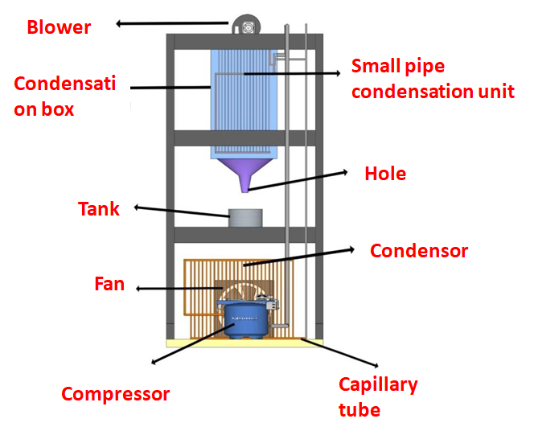
Figure 1. Parts of AWHM with an evaporator constructed using small pipes

This study aims to determine the performance of the AWHM, namely the freshwater mass, COP and the rate of heat transfer flow to the evaporator walls. Therefore, there were several stages that needed to be analyzed both on the refrigerant side and from the air side. The data obtained on the online psychometric chart were the part of the water vapor in the air when entering the evaporator (w₁) and the part of water vapor in the air when exiting the condensing unit (w₂), the required temperature and RH of the air entering the evaporator, the temperature and RH of the air exiting the evaporator. By entering temperature and RH into the online psychrometric chart: free online Psychrometric Calculator (hvac-calculator.net), the data (w₁ and w₂) could be obtained. However, due to the forced convection system, w₁ was enough to proceed the further analysis.
From the data obtained in the study, the following parameters could be calculated: the frestwater flow rate (ṁ_{w}), the rate of heat flow from dry air (Q̇_{d}), the heat flow rate from dew (Q̇_{w}), the heat flow rate from cooled vapour (Q̇_{v}), the flow rate of dry air mass (ṁ_{da}), the flow rate of the incoming vapour mass (ṁ_{v}), the flow rate of total air (ṁ_{t}), and the total heat flow rate absorbed by the evaporator walls (Q̇_{t}).
Refrigerant enthalpy is be used in the calculation of the vapour compression cycle, where the enthalpy includes: enthalpy when exiting the evaporator (h₁), enthalpy when exiting the compressor (h₂), enthalpy when exiting the condenser (h₃), enthalpy when entering the evaporator (h₄). h₁ and h₂ are found in the superheated refrigerant table 134A vapour, while h₃ and h₄ have the same enthalpy can be found at the same temperature of saturated refrigerant 134a liquid. The data that are used to find the enthalpy in the thermodynamics table include: refrigerant pressure out of the condenser unit (P₁), refrigerant pressure out of the compressor (P₂), refrigerant pressure out of the condenser (P₃), temperature out of the condenser unit (T₁), temperature out of the compressor (T₂) and temperature out of the condenser (T₃).
The results of tests that have been carried out to determine the amount of water produced from the air using the vapour compression cycle AWHM are presented in the form of graphs in order to be easy to analysis them. The data displayed in the graph is the average data of 3 repetitions in one variation. The following 3 graphs are displayed, namely the amount of freshwater produced (m_{w}), COP, and the heat absorbed by the evaporator from the air (Q̇_{t}). To examine the AWHM performance, some equatios are required and can be found in Mirmanto⁶⁻⁸, Ramadhan⁹, Kusuma¹⁰ and Mirmanto et al.¹¹.

- Results and Discussion

The average freshwater mass resulted is shown in figure 2. Case A produced the most water mass, which was 0.446 kg for 7 hours, while Case B is 0.395 kg for 7 hours and Case C is 0.353 kg for 7 hours. Increasing the evaporator area, at these experimental conditions, decreased the freshwater mass production. This means there is a maximum evaporator area at this experimental conditions and electrical power used. Therfore, increasing the area does not guaranty incrising the freshwater production. Most likely for the smallest area, all the refrigerant flowed evenly on each evaporator pipe so that each pipe had the same low temperatures. Therefore, dew formed on each pipe and caused a greater amount of frehwater mass production. In the area of Case A, the most freshwater mass production was obtained. However, the freshwater resulted in this study is less than that of Winata¹². This was due to the evaporator specification or evaporator construction. Winata¹² used parallel evaporator constructed from 6.35 mm cupper pipe diameter, while this study used a cupper pipe diameter of 1.7 mm. However, based on the Faroni³ study stating that decreasing diameter of the pipe increased the freshwater mass production, then this study seems having different phenomenon. This study used smaller pipe diameter but the results are lower than that of Winata¹².

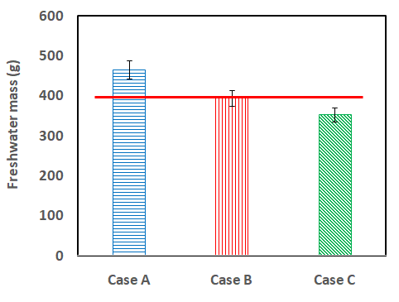
Figure 2. Freshwater mass for three cases

The average COP of the three cases can be seen in the figure 3. Figure 3 shows that the highest COP occurrs in the Case A, which is 4.57 and the lowest COP occurres in the Case C, which is 4.07. COP is the comparison of the heat load to the work of the compressor. However, the difference of the experimental COP of Case A and othe cases is significant as the COP of Case A dose not touch the red horizontal line, while the difference of COP of Case B and Case C is not significant because the error bars of the two cases touch the red horizontal line. This study applies the error of 5%. COP is determined using the enthalpy values of refrigerants h₁, h₂ and h₄, the highest actual COP is obtained from Case A, this can occur because the heat absorption in the evaporator is larger compared to other cases.

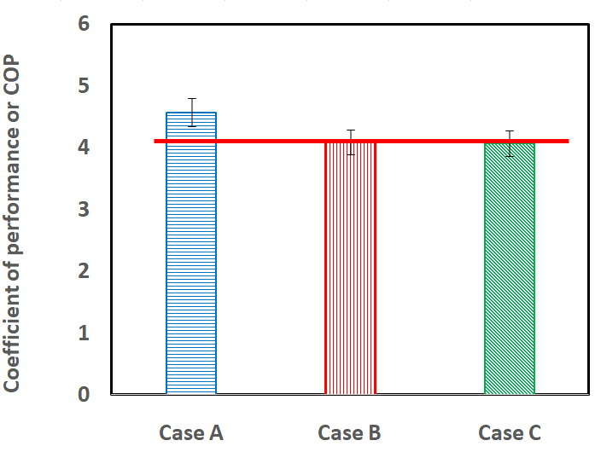
Figure 3. COP of the three cases

The total heat absorbed by the evaporator from the air of the three cases is given in figure 4. The heat transfer presented in figure 4 is the total heat transfer rate that included the Q̇_{d}, Q̇_{v} and Q̇_{w}.

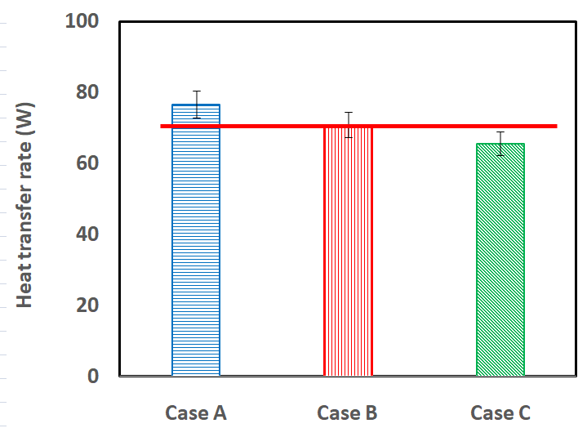
Figure 4. Total heat transfer rate from the air to the evaporator walls for the three cases.

Based on the figure 4 above, it can be concluded that the total heat transfer rate from the air to the evaporator decrease with the evaporator area. The highest heat transfer rate is found in Case A, which is 76.64 W, and the lowest total heat transfer rate is in Case C, which is 65.60 W. This is because the difference in temperature between the inlet and outlet air is higher in Case A compared to other cases. Why is the difference in air temperature in and out for Case A higher?, because most likely all the pipes in evaporator of Case A are wetted by refrigerant so that the temperature of the evaporator wall is evenly distributed uniformly and finally there is an even heat transfer rate on the entire surface of the evaporator.

- Conclusion
Based on the results of the study and analysis on the effect of evaporator area on the freshwater mass production from the forced convection AWHM with a power of 1/2 PK, and 134a refrigerant an the working fluid, it can be concluded as follows: (i) The smaller the surface of the evaporator, the more water mass is produced. The highest air mass of 446 g for 7 hours is produced using the smallest evaporator area variation (Case A), which is, 200820.27 mm². (ii) The highest COP obtained is 4.54 at the smallest evaporator area, Case A. (ii) The highest heat flow rate from the air occurs at the smallest evaporator area, Case A, It is 76.64 W. Base on this experimental set up and conditions, the smallest are of evaporator is recommended and in the next work, the smalles evaporator area will be studied further.

References
- Damanik YV. The effect of fan rotation speed ​​on the performance of water distillation machines from air using the vapor compression cycle. Thesis, Sanata Dharma University, Yogyakarta, 2018.
- Monica T. The effect of blowers and fans on the characteristics of air water harvesting machines. Thesis, Sanata Dharma University, Yogyakarta, 2018.
- Faroni A. The effect of the pipe diameter of the condenser unit on the mass of water produced from the air-water harvester. University of Mataram, Mataram, Indonesia, 2022.
- Gaol CL. Air water generation machine using 3/4 pk air conditioner components. Thesis, Sanata Dharma University, Yogyakarta, 2019.
- Pangestu ADA. Performance of water harvester machine at various heat transfer areas of condenser unit. Thesis, University of Mataram, 2022.
- Mirmanto M, Wirawan M, Sunaryo F. Performance of air water harvester machine with spiral condensing unit at various intake air velocities. JP Heat and Mass Transfer. 2023: 36(1): 59-69.
- Mirmanto M, Syahrul S, Sutrisno AI. Improved performances of air water harvester with two coil evaporators at various air inlet velocities. JP Heat and Mass Transfer. 2024: 37(3): 389-400.
- Mirmanto M, Nurpatria N, Hendra JK. Effect of air intake temperatures on the air-water harvester performance. Journal of Engineering Science (Ukraine). 2024: 11(1): G1-G8.
- Ramadhani MM. The performance of the water harvester machine at various variations of fan positions. Thesis, Mechanical Engineering, University of Mataram, 2023.
- Kusuma A. The effect of air inlet speed on water mass and heat transfer in a 0.5 pk water harvester machine. Thesis, University of Mataram, 2024.
- Mirmanto M, Syahrul S, Wijayanta AT, Faroni A, Azari A, Afriani I, Lestari DD, Habib A. Effect of an evaporator pipe length on the water production of a small air-water harvester. AIP Conference Proceedings. 2024: 2838.
- Winata LA. The effect of the number of vertical evaporator pipes on the mass flow rate of water condensed from air. Thesis, University of Mataram, 2021.

