**Requirement Engineering in Industry 5.0: A Systematic Literature Review of Current Practices and Future Challenges**

San Sudirman1, Ema Utami2, Hanif Al Fatta3

*1(Faculty of Computer Science, Universitas Amikom Yogyakarta, Yogyakarta)*

*2(Magister of Informatics and Engineering, Universitas Amikom Yogyakarta, Yogyakarta)*

*3(Magister of Informatics and Engineering, Universitas Amikom Yogyakarta, Yogyakarta)*

[*sansudirman@student.amikom.ac.id*](mailto:sansudirman@student.amikom.ac.id) *1,* [*ema.u@amikom.ac.id*](mailto:ema.u@amikom.ac.id) *2,* [*hanif.a@amikom.ac.id*](mailto:hanif.a@amikom.ac.id) *3*

***Abstract:***

***Background****:**Industry 5.0 signifies a transformative phase in industrial advancement characterized by the integration of advanced technologies and cyber-physical systems. This study conducts a systematic literature review to elucidate the existing state of Requirement Engineering practices in the context of Industry 5.0.*

***Materials and Methods****: The research methodology involved an extensive review of literature related to Requirement Engineering in the Industry 5.0 landscape. Various sources, including academic papers and industry reports, were analyzed to identify key trends and challenges. The study employed agile methodologies, model-driven engineering, and interdisciplinary collaboration as core approaches for gathering and analyzing data.*

***Results****: The findings of the study reveal the adoption of agile methodologies, model-driven engineering, and interdisciplinary collaboration as emerging and promising trends in Requirement Engineering within Industry 5.0. However, it is important to recognize significant challenges arising from the complexity of systems and the lack of standardization.*

***Conclusion:*** *In conclusion, this study underscores the critical importance of innovation, data security, and interdisciplinary approaches in successfully navigating the dynamic landscape of Industry 5.0. Addressing challenges related to system complexity and standardization will be imperative for harnessing the full potential of Industry 5.0. The insights derived from this research can guide practitioners and researchers in adapting their approaches to meet the evolving demands of the industrial sector in the Industry 5.0 era.*

***Key Word****: Industry 5.0; Requirement Engineering; systematic literature review; agile methodologies; model-driven engineering; interdisciplinary collaboration; technology integration; cyber-physical systems; innovation; data security; standardization;*

1. **Introduction**

Industry 5.0 represents a new era in industrial development, characterized by the integration of advanced technologies, the Internet of Things (IoT), artificial intelligence, and cyber-physical systems. The term of Industry 5.0 was introduced in the European Commision Policy Brief in 2021 named “Industry 5.0 – towards a sustainable, human-centric and resilient European industry” [10]. This transformative paradigm shift has the potential to revolutionize the software manufacturing, making it more efficient, flexible, and responsive to customer demands. However, Industry 5.0's success heavily relies also on effective requirement engineering, which forms the backbone of any engineering process. Requirement engineering in the context of Industry 5.0 brings forth a new set of challenges and opportunities that demand a reevaluation of current practices and a forward-looking perspective.

Traditionally, requirement engineering has played a pivotal role in ensuring that the end product aligns with customer needs, compliance, and quality standards. In Industry 5.0, these requirements become even more complex, as systems become interconnected, autonomous, and adaptable. In this era, where machines, humans, and data work seamlessly together, understanding and eliciting requirements takes on a whole new dimension.

The purpose of this systematic literature review is to investigate the current practices and challenges associated with requirement engineering in the context of Industry 5.0. By analyzing existing research, we aim to identify trends, gaps, and potential solutions that can guide practitioners, researchers, and organizations in their journey towards embracing the Software Engineering in Industry 5.0 paradigm. Our review will shed light on the state of requirement engineering, the methodologies and tools being employed, and the key issues that must be addressed to navigate this new industrial landscape effectively.

In summary, this systematic literature review serves as a comprehensive guide to understanding the crucial role of requirement engineering in Industry 5.0. It is our hope that the insights and knowledge gathered from this review will contribute to the development and implementation of effective strategies for successful Industry 5.0 projects and systems.

1. **Research and Methodology**

**Research Question:** The purpose of this systematic literature review is to investigate the current practices and challenges associated with requirement engineering in the Industry 5.0. Therefore, in order to keep the review focused on the objectives, the research questions outlined in Table 1 were posed.

**Table no 1 :** Research Questions.

|  |  |  |
| --- | --- | --- |
| **ID** | **Research Question** | **Motivation** |
| RQ1 | How are agile methodologies used in Industry 5.0 Requirement Engineering, and what are their pros and cons? | Explore the role of agile methods and their impact. |
| RQ2 | To what extent does model-driven engineering shape Industry 5.0 Requirement Engineering and cyber-physical systems? | Examine the impact of model-driven engineering. |
| RQ3 | How does interdisciplinary collaboration enhance requirement quality in Industry 5.0? | Understand the benefits of collaboration. |
| RQ4 | What challenges do complex cyber-physical systems pose to Requirement Engineering in Industry 5.0, and how can they be addressed? | Investigate strategies for addressing complexity |
| RQ5 | What are the implications of non-standardized practices in Industry 5.0 Requirement Engineering, and how can standardization improve efficiency? | Assess the value of standardization in enhancing efficiency. |
| RQ6 | How does innovation impact Requirement Engineering in Industry 5.0, and what can be learned from current trends? | Examine the effects of innovation on the field. |
| RQ7 | What measures can enhance data security in interconnected systems for Requirement Engineering in Industry 5.0? | Explore data security solutions. |
| RQ8 | How can interdisciplinary approaches optimize Requirement Engineering in the dynamic Industry 5.0 landscape? | Understand the value of interdisciplinary methods. |

**Study Selection:** Study included in this SLR is only study published in English, from journal, book and conference papers. The study criteria that may be included in SLR are based on the inclusion and exclusion criteria which are presented in Table II.

**Table no 2 :** Inclusion Criteria and Exclusion Criteria.

|  |  |  |
| --- | --- | --- |
| **Inclusion Criteria** | **Exclusion Criteria** |  |
| Research that discusses requirements engineering methods | Research that does not discuss requirements engineering methods | |
| Research that discusses the implementation of software development using requirements engineering | Research that does not specifically discuss the implementation of software development using requirements engineering | |
| The research explains the requirements engineering and implementation methods used that can be applied in industry 5.0 | The research conducted does not touch on application to industry 5.0 | |

The search process and number of studies identified at each stage are shown in Figure 1. The research selection process was carried out in two stages, namely selection based on title and abstract. and full text selection.

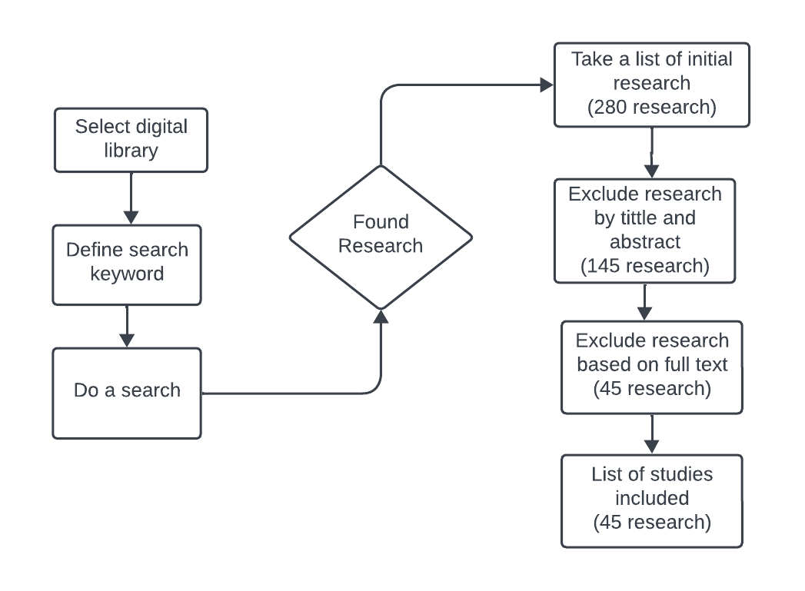

Scopus 200 paper

Google Scholar 80 paper

**Fig. 1.** Flow of research search and selection

**Data Extraction:** Once the relevant papers were identified, a systematic data extraction process was carried out to gather information on each paper. The following data points were extracted:

* Title and authors of the paper.
* Publication year.
* Abstract to provide a brief overview of the paper's content.
* Research methods and methodologies used in the paper.
* Key findings and contributions related to requirement engineering in Industry 5.0.
* Challenges and issues discussed in the paper.
* Tools, technologies, and frameworks mentioned in the paper.
* The extracted data was organized and cataloged for further analysis.

**Data Analysis:** The analysis of the collected data followed a structured approach. The papers were categorized based on common themes, methodologies used, and the main focus of the research. The analysis aimed to identify trends, current practices, and emerging challenges in requirement engineering in the context of Industry 5.0. Additionally, the review highlighted any gaps in the existing literature and identified areas that require further research.

**Quality Assessment:** To ensure the quality and reliability of the selected papers, a quality assessment was conducted. Each paper was evaluated for its research rigor, methodology, relevance to the research question, and the credibility of the sources used. Papers that did not meet the predefined quality criteria were excluded from the final analysis.

1. **Result and Discussion**

In  this study, from 280  studies found 45  studies that fulfill the inclusion and exclusion criteria that have been designed. Groupings by year are presented to show interest in detecting hate speech. The graph of research grouping by year is shown in Fig. 2.

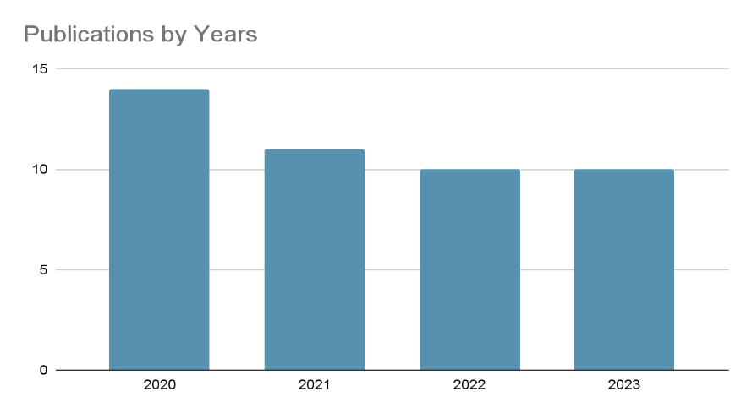

**Fig. 2.** Research Grouping by Year of publication

**Methodologies and Approaches:** This section presents an overview of the key findings related to methodologies and approaches used in requirement engineering in the context of Industry 5.0, Agile [1][2][3][4][5], Model-Driven [6], Colaborative.

1. Agile and Iterative Approaches: Several studies highlighted the adoption of agile and iterative approaches in Industry 5.0 requirement engineering, emphasizing the need for flexibility and adaptability in rapidly changing manufacturing environments.
2. Model-Driven Engineering: Model-driven engineering was found to be a popular approach, with a focus on creating detailed models of cyber-physical systems to facilitate requirement analysis and verification.
3. Collaborative Requirement Elicitation: The collaborative elicitation of requirements involving multidisciplinary teams was noted as a best practice in achieving comprehensive and accurate requirements in Industry 5.0 projects.

**Tools and Technologies:** This section discusses the tools and technologies identified in the literature that are used to support requirement engineering in Industry 5.0[7][8].

1. Digital Twins: Several papers highlighted the use of digital twin technology to create virtual representations of physical systems, aiding in requirement validation and early-stage testing.
2. Artificial Intelligence and Machine Learning: The integration of AI and machine learning algorithms for requirement analysis and predictive maintenance was a prevalent trend, improving the efficiency and accuracy of requirement engineering.
3. Requirements Management Software: Many organizations adopted specialized requirement management software to streamline the requirement lifecycle, enhance traceability, and ensure compliance with evolving standards.

**Challenges and Issues:** This section outlines the challenges and issues identified in the literature related to requirement engineering in Industry 5.0 [2][4][9].

1. Complexity and Interconnectedness: The complexity of cyber-physical systems and their interconnected nature introduced significant challenges in requirement elicitation and verification.
2. Lack of Standardization: The absence of standardized approaches and tools for Industry 5.0 requirement engineering was a common challenge, leading to inconsistencies in practice.
3. Data Security and Privacy: Several papers raised concerns about data security and privacy in the context of interconnected systems, indicating the need for robust security measures.

**Best Practices and Case Studies:** This section provides insights into best practices and real-world case studies related to requirement engineering in Industry 5.0.[4]

1. Case Study: Smart Factory Implementation: A case study highlighted a successful smart factory implementation that utilized a combination of agile methods and digital twin technology, resulting in improved production efficiency.
2. Best Practices: Cross-Functional Teams: Research emphasized the importance of cross-functional teams consisting of engineers, data scientists, and domain experts working collaboratively in requirement engineering processes.
3. **Conclusion**

Based on the results of this systematic study, it is evident that in the context of Requirement Engineering in Industry 5.0, current practices encompass the utilization of agile methodologies, model-driven approaches, and interdisciplinary collaboration. Meanwhile, significant challenges include the complexity of cyber-physical systems, the lack of standardization, and data security issues. Successful case studies underscore the potential of combining agile methods with digital twin technology. It is recommended that practitioners embrace standardized approaches, enhance data security measures, and consider interdisciplinary approaches in Requirement Engineering. These findings underscore the need for ongoing innovation and collaboration to address the challenges and opportunities inherent in developing effective and efficient Industry 5.0 systems.

**References**

[1] F. Dalpiaz and S. Brinkkemper, “Agile requirements engineering with user stories,” in *Proceedings - 2018 IEEE 26th International Requirements Engineering Conference, RE 2018*, Institute of Electrical and Electronics Engineers Inc., Oct. 2018, pp. 506–507. doi: 10.1109/RE.2018.00075.

[2] A. Rasheed *et al.*, “Requirement Engineering Challenges in Agile Software Development,” *Mathematical Problems in Engineering*, vol. 2021. Hindawi Limited, 2021. doi: 10.1155/2021/6696695.

[3] J. C. S. Coutinho, W. L. Andrade, and P. D. L. Machado, “Requirements engineering and software testing in agile methodologies: A systematic mapping,” in *ACM International Conference Proceeding Series*, Association for Computing Machinery, Sep. 2019, pp. 322–331. doi: 10.1145/3350768.3352584.

[4] R. Kasauli, E. Knauss, J. Horkoff, G. Liebel, and F. G. de Oliveira Neto, “Requirements engineering challenges and practices in large-scale agile system development,” *Journal of Systems and Software*, vol. 172, Feb. 2021, doi: 10.1016/j.jss.2020.110851.

[5] R. P. Ghozali, H. Saputra, M. Apriadin Nuriawan, Suharjito, D. N. Utama, and A. Nugroho, “Systematic literature review on decision-making of requirement engineering from agile software development,” in *Procedia Computer Science*, Elsevier B.V., 2019, pp. 274–281. doi: 10.1016/j.procs.2019.08.167.

[6] S. Mohammadzadeh and E. Lejeune, “Predicting mechanically driven full-field quantities of interest with deep learning-based metamodels,” *Extreme Mech Lett*, vol. 50, Jan. 2022, doi: 10.1016/j.eml.2021.101566.

[7] T. Wolfenstetter, M. R. Basirati, M. Böhm, and H. Krcmar, “Introducing TRAILS: A tool supporting traceability, integration and visualisation of engineering knowledge for product service systems development,” *Journal of Systems and Software*, vol. 144, pp. 342–355, Oct. 2018, doi: 10.1016/j.jss.2018.06.079.

[8] P. K. R. Maddikunta *et al.*, “Industry 5.0: A survey on enabling technologies and potential applications,” *Journal of Industrial Information Integration*, vol. 26. Elsevier B.V., Mar. 01, 2022. doi: 10.1016/j.jii.2021.100257.

[9] J. Horkoff *et al.*, “Goal-oriented requirements engineering: an extended systematic mapping study,” *Requir Eng*, vol. 24, no. 2, pp.133–160, Jun. 2019, doi: 10.1007/s00766-017-0280-z.

1. Breque M, De Nul L, Petridis A. Industry 5.0 – towards a sustainable, human-centric and resilient European industry. Luxembourg: Publications Office of European Union; 2021.
2. Bereiter-Hahn, J. (1990). Behavior of mitochondria in the living cell. International review of cytology, 122, 1-63.
3. Chen, H., Vermulst, M., Wang, Y. E., Chomyn, A., Prolla, T. A., McCaffery, J. M., & Chan, D. C. (2010). Mitochondrial fusion is required for mtDNA stability in skeletal muscle and tolerance of mtDNA mutations. Cell, 141(2), 280-289.
4. Dallas, C., Gerbi, A., Tenca, G., Juchaux, F., & Bernard, F. X. (2008). Lipolytic effect of a polyphenolic citrus dry extract of red orange, grapefruit, orange (SINETROL) in human body fat adipocytes. Mechanism of action by inhibition of cAMP-phosphodiesterase (PDE). Phytomedicine, 15(10), 783-792.
5. Flögel, U., Laussmann, T., Gödecke, A., Abanador, N., Schäfers, M., Fingas, C. D., Metzger S, Levkau B, Jacoby C, & Schrader, J. (2005). Lack of myoglobin causes a switch in cardiac substrate selection. Circulation research, 96(8), e68-e75.
6. Garnier, A., Fortin, D., Zoll, J., N’Guessan, B., Mettauer, B., Lampert, E., Veksler V., & Ventura-Clapier, R. (2005). Coordinated changes in mitochondrial function and biogenesis in healthy and diseased human skeletal muscle. The FASEB Journal, 19(1), 43-52.