**Design of a didactic furnace for heat treatments.**

J. Serrano-Arias1, M. Cota-Ruiz1, A. Mendoza-Acosta2, J. M. Cabanillas-Pérez1, R. F. Ramírez-León1 , M. Orozco1, L.E. Amador-Castro3.

1. Department of Electrical and Electronic Engineering, Tecnológico Nacional de México/I.T. Los Mochis, Los Mochis, 81223, Mexico

2. Division of Research and Graduate Studies, Tecnológico Nacional de México/I.T. Los Mochis, Los Mochis, 81223, Mexico

3. Department of Basic Sciences, Tecnológico Nacional de México/I.T. Los Mochis, Los Mochis, 81223, Mexico

Abstract

At the Technological Institute of Los Mochis, there is currently no furnace for heat treatments, so students of the careers of Industrial Engineering, Electromechanical Engineering and Mechatronics Engineering do not have the necessary tools to carry out practices in the subjects of Engineering of Materials and Manufacturing Processes, which is of utmost importance for them to understand some of their properties. The knowledge and mastery of heat treatment processes in Engineering careers is fundamental, because it is precisely at this stage of the academic process that the set of heating and cooling operations are known, under controlled conditions of temperature, dwell time, speed, pressure of metals or alloys in solid state. In order to improve its mechanical properties, especially hardness, strength and elasticity. Some of the most commonly used heat treatments are: standardized tempering, quenching (oil, water and brine) and annealing. Due to the importance of students learning to apply these heat treatments, heat transfer and heat exchangers, the idea of creating a heat treatment furnace as a teaching aid arises so that they can begin to become familiar with these treatments. The objective is to design and develop a didactic oven for heat treatments, so that teachers and students of the aforementioned careers can carry out the corresponding practices of heat treatments, in the subjects that require it safely.

Keywords: Temperature control, heat transfer, heat exchanger, didactic oven.

1. Introduction.

With the discovery of the first metals, man changed stone for materials with greater resistance and hardness, contributing to the evolution of ancient societies. Due to the above, metals were assigned a space in history, being classified as copper age, bronze age and iron age. The discovery of fire led to experimentation with methods and processes of forming metals, which led to their intensive use, thus contributing to the development of the smelting process. It is not possible to determine an exact date for the beginning of this process; However, this method helped to make weapons and tools more complex than those produced by forging, becoming the main process used in previous centuries. To achieve the improvement of tooling in casting, high temperatures and molds are needed. Temperatures could only be reached by burning charcoal, and as for the mold, the stone was a good ally, since it was easy to mold and could withstand high temperatures. The Egyptians made pieces using casting processes, but it was the Greeks who designed castings of greater difficulty and complexity, as they specialized more due to their application in warfare. Technological advances have promoted the development of new materials based mainly on copper and aluminum alloys, finding new characteristics of chemical elements, novel procedures for manufacturing models and molds, and better melting techniques, have been decisive in achieving the degree of industrialization and advancement in foundry that has been achieved up to the present century (Ruiz, 2014).

The use of ovens has been known since 4,000 B.C. within the Egyptian culture; in the beginning, a kind of adobe bell was used, which allowed the food they used to be wrapped in heat (Rodríguez, 2008). The Greek oven was built of clay, and since ancient times it was manufactured in its portable variant, characterized by having a flattened shape, ideal for concentrating heat and directing the vapors towards the food. In the Middle Ages, stoves began to be used taking advantage of the hole in the stove, however, the great advance occurred around the year 1,700 of our era, with the arrival of cast iron furnaces, which had a chimney that allowed the exit of combustion gases more efficiently, with chambers of easy and comfortable access for handling the material. Today's steel production uses blast furnaces, which are improved models of those used in the past.

The process of refining pig iron using air jets is due to the British inventor Henry Bessemer, who in 1855 developed the furnace or converter that bears his name. Since the 1960s, smaller furnaces have been used to produce steel from scrap metal. However, large blast furnace facilities continue to be essential for producing steel from iron ore (Concha, 2010).But it was not until the beginning of the nineteenth century, with the popularization of the use of gas as a fuel source, that the first general furnaces appeared; with this improvement it was possible to use this equipment within the industry, because the use of gas represents a saving of 40% compared to other heat sources. With these furnaces, the emission of pollutants, both solid (ash and slag) and gaseous (content of gases) was reduced (Setién & Díez-Aja, 44).

We will call furnaces all that equipment in a large part of the process, at high temperatures from 100°C to 1600°C, heating being carried out directly on the parts (induction, own resistance, dielectric losses, etc.), or indirectly by heat transmission from other elements (electrical resistance, electric or combustion radiant tubes, flame furnaces, etc.). etc.). This heat transmission can be carried out by contact, convection and radiation (Amstead, F. Ostwald, & Begeman, 2004). Heat treatments are the set of heating and cooling operations under controlled conditions of temperature, pressure, dwell time and speed of metals or alloys in a solid state to improve the mechanical properties of hardness, strength and elasticity. The most used heat treatments are quenching, tempering, and annealing. Tempering helps reduce toughness and increase brittleness through three phases involving temperatures from 700°C to 1250°C. Tempering is performed after quenching and is applied to increase toughness.

1. Methodology

**Materials.**

First, the structure of the oven was designed on a computer using the Solid Works software tool with measurements of 55 cm in height, 55 cm in width and 80 cm in depth, as shown in Figure 1. The furnace is proposed with 3-inch x 3-inch x1/4-inch A-36 structural angle; 1/4-inch thick A-36 steel plate and 1/8-inch thick A-36 steel sheet.

Secondly, it was determined to use to develop the home, refractory brick model JM23 of the IFB series brand MORGAN Advanced Materials, refractory concrete brand A.P. Green de México, for the manufacture of the roof silica-aluminous refractory concrete brand Insul-Therm brand was used and to join the refractory materials Insul-Therm brand refractory mortar was chosen.

Subsequently, for ignition and control of the flame, a pyrometer model XMTD-808 with a range of 50 to 1200 degrees Celsius, 1 solenoid valve 2 ways of direct bronze normally closed of high flow and high temperature of 1 1/2 inches with an operating temperature range of 30 to 70 degrees Celsius Cematic brand with working pressure for air of 0-1.0 was required. 0-0.7 water, 0-0.7 Mpa oil and 1.0 Mpa maximum working pressure, 1 gas flow control valve, 1 3/4 inch 8000 series Honeywall valve, 1 3 H.P electric motor, 1 1,500,000 Btu honeywall brand atmospheric burner, 1 roll of refractory ceramic fiber up to 1260 °C 7.62 m long, 60 cm wide and 1 cm thick model 2300 brand Termimex, Finally, to design the power panel, 1 ISE 6000 rail controller, 1 transformer, 1 connector, 1 timer, 1 relay and 1 board were implemented.

After casting the roof, it was removed from the mold and glued with refractory mortar to the brick structure, finally a ceramic blanket was placed to cover the exterior brick walls of the kiln and separate them from the metal structure.

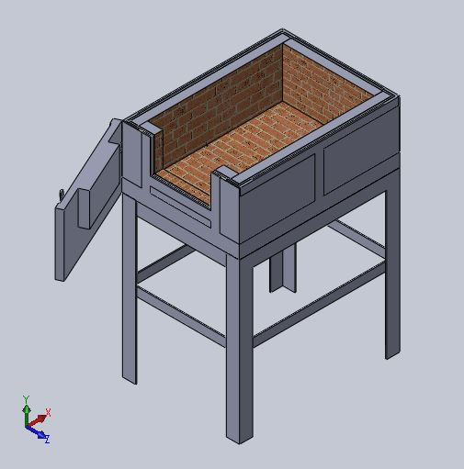

Figure 1. Furnace Schematic for Heat Treatments

Procedure

1. Study of the art of kilns for didactic heat treatment practices

8. Power Board Design and Installation

7. Installation of ignition and flame control equipment

9. Functional tests

2. Furnace Design in Solid Works

5. Furnace structure and hearth manufactory

6. Analysis of results

4. Selection of refractory materials for the home

3. Selection of materials for the structure

Figure 2. Procedure for the development of the Heat Treatment Furnace

3. Testing

Due to the high temperatures reached by the furnace, a torch connected by a fan was adapted to drive the gas and increase combustion

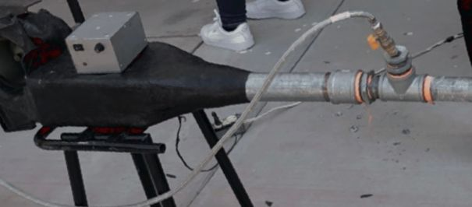 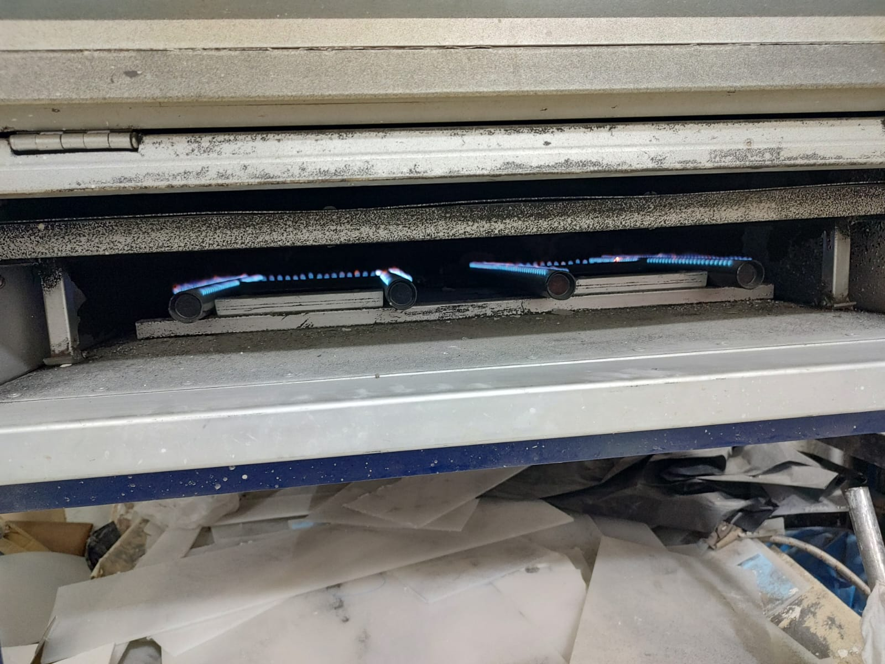 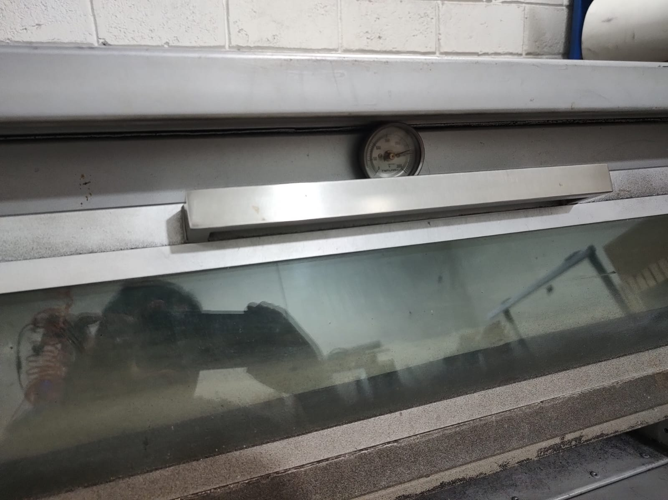

Figure 3. Torch connection via fan Figure 4. Burner Figure 5. Pyrometer

It began by heating the furnace, considering the equilibrium diagram or phase diagram of the steel, which allows observing the phase changes that the aluminum is going to undergo in this process and identifying the critical points.

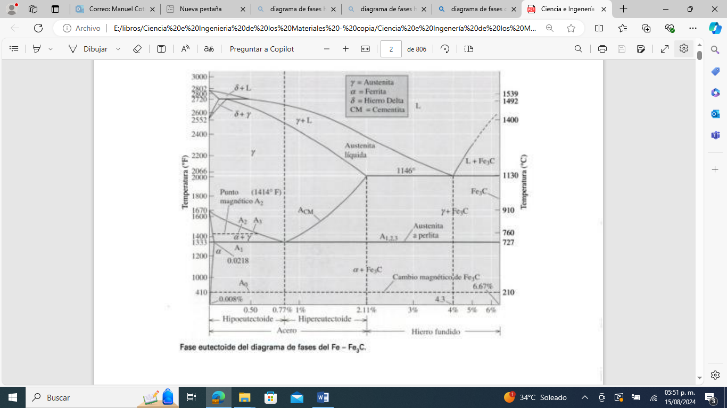

Figure 6. Steel Phase Diagram

**4. Results**.

To carry out the tempering test, the furnace was turned on and heated by torch to 250°C, then a test specimen was placed inside the furnace for a period of 30 minutes. Once the casting and tempering tests were carried out, it was possible to corroborate that the ferrous materials AISI 1010, AISI 1020, AISI 1045, AISI 4140 can be treated in this furnace, so it is possible to affirm that heat treatment processes can be carried out among others up to a maximum temperature of 1,100 °C.

**5. Conclusions**

At the Technological Institute of Los Mochis it is essential to have equipment to perform heat treatments on different metallic materials, in order to reinforce with practice the theory on heat treatment processes, in the subjects of the careers of Industrial Engineering, Mechatronics Engineering and Electromechanical Engineering. It is also the basis for students and professors to carry out and reinforce research on heat treatments at the TecNM/Instituto Tecnológico de los Mochis, to expand the knowledge of these processes.

Selecting a steel to heat treat (improve its mechanical properties) is a challenge that engineers often face.

When treating a material, we must analyze what work the environment to which it will be subjected will be carried out. The behavior of steel is strongly linked to its mechanical properties, which depend mainly on the structure, one of the fundamental variables that influence its chemical composition.

By means of heat treatment, a wide range of mechanical properties can be achieved with the same steel, due to the heating and cooling process that causes modifications in the molecular structure of the material. The use of the equipment is recommended for laboratory practices of heat treatments that do not exceed 700°C, using samples of low-carbon steels.

**6. Acknowledgments**

The authors of the present paper want to express their acknowledgement to the TecNM and Los Mochis Institute of Technology for the economic support to this project.

**7. References**.

[1] E.A., Auces and J.A., Rodríguez. "Calculation of energy needs in a stress relief furnace", Science and Engineering Journal, Vol. 24 No. 3, University of Monterrey. 2003.

[2] J. Apraiz Barreiro, "Tratamientos térmicas de los aceros", Madrid, CIE Dossat, 10th ed., 1961.

[3] N. M. Rendtorff Birrer et al, "Thermal Shock of Refractory Materials: Behavior, Evaluation, and Testing," Minerals and Ceramics (CETMIC). 2007.

[4] www.aislamientosyrefractarios.com

[5] F. W. Smith & Hashemi Javad, "Fundamentals of Materials Science and Engineering", USA: McGraw Hill Publishing Group, 3rd Edition, 2000.

[6] S. Antolovich, (First edition), "Science and Design of Materials for Engineering" USA: Grupo Editorial Continental S.A., 2000.

[7] Callister W. D. & Rethwisch D. G., "Fundamentals of Materials Science and Engineering," U.S. Wiley Publishing, Sixth Edition, 2021.

[8] E. M. Sánchez, V. Alvarez, J. M. Silverio, A. C. López; "Furnace for Heat Treatment Practices", Technological University of the Center of Veracruz, First Multidisciplinary Forum of Sciences and Engineering. 2018

[9] R. D. Askeland & J. W. Wright, "Materials Science and Engineering," Mexico, Cengage Learning, 7th Edition, 2020.