**Experimental studies on the ovality of Aluminum Alloy 6082**

**flow-formed tubes - A Taguhi method**

Dr. M. SRINIVASULU1, Er. A. PULLAIAH2 , Prof. M. KOMARAIAH3

1 *Principal, Govt. Engineering College, Kosgi, Department of Technical Education,*

*Telangana, India - 509 339*

2 *Secretary, State Board of Technical Education and Training, Department of Technical Education,*

*Telangana, India - 500 028*

*3Rtd. Professor, College of Engineering, Osmania University, Hyderabad,*

*Telangana, India.*

**Abstract:** Flow-forming is an advanced, chip less metal forming process. A single roller flow forming machine has been used to manufacture the thin-walled tubes of AA6082 alloy. The effect of process parameters on the ovality of flow formed tubes have been investigated by Taguchi method. The main flow-forming parameters selected for the present investigation are axial feed of the roller, speed of the mandrel, and radius of the roller. The effects of these input parameters on the response, Ovality (O) have been critically analysed. It has been found that the axial feed of the roller and radius of the roller are the most important process parameters influencing the ovality of flow formed tube. The tubes with an ovality of 0.15mm is produced by flow forming process when the process parameters were set at their optimum values.

**Keywords:** Flow-forming, AA6082 alloy, Taguchi method, Ovality.

---------------------------------------------------------------------------------------------------------------------------------------

Date of Submission: XX-XX-2025 Date of acceptance: XX-XX-2025

---------------------------------------------------------------------------------------------------------------------------------------

1. **INTRODUCTION(11 Bold)**

Flow-forming is an eco-friendly, chip less metal forming process which employs an incremental rotary point deformation technique. In flow-forming, the pre-form is elongated on a rotating mandrel without changing the internal diameter, which reduces the wall thickness of a tube*.* Flow-forming employed in the production of cylinders, flanged components, axi-symmetric sheet metal parts, seamless tubes for high strength aerospace and missile applications etc. Flow-forming is the capable technology for forming thin walled seamless tubes. AA6082 tubes are used in the field of defense, aerospace and missile applications. However, very little work has been done on the flow-forming of AA6082 tubes. The ovality, also called as roundness error, is one of the important characteristics of flow formed tube for defense applications.

Ram Mohan and Mishra [1] conducted experiments on power spinning of tubes and forces are estimated on the basis of the work of plastic deformation method. Chang et al. [2] investigated tube spinnability of AA 2024 and 7075 Aluminum alloys and revealed that the spinnability of solution-treated 2024 and 7075 tubes varies with annealing conditions. Rajan et al. [3] investigated effect of heat treatment of perform on the mechanical properties of flow formed AISI 4130 steel tubes. Lakshman Rao et al. [4] performed experiments to study the influence of flow forming parameters of maraging steel tubes. Srinivasulu et al. [5] conducted experiments to investigate the effect of various process parameters on AA 6082 flow formed tubes. Bikramjit Poddar et al. [6] conducted experiments on flow forming and found that axi-symmetric, components with complex geometry are produced by flow forming and also elevated the current state of art of flow forming process. Ashutosh Kumar Srivastwa et al. [7] proposed a linear relation between the hardness variation and thickness reduction based on experimental data and found that internal diameter increases with thickness reduction. Lai and Lee [8] investigated on fracture and creep properties of flow formed components and revealed that fracture toughness is recorded high value at 50% of thickness reduction.

Taguchi method can be applied successfully to optimize the process parameters of any machining process. [Xue Ping Zhang](https://www.researchgate.net/profile/Xueping-Zhang-5?_tp=eyJjb250ZXh0Ijp7ImZpcnN0UGFnZSI6InB1YmxpY2F0aW9uIiwicGFnZSI6InB1YmxpY2F0aW9uIn19) et al. [9] investigated the process parameters of cutting speed, depth of cut, and feed rate on inducing subsurface compressive residual stress by employing Taguchi method. Vijian et al. [10] optimized process parameters in squeeze-casting of LM6 Aluminum Alloy for surface roughness using Taguchi method. Joseph Davidson et al. [11] used Taguchi method to optimize process parameters to get maximum elongation on flow forming of Aluminum Alloy (AA6061) with a single roller flow forming machine. Amin Abedini and Samand Rash Ahmadi [12] used Taguchi Technique to optimize surface roughness of flow formed tubes. But very little work has been reported on the flow forming of AA6082 alloy tubes. [Ali Abdallah](https://www.researchgate.net/scientific-contributions/Ali-Abdallah-2090375504?_tp=eyJjb250ZXh0Ijp7ImZpcnN0UGFnZSI6InB1YmxpY2F0aW9uIiwicGFnZSI6InB1YmxpY2F0aW9uIn19) et al. conducted the experiments and optimized the parameters for aluminium alloy 6061on the surface roughness in CNC turning using Taguchi method.

Taguchi approach is a standardized version of design of experiments (DOE) technique, proposed by Dr. Genichi Taguchi of Japan. It is one of the most attractive quality building tool can be used by engineers in the manufacturing industry. Taguchi method significantly reduces the time required for experimental investigations.

The aim of the present work is to investigate the effect of important process parameters such as roller feed, mandrel speed and roller radius on the ovality of AA6082 flow formed tubes and to Propose the optimum process parameters to produce tubes with minimum ovality using Taguchi method.

# **FLOW FORMING PROCESS**

Flow forming is chip less, an advanced metal forming process used for the production of high precision, seamless tubular and other symmetrical products. In flow forming, the pre-form, is elongated by decreasing its wall thickness. The pre-form is stretched on a rotating mandrel by means of mechanically guided rollers. The flow forming process is classified into two types as forward flow forming and backward (reverse) flow forming process. In forward flow forming, the material flow takes place in the same directions as that of rollers. The forming is done near tail stock and requires tubes with closed ends. In backward flow forming the material flows with opposite direction of roller feed. In this process, tubes longer than mandrel can be formed.

## **EQUIPMENT**

The present work is carried out on a single roller CNC flow-forming machine, Leifield make of West Germany, used in present research work is shown in Figure. 1. The mandrel rotates at a speed, S rpm. The roller travels parallel to the axis of the mandrel with a feed rate, F mm/min and decreases the wall thickness of pre-form when a thickness reduction, t (%) is given by radial feed. The thickness reduction is affected by maintaining gap between the mandrel and the roller less than the thickness of pre-form. The axial and radial feeds are maintained by hydraulic power pack through servo motors. The pre-form is reduced to a final wall thickness by elongating it without change in the inside diameter of the tube. Due to volume constancy, this reduction in thickness of the pre-form leads to an increase in length of the tube. It is desired to produce seamless tubes with minimum thickness variation. The thickness variation is one of the important characteristics of flow formed tube for aerospace and defense applications and should be as low as possible.

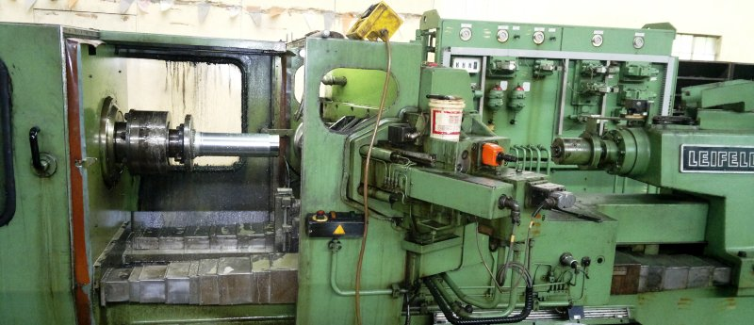

Figure 1: CNC flow forming machine

## **MATERIAL**

The material used for the present research work is AA6082 alloy. The major alloying elements are Al-1.2Mg-1.0Mn-01.3Si-0.50Fe-0.25Cr-0.1Cu. AA6082 has medium strength alloy with excellent corrosion resistance. Addition of Manganese controls the grain structure, which results in superior strength. The alloy age hardens by formation of Mg2Si precipitates.

**V. PRE-FORM DESIGN**

The pre-form was designed based on two factors namely maximum possible deformation and constant volume principle. These pre-forms were manufactured by hot forging. Generally 15% allowance is provided on the diameter for machining and other allowances including extra material required for test specimens. The pre-form was then annealed at a temperature of 510-540 0C for two hours and quenched in water. The flow-forming mandrel is made of tool steel. A slight taper is given in the mandrel for easy ejection of the product. The machined pre-form is shown in fig. 1.

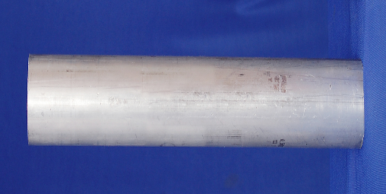 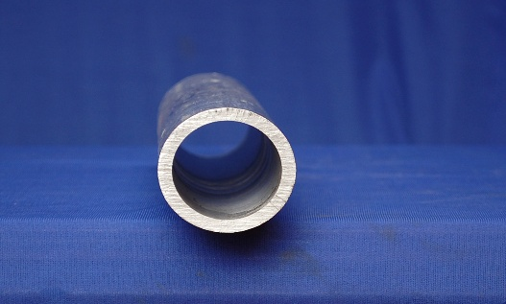

**Figure 1:** Machined pre-form

**VI. PLANNING OF EXPERIMENTS**

Taguchi method, a powerful design of experiments tool is used in the present investigation. This method provides a simple, efficient and systematic approach to determine optimal machining parameters. Conventional experimental design methods are too complex and expensive, as large numbers of experiments have to be carried out to study the process. Taguchi method uses an orthogonal array to study the entire process with only fewer experimental runs. Moreover, traditional experimentation involves one-factor-at-a-time experiments, wherein one variable is changed while the rest are held constant. It is also not possible to study all the factors involved in the process and to determine their main effects (i.e., the individual effects) in a single experiment. Taguchi technique overcomes all these drawbacks. Taguchi method is used for optimizing process parameters and identifying the optimal combination of factors for the desired responses. The steps involved are:

1. Identification of process parameters and their levels.

2. Identification of response function and its quality characteristic.

3. Selection of the appropriate orthogonal array.

4. Performing the experiments as per the conditions specified in orthogonal array.

5. Analysis of results through ANOVA and selection of the optimum level of process parameters.

6. Confirmation test to verify the optimal process parameters.

The input parameters chosen for the experiments are: (a) Axial feed of the roller, F (mm/min) (b) Speed of the mandrel, S (rpm) and (c) Roller radius (mm) while the response function selected isthe Ovality O (mm) of flow formed tube**.**The input parameters and their levels are given in Table 1.

**TABLE 1:** Parameters and their Levels

|  |  |  |  |  |
| --- | --- | --- | --- | --- |
| Symbol | Parameter | Level 1 | Level 2 | Level 3 |
| F | Axial feed, mm/min | 50 | 75 | 100 |
| S | Mandrel speed, rpm | 150 | 200 | 250 |
| t | Roller radius, mm | 4 | 8 | 12 |

**VII. SELECTION OF ORTHOGONAL ARRAY**

The flow forming process involves material non-linearity, which can be effectively studied by 3-level or 4-level variables. However by considering the cost factors, L9 (33) orthogonal array, with three columns and nine rows, which can handle 3-level factors is selected to study the optimize the flow forming process.

The L9 OA requires only nine experiments to formulate the entire process whereas in classical method, full factorial requires, 33= 27 experiments. The experimental layout using L9 OA is shown in table 2. The coded values of 1, 2 and 3 represent level 1, level 2 and level 3 of parameters respectively.

*Statistical analysis of variance* (ANOVA) is performed to find out the signification of the process parameters on the flow forming process which produce tubes with smaller ovality. Optimal combination of process parameters is predicted by ANOVA.

**VIII. EXPERIMENTATION AND RESULTS**

Experiments are conducted as per the plan given in table-3 and ovality is measured for each experiment. Each experimental trial combination is replicated twice to minimize the effect of noise factors.

S/N value can be arrived by,

S/N Ratio = -10 log (MSD).

C Where MSD= Mean square deviation.

The MSD value is calculated by,

MSD = ∑ (yi2)/ r for smaller-the-better characteristic.

**TABLE 2:** Experimental Layout using L9 Array

|  |  |  |  |  |  |  |
| --- | --- | --- | --- | --- | --- | --- |
| Experiment Number | Parameter Level | | | Experimental result for Ovality | | |
|  | F | S | t | Trial-1, O**1** | Trial-2, O**2** | S/N Ratio |
| 1 | 1 | 1 | 1 | 0.31 | 0.32 | 10.03 |
| 2 | 1 | 2 | 2 | 0.34 | 0.35 | 9.24 |
| 3 | 1 | 3 | 3 | 0.38 | 0.39 | 8.29 |
| 4 | 2 | 1 | 2 | 0.23 | 0.22 | 12.95 |
| 5 | 2 | 2 | 3 | 0.19 | 0.21 | 13.96 |
| 6 | 2 | 3 | 1 | 0.15 | 0.14 | 16.76 |
| 7 | 3 | 1 | 3 | 0.56 | 0.54 | 5.19 |
| 8 | 3 | 2 | 1 | 0.36 | 0.37 | 8.75 |
| 9 | 3 | 3 | 2 | 0.42 | 0.41 | 7.63 |

**IX. ANALYSIS OF EXPERIMENTS**

In the present investigation, two replications are performed for each of nine experiments. The Taguchi analysis is performed based on the S/N ratio methodology. The experimental results are analyzed by considering the main effects and their differences between the level 1, level 2, and level 2 and level 3 of the factors.

The factor main effects and their differences are analyzed by calculating the mean value of observations of the experiment. The overall mean value of ovality is calculated from the following equation (1),

∑(O)

Mean (O) = i= 1-9 ……. (1)

9

The main effect of a parameter level, for example, feed, F at low level 1 (i.e. F=50 mm/min), on Ois given by Eq (2) .

Mean [(O)] F=50 mm/min = (O1 + O2 +O 3) / 3 = 2.9 ------ (2)

The main effects and their differences for the ovality are given in table-3.

**TABLE 3:** Main Effects and their difference on the Ovality

|  |  |  |  |  |  |  |
| --- | --- | --- | --- | --- | --- | --- |
| Factors | Level 1 (L1) | Level 2 (L2) | Level 3 (L3) | Difference between levels | | |
| L2-L1 | L3-L1 | L3-L2 |
| F,  mm/min | 9.18 | 14.56 | 7.19 | 5.37 | -1.99 | -7.37 |
| S,  rpm | 9.39 | 10.65 | 10.89 | 1.26 | 1.50 | 0.24 |
| R,  mm | 11.85 | 9.94 | 9.14 | -1.90 | -2.70 | -0.79 |

**Figure 2:** Main effects of process parameters on Ovality

From the main effects, it is evident that he change of Roller feed from 50 to 75 mm/min, increases the main effect S/N value by 5.37 and raise of roller feed from 75 to 100 mm/min decreases the main effect S/N value by 7.37. .i.e., The process produces tubes with minimum ovality when the feed is at level 2. Lower value of roller feed rate (50 mm/min) produces, non-uniform plastic deformation as the roller passes slowly over the preform. This uneven plastic deformation leads to greater ovality, when the roller feed reaches to 75 mm/min; it becomes optimum and produces localized uniform plastic deformation which results in lower ovality. When the feed rate increases further to 75mm/min, the forming forces becomes higher, this leads to slightly increase in ovality from level 2 to level 3.

Also, the increase of mandrel speed from 150 to 200 rpm increases the main effect S/N value by 1.26 and from 200 to 250 rpm increases the main effect S/N value by 0.24. i.e., the process produces flow formed tubes with minimum ovality when the speed is at level 3. At the lower mandrel speed, lower forming forces cannot plasticize the material to the optimum level, which results in larger ovality. As the speed of the mandrel increases to level 3, the optimized plastic deformation produces the tubes with minimum ovality.

It is also observed that The change of roller radius from 4 to 8 mm results the decrease in the main effect S/N value by 1.90, and the change of roller radius from 8 to 12 mm decreases the main effect S/N value by 0.79. i.e., the process produces tubes with minimum ovality when the roller radius is at level 1. As the roller radius increases, the forming forces become high, results in diametric growth and produce the tubes with larger ovality.

Figure 2, shows the main effects and their differences between the levels of parameters on the ovality. The relative slope of linear graph indicates the significance parameters. In the present investigation, it is clear that, the slope of line indicating the roller feed is more as compared to slopes of other parameters. From the main effects and graphs of factor parameters, it is evident that the roller feed is having significant influence on the ovality of flow formed tube, followed by roller radius and mandrel speed. A flow formed tube is shown in Fig. 3.

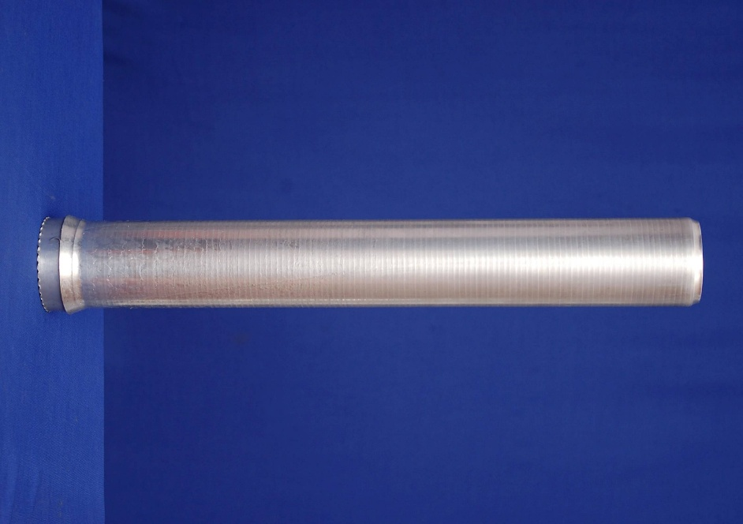

**Figure 3:** Flow formed tube

**TABLE 4:** - ANOVA Table

|  |  |  |  |  |  |  |  |
| --- | --- | --- | --- | --- | --- | --- | --- |
| Factor | Symbol | D.O.F | Sum of squares, S | Variance, V | F-Ratio, F | Pure Sum, S” | Percent (%) |
| Roller feed | F, mm | 2 | 87.17 | 43.58 | 180.83 | 86.68 | 84.0 |
| Mandrel speed | S, rpm | 2 | 3..92 | 1.96 | 8.13 | 3.43 | 3.4 |
| Roller radius. | R, mm | 2 | 11.56 | 5.78 | 23.98 | 11.07 | 10.8 |
| Others  /Error |  | 2 | 0.48 | 0.24 |  |  | 1.8 |
| Total |  | 8 | 103.13 |  |  |  | 100 |

The results of ANOVA performed for the response parameter are shown in Table- 4. For a process parameter to be significant, the calculated F-ratio should be more than the F-ratio from tables. The F-ratio from the tables, at F(2, 2) is 18. ANOVA table indicates that the roller feed is the most significant process parameter influencing the Ovality of flow formed tube followed by roller radius. Mandrel speed is insignificant parameter. This also confirms in the graph shown in fig. 2.



**Figure 4:** Contour plot of roller feed and mandrel speed on Ovality

The contour plot of roller feed and mandrel speed on S/N ratio of ovality is shown in Fig. 4. According to the contour plot, the minimum ovality can be produced when feed at level 2 is combined with higher level of mandrel speed. The lower and higher roller feeds are undesirable.



Figure 5: Contour plot of roller feed and roller radius on Ovality

The contour plot of roller feed and roller radius on ovality is shown in Fig. 5. As per the contour plot, Lower value of roller radius combined with intermediate level of feed produces the tubes with lower ovality. The lower and higher values of roller radius will lead to higher Ovality.



Figure 6: Contour plot of mandrel speed and roller radius on Ovality

The contour plot of mandrel speed and roller radius on ovality is shown in Fig. 6. The tubes with lower ovality can be produced when the higher mandrel speed combined with lower roller to medium radius.

**TABLE 5:** Optimum conditions and performance for minimum Ovality

|  |  |  |  |
| --- | --- | --- | --- |
| Factors | Level Description | Level | Contribution |
| Feed F, mm/min | 75 | 2 | 4.34 |
| Speed S, rpm | 250 | 3 | 0.58 |
| Radius R, mm | 4 | 1 | 1.53 |

Total Contribution from all factors ... 6.36

Current Grand average of performance ... 10.31

Expected Result (S/N Ratio) at Optimum condition ... 16.68

Expected Result at Optimum condition ... 0.14

**Figure 7:** Influences of parameters on ovality

**X. CONFIRMATION TEST**

In Taguchi method a confirmation test is required to verify the optimum conditions and to compare the results with expected conditions. The optimum condition for smaller ovality is shown in table-5. It reveals that the roller feed should be at level 2 , the mandrel speed should be at level 3 and the roller radius should be at level 1 for production of flow formed tube with minimum ovality. The model predicts an optimum value of 0.14mm for ovality. No extra confirmation test is required as the optimal combination of parameters is one of the experimental runs (experiment No.6 in table-2). The developed model produces tubes with ovality in the range of 0.14-0.15mm.

**XI. CONCLUSIONS**

In the present investigation, the effects of process parameters on the ovality of AA6082 flow formed tube have been successfully studied by Taguchi method. The influences of parameters on the ovality are shown in Figure 7, from the results derived from ANOVA Table. It is concluded that the parameters that have relative significant influence on ovality are roller feed (84 %), roller radius (11%) and mandrel speed (3 %) respectively. The optimum conditions for smaller ovality are roller feed at 75 mm/min, mandrel speed at 250 rpm and roller radius at 4 mm. The roller feed is significant process parameter for Ovality. It has been proved that the improvement of response function is significant, when the process parameters set at their optimal values.

**XII. REFERENCES:**

[1].  [Ram Mohan](https://www.tandfonline.com/author/RAM+MOHAN%2C+T), T., Mishra, R. (1972). Studies on power spinning of tubes. [*International Journal of Production Research*.](https://www.tandfonline.com/journals/tprs20) Volume 10, [Issue 4](https://www.tandfonline.com/toc/tprs20/10/4), pp 351-364.

[2 ] Chang S.C, Haung C.A. and others.(1998). Tube spinnability of AA 2024 and 7075 Aluminum. *Journal of Material Processing and Technology*, 80-81, 676-682.

[3] Rajan K.M., Narsimhan K. (2001). An investigation of the development of defects during flow forming of high strength thin wall steel tubes, *ASM Journal of Practical Failure Analysis*, 1(5), pp. 69–76*.*

[4 ] Lakshman Rao, M., Rao, T.V.L.N., Ramana. M.V., Rao, C.S.K.P. (2008). A Study on the influence offlow forming parameters of Maraging steel tubes. *Journal of Institution of Engineers (I)*, 89.

[5]. Srinivasulu M., Krishna Prasada Rao C.S., Komaraiah M. (2012). Experimental studies on the characteristics of AA6082 flow formed. *Journal of Mechanical Engineering Research Vol. 4(6), pp. 192-198*

[6]. Bikramjit Poddar, Prabas Banerjee, Ramesh Kumar K, Nirmal Baran Hui.(2018). Flow forming of thin-walled shells, Sadhana, Indian Academy of Sciences, 43, 208

[7] Ashutosh Kumar Srivastwa, Santosh Kumar, Pankaj Kumar Singh. (2019). Diametral Growth and Hardness Variation in Al 6101 T6 during Flow Forming. *International Journal of Innovative Technology and Exploring Engineering (IJITEE).* Volume-9, Issue-2, ISSN: 2278-3075 (Online).

[8]. Lai, MO., Lee, KS. Fracture and creep properties of flow-formed tubes. (1992). *Journal of Material Processing and Technology*, Vol. 29, 1-3, pp 321-330.

[9] [Xueping Zhang](https://www.researchgate.net/profile/Xueping-Zhang-5?_tp=eyJjb250ZXh0Ijp7ImZpcnN0UGFnZSI6InB1YmxpY2F0aW9uIiwicGFnZSI6InB1YmxpY2F0aW9uIn19), [Gao Erwei](https://www.researchgate.net/scientific-contributions/Gao-Erwei-82789428?_tp=eyJjb250ZXh0Ijp7ImZpcnN0UGFnZSI6InB1YmxpY2F0aW9uIiwicGFnZSI6InB1YmxpY2F0aW9uIn19), [. Richard Liu](https://www.researchgate.net/scientific-contributions/C-Richard-Liu-73656620?_tp=eyJjb250ZXh0Ijp7ImZpcnN0UGFnZSI6InB1YmxpY2F0aW9uIiwicGFnZSI6InB1YmxpY2F0aW9uIn19). C. (2009). Optimization of process parameter of residual stresses for hard turned surfaces. [*Journal of Materials Processing Technology*](https://www.researchgate.net/journal/Journal-of-Materials-Processing-Technology-0924-0136?_tp=eyJjb250ZXh0Ijp7ImZpcnN0UGFnZSI6InB1YmxpY2F0aW9uIiwicGFnZSI6InB1YmxpY2F0aW9uIn19), 209(9): 4286-4291.

[10]. Vijian, P., Arunachalam, V.P. (2006). Optimization of squeeze cast parameters of LM6 aluminium alloy for surface roughness using Taguchi method. *Journal of Material Processing and Technology*, Vol. 180, 1-3, pp 161-166.

[11]. Joseph Davidson M., Balasubramanian K, Tagore GRN. (2008). Experimental investigation on flow-forming of AA6061 alloy—A Taguchi approach. [*Journal of Materials Processing Technology*](https://www.sciencedirect.com/journal/journal-of-materials-processing-technology). [Vol. 200, 1–3](https://www.sciencedirect.com/journal/journal-of-materials-processing-technology/vol/200/issue/1), pp 283-287.

[12]. [Ali Abdallah](https://www.researchgate.net/scientific-contributions/Ali-Abdallah-2090375504?_tp=eyJjb250ZXh0Ijp7ImZpcnN0UGFnZSI6InB1YmxpY2F0aW9uIiwicGFnZSI6InB1YmxpY2F0aW9uIn19), [Bhuvenesh Rajamony](https://www.researchgate.net/profile/Bhuvenesh-Rajamony?_tp=eyJjb250ZXh0Ijp7ImZpcnN0UGFnZSI6InB1YmxpY2F0aW9uIiwicGFnZSI6InB1YmxpY2F0aW9uIn19). (2014). Optimization of cutting parameters for surface roughness in CNC turning machining with aluminium alloy 6061 material. [*IOSR Journal of Engineering*](https://www.researchgate.net/journal/IOSR-Journal-of-Engineering-2250-3021?_tp=eyJjb250ZXh0Ijp7ImZpcnN0UGFnZSI6InB1YmxpY2F0aW9uIiwicGFnZSI6InB1YmxpY2F0aW9uIn19), Vol. 04, 10, pp 01-10