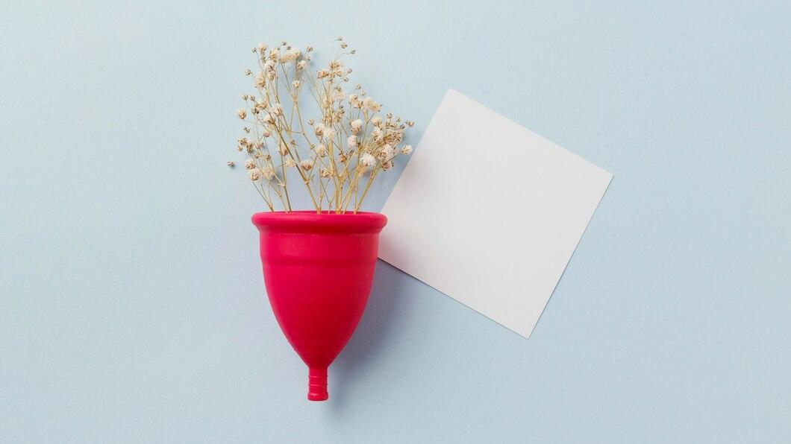

Menstruation has long been a topic that many people feel uncomfortable discussing. Social stigma, cultural taboos, and a general lack of education contribute to this silence. However, breaking the silence surrounding menstruation is essential for promoting gender equality, health awareness, and a more inclusive society. In this article, we will explore how to talk about menstruation openly, respectfully, and without shame.

## **The Importance of Normalizing Menstruation Conversations**

For centuries, menstruation has been treated as a topic of secrecy. This silence has led to misconceptions, embarrassment, and a lack of education about an essential [biological process](https://iosrjen.org/Papers/Conf.19010-2019/Volume-1/4.%2026-30.pdf). Normalizing conversations around menstruation is not only crucial for promoting awareness but also for ensuring that individuals who menstruate feel supported and understood.

By making menstruation a topic of open discussion, we can help reduce stigma, improve health literacy, and create an environment where people can feel comfortable discussing their needs without fear of judgment.

## **Educate Yourself and Others**

Before engaging in any discussions, it's important to have a clear understanding of what menstruation is and how it affects people physically and emotionally. Familiarizing yourself with terms like [menstrual health](https://azah.in/collections/sanitary-pads), period poverty, and menstrual hygiene can equip you with the knowledge needed to discuss the topic intelligently and respectfully. Additionally, share this information with others to help them gain a better understanding.

## **Use Positive Language**

When talking about menstruation, it’s essential to use respectful and inclusive language. Avoid using negative or demeaning words such as “gross” or “disgusting.” These words only perpetuate the stigma surrounding menstruation. Instead, opt for neutral and factual terms like “menstrual cycle,” “period,” and “menstruation.” Language shapes perceptions, so it's vital to choose words that reflect a positive attitude toward the topic.

## **Create Safe Spaces for Dialogue**

Conversations about menstruation are most productive when they take place in environments where individuals feel safe, respected, and free from judgment. Whether at home, in the workplace, or in educational settings, ensure that the space is inclusive and supportive. Encourage individuals to share their experiences, and offer empathy and understanding when needed.

## **Be Mindful of Diverse Experiences**

Menstruation is not the same for everyone. There are many different experiences of menstruation based on factors such as age, culture, gender identity, and health conditions. For example, trans men and non-binary individuals may also experience menstruation, but their needs and experiences can differ from those of cisgender women.

## **Menstruation and Its Impact on Health and Well-being**

Menstruation is an important part of reproductive health, and discussing it openly can shed light on various health issues that are often overlooked. Period-related health problems, such as dysmenorrhea (painful periods), endometriosis, and PCOS (polycystic ovary syndrome), are common but often underreported. Talking about these issues can help those affected feel less isolated and more empowered to seek medical advice and treatment. Opt for [Natural period protection](https://www.blissnatural.in/collections/organic-sanitary-napkins) for more safety and hygiene.

## **Menstrual Health and Hygiene**

Access to affordable and sustainable menstrual products is crucial for maintaining good health during menstruation. Unfortunately, period poverty remains a significant barrier in many parts of the world, leaving many individuals without the necessary resources to manage their periods hygienically.

## **Understanding the Emotional and Psychological Impact**

Menstruation affects not only the body but also the mind. Many individuals experience mood swings, fatigue, and anxiety during their menstrual cycle. For some, these emotional and psychological changes can be severe and disrupt daily life. Premenstrual syndrome (PMS) and [premenstrual dysphoric disorder (PMDD)](https://www.hopkinsmedicine.org/health/conditions-and-diseases/premenstrual-dysphoric-disorder-pmdd) are common conditions that deserve attention.

## **The Role of Menstruation in Gender Equality**

One of the most significant reasons to break the silence around menstruation is its direct connection to gender equality. Menstruation is a fundamental aspect of women’s biology, yet it is often treated as taboo, leading to gender-based discrimination and exclusion. In many cultures, menstruating individuals face stigma and discrimination at school, work, and within their families.

## **Menstruation in the Workplace: A Call for Change**

The workplace is one of the most important spaces where discussions about menstruation need to be normalized. Many employees face discomfort, stigma, and even discrimination because of their menstrual cycles. In some countries, there are movements pushing for [paid menstrual leave](https://www.drishtiias.com/daily-updates/daily-news-editorials/dilemmas-surrounding-paid-menstrual-leave), which acknowledges the physical and emotional toll menstruation can have on individuals.