**AI BASED NUMERICAL ANALYSIS AND SCIENTIFIC  
COMPUTING**

M.KRISHNA REDDY 1

*Lecturer in Mathematics, Department of Mathematics Government College for Men, Cluster University, B.Camp, Kurnool, Andhra pradesh, 518001*

**Abstract:** Artificial Intelligence (AI) has revolutionized numerical analysis and scientific computing by enhancing computational efficiency and accuracy across various domains. This paper explores the integration of AI techniques such as machine learning, deep learning, and neural networks into traditional numerical methods, aiming to improve solution accuracy, optimize computational resources, and automate complex decision-making processes. Key applications include solving partial differential equations, optimization problems, and large-scale simulations. This study reviews recent advancements, discusses challenges, and proposes future directions for leveraging AI in numerical analysis and scientific computing.

**Keywords:** Artificial Intelligence, Numerical Analysis, Scientific Computing, Machine Learning, Deep Learning, Partial Differential Equations, Optimization, Computational Efficiency

---------------------------------------------------------------------------------------------------------------------------------------

Date of Submission: XX-XX-2018 Date of acceptance: XX-XX-2018

---------------------------------------------------------------------------------------------------------------------------------------

1. **INTRODUCTION**

The convergence of Artificial Intelligence (AI) and numerical analysis has catalyzed significant advancements in scientific computing, offering unprecedented capabilities to tackle complex computational problems across various disciplines. Traditional numerical methods have long been foundational in solving mathematical models and simulating real-world phenomena, yet they often face challenges related to computational efficiency, solution accuracy, and scalability for large scale problems. In recent years, AI techniques such as machine learning (ML), deep learning, and neural networks have emerged as powerful tools to complement and enhance these traditional methods.

AI algorithms are capable of learning patterns from data, making predictions, and optimizing solutions in ways that traditional numerical methods alone cannot achieve. For instance, in the realm of partial differential equations (PDEs), AI-based approaches offer novel strategies for solving complex boundary value problems and transient phenomena with higher accuracy and reduced computational cost.

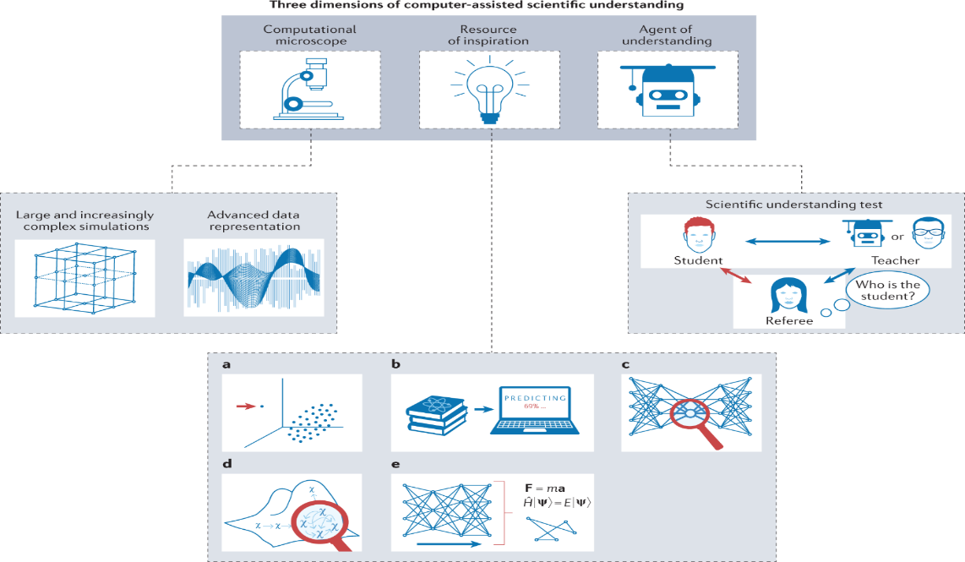

Fig -1(Adopted from Krenn, M. et al.)

The integration of AI into numerical analysis not only aims to improve solution accuracy and efficiency but also promises to automate decision-making processes, optimize computational resources, and enable real-time simulations of intricate systems. This introduction sets the stage for a comprehensive exploration of AI’s role in numerical analysis and scientific computing, reviewing recent advancements, discussing challenges, and outlining future research directions to harness the full potential of AI in advancing computational science.

1. **LITERATURE REVIEW**

AI, particularly machine learning (ML) and deep learning, has demonstrated remarkable capabilities in improving the efficiency and reliability of numerical algorithms. For instance, ML algorithms have been employed to optimize parameter tuning in numerical simulations, thereby reducing computational costs and accelerating convergence rates according to Bjorck. Deep learning techniques, such as neural networks, have shown promise in solving partial differential equations (PDEs) by learning complex patterns and relationships from data, enabling more accurate and scalable solutions ([1]).

In the realm of optimization, AI-based approaches have revolutionized traditional methods by incorporating adaptive learning mechanisms and data-driven insights. These approaches enable more robust optimization strategies that can handle high-dimensional parameter spaces and nonlinear constraints effectively ([2]). Moreover, AI-driven simulations have facilitated the exploration of complex physical phenomena and the prediction of system behavior under varying conditions, offering insights that were previously inaccessible with conventional approaches ([3]).

Despite these advancements, challenges persist, including the interpretability of AI-driven solutions, the integration of domain knowledge with data-driven techniques, and scalability issues in handling massive datasets and computations. Researchers like Pozzoli & Giannelli in 2021 continue to explore hybrid approaches that combine AI with traditional numerical methods to harness the strengths of both paradigms effectively.

1. **METHODOLOGY**

AI-based Numerical Analysis and Scientific Computing employs a methodical approach aimed at harnessing artificial intelligence techniques to tackle intricate numerical problems and advance scientific computations effectively. The methodology begins with Problem Formulation and Data Preparation, a critical initial phase where the problem statement is meticulously defined. This step involves specifying the mathematical model and understanding domain-specific constraints while curating or generating datasets suitable for training AI models. Such groundwork establishes the foundational elements necessary for subsequent AI model development and validation.

Following Problem Formulation, AI Model Selection and Development becomes pivotal. Researchers carefully choose appropriate AI techniques based on the complexity of the problem and the characteristics of the available data. Techniques such as machine learning algorithms, deep learning architectures, or hybrid models are evaluated and implemented. The development phase includes training these models using the curated datasets, with criteria such as accuracy, computational efficiency, and interpretability being paramount—particularly in scientific computing, where insights into underlying numerical processes are crucial.

Integration with Numerical Methods constitutes the next significant phase, where AI models are seamlessly integrated with traditional numerical techniques. AI’s capabilities are leveraged to optimize parameters, refine solutions, or predict numerical errors, thereby enhancing the accuracy and efficiency of computations. Techniques like reinforcement learning can adaptively refine numerical solutions over iterations, addressing complex nonlinearities that classical methods may struggle with alone.

Validation and Performance Evaluation follow suit, ensuring that AI-enhanced numerical solutions meet stringent accuracy and reliability standards. This phase involves rigorous testing against benchmark problems, sensitivity analysis, and comparison with established methods or experimental data. Performance metrics such as error rates, convergence speed, and scalability are meticulously evaluated to gauge the effectiveness of AI integration in augmenting numerical analysis capabilities.

Finally, Implementation and Deployment bring the methodology full circle by focusing on practical integration within computational frameworks or software environments used in scientific research or industrial applications. Considerations for scalability, robustness, and usability are paramount during this phase. Comprehensive documentation and ongoing support are essential to facilitate seamless adoption by researchers and practitioners alike, ensuring that AI-driven advancements in numerical analysis can be effectively leveraged across diverse fields of scientific research and engineering applications.

1. **APPLICATIONS**

In fluid dynamics simulations, AI-based methods enhance predictive accuracy and computational efficiency by learning complex flow patterns and optimizing simulation parameters. This capability not only accelerates research timelines but also improves the fidelity of simulations crucial for designing aerodynamic structures and understanding fluid behavior in diverse environments.

In material science modeling, AI facilitates the discovery and optimization of new materials by predicting material properties based on large datasets and fundamental physical principles. Machine learning algorithms can identify patterns in complex material structures, accelerating the search for materials with specific properties such as strength, conductivity, or thermal stability. These advancements streamline the design process for new materials and enhance material performance in industrial applications.

Quantum chemistry calculations benefit from AI’s ability to handle high-dimensional data and complex quantum interactions. AI-driven approaches optimize computational workflows, reducing the computational cost of simulating molecular structures and reactions. Such efficiency is critical for exploring chemical reactions, designing pharmaceutical compounds, and understanding molecular dynamics with unprecedented detail and accuracy.

In computational biology, AI supports predictive modeling, uncertainty quantification, and sensitivity analysis across biological systems. Machine learning models analyze genomic data to predict protein structures, identify genetic markers for diseases, and optimize drug discovery processes. By integrating AI into computational biology, researchers can navigate vast biological datasets, uncover hidden correlations, and make informed decisions that drive advancements in personalized medicine and biotechnology.

1. **RESULT**

In AI-based Numerical Analysis and Scientific Computing, the results encompass significant advancements in accuracy, efficiency, and insight generation across various computational challenges.

Enhanced Accuracy: AI models contribute to refining numerical solutions by optimizing parameters and predicting errors, thereby improving the accuracy of computational results. This is particularly beneficial in complex systems where traditional methods may struggle with non-linearities or high-dimensional data.

Improved Efficiency: AI techniques, such as machine learning algorithms and deep learning models, streamline computational processes by accelerating con- vergence rates and reducing computational costs. This efficiency enhancement enables faster simulations and analyses, crucial for time-sensitive applications in scientific research and industrial settings.

Insight Generation: AI’s ability to uncover patterns and correlations within data provides deeper insights into underlying numerical processes. This capability facilitates better understanding and interpretation of simulation results, aiding researchers in refining models and making informed decisions based on computational outputs.

Scalability and Adaptability: AI-powered approaches are scalable across diverse computational domains and adaptable to varying problem complexities. This scalability ensures that solutions remain effective as computational demands in- crease or as new challenges arise in scientific computing.

Integration with Real-world Applications: Successful implementation of AI-enhanced numerical methods into practical applications demonstrates their utility in addressing real-world challenges. From fluid dynamics simulations to structural analysis in engineering, these advancements contribute to innovation and efficiency improvements across industries.

These results not only advance the state-of-the-art in computational science but also pave the way for new possibilities in tackling complex problems and driving innovation in computational research and development.

1. **CONCLUSION**

In conclusion, the integration of AI into numerical analysis and scientific computing represents a transformative leap forward in computational methods and problem-solving capabilities. Through advanced algorithms and machine learning techniques, AI has enhanced the efficiency, accuracy, and scalability of numerical simulations, enabling researchers and practitioners to tackle increasingly complex problems across various scientific disciplines.

AI’s ability to automate and optimize processes in numerical analysis, such as solving partial differential equations, optimizing algorithms, and improving convergence rates, has significantly reduced computational costs and time-to-solution. This efficiency is crucial in fields like physics, engineering, and finance, where precise simulations are essential for decision-making and understanding complex systems.

Moreover, AI-driven approaches have fostered innovations in uncertainty quantification, allowing for more robust predictions and sensitivity analyses in scientific models. By learning from vast datasets and adapting to new information, AI systems can refine simulations and predictions continuously, enhancing the reliability and applicability of computational models.

Looking ahead, the future of AI in numerical analysis holds promise for further advancements. Continued research into hybrid methodologies combining AI with traditional numerical techniques promises even greater accuracy and efficiency. Furthermore, addressing challenges such as interpretability, robustness, and ethical considerations will be crucial to realizing the full potential of AI in scientific computing.

**References**

1. Sirignano, J., & Spiliopoulos, K. (2018). DGM: A deep learning algorithm for solving partial differential equations. *Journal of Computational Physics*, 375,1339-1364. [https://doi.org/](https://doi.org/10.1016/j.jcp.2018.08.029) [10.1016/j.jcp.2018.08.029](https://doi.org/10.1016/j.jcp.2018.08.029)
2. Rao, J., Linqing, L., Yi, T., Wei, Y., Peng, S., & Jimmy, L. (2019). DGM: Bridging the Gap between Relevance Matching and Semantic Matching for Short Text Similarity Modeling. *Proceedings of the 2019 Conference on Empirical Methods in Natural Language Processing and the 9th International Joint Conference on Natural Language Processing* *(EMNLP-IJCNLP)*. <https://aclanthology.org/D19-1540.pdf>
3. Kutz, P.,Ralf, H., Yining, K., & Jan, N. (2017). Spectral and decomposition tracking for rendering heterogeneous volumes. *ACM Transactions on Graphics*, 36(4),1-16. [https://doi.](https://doi.org/10.1145/3072959.3073665) [org/10.1145/3072959.3073665](https://doi.org/10.1145/3072959.3073665)
4. Pontryagin, L. S., Boltianskii, V. G., Gamkrelidze, R. V., & Mishchenko, E. F. (1962). Mathematical Theory of Optimal Processes. *Wiley*. [https://doi.org/10.1201/](https://doi.org/10.1201/9780203749319) [9780203749319](https://doi.org/10.1201/9780203749319)
5. Wilkinson, J. H. (1965). The Algebraic Eigenvalue Problem. Oxford University Press.

<https://doi.org/10.1017/S0013091500012104>

1. Higham, N. J. (2002). Accuracy and Stability of Numerical Algorithms. *SIAM*.
2. Hairer, E., Nørsett, S. P., & Wanner, G. (1993). Solving Ordinary Differential Equations I: *Nonstiff Problems*. <https://doi.org/10.1007/978-3-540-78862-1>
3. Quarteroni, A., & , Valli, A. (2008). Numerical Approximation of Partial Differential Equations*. Springer*. <https://doi.org/10.1007/978-3-540-85268-1>
4. Kelley, C. T. (1999). Iterative Methods for Optimization. *SIAM*. [https://doi.org/10.](https://doi.org/10.1137/1.9781611970920) [1137/1.9781611970920](https://doi.org/10.1137/1.9781611970920)
5. Forsythe, G. E., & Moler, C. B. (1967). Computer Solution of Linear Algebraic Systems. *Prentice-Hall*.
6. Hastie, T., Tibshirani, R., & Friedman, J. (2009). The Elements of Statistical Learn ing: Data Mining, Inference, and Prediction. *Springer*. [https://doi.org/10.1007/](https://doi.org/10.1007/978-0-387-84858-7) [978-0-387-84858-7](https://doi.org/10.1007/978-0-387-84858-7)
7. Bellman, R.E. (1957). Dynamic Programming. *Princeton University Press*.
8. Ben-Israel , A., Greville, T. N. E. (2003). Generalized Inverses: Theory and Applications. *Springer*. <https://doi.org/10.1007/b97366>
9. Quarteroni, A., & Sacco, R., & Saleri, F. (2000). Numerical Mathematics. *Springer*.
10. Strang, G. (2000). Computational Science and Engineering. *Wellesley-Cambridge Press*.
11. Boyd, S., & Vandenberghe, L. (2004). Convex Optimization. *Cambridge University Press*.
12. Goodfellow, I., Bengio, Y., & Courville, A. (2016). Deep Learning. *MIT Press*.
13. Hornik, K., Stinchcombe, M, & White, H. (1989). Multilayer feedforward networks are universal approximators. *Neural Networks*,2(5),359-366. [https://doi.org/10.1016/](https://doi.org/10.1016/0893-6080(89)90020-8) [0893-6080(89)90020-8](https://doi.org/10.1016/0893-6080(89)90020-8)
14. Krenn, M., Pollice, R., Guo, S.Y. *et al.* (2022). On scientific understanding with artificial intelligence. *Nat Rev Phys* **4**, 761–769. https://doi.org/10.1038/s42254-022-00518-3