**CLASS BALANCING AND CLASSIFICATION OF THYROID DISORDER IN A PERSON USING MACHINE LEARNING**

***ABSTRACT*: Thyroid nodules are a sign of a number of thyroid disorders, and medical image analysis is essential to their early identification and diagnosis. Within the current framework, machine learning techniques such as Support Vector Machine, Random Forest and Decision tree algorithm are implemented to classify thyroid nodules. In this study we suggest a novel application of transfer learning algorithms to the classification of thyroid nodules. Through the application of transfer learning, neural network models that have already been trained on big datasets can be adjusted for certain tasks that require less data. Our method involves extracting meaningful information from thyroid ultrasound scans using a cutting-edge convolutional neural network (CNN) that has been pre-trained on a variety of medical images. To optimise its performance for accurate classification, the model is trained on a particular dataset of thyroid nodule images. We examine the effectiveness of many transfer learning architectures, such as VGG16 and Xception CNN, and assess their overall accuracy, sensitivity, and specificity. The proposed methodology aims to provide physicians with a reliable thyroid problem diagnosis tool by increasing the categorization efficiency of thyroid nodules. The results pave the way for more precise thyroid image analysis diagnosis by demonstrating how transfer learning can be utilised to maximise model performance even in the presence of sparsely labelled medical data.**

***KEYWORDS:* Deep learning, Machine learning, Medical imaging, Thyroid analysis, Neural networks**

I. INTRODUCITON

Thyroid cancer eventually develops from the proliferation of thyroid cells. The thyroid is a butterfly-shaped gland located at the base of the neck, directly below the Adam's apple. The thyroid produces the hormones that regulate body temperature, heart rate, weight, and blood pressure. Thyroid cancer may not exhibit any symptoms at first. But as it gets larger, it can start to exhibit signs like neck growth, difficulty swallowing, and vocal changes. Thyroid cancer comes in different types. While most cultivators grow slowly, others can grow quite quickly. Medication is the standard of care for most thyroid malignancies. Thyroid cancer cases appear to be on the rise. The increase may be due to advances in imaging technology that enable doctors to spot small thyroid cancers in CT and MRI scans performed for unrelated reasons (incidental thyroid cancers). Thyroid tumors discovered in this manner are often little growths that respond well to medical intervention. One condition that is becoming more and more of a public health concern is thyroid cancer. It is distinguished by the thyroid gland's cells developing abnormally. The problem is that thyroid nodules might be malignant or benign, which complicates the process of making an accurate diagnosis. The rise could be attributed to developments in imaging technology that allow physicians to identify tiny thyroid malignancies during unrelated CT and MRI scans (incidental thyroid cancers). When thyroid tumors are found this way, they are frequently little growths that react favorably to treatment. Thyroid cancer is one illness that is growing more and more of a public health problem. It can be identified by the aberrant development of thyroid gland cells. The problem is that thyroid nodules might be malignant or benign, which complicates the process of making an accurate diagnosis. Figure 1 shows the thyroid gland with cancer locations.

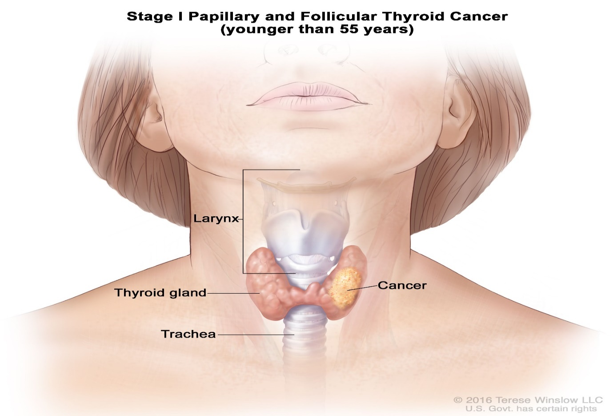**Figure 1: Thyroid gland image classification**

This paper is further divided into Section-II related work, Section-III Old Existing systems, Section-IV Suggested System Presentation, Section-V Results & Discussions and Section-VI Conclusion.

II. RELATED WORK

Rajasekhar Chaganti, et al.,[1] suggests a method that combines machine learning and deep learning models with feature selection. Deep learning and machine learning models are integrated with the features derived from FFS, BFS, BiDFE, and other tree classifiers. The findings show that when combined with the RF model, additional tree classifier-based chosen features typically yield the best accuracy of 0.99. Since feature reduction lowers the performance of machine learning and deep learning models, particularly linear models, other feature approaches produce worse outcomes. Machine learning methods like as RF are excellent for predicting thyroid disorders because of their lower computational complexity. The 10-fold cross-validation statistics also support similar conclusions. When compared side by side with state-of-the-art methods, the suggested strategy performs better. The detection approach is able to classify the patient's state of disease by the application of the proposed machine learning technique. Furthermore, the models' performance can be extended to other thyroid disorders with the addition of new data for classes that already exist as well as data from additional classes. Robust findings are demonstrated by the suggested method, which can be highly significant for real-time disease identification.

S. Sankar, et al.[2] Contains the knowledge discovery dataset from UC Irvin. As a result, this study proposes the XGBoost algorithm as a trustworthy marker of thyroid dysfunction. The suggested XGBoost algorithm's effectiveness is evaluated by contrasting it with the k-Nearest Neighbor (kNN), logistic regression, and decision tree techniques. All four algorithms' performances are compared and examined. Accuracy increases by 2%, 12%, and 17% when comparing the proposed XGBoost to KNN, Decision Tree, and logistic regression. Thyroid disease is becoming more and more commonplace worldwide these days. Notably, in India, thyroid disease affects one in ten persons. Numerous researchers have conducted a variety of studies on the identification of thyroid disease in recent years. As a result, it is challenging to safeguard against and prevent the worst health state during the early stages of thyroid disease prognosis.

Soma Prathibha, et.al,…[3] Investigate methods to enhance the CNN-based deep learning algorithm with the ResNet50 design. This makes it easier to diagnose thyroid issues and empowers people to take preventative action before the condition worsens. Two optimizers, the Adam and the stochastic descent gradient algorithm, are proposed to further enhance the accuracy of the proposed model for the full categorization of thyroid illness. The recommended dual optimizer model outperforms the current method by 97%, according to experiment results. Furthermore, the suggested model performs better than the current systems in terms of F1-Score and Recall, among other metrics. Subsequent investigations will focus on developing novel techniques for contextually identifying a greater range of malignant locations.

Ege Savcı, among others,[4] talk about various machine learning methods that can be used to identify thyroid conditions. Globally, thyroid disease is very frequent, particularly among women. An estimated 200 million individuals worldwide are thought to suffer from thyroid disorders. Thyroid hormones originate from the thyroid gland, a little structure located in front of the neck. Your entire body may be impacted if your thyroid is malfunctioning. Hyperthyroidism is the outcome of the body producing too much thyroid hormone. When the body produces insufficient levels of thyroid hormone, a condition known as hypothyroidism develops. These are dangerous conditions that require medical attention. This means that an inaccurate diagnosis could be dangerous and call for a comprehensive investigation by experts.

Masoumeh Soleimani et al. established a classification strategy for uneven medical data [5]. This work makes use of the UCI repository's hypothyroidism dataset. The wrapper algorithm is employed as a search strategy and the support vector machine approach is employed as a cost function to identify the ideal subset of features during the feature selection stage. By employing learning automata to optimize a neural network for data categorization, the suggested method achieves excellent accuracy, with 99.6% accuracy. Prior classification techniques assigned data to the maximum class, which produced high accuracy but unreliable results. To solve this problem, new combination techniques at the data level will be presented in this study.

III. EXISITNG METHODOLOGIES

With thyroid cancer becoming more common, early detection and accurate diagnosis are critical to effective therapy. Ultrasound scans have a critical role in identifying potential tumours in medical imaging. That being said, because thyroid nodule shapes and sizes vary so much, complex segmentation techniques are needed for accurate analysis. This study aims to enhance the precision of identifying malignant nodules and optimise the segmentation procedure by utilising Graph Cut and Conditional Random Fields (CRFs) in an innovative manner for the prediction of thyroid cancer. Conditional Random Fields (CRFs) are a probabilistic framework that can be used to model the spatial dependencies of a picture. By including contextual information and accounting for pixel correlations, CRFs help to improve the accuracy of thyroid nodule delineation. Process optimisation is a well-known application of graph cut algorithms. By identifying the optimal cut in the image's graph representation, they outperform the segmentation map and emphasise the importance of spatial coherence.

When paired with CRFs, graph cut approaches offer a synergistic solution for thyroid nodule segmentation issues. This combination technique seeks to give a more accurate and nuanced delineation of thyroid lesions by capturing complicated spatial relationships. The enhanced segmentation maps serve as the foundation for more research and, eventually, thyroid cancer forecasting.

IV. PROPOSED SYSTEM

The rising incidence of thyroid cancer highlights the need for accurate and innovative predictive algorithms to facilitate early identification. In this work, we apply the VGG16 and Xception CNN architectures to create a novel deep learning-based thyroid cancer prediction system. Our strategy attempts to improve feature extraction and classification by integrating the strengths of these two cutting-edge convolutional neural networks (CNNs). In the end, this will raise the consistency and accuracy of thyroid cancer prognoses.

Xception's exceptional ability to capture intricate patterns and hierarchical characteristics makes it useful for deep learning. Concurrently, by supporting dependable feature extraction, the VGG16 architecture—which is renowned for its effectiveness and simplicity—improves the Xception model. By examining these two architectural strategies, the optimal model is produced that takes advantage of each one's unique benefits and offers a deeper understanding of the intricate features present in thyroid medical imaging. Training, validation, and testing are the three separate subsets of the dataset that are used to assess the system's efficacy and generalizability. Cross-validation approaches can also be used to validate the resilience of the model and lessen the likelihood of overfitting. Another crucial component of fine-tuning is hyperparameter tuning, which entails modifying variables like learning rates, batch sizes, and regularization techniques. This fine-tuning procedure is essential to guaranteeing optimal performance and an efficient convergence of the model. The next stage is model evaluation, where the system's performance is assessed using common metrics such as accuracy, precision, recall, and F1-score. This evaluation is performed on the particular testing dataset, allowing for a precise understanding of the system's ability to detect brain tumors. Furthermore, by accelerating the creation of brain tumor detection models and enabling their practical medical use, this approach can ultimately enhance patient outcomes and treatment. The proposed architecture is shown in figure 4.

**4.1 VGG16 MODEL**

The VGG16 model is one of the convolutional neural networks (CNNs) that are increasingly being used in computer vision applications such as picture classification. It was developed by the Visual Geometry Group (VGG) at the University of Oxford and took part in the 2014 ImageNet Large Scale Visual Recognition Challenge. The amount of weight layers it has is indicated by the "16" in its name.   
Important features and elements of the VGG16 model consist of:   
Layers of Convolution: VGG16, which is used to extract information from input images, is composed of thirteen convolutional layers. These layers are followed by max-pooling layers, which down sample the feature maps to produce hierarchical information. Completely Connected Layers: The convolutional layers are followed by three completely connected layers in the VGG16, and an output layer for classification is positioned at the end. The final decisions regarding the class of the input image are made by these completely connected layers.  
Receptive Fields: The layers of VGG16 employ comparatively tiny 3x3 convolutional filters. Each neuron in the architecture has a very small receptive field, which enables it to pick up fine features in the images.  
Convolutional Layer Stacking: To enable the VGG16 architecture to learn features at various scales, convolutional and pooling layers are repeatedly stacked Pretraining on ImageNet: The ImageNet dataset, with millions of labelled images in thousands of categories, was used to pretrain VGG16. The model gains a thorough comprehension of a variety of visual ideas from this pertaining. Transfer Learning: VGG16 is a great option for transfer learning because of its pretraining. By swapping out the final few layers while maintaining the weights of the pretrained layers, you can fine-tune the model for a particular job, such as brain tumour identification.  
Deep Network: VGG16 can recognise complex characteristics and patterns in photos and is rather deep in comparison to its predecessors. Nevertheless, increasing depth also leads to higher computing complexity.  
Many image-related tasks, such as object recognition, picture segmentation, and medical image analysis, like brain tumour diagnosis, have made extensive use of the VGG16 model. Despite requiring a significant amount of resources because of its depth, its design offers a solid framework for developing precise and potent convolutional neural networks. Fig 2 shows the VGG16 model

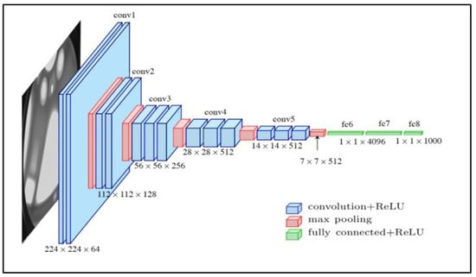

**Figure 2: VGG16 MODEL**

**4.2 Xception CNN**

A deep learning convolutional neural network (CNN) architecture called Xception (pronounced "exception") is specifically made for image classification applications. It was included in the Keras library, which is currently connected with TensorFlow, and was first presented by François Chollet in 2017. "Extreme Inception," or "Xception," is an architecture that improves on the Inception design by making it more accurate and efficient. The following are some of the Xception model's salient features:  
Segment able Convolutions based on Depth: The main novelty of the Xception architecture is the use of depth-wise separable convolutions. This means dividing the conventional convolution process into its depth-wise and point-wise components. While depth-wise convolution applies a single filter to each input channel, point-wise convolution aggregates the results by executing 1x1 convolutions. Great Efficiency: Xception achieves great efficiency by lowering the computing cost while preserving accuracy. This is made possible by the use of depth-wise separable convolutions. This is especially useful for apps on mobile devices or other devices with low processing power.

Enhanced Depth: When comparing Xception models to Inception models, the latter have a considerably shallower architecture. It is ideally suited for a variety of computer vision tasks because of its depth, which enables it to extract complex and hierarchical information from images.

Completely Convolutional: Because Xception is completely convolutional, it can handle a range of input sizes. Because of its adaptability, it may be used for tasks where the input dimensions are variable, such as object detection and image segmentation.

Transfer Learning: Xception can be used for transfer learning, much as other pre-trained models. Through the use of its pre-trained weights on a sizable dataset such as ImageNet, the model can be optimized for a particular job. The Xception CNN model is displayed in Fig 3. Xception can be fine-tuned for a particular task by making changes to the network's end layers while leaving the early layers, which capture more universal properties, mostly unaltered. With this method, the model can preserve the important information from the initial training while adjusting its learnt representations to the subtleties of the incoming data.

Figure 3 illustrates the architecture of the Xception CNN model, showcasing its various layers and components. Understanding this architecture can aid in customizing and fine-tuning the model for specific tasks through transfer learning.

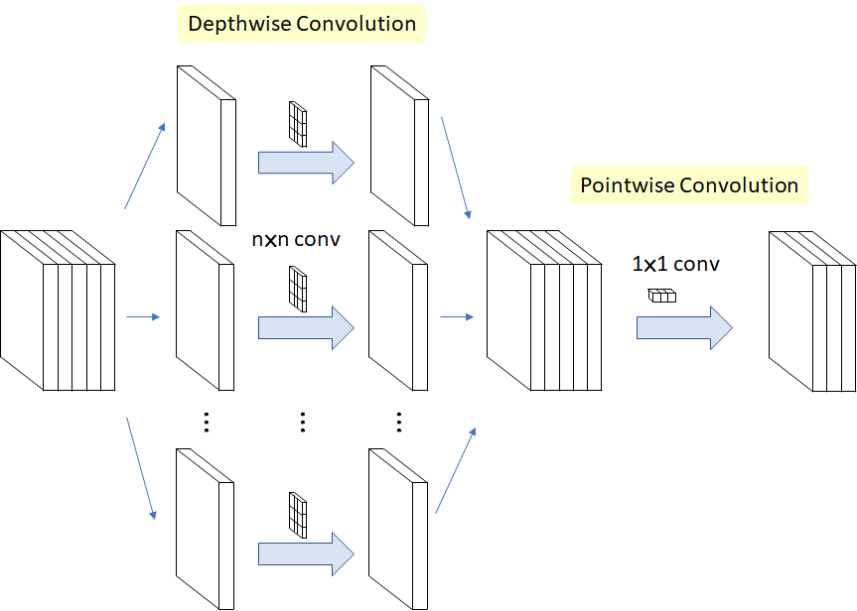

**Figure 3: Xception CNN model**

Dataset Acquisition

Kaggle Dataset (Images)

Preprocessing

Noise Removal

Resizing

Model Building – Deep learning algorithm

VGG16 model, Xception CNN

Post Processing

Using Median Filtering

Thyroid Image datasets

Testing Phase

Input Thyroid image

Model .h5 file generated

Classified Results

Performance Metrics

Accuracy

Loss Values

Training Sets

Testing Sets

Thyroid or normal

Match with model file

**Figure 4: Proposed architecture diagram**

V. EXPERIMENTAL RESULTS

Plotting confusion metric allows for the evaluation of disease classification. We can determine the link between the expected and actual values for each target attribute with the aid of the confusion matrix. By utilizing the VGG16 and XCeption CNN models to compare the confusion matrix of the balanced dataset with the imbalanced data, we can see that the model is able to recognize every label. The ratio of accurate forecasts to those that were expected to be correct but weren’t known as accuracy precision. The recall was not equal, but it was expected to be distinct based on the number of correct predictions divided by the number of accurate forecasts and models. The following formulae may be used to calculate the accuracy, recall, and f-score. Figure 5 shows the confusion matrix in disease classification

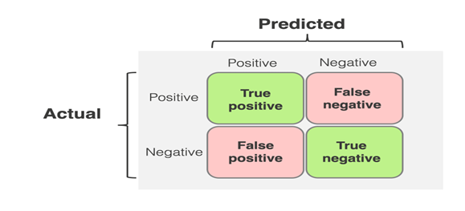

**Figure 5: CONFUSION MATRIX**

The sign facts that are obtained from key features datasets in experimental outcomes are used to gauge how beneficial the recommended approach is. F-measure, Recall, and Precision are used to assess the system's performance.

Precision = $\frac{TP}{TP+FP}$

Recall = $\frac{TP}{TP+FN}$

F measure = 2 $\frac{Precision*Recall}{Precision+Recall}$

*

The ratio of the overall number of perfect predictions to the total quantity of test data is known as accuracy (ACC). Another way to show it is as 1 - ERR. The accuracy ranges from 0.0 to 1.0, with 1.0 being the best attainable accuracy.

$ACC=\frac{TP+TN}{TP+TN+FN+FP}$ x 100

|  |  |
| --- | --- |
| **ALGORITHM** | **ACCURACY** |
| VGG16 model | 87% |
| Xception model | 83% |

**Figure 6: Performance chart**

From the table and graph in figure 6, Xception model provide improved accuracy in disease prediction

VI. CONCLUSION

To sum up, the application of the VGG16 and Xception models to the identification of thyroid cancer is a noteworthy development in the domain of medical imaging and healthcare. These deep learning models are well known for their effectiveness in image processing, and they provide useful tools to help doctors diagnose thyroid cancer in an accurate and timely manner. With its robust picture categorization capabilities and well-established architecture, VGG16 offers a strong platform for this important endeavour. Its versatility and adaptability make it a dependable option for medical scan classification, improving the speed and precision of disease identification. In compliance with the legal and ethical standards of the medical business, the VGG16 model can be precisely tailored to meet the needs of a given dataset. Conversely, the Xception model exhibits remarkable potential for brain tumour analysis because to its superior feature extraction capabilities and computational efficiency. Because of its depth-wise separable convolutions, the Xception architecture is an excellent choice in resource-constrained environments because it reduces computing costs. It can be applied to many different medical imaging tasks, including the detection of abnormalities in MRI and X-ray scans. These models have been at the forefront of research on cancer diagnosis, helping to create systems that are precise, effective, and easy for medical practitioners to understand. They perform well and have the capacity to generalise well to a variety of cancer patients. Furthermore, they save time and resources in the construction of specialised models because their pre-trained weights on large datasets enable rapid deployment and encourage the use of transfer learning.

REFERNECES

[1] Chaganti, Rajasekhar, et al. "Thyroid disease prediction using selective features and machine learning techniques." Cancers 14.16 (2022): 3914.

[2] Sankar, S., et al. "Thyroid disease prediction using XGBoost algorithms." Journal of Mobile Multimedia 18.3 (2022): 1-18.

[3] Prathibha, Soma, et al. "A Novel Technique for Detecting Various Thyroid Diseases Using Deep Learning." Intell. Autom. Soft Comput 35.1 (2023): 199-214.

[4] Savcı, Ege, and Fidan Nuriyeva. "Diagnosis Of Thyroid Disease Using Machine Learning Techniques."  Journal of Modern Technology & Engineering 7.2 (2022).

[5] Soleimani, Masoumeh, et al. "Imbalanced Multiclass Medical Data Classification based on Learning Automata and Neural Network." EAI Endorsed Transactions on AI and Robotics 2 (2023).

[6] Zhao, Xiaohui, et al. "Automatic thyroid ultrasound image classification using feature fusion network." IEEE Access 10 (2022): 27917-27924.

[7] J. Kim, J. E. Gosnell, and S. A. Roman, ‘‘Geographic influences in the global rise of thyroid cancer,’’ Nature Rev. Endocrinol., vol. 16, no. 1, pp. 17–29, Jan. 2020.

[8] E. K. Alexander and E. S. Cibas, ‘‘Diagnosis of thyroid nodules,’’ Lancet Diabetes Endocrinol., vol. 10, no. 7, pp. 533–539, 2022.

[9] A. Prete, P. B. D. Souza, S. Censi, M. Muzza, N. Nucci, and M. Sponziello, ‘‘Update on fundamental mechanisms of thyroid cancer,’’ Frontiers Endocrinol., vol. 11, p. 102, Mar. 2020.

[10] G. Luo, Y. Zhang, J. Etxeberria, M. Arnold, X. Cai, Y. Hao, and H. Zou, ‘‘Projections of lung cancer incidence by 2035 in 40 countries worldwide: Population-based study,’’ JMIR Public Health Surveill., vol. 9, no. 1, Feb. 2023, Art. no. e43651.

[11] S. Sorrenti, V. Dolcetti, M. Radzina, M. I. Bellini, F. Frezza, K. Munir, G. Grani, C. Durante, V. D’Andrea, E. David, P. G. Calò, E. Lori, and V. Cantisani, ‘‘Artificial intelligence for thyroid nodule characterization: Where are we standing?’’ Cancers, vol. 14, no. 14, p. 3357, Jul. 2022.

[12] A. Tahmasebi, S. Wang, K. Daniels, E. Cottrill, J. Liu, J. Xu, A. Lyshchik, and J. R. Eisenbrey, ‘‘Ultrasonographic risk stratification of indeterminate thyroid nodules; a comparison of an artificial intelligence algorithm with radiologist performance,’’ in Proc. IEEE Int. Ultrason. Symp. (IUS), Sep. 2020, pp. 1–4.

[13] X.-X. Yin, L. Sun, Y. Fu, R. Lu, and Y. Zhang, ‘‘U-Net-based medical image segmentation,’’ J. Healthcare Eng., vol. 2022, Apr. 2022, Art. no. 4189781.

[14] A. Shahroudnejad, X. Qin, S. Balachandran, M. Dehghan, D. Zonoobi, J. Jaremko, J. Kapur, M. Jagersand, M. Noga, and K. Punithakumar, ‘‘TUN-Det: A novel network for thyroid ultrasound nodule detection,’’ in Medical Image Computing and Computer Assisted Intervention—MICCAI 2021. Strasbourg, France: Springer, Sep./Oct. 2021, pp. 656–667.

[15] X. Li, Y. Jiang, M. Li, and S. Yin, ‘‘Lightweight attention convolutional neural network for retinal vessel image segmentation,’’ IEEE Trans. Ind. Informat., vol. 17, no. 3, pp. 1958–1967, Mar. 2021.

[16] J. Li, J. Chen, B. Sheng, P. Li, P. Yang, D. D. Feng, and J. Qi, ‘‘Automatic detection and classification system of domestic waste via multimodel cascaded convolutional neural network,’’ IEEE Trans. Ind. Informat., vol. 18, no. 1, pp. 163–173, Jan. 2022

[17] A. Dosovitskiy, L. Beyer, A. Kolesnikov, D. Weissenborn, X. Zhai, T. Unterthiner, M. Dehghani, M. Minderer, G. Heigold, S. Gelly, J. Uszkoreit, and N. Houlsby, ‘‘An image is worth 16 × 16 words: Transformers for image recognition at scale,’’ 2020, arXiv:2010.11929.

[18] J. Chen, Y. Lu, Q. Yu, X. Luo, E. Adeli, Y. Wang, L. Lu, A. L. Yuille, and Y. Zhou, ‘‘TransUNet: Transformers make strong encoders for medical image segmentation,’’ 2021, arXiv:2102.04306.

[19] H. Cao, Y. Wang, J. Chen, D. Jiang, X. Zhang, Q. Tian, and M. Wang, ‘‘Swin-UNet: UNet-like pure transformer for medical image segmentation,’’ 2021, arXiv:2105.05537.

[20] C. Öksüz, O. Urhan, and M. K. Güllü, ‘‘Ensemble-CVDNet: A deep learning based end-to-end classification framework for COVID-19 detection using ensembles of networks,’’ 2020, arXiv:2012.09132.

**Authors**

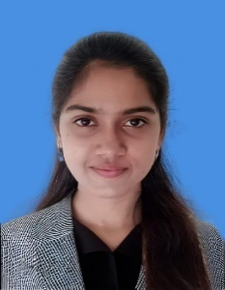Tamil Bharathi K

Department of Computer Science and Engineering, Mahendra Engineering College, Tamil Nadu, India

Tamil Bharathi K, a B.E. Student at Mahendra Engineering College. Her passion for machine learning drives her to delve into advanced disease detection which contributes to research in analysis of images.

Sowmiya P

Department of Computer Science and Engineering, Mahendra Engineering College, Tamil Nadu, India

Sowmiya P, a B.E. Student at Mahendra Engineering College, excels in transfer learning and image analysis, aiming to innovate in accuracy detections.

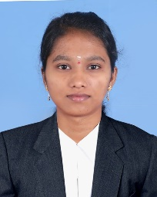Varsha Y

Department of Computer Science and Engineering, Mahendra Engineering College, Tamil Nadu, India

Varsha Y, a B.E. Student at Mahendra Engineering College, specialized in machine learning. Her proficiency in application development underpins her project to create disease detection.