**Design To Develop an Electro-Pneumatic Robotic Arm**

**Author: Berisso Woyessa Bekele**

**Corresponding Author: Berisso Woyessa Bekele (berissowoyessa629@gmail.com)**

**Contact Number: 9043378104**

Student, Department of Instrumentation and Control Engineering, National Institute of Technology Tiruchirappalli-620015, India

***Abstract***

*The goal of this endeavor intends to design and build a pneumatic arm for a pick-and-place system that uses pneumatic components to operate an arm and an air compressor as a power source. The handling of materials and devices for picking and placing objects from lower to higher planes are common in factories and industrial manufacture. There are numerous electrical and hydraulic arms available, each with its own set of mechanisms, making them pricey. The pneumatic arm was constructed with three cylinders and uses compressed air via a four-way, three-position directional control valve (4/3) DCV. The specified processes are implemented using integrated information from kinematics dynamics and structural analysis of the desired robot configuration as a whole. The extremely dynamic pneumatic arm model may be easily adjusted to intermediate positions by changing the pressure using the flow control valve. It can be utilized for loading and unloading commodities in a maritime harbor since the goods are moved from lower to higher levels.*

***Keywords:*** *robotic arm, pneumatic actuator, pick-and-place, material handling.*

1. **Introduction**

Material management is a critical component of any productive activity. It is something that occurs continuously in all plants. Material handling entails giving the right amount of the right material, in the right condition, at the right time, in the right position, and at the right cost, using the correct method. It is just the picking up, moving, and lying down of items during manufacturing. It covers the movement of raw materials, in-process parts, finished goods, packing materials, and scrap disposal. In general, hundreds of thousands of tons of materials are handled every day, requiring a considerable quantity of people when materials are moved from one processing area to another.

Pneumatic systems typically function at significantly lower pressures than hydraulic systems; yet, pneumatics has numerous advantages that make it more suitable for a variety of applications. Because pneumatic pressures are lower, components can be built of thinner, lighter-weight materials like aluminum and engineered polymers, whereas hydraulic components are typically made of steel and ductile or cast iron. Hydraulic systems are frequently regarded inflexible, but pneumatic systems typically provide some cushioning, or "give." Pneumatic systems are generally easier since air may be expelled into the atmosphere, whereas hydraulic fluid is typically returned to a fluid reservoir.

Pneumatics has advantages over electromechanical power transmission technologies. Heat generation is a common limitation for electric motors. Heat generation is normally not an issue with pneumatic motors because the compressed air that flows through them removes heat from them. Furthermore, because pneumatic components do not require electricity, they do not require the large, heavy, and expensive explosion-proof enclosures that electric motors do. In reality, even without specific casings, electric motors are significantly larger and heavier than pneumatic motors with comparable power ratings.

Furthermore, if overloaded, pneumatic motors will simply stall and not provide any power. In contrast, electric motors can overheat and burn out if overused. Furthermore, torque, force, and speed control using pneumatics frequently necessitates simple pressure- or flow-control valves, as opposed to more expensive and complex electrical drive controllers. Furthermore, pneumatic actuators, like hydraulics, can reverse direction instantaneously, but electromechanical components frequently rotate with tremendous momentum, delaying direction changes.

Robots! Robots on Mars and in the oceans, in hospitals and homes, in factories and schools; robots battling fires, producing goods and services, saving time and lives. Today, robots have a significant impact on many parts of modern life, ranging from industrial manufacturing to healthcare, transportation, and deep space and marine research. Robots will be as widespread and personal as today's personal computers. [1]

These numerous inventive historical realizations clearly proved the robot notion. Nonetheless, the physical robot had to wait for the development of its underlying technology throughout the twentieth century. Karel Capek, a Czech playwright, used the term "robot" in his play Rossum's Universal Robots (R.U.R.) in 1920. The phrase comes from the Slavic word "robota," which meaning "subordinate labor." In his novel Runaround, Isaac Asimov, a Russian science-fiction writer, proposed three essential laws to govern the ethics of human-robot interactions in 1940.[2]

If no other instructions are provided, use the manipulator. National robotics societies, including the British Robot Association (BRA) and the Japanese Industrial Robot Association (0IRA), typically define robots as industrial in nature. For example, consider the Robot Institute of America (RIA). [3].

1. **Literature Review**

**(M. A. B. Mabanta, J. P. Pabillaran, and M. B. Adiong, , 2011)** [4] Have Design and manufacture of a pneumatic arm for picking up and placing cylindrical objects. Material handling and systems for picking and placing objects from lower to higher places are commonly used in factories and industrial manufacturing. There are numerous pneumatic arms available, each with its own set of mechanisms and thus a high cost. The planned pneumatic arm consists of two cylinders, a shaft, and a lead screw mechanism capable of converting piston motion to arm rotation using compressed air. The designed method is carried out using integrated information from kinematics dynamics and structural analysis of the desired robot configuration as a whole.

In the task at hand, we attempted to design a pneumatic arm for picking and placing metals and other materials, but not cylindrical things. This design consists of three pneumatic cylinders.   
**(K. Kruthika, B. M. Kiran Kumar, and S. Lakshminarayanan, 2016)** [5] According to the literature, for a robotic arm to engage with humans, it should have simple control techniques and be lightweight. The author presents the design of the 7-DOF robotic arm with cable drive, which is utilized as a pick and place robotic arm. Cable driven methods are disadvantageous since they are not practicable. So we want to design four degrees of freedom for ease of control.  
**(Swapnil Gurav et al. , 2021)** [6]This paper discusses the design and manufacture of robot end effectors for pick and place activities. Robots with particular purpose end effectors are extremely useful for material handling in industries, as they minimize cycle time and manufacturing costs. The gripper's design is driven by the need to grasp sheet metal pieces in the stamping and forging industries. The concept focuses on a provincial general-purpose gripper with kinematics and dexterity similar to the human hand (humanoids).

**(A. Che Soh, S. A. Ahmad, A. J. Ishak, and K. N. Abdul Latif, , 2012)** [7]Adjustable grippers for robotic systems that can determine the shape and size of an object are required in various applications, particularly for picking and placing operations. This is because some gripper designs are limited to a single form or size, making choosing and putting operations difficult. The primary goal is to create a strong gripper that can select and place things of all shapes and sizes with greater ease and speed. This customizable gripper for robotic systems can improve picking and placing operations in the manufacturing area, allowing for increased production without the need to.

**(S. P. kumar, K. S. Varman, and R. B. murugan, 2016)** [8]Robot manipulator is a fundamental motion subsystem component of the robotic system for positioning and orienting objects so that robot can do meaningful tasks. The primary goal of our research is to integrate the gripper and vacuum sucking mechanisms into a single pick and place robotic arm. This robot can control itself, starting with fundamental operations like grabbing, sucking, lifting, placing, and releasing with a single robotic arm. The primary goal of our study is to design a robotic arm for the aforementioned purpose. Robotic arms are made up of revolute joints, which allow for angular movement between adjacent joints.

1. **Methodology**

Methodology is the methodical, theoretical examination of the procedures used in a subject of study. It includes a theoretical examination of the body of methods and principles related with a field of knowledge. In general, methodology determines the methodologies to be followed and directs the study process.

In this project, methodology includes data gathering, which may be divided into two categories: primary and secondary data collecting. Primary data is gathered directly from sources such as observations of various industries and workshops. Secondary data is gathered from various sources, including the internet, textbooks, journals, and literature, to provide knowledge about robots and other pertinent issues.

Literature collection

Literature review

Design the component

Analysis

Drawing

Figure 1 methodology chain

The project methodology takes a methodical approach from the beginning to the end of the project. The acquired primary and secondary data is examined by designing several components and overcoming the restrictions found during data collecting. In addition, detailed literature reviews are carried out. The robot hand in this study has seven degrees of freedom, but we plan to employ only four in our work. All required components will be designed utilizing various statistical sources and data tables. The design process will also be studied and modeled with different software, including SolidWorks.

1. **Detail design of components**
   1. **Material Selections**

Robots are mostly made from common materials. Some specialized robots for clean room applications, the space program, or other "high tech" endeavors may make use of titanium metal and carbon fiber structural composites. The working environment and the strength required are important considerations in material selection. Nowadays, the industry offers a diverse range of metals and composites. Material selection is a highly involved process. We used material and process charts created by Mike Ashby. He has presented us with a variety of plots that compare the varied quality and attributes of materials.

We concentrated on two charts: strength vs. density plot and strength vs. relative cost figures 2 and 3 The selection of materials and cost analysis to design an economic model is a completely distinct and more complex field of engineering. That case study requires extra parameters to compare and judge the material selection. We won't get into that right now, but we tried to use materials that meet your weight bearing capacity needs while also being reasonably priced. [9]

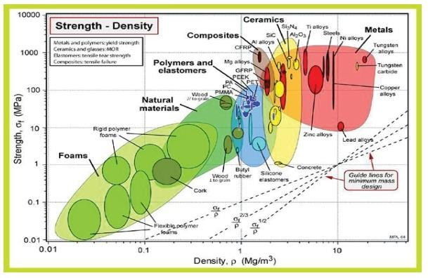

Figure 2-Strength and Density of the Material  
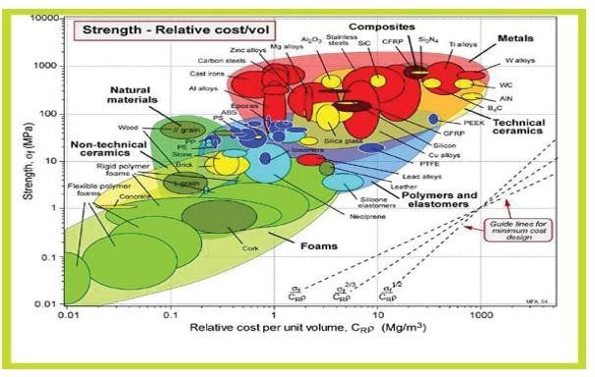Figure 3-Strength and Relative cost per unit volume

The most common materials used for robot arms and bases are steel, cast iron, and aluminum alloy. Aluminum alloy is a softer substance and so easier to deal with. However, steel is many times stronger. We decided to design the pieces using aluminum alloy. It has not been a direct selection. The base can be heavier than the rest of the pieces. The remaining sections are not grounded and must support the weight of the other arms and end effectors, as well as the sheet in this case. As a result, they cannot be heavier than the base, as this would harm component 1. We chose to assign aluminum to all sections, including part one. Of course, we always have the option to modify the material. Our option was confirmed correct because aluminum performed well for parts 1, 2, 3, and 4, despite having reduced load bearing capacity with aluminum. In the contrary instance, we decided to use stainless steel for the pieces. We focus our research on the industry's utilization requirements. Most of the pieces of the robotic arm are made of aluminum 6061 alloy.

**Aluminum 6061** is a precipitation-hardened aluminum alloy with magnesium and silicon as the main alloying constituents. It has high mechanical qualities, welds well, and is widely extruded (second only to 6063). It is one of the most often used aluminum alloys for general purpose applications. The mechanical properties of 6061 are highly dependent on the material's temperature, or heat treatment.

* Young's Modulus measures 69 GPa (10,000 ksi).
* The maximum tensile strength for aluminum 6061 (6061-O temper) is 120 MPa (18,000 psi).
* Maximum yield strength of 55 MPa (8,000 psi).
* The material has a stretch before failure of 25-30%.
  1. **An air compressor**

A compressor is a device that transfers electricity (from an electric motor, diesel or gasoline engine, etc.) into potential energy stored in pressurized air (also known as compressed air). An air compressor uses one of several methods to pump more and more air into a storage tank, increasing pressure. When the tank pressure exceeds the engineered top limit, the air compressor turns off. The compressed air is then stored in the tank until it is used.

The energy contained in compressed air can be used for a variety of uses, including harnessing the air's kinetic energy as it is released and the tank depressurizes. When the tank pressure hits its lowest point, the air compressor restarts and repressurizes the tank. An air compressor differs from a pump in that it can function with any gas or air, whereas pumps only work with liquids. [10]

**Classification**

Compressors can be classed based on the pressure delivered.

1. Low-pressure air compressors (LPACs) with discharge pressures of 150 psi or lower.  
2. Medium-pressure compressors with discharge pressures from 151 to 1,000 psi.  
3. High-pressure air compressors (HPACs) with discharge pressures over 1,000 psi [2].  
**They can also be classed based on the design and principle of functioning.**

1. A single-stage reciprocating compressor.

2. Two-stage reciprocating compressor.

3. Compound Compressor

4. Rotary screw compressor.

5. Rotary Vane Pump

6. Scroll compressor.

7. Turbo compressor.

8. Centrifugal Compressor

**4.3 Robotic arm components. End effectors**

The end effectors are one component that enables the robot to provide adaptive solutions. This device is meant to have a strong connection with the environment, and the operation of end effectors is entirely dependent on the robot applications. Essentially, end effectors are grippers or devices that function according to the many applications generated in them, particularly when it comes to robotic awareness.

**Electro-pneumatic devices**

Electric circuits are capable of controlling pneumatic circuits. A solenoid valve serves as the interface between these two circuits. Solenoid valves serve the same purpose as standard pneumatic valves, except they are controlled electrically. Inside the solenoid valve, there is a wire coil that conducts electric current. It generates a magnetic field that attracts an iron armature, and the movement of the armature activates the valve.

**5/2 Double-acting solenoid valve**

The directional valve is a key component of a pneumatic system. This valve, also known as DCV, controls the direction of air flow in a pneumatic system. The directional valve accomplishes this by shifting the positions of its internal movable components. This valve was chosen for rapid operation, to reduce manual effort, and for the adjustment of the use of a solenoid valve converts the machine into an automatic machine. A solenoid is an electrical device that converts electrical energy into linear motion and force. These are also employed to initiate a mechanical operation, which in turn activates the valve mechanism. Solenoids can be push or pull type. When a push type solenoid is electrically activated, the plunger is pushed. The pull type solenoid is one in which the plunger is pulled when it is activated. The names of the solenoid's components should be known so that they may be identified when called upon to make repairs, perform service work, or install them.

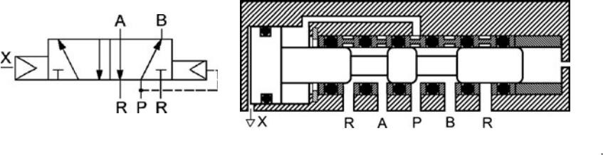**Poisition-1**  
When the spool is actuated in the outer direction, port 'P' is connected to 'B', 'S' remains closed, and 'A' is connected to 'R'.

Figure 4-solenoid operated valves 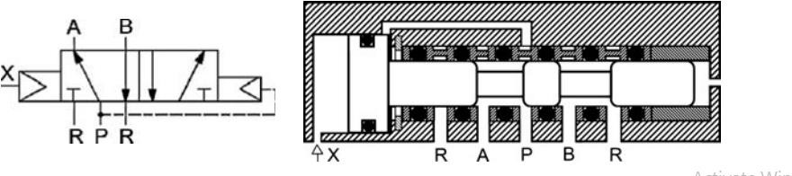

**Poisition-2**   
When the spool is pulled in the inner direction, ports 'P' and 'A' are connected to one other, and 'B' to 'S', but port 'R' stays closed.

**Parts of the solenoid valve coil (electrical)**

The solenoid coil is comprised of copper wire. Wire layers are separated by an insulating layer.  
The entire solenoid coil is coated with a varnish that is impervious to solvents, dampness, cutting oil, and many other fluids.

**Frame**   
The solenoid frame has multiple applications. It is made of laminated sheets and is magnetic when current flows through the coil. The magnetized coil attracts the metal plunger and causes it to move. The frame includes provisions for attaching the mounting. They are often bolted or welded to the frame. The frame includes accommodations for receivers and the plunger. The wear strips are installed on the solenoid frame and might be made of metal or impregnated less fiber cloth.

**Solenoid plunger**

The solenoid plunger is the mover mechanism for the solenoid. The plunger is built of steel laminations that are riveted together under high pressure, ensuring that the laminations do not move relative to each other. A pin hole is drilled into the top of the plunger to link it to another device. A magnetic force moves the solenoid plunger in one direction, and spring action normally returns it. Solenoid-operated valves are typically equipped with a cover over either the solenoid or the entire valve. This protects the solenoid from dirt and other foreign debris, as well as the actuator.

**Relays**   
A relay is an electromagnetically operated switch. It is a basic electrical gadget used for signal processing. Relays are designed to endure high power surges and extreme environmental conditions. When a voltage is applied to the solenoid coil, it induces an electromagnet field. This leads the armature to get attracted to the coil core. The armature activates the relay contacts, either closing or opening them depending on the configuration. When the current to the coil is disconnected, a return spring causes the armature to return to its original position. Relays, unlike push button stations, may accommodate a large number of control contacts. Relays are commonly referred to as K1, K2, and K3. Relays also have interlocking capabilities, which is a critical safety element in control circuits. Interlocking prevents certain coils from switching on at the same time.

**Pushbutton switches**

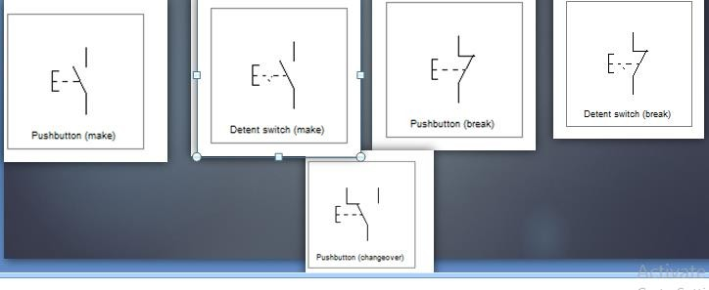A push button is a switch that closes or opens an electrical control circuit. They are typically used to start and halt the functioning of machinery.

Figure 5-push button switches

**Limit switches**

A limit switch is an electrical signal that initiates an appropriate system response. Limit switches are defined as any switch that is operated by the position of a fluid power component (often a piston rod or hydraulic motor shaft) or the position of the load. The activation of a limit switch provides the same functionality as push button switches. Push buttons are manually actuated, whereas limit switches are mechanically activated. Limit switches are classified into two types based on the way of actuating the contacts. a) Lever-actuated contacts Lever type limit switches have spring-loaded contacts that function slowly. The contacts of spring-type limit switches are rapidly operated. Figure below depicts a Simplified cross sectional view of a limit switch and its symbol

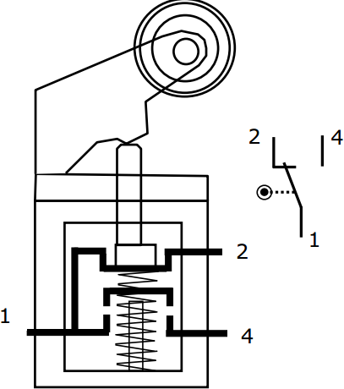  
Figure 6-limit switches

**Pneumatic cylinders**

Pneumatic cylinders are mechanical devices that employ compressed gas to generate force in reciprocating linear motion. Pneumatic cylinders, like hydraulic cylinders, transfer the stored potential energy of a fluid, in this instance compressed air, into kinetic energy as the air expands to achieve atmospheric pressure. The air expansion causes a piston to move in the desired direction. The piston is a disc or cylinder, and the piston rod transmits the force it generates to the object being moved. Engineers prefer to use pneumatics because they are quieter, cleaner, and do not require vast amounts of fluid storage space.

##### Telescopic Cylinder

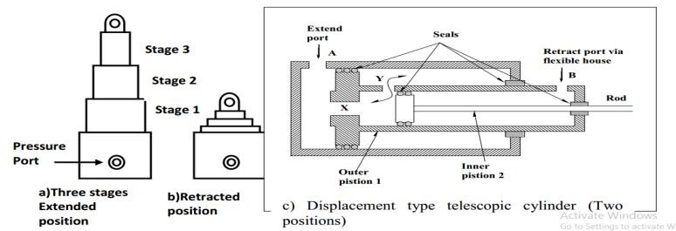

Figure 7-Telescopic cylinders

The telescopic cylinder is employed when a long stroke length and a short retraction length are needed. They progress in stages, with each step consisting of a sleeve that fits inside the preceding stage. Figure (c) depicts a typical double-acting telescopic cylinder with two pistons (two stages).

**Extension stroke:** When pressure is applied at port A, air flows through ports X and Y, and pressure is applied to both sides of piston 1. However, the difference in regions leads piston 1 to travel to the right. When piston 1 fully extends, inner piston 2 will also extend.  
To retract, air is applied to port B. The air pressure will affect the annulus of thinner piston 2 and moves inner piston 2 to the left. When the inner piston moves to left and started to close port X, air from port B goes to annular side of the piston 1 via port Y and pushes the piston 1 to the left. Figure shows the construction of a typical double acting telescopic cylinder with three pistons (three stages).

**Forward stroke:** when the pressurized air enters the port p, larger ram of diameter A moves first. Since the diameter of Ram A is relatively large, this ram produces large force at the beginning of the lift of the load. (usually in many application, initial inertial is high and larger force is required in the beginning, once initial inertia is overcome, smaller force is required to keep moving the weight). When ram A reaches the end of the stroke, ram B begins to move, providing smaller force. When ram B reaches its end position, Ram C will move outward to complete the stroke.

**Retraction stroke:** When the pressurized air enters the port T, then it acts on the annular area of Ram A and ram A is retrieved. Once the Ram A is retrieved, pressure continues to act on annular area of Ram B and retrieves Ram B. In similar way, the Ram C is also retrieved.

**Flow Control Valves**

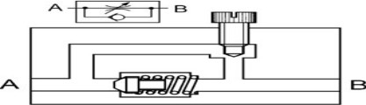In general, the flow rate is controlled by using a simple throttling element, of fixed or variable area, with or without a parallel connected check valve as shown in Fig.[11]

Figure 8-Flow control valves

**4.4 Kinematic Analysis**

**4.4.1 Degrees of freedom**

A manipulator's degree of freedom (DOF) is the number of independent position variables that must be given in order to locate all sections of the mechanism; it refers to the number of various ways in which a robot arm can travel in a specific direction. Moving the arm exclusively from the elbow, while keeping the shoulder in the same posture. The elbow joint has the same pitch as the shoulder joint; hence it has one degree of freedom. Gruebler's equation [12] can be used to calculate planar linkages linked with common joints.

***M* = *degree of freedom* =3(n-1)-2jp-jh** (4.1)

where

* + - * *n* = total number of links in the mechanism. =5
      * *j*p= total number of primary joints (pins or sliding joints) =4
      * jh =total number of higher-order joints (cam or gear joints) =0 M =3(5-1)-2*4-0 = 4

With four degree of freedom, the robotic arm mechanism is unconstrained

* + 1. Position analysis

the figure below link 1,2,3 and 4 are set as shown due to the extension stoke of cylinder, A+, B+, C+.

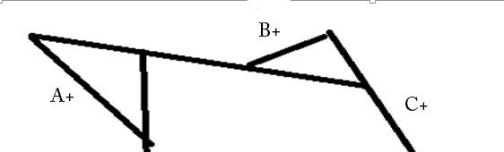Link 1 and 2

Figure 3-position of pick and place robot

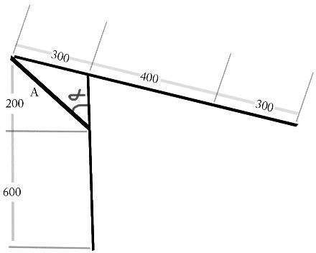

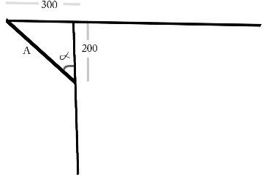But before the extension of cylinder A. its position will be.

A1=√3002 + 2002 = 360.55mm

𝜕 = tan-1(300) = 56.37o

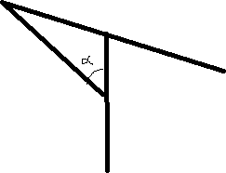200

Sin law

❑ =180-105-56.31= 18.690

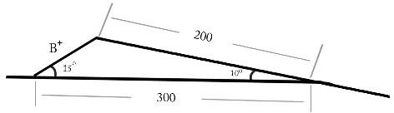**Link -2**

**4.5 Velocity analysis of pneumatic cylinder**

CYLINDER-A

Based on position analysis, we discovered that its extension length and retraction can aid in piston stroke.

Stroke (L) = 602.86mm–360.55mm = 242.31mm

Take the diameter cylinder and the piston rod.

Cylinder diameter (D): 80mm = 8 cm.

Piston rod diameter (d): 40mm = 4 cm.

Maximum pressure applied in the cylinder (P) = 10 bar.

Applied pressure: 3 bar = 30 N/cm2

Therefore, the forward Stroke for Double Acting Cylinder

$$Force=\frac{πD^{2}P}{4}=\frac{π*8^{2}*30}{4}=1507.96N$$

Return Stroke for Double Acting Cylinder

$$Force=\frac{π{(D}^{2}-d^{2})}{4}p=\frac{π{(8}^{2}-4^{2})}{4}30=1130.97N$$

We know that force (F) =m* a (4.2)

Where

m=mass of the piston a = acceleration

We have taken that mass of the piston = 3 kg; Then calculate forward stroke acceleration $acceleration=\frac{F}{m}=\frac{1507.96}{3}=502.654m/{s^{2}}$

We know that V2 -U2 =2*a*L0 (4.3)

Where U=initial velocity

V=final velocity

In this case initial velocity is zero.

Therefore, final velocity (V) =√ (2 ∗ 𝑎 ∗ 𝑙) (4.4)

=√ (2 ∗ 502.654 ∗ 0.24231) = 15.608m/sec

This speed is very fast but it can be reduced by flow control valves. For return stroke

$$a=\frac{F}{m}=\frac{1130.97}{3}=376.99m/sec2$$

We know that V2 -U2 = 2*a*L, where U = starting velocity = 0.

Therefore, final velocity (V) = √ (2 ∗ 𝑎 ∗ 𝑙) = √ (2 ∗ 376.99 ∗ 0.24231) = 13.5165 m/sec.

CYLINDER-B

Cylinder B is slightly smaller than cylinder -A, as is its piston. Similarly, we will extract its dimension via position analysis.

Stroke (L) = 377.8 - 134.2 = 243.6 mm. Take the diameter cylinder and the piston rod. Cylinder

Diameter (D): 60mm = 6cm.

Piston rod diameter (d): 35mm = 3.5 cm

Therefore, the forward stroke for a double-acting cylinder $Force, F=\frac{πD^{2}P}{4}$ (4.5)

$$Force, F=\frac{π6^{2}*30}{4} =848.23N$$

Return Stroke for Double Acting Cylinder

$Force, F=\frac{π{(D}^{2}-d^{2})}{4}p=\frac{π6^{2}-{3.5}^{2}}{4}*30=559.6N$ (4.6)

We know that force (F) =m*a

We have taken that mass of the cylinder-b = 2 kg;

Then compute the forward stroke acceleration.

Acceleration (a) = F/2 = (848.23)/2 = 424.115 $m/sec2$

We know that V2 -U2 = 2*a*L, where U represents zero starting velocity.

Therefore, final velocity (V) = √ (2 ∗ 𝑎 ∗ 𝑙) = √ (2 ∗ 424.115 ∗ 0.2436) = 14.375 m/sec.

For return stroke.

Acceleration (a) = F = (559.6) = 279.8 $m/sec2$

We know that V2 - U2 = 2*a*L U= starting velocity = 0.

Therefore, final velocity (V) = √ (2 ∗ 𝑎 ∗ 𝑙) = √ (2 ∗ 279.8 ∗ 0.2436) = 11.676 m/sec.

CYLINDER-C

The same analysis is required to establish its acceleration and velocity, as well as the forward and backward force it experiences.

Stroke (L) = 143.2mm–67.35mm = 75.85mm.

Take the diameter cylinder and the piston rod.

Cylinder diameter (D): 40mm = 4cm.

Piston rod diameter (d): 20mm = 2 cm

To calculate the forward stroke for a double acting cylinder, use the formula: $Force, F=\frac{πD^{2}P}{4}$ $Force, F=\frac{π4^{2}*30}{4}=480N$

Return Stroke for Double Acting Cylinder: Force (F) = (л×D2-d2)/4 ×P = л× (42-22) ×30 = 282.74 N.

We understand that force (F) = m * a.

To compute forward stroke acceleration for a cylinder with a mass of 1.25 kg, use the formula:

Acceleration (a) = F = (480)/ 1.25 = 384m/sec2.

We know that V2 -U2 = 2*a*L, where U represents zero starting velocity.

The final velocity (V) = √ (2 ∗ 𝑎 ∗ 𝑙) = √(2 ∗ 384 ∗ 0.07585) = 7.63 m/sec.

For return stroke.

Acceleration (a) = F = (282.74)/ 1.25 = 226.2 meters per second.

We know that V2 - U2 = 2*a*L U= starting velocity = 0.

The final velocity (V) = √ (2 ∗ 𝑎 ∗ 𝑙) = √ (2 ∗ 226.2 ∗ 0.07585) = 5.85 m/sec.

Stress analysis

The sheet metals are constructed of steel, thus their density is 7.9 g/cm3. Width (w) = 200 cm, length (l) = 100 cm, and thickness (t) = 0.15 cm.

Volume of sheet metal = w*l*t = 200cm*100cm*0.15cm = 3000cm3.

Mass of sheet metal (M) = density * volume = 7.9*g/cm3 * 3000cm3 = 23700g = 23.7kg.

Weight of sheet metal (w) = m*g = 23.7 kg*9.81 m/sec2 = 232.497 N

The sheet weighs 232.497 N and has a mass of 23.9 kg. There are eight suction cups on the end effectors. The weight of the sheet acts downwards (by gravity). The suction cups must generate sufficient force to resist gravity. The only external loading specified in this model is the pressure exerted on the sheet at the suction cups to lift the object. As we previously stated, the suction cup phenomenon is already in use in the industry. The locking of suction cups creates 8 bars of pressure on the sheet in the opposite direction of gravity. In our case, we have eight suction cups. This pressure is divided among 8 cups and is converted to force by multiplying the divided pressure with the area of the suction cup.

The force required to detach an ideal suction cup by pulling it directly away from the surface is given by the formula:

F = P*A

In this equation, F represents the force, A represents the cup's surface area, and P represents the pressure outside the cup, which is normally atmospheric.

This stems from the definition of pressure, which is: P = 𝐹/𝐴

A suction cup with a radius of 2.0 cm has an area of 𝐴 = 𝜋𝑟2 = (0.020 m)2 = 0.0013 square meters. Using the force formula (F = AP), the answer is F = (0.0013 m2)*(100,000 Pa) = about 130 [Newton’s.](https://en.wikipedia.org/wiki/Newton_(unit)) The force F that is calculated above is the force that acts against gravity at one suction cup. There are 8 of them on the end effectors so the net force against the gravity is 8 times F.

F=8*130N =1040N

The human body and arms have a maximum caring capacity of 1040N.

* 1. **Designing components for ARM 1**

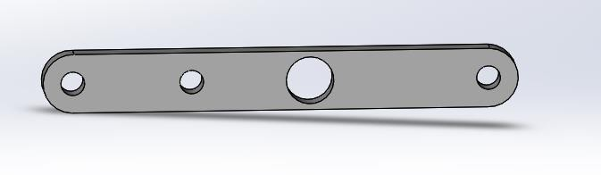

Figure 9-arm1

According to our stress studies, our robotic arm can carry a maximum load of 1040N.  
Since for buckling of the arm in vertical plane, the end assumed as hinged, the corresponding length of the arm

$$\frac{F}{2}=\frac{1040}{2}=520$$

Total length of the arm is 399.56mm.

Where: - L = half-length of arm = 399.56/2 = 199.78𝑚𝑚 we used mild steel to make the arm. 𝛿𝑐=834𝑁/𝑚𝑚2.  
From the determined dimensions T = 20mm; B = 25mm.

Since our arm is fixed on both sides using pins, us use: Rankin's constant is a (1/7500).

Where A represents cross-sectional area. I = moment of inertia. k=radius of gyration.

That force is applied vertically.

$$I=\frac{bt^{3}}{12}=\frac{25{*20}^{3}}{12}=16666.67$$

$$A=b*t=20*25=500{mm}^{2}$$

$$k=\frac{I}{A}=\frac{16666.67}{500}=5.773$$

According to Rankin’s formula, buckling load 𝑊𝑐𝑟 is:-

$$Wcr=\frac{{A*σ}_{C}}{1+a(\frac{L^{2}}{K^{2}})}=\frac{834*500}{1+\frac{1}{7500}(\frac{{199.78}^{2}}{{5.773}^{2}})}==358,839.32N$$

The arm's calculated dimension requires a weight of 358,839.32N to buckle, but 1040N is far less than 𝑊𝑐𝑟, making it safe from buckling.

##### ARM 2 design

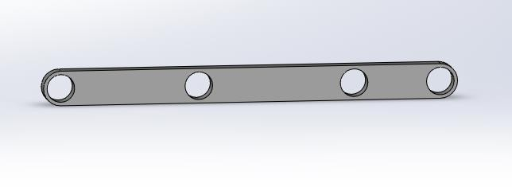

Figure 10-arm2

Also From our stress analysis we have maximum load that our robotic arm can carry F=1040N

$$\frac{F}{2}=\frac{1040}{2}=520$$

Also for arm 2 for buckling of the arm in vertical plane, the end assumed as hinged, so

Equivalent length of the arm.

Total length of the arm is 550mm.

Where: - L= half-length of arm = 550/2 = 250 𝑚𝑚

We built the arm using mild steel. 𝛿𝑐 = 834𝑁/𝑚𝑚2.

From the design dimensions t = 20mm; B = 25mm.

Since our arm is fixed on both sides using pins, us use: Rankin's constant is a (1/7500).

Where A represents cross-sectional area. I = moment of inertia. k=radius of gyration.

That force is applied vertically.

$$I=\frac{bt^{3}}{12}=\frac{25{*20}^{3}}{12}=16666.67$$

$$A=b*t=20*25=500{mm}^{2}$$

$$k=\frac{I}{A}=\frac{16666.67}{500}=5.773$$

According to Rankin’s formula, buckling load 𝑊𝑐𝑟 is:-

$Wcr=\frac{{A*σ}_{C}}{1+a(\frac{L^{2}}{K^{2}})}=\frac{834*500}{1+\frac{1}{7500}(\frac{{250}^{2}}{{5.773}^{2}})}=$ 333600N

The arm's predicted dimension requires 333600N load to buckle, however 1040N is far less than 𝑊𝑐𝑟, making the arm safe from buckling.

**Design of the handle**

To prevent buckling of the handle tip in vertical plane, the end is considered to be hinged, resulting in an efficient length of 100mm for the link. We used mild steel to

make the arm. 𝛿𝑐 = 834𝑁/𝑚𝑚2.

We determined that h = 15mm and b = 30mm.

Because our handle is secured by pins on one side and free at the end.

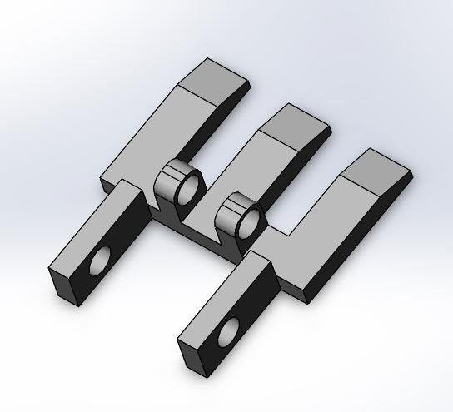

Figure 11-handle

Table 1-standards of end fixity coefficient

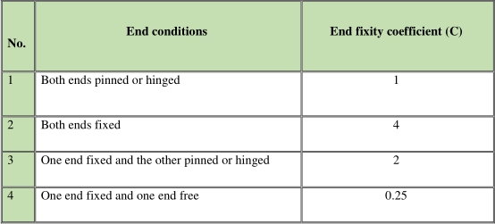

End fixity coefficient (C) equals 0.25 Where A represents cross-sectional area. I = moment of inertia. k represents the radius of gyration, since the force is delivered vertically.

$$I=\frac{bt^{3}}{12}=\frac{20{*15}^{3}}{12}=8437.5$$

A=b×h

A= 15×30=450𝑚𝑚2

**Design of Base**

Each pin and roller joint has a clearance of 0.02m.

When the lift table is at its greatest height, the platform experiences significant bending stress.

Assume thickness, t = 20mm.

This component bears the weight of the upper plat form and scissors arms. It is also responsible

for the overall stability of the assembly.

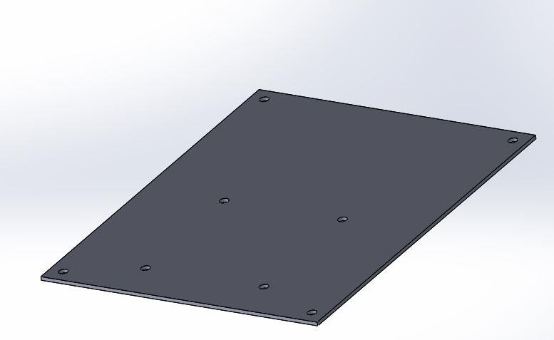

Figure 12-base

Free body diagram across the width

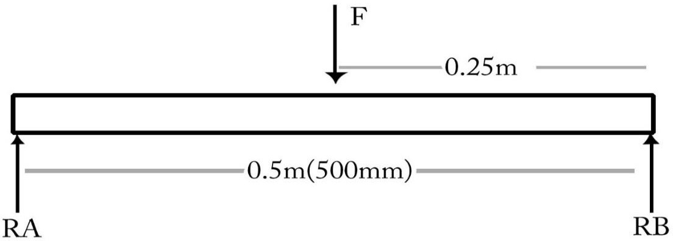

• ∑ 𝑓𝑦 =0

RA+RB-P=0

RA+RB=P

P=2×W=2×1040N=2080N

• ∑ 𝑀𝐵 =0 -0.25(2080) +0.8RA=0

520=0.8RA

RA=650N

RA+RB=P

RB=P-RA

RB=1430N

• The maximum bending moment can be calculated as;

• Mmax=M=RA×0.25=1625Nm

• The maximum bending moment occurs along the width where the piston force is applied. Mmax=M=RA×0.25=1625Nm

Taking a factor of safety of 2, the allowable stress is:

$$σall=\frac{σ_{y}}{F.S}=\frac{250}{2}=125$$

The bending stress is given by;

$$σ_{Y}=\frac{M_{y}}{I}$$

$$moment of inertia, I=\frac{bh^{3}}{12}$$

𝑦 =Centre in of the object

M=maximum moment of inertia

$$h^{2}=\frac{6M}{σ_{b}*b}=\frac{6*1625000}{125*500}=156mm$$

h=12.6mm

For better safety let’s take h=13mm

* 1. **Design of Cylinders**

A cylinder is a device that turns fluid power into linear mechanical force and motion. It typically consists of moving pieces or elements such as a piston, piston rod, plunger, or rams that operate within the cylinder bore. The cylinder is designed using the loop stress and longitudinal stress generated inside the cylinder bore as a result of the internal pressure and maximum sheer force applied to it.

Let ri1 be the internal radius of the smaller cylinder.

• Ro1 denotes the outer radius of the smaller cylinder.

• Di1 represents the inner diameter of the smaller cylinder. Do1 is the outer diameter of the smaller cylinder.

• σt represents tangential tension in the cylinder.

• Poisson's ratio (μ) for aluminum is 0.4.

• t1 represents the thickness of the larger cylinder.

* + *p*= intensity of internal pressure=1mpa

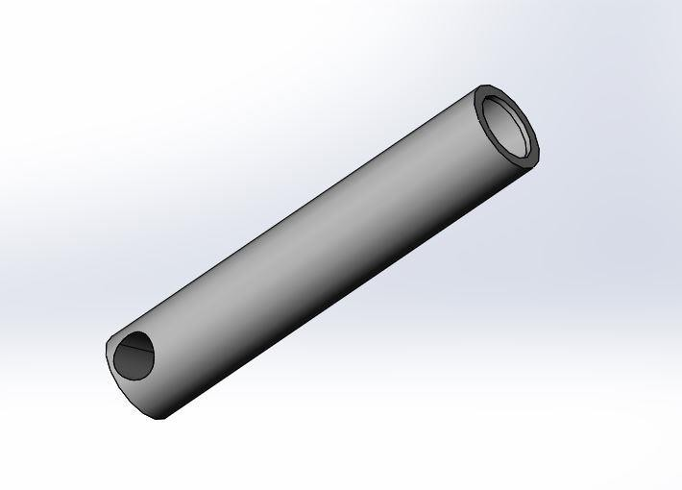**Cylinder A** of the robotic arm can be designed with having the specified data of length 175 mm, internal diameters of 74 mm. (equal to piston diameter c with clearance)

Figure 13-cylinder a

According to the pressure vessel design study, cylinder t1 = ri1*√ (𝛿𝑡+ (1−μ) 𝑝) − 1 (4.13) (𝛿𝑡− (1+𝜇) 𝑝).

t1= 37* (164+ (1−0.4)1𝑚𝑝𝑎) − 1 √ ( ) (164− 1+0.4 1𝑚𝑝𝑎)

t1=37*√0.0123 t1=37*0.1109 t1=4.1mm, say 3mm

To determine if a cylinder is thick or thin, t1 must be greater than 1/10 of its diameter. If t1=4.1mm and di1=74mm with clearance 0.002mm, the cylinder is thin. The outer diameter is Do=2(ri1+t1) or Do=2(37mm+4.1mm+0.002) =82.2mm or Do=60mm. Taking factor of safety 3,

$$rall=\frac{c}{F.S}$$

From our given data the allowable shear stress is 55.67Mpa so the cylinder is safe. **Cylinder b** of the robotic arm can be designed with having the specified data of length 160 mm, internal diameters of 50 mm. (almost equal to piston diameter c)

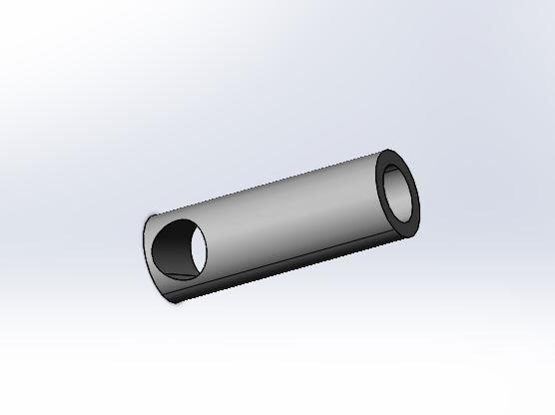  
  
Figure 14-cylinder b

From our given data the allowable shear stress is 55.67Mpa so the cylinder is safe.

**Cylinder c** of the robotic arm can be designed with having the specified data of length 80mm, Internal diameters of 36 mm. (almost equal to piston diameter c)

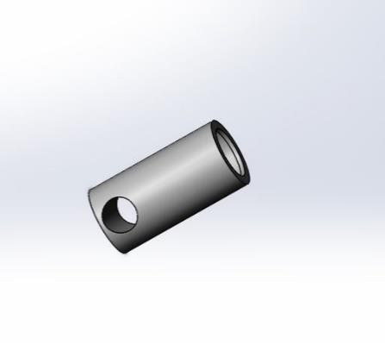

Figure 15-cylinder c

**Design for the piston rod**

A piston rod is a rod-like material or component of the system that anchors and lifts the main lode to the desired height or length. Short compression members that are applied centrally can be created via direct comparison. However, lengthy columns with a higher slenderness ratio are categorized as columns and fail buckling. As a result, they must evaluate the key lode.  
The safe lode is the real lode on which a column can safely stand. However, in this case, the piston rod is subjected to fluctuating stress caused by the changing lode for the various positions of the hydraulic system. Material Selection High carbon steel is the best material for this part because it has a high compressive stress, good hardness, is relatively inexpensive, and is widely available.

σy = 210 Mpa

σt = 124 Mpa

E = 207 Gpa

G = 89 Gpa

Assumptions: - The main factors

Ka (lode correction factor) = 0.8

Ke (fatigue strength-reduction factor) = 1/𝐾𝑓 = 0.66

Kf (Factor of fatigue stress concentration) = 1.5

Other factors (Kb, Kc, Kd)

Rankin's constant (𝛼) is 1/7500.

Crippling stress is 550Mpa.

F.S = 4

Buckling requires the effective length to be considered, whereas fatigue is simply concerned with cross-section. As a result, fatigue failure may not be sufficient to ensure buckling stability. To check for buckling, apply Rankin's theory formula. And the two piston rod ends are regarded fixed.

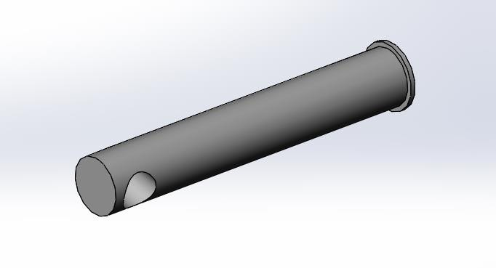

Figure 16-piston a

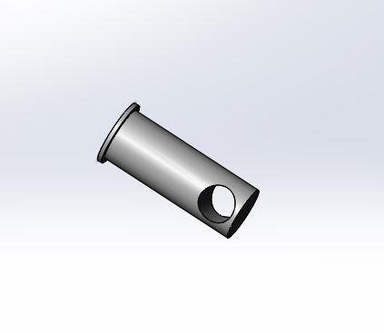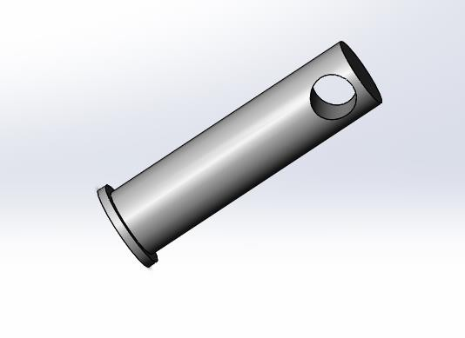The pistons and the head (rod) end covers have rings and sealing for protecting of the fluid from leakage and to increase the strength of the end plate covers.

Figure 17-piston b Figure 18-piston c

**Design of bolts and nuts for the base**   
• We use carbon steel for the bolt design.   
• Based on the standard table for carbon steel.   
• 𝛿𝑦 = 210𝑚𝑝𝑎   
• 𝛿𝑦 = 380𝑚𝑝𝑎   
• 𝐸 = 207𝐺𝑝𝑎   
We chose carbon steel for the bolt. $$F(Load)=\frac{W}{4}=\frac{1040}{4}=260N$$

$$δt=\frac{F}{A}=380mpa=\frac{206N}{A}$$

$$A=\frac{260}{380}=0.68mm \\ A=\frac{πd^{2}}{4}$$

$$d=\frac{√(0.68*4)}{π}=0.93mm$$

The has a great carrying capacity, thus we utilize M12 bolts to ensure safety.

Length of bolt   
L=2d+12=

L=2(12) +12=36mm

L=36mm

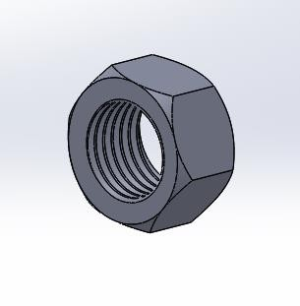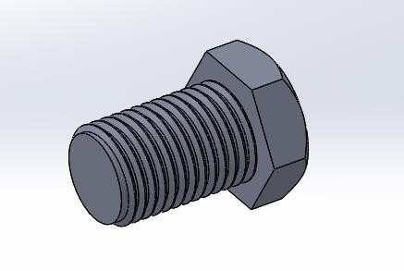Say, 12mm nominal diameter of pin (bolt).  
The table shows the fundamental dimensions for trapezoids and pins.  
Nominal diameter (𝑑1) = 12mm.  
Core diameter (𝑑𝑐) = 10mm.  
Pitch diameter = 2mm.  
Bolt head = nut; outer diameter = 19mm  
Bolt head thickness equals 8mm.  
Nut thickness equals 10mm.  
Nut main diameter is 12.5mm.  
The length of the pin is equal to the thickness of the nut's collar and the width of the two links in the connection, plus the height of the nut.  
For nuts  
The length of the pin is equal to the thickness of the collar plus the thickness of the metal plate used to mount the nut.  
For link length of pin, breadth of link in connection, and height of pin (bolt) nut  
  
Figure 19-bolt and nut

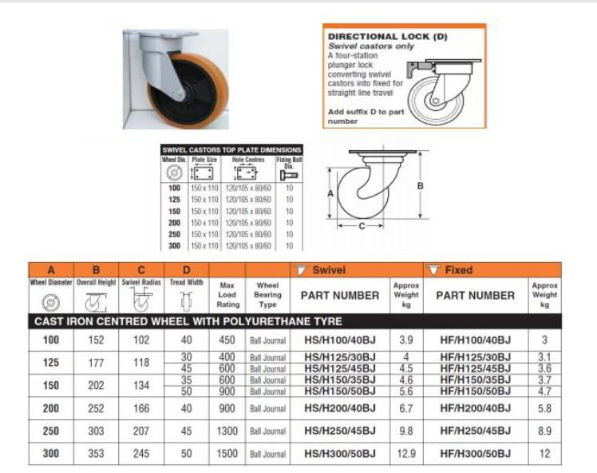**Wheel selection**

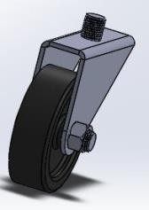The wheel diameter we have selected is 100mm with ball journal. The load capacity is 450kg which is greater than the total mass of the load and the machine. [13]

Figure 20-wheel

**Assembly**

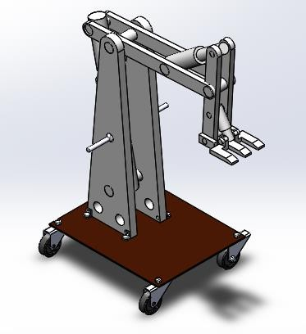  
Figure 23 assembly

**Results and Discussion**

**6.1. Result**

Table 2-Result for base

|  |  |
| --- | --- |
|  | **Result** |
| Area | 500*400 |
| Mass | 7.85 |
| Thickness of the base | 13mm |

Table 3-Result for cylinders

|  |  |  |  |
| --- | --- | --- | --- |
|  | **Result for pistons** | | |
|  | **Cylinder a** | **Cylinder b** | **Cylinder c** |
| Length of the cylinder | 415mm | 175mm | 80mm |
| Outer diameter of cylinder | 80mm | 60mm | 40mm |
| Thickness of cylinder | 30mm | 20mm | 20mm |
| Stroke (L | 242.31mm | 243.6mm | 75.85mm |
| forward Stroke | 1130.97 N | 848.23 N | 480 N |
| Return Stroke | 1507.96 N | 559.6 N | 282.74 N |
| Mass of cylinders | 3 kg | 2 kg | 1.25 kg |
| C:\Users\DEFAUL~1.LAP\AppData\Local\Temp\ksohtml\wps6469.tmp.jpg | 2.75mpa | 2.47mpa | 2.5mpa |

Table 4-Result for pistons

|  |  |  |  |
| --- | --- | --- | --- |
|  | **Result for pistons** | | |
| **Results** | **Piston a** | **Piston b** | **Piston c** |
| diameter piston | 40mm | 35mm | 20 mm |
| Length of piston | 366mm | 125mm | 60 |
| Area | 1256.63𝑚𝑚2 | 962.11𝑚𝑚2 | 314.15𝑚𝑚2 |
| Moment of inertia | 502654.82𝑚𝑚4 | 73661.75𝑚𝑚4 | 7853.98𝑚𝑚4 |

Table 5-result for arm

|  |  |  |
| --- | --- | --- |
|  | **Result of arms** | |
| **Results** | **Arm 1** | **Arm2** |
| Length of the arm | 399.6mm | 550mm |
| Thickness of arm | 20mm | 20mm |
| No of holes for pin | 4 | 4 |
| Height(tip diameter) | 25mm | 45mm |

Table 6-result for handle

|  |  |
| --- | --- |
|  | **Result** |
| Mass | 2.53 kg |
| efficient length of the handle | 100mm |
| H of one side connected to pin | 15mm |
| H of one side connected to pin | 30mm |

Table 7-result for pins

|  |  |
| --- | --- |
| **Pins** | **Result** |
| diameter PIN for arm 1 | 46mm |
| diameter pin for arm 2 | 3mm |
| diameter pin for body | 87mm |

Table 8-result for bolt and nut

|  |  |
| --- | --- |
| **Bolt** | **Result** |
| Nominal diameter **(C:\Users\DEFAUL~1.LAP\AppData\Local\Temp\ksohtml\wps647E.tmp.jpg)** | 12mm |
| Core diameter (C:\Users\DEFAUL~1.LAP\AppData\Local\Temp\ksohtml\wps647F.tmp.jpg ) | 10mm |
| pitch(p) | 1.75mm |
| head diameter(B) | 19mm |
| Bolt head thickness(H) | 8mm |
| Length of bolt for all connection | 80 mm |
|  |  |
| **Nut** | **Result** |
| nut thickness | 10mm |
| Nut major diameter | 12.5mm |

**6.2 Discussions.**

The outcomes of the above study are critical to this technical project, since they will determine whether to change, continue, or complete the project. Everyone has designed the cylinder, piston, arms, and base. Additionally aim to create pins for connecting parts. As shown in the above result, the maximum bending moment at the mid span and end of the movable arm is chosen to account for unexplained variables such as overloading. The most appropriate bolt and nut are chosen by estimating the basic dynamic load supplied to the bolt. The preferred arm length is computed by combining the shear and bending stresses created in the arm using the American Society of Mechanical Engineers (ASME) code. Using the maximum main stress and maximum shear stress theories, the maximum bending (tensile) and shear stress created in the arm and base are compared to the permissible bending and shear stress. The width and thickness of the base, as well as its length, are estimated taking into account the material's shearing and crushing strength. Also, cylinder design If t1 is more than 1/10 of its diameter, the cylinder is thick, and since t1=4.1mm, both the hoop and longitudinal stress produced by the internal pressure may be used to calculate the maximum shear stress formed in the interior component of the cylinder.   
In general, all of these components are designed and selected using optimum concepts and appropriate formulas to reduce failures caused by design errors and bad material selection, indicating that acceptable design and material selection are well performed. The outcome of this study demonstrates that all of the designed and selected components are efficient and safe for practical application.

1. **Conclusion**

The rise of automation is transforming the industrial sector by lowering labor requirements and production times. Electro-pneumatic robotic arms are playing an important role in this transformation, notably in pick-and-place operations. These robots provide significant cost savings in manpower and material handling. They require few operators, generally just one with basic training, which dramatically reduces dependency on skilled labor. Furthermore, employing air as working medium results in reduced energy use than other kinds of power. This leads into cost reductions because air is readily available and free. Furthermore, electro-pneumatic robots are frequently built using easily available local components, making them simple to build and assemble.

In essence, electro-pneumatic robotic arms provide a low-cost, high-efficiency solution for industrial pick-and-place activities. Their simplicity and ease of use make them an effective tool for streamlining industrial processes and minimizing dependency on expert labor. This technology eventually leads to a more automated and efficient industrial environment.

**References**

[1] S. N. Teli, A. Bhalerao, S. Ingole, M. Jagadale, and K. Kharat, “Design and Fabrication of Pneumatic Robotic Arm,” vol. 8, no. 3, p. 8, 2017.

[2] B. Siciliano and O. Khatib, Eds., *Springer Handbook of Robotics*. Cham: Springer International Publishing, 2016.

[3] D. J. Todd, *Fundamentals of Robot Technology*. Dordrecht: Springer Netherlands, 1986.

[4] M. A. B. Mabanta, J. P. Pabillaran, and M. B. Adiong, “Robotic Arm Pick and Place System,” *CU Eng. J.*, vol. 8, no. 1, 2011.

[5] K. Kruthika, B. M. Kiran Kumar, and S. Lakshminarayanan, “Design and development of a robotic arm,” in *2016 International Conference on Circuits, Controls, Communications and Computing (I4C)*, Bangalore, Oct. 2016, pp. 1–4, doi: 10.1109/CIMCA.2016.8053274.

[6] P. Velineni, J. Suresh, N. K. C, and S. M, “Design of Pneumatic Gripper for Pick and Place Operation (Four Jaw),” *Int. Res. J. Multidiscip. Technovation*, vol. 2, no. 2, pp. 1–8, Mar. 2020, doi: 10.34256/irjmt2021.

[7] A. Che Soh, S. A. Ahmad, A. J. Ishak, and K. N. Abdul Latif, “DEVELOPMENT OF AN ADJUSTABLE GRIPPER FOR ROBOTIC PICKING AND PLACING OPERATION,” *Int. J. Smart Sens. Intell. Syst.*, vol. 5, no. 4, pp. 1019–1043, 2012, doi: 10.21307/ijssis-2017- 521.

[8] IFET College of Engineering, S. P. kumar, K. S. Varman, and R. B. murugan, “Design and Implementation of multi handling Pick and Place Robotic Arm,” *Int. J. Eng. Trends Technol.*, vol. 33, no. 3, pp. 164–166, Mar. 2016, doi: 10.14445/22315381/IJETT-V33P230.

[9] M. F. Ashby and K. Johnson, *Materials and Design: The Art and Science of Material Selection in Product Design*. Butterworth-Heinemann, 2013.

[10] “Air compressor - Wikipedia.”https://en.wikipedia.org/wiki/Air_compressor#cite_note-1 (accessed Dec. 29, 2020).

[11] “Electro Pneumatic valve Positioner Principle | Electro Pneumatic Positioner.” https://instrumentationtools.com/electropneumatic-valve-positioner-schematic-principle/ (accessed Jan. 09, 2021).

[12] “Chapter 4. Basic Kinematics of Constrained Rigid Bodies.” https:/[/www.cs.cmu.edu/~r](http://www.cs.cmu.edu/~rapidproto/mechanisms/chpt4.html)a[pidproto/mechanisms/chpt4.html](http://www.cs.cmu.edu/~rapidproto/mechanisms/chpt4.html) (accessed Dec. 30, 2020).http://en.m.wikipedia.org