Prediction of Slow Light Parameters of Photonic Crystal Waveguide Using Machine Learning Algorithm

Vaishnavi Mane, Shivanand Shetye, Kaushal Shinde and Gayatri Gawai
Abstract—Slow light, a phenomenon where the group velocity of light is significantly reduced, plays a crucial role in applications such as optical communication, nonlinear optics, and biosensing. This study investigates the prediction of group velocity in photonic crystal structures using both machine learning (ML) and physics-based models. A dataset comprising geometrical parameters, particularly hole radius, was utilized to train and validate various ML algorithms. Among these, Linear Regression achieved the highest accuracy (99.27%) with minimal training time. In contrast, physics-based models based on Maxwell's equations and Effective Medium Theory (EMT) provided theoretical predictions but had lower accuracy (66.12%). Furthermore, the study analyzed the impact of dataset size on model performance, concluding that larger datasets enhance prediction stability while optimizing computational efficiency.

Keywords— Slow light, photonic crystals, machine learning, group velocity, physics-based modeling, optical communication.

INTRODUCTION
"Slow light" refers to the phenomenon in which the group velocity of light is significantly reduced as it passes through a particular medium, without changing its frequency or wavelength. It is well known that, in a vacuum, light propagates with a constant velocity c ≌ 3 ×10^8 m/sec. Light travels at its maximum speed (approximately 300,000 kilometers per second), but under certain conditions, its speed can be dramatically slowed down to just a few meters per second or even less. The phase velocity and the group velocity are given by:
𝑣𝑝 = 𝑐 / 𝑛
The group refractive index ng is used in place of n, and the velocity of optical pulses is usually expressed in terms of the group velocity:
𝑣𝑔 = 𝑐 / 𝑛𝑔
The applications of slow light include optical communication, nonlinear optics, medical imaging, and biosensing. There are two primary methods for slow light generation: Material Dispersion and Structural (Geometrical) Dispersion. Material dispersion occurs when the refractive index of a material depends on the wavelength (or frequency) of light. Structural dispersion arises from the design and structure of the material itself rather than its inherent properties. Our research focuses on structural dispersion because it offers several advantages by allowing precise control over how light propagates through a material or device.
A Photonic Crystal is a periodic optical structure that influences the motion of photons (light particles) in a manner like how the periodic potential in a semiconductor crystal affects the motion of electrons. The key feature of a photonic crystal is its ability to control the propagation of light through constructive and destructive interference due to its periodic variation in the refractive index. This periodic structure can exist in one-dimensional (1D), two-dimensional (2D), or three-dimensional (3D) configurations. The periodic structure consists of a lattice, which is a repeating arrangement of points, atoms, or structures in space.
A photonic crystal waveguide is formed by removing one row of holes from a photonic crystal. The photonic band gap is a range of frequencies within which light cannot propagate through the crystal. This occurs due to interference from the periodic structure, which causes certain wavelengths to be reflected or blocked.
For decades, widely used methods for calculating the photonic band structure include the Plane Wave Expansion Method (PWEM), the Finite Element Method (FEM), and the Finite Difference Time Domain (FDTD) method. According to Bloch’s theorem, a wave function propagating in a periodic structure has the same periodicity as the structure.[2]
Several software tools are available for photonic band structure prediction. However, their major drawback is the high computational cost—running simulations for different parameter variations (e.g., changing lattice constants or refractive indices) requires significant processing power and time, making large-scale optimization impractical. Additionally, traditional simulation tools lack adaptability—they do not inherently learn from previous results. Each new structure or parameter set must be simulated from scratch, whereas machine learning (ML)-based models can learn from existing datasets and generalize predictions to new cases instantly. The complexity of physics-based models makes real-time prediction infeasible for real-world applications where an instant response is needed. In contrast, ML provides a significant advantage through fast, data-driven approximation. The average accuracy of prediction achieved is about 0.5% (using MAPE, mean absolute percentage error, as a metric of accuracy). However, the dataset is we used is taken from GitHub and from some research paper mentioned below. The models were validated by dividing the dataset into training, validation, and test sets (70%, 15%, and 15%, respectively)[5].
In the following section, the prediction methods and results of both ML and physics-based models are presented, where the hole radius is varied while keeping other parameters constant. However, for the physics-based model, we have pre-trained the method for group velocity, which is linearly proportional to the hole radius.

Methodology
In this study, a hybrid approach combining machine learning (ML) and physics-based models is employed to predict the group velocity of slow light in photonic crystal structures. The methodology integrates physics-driven numerical simulations with data-driven ML techniques to enhance prediction accuracy while maintaining physical consistency. A dataset is generated using physics-based methods for predicting group velocity using Effective Medium Theory to extract key optical parameters. This dataset serves as the foundation for training ML models, where supervised learning algorithms, such as regression models, MLP Regression, Gaussian Process Regressor, and Support Vector Regressor, are utilized to map the relationship between structural parameters and the resulting group velocity. The trained ML model is then validated against numerical simulations to assess its predictive accuracy using performance metrics such as mean absolute error (MAE) and R-squared (R²).

ML based model
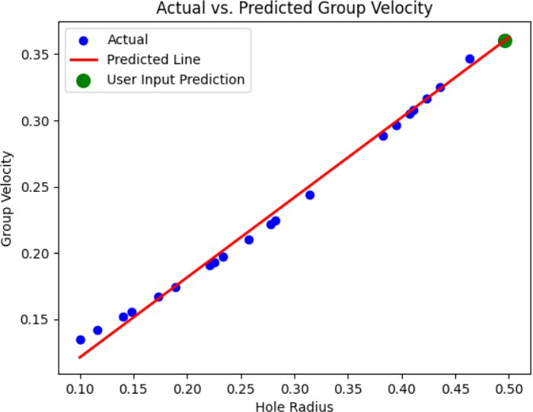
In this we have used the linear regression algorithm which was trained and performed on google collab where first get trained and tested with the ratio of 80% - 20% and after the training we got the MAE(Mean Absolute Error) as 0.0046 and the Cross validation accuracy with the R squared method for testing the generalizability of the model about 99.08%.
Figure 1 Actual vs Predicted group velocity
Figure 1 shows that the increase in hole of radius increases the group velocity of the light [5]. This accuracy is because of the linear relation of hole of radius and the group velocity as they are directly matched so the accuracy or the predicted values get more accurate and this proves that the ML model is perfectly trained.

Physic based model
A physics-based model is utilized to compute the group velocity of slow light in photonic crystals. This model relies on the Plane-Wave Expansion (PWE) method to solve Maxwell’s equations and obtain the photonic band structure. The group velocity (vg=dω/dk) is derived from the slope of the dispersion curve, correlating with variations in the hole radius.

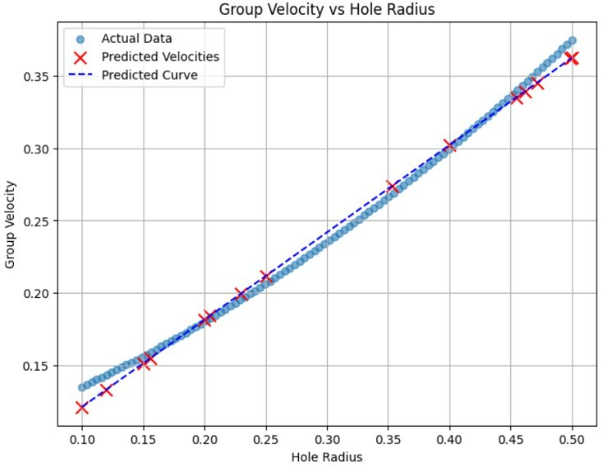
Figure 2 Actual vs Predicted group velocity
Figure 2 also proves the same theory that increase in hole radius increases the group velocity [5] but the accuracy here is not so proper or not that accurate as the ML gives us. Because, the physics-based approach ensures that the model captures fundamental electromagnetic wave behavior, providing accurate results that align with theoretical expectations.

Result

This section provides a comparison between ML-based and physics-based models, an analysis of different ML algorithms, and the impact of dataset size on performance. The findings highlight that ML-based approaches offer superior prediction accuracy and efficiency.

Comparison Between ML and Physic based model.
In this we have compared the ML algorithm with the physic technique of Maxwell equation by making a separate dataset of both ML and Physic which show that which technique can give or predict the value with accuracy.
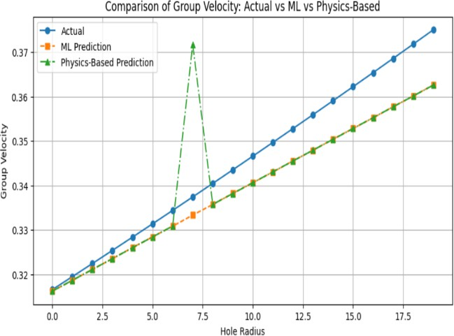
Figure 3 Comparison graph of ML and physic based model

Here we can clear see through the figure 3 that ML based is completely linear with actual values but not the physic based as the value of maxwell depends on some other factor that it gets vary and so the difference is seen in the graph of comparison. As the ML has the training and the testing ratio but not in case of physic so shall it gives the accuracy difference. They Accuracy vary in ML is about 84.57% and that of physic is about 66.12% which show more error in physic. As the ML takes some times for training and then testing but still it gives the value and accuracy of the model not exact but somewhat approx. But this is not the scene with the physic because it is an electromagnetic wave dispersion which gets varied in its refractive index and the complex nature of the hole of radius.
So, from this we conclude that ML Prediction is more stable but currently lacks coverage across the full range. Physics-based prediction has an anomaly that may need refinement or correction. Actual data suggests a near-linear trend, and a more refined ML model trained on a broader dataset could provide better accuracy.

Comparison between the algorithm used in ML.

In this we have done the comparison between MLP Regressor, Gaussian Process Regressor, Linear Regression, Decision Tree Regressor, Random Forest Regressor all this algorithm with the dataset of 100 samples only and got the absolute error, accuracy, cross validation, and training time taken. Each algorithm is trained with the 80% and testing 20% of ratio where the result was about.
Algorithm | Absolute Error | Accuracy  (%) | Training  Time (sec)
Linear  Regression | 0.0046 | 99.27 | 0.0045
MLP  Regressor | 0.0723 | 67.14 | 0.0863
Gaussian Regressor | 0.000 | 100 | 0.0037
Support vector | 0.0556 | 18.2452 | 0.0028
Table 1 Comparison among algorithm about error, accuracy, and epoch time
Table 1 show how the linear regression algorithm and gaussian regressor is aligned to this experiment because of accuracy but the algorithm like decision tree and random forest is more accurate but it take more time to trained.
As linear regression is used for non-linear and simple data set and can be used to trained. As it also struggles with the highly complex pattern but within less time for training.
The Multi-layered perceptron is highly complex and used to solve the data problem like bandgap frequency and requires long time for training.
In Gaussian Process the accuracy is great but the data should be linear and small but smooth dataset. It cannot handle more samples of dataset to be trained.
Support vector is the algorithm based on supervised learning which is only used in the linear and small to medium based dataset but the accuracy is low.

Comparison between the datasets used 100, 150,300 no of samples.

Now in this, the we have increased the number of samples in the dataset and check the accuracy and the epoch time of the different number of datasets with same algorithm called linear regression.
Data size | Epoch time (sec) | Accuracy (%)
100 | 0.0017 | 99.47
150 | 0.0016 | 100
300 | 0.0015 | 100

Table 2 Comparison among dataset size for epoch time
and average
From Table 2 illustrates the alignment of the Linear Regression and Gaussian Process Regressor models with the experiment due to their high accuracy. However, algorithms such as Decision Tree and Random Forest Regressor, while highly accurate, require significantly more training time. But when the dataset size increases, modern optimized linear algebra libraries (like NumPy, SciPy, and scikit-learn) can handle larger datasets more efficiently due to parallel computations and optimized memory management
For smaller datasets, the overhead of memory allocation, data loading, and processing can be relatively higher compared to actual training. Larger datasets can sometimes lead to better CPU/GPU utilization and caching benefits, reducing the relative training time per data point.

Conclusion
In this research, we analyses the prediction of group velocity in photonic crystal structures using both machine learning (ML) and physics-based models. By leveraging a dataset of geometrical parameters, including hole radius, we applied various ML algorithms such as Linear Regression, MLP Regressor, Gaussian Process Regressor, Support Vector Regressor, and Decision Tree Regressor. Among these, Linear Regression was identified as the most effective algorithm due to its high accuracy (99.27%) and minimal training time.
The study also compared ML-based predictions with physics-based models derived from Maxwell's equations and Effective Medium Theory (EMT). While the physics-based approach provides theoretical insight, its accuracy (66.12%) was lower than the ML-based approach (84.57%) due to its dependency on approximations and other influencing factors such as refractive index variations.
Our findings highlight that ML-based approaches are more reliable for predicting group velocity in photonic crystals, offering faster and more accurate predictions than purely physics-based models. Future work could focus on integrating hybrid ML-physics models to further enhance predictive accuracy and generalizability.

REFERENCE

- The Influence of Geometric Parameters for Training an Artifical Neural Network to predict the band structure of 1-D Fishbone Photonic Crystal.
- Artificial Neural Network for Photonic Crystal Band Structure prediction in different geometric parameters and refractive index Fu-Li Hsiao 1, Hsin-Feng Lee 1, Su-Chao Wang 1, Yu-Ming Weng 1 and Ying-Pin Tsai 2.
- Machine Learning models for photonic crystal band diagram prediction and gap optimization A. Nikulin1, IZisman1, M.Eich1,2,A.Yu.Petrovl,2,and A.Irin1 * 1Hamburg University of Technology, Institute of Optical and Electronic Materials Hamburg, Germany.
- Design and optical Studies of photonic components using slow light properties « Conception et Etudes Optiques de Composants Photoniques en Utilisant Les Proprieties de Lumière Lente ».
- Review on the optimization method of slow light in photonic crystsl waveguide Yong Zhao, Member, IEEE, Ya-nan Zhang , Qi Wang Member, IEEE, and Haifeng Hu.
- Inverse Design of slow light device at telecommunication band based on metamaterials using a deep learning attempt.
- Exploring high – performance photonic crystal slow light waveguides through deep reinforcement learning.

